Electronic Structure and Optical Properties of CaF₂ Films Implanted with Low-Energy Ba⁺ Ions
Eshboy Rabbimov¹, Nilufar Allamuratova ², Bakhtiyor Mukhammadiev¹, Khasan Abdiev ^{2, a)}
¹ Jizzakh Polytechnical Institute, Jizzakh, Uzbekistan
² Jizzakh Sambhram University, Jizzakh, Uzbekistan
^{a)} Corresponding author: xabdiyev857@gmail.com
Abstract. The using of monocrystalline CaF2 films the necessity of the inspected alteration of the electron structure, crystalline lattice parameter and other surface layers` properties appears. Our investigations have showed that the low energy Ba+ ion implantation combined with annealing can be employed to this effect. The research results can be useful to get optical resonators in UV region with the changeable frequency (7,8 eV ≤ hy ≤ 9,2 eV).
INTRODUCTION
In the world, thin layers of calcium fluoride system (CaF₂) are widely used in modern nanoelectronics, micro - and optoelectronics devices in solar devices due to their wide band transition range (Eg ≈ 9-10 eV), high-resolution transparency and chemical stability to light-light-based ultraviolet light [1], [8].n the world, thin layers of calcium fluoride system (CaF₂) are widely used in modern nanoelectronics, micro - and optoelectronics devices in solar devices due to their wide band transition range (Eg ≈ 9-10 eV), high-resolution transparency and chemical stability to light-light-based ultraviolet light [1], [8]. But nevertheless, in most cases, the need arises to change the electronic structure of the surface, the parameters of the grid and the optical properties of the LED circuit, and there will be a solution to this.
One good effective method for these is the chisobed — very low-energy ion implantation pathway, which allows the surface composition of a crystal to be controlled on an atomic scale without slowing or altering the interior of the crystal [2].ne good effective method for these is the chisobed — very low-energy ion implantation pathway, which allows the surface composition of a crystal to be controlled on an atomic scale without slowing or altering the interior of the crystal [2]. In the last 10 years, heteroepitaxial systems for nano and microintegral circuits, solar cells and optical modifiers i.e. resonators have been successfully used by the extensive use of ion implantation dressing and Thermo heating (annealing) process [3].
We can see the local structure rearrangement, defect formation and refractive index (refractive index) change as a result of the introduction of active metal ions such as Ba⁺ ion in CaF₂ content elements.e can see the local structure rearrangement, defect formation and refractive index (refractive index) change as a result of the introduction of active metal ions such as Ba⁺ ion in CaF₂ content elements.
METHODS
Thermally heated elements to about 100 Å thick epitaxial CaF₂ two-layer nanoplanes were grown on monocrystalline Si(100) substrates. Molecular layer epitaxy (MLE) as well as ultra-high vacuum (UHV) methods were applied.hermally heated elements to about 100 Å thick epitaxial CaF₂ two-layer nanoplanes were grown on monocrystalline Si(100) substrates. Molecular layer epitaxy (MLE) as well as ultra-high vacuum (UHV) methods were applied. Before the deposition work was carried out, the silicon substrates were chemically cleaned and thermally treated at a temperature of 900-1050 K, removing the foreign atomic Elementals on the surface. the resulting films are smooth monocrystals and monoecious, and have been confirmed to have (1×1) crystalline character by electron diffraction.
The work done was then generated using an ion source that generated monoenergetic radiation from Ba⁺ ions barium titanate (BaTiO₃) targets.he resulting films are smooth monocrystals and monoecious, and have been confirmed to have (1×1) crystalline character by electron diffraction.

The work done was then generated using an ion source that generated monoenergetic radiation from BA⁺ ions barium titanate (BaTiO₃) targets. The current density of the ion–specific beam was J = 0.5–20 µA/cm², and the energy range was E. = 0.5-5 keV. The intermediate distance of the two beams was that the ion Beam in the sample was about 4 mm in diameter.
Each method has its own function, and the Bulls depend on the nature of the elemnet. The implanted dose varied from experimental xar xil D = 6×101⁴ to 8×101⁶ ion/cm². After each immersion phase, a relaxation period was performed to ensure a stable distribution of ions to parts near the surface.ach method has its own function, and the Bulls depend on 0
(r) — were calculated following conventional optical analysis procedures.
RESULTS AND DISCUSSION
According to the AES data, noticeable changes were found in the near-surface region of the CaF₂ films after Ba⁺ ion implantation. The depth distribution of barium (see Figure 1) transforms from a nearly step-like form at low ion energies (E₀ ≤ 1 keV) to a distinct peak appearing deeper in the film when the energy is raised to E₀ ≥ 3 keV. With increasing ion energy, the maximum shifts to deeper layers and broadens [4].
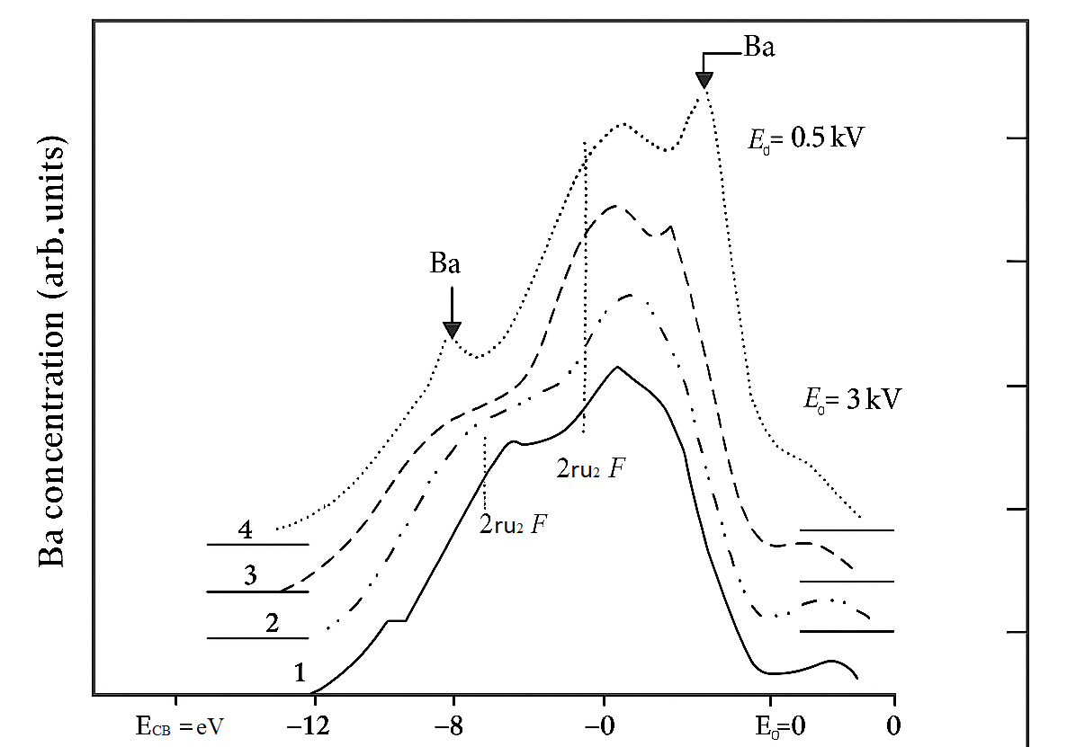

FIGURE 1. Schematic representation of the depth distribution of barium atoms implanted into CaF₂ at different ion energies (E₀ = 0.5, 3, and 5 keV) with a dose of D = 8×10¹⁶ cm⁻².

At ion energies E₀ ≤ 1 keV, the distribution curve exhibits a step-like profile, while at E₀ ≥ 3 keV, a well-defined maximum appears at greater depths. Increasing the ion energy results in a broader distribution and a shift of the maximum concentration toward deeper regions of the film.
In the energy range E₀ = 3–5 keV, the fraction of barium atoms forming chemical bonds with the matrix atoms reaches 20–30 at.%, while the remaining Ba atoms accumulate near the surface as unbound metallic species. However, the overall concentration of Ba decreases sharply in the near-surface region at higher energies, reducing the formation of complex Ba–Ca–F compounds.
Electronic Structure and Photoelectron Spectra. PES measurements (Figure 2) showed a clear modification of the valence band. Increasing the implantation dose broadens the spectrum, shifts the valence-band edge upward by ~2.5 eV, and produces new peaks assigned to Ba–F and Ba–Ca–F bonds [5].
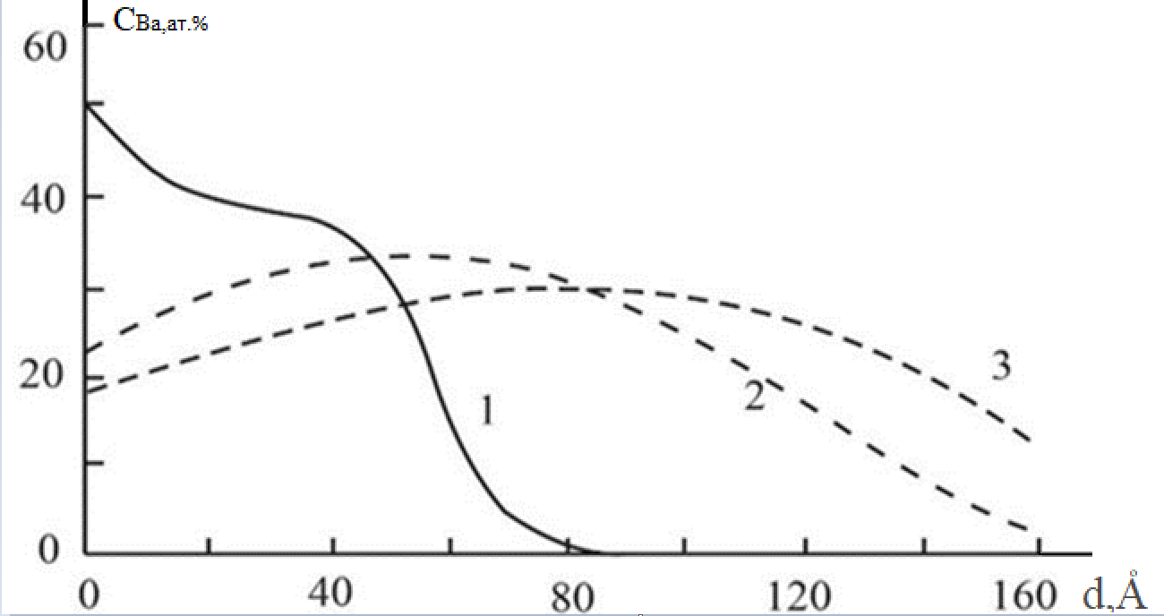

FIGURE 2. Photoelectron spectra of Ba⁺-implanted CaF₂ films at E₀ = 0.5 keV with doses D = 0, 6×10¹⁴, 6×10¹⁵, and 8×10¹⁶ ions/cm². The upward shift of 2.5 eV corresponds to valence band modification after implantation.

Ion implantation increased both n and r, indicating partial metallisation. Annealing slightly reduced them but kept values higher than pristine CaF₂. The Ion implantation method can be used to accurately control refractive index and reflectivity, which is useful for UV optical resonators and dielectric waveguides [7],[9].
After experimenting with methods, the composition of the element was alienated. Post-implantation annealing resulted in significant structural changes within the films. According to RHEED samples (Figure 3), recrystallization begins at T = 800 K and ends at T = 1000 k, resulting in epitaxial Сa0,5Ba0,5F2 phase is formed, the crystal lattice of which is approximately a = 5.73 Å.
It was also observed that with an increase in depth, the concentration of Ba gradually decreases, which forms a constantly changing crystal lattice. This effect is useful in creating optical coatings with a gradated refractive index and optical modifiers.
FIGURE 3. TEM image of the CaF₂/Si(100) film. Growth temperature Ts = 1000 K. Film thickness h = 2200 Å.
ANALYSIS
The dependence of the thickness of the CaF₂ double layer film on the maximum secondary electron emission coefficient (δ.) and the uniformity of the photoelectronic quantum efficiency (Y) (Figure 4) suggests that in both cases the nanoplyon is increased by thickening. This behavior is explained by the fact that the improvement in release efficiency of CaF₂ compared to the Si substrate has received good results in usha methods.
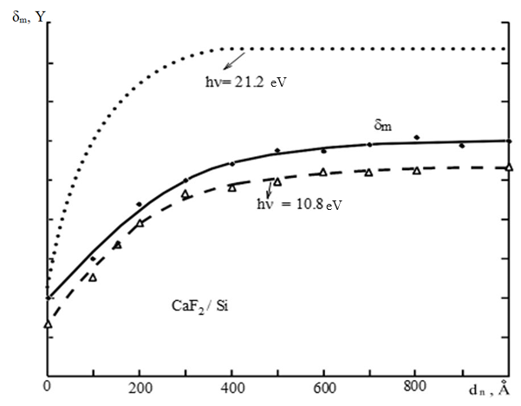
FIGURE 4. Changes in the maximum secondary electron emission (δₘ) and photoelectron quantum yield (Y) as a function of CaF₂ film thickness on Si(111).

For very thin films (d ≈ 100 Å), the refractive index (n) and emission properties of CaF₂ differ significantly from those of bulk material. These differences are primarily caused by the influence of the substrate, slight deviations from stoichiometry, and structural imperfections in the initial layers. As the film becomes thicker, the impact of the substrate diminishes, and both optical and electronic characteristics gradually converge toward those of bulk CaF₂.
The escape depth of secondary electrons in CaF₂, when excited by primary electrons or photons with an energy of hν = 10 eV, is estimated to be around 350–400 Å. Consequently, the emission is largely dominated by the near-surface region. The observed increase in δₘ and Y with film thickness reflects improved charge transport and lower recombination losses in thicker coatings, highlighting the superior emission efficiency of CaF₂ compared to Si.
DISCUSSION
The changes observed in the electronic and optical properties of CaF₂ films are a result of interactions between the implanted Ba⁺ ions and the host lattice. Ion implantation generates atomic displacements and creates defects near the surface, producing a disordered layer. Annealing afterward partially restores crystallinity and strengthens chemical bonding between Ba and F atoms.
The narrowing of the band gap and the increase in refractive index are likely caused by local metallization in the surface layer due to Ba incorporation. Similar effects have been documented in other alkaline-earth fluoride systems, showing that low-energy ion implantation is an effective approach for tuning thin-film optical properties.
CONCLUSION
This study explored the impact of low-energy Ba⁺ ion implantation followed by annealing on epitaxial CaF₂/Si(100) films. The main findings are summarized as follows:
Ba⁺ implantation allows precise modification of the near-surface composition and electronic structure, leading to the formation of new chemical compounds such as Ba–F and Ba–Ca–F.
Photoelectron spectroscopy indicates the emergence of additional electronic states and a reduction in the band gap of about 2.5 eV due to implantation-induced disorder. Auger spectroscopy and RHEED measurements show that annealing at 1000 K promotes recrystallization and forms an epitaxial Ba₁₋ₓCaₓF₂ layer with a controllable lattice parameter of approximately 5.73 Å.
Optical properties, including the dielectric constant, refractive index, and reflectivity, increase significantly after implantation and partially return toward initial values after annealing, remaining higher than those of unimplanted films. The implantation–annealing combination provides reliable control over optical transparency, refractive index, and reflectivity, making it suitable for applications in UV optical resonators, dielectric waveguides, and thin-film memory devices.
In our scientific work in general, the element surfaces were initially heated and hung up in thermoemissa methods, and in general, the results obtained show that low-energy ion implantation is an effective method in changing the physical and optical properties of wide-particle dielectric materials, which provides ample opportunities for next-generation Optoelectronics and photonic applications.
REFERENCES
- Harrison, T.R., et al. Applied Physics Letters, 41(11), 1102–1104 (1982).
- Ozerov, A.G., Altukhov, A.A., Ivanov, V.V., & Mityagin, A.Yu. Special Communication Equipment Technology Journal, 1, 115–119 (1988).
- K. Naskar, S. K. Pradhan, and R. N. Basu.“Structural and optical properties of nanocrystalline CaF₂ thin films prepared by sol–gel method,” Journal of Materials Science: Materials in Electronics, 31, 15235–15245 (2020).
- Y. He, G. Chen, and Z. Liu.“Influence of rare-earth ion implantation on optical properties of fluoride thin films,” Applied Surface Science, 567, 150823 (2021).[DOI: 10.1016/j.apsusc.2021.150823].
- M. Wang, H. Zhang, and J. Xu.“Modification of optical constants in Ba-implanted CaF₂ thin films,” Vacuum, 186, 110034 (2021).[DOI: 10.1016/j.vacuum.2021.110034].
- A. H. Habibi, J. F. O’Hanlon, and T. C. Ma.“Photoelectron spectroscopy study of metal fluoride thin films,” Surface and Interface Analysis, 54, 1041–1049 (2022).[DOI: 10.1002/sia.7101]
- Umirzakov, B.E., Normuradov, M.T., Rabbimov, E.A., & Tashatov, A.K. Surface Physics, No. 2, 47–53 (1992).
- R. S. Devanathan and L. R. Corrales.“Ion-induced defect structures in wide band-gap materials,” Journal of Applied Physics, 124, 145303 (2018).[DOI: 10.1063/1.5046287]
- Tashatov, A.K., Umirzakov, B.E., Altukhov, A.A., & Rabbimov, E.A. Proceedings of the IX All-Union Conference “Ion-Surface Interaction”, Moscow, 85–87 (1991).

