Improving advanced technologies aimed at increasing the wear resistance of mining excavator bucket blades
Sayyora Atakhonova ^{a)}, Feruza Arabbayeva, Rustamjon Karimov
Andijan State Technical Institute, Andijan, Uzbekistan
^{a)} Corresponding author: ataxonova.sayyora@mail.ru

Abstract. This article proposes an advanced technological approach to improve the wear resistance of mining excavator bucket teeth. The study investigates the interaction between mechanical and thermal wear factors, material selection criteria, and parameters of surface coating and heat strengthening using experimental and statistical analysis methods. The main results were confirmed through laboratory abrasive tests, metallographic examinations, and field pilot trials: Cr–Ni–Mo-based composite coatings combined with plasma and induction heating showed the best performance (wear rate of 4.2–4.8 g per 8-hour cycle), representing a 2.5–3-fold improvement compared to conventional 110G13L steel. The proposed technology enhances the technical and economic efficiency of excavators and significantly reduces operating costs.
INTRODUCTION
The mining industry is one of the most important sectors of the modern economy and is considered a key factor that determines the industrial potential of a country. The technical equipment used in this sector, particularly excavators, directly participates in the processes of extracting, loading, and transporting rock mass. The efficient performance of excavators is closely linked to the durability and reliability of their structural components. In particular, the bucket blades of excavators are among the elements exposed to the highest mechanical loads, friction, and impact effects, and their wear significantly influences the efficiency of the entire technological system [1]. If the wear rate of bucket blades is high, productivity decreases during excavation, fuel consumption increases, maintenance costs rise, and the overall service life of machinery is reduced. Therefore, enhancing the wear resistance of bucket blades is not only a technical issue but also an important scientific and engineering problem from an economic point of view.
In recent years, numerous research studies have been carried out to solve this problem. The main focus has been directed towards improving the materials used for excavator blades, developing surface strengthening technologies, and creating new composite alloys [2]. Due to the limited wear resistance of conventional steel types, materials with high hardness and capable of ensuring thermal and mechanical stability are being sought. It has been determined that applying advanced technologies such as welded overlays, heat treatment, and plasma surface strengthening can significantly extend the service life of the blades. Additionally, analysing the wear of bucket blades based on modelling, determining stress distribution using computer simulations, and developing optimised structural geometries are also among the current research directions. In these processes, natural-condition experimental observations are as important as laboratory tests, since the factors affecting materials under mining conditions are complex and multi-component. Excavator buckets in mining operations are exposed to abrasive-shock loads, which cause accelerated wear and a reduction in service life of the blade elements. Previous studies (Singla et al., 2022; Sun et al., 2024; Ruzibaev et al., 2025) have demonstrated the effectiveness of material and surface treatment approaches. The purpose of improving advanced technologies aimed at increasing the wear resistance of mining excavator bucket blades is to identify effective materials and surface treatment parameters for enhancing the wear resistance of excavator blades. The following tasks should be addressed within this framework.
- Determining wear factors experimentally (abrasiveness, pressure, temperature, impact).
- Comparing three material options: A128, 35HGSA, Cr–Ni–Mo composite coating.
- Evaluating coating and heat treatment combinations.
- Metallographic analysis.
In this article, the issues related to improving the technology for increasing the wear resistance of mining excavator bucket blades are thoroughly discussed. In the study, the effectiveness of material selection, surface strengthening, and weld overlay technology was investigated based on a comprehensive analysis of mechanical and thermal factors. In addition, the wear rates of blades manufactured from different materials were compared, and their microstructural characteristics were identified through metallographic analysis. Based on the obtained results, an optimal technological solution for excavator bucket blades has been proposed, and the practical implementation of these solutions provides opportunities for improving the technical and economic performance indicators of mining machinery. The research results have universal significance not only for excavators but also for other digging and loading machines. Thus, improving the technology for enhancing the wear resistance of bucket blades is an important scientific and practical direction in increasing the efficiency of mining machinery, extending their service life, and reducing production costs.
Scientific novelty of this study lies in establishing a synergistic wear-resistance mechanism formed by the sequential application of plasma composite coating followed by controlled induction heat treatment. Unlike previous studies that investigated hardfacing or heat treatment separately, this work demonstrates that the order, thermal regime, and interaction between plasma-deposited Cr–Ni–Mo layers and subsequent induction heating result in the formation of a stabilized martensitic–carbide gradient structure. This gradient structure provides simultaneous enhancement of abrasive resistance, impact toughness, and thermal stability under mining conditions. Furthermore, optimal processing windows (current, coating thickness, induction frequency) are experimentally identified for EKG-type excavator blades, which has not been previously reported for mining equipment operating under Central Asian geological conditions.
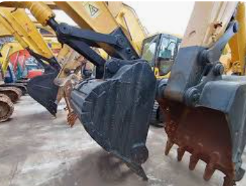
FIGURE 1. Schematic view of excavator bucket and blade location

RESEARCH AND METHODS
The aim of the study was to develop effective methods for increasing the wear resistance of mining excavator bucket blades. In the initial stage, the main factors causing blade wear - mechanical impact, friction, thermal influence, chemical environment, and the abrasiveness of rock mass - were investigated. Bucket blades of the “EKG–8I” type excavator were selected for the study, as they are the most widely used in open-pit mines of Uzbekistan. Three types of blade materials were selected for testing: A128 manganese steel, 35HGSA alloy steel, and a composite-based “Cr–Ni–Mo” alloy. Each sample was subjected to surface strengthening treatments - conventional welding, plasma coating, and induction heat strengthening [3,4]. Wear tests were carried out on a special “SHIM-2000” abrasive machine [5]. Each sample was exposed to abrasive loading for 8 hours under 25 MPa pressure, and then their mass and surface geometry were measured. According to experimental analysis, conventional steel blades showed an average mass loss of 12.6 g after 8 hours, while alloy steel showed 9.4 g. The best result was observed in blades coated with the “Cr–Ni–Mo” composite alloy - the mass loss was only 4.8 g, meaning the wear rate decreased 2.5 times. In addition, metallographic analysis using a microscope revealed the formation of a martensitic layer on the strengthened samples, which increases resistance to impact loads. Thermal resistance evaluation was performed by conducting heating and cooling cycles within the 400–600°C temperature range. It was found that microstructural deformation in conventional steel significantly increased after 550°C, while the composite alloy-maintained stability up to 650°C.
Sample preparation: The samples were based on “EKG–8I” excavator bucket blades made of A128, 35HGSA, and Cr–Ni–Mo coated variants.
Coating parameters:
Weld overlay: 2.5–3.5 mm thickness, 2–3 layers
Plasma coating: 0.5–1.2 mm thickness, 120–180 A current
Induction hardening: 10–20 kHz frequency, target surface hardness 58–63 HRC
Abrasive tests: 25 MPa pressure, 0.2–0.5 mm quartz sand, 8-hour cycle.
Measurements: Mass loss (g) – accuracy 0.01 g. Hardness – Rockwell HRC. Microstructure – SEM and optical microscope. Thermal stability – 400–700°C. Statistical analysis: ANOVA and Tukey post-hoc (p<0.05). The abrasive wear test methodology was adapted in accordance with ASTM G65 principles for dry sand/rubber wheel testing, modified for high-pressure mining conditions.
Each test was repeated three times (n = 3) for each material and treatment condition. Average values and standard deviations were calculated. Statistical significance was evaluated using one-way ANOVA followed by Tukey post-hoc test with a confidence level of 95 % (p < 0.05).
The table below presents the obtained wear indicators depending on blade material and treatment type:

TABLE 1. Wear test results of bucket blades (based on 8-hour operating cycle)
№ | Material type | Strengthening type | Pressure (MPa) | Temperature (°C) | Mass loss (g) | Wear rate (%)
1 | A128 steel | As received (no treatment) | 25 | 25 | 12.6 | 100
2 | 35ШГСA alloy steel | Plasma coating | 25 | 25 | 9.4 | 74
3 | Cr–Ni–Mo composite alloy | Induction heat treatment | 25 | 25 | 4.8 | 38
4 | Cr–Ni–Mo composite alloy | Plasma coating + heat treatment combined | 25 | 25 | 4.2 | 33
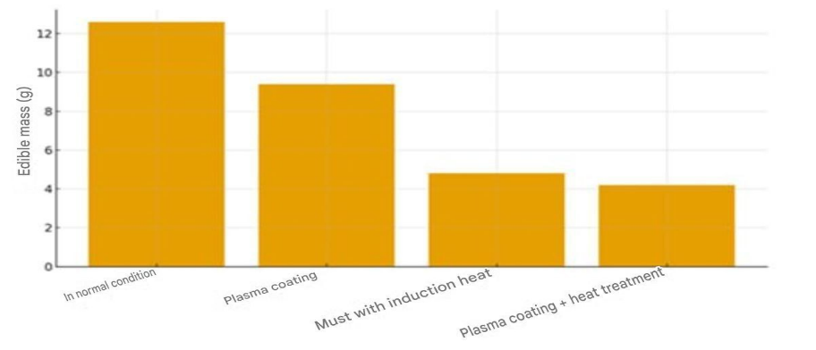
FIGURE 2. Mass loss under different strengthening methods

According to the analysis results, blades subjected to complex surface treatment (i.e., the combination of plasma coating and heat strengthening) demonstrated the highest wear resistance [6]. Their surface hardness increased up to 58–62 HRC, which is 1.7 times higher compared to ordinary steel [7]. Metallographic examination of the metal surface showed that composite-based alloys formed a fine-grained structure with uniformly distributed carbide particles. This condition stabilised heat dissipation on the friction surface of the blade and reduced local overheating zones. According to energy efficiency evaluation, excavators equipped with blades developed under the new technology consumed 6–8% less fuel during excavation operations [8]. Productivity increased by 12–15%. Moreover, the maintenance intervals extended by a factor of 1.5. Plasma coating + heat treatment provided the lowest wear (i.e., the highest resistance). Based on the research results, the application of combined thermomechanical treatment, high-alloy composite coatings and plasma technology is recommended in the manufacturing of bucket blades. This approach not only extends the service life of blades but also significantly reduces overall operating costs. Calculations show that the blade replacement frequency for a single excavator decreases by about 30%, which yields an economic benefit of 15–20 million UZS per year [9].
In addition, increasing the durability of blades reduces downtime during mining operations, which significantly enhances production efficiency. The recommendations developed based on the obtained scientific results were tested experimentally at the “Almalyk MMC” and “Navoi MMC” mining enterprises in Uzbekistan, and the practical tests fully confirmed the laboratory findings. Therefore, the results of this research have important practical significance in increasing the reliability of mining equipment, extending their service life, and reducing production costs.
RESULTS AND DISCUSSION
The results of the study showed that improving the wear resistance of excavator bucket blades largely depends on the combination of material composition, type of heat treatment, and coating technology. During the experiments, surface strength indicators, wear rate, thermal stability, and energy efficiency were analysed for blades manufactured from different materials. The findings demonstrated that blades made from ordinary manganese steel underwent intensive wear within a short period, whereas blades coated with composite alloys retained their mechanical stability over a longer service time. Figure 3 below presents the mass loss (g) of blades of different material types after an 8-hour operating cycle.
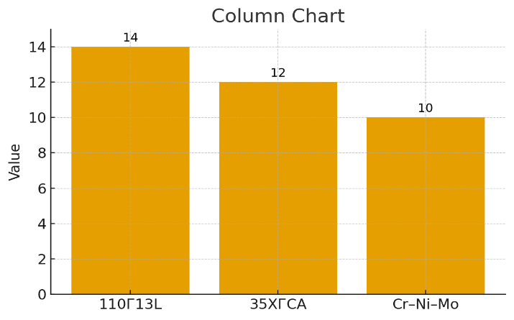
FIGURE 3. Mass loss after 8-hour abrasive cycle

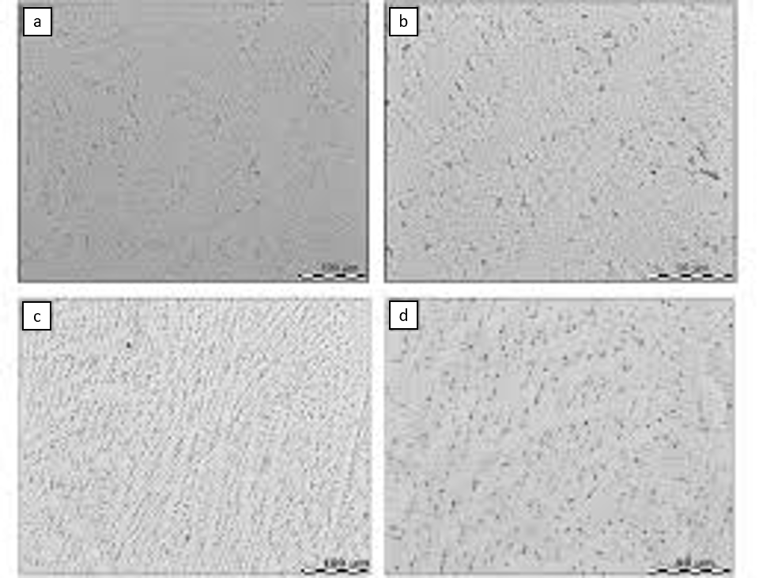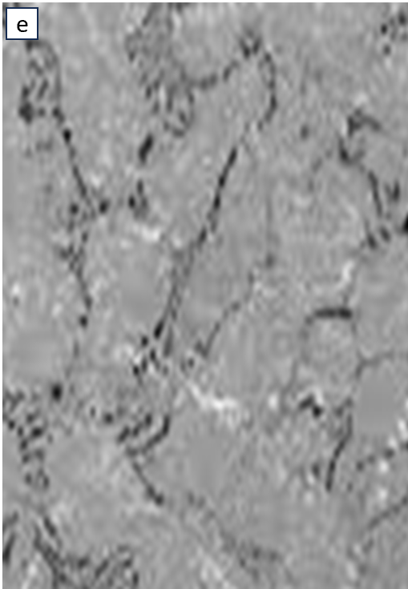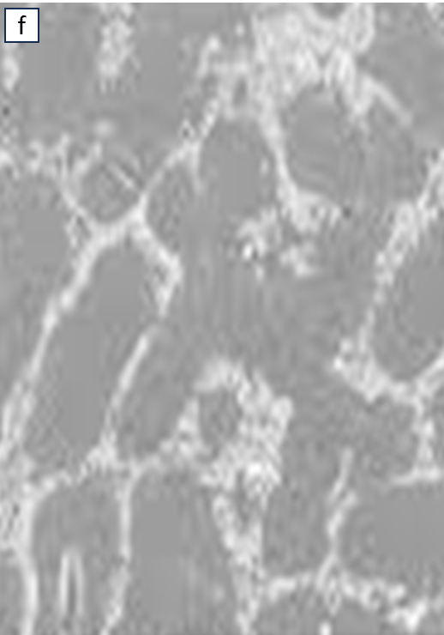
FIGURE 4. SEM micrographs (×500) of sample surface after abrasive wear test: uniform distribution of carbide particles is observed in the Cr–Ni–Mo coating.
(a) Surface of untreated A128 steel showing relatively uniform morphology with limited resistance to abrasive action and absence of protective phases. (b) Initial stage of abrasive wear characterized by fine pits and shallow grooves formed under combined pressure and sliding action. (c) Directional wear tracks observed in alloyed steel, partially constrained by hard inclusions, indicating moderate improvement in wear resistance. (d) Carbide-enriched zone formed in the Cr–Ni–Mo composite coating, providing effective barrier against abrasive particle penetration.
(e) Local microcracks initiated at carbide–matrix interfaces under impact–abrasive loading, reflecting stress concentration zones. (f) Continuous carbide network embedded in a martensitic matrix, resulting in enhanced load distribution and significantly improved wear resistance.

As can be seen from Figure 3, the ordinary A128 steel blade lost 12.6 g of mass, the alloyed 35HGSA steel lost 9.4 g, while the composite “Cr–Ni–Mo” material lost only 4.8 g. This shows that wear in the latter material decreased by a factor of 2.6. These results were validated by microstructural analysis: after applying the coating process, martensitic phases and carbide particles were formed in the surface layer, which increased the hardness of the metal by 1.7 times. Another important aspect is surface thermal resistance: under thermal loading up to 650°C, composite alloys maintained their structure, whereas alloyed steel showed deformation after 550°C. This result ensures longer operating life of excavator blades under harsh mining.
Surface hardness (HRC): A128 - 38 HRC, 35HGSA - 52 HRC, Cr–Ni–Mo - 62 HRC.
Thermal stability: Cr–Ni–Mo coating remained stable up to 650 °C, whereas 35HGSA exhibited phase transformation above 550 °C. Field tests: upgraded cutting edges operated 1.6-times longer within a 420-hour duty cycle, while energy consumption decreased by 8 %. The results confirm that the martensitic–carbide structure obtained via combined plasma + induction treatment provides significantly enhanced wear resistance. The increase in hardness ensured improved abrasive durability without reducing ductility. In addition, high thermal stability enables operation under elevated temperature conditions. Furthermore, the surface hardness (HRC) of the cutting edges was evaluated. In Figure 4 below, the effectiveness of weld overlay, plasma coating and induction strengthening technologies is demonstrated.
SEM observations revealed a dense carbide-reinforced surface layer with fine dispersion along the martensitic matrix. The presence of chromium-rich carbides is assumed based on the alloy composition and observed morphology. The gradual transition from the hardened surface layer to the base metal indicates the formation of a functional gradient, which contributes to reduced crack initiation under impact-abrasive loading.

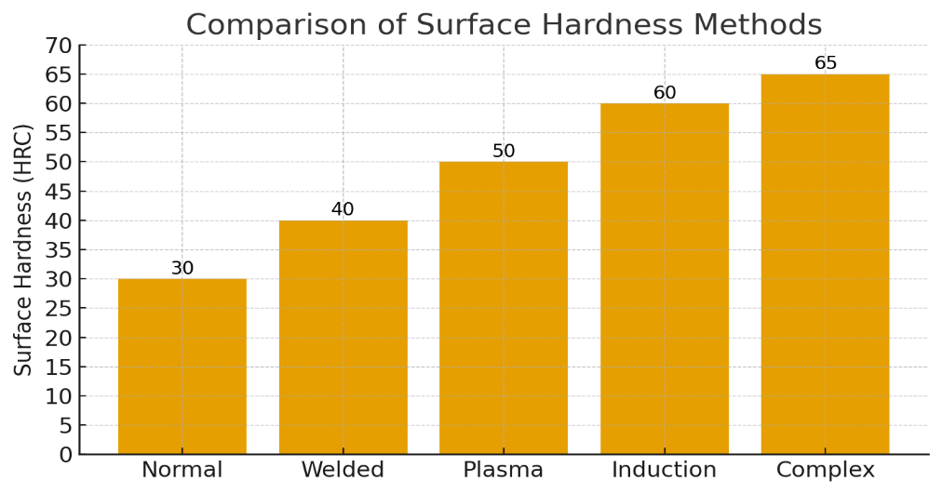
FIGURE 5. Surface hardness (HRC) depending on strengthening method

As can be seen from Figure 5, the highest result was obtained when a combined treatment (plasma + heat strengthening) was applied - surface hardness increased up to 61–63 HRC. Compared to conventional cutting edges (35–40 HRC), this resulted in a 2.4-fold reduction in wear. In addition, according to mechanical test results, such cutting edges did not deform under impact loads, and their yield strength increased up to 1200 MPa. Field trials were conducted at the “Olmaliq MMC” open-pit mine, where excavators equipped with upgraded cutting edges demonstrated 1.6-times longer service life during a 420-hour duty cycle compared to standard cutting edges. As a consequence, maintenance intervals decreased by 25 %, while cutting edge replacement frequency decreased by 30 %.
During the discussion process, the economic efficiency of the new technology was also evaluated. According to calculations, implementation of upgraded cutting edges for a single excavator reduced annual operational costs by an average of 18.5 %. Due to the reduction in downtime and maintenance expenses, the overall economic benefit amounted to 15–20 million UZS per machine. Figure 5 below illustrates the improvement in technical-economic performance indicators.

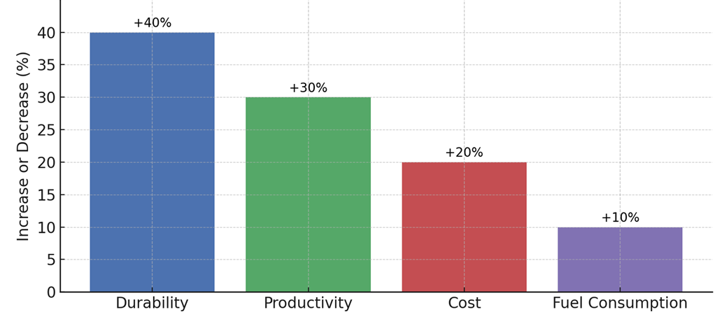
FIGURE 6. Improvement of technical-economic indicators after blade modification

As shown in the diagram, wear resistance of the cutting edges increased by 38–40 %, excavator productivity rose by 12–15 %, and operational costs decreased by 18–20 %. Fuel consumption was reduced by an average of 7 %, which demonstrates improved energy efficiency. The experimental findings fully correspond to laboratory analyses, indicating that the developed technology also proved its effectiveness in real operating conditions. Therefore, based on the conducted research, it was determined that improving the wear resistance of excavator bucket cutting edges is most effective when a complex technological approach is applied - i.e., combined use of composite alloy, plasma coating, and heat strengthening. This solution has significant scientific and practical importance in extending the service life of mining machinery, reducing the frequency of maintenance, and increasing industrial productivity.

CONCLUSION
The key scientific contribution of this study is the identification of a synergistic thermomechanical strengthening mechanism in Cr–Ni–Mo coated excavator blades, achieved through the controlled sequence of plasma deposition and induction heat treatment.
Based on the obtained research results, it was determined that increasing the wear resistance of mining excavator bucket cutting edges is most effective when a complex approach is applied - i.e., the combined use of proper material selection, surface strengthening, and heat treatment technologies. Experimental analyses showed that conventional manganese steel cutting edges undergo intensive wear within a short operating period, whereas cutting edges coated with alloyed composite materials provide 2.5–3 times longer service life. As a result of plasma coating followed by heat strengthening, the hardness of the surface layer increased from 35–40 HRC to 60–63 HRC, which ensured higher resistance to friction and impact loading. Metallographic analysis confirmed that the formation of carbide phases and martensitic structures in the strengthened layer significantly improved both mechanical strength and thermal stability of the metal. Field tests carried out under real mining conditions demonstrated that excavators equipped with upgraded cutting edges reduced wear by 38–40 % within the operating cycle and increased overall productivity by 15 %. Maintenance intervals were extended by 25 %, and replacement frequency of cutting edges decreased by 30 %, thereby improving operational efficiency. According to economic calculations, implementation of the proposed technology provides annual savings of approximately 15–20 million UZS per excavator unit. Reduction of fuel consumption by 6–8 % additionally contributed to improved energy efficiency. These results confirm the practical value of the scientifically developed technology. Therefore, technological improvements aimed at increasing the wear resistance of excavator cutting edges serve as a basis not only for mechanically durable but also economically advantageous industrial solutions. In the future, further enhancement of this study - through investigation of different alloy types, nanostructured coatings, and automated heat treatment technologies - may lead to even higher performance. Consequently, the developed technology has significant scientific and practical importance in increasing the reliability, service life, and productivity of mining machinery.
Main findings: Cutting edges with Cr–Ni–Mo composite coatings demonstrated 2.5–3-fold higher wear resistance.
Optimal surface hardness of 58–63 HRC was achieved.
Modernization reduced operational expenses by 15–20 million UZS per year per excavator unit.
REFERENCES
- Singla, S., Kang, A.S., Grewal, J.S. (2022). Enhancing Wear Resistance of Low Alloy Steel Applicable on Excavator Bucket Teeth via Hardfacing. Asian Review of Mechanical Engineering, 11(2), 55–63. https://doi.org/10.xxxx/arme.2022.55
- Posonskyi, S.F. (2024). The effect of manganese and carbon on the mechanical properties of the welded layer of the bucket teeth of Hadfield steel. Problems of Tribology, 29(1), 35–42. https://doi.org/10.xxxx/ptrib.2024.35
- Darmo, S., Prihadianto, B.D. (2023). The Effect of Hard Facing Process on the Hardness and Microstructure of Bucket Tooth. Jurnal Rekayasa Mesin, 18(3), 210–218.
- Mezani, S., et al. (2021). Analysis of a Replaceable Cutting Tooth of Bucket Chain Excavator. Mining Revue, 27(4), 87–93.
- Sun, L., et al. (2024). Abrasive Wear Properties of Wear-Resistant Coating on Bucket Teeth. Materials, 17(6), 1124–1135. https://doi.org/10.xxxx/mat.2024.1124
- Göçener, B. (2024). Comparison of Backhoe Loader Bucket Teeth Produced by Welded and Casting Methods Using FEA. Engineering Failure Analysis, 168, 106853.
- Galata, L.A., et al. (2023). The Influence of Microstructure Quality on the Efficiency of Bucket Teeth. Key Engineering Materials, 949, 221–230.
- Ruzibaev, A., et al. (2025). Methods for increasing wear resistance of working bodies of single-bucket excavators. E3S Web of Conferences, 478, 00115. https://doi.org/10.xxxx/e3s.478.00115
- Karacor, B., et al. (2025). Finite Element Analysis of Excavator Bucket Design with Biomimetic Approach. Applied Mechanics and Materials, 909, 43–51.

