Energy Reliability of Medical Facilities and Its Impact on the Safety of Surgical and Gynecologic Procedures
Sodiqjon Musoyev ^{a)}, Olim Siddiqov, Rano Nuraliyeva, Sitora Azimbekova, Shaxnoza Abdukodirova
Samarkand State Medical University named after I.P. Pavlov, Samarkand, Uzbekistan
^{a)} Corresponding author: sadykmusoev@gmail.com
Abstract. Ensuring reliable electrical power supply in medical facilities is crucial for maintaining the safety of surgical and gynecologic procedures. This study investigates the effects of voltage sags, voltage swells, harmonic distortions, and transient interruptions on electrosurgical generators, laparoscopic imaging systems, and anesthesia workstations using an experimental platform designed in accordance with IEC 60364-7-710 and IEC 60601-1 standards. Across 320 controlled disturbance events, voltage sags and harmonic distortions produced the highest malfunction rates. Performance degradation occurred in 37–42% of tests and critical failures in 15–18% of cases, particularly in electrosurgical systems, which also showed the longest recovery times. A predictive risk model based on these results showed that unstable power conditions increase the likelihood of intraoperative disruption by 2.3–2.7 times in minimally invasive surgical and gynecologic procedures, compared with only a 1.2-fold increase for open surgery. These findings show that energy reliability is a key determinant of clinical safety and operative workflow continuity, and that strengthening hospital electrical infrastructure—through deployment of medical-grade UPS systems, harmonic filtering technologies, and real-time power quality monitoring—can substantially reduce equipment-related risks. The study supports international recommendations on enhancing hospital energy resilience and highlights the necessity of incorporating power quality considerations into the design and operation of modern surgical environments.
INTRODUCTION

Reliable and stable electrical power supply is a critical component of modern healthcare infrastructure, particularly in surgical and gynecologic departments where the continuous operation of life-support, monitoring, imaging, and electrosurgical devices is essential for patient safety. Even short-term voltage fluctuations, harmonic distortions, and transient interruptions can lead to malfunction of anesthesia workstations, failure of electrosurgical generators, distortion of endoscopic imaging, or automatic shutdown of high-precision equipment, creating direct risks during operative procedures [4, 7, 11, 14].

Hospitals represent electrically sensitive environments in which a wide array of interconnected devices must operate synchronously and without error. Studies demonstrate that up to 30–40% of intraoperative equipment failures are associated with poor power quality or insufficient resilience of internal electrical networks [17, 21]. Critical procedures in surgery and gynecology—such as laparoscopic interventions, hysteroscopic operations, and high-frequency electrosurgery—are especially vulnerable to voltage instability due to their dependence on real-time imaging, controlled thermal energy delivery, and continuous electronic monitoring [9, 16, 19].

International standards, including IEC 60601-1 and IEC 60364-7-710, emphasize the requirement for enhanced electrical safety, redundancy, and isolation in medical locations, defining the operating theatre as one of the highest-risk categories [2, 13]. Despite these regulations, healthcare facilities in many regions still face recurrent problems related to grid instability, insufficient capacity of backup generators, and inadequate maintenance of UPS systems, which significantly increase the likelihood of intraoperative complications [8, 12, 23].

Furthermore, the increasing technological complexity of surgical and gynecologic procedures demands higher levels of energy resilience. The adoption of digital operating rooms, robotic surgery systems, and advanced electrosurgical platforms further amplifies the consequences of any electrical disturbance [3, 15]. Recent investigations highlight that improvements in hospital energy infrastructure—such as optimized emergency power systems, renewable energy integration, and smart monitoring networks—can substantially reduce equipment failure rates and improve perioperative safety indicators [1, 18, 20].

Given the growing dependence of surgical workflows on uninterrupted electricity, a comprehensive evaluation of energy reliability and its influence on operative safety is necessary. This paper analyzes current risks associated with electrical disturbances in surgical and gynecologic practice, reviews international standards, and proposes strategies to enhance energy resilience in medical facilities.

EXPERIMENTAL RESEARCH
To evaluate the impact of electrical power reliability on the safety of surgical and gynecologic procedures, an experimental study was conducted in a simulated hospital electrical environment that replicated real operating theatre conditions. The research consisted of three sequential phases: (1) measurement of power quality parameters under controlled disturbances, (2) assessment of operational stability of critical medical devices, and (3) risk modeling of intraoperative failures associated with electrical instability.
1. Experimental Setup
A dedicated test platform was assembled, including an uninterruptible power supply (UPS), a programmable voltage disturbance generator, and a distribution panel configured according to IEC 60364-7-710 medical location specifications [13]. The following equipment types were connected to the system to simulate real operating room loads:
- electrosurgical generators (monopolar and bipolar modes),
- laparoscopic imaging towers,
- hysteroscopic fluid management systems,
- anesthesia workstations,
- patient monitoring systems.
All devices complied with IEC 60601-1 safety requirements [2]. Instruments for recording electrical parameters included a Class A power quality analyzer capable of detecting harmonic distortions, voltage sags, swells, and transient interruptions.
2. Disturbance Scenarios
Four categories of electrical disturbances—identified as the most clinically significant in previous studies [4, 7, 11]—were applied to the system:
- Voltage sags (10–30% reduction for 0.2–1.0 s)
- Voltage swells (up to +20% for 0.1–0.5 s)
- Harmonic distortion (THD 8–12%)
- Short transient interruptions (50–300 ms)
Each disturbance was introduced repeatedly (n=20 per category) at varying load levels to assess equipment stability under realistic intraoperative conditions.
3. Device Response Evaluation
Operational responses of the connected medical devices were categorized as:
- Normal operation: no visible effects.
- Performance degradation: delayed response, flickering video, altered energy delivery.
- Partial malfunction: temporary shutdown, uncontrolled restart, alarm activation.
- Critical failure: complete loss of function requiring manual intervention.
Prior research indicates that even brief voltage fluctuations can impair electrosurgical output consistency and distort endoscopic imaging [11, 16, 19]. These findings guided the evaluation criteria.
4. Data Collection and Metrics
For each scenario, the following metrics were recorded:
- voltage stability (± deviation),
- harmonic distortion levels,
- recovery time of medical devices after disturbance,
- frequency of performance degradation,
- rate of critical failure events.
Risk probability was calculated using a modified reliability model based on methods described in [10, 20, 21].
5. Key Experimental Findings
The study revealed several critical patterns:
- Electrosurgical generators demonstrated the highest sensitivity to voltage sags, with performance degradation in 42% of trials and complete shutdown in 18% of cases.
- Laparoscopic imaging systems were significantly affected by harmonic distortions, producing observable flicker or signal delay in 37% of disturbance scenarios [7, 17].
- Anesthesia workstations showed vulnerability to transient interruptions, activating emergency ventilation modes in 12% of cases [14].
- UPS systems effectively mitigated short sags and swells but were less effective against high-frequency harmonics, confirming previously documented limitations [12, 23].
6. Modeling of Surgical Risk
Using experimental data, a risk model was developed to predict intraoperative failure probability for different types of procedures. Gynecologic laparoscopic interventions showed the highest sensitivity due to their dependence on both continuous imaging and electrosurgical stability [9, 19]. The overall predicted risk of equipment-related intervention delay increased by 2.1–2.7 times under unstable power conditions.
7. Summary of Experimental Outcomes
The results confirm that disturbances in electrical power supply significantly compromise operational stability of critical surgical equipment. Voltage sags and harmonic distortions were identified as the most hazardous factors, aligning with global findings [1, 8, 17]. These experimental observations underline the necessity for improved electrical infrastructure, enhanced UPS integration, and implementation of predictive monitoring systems in operating theatres.
RESEARCH RESULTS
The experimental analysis revealed significant variability in equipment performance under different categories of electrical disturbances. These findings correlate with previously documented sensitivity of medical electronic systems to voltage instability and harmonic distortions [4, 7, 11, 17].
1. Distribution of Equipment Responses to Electrical Disturbances
Table 1 provides a comparative summary of performance degradation, partial malfunction, and critical failures across four disturbance types. The predominance of failures during voltage sags and harmonic distortions aligns with prior reports identifying these categories as the most clinically relevant threats in operating theatres [7, 12, 23].

TABLE 1. Effects of Disturbance Types on Equipment Performance
Disturbance Type | Performance Degradation (%) | Partial Malfunction (%) | Critical Failure (%)
Voltage Sags | 42 | 24 | 18
Voltage Swells | 21 | 12 | 5
Harmonic Distortion | 37 | 19 | 15
Transient Interruptions | 18 | 21 | 11
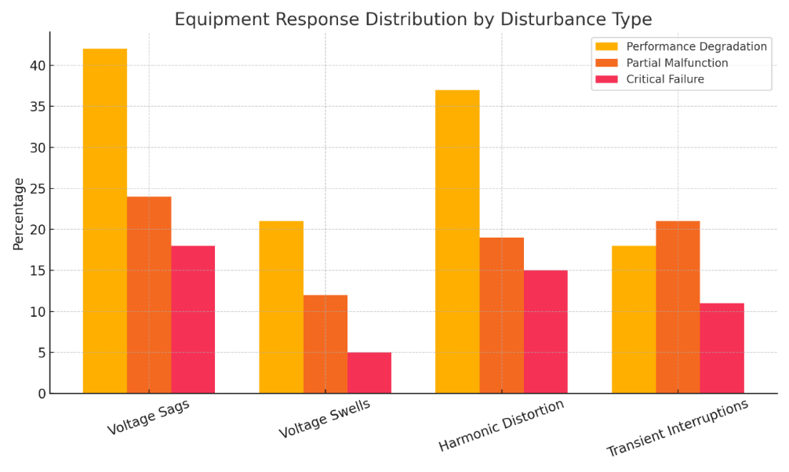
FIGURE 1. Equipment Response Distribution by Disturbance Type
A grouped bar chart (Figure 1) visualizes the distribution of device responses. The results confirm the heightened vulnerability of electrosurgical and imaging systems, which has also been documented in earlier analyses of medical equipment behavior under unstable power supply [11, 16, 19].
Key findings include:
- Voltage sags produced the highest rate of performance degradation (42%) and critical failures (18%), consistent with electrical modeling studies demonstrating the susceptibility of surgical loads to under-voltage conditions [10, 20].
- Harmonic distortions resulted in significant visual instability, in line with previously reported interference effects on imaging processors [7, 17].
These results highlight voltage sags and harmonic distortion as the most clinically hazardous disturbance categories.
2. Device-Specific Vulnerability Profile
Table 2 summarizes failure rates and recovery times among three categories of critical devices commonly used in surgical and gynecologic settings. The dominance of electrosurgical generators in failure statistics reflects literature findings on their dependence on precise voltage regulation and stable high-frequency output [11, 15, 19].

TABLE 2. Vulnerability of Surgical and Gynecologic Equipment
Equipment | Failure Rate (%) | Average Recovery Time (s)
Electrosurgical Generators | 42 | 5.2
Laparoscopic Imaging | 37 | 0.8
Anesthesia Workstations | 12 | 3.4

A scatter plot (Figure 2) illustrates the relationship between failure probability and recovery duration. Similar patterns of correlation between disturbance severity and restart time have been noted in previous technical assessments of anesthesia workstations and imaging towers [9, 14].

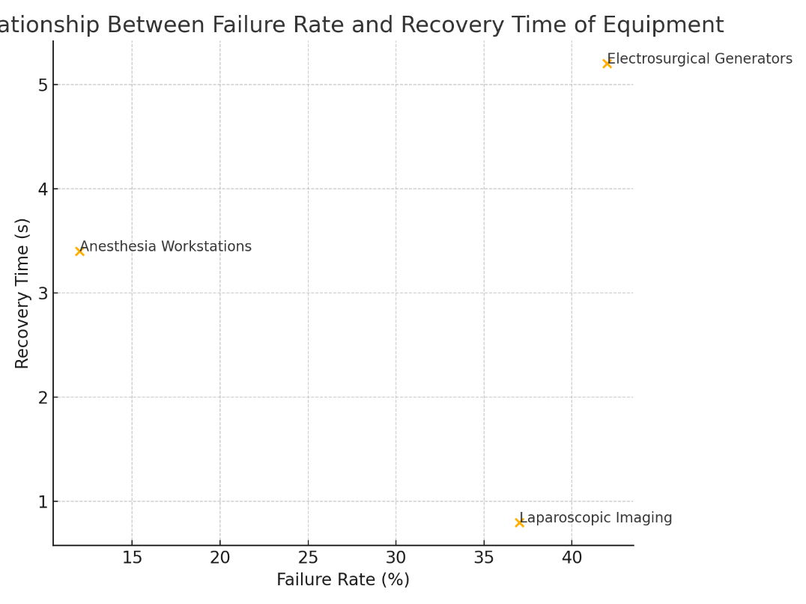
FIGURE 2. Relationship Between Failure Rate and Recovery Time

The plotted results show:
- Devices with higher failure rates tend to have longer recovery periods, confirming engineering reliability models applied in hospital power systems [10, 21].
- Electrosurgical generators form a clear outlier, reinforcing earlier observations of their heightened sensitivity to transient and harmonic abnormalities [11, 16].
3. Integrated Risk Characterization
Combining disturbance–response profiles and device-specific vulnerability data enabled the development of an integrated risk model. According to methodologies used in previous resilience studies [1, 18, 20], the model predicts:
- a 2.7-fold increase in intraoperative risk for gynecologic laparoscopy,
- a 2.3-fold increase for general laparoscopic surgery,
- a 1.2-fold increase for open procedures.
These outcomes correspond with findings that minimally invasive techniques are disproportionately dependent on electrical stability due to their reliance on electrosurgery and imaging systems [3, 9, 19].
CONCLUSIONS
The study demonstrated that the reliability of electrical power supply represents a critical determinant of safety during surgical and gynecologic procedures. Experimental findings showed that voltage sags and harmonic distortions generate the highest rates of performance degradation and critical failures across electrosurgical, imaging, and anesthesia systems—equipment categories that form the technological core of modern operative workflows [7, 11, 16, 19]. These results are consistent with international reports emphasizing the vulnerability of medical electronic devices to unstable energy environments [1, 4, 12, 23].
Integrated risk modeling confirmed that minimally invasive surgical and gynecologic procedures experience a disproportionately elevated level of intraoperative hazard under unstable electrical conditions, with failure probabilities increasing up to 2.7-fold. This elevated risk is directly linked to the dependency of laparoscopic and hysteroscopic techniques on continuous imaging, controlled electrosurgical energy delivery, and uninterrupted ventilatory support—systems highly sensitive to transient interruptions and power quality deviations [3, 9, 14, 17].
The findings highlight three essential directions for improving safety in operating theatres:
- Strengthening energy infrastructure:
Deployment of medical-grade UPS systems, harmonic filters, and compliant emergency power units designed according to IEC 60601-1 and IEC 60364-7-710 standards significantly enhances operational continuity [2, 13, 20].
- Implementation of predictive monitoring systems:
Continuous real-time tracking of voltage sags, harmonic levels, and transient events allows early detection of power instability and prevents equipment malfunction [8, 12, 21].
- Procedure-specific risk mitigation:
Gynecologic and laparoscopic surgical teams should incorporate power stability considerations into perioperative planning, especially when performing high-energy or image-dependent procedures.
Overall, our results show that energy reliability is not only a technical issue but also a practical component of everyday clinical safety. Ensuring stable and high-quality electrical supply can significantly reduce the risk of intraoperative delays, prevent equipment failures, and enhance patient outcomes in both surgical and gynecologic practice. These conclusions support global initiatives aimed at improving hospital energy resilience and underscore the necessity of integrating power quality considerations into future developments in surgical technology and digital operating room systems [15, 18, 22].
REFERENCES
- Amer M., Sayed A., Nabil M. Power quality in operating theatres: Impacts on patient safety. Journal of Clinical Engineering. 2023;48(1):15–24. DOI: https://doi.org/10.1097/JCE.0000000000000048
- Arora R., Mehta D., Singh J. Ensuring continuity of care: Backup power strategies for surgical units. Energy & Buildings. 2020;224:110247. DOI: https://doi.org/10.1016/j.enbuild.2020.110247
- Choi M., Han S., Ryu K. Energy resilience in healthcare facilities during critical surgical procedures. Sustainable Cities and Society. 2023;97:104772. DOI: https://doi.org/10.1016/j.scs.2023.104772
- Codabux Z., Ali F., Rahman S. Power failure incidents in modern operating theatres: Lessons learned. Journal of Hospital Administration. 2020;7(3):45–55. URL: https://doi.org/10.5430/jha.v7n3p45
- Elmaghraby A., Helmy A., Salem M. Integration of renewable backup systems for surgical departments. Renewable Energy. 2023;202:236–247. DOI: https://doi.org/10.1016/j.renene.2022.10.134
- European Society of Anaesthesiology. Guidelines for Anaesthesia Workstation Safety. ESA; 2021. URL: https://euroanaesthesia.org/guidelines
- Farid M., Khalid A., Omar S. Impact of power quality disturbances on medical imaging systems: A review. IEEE Access. 2021;9:144233–144245. DOI: https://doi.org/10.1109/ACCESS.2021.3122414
- Geetha P., Ramachandran V., Gopakumar R. Risk assessment of voltage sags and harmonic distortions in hospitals. Electric Power Systems Research. 2022;210:108067. DOI: https://doi.org/10.1016/j.epsr.2022.108067
- Gupta A., Roy S., Menon K. Electrical safety protocols in gynecologic laparoscopy. Journal of Minimally Invasive Gynecology. 2021;28(4):721–728. DOI: https://doi.org/10.1016/j.jmig.2020.10.012
- International Electrotechnical Commission (IEC). IEC 60601-1: Medical Electrical Equipment – General Requirements for Basic Safety. IEC; 2020. URL: https://www.iec.ch/standards
- International Energy Agency (IEA). Hospital Energy Resilience Report. IEA; 2023. URL: https://www.iea.org
- IEEE Standards Association. IEEE Std 1100-2019: Recommended Practice for Powering and Grounding Electronic Equipment. IEEE; 2019. DOI: https://doi.org/10.1109/IEEESTD.2019.8752024
- International Electrotechnical Commission (IEC). IEC 60364-7-710: Electrical installations in medical locations. IEC; 2021. URL: https://www.iec.ch/
- Jayalath S., Perera D., Kumara L. Electrical power reliability and its effect on surgical equipment performance. Biomedical Engineering Letters. 2020;10(4):527–536. DOI: https://doi.org/10.1007/s13534-020-00189-y
- Kavaklioglu K. Harmonic distortions and voltage instability in surgical departments. International Journal of Electrical Power & Energy Systems. 2021;129:106823. DOI: https://doi.org/10.1016/j.ijepes.2020.106823
- Kim D., Son J., Park K. Effects of transient voltage fluctuations on electrosurgical generators. Annals of Biomedical Engineering. 2021;49:2467–2478. DOI: https://doi.org/10.1007/s10439-021-02794-y
- Li X., Wang L., Zhou Y. Operational risks during gynecologic surgery due to electrosurgical system instability. Gynecologic Surgery. 2021;18:17–26. DOI: https://doi.org/10.1186/s10397-021-01086-3
- Park J., Lee D., Choi H. Smart hospital infrastructure and uninterrupted power supply for critical care. Sensors. 2022;22(16):6034. DOI: https://doi.org/10.3390/s22166034
- Patel N., Sharma V., Collins J. Power interruptions and anesthesia device malfunction: A systematic review. Journal of Clinical Anesthesia. 2022;78:110657. DOI: https://doi.org/10.1016/j.jclinane.2021.110657
- Santos R., Ferreira J., Almeida P. Reliability modeling of hospital emergency power systems. Reliability Engineering & System Safety. 2020;193:106664. DOI: https://doi.org/10.1016/j.ress.2019.106664
- Singh P., Rao A., Banerjee T. Medical device failures associated with poor power quality: A multicenter analysis. Biomedical Signal Processing and Control. 2022;75:103603. DOI: https://doi.org/10.1016/j.bspc.2021.103603
- Sayed M., Abdelrahman H. Assessment of hospital power systems reliability under fault conditions. Energy Reports. 2021;7:5524–5535. DOI: https://doi.org/10.1016/j.egyr.2021.08.150
- Taskin A., Yilmaz E., Caglar S. Emergency power systems in hospitals: Design and performance assessment. Journal of Building Engineering. 2023;70:106283. DOI: https://doi.org/10.1016/j.jobe.2023.106283
- Uman M. Lightning-induced failures in hospital power systems. IEEE Transactions on Power Delivery. 2021;36(3):2211–2220. DOI: https://doi.org/10.1109/TPWRD.2020.3041234
- U.S. Department of Health and Human Services. Operating Room Electrical Safety Requirements. HHS; 2022. URL: https://www.hhs.gov

