Experimental Testing of Tensile Wooden Structural Elements Joints
Sobirjon Razzakov ^{1, 3,} ^{a)}, Dauranbay Berdakov², Nasiba Sayımbetova², Yulduz Utemuratova ²
¹ Namangan State Technical University, Namangan, Uzbekistan
² Karakalpak State University named after Berdak, Nukus, Uzbekistan
³ Tashkent state technical university named after Islam Karimov, Tashkent, Uzbekistan
^{a)} Corresponding author: davranberdakov7@gmail.com
Abstract. The article covers the details and results of the test conducted on increasing the strength of the compound, studying the deformability, due to the expansion of the attachment surface in the joints of wood elements.
INTRODUCTION
Having studied the joints of wooden structural elements with high technological properties in developed countries of the world, including Russia, Germany, Finland, Kazakhstan, Kyrgyzstan and other countries, and relying on their experience, the Republic of Uzbekistan is also in great demand for the creation of new types of joints of wooden structural elements, recommendations for making changes to regulatory legal acts in the field of construction. Conducting scientific research aimed at developing special instructions and standards for the development of the wooden structural industry, increasing the production volumes of new environmentally friendly building materials, products and structures is considered an urgent task [6].
а) | 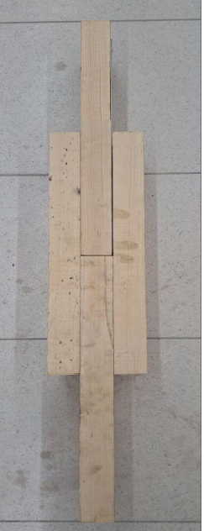 | b) | 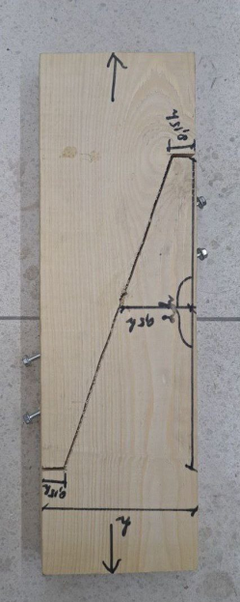 | c) | 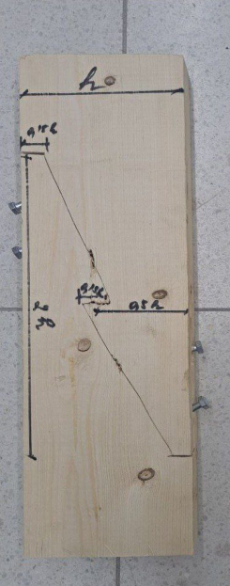
Figure 1. Connections of wooden structural elements: a) current connection of type T-1,
b) improved connection of type T-2, c) improved connections of type T-3
The joints of wooden structures were made to a certain extent, and the structural elements were prepared so that they could be assembled and disassembled using screws. For experimental testing, the cross-sections of wooden structural elements were taken in the size of 50x150x800 mm. The fastening of wooden elements was carried out on horizontally arranged rafters, and the reinforcement of structural elements relative to wood fibers was ensured in this way [7].
Experimental tests were carried out in three series, with the elements of wooden structures connected on a screw basis in accordance with interstate GOST 58959-2020. We have adopted pine wood of the II grade, which has all the characteristics and high load-bearing capacity, and have conducted our final experimental work on the joints of wooden structural elements [2]. The types of wooden structural joints that we recommend and use are shown in Figure 1.
EXPERIMENTAL RESEARCH
We carried out tensile testing of joints of wooden structural elements, which is included in the state register of the Russian Federation - No. H1000.0322.9, manufactured in accordance with TU 26.51.62-001-40843429-2020. We carried out the tests using the Alfa Test H1000 hydraulic universal testing machine. The main task of the hydraulic universal testing machine is to determine the standard value of the force when conducting physical and mechanical testing of samples made of various materials [1]. The two-column force module is equipped with an automated measurement and control system, which allows you to conduct testing in accordance with the mode set by the computer using a special software program in accordance with GOST "LabX-V9.0". The Alfa Test H1000 hydraulic universal testing machine is shown in Figure 2.

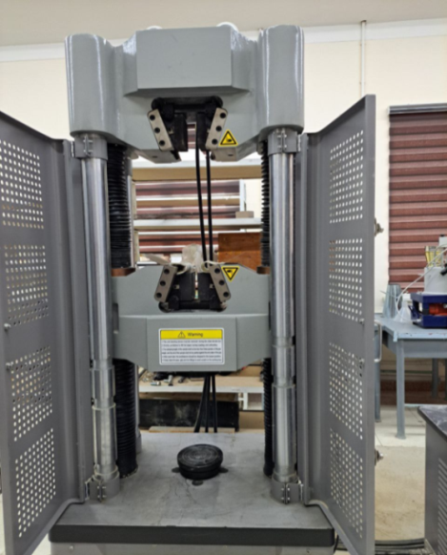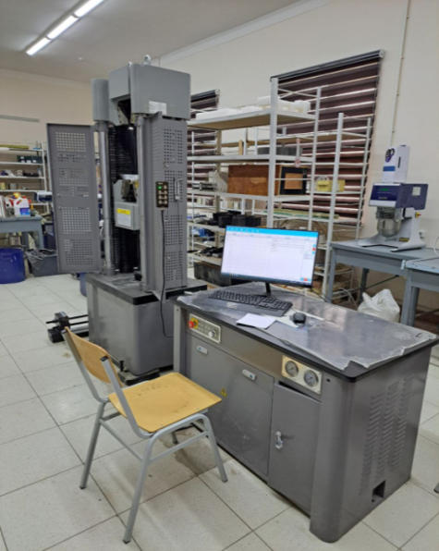
a) b)
Figure 2. Alfa Test H1000 hydraulic universal testing machine; a) working section of the testing machine;
b) general view of the testing machine.

When testing the joints of the main load-bearing wooden structural elements, the existing joint web T-1 and the improved joint webs T-2 and T-3 were tested up to the failure point.
Within the framework of the research, 3 joint webs were tested, and 10 studies were conducted in each series. The results of the experimental studies were obtained and presented in the form of graphs and tables [3].
The general appearance of the joints during the tensile test is shown in Figure 2.
а) | 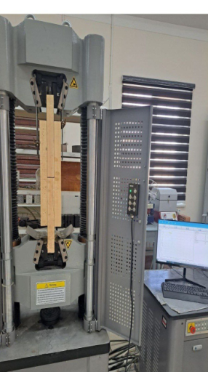 | b) | 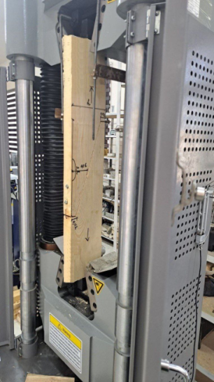 |  | с) | 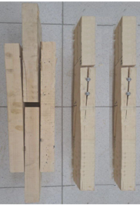
Figure 3. General view during experimental tests: a) current compound T-1,
b) improved compounds T-2 and T-3, c) description of the failure
RESEARCH RESULTS
To determine the conditions of deformation of the joints of the elements of the wooden structure, experimental test work was carried out and loads were loaded.
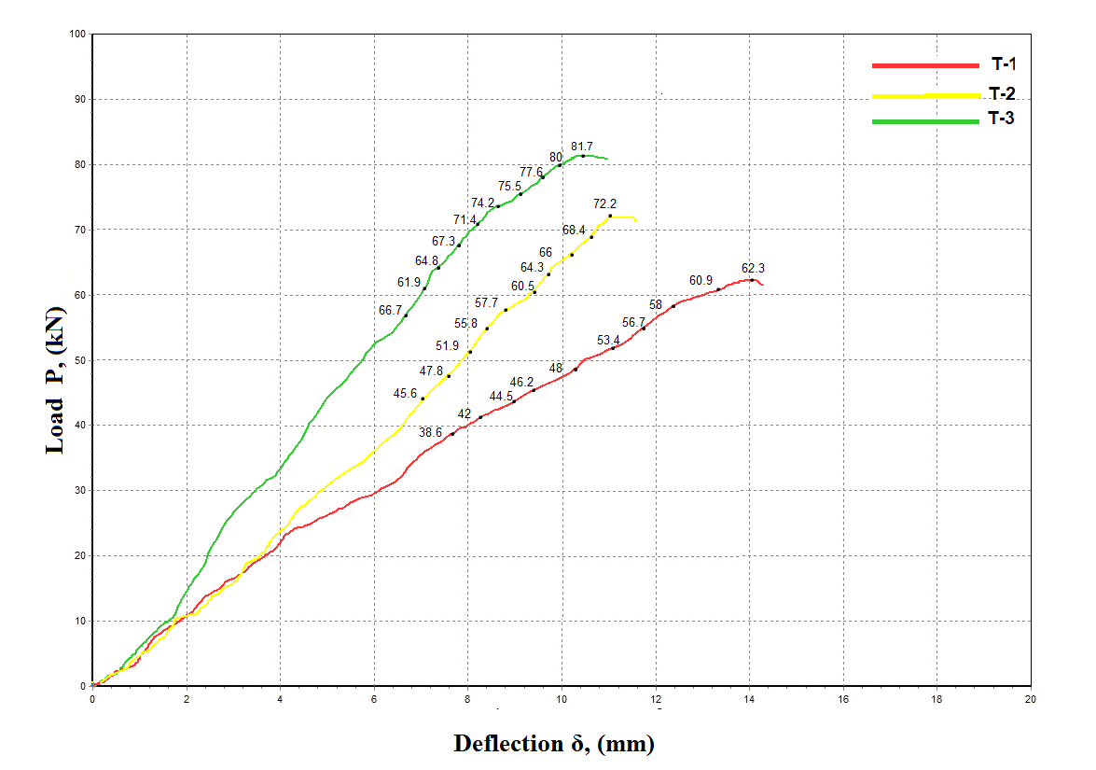
Figure 4. Graph of the relationship between load (kN) and elongation deformation (mm)
of T-1, T-2 and T-3 type joints

When the load was placed, the joints of the elements of the wooden structure were held until they were broken, then bending indicators were taken and moved to the next stage of loading. When testing the joints of the main load-bearing wooden structural elements, the compound mesh T-1 improved with the current compound mesh T-2 and T-3s were carried out up to the choking circuit [4].
As part of the studies, 3 compound nets were tested and 10 studies were carried out in each series. The results of experimental studies are presented in the form of graphs and tables [5]. An overview of the joints in test time for bending is shown in Figure 3. The results of the tests performed are reflected in Figures 4.
The results of experimental tests of tensile strength limits in stress-strain conditions of joints of wooden structural elements are presented in Table 1:

Table 1. Results of the bending strength limit of joints of wooden structural elements
Series | example | Breaking load in tension, kN | Limit deformation during stretching, mm
1 | 2 | 3 | 4
T-1 | 1 | 62.3 | 14
T-1 | 2 | 60.9 | 13.6
T-1 | 3 | 58 | 12.4
T-2 | 1 | 72.2 | 11.3
T-2 | 2 | 68.4 | 10.8
T-2 | 3 | 66 | 10.2
T-3 | 1 | 81.7 | 10.5
T-3 | 2 | 80 | 9.9
T-3 | 3 | 77.6 | 9.6
CONCLUSIONS
1. Experimental studies on the absorption of screws from a wood array in samples made it possible to determine the dependence of the voltage corresponding to the strength limit on the absorption of a screw from a monolithic wood array on the following factors: screw length, screw diameter and the angle of deviation of the force from the direction of movement of the.
2. Comparing experimental research studies on the tensile strength of wooden structural element joints, it was found that the strength of the T-2 joint type is 15.8% higher than the T-1 joint, which is considered to be the practical joint, and the T-3 joint type is 13.3% higher than the T-2 joint.
REFERENCES
1. ugli Bakhtiyorjon, M., Razzakov, S.J., (2025). Experimental investigation of steel fiber dispersed reinforced concrete beams. In EPJ Web of Conferences (Vol. 318, p. 01010). EDP Sciences.
2. Rakhmanov, B., Razzakov, S., Kosimov, L. (2023). The research on the influence of temperature on the properties of synthetic fibres for load-handling devices. In E3S Web of Conferences (Vol. 460, p. 10003). EDP Sciences.
3. Mavlonov, R., Razzakov, S., Numanova, S. (2023). Stress-strain state of combined steel-FRP reinforced concrete beams. In E3S Web of Conferences (Vol. 452, p. 06022). EDP Sciences.
4. Razzakov, S., Martazaev, A. (2023). Mechanical properties of concrete reinforced with basalt fibers. In E3S Web of Conferences (Vol. 401, p. 05003). EDP Sciences.
5. Mavlonov, R., Razzakov, S. (2023). Numerical modeling of combined reinforcement concrete beam. In E3S Web of Conferences (Vol. 401, p. 03007). EDP Sciences.
6. Razzaqov, S. J., Jurayev, S. S., Xakimov, S. A., Qayumov, D. A.,Yuldashev, J. G. (2023, August). The importance of soil and water for increasing the strength of ceramic products. In IOP Conference Series: Earth and Environmental Science (Vol. 1231, No. 1, p. 012080). IOP Publishing.
7. Razzakov, S., Berdakov, D., Sayımbetova, N., Utemuratova, Y. (2025, November). Improvement, stress-strain behavior and strength of connections of wooden structure elements. In AIP Conference Proceedings (Vol. 3331, No. 1, p. 070007). AIP Publishing LLC.

