Some results of reinterpretation of seismic survey materials using the example of the southeastern part of the Bukhara stage
Batir Khaydarov ^{a)}, Umar Najmiddinov
Tashkent state technical university named after Islam Karimov, Tashkent, Uzbekistan
^{a)} Corresponding author: Haydarov-batir@rambler.ru
Abstract. In this article information about processing and reinterpretation of field seismic data is much more complex and extensive than processing data from other geophysical methods, and consists of selecting the necessary ones from several dozen waves is given. Solving the most complex problems of seismic exploration, separating useful waves from a multitude of waves, is impossible without their digital processing on a computer.
INTRODUCTION
Mineral deposits discovered as a result of seismic exploration data of geophysical methods used in the search and exploration of oil and gas, make a significant contribution to the energy and economy of Uzbekistan. [1,2]
Processing and reinterpretation of field seismic data is much more complex and extensive than processing data from other geophysical methods, and consists of selecting the necessary ones from several dozen waves. Using a rational system for monitoring and processing complex digital data, it will be necessary to extract the kinematic (time of arrival) and dynamic (amplitude of signals) properties from the multitude of interfering waves and make static corrections to the obtained data.[3]
Solving the most complex problems of seismic exploration, separating useful waves from a multitude of waves, is impossible without their digital processing on a computer.
The article presents the results of processing, comparing and analyzing seismic data in the computer center.

EXPERIMENTAL RESEARCH
The system of studied profiles was worked out by curvilinear longitudinal profiling with the use of non-explosive sources (NES).
At the stage of pre-processing, the loading, visual assessment of the source material, sorting of SPS-files, as well as its compliance with the operator's reports were carried out. Poor-quality tracks and seismograms in general were discarded. Based on a priori information, preliminary sections of the CMP were obtained by using a notch filter (50 Hz) and a wide-band band filter.
One of the disadvantages that reduces the quality of the vibroseismic material is the unresolved nature of the seismic sections obtained.[5]
To improve the quality of the resulting sections, procedures were introduced into the production graph that provide geophysicists with additional information about the structure of the environment.
“GeoCluster” software has developed technological chains to increase signal coherence, suppress irregular noise (ANTIB module), attenuate abnormal amplitudes (NOISY, NOISE modules), suppress single-frequency interference (MFNAT module), and also used modules that suppress random interference in the space-time interval without affecting regular. The waves are FXNAT and SPARN, which increased the resolution of the seismic recording.
To exclude the influence of surface conditions and to align the amplitude-frequency spectrum of the initial traces, deconvolution was applied, taking into account the non-identical surface conditions (DECSC).
The suppression of linear interferences observed throughout the seismic section was carried out using the FKFIL procedure (for interferences with apparent velocities up to 3000m/s).
After each kinematic correction procedure (VESPA, TVELTS) and static correction procedure (SATAN, ADDST, TVELTS), linear interference was suppressed for each resulting time slice with Δτ 0 by selecting the FKFIL parameters using the MIX procedure.
The program of predicting deconvolution (TRITA), performed in stages, was used to suppress satellite waves, compress the signal, increase the resolution of the recording against the background of interference oscillation and noise, and increase the dynamic expressiveness. The procedure of suppressing random interference in the frequency-space domain (FXNAT) was used to suppress noise caused by deconvolution.
The original material was edited after using the above set of procedures.
The correction of kinematic and static corrections was carried out according to the standard procedure.
After using the technological chains, having obtained a dynamically expressed material, we proceed to the correction of kinematic corrections.
The basis for calculating the a priori kinematic corrections was the V_{CMP} = f (to) curves, with which the materials of previous years were processed, as well as the materials of seismic studies of wells on the studied areas.
On profiles with good quality of the traceability of horizons, a quantitative analysis of velocities was carried out in advance, that is, on the basis of the analysis of velocity spectra (step on CMP 1km). The VESPA program was used to select the summation rates that maximized the coherence coefficient.
In addition to the vertical spectra, multispeed time cuts were solved with a shift from the selected curve by Δτ 24, 48 in the arrow of the hodograph deflection, which were evaluated interactively on the computer screen.
The kinematic corrections were entered using the FANMO program, which uses the LIBRI VI velocity libraries.
An example of correcting the kinematic corrections of the first stage is shown in Figure 1, which presents a time-resolved CMP image with a priori kinematics and a time-resolved CMP image with selected kinematics after applying the previously described technological chains to the initial material.
KINEMATIC CORRECTION (STAGE I)
Shodlik Field / Shodlik Area Line 30172717
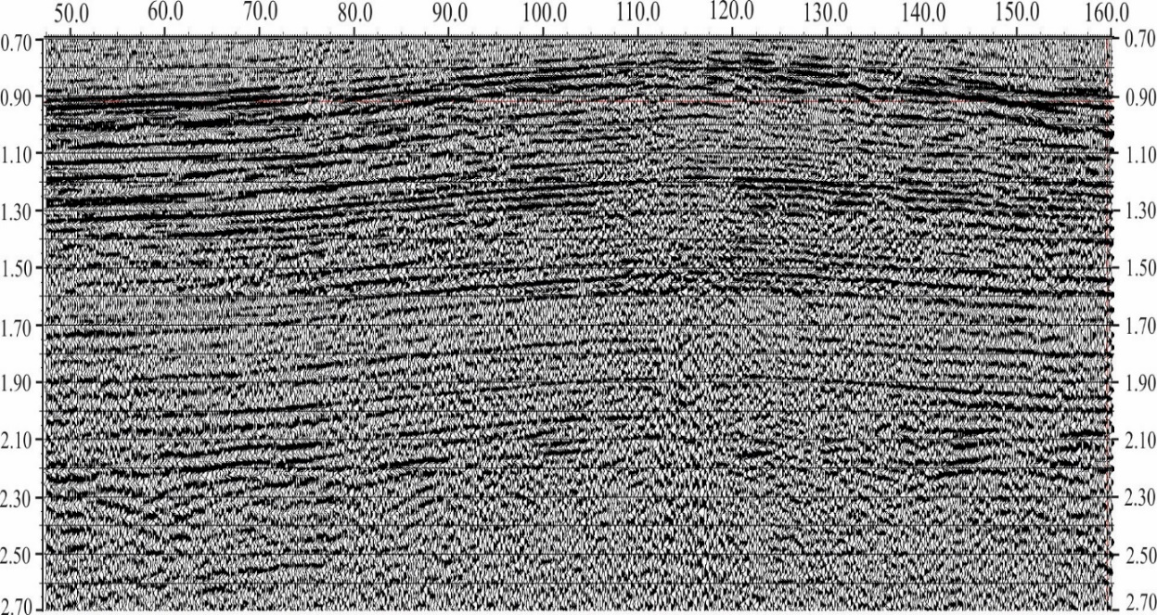
FIGURE 1а. Preliminary, before linear noise suppression
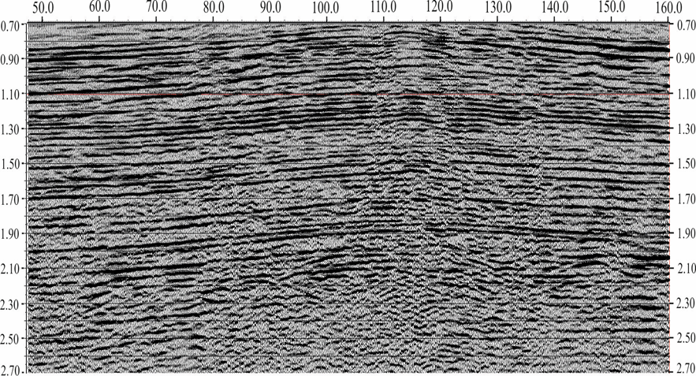
FIGURE 1 b. With a priori kinematics after linear noise suppression

A priori static corrections were determined based on the MSF data and leveling sections using the average velocity method.
The static corrections were entered using the HISTA program, which were previously stored in the LIBRI STAT library.
The static corrections were automatically adjusted using the SATAN module, and poorly traceable horizons were piked to obtain a clear picture of the reflecting boundaries on the seismic section.
The automatic correction of static corrections was performed in a wide window with a large range of acceptable corrections (40 m/s). without horizon description, and then with horizon description in a narrow time window of 200 – 400m/sec with an adjustment range of 20m/sec.
STATIC CORRECTION
Shodlik Field / Area Line 10172717
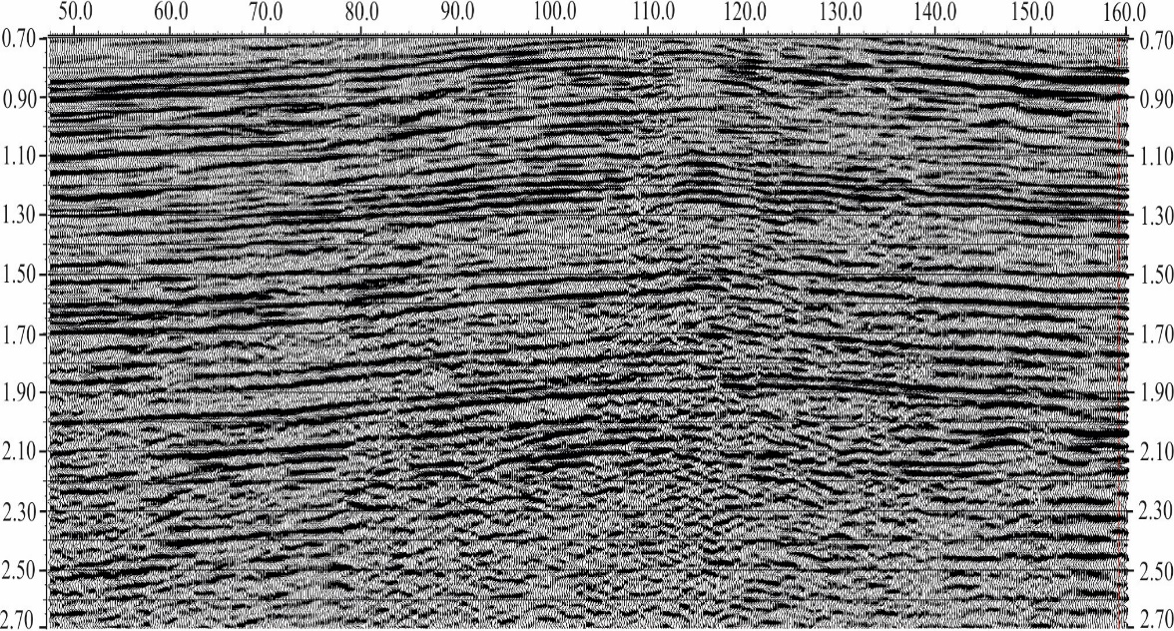
FIGURE 2. After static and kinematic corrections

In general, the correction of static corrections gave positive results in the areas of research.
An example of the effectiveness of static correction is shown in Fig. 2. Here are the results of the correction on the total CMP profile 10172717 area of the Shodlik.
After the static correction, the kinematics of the second stage was corrected, which included obtaining multispeed time sections of the CMP with a shift from the final selected curves Δτ 24 in the arrow of the bending of the hodograph.
Velocity scans together with velocity spectra are necessary for the comprehensive interpretation of CMP seismic exploration results using "direct search" programs and for identifying "reservoir" anomalies.
In accordance with the methodology of field work, the main variants of temporary sections of the CMP with 120-fold summation were obtained for all profiles.
Longitudinal profiling was carried out using a 240-channel seismic station with the same reception and explosion steps of 25 m, and a symmetrical firing system.
All final versions of the sections were subjected to migration transformation using the MIGRV program, followed by corrective filtering, which helped to resolve the wave pattern (Fig. 3).
RESIDUAL STATIC CORRECTION
Shodlik Area / Field Line 10172717
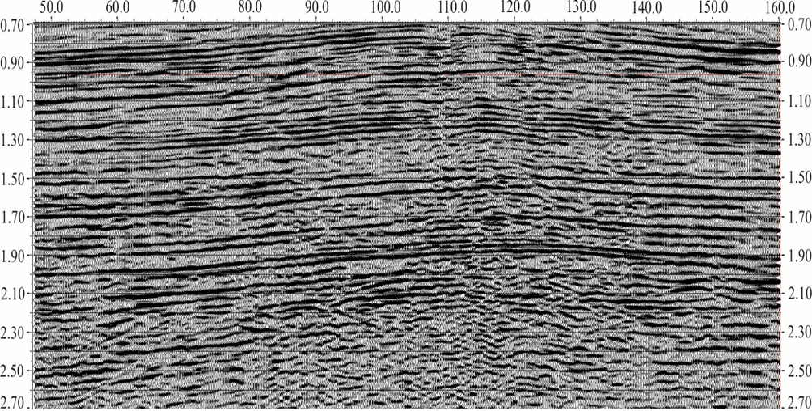
FIGURE 3a. Preliminary version

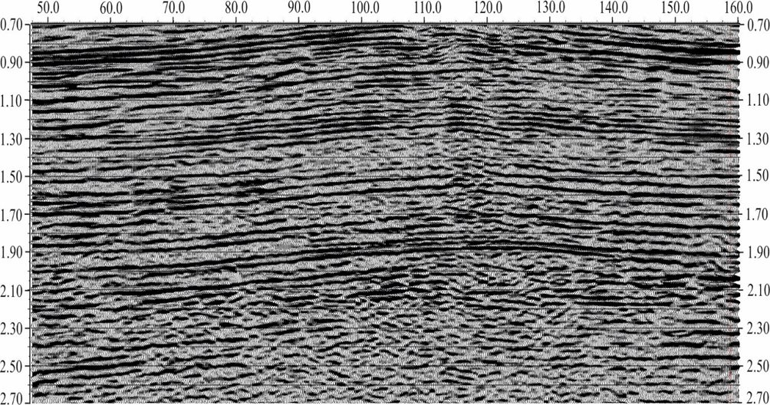
FIGURE 3b. Final stack with residual static and kinematic corrections
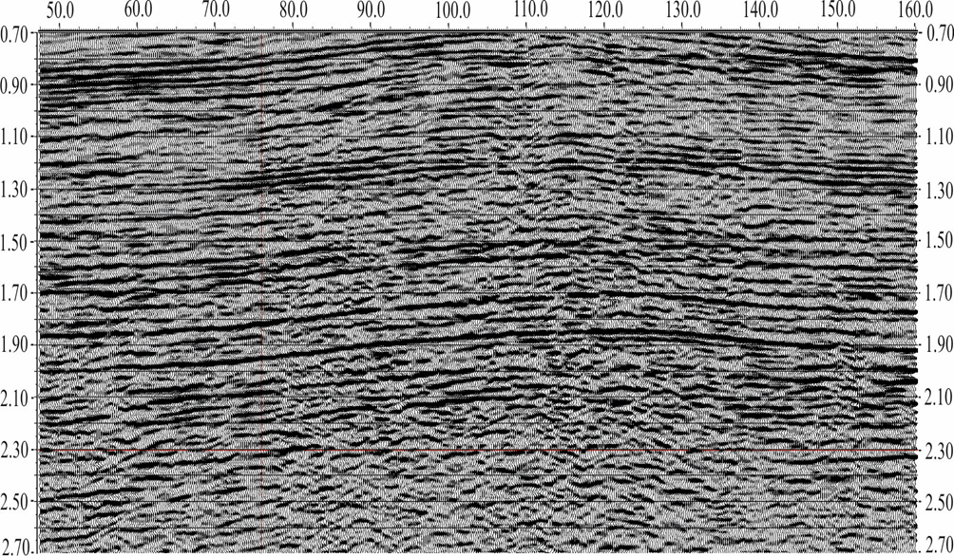
FIGURE 3c. Post-stack F-X filtering (FXNAT) based on the final CMP stack
RESEARCH RESULTS
During the field seismic exploration, the main focus was on obtaining reflected waves recorded in the time interval of 0.4-2.6 s, which corresponds to the range of recording reflections from the Lower Cretaceous (T₂) and Upper Jurassic (T₃, T₄, T₅, T₆) reflecting horizons, as well as from the terrigenous formations of the Middle-Lower Jurassic complex (T₇). [7,8]
Based on this, the quality of the primary data was evaluated.
In general, the field material obtained in the area of the studied works has different quality, which is due to both different surface and deep seismogeological conditions, and different methodological approaches to processing profiles in the field.
The analysis of all time sections of the CMP obtained along the studied profiles showed the following results:
Stable material of good quality was obtained on the profiles worked out on the area of Beshkent, Kamashi, Turunkul, Severny Kamashi, Muglan, Kasbi, Shodlik, Mirishkor, Yangiaryk. On all profiles, high-frequency, dynamically expressed time cuts of CMP were obtained.
On profiles where the quality of the field data in terms of the informativeness of the seismograms is good, reflections were recorded in the time interval of 0.8 to 2.4 s, which corresponds to the range of recording reflections from the Lower Cretaceous (T₂) and Upper Jurassic (T₃, T₄, T₅, T₆) reflecting horizons.
The correlation was based on time sections of the CMP with full summation, and additional processing options were also used (speeds, D-transformations, migration, etc.).
Depending on the geological structure of the section and the research region, the correlation of waves on time sections was carried out using dynamic and kinematic features for their identification.
In the areas of the Bukhara tectonic steppe, due to a significant reduction in the thickness of the salt-anhydrite Tithon stratum, the reflected waves from the T₃, T₅, and T₆ horizons are closely interfering with each other, making it almost impossible to distinguish individual phases associated with specific stratigraphic horizons. In the time sections, the correlation was based on reflections associated with the Neocomian XIII horizon (T₂) and reflections related to the roof of the Tithon and the Oxford-Kimeridge limestone.
For areas located within the Beshkent depression, reflections associated with the XIII horizon of the Neocomian (T₂) and the roof of the upper Tithonian anhydrites (T₃) are most clearly and confidently identified on time sections. Moreover, the former is continuously correlated, while the latter, although rarely, undergoes correlation breaks. [6]
Due to the consistent occurrence of the Cretaceous and Upper Jurassic horizons and the insignificant horizontal gradient of changes in average velocities, the correctness of the correlation in the areas of discontinuity is controlled by maintaining a constant value of Δ t3-2.
The reflected waves from the roof of the medium-aged anhydrites of the chemogenic stratum are distinguished by the dynamic expressiveness of the recording. Therefore, despite their absence in some areas, the T₄ horizon is traced almost confidently across all areas of work. The areas of reflection disappearance from intermediate anhydrites are associated with a change in the reflective properties of the boundaries caused by the predominance of salts in the section, and possibly by brine.
Reflected waves associated with the roof of the lower Tithonian anhydrites and Oxford-Kimmeridge limestones are characterized by zones of ambiguous correlation. These waves are mainly the result of the superposition of useful waves with diffracted and lateral waves, as well as the interference of oscillations in the areas where the highly porous Oxford-Kimmeridge limestones are eroded. Within the Talishbe and Uzunnavo areas, the correlation of T3-T5 waves is difficult due to the lack of dynamic expressiveness and unresolved recording. In the areas of Turunkul, Kasbi, Muglan, Yangiaryk, and Shodlik, the correlation of waves from the T₃-T₅ horizons is confident and undeniable.
Stratigraphic reference of reflecting horizons was carried out
by determining the value of "t0" according to the VSP data performed on deep wells, which was transferred to the CMP profiles for the entire polygon. [6]
Within the study area, stratigraphic reference was carried out on the basis of the VSP data performed in the wells No. 1-Yangiarik, North Kamashi No. 2, No. 6 and was controlled when the CMP profiles intersected with deep wells Zap. Maimanak No. 1, No. 2, Rasylkuduk No. 2, etc.
At the same time, the corrections for filtration of 0.008 s, phase of 0.03 s, first entrances of 0.01 s and the line of reduction determined for each specific case by the ZMS-MPV hodographs were taken into account.
According to the VSP data, the following reflecting horizons are allocated on the studied areas:
T₁ – the roof of the Bukhara limestones of the Paleogene
T₂^{III} – Turonian sandstones (VIII horizon)
T₂^{II} – Cenomanian sandstones (IX horizon)
T₂^{I} – Albian sandstones (XI horizon)
T₂ – Neocomian-Aptsian stage, the reference reflecting horizons are the sandstones of the XII and XIII.
The reflection waves were linked to specific geological boundaries by using the to= f (H) curve for the above-mentioned wells, followed by the appropriate corrections for the reduction lines and the transfer of time values from the old CMP profiles to the CMP profiles of the studied areas.
The stratigraphic correlation of the T₂, T₃, and T₄ reflection horizons is not particularly challenging, as they are dynamically well-defined and recognizable across all areas.
The T₅ reflected wave is characterized by the presence of zones with complex wave patterns, so these zones are sometimes stratified conditionally.
Simultaneously with the correlation of time sections,
analysis of the wave pattern is carried out on all the worked profiles. At the same time, attention was paid to the nature of the traceability of individual horizons, to the simplicity and resolution of the recording, to the change in the time difference of registration of the main reference waves, areas of abnormal complication of the recording were allocated.
The analysis of time sections showed that the nature of the recording both in the vertical and in the horizontal directions, especially in the sub-salt time interval, is different.
Along with a clear, confident tracing, there are areas with complex recording and discontinuous wave-phase axes, where the recording intensity is comparable to the background of interfering waves.
The different recording patterns are caused by changes in the geological and geophysical parameters of the environment.
The reflected waves recorded from the boundaries in the Cretaceous rock complex have a more regular pattern and are dynamically better expressed. Among them, the wave associated with the XII
The accuracy of seismic constructions depends on the degree of study of the velocity characteristics of the section.
As already noted above, the analysis of the VSP and MCMP data showed that the reflecting horizons, confidently traced throughout the area under consideration, are the XIII horizon of the Neocom-apt (horizon T₂) and the roof of the upper Tithonian anhydrites (horizon T₃). Both horizons are the basis, i.e. the boundaries from which the construction of all deeper horizons is carried out.
Within the southeastern part of the Bukhara tectonic step, the roof of the Upper Jurassic deposits (T₃ horizon) was selected as the base boundary. The dependence of the depth of the Tithon roof on the time of passage of the T₃ wave, H3 = (t03/2), was established. This was based on data from VSP, deep exploration drilling, and CMP materials.
The basis for constructing seismic sections at a scale of 1:20,000 was the adjusted and correlated temporary sections of the CMP, from which sections were taken every 500 m.
CONCLUSIONS
In the context of such rapid growth in the industry, it is necessary to constantly improve the methodology and technology of field research in order to ensure the proper efficiency of geological exploration. This requires a critical analysis of previously completed work and data to identify new and potentially promising sites, as well as to determine the most effective technologies.
The oil and gas potential of the studied territory has not been fully investigated, since a reliable correlation of the wave pattern with the characteristics of the proposed oil and gas accumulation zones (deposits associated with facies substitution, wedging zones, zones of sedimentation of the Upper Jurassic (XV horizon), as well as with non-anticline traps in elevated basement areas) has not always been established.
To solve the above problems, reinterpret the materials of seismic exploration using the CMP method (general the depth point) was performed in the following sequence:
Analysis and generalization of the methodology of field work:
Reinterpretation of research materials from previous years conducted in this area.
Operational interpretation of the materials of seismic exploration using the CMP method and clarification of further directions of seismic exploration using the CMP method, taking into account the reinterpretation data.
REFERENCES
1. Akramkhodzhaev A.M., Khodzhaeva A.R. Oil and gas fields of Uzbekistan, Books I and II. Uzbekistan, "Fan" 1974.
2. Babajanov T.L., Kunin A.Ya., Luk-Zilberman V.I. According to geophysical data, the structure and oil and gas potential of deep-bottomed complexes of Central Asia. Tashkent,"Fan" 1986.
3. Gurwich I.I. Seismic exploration. "Nedra", Moscow 1981.
4. Gurwich I.I. "Guidelines for seismic research" Moscow, 1986.
5. Schneerson M. B., Mayorov V. B. Seismic tremors caused by explosions in port facilities. "Nedra", Moscow, 1982.
6. Zuev S.N. In 1979-1982, experimental and methodological work was carried out at the Ministry of Natural Gas of Uzbekistan to improve the methodology for developing seismic models and forecasts of the occurrence of oil and gas fields.
7. Saotov M.Kh., Normurodov K.Y. Geophysical materials for the passport of the Ijabat structure. Yakkabag., 2020, yage Foundation.
8. Khujamshukurov N.B. The structure and geophysical materials for the passport. Yakkabag K., 2020, YaGE Foundation.

