Characteristics of high-harmonic generation in plasma induced by laser radiation
Zukhriddin Ruziev^{1,a)}, Usman Sapaev², Nigora Akbarova ³, Ernazar Kosbergenov ¹, Nuraddin Abdullaev ¹, Khushbak Shamaev ¹, Malika Xudoyberdieva ¹, Khurshida Begmurodova ⁴
¹ National University of Uzbekistan, Tashkent, Uzbekistan
²Tashkent Branch of the Russian Gubkin University, Tashkent, Uzbekistan
³Tashkent state technical university named after Islam Karimov, Tashkent, Uzbekistan
⁴Denov Institute of Entrepreneurship and Pedagogy, Denau, Surkhandarya, Uzbekistan
^{a)} Corresponding author: zuhriddinrj@gmail.com
Abstract. In this article the formation of plasma in silicon dioxide (SiO₂) through strong ionization induced by intense laser irradiation, as well as the subsequent generation of high-order harmonics within this plasma medium, has been theoretically modeled. In this study, four different cases of laser pulse amplitude were examined to analyze the evolution of high-harmonic generation and to understand how variations in field strength affect the harmonic emission dynamics.
INTRODUCTION
The interaction of intense ultrashort laser pulses with wide-bandgap dielectric materials such as silicon dioxide (SiO₂) leads to strong-field ionization, rapid plasma formation, and the emergence of highly nonlinear optical phenomena, including high-harmonic generation (HHG). Accurate theoretical modeling of these processes is essential for understanding electron dynamics in solids subjected to extreme light fields and for predicting the spectral and temporal properties of harmonic emission. The transient plasma created within the material plays a decisive role in shaping the nonlinear response, making the study of plasma-assisted HHG a key topic in ultrafast optics.
Recent advances in strong-field theory have improved the description of ionization mechanisms in solids, providing more reliable tools for modeling laser–matter interaction under high-intensity conditions [1]. Such theoretical developments are closely linked to earlier studies of nonlinear optical processes in crystals, where the influence of self-action, dispersion, and nonstationarity on harmonic generation was systematically analyzed [2,3]. These works laid the conceptual foundation for understanding how ultrashort pulses evolve in structured media and how nonlinear polarization governs the generation of higher-order harmonics.
Additional contributions focusing on the propagation of femtosecond pulses in dispersive photonic structures have demonstrated the importance of high-order dispersion and phase control in maintaining pulse integrity under strong-field conditions [5]. These insights are highly relevant for scenarios where plasma formation and harmonic generation occur simultaneously, as both processes depend sensitively on the temporal evolution of the driving field.
Progress in computational modeling within related areas of optical physics further underscores the value of mathematically rigorous approaches for analyzing complex light–matter interactions [6]. Meanwhile, investigations into the electronic and magnetic properties of doped silicon systems [7–9] highlight how microscopic modifications in solid-state environments can strongly influence their electromagnetic response—an idea that parallels the behavior of laser-induced plasma, where rapid electronic restructuring dictates the efficiency of harmonic emission.
In this context, radiation-induced modification of solids provides an important parallel to strong-field laser–matter interaction. Studies on nickel-doped silicon have shown that γ-irradiation significantly alters carrier concentration, resistivity, and mobility due to the formation of radiation-induced defect complexes [10,11]. The thermal stability of these modified electrical parameters is governed by impurity–defect interactions and relaxation processes involving deep energy levels [12].
Related insight into microscopic light–matter interaction has been obtained from Raman spectroscopic studies, where laser excitation was shown to strongly influence vibrational dynamics in molecular and condensed systems [13,14]. Together, these results emphasize that external electromagnetic or radiation fields can induce rapid electronic and structural reconfiguration in matter, a mechanism that is closely related to plasma formation and nonlinear polarization effects governing high-order harmonic generation in solids.
Together, these foundational studies motivate a deeper theoretical examination of HHG in laser-induced plasma within dielectrics. In this work, plasma formation in SiO₂ under strong-field laser irradiation is modeled, and the generation of high-order harmonics within the evolving plasma environment is analyzed. To investigate the dependence of harmonic emission on driving-field strength, four distinct laser pulse amplitude regimes are considered. This approach enables a systematic study of ionization dynamics, plasma density growth, and nonlinear polarization, providing new insights into the ultrafast processes governing high-harmonic generation in solid-state plasma environments.

THEORETICAL RESEARCH
The theoretical modeling of plasma formation and high-harmonic generation (HHG) in SiO₂ under strong laser irradiation is based on the coupled dynamics of ionization, plasma buildup, and nonlinear polarization within the dielectric medium. When an intense femtosecond laser pulse interacts with SiO₂, the electric field becomes strong enough to induce significant ionization, leading to the creation of a rapidly evolving electron–ion plasma. The rate and efficiency of this ionization process depend sensitively on the instantaneous amplitude of the laser field, which determines whether the material responds through multiphoton, tunneling, or mixed ionization mechanisms, as discussed in comparative studies of strong-field models for solids {1}.
As plasma density increases during the pulse, the optical properties of the medium change dynamically. The refractive index becomes time-dependent, and the induced free-electron current generates a highly nonlinear response that plays a central role in harmonic emission. This behavior is conceptually related to the nonlinear and dispersive effects observed in crystals exposed to ultrashort pulses, where self-action, nonstationarity, and phase-matching strongly influence harmonic generation efficiency {2,3}. In the present model, both the bound-electron nonlinearity and the plasma-induced response are considered essential contributors to the high-harmonic signal.
To analyze how harmonic generation evolves under different laser intensities, four separate regimes of pulse amplitude are examined. This approach makes it possible to track how variations in the driving field strength affect ionization dynamics, plasma growth, and the resulting harmonic spectrum. Earlier research on ultrashort-pulse propagation in dispersive photonic structures has shown that such intensity-dependent effects are crucial for understanding nonlinear frequency conversion processes {5}, and similar principles apply to the plasma-driven harmonic generation investigated here.
The numerical modeling procedure consists of defining the laser pulse, computing the temporal evolution of ionization and plasma density, determining the nonlinear polarization response, and extracting the harmonic spectrum from the resulting time-dependent signal. This framework provides a self-consistent description of ultrafast processes in laser-induced plasma and forms the theoretical foundation for interpreting the amplitude-dependent evolution of high-order harmonics in SiO₂.
RESEARCH RESULTS
In this study, a 10-fs Gaussian laser pulse with a central wavelength of 800 nm was used to investigate the formation of laser-induced plasma in SiO₂ and the subsequent generation of high-order harmonics. For the silicon dioxide medium, typical solid-state parameters were adopted, including a band gap of approximately 8.9 eV, an atomic number density of $2.2×{10}^{22} {\text{cm}}^{-3}$, and a high-frequency dielectric constant of about 5.5. These values allow a realistic description of the ionization threshold and dispersion properties under strong-field excitation. To explore the influence of the driving-field strength on plasma formation and harmonic emission, four peak intensities were considered: 1, 40, 80, and 120 TW/cm². These intensity regimes correspond to the temporal field responses presented in Figure 1.
As shown in Figure 1, the time-domain nonlinear current (or equivalently, the effective intensity response) exhibits a clear evolution as the peak laser amplitude increases. At the lowest intensity of 1 TW/cm², the waveform remains nearly sinusoidal with only small distortions, indicating that the material response is dominated by bound-electron nonlinearities. Ionization is minimal in this regime, and consequently the formation of a plasma layer is negligible. When the intensity increases to 40 TW/cm², noticeable distortions emerge around the central part of the pulse, signaling the onset of significant strong-field ionization. The amplitude of the oscillations grows, and the waveform becomes increasingly anharmonic due to the contribution of a rapidly developing free-electron population.
The behavior becomes more pronounced at 80 TW/cm², where the distortions are stronger and the time-domain signal displays transient asymmetries that reflect rapid changes in electron density during the pulse. These modifications produce a nonlinear source term capable of generating a broad range of harmonic frequencies. At the highest considered intensity, 120 TW/cm², the temporal signal exhibits the strongest anharmonicity. The response is dominated by the plasma formed near the peak of the pulse, where the electron density grows steeply. This leads to a pronounced deformation of the oscillatory pattern, which directly influences the nature and efficiency of harmonic generation.

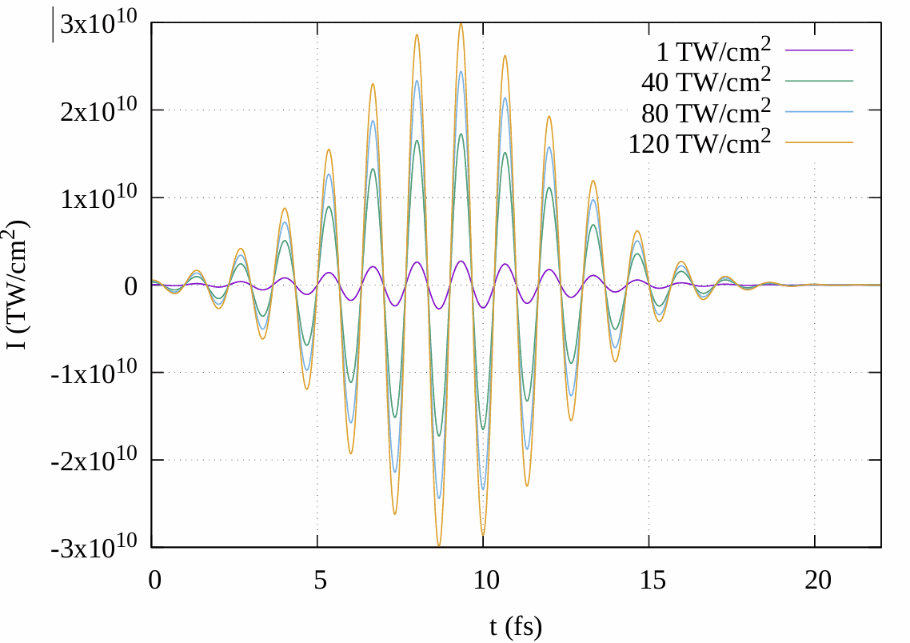
FIGURE 1. Time-domain nonlinear intensity response of SiO₂ for four different peak laser intensities:
1, 40, 80, and 120 TW/cm².

The corresponding harmonic spectra, shown in Figure 2, reveal how the spectral content evolves with increasing intensity. For the lowest intensity (Figure 2a), the spectrum is characterized by a sharp fundamental peak followed by a rapidly decaying sequence of low-order harmonics. No plateau structure is present, which is consistent with weak nonlinear response and negligible plasma-induced contributions. At 40 TW/cm² (Figure 2b), the harmonic yield increases significantly, and the beginnings of a plateau can be identified. The increased spectral width reflects stronger nonlinear polarization effects resulting from the onset of ionization.
At 80 TW/cm² (Figure 2c), the plateau becomes more pronounced, extending to higher normalized frequencies. The appearance of distinct modulations within the spectrum indicates interference between harmonic emission bursts generated at different times during the pulse. These spectral oscillations originate from the time-dependent refractive index changes caused by the rapidly evolving plasma density. The harmonic cutoff also shifts to higher frequencies, signaling increased electron acceleration in the stronger laser field. The most extended plateau appears at 120 TW/cm² (Figure 2d). At this intensity, the spectrum displays a rich structure with multiple local maxima, reflecting the interplay between plasma-induced dispersion, temporal ionization dynamics, and phase variations in the nonlinear current.
The harmonic yield increases by several orders of magnitude compared to the 1 TW/cm² case, demonstrating how strongly the efficiency of high-harmonic emission depends on the driving-field amplitude. The shift of the cutoff to even higher harmonic orders confirms that higher intensities enable the generation of more energetic harmonic photons. Overall, the combined analysis of time-domain signals and harmonic spectra demonstrates that the laser amplitude is the key parameter governing both plasma formation and high-harmonic generation in SiO₂. As the intensity increases, ionization becomes stronger, the temporal response becomes markedly anharmonic, and the harmonic spectrum evolves from a weak low-order distribution to a broad plateau extending toward high frequencies. The spectral modulations observed at intermediate and high intensities emphasize that harmonic emission in solids is not simply governed by a single-atom-like recollision mechanism, but instead arises from the interplay of bound-electron nonlinearities, rapidly changing plasma dispersion, and interference between multiple emission events during the ultrashort pulse. These findings highlight the crucial role of time-dependent plasma dynamics in shaping the high-harmonic output of dielectric materials under strong-field excitation and provide a theoretical basis for controlling harmonic emission through the adjustment of laser amplitude, pulse duration, and medium properties.

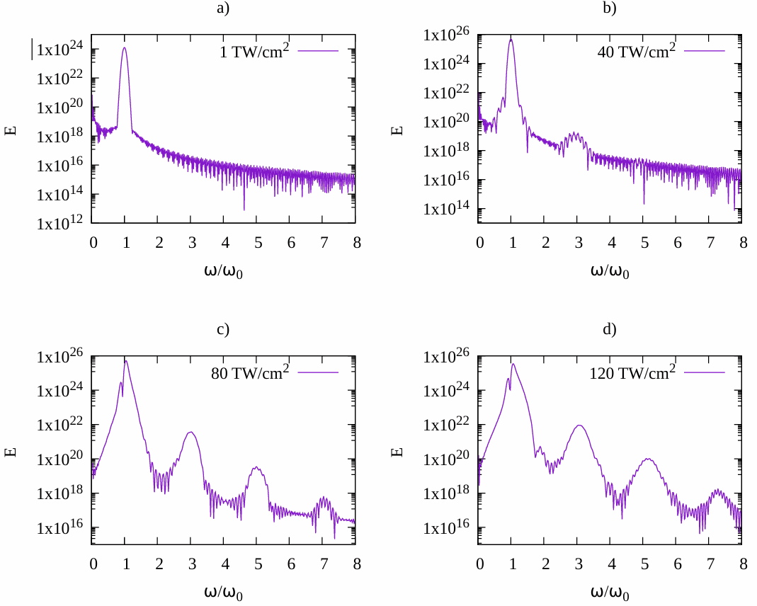
FIGURE 2. High-harmonic spectra generated in SiO₂ at the same peak intensities as in Figure 1. Panel (a) depicts high-harmonic generation at 1 TW/cm², panel (b) at 40 TW/cm², panel (c) at 80 TW/cm², and panel (d) at 120 TW/cm².
CONCLUSIONS
In summary, the interaction of a 10-fs, 800-nm Gaussian pulse with SiO₂ was analyzed for four peak intensities: 1, 40, 80, and 120 TW/cm². The results show that increasing the laser amplitude dramatically enhances strong-field ionization, leading to pronounced waveform distortions and the rapid buildup of a laser-induced plasma. This evolving plasma strongly modifies the nonlinear response of the medium. The harmonic spectra reveal a clear transition from weak low-order harmonics at low intensity to the formation of a broad plateau and an extended cutoff at higher intensities. The appearance of spectral modulations at stronger fields is attributed to time-dependent plasma dispersion and interference between different emission bursts. Overall, the study demonstrates that the driving-field amplitude is the key parameter controlling plasma formation and high-harmonic generation in SiO₂, making intensity tuning an effective way to manipulate the spectral features of harmonics in solid-state media.
REFERENCES
- Husakou, A., Morales, F., Richter, M., Ruziev, Z., Koraboev, K., & Yabana, K. (2024). Benchmarking of analytical photoionization models for solids using photoionization-induced reflection. Physical Review A, 110(6), 063511. https://doi.org/10.1103/PhysRevA.110.063511
- Ruziev Z. J. et al. On theory of approximation methods in the study of second harmonic generation of ultrashort laser pulses in periodic crystals //AIP Conference Proceedings. – AIP Publishing LLC, 2022. – Т. 2432. – №. 1. – С. 020008. https://doi.org/10.1063/5.0089970
- Ruziev, Z. J., Fedotova, O. M., Khasanov, O. K., & Sapaev, U. K. (2021). Features of second harmonic generation of intense short laser pulses in crystals with a regular domain structure under conditions of self-action, nonstationarity, and synchronism of group velocities. Journal of Applied Spectroscopy, 88(3), 514-518. https://doi.org/10.1007/s10812-021-01202-7
- Razzokov, J., Fazliev, S., Yusupov, M., Sharipov, A., Ruziev, Z., & Mamatkulov, S. (2021). Effect of mutation and disulfide bond formation on the catalytic site of monomeric cytoglobin: A molecular level insight. Plasma Medicine, 11(4). https://doi.org/10.1615/PlasmaMed.2021041420
- Olimov, A. N., Ruziev, Z. J., Yusupov, D. B., & Sapaev, U. K. (2019). Frequency doubling of femtosecond laser pulses in nonlinear photonic crystals with account of high-order dispersion. Journal of Russian Laser Research, 40(3), 280-287. https://doi.org/10.1007/s10946-019-09803-6
- Yakubov, D., Sattarov, O., Abdurakhmanov, B., Ismailov, T., Kholikova, P. Mathematical modeling based on astronomical and physical-geometric principles for optimizing the efficiency of solar panels //Optical and Computational Technologies for Measurements and Industrial Applications (OptiComp 2025). – SPIE, 2025. – Т. 13803. – pp. 152-157. https://doi.org/10.1117/12.3077879
- Zikrillaev, N. F., Urakova, F. E., Toshev, A. R., Kushiev, G. A., Ismailov, T. B., Abduganiev, Y. A., Norkulov, N. Physical and Magnetic Properties of Silicon Doped with Impurity Germanium Atoms. East European Journal of Physics, 2025 (1), pp. 184-189. https://doi.org/10.26565/2312-4334-2025-1-18
- Zikrillaev, N. F., Koveshnikov, S. V., Trabzon, L., Mavlonov, G. K., Ismaylov, B. K., Ismailov, T. B., Urakova, F. E. Ferromagnetic Properties of Silicon Doped Manganese Atoms. Surface Engineering and Applied Electrochemistry, (2025). 61(1), pp. 75-80. https://doi.org/10.3103/S1068375524700571
- Zikrillayev, N. F., Mavlonov, G. K., Trabzon, L., Koveshnikov, S. V., Kenzhaev, Z. T., Ismailov, T. B., Abduganiev, Y. A. Magnetic properties of silicon with paramagnetic impurity atoms. East European Journal of Physics, 2023.(3), pp.380-384. https://doi.org/10.26565/2312-4334-2023-3-40
- M. Iliev, K. A. Ismailov, E. Zh. Kosbergenov, V. B. Odzhaev, V. S. Prosolovich, Yu. N. Yankovsky, Z. T. Kenzhaev, B. O. Isakov, and G. A. Kushiev, The Influence of γ-Irradiation on the Electrophysical Parameters of Nickel-Doped Silicon Grown by the Czochralski Method, Surface Engineering and Applied Electrochemistry 61(6), 854–859 (2025). https://doi.org/10.3103/S1068375525700942
- Kenzhaev Z.T., Iliev Kh.M., Odzhaev V.B., Mavlonov G.Kh., Prosolovich V.S., Kosbergenov E.Zh., Ismaylov B.K., Isamov S.B., Ollambergenov Sh.Z. The Effect of Gamma Irradiation on the Electrophysical Parameters of Nickel-Doped Silicon Solar Cells // Surface Engineering and Applied Electrochemistry, 2024, Vol. 60, No. 6, pp. 851–856. DOI: 10.3103/S1068375524700467.
- Bakhadyrkhanov M.K., Ismailov K.A., Kosbergenov E.Zh. Thermal stability of electrical parameters of silicon crystal doped with nickel during growth // Semiconductor Physics, Quantum Electronics & Optoelectronics, 2022, Vol. 25, No. 1, pp. 6–9. DOI: 10.15407/spqeo25.01.006.
- Khudoyberdieva, D., Otajonov, S., Eshchanov, B., Eshquvatov, H., & Abdullayev, N. (2024). Mechanisms of Raman scattering spectrum of light from pyridine molecule in the lower frequency range. Results in Optics, 16, 100685.
- Otajonov, S., Allaquliyeva, S., Eshchanov, B., Abdullayev, N., & Eshkuvatov, H. (2023). Manifestation of the laws of vibrational motion of molecules of the condensed medium under the influence of laser radiation in the Raman spectrum. Results in Optics, 13, 100550.

