Improving the energy efficiency of pumping stations using artificial intelligence technologies
Fakhriddin Nosirov^{1,а}, Oleg Glovatsky², Ravshan Dusmatov¹, Naira Nasyrova², Gulnoza Azizova¹, Zhurabek Uralov¹
¹Tashkent state technical university named after Islam Karimov, Tashkent, Uzbekistan
²Research Institute of Irrigation and Water Problems, Karasu-4 Street, Tashkent, 100187, Uzbekistan
^{a)} Corresponding author: nosirov-0173@mail.ru
Abstract. This article presents research aimed at creating favorable conditions for the implementation of artificial intelligence technologies in energy resource management by optimizing energy-efficient operating modes at pumping stations. The study provides recommendations for the intelligent management of energy facilities. To build a knowledge base, a methodology has been developed for combining various forms of knowledge representation within a single intelligent system. Optimization of the operating modes of electric motors of pumping stations and the power supply network consists of achieving a minimum of power losses in the network under given active loads of electric motors. To optimally plan the operation of a centrifugal pump, software was used for hydraulic modeling of the modes of the D3200-75 pumps most commonly used in irrigation systems.
INTRODUCTION
Energy conservation issues and solutions based on energy-efficient technologies, cost reduction, and increased economic efficiency to maintain the required microclimate parameters are particularly pressing worldwide. To reduce dependence on hydrocarbons and reduce greenhouse gas emissions, developed countries have begun to implement more environmentally friendly technologies for energy production and use, including the use of solar, wind, small rivers and canals. At the same time, technologies that reduce energy losses and increase energy efficiency have begun to be widely implemented. However, energy consumption tends to increase due to the growing amount of equipment and its wear and tear [1,2,22].
When optimizing modes and calculating technical and economic indicators of power plants, the initial information is the flow characteristics of individual units. Conventional methods for obtaining energy characteristics of equipment require special tests that are time-consuming and costly, making it impossible to conduct them partially. This leads to a discrepancy between the characteristics and the actual state of the equipment and, ultimately, affects the efficiency of the power plant.
Pumps are the primary energy consumers in irrigation systems. Pump monitoring is essential to minimize energy consumption and reduce operating costs. An optimization algorithm is used to control pumps. In hydraulic systems, pumps account for up to 95% of the total energy consumed [3,4].
Currently, the concept of intelligent manufacturing is used to manage processes as a process where intelligent robots use the integration of engineering knowledge, technological software systems for real-time optimization [5,6]. With the acceleration of the new wave of digital and technological revolution with the introduction of artificial intelligence (AI), it is possible to develop the management and optimization of processing of operating and maintenance parameters of pumps [7,8].

EXPERIMENTAL RESEARCH
Intelligent technologies are the main driving force of the fourth industrial revolution, which has an important impact on high-quality economic development.
To find the optimal scheduling of a centrifugal pump, the authors used EPANet hydraulic modeling software to test the modes of the D3200-75 (20 VAT) pumps most commonly used in irrigation systems. These modes are characterized by a flow rate from start to finish of 2700-3650 m³/h with an operating point of 3200 m³/h; corresponding to these values, a pressure of H=63-86 (75) m; and a power of N=695-940 (820) kW. Measurements at natural sites in the Khorezm region at the PS "Sartarosh", "Shpor", "Gagarin" with the installation of pumps 20 NDN and 20 NDS showed the efficiency value η from 74-80 to 88% and the permissible cavitation reserve of 5.5-7.4 (6.5) m.
Power consumption by pump i during time period j
$N_{ij}=ρ_{i}^{j}\frac{Q_{i}^{j}∙H_{i}^{j}}{η_{i}}$ , (1)
where $ρ_{i}^{j}$ – is the period of one hour, depending on the pump efficiency ($η$), pump flow rate (Q), and pump head (H).
The pump flow rate and head are calculated using the EPANet hydraulic simulator according to the diagram (Fig.1).
FIGURE 1. Calculation scheme for the parameters of the РS network

The performance curves and installation of these pumps are shown in Figure 2. 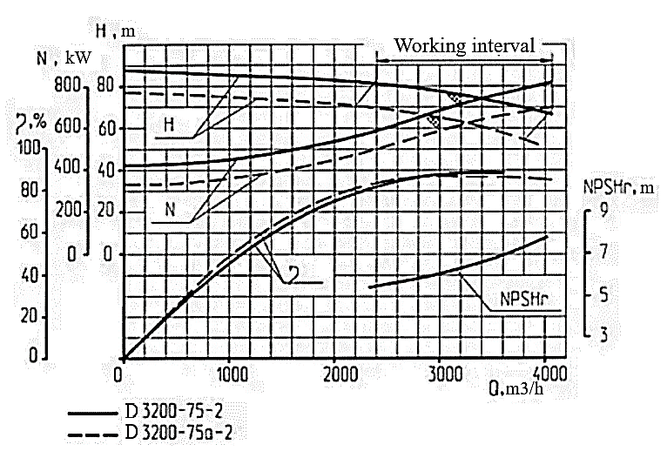 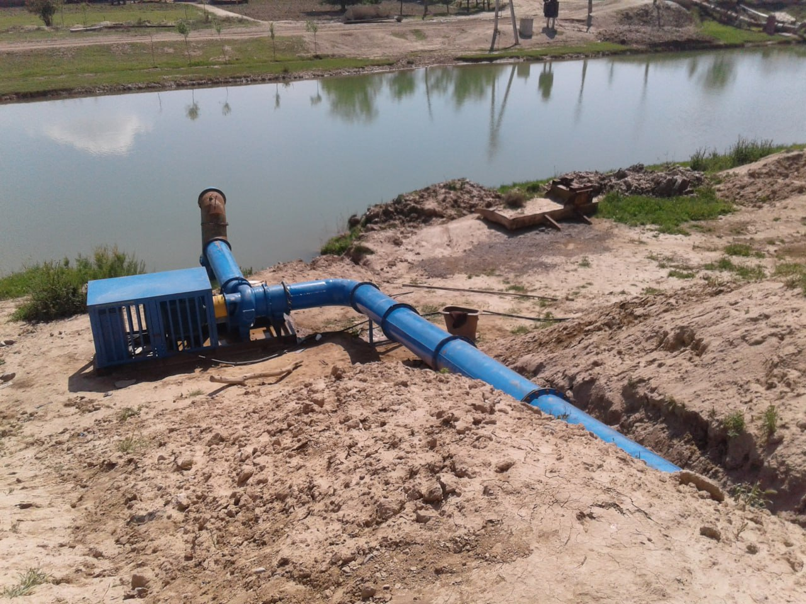
a) b)
FIGURE 2. Full-scale testing of D3200-75 pumps; a) characteristics of the D3200-75 pump; b) location of the pumping unit.

EPANet maintains a constant efficiency value for all flow rates, regardless of pump operation or any combination thereof. The results of water pumping mode optimization are compared with the currently optimized curves. Figure 2 shows the pump schedules tested for hydraulic feasibility using the EPANet simulator, and it is evident that the proposed methodology minimizes pump activation during periods of high system power demand.

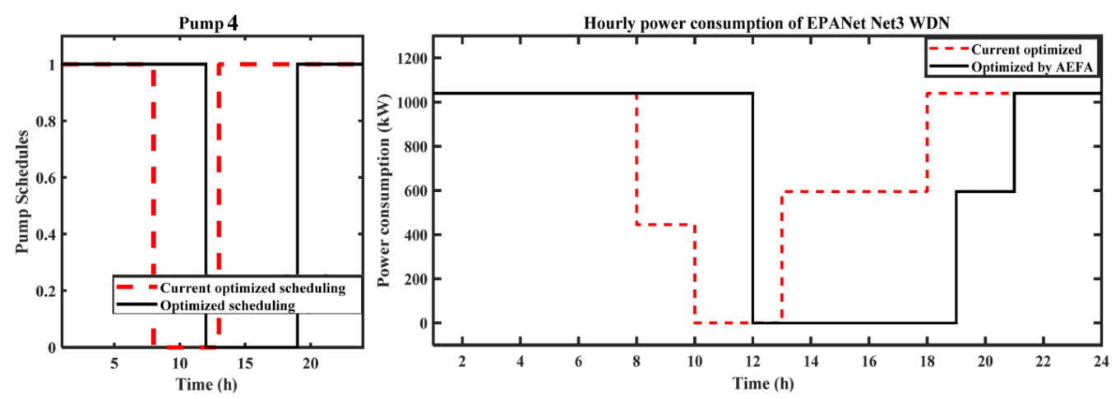
FIGURE 3. Scheme of optimal water supply schedule and daily electricity consumption by the PS network

The solution to the problem of optimally distributing a given load schedule between units was carried out using the dynamic programming method, provided that the flow characteristics of the units ($N_{ij}$) are known. Optimality criterion
$min\sum_{i=1}^{n}{H_{i}\left(N_{i}\right)}$ (2)
under control restrictions $N_{i}^{min}≤N_{i}≤N_{i}^{max}$
Condition (2) reflects the limitations of the power equipment's operating conditions. A program for calculating the pumping station's flow characteristics was developed using this algorithm. The specified method allows calculating the flow characteristics of the PS units during operation according to the operating parameters without conducting special tests and solving the issue of optimal control of the modes [9,10,23,24,26].
RESEARCH RESULTS
Optimization of the operating modes of synchronous electric motors and the power grid should ensure their highest efficiency while maintaining voltage within specified limits and under varying shaft loads. This can be achieved by selecting operating modes for synchronous electric motors that minimize active and reactive power losses in the grid. To select normal operating modes of electric motors and the power supply network, we use a typical power supply circuit for the PS, which, for example, corresponds to the power supply circuit for the PS [11,12,25].

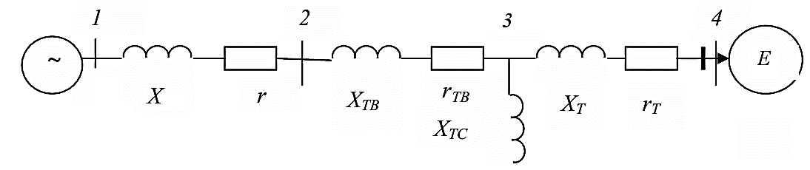
FIGURE 4. Equivalent circuit diagram of an electric motor and a power supply network

The equivalent circuit diagram of a power supply network is based on the assumption that the resistance of the wires in power transmission lines is independent of the ambient temperature and operating parameters. This allows for the construction of an equivalent circuit diagram in which currents and voltages are related by linear equations [13,14]. In the power supply network diagram, there are several voltage levels, so we will reduce them to uniform basic conditions: voltage Vδ = 230 kV, total power Sb = 100 MVA and resistance Zb=Sb/Vb. In the equivalent circuit of the power supply network, the parameters of the power transmission line and step-down transformers are indicated.
All synchronous electric motors are reduced to a single equivalent. Determination of normal modes is reduced to determining the voltages in nodes 1-4, the flows of active and reactive power along the branches, and the total power losses in the circuit under consideration. The following are specified for the circuit: - the parameters of the elements rΛ, xΛ, r_{TB}, x_{TB}, r_{TC}, x_{TC}, r_{TH}, and x_{TH};
$K_{TBH}=\frac{U_{BN}}{U_{HH}};$ $K_{TBС}=\frac{U_{BН}}{U_{СH}};$ (3)
QH = 40 MBAp; - power system voltage U₀ = 230 V. In node 4 the following are specified: 1) N_{eng} = 75 MW, Q_{eng}= 0; 2) N_{eng} and │U1│ - voltage modulus, which should be provided by regulating reactive power within Q_{min} and Q_{max}. The main relationships for calculating normal modes are obtained on the basis of nodal equations in the form of power loss balances in the following form [15,16]:
$ΔN_{k}=\sum_{j=0}^{4}{\left|U_{k}\right|}\left|U_{j}\right|\left[-g_{ki}∙cos\left(δ_{k}-δ_{j}\right)+B_{kj}∙sin\left(δ_{k}-δ_{j}\right)\right]+N_{k},$ ` (4)
$ΔQ_{k}=\sum_{j=0}^{4}{\left|U_{k}\right|}\left|U_{j}\right|\left[q_{kj}∙q_{m}\left(δ_{k}-δ_{j}\right)+B_{kj}cos\left(δ_{k}-δ_{j}\right)\right]+Q_{k},$ ` (5)
where
$q_{kj}$, $B_{kj}$- - elements of the matrix of nodal conductivities obtained on the basis of the circuit topology and elements of the equivalent circuit;
|U_{k}|, |U_{j}| - voltage modules at the circuit nodes;
$δ_{k}$, $δ_{j}$ – phase angles of voltages at nodes 1-4; Pk,
$Q_{k}$ – active and reactive power in nodes 1-4.
The initial data are presented in Table 1.

TABLE 1. Assignment of the phases in the slots
The section of the circuit between the nodes | Element Options
The section of the circuit between the nodes | r, Ohm | х, Ohm | Кт
1 | 2,15 | 9,5 | 1,0
1-2 | 0,20 | 14,0 | 1,0
2-3 | 0,05 | 0,0 | 1,0
2-4 | 0,05 | 24,3 | 5,8

In accordance with the obtained mathematical model, the algorithm for calculating the normal mode is as follows: formation of constant coefficients (nodal conductivity matrices) in the system of equations; iterative solution of the system of nonlinear equations; verification of the convergence of the iterative process. If convergence occurs, the system moves on to the next block. Otherwise, it returns to the beginning of the current block and continues the iteration process. If convergence fails, resulting in the impossibility of implementing the specified mode, the system exits the current block. This exit occurs when the number of iterations exceeds a specified value. Based on the obtained voltages and phase nodes, power flows and total power losses are calculated. The normal mode calculation was performed for two cases: 1. N=75 kW, Q=0, V₀=230 kV. 2. N=65 kW, Q=3200 m³/h, while the voltage on the РS buses is equal to V=10.3 kV. N=75 MW, Q=7.6 MVAp, V₀=230 kV. N=65 kW, Q=3200 m³/h; when the electric motors supply reactive power to the network equal to Q=7.6 MVAp, the voltage on the YC buses increases to V4=10.5 kV.
Table 2 shows the results of calculating the normal operating conditions of the synchronous electric motors of the Shpor РS and the power supply network for both cases.

TABLE 2. Results of calculating the normal operating conditions of the electric motors of the «Shpor» РS and the power supply network
End | ƩN_{1,} MW | ƩN_{1,} kW | ƩN, MW | ƩN, kW | N, MW | N, kW
1 | 87,3 | 28,6 | 85,1 | 20,4 | 2,2 | 8,16
2 | 85,0 | 30,0 | 84,6 | 16,6 | 0,4 | 13,4
3 | 12,0 | 6,5 | 12,0 | 6,5 | 0,0 | 0,0
4 | 72,0 | 14,5 | 72,5 | -7,6 | 0,1 | 6,94

From the data in Table 2 it is evident that increasing the voltage on the pumping station buses ensures a reduction in the consumption of active and reactive power in the supply electrical network due to the supply of regulated reactive power to the network. Optimization of the operating modes of electric motors of pumping stations and the power supply network consists of determining the value of the regulated reactive power generated by electric motors, which achieves a minimum of losses of active and reactive power in the network under given active loads of electric motors. In this case, the optimization criterion is as follows:
$$I=\sum_{k-1}^{n}{ΔS_{k}\underset{→}{}min} (6)$$
where
$ΔS_{k}= ΔN_{k}+ΔS_{k}$- losses of apparent power in electric motors and the network,
K=1, 2…n – number of branches of the equivalent circuit.
When implementing this criterion, the minimum and maximum voltage values ​​on the pumping station busbars – V_{min}, V_{max} – are taken into account as network and electric motor operating restrictions. The optimization algorithm is based on the one-dimensional search method – the “uniform bisection search” method [17,18]. The implementation of this method is characterized by its sufficient simplicity and fairly fast convergence. To calculate the optimization mode, a calculation program developed on the basis of the proposed method was used [19,20]. The optimization mode calculation was carried out using the same initial data as the normal mode calculation: N_{eng} = 75 MW, N_{load} = 65 MW, Q_{load} = 40 MBAp, V₀ = 230 kV. The results of the optimization mode calculation are presented in Table 3.

TABLE 3. Results of the calculation of optimization of operating modes of synchronous electric motors and network switching
№ | Start | End | ƩN_{1,} MW | ƩN_{1,} MW | ƩN_{2,} MW | ƩN_{2,} kW | $ΔN,$MW | kW
1 | 0 | 1 | 85,1 | 20,4 | 83,0 | 12,8 | 2,1 | 7,6
2 | 1 | 2 | 84,6 | 16,6 | 84,2 | 13,5 | 0,3 | 3,1
3 | 2 | 3 | 12,0 | 6,5 | 12,0 | 6,5 | 0,0 | 0,0
4 | 2 | 4 | 72,5 | -7,6 | 72,4 | -13,4 | 0,05 | 5,8

A comparison of the calculation results for the normal mode and the optimization mode shows that, with the same initial data and conditions, in the optimization mode an increase in voltage is observed in the nodes of the power supply circuit (on the РS buses - up to 10.85 kV), and a decrease in the losses of active and reactive power in the power supply network.
CONCLUSIONS
Modernization of existing pumping stations and pumping and energy equipment is being carried out at many facilities where it has served its purpose. The authors have developed and tested an intelligent control system for nuclear power plants, enabling the transition from traditional dispatch control to a distributed digital model with elements of AI and predictive analytics. When conducting an energy audit of a power plant, the problem of more accurately calculating energy savings from the implementation of a particular energy-saving measure is solved. When several measures are implemented simultaneously, the amounts of energy consumption reduction are not summed up, and additional calculations are required to assess the potential for this comprehensive reduction.
The presented results of intelligent production should accelerate cooperation with domestic and foreign research institutes along the innovation chain.
The study provides recommendations for the intellectualization of energy facility management. To build a knowledge base, a methodology was developed for integrating various forms of knowledge representation within a single intelligent system.
Optimization of the operating modes of the electric motors of the power supply network and the supply electric network consists of determining the value of the regulated reactive power generated by the electric motors, which achieves a minimum of power losses in the network under given active loads of the electric motors.
REFERENCES
- Andrizhievsky A.A. Energy saving and energy management: textbook / A.A. Andrizhievsky, V.I. Volodin. 2nd ed., corrected. - Minsk: Higher school, 2005.-294 p.
- Murzakulov N.A., Absamat kyzy Guliza, Zhanbaeva Aigerim Current problems of energy saving and ways to solve them based on energy efficient technologies // Research Focus International Scientific Journal, Uzbekistan V 3 2024, р.93-97 https://zenodo.org/records/10658978
- L.A. Rossman, EPANet Version 2 User’s Manual, US Environmental Protection Agency (USEPA), Cincinnati, 2000
- A.M. Bagirov, A.F. Barton, H. Mala-Jetmarova, A. Al Nuaimat, S.T. Ahmed, N. Sultanova, J. Yearwood, An algorithm for minimization of pumping costs in water distribution systems using a novel approach to pump scheduling, Math. Comput. Model. 57 (2013) 873–886.
- Lyu, Wenjing, and Jin Liu. "Artificial Intelligence and emerging digital technologies in the energy sector." Applied energy 303 (2021): 117615.
- Światowiec-Szczepańska, Justyna, and Beata Stępień. "Drivers of digitalization in the energy sector—The managerial perspective from the catching up economy." Energies 15.4 (2022): 1437.
- Qi, Y., and K. Xu. "The essence of intelligent manufacturing." J. Beijing Norm. Univ.(Soc. Sci.) 291 (2022): 93-103.
- Wang, Lihui. "From intelligence science to intelligent manufacturing." Engineering 5.4 (2019): 615-618.
- O. Ya. Glovatsky, F. Zh. Nosirov, R. K. Dusmatov, Zh. I. Rashidov, G. S. Azizova - Improving the energy efficiency of operation of pumping units of irrigation systems // “Development of Specialized Higher Education and Science in the Conditions of Globalization: Problems and Opportunities ” International Scientific Conference, 2025, Tashkent. р. 172-179.
- Chang S.C. Effects of financial developments and income on energy consumption // International Review of Economics and Finance. – 2015. – Vol. 35. – P. 28–40. URL: http://dx.doi.org/10.1016/j.iref.2014.08.011
- Khamudkhanov M.M., Dusmatov R.K. Control properties of the frequency converter-asynchronous motor system. International scientific and practical conference "Science, Research, Development". Collection of articles. Poznan 2020. pp. 84-88.
- F. Nosirov, O. Glovatsky, R. Dusmatov, G. Azizova. Innovative methods for improving the energy efficiency of a pumping unit // Journal of Problems of Energy and Resource Saving. No. 86, 2024, pp. 158-164.
- Li, Yang, et al. "A study of total-factor energy efficiency for regional sustainable development in China: an application of bootstrapped DEA and clustering approach." Energies 15.9 (2022): 3093.
- Borozan, Djula. "Technical and total factor energy efficiency of European regions: A two-stage approach." Energy 152 (2018): 521-532.
- Chui, Kwok Tai, Miltiadis D. Lytras, and Anna Visvizi. "Energy sustainability in smart cities: Artificial intelligence, smart monitoring, and optimization of energy consumption." Energies 11.11 (2018): 2869.
- Singh, Rajesh, et al. "Energy System 4.0: Digitalization of the energy sector with inclination towards sustainability." Sensors 22.17 (2022): 6619.
- Hanusz Z., Tarasinska J., Zielinski W. (2016), Shapiro–Wilk test with known mean, REVSTAT Statistical Journal, 14(1), 89–100.
- Sobczyński D., Balawejder M. (2015) Participation of consumers in Smart Grid development (in Polish), Scientific Journals of Rzeszіw University of Technology, Series: Electrotechnics, RUTJEE , 34(4), 5–13.
- Roy R., Vijayakumar A., Nair R. (2015), A Study on Electrical Accidents and Safety Measures, International Journal of Latest Trends in Engineering and Technology (IJLTET), 5(2), 147–154.
- A.B. Urazkeldiev, O.Ya. Glovatsky, R. Dusmatov Implementation of artificial intelligence technologies for energy resource management and the use of renewable energy sources at pumping stations // Collection of materials of the international scientific and practical conference on the topic "Scientific approaches to solving global ecological and water problems of Central Asia" dedicated to the 100th anniversary of the establishment of the Research Institute of Irrigation and Water Problems / T., 2025, p.467-476
- Negnevitsky M., Tomin N., Panasetsky D., Kurbatsky V. (2013), Intelligent Approach for Preventing Large-Scale Emergencies in Electric Power Systems, Proceedings from IEEE International Conference on Electric Power Engineering PowerTech, Grenoble, France, 16-20 June, 1–6
22. Boborakhim Urishev and Fakhriddin Nosirov. Hydraulic Energy Storage of Wind Power Plants. Proceedings of International Conference on Applied Innovation in IT (2023). Volume. 11, issue 1, pp. 267-272. https://icaiit.org/paper.php?paper=11th_ICAIIT_1/4_10
23. B. Urishev, F. Nosirov, O. Nurmatov, S. Amirov, and D. Urishova. 2025. “Local energy system based on thermal, photovoltaic, hydroelectric stations and energy storage system,” AIP Conference Proceedings, Volume. 3331, Issue 1.(2025), https://doi.org/10.1063/5.0306446
24. Nurmatov Obid, Fakhriddin Nosirov, Khusniddin Shamsutdinov, and Dildora Obidjonova. 2025. “Research on Control Systems for Automatic Excitation Regulation Utilizing Fuzzy Logic Methodology.” AIP Conference Proceedings, Volume. 3331, Issue 1. https://doi.org/10.1063/5.0306119
25. S. Turabdjanov, Sh. Dungboyev, F. Nosirov, A. Juraev, and I. Karabaev. “Application of a two-axle synchronous generator excitations in small hydropower engineering and wind power plants,” AIP Conference Proceedings, vol. 2552, issue 1, article 050024, 2023. https://doi.org/10.1063/5.0130649
26. Boborakhim Urishev, Sobir Eshev, Fakhriddin Nosirov, and Ulugbek Kuvatov. A device for reducing the siltation of the front chamber of the pumping station in irrigation systems. E3S Web of Conferences 274, 03001 (2021), STCCE – 2021, https://doi.org/10.1051/e3sconf/202127403001

