Improving the energy efficiency of pumping stations
Boborakhim Urishev¹, Fakhriddin Nosirov^{2,а}, Ravshan Dusmatov², Zhurabek Uralov², Shokhboz Amirov³, Umidjon Boboraimov¹
¹Karshi State Technical University, Karshi, Uzbekistan
²Tashkent state technical university named after Islam Karimov, Tashkent, Uzbekistan
³Termiz State University of Engineering and Agritechnologies
^{a)} Corresponding author: nosirov-0173@mail.ru
Abstract. This article discusses ways to improve the energy efficiency of pumping stations by optimizing the dimensions of in-station pressure pipelines and the equipment installed within them. It also presents a methodology for determining the optimal diameters of in-station pressure lines at a pumping station based on the criterion of minimum reduced costs, which consists of the sum of the capital costs for equipment installation and the energy lost to overcome hydraulic resistance in the equipment. The results of calculations to determine the optimal diameters of in-station pressure lines at the Korasuv pumping station using the above methodology are presented. These calculations demonstrate that the existing equipment dimensions are not optimal and that replacing them with optimal ones will result in significant energy savings.
INTRODUCTION
Energy costs in pumping stations constitute the main part of operating costs, for example, according to a number of studies, electricity costs account for 50...85% of total operating costs [1,2,3].
The energy costs of a typical pumping station equipped with centrifugal pumps, asynchronous motors and frequency converters, according to T. Ahonen, are 60% of operating costs [4], and according to M. Pemberton, 75% of operating costs are spent on energy costs and maintenance [5].
A study of the results of scientific research on increasing the energy efficiency of modern pumps has shown that it is possible to reduce energy losses by up to 40%, where: by increasing the efficiency - up to 3%; due to adjustments to pump parameters and water supply network parameters, it can be increased by up to 4%, by regulating the pump operating mode - up to 18...20%, by using various devices by up to 4%, and by optimizing the water supply and distribution system by up to 10...12% [6]. A similar conclusion was made in [7], according to which, as a result of optimizing the operating modes of hydraulic devices (pumps, fans, compressors), it is possible to save 62% of energy, and in [8] only in pumping devices - 30...50%. The use of pumping stations as a regulator of energy consumption in energy systems also increases their efficiency [9,23].
The energy efficiency of pumping stations primarily depends on the operation of pump units in optimal operating modes. The optimal operating modes of pumps are understood to be those operating modes that deliver the required amount of water to a specified height and distance with the values ​​of their maximum useful efficiency [10].
Optimal operating modes of pumps require the development of scientifically based constructive-technical, design and operational-technological measures. The measures taken should be aimed at reducing the main technical and economic indicators of the pumping station - energy consumption and the cost of pumped water. Based on the above, it is of great interest to identify the factors affecting the reduction in the efficiency of the pumping unit.
The results of observations and research conducted at pumping stations show that the factors that negatively affect the optimal operating modes of pumping units are the following:
- excessive head loss due to the non-optimal diameters of the pump piping system [11];
- failure to perform timely and high-quality repair and restoration work;
- electric motor power, which in most cases significantly exceeds the power required for the pump [12,24];
- increased hydraulic resistance due to wear and contamination of suction and pressure pipes;
- increased hydraulic resistance due to the accumulation of sludge deposits in the pre-chamber and suction chamber, which disrupts the established design structure of the flow and increases the hydraulic resistance [13,14,22,25];
- increased hydraulic resistance due to cavitation and hydroabrasive erosion of the pump impeller and suction pipe;
- excessive water leakage in the pump housing, in its parts connected to the pipes;
- misalignment of the axes of the electric motor and the pump shaft, static imbalance in the impeller, high mechanical resistance in the bearings.
In recent research works, programmed methods of planning the operating mode of equipment to increase energy efficiency based on special programs in the control system of the power plant have been recommended [15,16,17,18,19,20].
In many pumping stations equipped with centrifugal pumps in the Republic of Uzbekistan, in order to reduce construction costs, the diameters of the gate and check valves installed in the pressure section of the units are taken to be minimal, that is, equal to the diameter of the pressure branch pipe (outlet) of the pump (Figure 1).
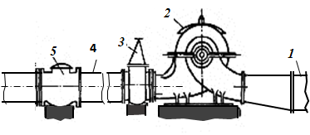 | 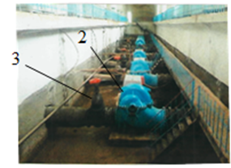
а) | b)
FIGURE 1. Location of internal pressure communications at the pumping station.
a) diagram of the location of shut-off communications in the pipeline; b) machine room of the Korasuv pumping station. 1 – suction pipe; 2 – pump; 3 – gate valve; 4 – station internal pressure pipe; 5 – check valve.

But this situation, despite the reduction of capital costs, can lead to an increase in energy costs, so it is necessary to determine the diameters of the equipment according to the minimum total costs that take into account the operation and capital costs.
Currently, in the methods for determining the size and location of equipment for intra-station pressure communications, the method of minimizing capital costs is mainly used, based on the size of the pumps and the pumping station building [12,16].
METHODS AND MATERIALS
The energy consumption of pumps can be determined using the following formula:
(1)
Where Q(t) and H_{G}(t) are the pump's performance and geometric head at time t, ΔН(t) is the pressure loss in the pipeline system at time t, η(t) – ) is the pump's efficiency at time t, and Т = t ₁ – t₀ is the pump's operating time.
As can be seen from equation (1), to reduce the pump's energy consumption, ΔH must be reduced, which primarily requires increasing the diameters of valves, check valves, and in-station pressure pipes. However, increasing the size of pipes and equipment naturally leads to increased capital expenditures, necessitating a search for a criterion for minimizing total costs, including both capital and energy costs, equivalent to those spent on pressure loss ΔH.
This optimality criterion can be expressed as follows:
K_{i} = J_{i}·р + c·E_{ΔHi} → min (2)
where K_{i} is the annual cost of internal pressure pipelines, sum, J_{i} is the cost of purchasing and installing internal pressure pipelines and equipment on them, sum, p – is the annual bank coefficient (rate) of expenses for J_{i}, с is the electricity tariff, sum/kW⋅h, E_{ΔHi} is the amount of electricity equivalent to the pressure loss in the internal pressure pipeline, kW⋅h.
The value of E_{ΔHi} can be determined using known methods for calculating pressure losses in pipelines, using the following equation:
(3)
where η is the efficiency of the pumping unit, λ is the coefficient of hydraulic resistance due to friction in the pipe, D_{pipi}, l_{pipi} are the diameter and length of the intra-station pressure pipeline, m, Σξ_{i} is the sum of the coefficients of local resistance in the intra-station pressure pipeline, Q_{i} is the pump capacity, m3/s, T is the operating time of the intra-station pressure pipeline adopted for the calculation, h, i are the variants of the diameters of the intra-station pressure pipeline, j are the types of local resistance.
The size of the bank rate can be determined by the following formula [21].
(4)
r is the annual investment coefficient, and τ is the investment period in years.
It should be noted that r also includes depreciation costs and deductions for repairs.
Substituting expressions (3) and (4) into formula (2), we obtain the following equation:
(5)
In this equation, the value of Qi is determined for each option under consideration using the following formula.
(6)
where H₀ is the initial pressure value in the working zone of the pressure characteristic, a is the pump pressure characteristic coefficient, H_{G} is the geometric pressure.
The values ​​of H₀ and a can be calculated using the following formulas [12]:
H₀ = H₂ +а ·; or H₀ = H₁ +а · (7)
(8)
where Н₁, H₂, Q₁, Q₂ are the parameters obtained at the boundary points of the working zone of the pump's pressure characteristic.
The hydraulic resistance coefficient of the in-station pipeline system bi is determined by the following relationship:
(9)
To ensure that the optimization criterion (5) is met, the following constraints and conditions must be met.
1. For all variants, l_{pip} = 1,0 м, and the values ​​of η, τ, Т, с must be the same.
2. For the pump head and capacity, the following condition must be met: H_{min} < H_{i} < H_{max} and Q_{min} < Q_{i} < Q_{max}.
3. The minimum diameter of in-station pipes and equipment is equal to the diameter of the pump discharge pipe.
RESEARCH RESULTS
Determining the optimal dimensions of the in-station pipeline and its equipment using the above method is considered using the example of the Korasuv PS in the Kashkadarya region (Figure 2). At this PS, the internal diameter of the suction pipes is D_{val} = 800 mm, the diameter of the gate valve is D_{pr.val} = 600 mm, the diameter of the in-station pressure pipeline is D_{pip}=800 mm, and the diameter of the check valve is D_{chek.}= 800 mm.

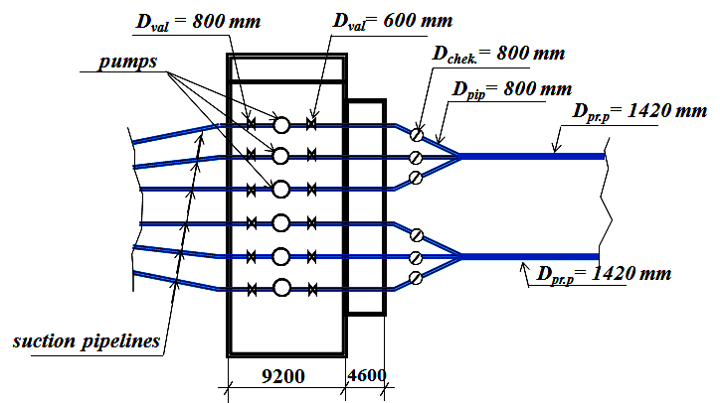
FIGURE 2. Layout of pressure communications at the Korasuv pumping station.

The results of calculations according to criterion (5) for seven variants of pressure communication diameters are given in Table 1. In the variant numbers in brackets, the gate valve diameters are shown in the numerator, and the check valve diameters in the denominator. ξ_{val}, ξ_{diff}, ξ_{chek}, ξ⁴⁵_{turn}, ξ_{merg} are the coefficients of local resistance of the gate valve, diffuser, check valve, 45° turn, and flow merging in pipes.

TABLE 1. Results of calculations of reduced costs according to criterion
Options | ξ_{val} | ξ_{diff} | ξ_{chek} | ξ⁴⁵_{turn} | ξ_{merg} | λ | СЕ_{ΔН}  thous. of sums | J·p,  thous. of sums | К,  thous. of sums
1(0.6/0,6) | 0,15 | - | 1,7 | 0,13 | 1,72 | 0,0181 | 20189 | 24940 | 45129
2(0,6/0,7) | 0,15 | 0,06 | 1,7 | 0,13 | 1,15 | 0,0175 | 13937 | 28413 | 41669
3(0,6/0,8) | 0,15 | 0,096 | 1,7 | 0,13 | 0,85 | 0,0169 | 12179 | 28951 | 41130
4(0,8/0,8) | 0,15 | - | 1,7 | 0,13 | 0,85 | 0,0169 | 6514 | 32241 | 40755
5(0,8/0,9) | 0,15 | 0,05 | 1,7 | 0,13 | 0,52 | 0,0164 | 3820 | 36521 | 40341
6(0,8/1,0) | 0,15 | 0,08 | 1,7 | 0,13 | 0,48 | 0,0160 | 2703 | 37747 | 40450
7(0,9/1,0) | 0,15 | 0,04 | 1,7 | 0,13 | 0,48 | 0,0160 | 2402 | 40414 | 42816

Based on the calculation results, a graph was created for determining the optimal diameters for in-station pressure lines (Figure 3). The options are shown with the valve diameters, and the check valve diameters are given in parentheses.
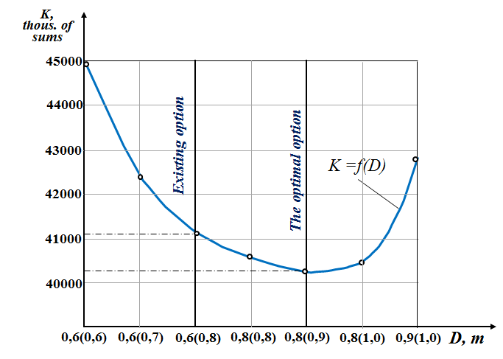
FIGURE 3. Schedule for determining the optimal diameters of intra-station pressure communications
In contrast to the existing arrangement of pressure communications shown in Fig. 1, the optimal option is to install the gate valve after the mounting insert and diffuser according to the diagram shown in Figure 4.
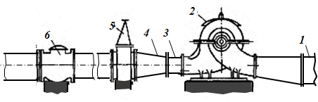
FIGURE 4. The pump station is designed for communication and optimal operation.
1 – water pump; 2 – pump; 3 – mounting insert; 4 – diffuser; 5 – gate valve; 6 – check valve.

According to calculations, if the optimal diameter option for in-station pressure communications is used instead of the existing option, it is possible to save 59,361 kWh of electricity per year per pump, with its average operating life of 5,000 hours.
CONCLUSIONS
1. A methodology has been developed for determining the optimal diameters of in-station pressure lines based on the criterion of minimum reduced costs, consisting of the sum of capital costs for equipment installation and energy losses due to overcoming hydraulic resistance in the equipment.
2. The results of calculations to determine the optimal diameters of in-station pressure lines at the Korasuv pumping station using the above methodology showed that reconstructing the lines with equipment with optimal diameters in place of the existing equipment allows for energy savings of 59,361 kWh per year per pump, with an average operating life of 5,000 hours.
REFERENCES
- A. T. de Almeida, P. Fonseca, H. Falkner, and P. Bertoldi, “Market transformation of energy-efficient motor technologies in the EU,” Energy Policy 31, 563–575 (2003).
- D. Kaya et al., “Energy efficiency in pumps,” Energy Conversion and Management 49, 1662–1673 (2008).
- R. Saidur, “A review on electric motors energy use and energy savings,” Renewable and Sustainable Energy Reviews 14, 877–898 (2010). https://doi.org/10.1016/j.rser.2009.10.018
- T. Ahonen et al., “Life-cycle cost analysis of inverter-driven pumps,” in Proc. 20th Int. Congress on Condition Monitoring and Diagnostic Engineering Management (COMADEM 2007), pp. 397–405 (2007).
- M. Pemberton and J. Bachmann, “Pump systems performance impacts multiple bottom lines,” Engineering & Mining Journal, 56–59 (2010).
- V. Nenja, S. Khovansky, and L. Gapich, “Providing of the law of pumping station parameters regulation by means of throttling elements,” Procedia Engineering 39, 175–181 (2012). https://doi.org/10.1016/j.proeng.2012.07.022
- T. Ahonen, Monitoring of Centrifugal Pump Operation by a Frequency Converter, Ph.D. thesis, Lappeenranta University of Technology, Finland (2011).
- V. K. A. Shankar, S. Umashankar, S. Paramasivam, and N. Hanigovszki, “A comprehensive review on energy efficiency enhancement initiatives in centrifugal pumping systems,” Applied Energy 181, 495–513 (2016). https://doi.org/10.1016/j.apenergy.2016.08.070
- B. Urishev, M. Mukhammadiev, A. Abduaziz uulu, and H. Murodov, “Use of large irrigation pumping stations for highly manual daily regulation of capacities in the energy system of the Republic of Uzbekistan,” E3S Web Conf. 264, 04057 (2021). https://doi.org/10.1051/e3sconf/202126404057
- S. Perju, A. Aldea, and M. Mădălin, “Progresses in the operation and functioning of pumping stations for water and wastewater networks,” Procedia Engineering 209, 172–179 (2017). https://doi.org/10.1016/j.proeng.2017.11.144
- B. U. Urishev, Improving the Operation and Energy Efficiency of Pumping Stations (Intellect, Karshi, 2021), 132 pp.
- B. S. Leznov, Energy Saving and Variable-Speed Drives in Pumping and Blower Units (Energoatomizdat, Moscow, 2006), 360 pp.
- B. Urishev, S. Eshev, F. Nosirov, and U. Kuvatov, “A device for reducing the siltation of the front chamber of the pumping station in irrigation systems,” E3S Web Conf. 274, 03001 (2021). https://doi.org/10.1051/e3sconf/202127403001
- F. Nosirov, O. Glovatsky, B. Khamdamov, and A. Gazaryan, “Increasing the stability of the supply hydraulic structures,” AIP Conf. Proc. 3152, 040010 (2024). https://doi.org/10.1063/5.0218867
- Y. M. Chiang, L. C. Chang, M. J. Tsai, Y. F. Wang, and F. J. Chang, “Auto-control of pumping operations in sewerage systems by rule-based fuzzy neural networks,” Hydrol. Earth Syst. Sci. 15, 185–196 (2011). https://doi.org/10.5194/hess-15-185-2011
- D. Al-Ani and S. Habibi, “Optimal operation of water pumping stations,” WIT Trans. Ecol. Environ. 178, 217–226 (2014).
- P. Sorin, A. Aldea, and M. Mădălin, “Progresses in the operation and functioning of pumping stations for water and wastewater networks,” Procedia Engineering 209, 172–179 (2017).
- M. Moradi-Jalal and B. W. Karney, “Optimal design and operation of irrigation pumping stations using mathematical programming and genetic algorithm,” J. Hydraulic Research 46(2), 237–246 (2008).
- H. Zhu, B. Ge, Y. Zhou, R. Zhang, and J. Cheng, “Pump selection and performance prediction for the technical innovation of an axial-flow pump station,” Math. Problems in Engineering 2018, 6543109 (2018). https://doi.org/10.1155/2018/6543109
- W. Song, Y. Pang, X. Shi, and Q. Xu, “Study on the rectification of forebay in pumping station,” Math. Problems in Engineering 2018, 2876980 (2018). https://doi.org/10.1155/2018/2876980
- J. C. Pulido-Calvo and J. Gutiérrez-Estrada, “Selection and operation of pumping stations of water distribution systems,” Environmental Research Journal 5(3), 1–20 (2011).
- B. Urishev and F. Nosirov, “Hydraulic energy storage of wind power plants,” Proc. Int. Conf. Applied Innovation in IT 11(1), 267–272 (2023).
- B. Urishev, F. Nosirov, O. Nurmatov, S. Amirov, and D. Urishova, “Local energy system based on thermal, photovoltaic, hydroelectric stations and energy storage system,” AIP Conf. Proc. 3331, 030044 (2025). https://doi.org/10.1063/5.0306446
- S. Turabdjanov, Sh. Dungboyev, F. Nosirov, A. Juraev, and I. Karabaev, “Application of a two-axle synchronous generator excitations in small hydropower engineering and wind power plants,” AIP Conf. Proc. 2552, 050024 (2023). https://doi.org/10.1063/5.0130649
- M. M. Mukhammadiev, B. U. Urishev, A. Abduaziz uulu, S. K. Gadaev, and S. U. Zhankabylov, “Issues of using local energy systems with hydraulic energy storage in the power system of the Republic of Uzbekistan,” E3S Web Conf. 216, 01138 (2020). https://doi.org/10.1051/e3sconf/202021601138

