Modeling and analysis of the effects of symmetric and asymmetric loads on 0.38 kV voltage electrical networks
Muzaffar Khudayarov, Jakhongir Abdukhalimov ^{a)}
Tashkent state technical university named after Islam Karimov, Tashkent, Uzbekistan
^{a)} Corresponding author: abduxalimovjahongir48@gmail.com
Abstract. The uneven distribution of loads across phases in low-voltage power supply networks significantly affects the quality of electricity, voltage regimes, and power losses. In particular, asymmetrical load conditions lead to increased voltage imbalance, current flow in the neutral wire, and higher active and reactive power losses. This article presents a comparative analysis of the influence of symmetrical and asymmetrical loads on the network operating mode in a 0.38 kV electrical network, modeled using the DigSILENT PowerFactory software environment. During the research, a mathematical model of the electrical network was developed, line and consumer parameters were incorporated, and power flows for symmetrical and asymmetrical modes were calculated. The obtained results showed that under symmetrical loading conditions, voltage deviations remained within permissible limits, and power losses were recorded at minimal levels (0.3-1.5%). In the asymmetric load mode, however, the phase voltage imbalance exceeded the allowable level, resulting in large currents in the neutral wire and active power losses reaching up to 6.29%. The research findings confirm that balancing loads across phases in low-voltage networks is a crucial factor in improving electricity quality and reducing losses.
INTRODUCTION
In the current era, the increasing demand for electricity, the growing complexity of consumer composition, and the rising number of modern devices connected to power networks are further elevating the requirements for the reliability of power supply systems and electricity quality. The uneven distribution of loads across phases results in asymmetric modes in the networks, which in turn leads to disruptions in power flows, voltage imbalances, and increased electricity losses [1-5]. These processes are significant as they reduce the system's efficiency and negatively impact the service life and technical condition of equipment. Asymmetric loads pose a serious threat to power supply systems. Therefore, in-depth analysis of network elements in symmetric and asymmetric modes, modeling of power flows and voltage changes in each phase is one of the urgent tasks today [6-8]. Modern computer programs, in particular DigSILENT PowerFactory, allow modeling electrical networks in close proximity to real operating conditions, accurately assessing the influence of loads in each phase, and deeply studying the processes of electricity quality degradation [9,10]. This program has extensive functionality for analyzing networks in symmetrical and asymmetrical states, quantitative assessment of power losses, voltage deviations, and the influence of load in each phase on network stability. In this study, power flows under symmetrical and asymmetrical load conditions of the network were calculated using the DigSILENT PowerFactory software environment, the phase variation of bus voltages was determined, and the difference in active and reactive power losses in the lines was analyzed. The obtained results allow for a deep study of the influence of asymmetrical load on network efficiency, electricity quality, and losses, and serve as a scientific basis for the development of practical recommendations for optimizing power supply systems.
EXPERIMENTAL RESEARCH
The study was conducted using the DigSILENT PowerFactory software environment to assess the influence of symmetrical and asymmetrical loads on electrical networks in power supply networks. The methodology includes the stages of creating a mathematical model of the network, distribution of loads by phases, and comparison of power flows in symmetrical and asymmetrical modes [13]. Using the DigSILENT PowerFactory software environment, the scheme was assembled, and the network parameters were introduced step by step, forming the model. For each line, technical parameters such as active resistance, reactive resistance, length, nominal voltage, and nominal current were introduced. Tire connection groups, as well as active power and power coefficients of consumers for each phase, were determined. When modeling the symmetrical mode, the phase loads of all consumers were set equal. In the asymmetrical mode, taking into account the uneven distribution of loads by phases, different load values were assigned to each consumer. Thus, an asymmetric situation that can occur in real operation was analyzed. Calculations were performed using the Balanced Load Flow [11,12] and Unbalanced Load Flow [13-15] functions of the DigSILENT PowerFactory program. In both modes, the active and reactive power at the input and output of the lines was determined, ΔP and ΔQ losses were calculated and compared. The voltage differences between each phase (A, B, C) in symmetrical and asymmetrical modes were determined, and voltage deviations were analyzed. This process allows us to identify the main factors causing the stress imbalance of the asymmetric load. The obtained results make it possible to quantitatively compare symmetrical and asymmetrical modes, assess the degree of increase in power losses, and scientifically substantiate the influence of asymmetrical loads on network stability. This methodology provides a practical basis for further research on the optimization of real networks, load balancing, and reduction of electricity losses in the network.
RESEARCH RESULTS
During the study, in the DigSILENT PowerFactory program for the power supply network, power flows under symmetrical and asymmetrical load conditions, voltages of each phase of each tire, and power losses in lines were analyzed in detail. The calculation results allow for a deeper determination of the network performance characteristic. With the help of the DigSILENT PowerFactory program, the symmetrical network mode was analyzed (Fig. 1).
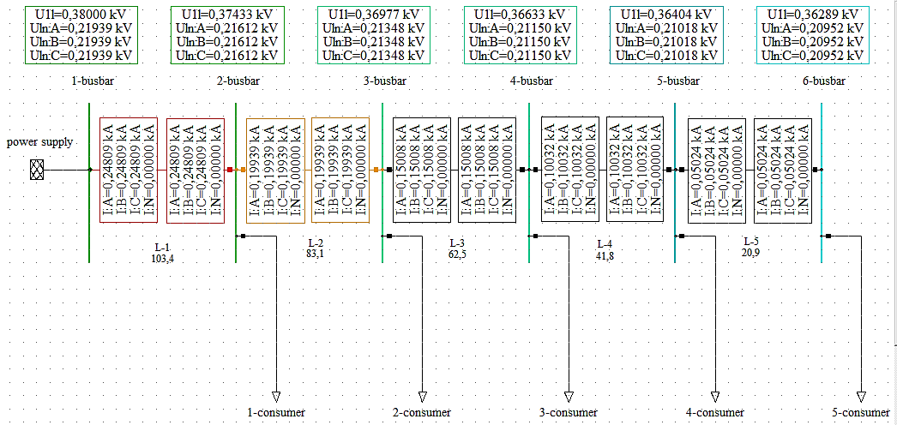
FIGURE 1. Symmetrical diagram of a 0.38 kV network.

Parameters were entered into each line in the assembled circuit using the DigSILENT PowerFactory program (Table 1).

TABLE 1. The parameters of each line.
№ | Line name | Phase/zero number | Active resistance,  Ω | Reactive resistance,  Ω | Length,  m | Nominal voltage,  kV | Nominal current,  kA
1 | L-1 | 3/1 | 0,2542 | 0,072256 | 50 | 1 | 0,24
2 | L-2 | 3/1 | 0,2542 | 0,072256 | 50 | 1 | 0,24
3 | L-3 | 3/1 | 0,2542 | 0,072256 | 50 | 1 | 0,24
4 | L-4 | 3/1 | 0,2542 | 0,072256 | 50 | 1 | 0,24
5 | L-5 | 3/1 | 0,2542 | 0,072256 | 50 | 1 | 0,24
Now each consumer is connected to a consumer consuming the same power (Table 2).

TABLE 2. Active and reactive powers of each consumer.
№ | Consumer name | Active power, kW |  |  | Reactive power, kVar |  |  | Power factor
№ | Consumer name | A | B | C | A | B | C | Power factor
1 | 1- consumer | 10 | 10 | 10 | 3 | 3 | 3 | 0,95
2 | 2- consumer | 10 | 10 | 10 | 3 | 3 | 3 | 0,95
3 | 3- consumer | 10 | 10 | 10 | 3 | 3 | 3 | 0,95
4 | 4- consumer | 10 | 10 | 10 | 3 | 3 | 3 | 0,95
5 | 5- consumer | 10 | 10 | 10 | 3 | 3 | 3 | 0,95

After each consumer consumed the same active power, the difference in active and reactive power entering and exiting each line was calculated (Table 3).

TABLE 3. Active and reactive power entering and leaving each line.
№ | Line name | Active input power, kW | Reactive input power, kVar | Active output power, kW | Reactive output power, kVar
1 | L-1 | 155,19 | 50,78 | 152,85 | 50,11
2 | L-2 | 122,85 | 40,25 | 121,33 | 39,82
3 | L-3 | 91,33 | 29,96 | 90,47 | 29,72
4 | L-4 | 60,48 | 19,86 | 60,09 | 19,75
5 | L-5 | 30,09 | 9,89 | 30 | 9,86
The results of power losses in the electrical network are presented in Table 4.

TABLE 4. Active and reactive power losses in each line.
№ | Element name | ΔP, kW | ΔQ, kVar
1 | L-1 | 2,34 | 0,67
2 | L-2 | 1,52 | 0,43
3 | L-3 | 0,86 | 0,24
4 | L-4 | 0,39 | 0,11
5 | L-5 | 0,09 | 0,03
For electrical grid |  | 5,2 | 1,48

Active power losses on the lines were recorded in the range of 0.3-1.5%, and reactive power losses in the range of 0.3-1.3%. At symmetrical loads, the voltage values in all phases were practically equal, and due to the absence of current flow from the neutral wire, stable network operation was ensured. The voltage drop from bus 1 to bus 6 decreased from 219.39 V to 209.52 V, and the voltage in the network decreased from 380 V to 362.89 V. We can see that these values are within the permissible limits according to GOST, that is, in the range of -5% and 5%. (Table 5).
TABLE 5. Voltage values in each phase of each winding.
№ | Busbar name | Connection group | Voltage, V
№ | Busbar name | Connection group | A | B | C
1 | 1- busbar | ABC-N | 219,39 | 219,39 | 219,39
2 | 2- busbar | ABC-N | 216,12 | 216,12 | 216,12
3 | 3- busbar | ABC-N | 213,48 | 213,48 | 213,48
4 | 4- busbar | ABC-N | 211,5 | 211,5 | 211,5
5 | 5- busbar | ABC-N | 210,18 | 210,18 | 210,18
6 | 6- busbar | ABC-N | 209,52 | 209,52 | 209,52

These results confirm that the network's energy efficiency is high under symmetrical loads, and the voltage quality is optimal in all phases.
Now, using the DigSILENT PowerFactory program, the asymmetric network mode is analyzed (Fig. 2).

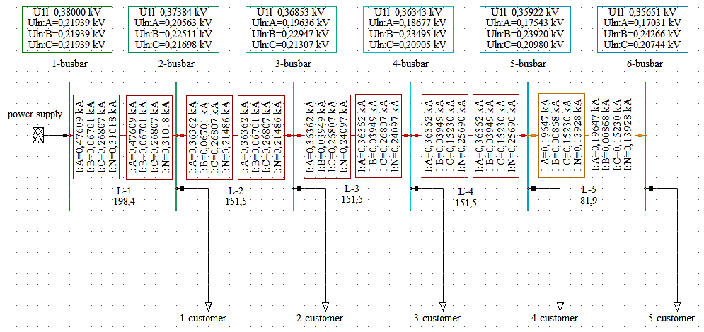
FIGURE 2. Asymmetrical diagram of a 0.38 kV network.

Parameters were entered into each line in the assembled circuit using the DigSILENT PowerFactory program (Table 6).

TABLE 6. The parameters of each line.
№ | Line name | Phase/zero number | Active resistance,  Ω | Reactive resistance,  Ω | Length,  m | Nominal voltage,  kV | Nominal current,  kA
1 | L-1 | 3/1 | 0,2542 | 0,072256 | 50 | 1 | 0,24
2 | L-2 | 3/1 | 0,2542 | 0,072256 | 50 | 1 | 0,24
3 | L-3 | 3/1 | 0,2542 | 0,072256 | 50 | 1 | 0,24
4 | L-4 | 3/1 | 0,2542 | 0,072256 | 50 | 1 | 0,24
5 | L-5 | 3/1 | 0,2542 | 0,072256 | 50 | 1 | 0,24
Now each consumer is connected to a consumer consuming different power (Table 7).

TABLE 7. Active and reactive powers of each consumer.
№ | Consumer name | Active power, kW |  |  | Reactive power, kVar |  |  | Power factor
№ | Consumer name | A | B | C | A | B | C | Power factor
1 | 1- consumer | 22 | 0 | 0 | 8 | 0 | 0 | 0,95
2 | 2- consumer | 0 | 6 | 0 | 0 | 2 | 0 | 0,95
3 | 3- consumer | 0 | 0 | 23 | 0 | 0 | 6 | 0,95
4 | 4- consumer | 28 | 7 | 0 | 11 | 2 | 0 | 0,95
5 | 5- consumer | 32 | 2 | 30 | 13 | 1 | 8 | 0,95

After each consumer consumed different active power, the difference in active and reactive power entering and exiting each line was calculated (Table 8).

TABLE 8. Active and reactive power entering and leaving each line.
№ | Line name | Active input power, kW | Reactive input power, kVar | Active output power, kW | Reactive output power, kVar
1 | L-1 | 168,76 | 54,65 | 162,47 | 52,86
2 | L-2 | 140,48 | 45,63 | 136,66 | 44,54
3 | L-3 | 130,66 | 42,57 | 126,58 | 41,41
4 | L-4 | 103,58 | 33,85 | 99,91 | 32,81
5 | L-5 | 65,07 | 21,34 | 63,79 | 20,97
The results of power losses in the electrical network are presented in Table 9.

TABLE 9. Active and reactive power losses in each line.
№ | Element name | ΔP, kW | ΔQ, kVar
1 | L-1 | 6,29 | 1,79
2 | L-2 | 3,82 | 1,09
3 | L-3 | 4,08 | 1,16
4 | L-4 | 3,67 | 1,04
5 | L-5 | 1,28 | 0,37
For electrical grid |  | 19,14 | 5,45

Active power losses on the lines were recorded in the range of 1.28-6.29%, and reactive power losses in the range of 0.37-1.79%. Active power losses in symmetrical and asymmetrical modes are shown in Fig. 3.

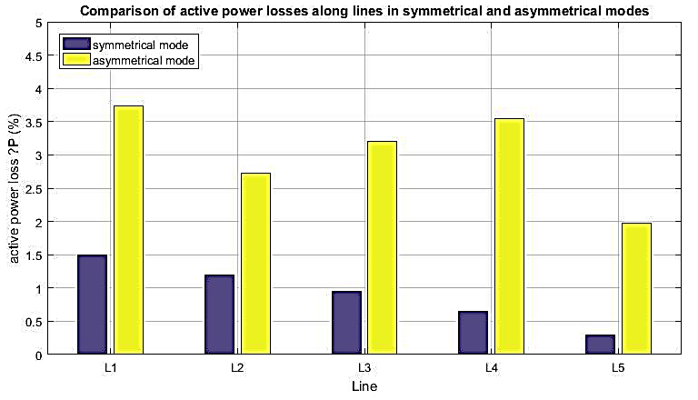
FIGURE 3. Active power losses in symmetric and asymmetric modes.

Reactive power losses in symmetrical and asymmetrical modes are shown in Fig. 4.

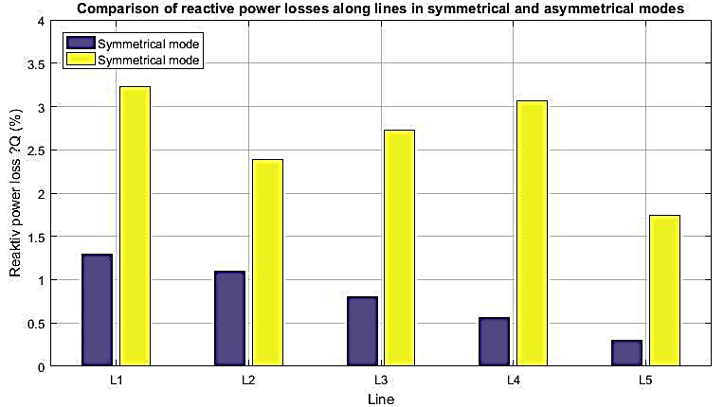
FIGURE 4. Reactive power losses in symmetric and asymmetric modes.
At asymmetric loads, the voltage values in all phases were different, and due to current flowing through the neutral wire, stable network operation was not ensured. The voltage drop from bus 1 to bus 6 decreased from 219.39 V to 170.31 V, and the voltage in the network decreased from 380 V to 356.51 V. We can see that these values are within the permissible limits according to GOST, that is, in the range of -5% and 5%. Asymmetric loads lead to uneven power distribution across phases. Calculations showed that under asymmetric loads, the stresses in the tires differ significantly (Table 10).

TABLE 10. Voltage values in each phase of each winding.
№ | Busbar name | Connection group | Voltage, V
№ | Busbar name | Connection group | A | B | C
1 | 1-busbar | ABC-N | 219,39 | 219,39 | 219,39
2 | 2- busbar | ABC-N | 205,63 | 225,11 | 216,98
3 | 3- busbar | ABC-N | 196,36 | 229,47 | 213,07
4 | 4- busbar | ABC-N | 186,77 | 234,95 | 209,05
5 | 5- busbar | ABC-N | 175,43 | 239,20 | 209,80
6 | 6- busbar | ABC-N | 170,31 | 242,66 | 207,44

Asymmetric loads, along with an increase in voltage imbalance in busbars and electricity losses in lines, negatively affect the stable operation of the network. Calculations show that:
• With the asymmetry of the power consumed by consumers by phases, excessive heat losses occur in the network elements;
• Increased voltage imbalance, which reduces the quality of operation of electrical equipment;
Active and reactive power losses on the lines increase, and overall power efficiency decreases.
The research results showed that the phase distribution of loads in power supply systems significantly affects the overall network efficiency and voltage regimes. In the case of a symmetrical load, power flows are stable, and losses of active and reactive power on the lines are recorded at a minimum level. This situation corresponds to the normal operating mode of the network, and the equality of voltage in all phases confirms the high quality of electricity. In the symmetrical mode, active power losses are in the range of 0.3-1.5%, and reactive power losses are in the range of 0.3-1.3%, which is the result of the natural influence of line resistance and indicates the absence of excessive losses. The maximum value of the voltage drop across the tires is 9.87 V, which indicates a high level of energy efficiency of the network. In the asymmetric load mode, the results differed significantly.
CONCLUSIONS
In this study, the influence of symmetrical and asymmetrical load modes on the network in a 0.38 kV low-voltage power supply network was modeled and comparatively analyzed using the DigSILENT PowerFactory software environment. The calculation results confirmed that the degree of load distribution by phase directly affects the quality of electricity, voltage regimes, and power losses. In the symmetrical load mode, active power losses in all lines were recorded in the range of 0.3-1.5%, and reactive power losses in the range of 0.3-1.3%. These values are related to the natural resistances of the network elements, and no excessive energy losses were observed. The voltage values in the busbars for each phase were practically equal, and the voltage drop from busbar 1 to busbar 6 varied from 219.39 V to 209.52 V. As a result, voltage deviations were maintained within the permissible limits of −5% and +5% established by GOST, ensuring stable and reliable operation of the network. The absence of current flow through the neutral wire was also noted as one of the positive features of the symmetrical mode. In the asymmetric load mode, significant negative changes in network performance were revealed. In each line, active power losses increased to 1.97-3.73%, and reactive power losses were recorded in the range of 1.74-3.23%. This is explained by the uneven distribution of currents by phases and the flow of a large current through the neutral wire. The voltages on the tires differed sharply by phase, and in some phases the voltage values decreased to 170.31 V. As a result, voltage deviations exceeded the permissible limits of −5% and +5% according to GOST, which indicates a deterioration in the quality of electricity and negatively affects the reliability of consumer electrical equipment. In general, the research results showed that asymmetrical loads lead to an increase in power losses in low-voltage electrical networks, an increase in voltage imbalance, and a decrease in network stability. Therefore, the implementation of technical and organizational measures to balance loads by phase in power supply systems, reduce asymmetric modes, and improve the quality and energy efficiency of electricity is of great scientific and practical importance.
REFERENCES
1. Rakhimov O.S., Mirzoev D.N., Gracheva E.I. Experimental study of electricity quality indicators and losses in low-voltage rural electrical networks. Proceedings of Higher Education Institutions. ENERGY PROBLEMS. 2021, pp. 209-222. https://www.energyret.ru/jour/article/view/1855
2. Muzaffar Khudayarov, Bahrom Bobonazarov Estimation of the steady states parameters in open-loop distribution networks based on feedforward neural networks. E3S Web of Conferences 377, 01005 (2023) https://doi.org/10.1051/e3sconf/202337701005
3. A.O. Gorbunov. Criterion for calculating losses from non-sinusoidal currents in a power line. Bulletin of Altai State Agrarian University No. 5 (199). 2021, pp. 113-118. https://cyberleninka.ru/article/n/kriteriy-raschyota-poter-ot-nesinusoidalnyh-tokov-v-linii/viewer
4. F.D. Kosoukhov, N.V. Vasiliev, A.O. Gorbunov. Reduction of power losses from non-sinusoidal currents in rural electrical networks 0.38 kV. 2019 pp. 125-135. https://cyberleninka.ru/article/n/snizhenie-poter-moschnosti-ot-nesinusoidalnyh-tokov-v-selskih-elektricheskih-setyah-0-38-kv/viewer
5. A.A. Gerkusov, E.I. Gracheva, O.A. Shumikhina. Influence of asymmetrical load on electricity losses in distribution networks 0.4-20 kV. Bulletin of KSPEU. 2022 Volume 14 No. 2 (54). https://cyberleninka.ru/article/n/vliyanie-nesimmetrichnoy-nagruzki-na-poteri-elektroenergii-v-raspredelitelnyh-setyah-0-4-20-kv/viewer
6. K.A. Smagin, R.A. Galstyan, M.A. Antonov, A.V. Arnautov. Analysis of the impact of asymmetry on losses in the 0.4 kV network. Young Researcher of the Don Theoretical and Scientific-Practical Journal No. 4 (19) 2019. pp. 80-87. https://cyberleninka.ru/article/n/analiz-vliyaniya-nesimmetrii-na-poteri-v-seti-0-4-kv/viewer
7. D.V. Kovalenko, P.S. Smirnov. Accounting for the influence of higher harmonics when calculating power and energy losses occurring in a cable power transmission line when connecting a group of personal computers to the network. OMSK SCIENTIFIC BULLETIN No. 5 (161) 2018. pp. 96-101. https://cyberleninka.ru/article/n/uchet-vliyaniya-vysshih-garmonik-pri-raschetah-poter-moschnosti-i-energii-voznikayuschih-v-kabelnoy-linii-elektroperedachi-pri/viewer
8. O.G. Shirokov, T.V. Alferova, A.A. Alferov, S.L. Prusakov. Assessment of electrical energy losses caused by non-sinusoidal modes when calculating imbalances of 10 kV system substations. 2015. https://cyberleninka.ru/article/n/otsenka-poter-elektricheskoy-energii-vyzvannyh-nesinusoidalnymi-rezhimami-pri-raschete-nebalansov-sistemnyh-podstantsiy-10-kv/viewer
9. A.Yu. Pshenichnaya. Analysis of the impact of electricity quality on losses in distribution networks. // International Scientific Journal Synergy of Sciences. 2017. No. 14. pp. 400-407. http://synergy-journal.ru/archive/article0844
10. E.B. Solntsev, A.M. Mamonov, A.N. Fitasov. Computational-analytical model for studying the influence of distributed generation on the quality of electrical energy - voltage fluctuations. pp. 74-86. https://ie.nntu.ru/frontend/web/ngtu/files/nomera/2018/3(3)/solncev_mamonov_fitasov.pdf
11. A.V.Ded, A.V.Parshukova. On methods for accounting for uneven load when calculating power losses. International scientific journal "innovative science" No10-2/2016 ISSN 2410-6070. 35-37 pp. https://cyberleninka.ru/article/n/o-sposobah-ucheta-neravnomernoy-nagruzki-pri-raschete-poter-moschnosti/viewer
12. A.V.Ded, A.V.Parshukova. Method for calculating additional power losses in the case of asymmetry of the power supply system operating mode. International scientific journal "innovative science" No10/2015 ISSN 2410-6070. 61-65 pp. https://cyberleninka.ru/article/n/metod-rascheta-dopolnitelnyh-poter-moschnosti-pri-nesimmetrii-rezhima-raboty-sistemy-elektrosnabzheniya/viewer
13. A.V.Ded. Mathematical modeling of power loss calculation in a three-phase network under load asymmetry. OMSK SCIENTIFIC JOURNAL No. 5 (149) 2016. 98-101 pp. https://cyberleninka.ru/article/n/matematicheskoe-modelirovanie-rascheta-poter-moschnosti-v-trehfaznoy-seti-pri-nesimmetrii-nagruzki/viewer
14. A.V.Ded. Development of an algorithm for calculating power losses in a four-wire three-phase network under asymmetrical load. OMSK SCIENTIFIC JOURNAL No. 5 (149) 2016. 101-104 pp. https://cyberleninka.ru/article/n/razrabotka-algoritma-rascheta-poter-moschnosti-v-chetyrehprovodnoy-trehfaznoy-seti-pri-nesimmetrichnoy-nagruzke/viewer
15. Khudayarov M.B., Abdukhalimov J.A. Analysis of power losses in various modes of low-voltage electrical networks // Scientific and Technical Journal of Innovative Technologies. 2025 130-137.

