Modelling of thermal conversion and autonomous heat supply based on secondary energy resources at gas compressor stations
Shoira Samatova^{1, a)}, Shohida Karamova², Iroda Zokirova³, Maxammadjon Mamadaliyev³
¹ Karshi state technical university, Karshi, Uzbekistan
² Karshi state university, Karshi, Uzbekistan
³Andijan state technical institute, Andijan, Uzbekistan
^{a)} Corresponding author: bobur160189@mail.ru
Abstract. The issue of making more complete use of energy remains relevant. Releasing heat into the atmosphere puts additional pressure on the environment and increases producers costs. This article explores the potential for utilising secondary energy resources (SER) produced in gas compressor stations (GCS) for autonomous heating and hot water supply systems. The technical potential of the secondary heat released during multi-stage gas compression in GCS was analysed within the framework of the study, and the composition of energy flows and heat exchange processes was modelled mathematically. The change in gas temperature along the pipeline was described using a differential equation, and the relationship with adiabatic compression, external heat losses and the Joule–Thomson effect was demonstrated. The efficiency of using IER was evaluated using the conversion coefficient $μ_{HE}$, with $μ_{HE}>2,0$ was defined as the criterion for technical and economic feasibility. According to 3D modelling results based on MATLAB, it was determined that heat could be obtained up to Q = 100 kW with a heat exchange surface area of F = 1. The proposed system is recommended as a promising technology for enhancing the energy efficiency of GCS, reducing fuel consumption and greenhouse gas emissions.
INTRODUCTION
Over The depletion of natural fuel and energy resources, coupled with the exacerbation of economic, social and environmental issues related to their extraction and processing, makes the efficient use of energy resources in economic sectors an urgent scientific and practical challenge. In particular, the effective use of secondary energy resources (SER) to optimise the fuel and energy balance at high-energy industrial enterprises is of great strategic importance [1].
The concept of fuel and energy resource conservation (FERC) is being implemented in two main areas. Firstly, it aims to modernise technological processes and energy-technological devices by increasing their useful working efficiency and energy efficiency through the introduction of energy-saving, waste-free technologies. This reduces energy losses, improves the thermodynamic efficiency of production processes and the exergy efficiency of energy devices, and significantly reduces fuel and energy consumption and the cost of products per unit of production [2].
Secondly, it addresses issues related to identifying, recovering and effectively utilising the technical potential of secondary energy resources inevitably generated in technological processes. Practical and theoretical studies show that the consumption of fuel and energy resources can be reduced by an average of 30–35% through the complex utilisation and reuse of SERs. This increases economic efficiency and reduces the environmental impact of industrial enterprises while increasing energy efficiency.
Secondary energy resources are defined as the thermal energy potential of exhaust gases, combustion products, heated technological products, and production waste generated by high-temperature technological devices, processes, heating devices, industrial furnaces, and aggregates. The technical potential of SER is suitable for full or partial reuse and utilisation in other technological units, auxiliary devices and equipment, as well as for the direct needs of the main technological process. SERs are categorised as internal or external according to their usage. Redirecting secondary energy generated in a technological device for the needs of that device is called using internal SERs, while using secondary energy resources generated in one device in other devices, processes or energy systems is called using external SERs. Technological devices and units that generate IERs can be used as sources of secondary energy resources [3,4,5].
Therefore, identifying secondary energy resources and analysing their technical potential in depth, as well as integrating them into industrial energy systems, is one of the most important scientific and practical approaches to increasing energy efficiency, saving fuel and energy resources, and ensuring sustainable industrial development. Currently, processes and devices for energy production and consumption based on traditional fuel and energy resources account for the majority of greenhouse gases emitted into the atmosphere. Using traditional fuels poses a serious threat to both energy security and environmental sustainability. Therefore, reducing the share of traditional energy resources is a priority area for modern energy policy. This can be achieved not only by introducing renewable and non-traditional energy sources, but also by making full and effective use of secondary energy resources generated in industrial and energy processes. To fully identify the technical potential of secondary energy resources and ensure their effective use, each operating industrial enterprise should systematically identify all types of SER generated in technological processes, assess their technical potential and quality indicators, and determine areas of utilisation and reuse that are technically feasible. At the same time, when choosing methods for using SER, it is necessary to conduct a comprehensive [6]
On Sunday, one of the most important tasks in the development of modern energy is to scientifically determine the alternative priorities of traditional energy systems. In this process, the main scientific approaches are, on the one hand, to introduce renewable energy sources and, on the other hand, to increase the energy efficiency of existing high-energy industries to reduce the demand for primary energy resources. These approaches are not mutually exclusive, but rather complement each other to form an energy efficiency system that ensures the stability of energy systems.
From this perspective, identifying and evaluating the potential of the secondary energy resources generated in gas transmission networks, which are considered to be one of the energy-intensive networks, is of particular scientific and practical importance. In gas transmission networks, particularly in the operation of gas compressor stations, large amounts of low and medium potential heat energy are produced. These secondary energy flows are often lost to the environment without being utilised, and their recovery and targeted use is a key way to increase energy efficiency. For this reason, a comprehensive analysis of the technical potential of SER in gas transmission systems and the identification of the most favourable technical, economic and ecological approaches to utilising them is considered essential [7,8].
MATERIALS AND METHODS
The main objective of this research is to evaluate the technical potential, heat power and quality indicators of secondary energy resources produced in gas compressor stations. The research will also develop scientific solutions to increase the efficiency with which autonomous consumers use this SER power for heating. The research will analyse the potential for using IERs in gas compressor facilities to reduce the use of primary energy and fuel resources, as well as operating costs and harmful emissions [9].
In developed countries, demand for fuels, including natural gas, is increasing year on year, putting greater pressure on the need for stable global energy systems. The extraction, processing and transportation of natural gas are among the most energy-intensive technological processes. An increase in gas production leads to increased internal gas consumption and greater potential for secondary energy resources (SERs) in the gas supply system.
Compressor stations (CSs) are an important part of the gas transmission system. The compression of pressurised gas using pressure-driven machines causes a significant increase in temperature at the station outlet. The gas compression process is mainly adiabatic in nature; the mechanical work performed on the gas during compression increases its internal energy and, consequently, its temperature. The final temperature of the gas after compression depends directly on the initial temperature at the compressor station inlet and the degree of compression (pressure ratio). In the technological schemes of existing compressor stations, the gas is usually transferred to cooling devices after compression and heated from an initial temperature of about 30÷35 °C to values of 45÷55 °C or higher. An increase in gas temperature leads to higher energy consumption for transportation through main pipelines, decreased thermal insulation efficiency, and decreased hydraulic conductivity of gas pipelines. This negatively affects the system's overall energy efficiency [10,11].
Various types of heat exchanger are used to cool compressed gas. Shell-and-tube heat exchangers, air coolers, adsorption and absorption coolers, and cooling towers are widespread technological devices for this purpose. In practice, air coolers are considered the most widely used solution, both technically and economically, for cooling gas transported after compression at compressor stations. These devices can usually reduce the gas temperature by 15÷20 °C, thereby increasing the reliability and energy efficiency of the gas transmission system.
Figure 1 figure the secondary heat and its utilisation methods in gas compressor plants.
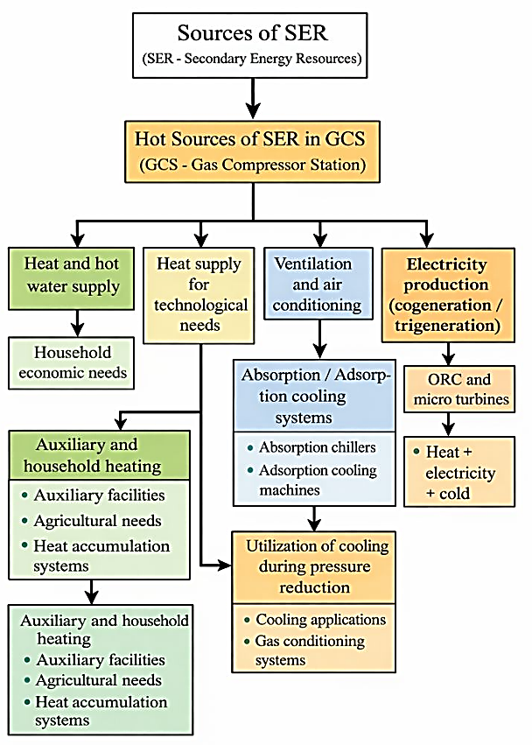
FIGURE 1. Heat and material IER sources in GKM and their use areas.

This technological scheme reflects the potential for identifying and comprehensively utilising secondary energy resources (primarily thermal and pressure energy) generated during gas compression processes in gas compressor plants for technological needs, as well as in ventilation and air conditioning, absorption or adsorption cooling, and the production of electricity and cold energy through cogeneration and trigeneration systems.

EXPERIMENTAL RESEARCH
The secondary energy resources generated during gas compression processes in gas compressor plants (GCPs) are primarily manifested as waste heat. Recovering and utilising this heat is an important source of energy for autonomous consumer heating and hot water supply systems. According to the proposed scheme, hot IER sources in GCPs are separated via heat exchangers and transferred to low- and medium-temperature heat carriers, which are then distributed according to consumer demand.
Autonomous consumers include administrative buildings, control rooms, ancillary structures, workshops, warehouses and economic facilities located within the GCP territory. Using IER in these consumers' heat supply systems significantly reduces the need for central boiler houses or heating devices with separate fuel combustion. Consequently, fuel and energy consumption, as well as operating costs, are reduced.
Using IER in hot water supply systems is highly efficient, particularly in gas compressor facilities, due to the continuous generation of waste heat throughout the year. Heat extracted during gas cooling using heat exchangers is used to heat water, which is then used for technological, domestic, and economic purposes. Using heat accumulation systems in this case allows for compensation of uneven heat loads and ensures stable system operation.
Also, as envisaged in the scheme, heating and hot water supply systems based on SER can operate alongside other energy solutions. In particular, it is possible to increase the temperature using low-potential waste heat pumps to provide comfortable conditions for end users. This increases the scope for using SER and further improves the system's overall energy efficiency.
In general, using secondary energy resources generated in gas compressor facilities for autonomous consumer heating and hot water supply systems is scientifically and practically important for saving fuel and energy resources, reducing greenhouse gas emissions and ensuring a stable and reliable energy supply. Figure 1 shows the heating scheme developed by the authors for an autonomous consumer heating and hot water supply system utilising secondary heat from GCP (Figure 2).

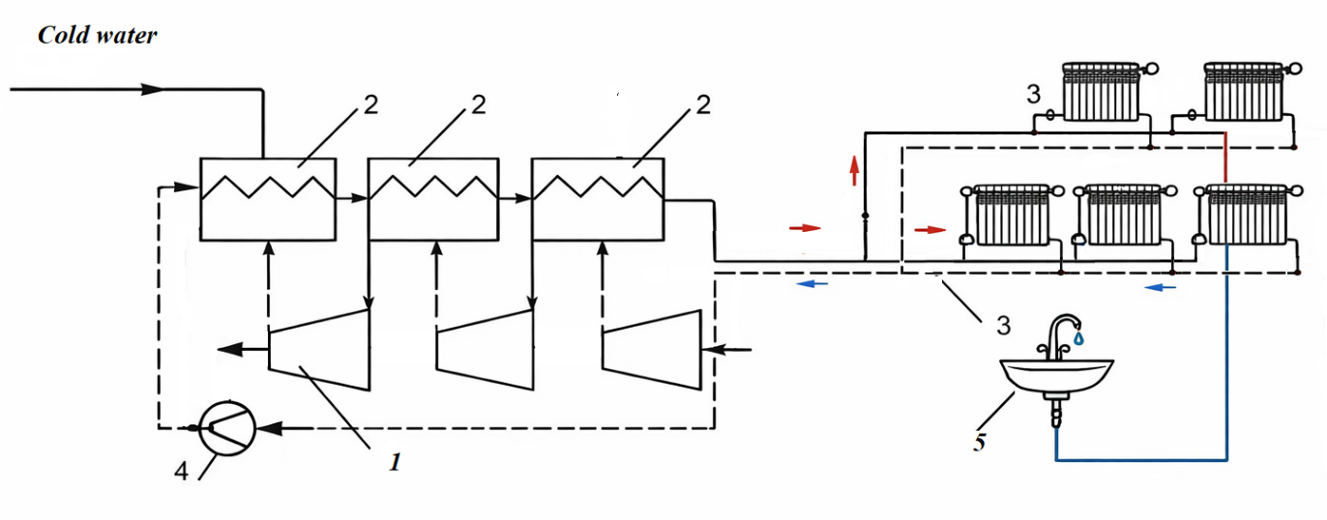
FIGURE 2. Thermal scheme of the heat and hot water supply system for autonomous consumers, utilising secondary heat from the GCP.

Where, 1. Multi-stage compressors; 2. Heat exchangers; 3. Autonomous heat supply system; 4. Circulation pump; 5. Hot water supply system.
Figure 2 shows the thermal scheme of an autonomous heating and hot water supply system for consumers, based on the utilisation of secondary heat energy generated in gas compressor facilities. As can be seen from the diagram, during multi-stage gas compression (1), the mechanical operation of the compressors results in an adiabatic increase in gas temperature and the formation of waste heat with a high secondary energy potential around the technological device blocks. In conventional systems, this energy resource is lost to the external environment through cooling; however, in the system proposed by the authors, it is transferred to the secondary heat carrier (water) using special heat exchangers (2). The heat carrier fluid generated in the heat exchangers continuously circulates around a closed circuit via a water circulation pump (4). The heated water is transferred to the consumer part of the system — the autonomous heating system (3). In this system, heat is supplied to heating devices (radiators) via convective heat exchange and the internal microclimate of the serviced facility (e.g. administrative buildings, technical rooms and auxiliary infrastructure) is maintained at a stable temperature. The lower branch of the scheme contains a hot water supply system (5) which extracts the required amount of heat from the supply system circuit. This system supplies the hot sanitary water necessary for household and technical needs, such as sinks and taps. When cooled down again, the used water is returned to the heat exchange devices through the return network and the cycle restarts. Thus, the proposed system works as follows:
- In multi-stage compressors, gas compression generates waste heat.
- Heat exchangers then transfer this waste heat to the energy carrier.
- The circulation pump constantly moves water through the system.
- Thermal energy heats the rooms via autonomous heating devices that operate based on convective heat exchange.
- The hot water network provides hot water for domestic use.
- The cooled water returns to the heat exchangers using a circulation pump, and the cycle repeats. The same applies to the water in the system.
The conversion coefficient is the main indicator reflecting the efficiency of using secondary energy resources in gas compressor plants (GCP). It represents the ratio of the useful thermal energy transferred to consumers to the mechanical work consumed by the compressor. It is calculated using the following formula:
$μ_{HE}=\frac{Q_{HE}}{А_{C}}$ (1)
here, $Q_{HE}$-heat energy delivered to the consumer, kWh, $А_{C}$-mechanical work of the compressor, kWh. $μ_{HE}$ -the conversion coefficient always satisfies $μ_{HE}>1,0$, indicating that the heat recovered exceeds the compressor work. In practical applications at GCP, the condition $μ_{HE}>2,0$ is typically fulfilled, confirming that the utilization of SER through heat exchangers and their integration into autonomous heat supply systems is energetically efficient and justified.
The temperature of natural gas in the main pipeline after compression is determined using the following thermodynamic expression:
$Т_{C}=Т_{0}+\left(Т_{in}-Т_{0}\right)е^{-αL}-D_{i}\frac{P_{in}^{2}-P_{о}^{2}}{2αLP_{aver}}(1-е^{-αL})$, (2)
here
$α=225,5\frac{k_{aver}∙d_{o}}{q∙∆∙c_{p}∙{10}^{6}}$, (3)
$Т_{0}$-Ambient temperature, К, $Т_{in}$- Initial gas temperature at pipeline section inlet, К, $Р_{in},Р_{о}$-Initial and final pressure values along the pipeline, MPa, $Р_{aver}$-Average pressure within the pipeline section, MPa, $d_{o}$-Outer diameter of the main pipeline, m, $k_{aver}$-Heat transfer coefficient from gas to environment, W/m²·К, с_{р}-Average isobaric heat capacity of natural gas, kDj/kgK, $D_{i}$-Average Joule–Thomson coefficient, К/MPa, q-Pipeline gas capacity, mln.·m³/day, Δ- Relative density of natural gas compared to air, L-Gas pipeline length, km.
Equation (2) reflects temperature changes along the pipeline, taking into account two effects, (1) heat loss to the environment (exponential decay), (3) cooling due to pressure drop (the Joule–Thomson effect).
Equation (3) describes the dependence of heat leakage intensity on pipeline geometry, gas flow rate, and thermal properties.
If we neglect heat losses along the pipeline, the heat balance of the heat carrier can be described as follows:
$Q=G_{1}∙c_{p1}(t_{1}^{'}-t_{1}^{''})=G_{2}∙c_{p2}(t_{2}^{''}-t_{2}^{'})$, (4)
As an alternative, the expression may be written as follows, based on water-equivalent heat capacities:
$\frac{C_{1}}{C_{2}}=\frac{(t_{2}^{''}-t_{2}^{'})}{(t_{1}^{'}-t_{1}^{''})}=\frac{δ{∙t}_{2}}{δ∙t_{1}}$, $t_{2}^{''}=92 ℃$ (5)
here, $C_{1}=G_{1}∙c_{p1},C_{2}=G_{2}∙c_{p2}$- the water-equivalent heat capacities represent the useful thermal power of both circuits.
Equation (4) shows that the energy supplied to the autonomous heating and hot water system is equal to the thermal energy extracted from the secondary source at GCS. Equation (5) shows that an achievable temperature of 92°C corresponds to the upper limit for effective HW (hot water) heating using recovered heat.
We have calculated a continuous process model of the change in gas temperature along the main pipeline, based on the following differential heat transfer equation.
$\frac{dT}{dL}=-α\left(T-T_{0}\right)-\frac{D_{i}}{{2P}_{aver}}∙\frac{{d(P)}^{2}}{dL}$ (6)
T=T(L)-temperature function along the pipe, K.
Integrating the boundary condition according to equation (6) with $T\left(0\right)=T_{in}$_(in) yields the following form of equation (2):
$Т_{C}=Т_{0}+\left(Т_{in}-Т_{0}\right)е^{-αL}-D_{i}\frac{\left(P_{in}^{2}-P_{о}^{2}\right)}{2αLP_{aver}}(1-е^{-αL})$ (7)
This means that (2) to (6) is a physical solution to the differential equation.
The heat balance along the pipe is determined by the principle of conservation of energy.
$\frac{d}{DL}\left(Gc_{p}T\right)=-k_{aver}πd_{o}\left(T-T_{0}\right)-Gc_{p}D_{i}\frac{dP}{dL}$ (8)
Where, G is the mass flow. Simplifying (7), we pass to expression (6).
The proposed differential heat model (6) accurately reflects the exponential decrease in gas temperature along the main pipeline, depending on distance, as well as the additional effect of the Joule–Thomson cooling effect on temperature due to pressure changes. The model can be used to evaluate SER utilisation levels in GCPs, compile heat loss and balance calculations, and design optimal heat recovery technologies.
The result obtained using the proposed equation is shown in the figure.
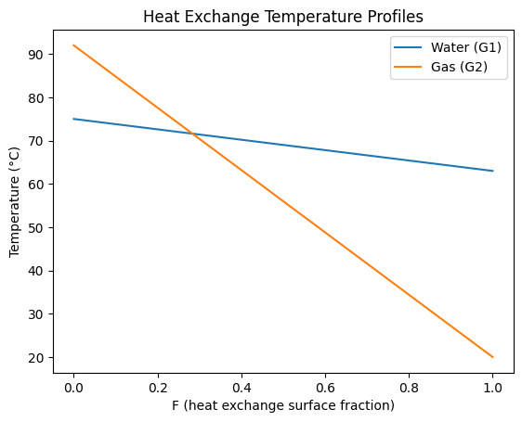
FIGURE 3. This graph shows the temperature changes of water (G₁) and gas (G₂) flows during heat exchange in a GCPs.

Figure 3 shows that utilising secondary heat in a gas compressor room involves a decrease in the temperature of the water (G₁) and gas (G₂) streams as the heat exchange surface ratio (F) increases. The sharp decrease in the temperature of the gas stream from 92 °C to 20 °C indicates a high heat transfer intensity, due to the low heat capacity of the gas and the high temperature gradient. In the water stream, a relatively slow decrease from 75 °C to 63 °C is observed, indicating that the temperature change of water is smaller due to its high heat capacity. Thus, the graph confirms that heat recovery efficiency depends directly on the heat exchange area and the thermophysical properties of the heat transfer substances.
Figure 4 shows the results of the 3D modelling of the relationship between the heat transfer rate (Q) and the heat exchange surface area (F), as well as the relationship between the heat transfer rate (Q) and water consumption (G), when using secondary heat in a GCMs.
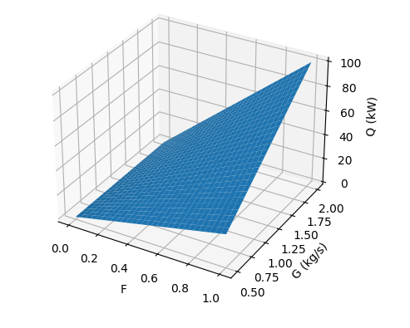
FIGURE 4. Results of 3D modelling showing the dependence of the heat transfer rate (Q) on the heat exchange surface area (F) and water consumption (G).

This 3D model illustrates the technical value of utilising the secondary heat energy generated in gas compressor plants. The surface model shows that the amount of heat transferred to the consumer (Q) increases linearly with increasing water flow rate (G) and heat exchange surface area (F). The heat balance equation is as follows:
$Q=G∙c_{p}∙∆T∙F$ (9)
As can be seen from the graph, under maximum conditions (G = 2 kg/s and F = 1), the heat recovery capacity reaches Q = 100 kW. This proves that there is sufficient potential to provide autonomous heating and hot water systems with energy in the GCMs area. The results obtained demonstrate that increasing water consumption and expanding the heat exchange surface are the primary factors in enhancing the efficiency of processing secondary energy resources.
CONCLUSIONS
During the scientific research conducted, the possibilities of using secondary energy resources (IRE) generated in gas compressor stations (GCS) were thoroughly studied. The potential of these resources in the form of thermal energy was scientifically assessed and technical and technological solutions for integrating autonomous consumers into heat and hot water supply systems were developed. The proposed heat and power scheme (GCS – heat exchangers – circulation pump – autonomous heating system – hot water supply – thermal power) enables secondary heat lost from GCS to be recovered and transferred to consumers, thereby increasing energy efficiency and reducing reliance on external energy sources. The calculation results showed that, in order to achieve energy efficiency,$μ_{HE}>2,0$ is required. This means that additional energy devices, such as heat pumps, may need to be integrated into the GCSs. The analysis shows that adding a heat pump to the developed scheme can increase $μ_{HE}$to a range of 3.0÷4.5, which would more than double the energy saving indicator for autonomous heating systems.
Practically, the research demonstrates that collecting secondary heat in GCSs and directing it to autonomous heating systems reduces fuel consumption and dependence on external energy supplies, optimises operating costs, and significantly reduces the carbon footprint (CO₂ emissions) of the energy system. The developed system also increases the region's energy independence and is fully consistent with environmental sustainability principles.
REFERENCES
- I. Andrić, A. Pina, P. Ferrão, J. Fournier, B. Lacarrière, O. Le Corre. Assessing the feasibility of using the heat demand-outdoor temperature function for a long-term district heat demand forecast // Energy Proc. 143. .2017. PP, 396—403. https://doi.org/10.1016/j.egypro.2017.12.702
- S. Sharma, V. Gupta, A. Rathi. Energy performance benchmarking of compressed air systems in medium-scale manufacturing industries // J. Clean. Prod. 279. 2021. P, 123783. https://doi.org/10.1016/j.jclepro.2020.123783
- Y. Wang, M. Zhang, X. Xu, et al. Evaluation of PCM thermophysical properties on a compressed air energy storage system integrated with packed-bed latent thermal energy storage. // Appl. Therm. Eng. 226. 2023. P, 120217. https://doi.org/10.1016/j.applthermaleng.2023.120217
- Uzakov G.N. et al. Development of a hybrid pyrolysis device and justification of energy efficiency // E3S Web of Conferences 623. 2025. P, 03012. https://doi.org/10.1051/e3sconf/202562303012
- B. Toshmamatov. Development of automation and control system of waste gas production process based on information technology // Communications in Computer and Information Science. 2112. 2024. PP, 196–205. https://doi.org/10.1007/978-3-031-60318-1_17
- Z. Li, Q. Chen, X. Wang, et al. Experimental investigation on the output performance of a micro compressed air energy storage system based on a scroll expander // Energy Convers. Manag. 273. 2022. P, 116379. https://doi.org/10.1016/j.enconman. 2022.116379
- E. Yandri, R. Ariati, et al. Optimizing compressed air operations for electrical energy savings: a case study in pharmaceutical packaging manufacturing // Grimsa Journal of Science Engineering and Technology. 2 (2). 2024. https://doi.org/10.61975/gjset. v2i2.58
- Y. Luo, H.H. Tseng et al. Balancing accuracy and interpretability of machine learning approaches for radiation treatment outcomes modeling // BJR Open 1 (1). 2019. PP, 20190021. https://doi.org/10.1259/bjro.20190021
- Hernan Hernandez-Herrera et al. Energy savings measures in compressed air systems // International Journal of Energy Economics and Policy. 10 (3) .2020. PP, 414—422. https://doi.org/10.32479/ijeep.905
- S. Sharma, V. Gupta, A. Rathi. Energy performance benchmarking of compressed air systems in medium-scale manufacturing industries // J. Clean. Prod. 279. 2021. PP, 123783. https://doi.org/10.1016/j.jclepro.2020.123783
- Atlas Copco. Energy Recovery and System Optimization: Reduce Your Compressor Room Energy Costs // Technical Report. 2021. https://www.atlascopco.com/en/compressors/insights/energy-recovery-andsystem-optimization

