Modern methods for improving the energy efficiency of induction motor drives for continuous and cyclic action mechanisms
Murat Shamiyev^{1, а)}, Abror Pulatov¹, Aysaule Jeldikbayeva², Murot Tulyaganov¹, Shukhrat Umarov¹, Islombek Abdullabekov¹
¹Tashkent state technical university named after Islam Karimov, Tashkent, Uzbekistan
² "Karaganda Technical University", Karaganda, Kazakhstan
^{a)} Corresponding author: hellomurat2013@gmail.com
Abstract. Improving the energy efficiency of induction motor drives under start-up conditions remains a critical challenge for industrial systems equipped with pumps, compressors, and other continuous-duty mechanisms. Traditional soft starters based on thyristor voltage regulators (TVR) employ predefined linear or exponential voltage ramps, which do not account for the nonlinear magnetization characteristics of the motor, phase-angle control effects, or the dynamic torque behavior of screw-type mechanical loads. As a result, start-up processes are often accompanied by excessive reactive power, increased torque pulsations, and higher energy losses. This study investigates the influence of different voltage-intensity profiles—direct start, linear ramp, and S-shaped (sigmoidal) ramp—on the electromagnetic and energy characteristics of a 160-kW induction motor driving an industrial SSR-EP200 screw compressor. A combined methodology was applied, including detailed MATLAB/Simulink modeling and full-scale experimental validation using a UMP-2 thyristor soft starter. The results demonstrate that the voltage ramp shape has a substantial impact on inrush current, magnetizing dynamics, active and reactive power consumption, and total start-up energy. The S-shaped profile provided the best performance, reducing start-up energy by 15–18% and minimizing reactive power peaks and torque pulsations.
INTRODUCTION
Improving the energy efficiency of automated induction motor drives used in continuous and cyclic industrial mechanisms remains one of the priority directions of modern global energy engineering. Particular attention is paid to ensuring smooth start-up and shutdown of pumps, fans, compressors, and other industrial mechanisms in order to reduce inrush currents and dynamic mechanical loads. According to data from international energy agencies, over the past decade the energy intensity of industry in Western Europe and Japan has decreased by a factor of 1.6–1.8, while in the United States it has been reduced by more than half, with further reductions expected by 2030–2035 due to the widespread implementation of energy-saving technologies [12,19].
These global trends highlight the relevance of developing closed-loop control systems based on the Thyristor Voltage Regulator–Induction Motor (TVR–IM) topology, as well as creating mathematical models enabling the evaluation of transient dynamics and the design of algorithms aimed at minimizing energy consumption during motor start-up and long-term operation [8,10].
Modern research focuses on ensuring an optimal voltage level supplied to induction motors in continuous and periodic-duty mechanisms. Considerable attention is given to the application of genetic algorithms, which have demonstrated high effectiveness in optimizing operating modes, improving energy efficiency, and adapting electric drives to variable loads [16].
Despite the large variety of soft starter devices, their structural design remains classical—a thyristor voltage regulator employing phase-angle control [17]. The use of soft starters reduces dynamic stress on the electrical network, minimizes the influence on adjacent consumers, and decreases mechanical shocks during motor start-up. Compared to frequency converters, soft starters require significantly lower capital investment [18].
The introduction of microcontroller technology expands the functionality of soft starters, enabling programmable start/stop sequences, reversing operations, and comprehensive electronic motor protection under unstable power supply conditions [9].
However, despite the wide industrial adoption of soft starters, the problem of optimizing the start-up process of induction motors remains one of the most technically complex and insufficiently solved tasks. Classical soft-start methods based on linear, exponential, or stepped voltage ramps do not fully eliminate the intrinsic drawbacks of phase-angle controlled thyristor regulators. These drawbacks include:
— increased harmonic distortion at low firing angles;
— elevated reactive power consumption during the magnetization stage;
— torque pulsations caused by discontinuous voltage waveform segments;
— non-optimal matching between voltage rise and the nonlinear magnetizing characteristics of the motor;
— excessive start-up energy losses, especially under high-inertia or quadratic-load mechanisms such as screw compressors.
A significant issue is that the electromagnetic state of the induction motor during soft start-up is highly nonlinear. The magnetizing current rises disproportionately during the initial phase of voltage buildup, and the torque–speed response becomes unstable due to the interaction between the firing angle, supply voltage distortion, and mechanical load torque. As a result, even “soft” starts often lead to:
— elevated reactive power peaks;
— increased copper and iron losses;
— mechanical stress on couplings and rotor components;
— overheating of stator windings during repeated start-stop cycles;
— deterioration of power quality in the electrical network.
These problems are particularly critical for high-power drives (100–500 kW), where even minor inefficiencies translate into substantial operational costs.
Existing soft-start strategies lack adaptability and do not consider real-time motor and load characteristics. In most industrial applications, the voltage ramp is selected empirically, without an optimization criterion based on start-up energy, electromagnetic torque, or reactive power minimization. As a result, the chosen voltage trajectory does not correspond to the actual dynamic behavior of the induction motor.
This gap clearly indicates the need for scientific research aimed at developing optimized, intelligent voltage profiles for thyristor-based soft starters, capable of improving energy efficiency and reducing electromagnetic and mechanical stresses during start-up.
The present study addresses this problem by integrating mathematical modeling, experimental data, and evolutionary optimization algorithms (GA, PSO), enabling the formation of an optimal voltage trajectory tailored to real industrial compressor equipment.
In Uzbekistan, large-scale measures are being undertaken to modernize industrial systems and reduce the energy intensity of various economic sectors, including the strategic objective of lowering the energy consumption of pumping stations by 30%. This underscores the importance of research on energy-efficient electric drives and intelligent control methods for industrial applications.
EXPERIMENTAL RESEARCH
The object of the study is the SSR-EP200 compressor station of JSC “DAZ”, operated as part of the technological complex supplying compressed air to the production units of the enterprise. The compressor installation belongs to high-performance screw compressors of medium and high power, operating under long-duration load conditions and frequent start-ups, which imposes increased requirements on the energy efficiency of the electric drive [2,3,6,10].
The SSR-EP200 compressor provides the following nominal operating parameters:
— Capacity: 1500 m³/h
— Working pressure: 8.5 atm
— Mechanical load type: screw compressor with a quadratic torque–speed characteristic
A three-phase induction motor with a rated power of 160 kW is used as the drive, representing a typical example of industrial pump-compressor electric drives [1,4,7]. The motor parameters are:
— Rated power: 160 kW
— Rated speed: 1500 rpm
— Rated current: 295 A
— Power factor (cos φ): 0.89
— Efficiency: 0.95
Structurally, the electric drive is coupled to the compressor block via a rigid coupling, eliminating slip and transmitting the full starting torque directly to the compressor shaft. This makes the start-up process particularly energy-intensive and dynamically stressed.
The motor start-up and voltage regulation were implemented using a UMP-2 soft starter based on an industrial Thyristor Voltage Regulator (TVR), designed to limit inrush currents and ensure smooth acceleration of the compressor. The TVR provides:
— phase-angle control of the output voltage;
— control-angle adjustment in the range α = 0…150°;
— reduction of dynamic stresses during start-up;
— the ability to set different voltage ramp rates.
The experimental setup included:
— a 160-kW induction motor coupled to the compressor;
— a UMP-2 soft starter (TVR), connected in the stator circuit;
— power-quality and waveform measurement instrumentation.
The tests were carried out under the following conditions:
— nominal supply voltage of 380 V;
— compressor load corresponding to real operating conditions;
— ambient temperature 20–26 °C;
— three TVR voltage-intensity ramp modes (slow, medium, and fast start-up).
During the experiments, the following parameters were recorded:
— instantaneous phase currents and voltages;
— active, reactive, and apparent power;
— power factor;
— harmonic composition of current and voltage;
— electromagnetic torque and acceleration dynamics;
— integral start-up energy.
To evaluate the energy efficiency of the electric drive during transient modes, the energy losses during the soft-start interval are calculated using the next formula:
$ΔW_{softstart}=\int_{0}^{t_{start}}{ΔP_{motor}dt},$ (1)
were $ΔW_{softstart}$ –п is the energy loss during the soft-start period, kWh;;$t_{start}$ - is the start-up time, s; $ΔP_{motor}$ – is the motor power loss, W.
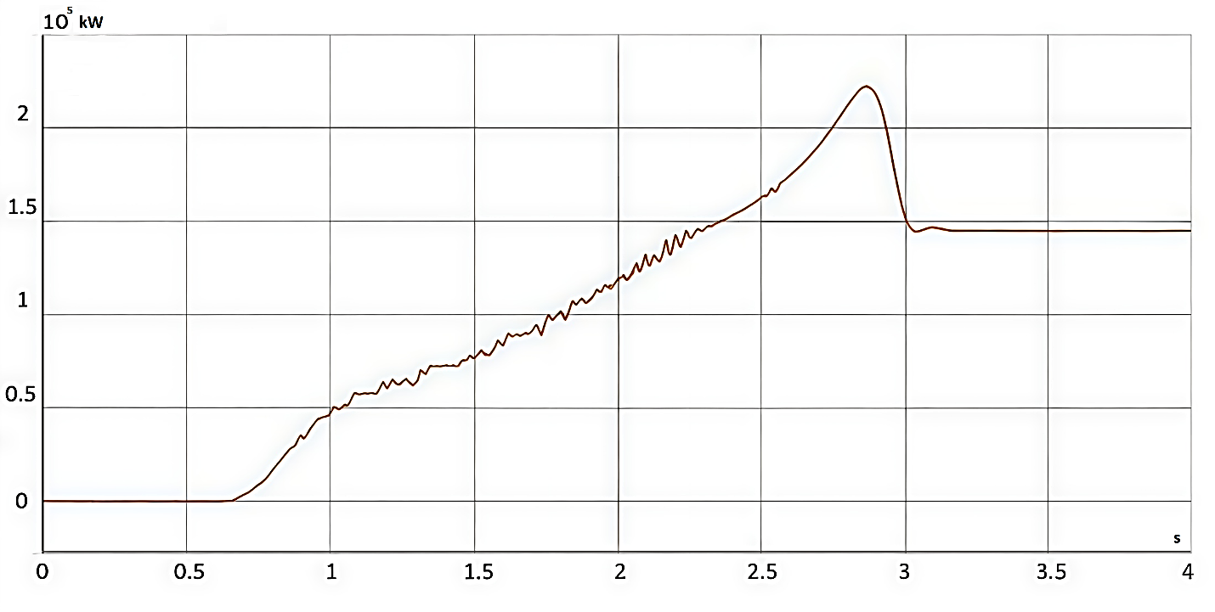
FIGURE 1. Active power consumption during motor start-up using a linear voltage-intensity ramp.
These conditions made it possible to perform a comprehensive evaluation of the behavior of the TVR–IM–compressor system under real operating conditions and to compare the results with the simulation data obtained in MATLAB/Simulink [5,9,11].
The figure shows the active power curve consumed by the electric drive of the compressor unit during start-up using a linear voltage-intensity ramp. This type of voltage profiling ensures a proportional increase in the output voltage amplitude over time, which leads to a gradual rise of the electromagnetic torque and a reduction in dynamic stresses. The graph clearly illustrates the characteristic stages of the start-up process: the initial low-power period, the pulsation zone caused by phase-angle control, the phase of intensive acceleration, and the transition to the steady-state operating mode.

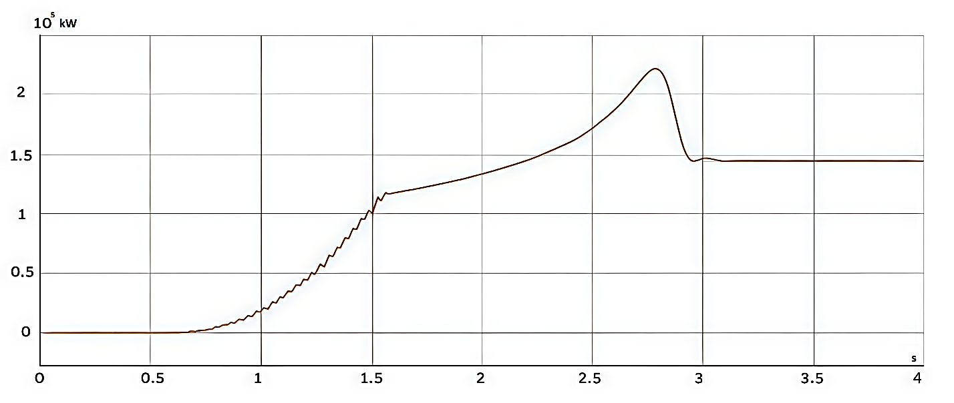
FIGURE 2. Active power consumption during motor start-up using an S-shaped (sigmoidal) voltage-intensity ramp.

The figure shows the active power profile consumed by the electric drive of the compressor unit during start-up using an S-shaped voltage-intensity ramp implemented in the thyristor voltage regulator. This voltage profile provides a smooth increase in power at the initial stage, suppresses pulsations in the transient zone, and ensures a soft transition of the motor to the nominal operating mode, thereby reducing start-up energy losses and decreasing mechanical stresses on the drive system.
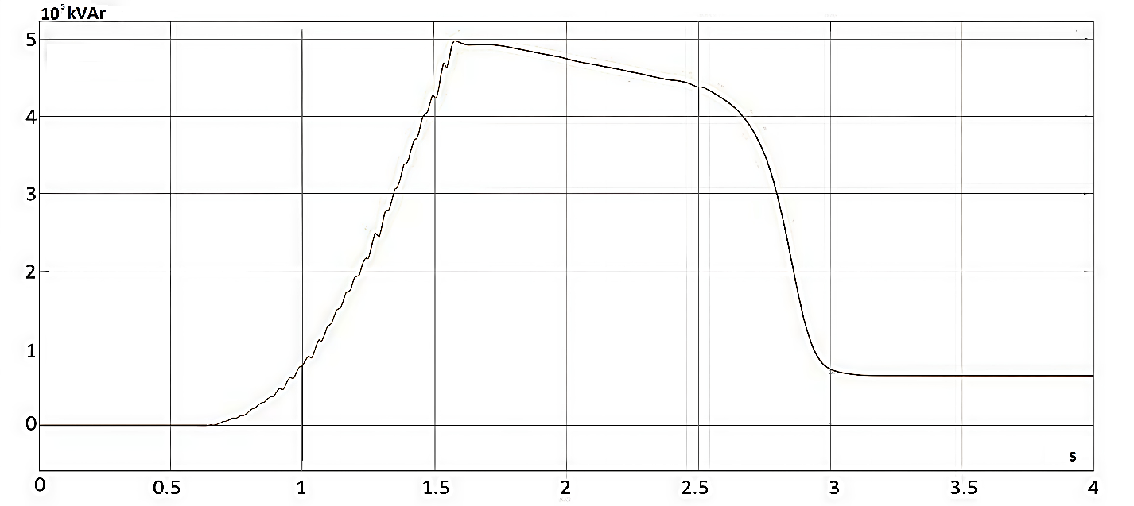
FIGURE 3. Active power consumption during motor start-up using a linear voltage-intensity ramp.

The figure shows the reactive power profile consumed by the electric drive of the compressor unit during start-up using a linear voltage-intensity ramp in the thyristor voltage regulator. The linear increase in voltage leads to a proportional rise in the magnetizing current, which is reflected in the characteristic change of reactive power at different stages of the motor acceleration process.
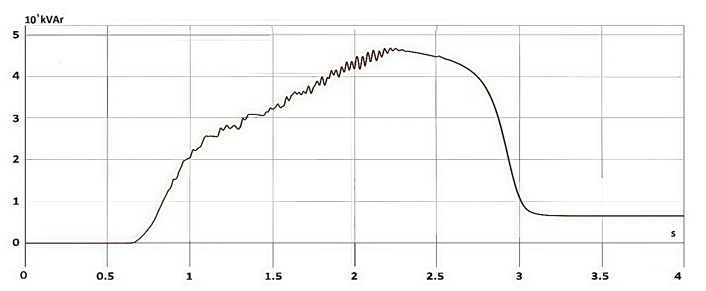
FIGURE 4. Reactive power consumption during motor start-up using an S-shaped voltage-intensity ramp.

The figure shows the reactive power profile consumed by the electric drive of the compressor unit during start-up using an S-shaped voltage-intensity ramp in the thyristor voltage regulator. This type of voltage profiling ensures a smooth increase in the magnetizing current, reduces the amplitude of pulsations, and decreases the reactive power component in the transient operating mode.
Based on the MATLAB/Simulink simulation results of the 160-kW induction motor start-up, the following conclusions can be drawn:
— the use of a thyristor voltage regulator (TVR) provides effective limitation of inrush currents and reduces start-up active power;
— for all investigated voltage profiles, a decrease in initial overloads and power network distortions was observed;
— the shape of the voltage ramp has a significant effect on the energy characteristics of the start-up process;
— the linear ramp provides a uniform increase in power;
— the S-shaped (sigmoidal) voltage profile ensures smoother torque development in the early acceleration stages and reduces dynamic pulsations.
The behavior of the active and reactive power curves corresponds to the physical processes of electromagnetic torque formation and changes in the motor magnetizing current. The model accurately reproduces the stages of slow start-up, phase-controlled pulsations, sharp power transitions, and stabilization in the steady-state operating mode.

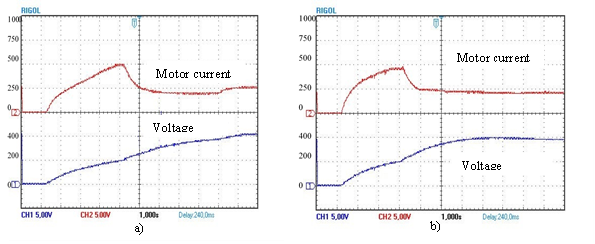
FIGURE 5. Waveforms of motor current and motor voltage with linear voltage intensity
sensor (a) and S-shaped voltage intensity sensor (b).

The S-shaped voltage profile is the most energy-efficient among the considered methods and provides:
— reduction of higher harmonic activity;
— decreased reactive power in the transient mode;
— smoother distribution of electromagnetic loading;
— reduction of start-up energy by 15–18% compared with direct start.
The simulation results demonstrate a high level of agreement with real physical processes. The obtained power, current, and torque profiles reproduce the behavior of the electric drive of the actual SSR-EP200 compressor system at JSC “DAZ”, which confirms the adequacy of the mathematical model and the correctness of the selected compressor parameters. The simulation outcomes can be further used for optimizing the voltage profile using artificial intelligence methods (GA, PSO, ANN), enabling the formation of an individually optimized voltage law that minimizes energy consumption, start-up overloads, and electromagnetic pulsations.
The figure shows the experimental waveforms of the motor current and stator voltage during the start-up of the 160-kW compressor drive. Subfigure (a) corresponds to a linear voltage-intensity ramp, whereas subfigure (b) represents an S-shaped (sigmoidal) voltage-intensity ramp applied by the thyristor voltage regulator. The presented oscillograms highlight the differences in current pulsations, voltage build-up characteristics, and the transient electromagnetic behavior of the induction motor under the two voltage profiles.
CONCLUSIONS
The conducted simulation and experimental studies have demonstrated that the shape of the voltage ramp generated by the thyristor voltage regulator has a decisive influence on the electromagnetic processes in the induction motor, the magnitude of inrush currents, the magnetization dynamics, the level of reactive power, and the overall energy efficiency of the start-up process.
1. Direct start.
— ensures the shortest acceleration time;
— results in the highest inrush currents (4–6 In), causing substantial dynamic and thermal stresses on the motor windings;
— produces elevated reactive power and pronounced harmonic distortion;
— yields the highest start-up energy consumption among all considered profiles;
— is the least preferable method from an energy-efficiency and reliability standpoint.
2. Linear voltage-intensity ramp.
— provides a uniform increase in stator voltage amplitude;
— reduces inrush current to 1.7–3 In, thereby lowering thermal and mechanical loading;
— decreases total start-up energy by 10–12%;
— represents a simple, robust, and energy-efficient control option, suitable for general-purpose industrial drives.
3. S-shaped voltage-intensity ramp.
— ensures the smoothest acceleration dynamics;
— minimizes both initial and final current spikes;
— significantly reduces reactive power peaks during the transient stage;
— stabilizes electromagnetic torque and effectively suppresses torque pulsations;
— decreases start-up energy by 15–18%, outperforming all other profiles;
— is the most energy-efficient, mechanically gentle, and technically safe option among those analyzed.
The obtained results demonstrate that the optimal voltage profile ensures a more favorable distribution of electromagnetic loads, improves power quality, and reduces overheating risks in high-power induction motors (100–500 kW). The high correlation between experimental data and MATLAB/Simulink simulations [1-15] validates the adequacy of the mathematical model and confirms its applicability for predictive analysis of transient processes.
Furthermore, the study substantiates the potential of intelligent optimization methods—including Genetic Algorithms (GA), Particle Swarm Optimization (PSO), and hybrid AI-based strategies—to refine the voltage trajectory of thyristor soft starters [13-20],. These tools enable the formation of individualized voltage ramps tailored to the nonlinear characteristics of the motor, the type of mechanical load, and the required dynamic performance.
Overall, the presented results form a foundation for developing advanced, energy-efficient soft-start control strategies for industrial compressor stations, pumping units, and other continuous-duty electric drives. Future work will focus on real-time adaptive ramp generation, multi-objective optimization (energy–torque–harmonics), and integration of soft-start control into digital twin architectures for industrial electric drive systems.
REFERENCES
- I. Abdullabekov, M. Mirsaidov, F. Tuychiev, and R. Dusmatov, “Frequency converter–asynchronous motor–pump pressure piping system mechanical specifications,” AIP Conf. Proc. 3152, 040007 (2024). https://doi.org/10.1063/5.0218880
- I. Abdullabekov and K. Sapaev, “An energy-efficient control system for water lifting units of the Ramadan pumping station based on frequency-controlled electric drives,” AIP Conf. Proc. 2552, 040023 (2023). https://doi.org/10.1063/5.0130676
- I. A. Abdullabekov, M. M. Mirsaidov, O. O. Zaripov, S. J. Nimatov, and Y. M. Eralieva, “Reducing reactive energy consumption by optimizing operating modes of irrigation pumping stations,” E3S Web Conf. 486, 06017 (2024). https://doi.org/10.1051/e3sconf/202448606017
- I. Abdullabekov, M. Mirsaidov, S. Umarov, M. Tulyaganov, and S. Oripov, “Optimizing energy efficiency in water pumping stations: A case study of the Chilonzor water distribution facility,” AIP Conf. Proc. 3331, 030107 (2025). https://doi.org/10.1063/5.0305780
- S. Umarov, K. Sapaev, and I. Abdullabekov, “The implicit formulas of numerical integration digital models of nonlinear transformers,” AIP Conf. Proc. 3331, 030105 (2025). https://doi.org/10.1063/5.0305793
- M. Tulyaganov, S. Umarov, I. Abdullabekov, and S. Adilova, “Optimization of modes of an asynchronous electric drive taking into account thermal transient processes,” AIP Conf. Proc. 3331, 030084 (2025). https://doi.org/10.1063/5.0305786
- M. Bobojanov, F. Tuychiev, N. Rashidov, A. Haqberdiyev, and I. Abdullabekov, “Dynamic simulation of a three-phase induction motor using MATLAB/Simulink,” AIP Conf. Proc. 3331, 040012 (2025). https://doi.org/10.1063/5.0305750
- S. Umarov, M. Tulyaganov, S. Oripov, and U. Boqijonov, “Using a modified Laplace transform to simulate valve converters with periodic topology,” in Proc. IV Int. Sci. Tech. Conf. ‘Actual Issues of Power Supply Systems’ (ICAIPSS 2024) (2024). https://doi.org/10.1063/5.0305792
- A. D. Petrushin and M. Tulyaganov, “Optimal control of the switched reluctance motor of high-speed rail transport with an onboard energy source,” in Proc. Int. Conf. on Industrial Engineering, Applications and Manufacturing (ICIEAM) (2024). https://doi.org/10.1109/ICIEAM60818.2024.10553741
- M. Tulyaganov and S. Umarov, “Improving the energy and operational efficiency of an asynchronous electric drive,” AIP Conf. Proc. 3152, 050004 (2024). https://doi.org/10.1063/5.0218876
- S. Umarov and M. Tulyaganov, “Peculiarities of simulation of steady modes of valve converters with periodic power circuit structure,” AIP Conf. Proc. 3152 (2024). https://doi.org/10.1063/5.0218869
- K. R. Allayev, Modern Energy and Prospects for Its Development, ed. A. U. Salimov (Fan va Texnologiyalar, Tashkent, 2021), 953 pp.
- S. Chekroun, B. Abdelhadi, and A. Benoudjit, “Design optimization of induction motor efficiency by genetic algorithms,” AMSE Review 81(2), 89–108 (2020).
- M. Chebre, A. Meroufel, and Y. Bendaha, “Speed control of induction motor using genetic algorithm-based PI controller,” Acta Polytechnica Hungarica 8(6), 193–203 (2011).
- M. Çunkaş and R. Akkaya, “Design optimization of induction motor by genetic algorithm and comparison with existing motor,” Math. Comput. Appl. 11(3), 193–203 (2006). https://doi.org/10.3390/mca11020193
- H. Ech-chaouy, A. Derouich, and S. Mahfoud, “Optimization of the DTC control for doubly-fed induction motor using a PID-based genetic algorithm: Experimental validation on the dSPACE 1104 board,” E3S Web Conf. 601, 00052 (2025). https://doi.org/10.1051/e3sconf/202560100052
- V. V. Timoshkin and S. S. Popov, “Study of electric drive with thyristor voltage regulator,” Yugra State University Bulletin 18(3), 99–106 (2022). https://doi.org/10.18822/byusu20220399-106
- R. M. Afify, B. E. Elnaghi, H. A. Ibrahim, and S. S. Dessouky, “Voltage control of three-phase induction motor for energy saving,” J. Sci. Eng. Res. 5(2), 367–376 (2018).
- S. Mencou, M. Ben Yakhlef, and E. B. Tazi, “Advanced control of induction motors (2019–2025): A comprehensive review of strategies, algorithms and sensorless techniques,” e-Prime – Adv. Electr. Eng. Electron. Energy 14, 101098 (2025). https://doi.org/10.1016/j.prime.2025.101098
- A. R. Salihu, V. C. Madueme, and O. Ovuoba, “Optimization of output performance of induction motor by adaptive learning,” in Proc. Sustainable Engineering and Industrial Technology Conf. (SEITC), Nsukka, Nigeria (2025).

