Optimization of Solar Heating System Energy Efficiency Using Genetic Algorithms
Abror Pulatov ᵃ⁾, Murat Shamiyev, Murot Tulyaganov; Shukhrat Umarov; Abdulla Mirisaev; Murakam Mirsaidov; Shahzod Boboyorov
Tashkent state technical university named after Islam Karimov, Tashkent, Uzbekistan
^{a)} Corresponding author: abrorobidovich@mail.ru
Abstract. This article examines heating issues in the residential sector of Uzbekistan, which accounts for significant electricity consumption. It also presents information on the prospects for developing sustainable and energy-efficient solutions using solar panels for heating residential buildings. The potential application of the simulation in winter conditions is discussed, demonstrating that the proposed system significantly reduces grid dependence and increases heating autonomy.
INTRODUCTION
The modern development of the energy sector is characterized by increasingly stringent requirements for reliability, energy efficiency, and the large-scale integration of renewable energy sources. According to fundamental studies in energy policy and systems engineering, the energy sector of Uzbekistan is undergoing a structural and technological transition involving the adoption of intelligent control architectures, the expansion of distributed generation, and the implementation of integrated solutions aimed at enhancing the efficiency of end-use energy consumption [1].
Space heating in residential buildings remains one of the most energy-intensive components of the utility sector, particularly in regions with long and cold winter seasons. The specific heating load of buildings plays a decisive role in shaping their overall energy demand, and its reduction can be achieved through improvements in thermophysical processes, the deployment of energy-efficient technologies, and the integration of renewable energy sources, including solar energy [2–5]. However, the pronounced temporal mismatch between the photovoltaic (PV) generation profile—concentrated during daytime hours—and the peak heating demand, which typically occurs during evening and nighttime periods, limits the direct applicability of PV technologies for residential heating.
Overcoming this discrepancy necessitates hybrid energy architectures that combine photovoltaic panels (PV), battery energy storage systems (BESS), and thermal energy storage (TES). Such systems enable the capture and storage of surplus solar energy and its subsequent utilization during peak demand periods, thereby reducing the load on the power grid and increasing the energy autonomy of buildings [4,6–10]. Recent studies further demonstrate that the deployment of optimization methods, including evolutionary algorithms and intelligent control strategies, substantially enhances the performance of hybrid energy systems by improving the allocation of power and heat flows [10–12].
Uzbekistan possesses one of the highest solar irradiation levels in Central Asia, with a mean annual global horizontal irradiance exceeding 5.4 kWh/m²/day [3], making solar power a highly promising avenue for improving the energy efficiency of the residential sector. According to the Ministry of Energy, the annual electricity generation from solar power plants exceeded 875 million kWh in 2025 [16]. A growing interest in energy-efficient technologies is also observed in adjacent engineering domains, including water supply systems, electric drives, and distributed power generation [13–15,17].
Globally rising energy demand, increasing electricity tariffs, and the tightening of environmental regulations stimulate the search for advanced energy-efficient heating solutions. In cold-climate countries, space heating accounts for a major share of building energy use, leading to significant seasonal peaks in electricity consumption. Against this backdrop, hybrid energy systems combining solar generation with electrical and thermal energy storage have emerged as a key technological pathway.
Hybrid PV–BESS–TES systems provide multi-level integration of generation, storage, and consumption processes, enabling load shifting, reducing evening peak demand, and enhancing the autonomy of residential buildings. However, the inherent variability of solar radiation, the dynamic nature of heat loads, and the operational constraints of storage units necessitate the development of advanced intelligent optimization strategies [21].
International research highlights the growing importance of hybrid systems for enhancing building energy efficiency. According to findings from Fraunhofer ISE, the integration of TES can increase the self-consumption rate of solar energy by 30–40%. Models developed by NREL demonstrate the effectiveness of computational optimization algorithms for multi-energy systems, while research groups in Japan, South Korea, and China actively explore AI-based control methods, including evolutionary and genetic algorithms [22].
Uzbekistan is currently developing a comprehensive scientific and technological foundation for integrated solar heating solutions. Research efforts encompass concentrated solar power technologies, low-temperature heating systems with TES, mathematical modeling of solar-thermal processes, and the enhancement of PV module efficiency. These developments form a solid platform for advancing PV–BESS–TES architectures and underline the importance of energy-efficient system design tailored to the climatic features of the region [23,24].
Several control approaches for hybrid energy systems are presented in the literature:
1. Rule-based strategies.
They are simple to implement but exhibit limited adaptability to stochastic variations in weather conditions and load patterns.
2. Model Predictive Control (MPC).
MPC offers high control accuracy but requires reliable forecasting models and significant computational resources, making it sensitive to prediction errors.
3. Linear and nonlinear optimization (LP/NLP).
These methods often necessitate the simplification of complex nonlinear system dynamics, reducing their applicability to real-world hybrid systems.
4. Machine learning (ML) methods.
ML techniques perform well in forecasting tasks but do not inherently optimize the allocation of energy flows.
5. Genetic Algorithms (GA).
GAs are robust to uncertainties, require no linearization of system models, and are capable of solving high-dimensional nonlinear optimization problems while identifying near-global optimal solutions in highly variable environments.
Despite significant technological progress, existing approaches to controlling hybrid energy systems exhibit limitations that reduce their suitability for heating applications, particularly under conditions of seasonal variability and high uncertainty. A comparative analysis indicates that genetic algorithms offer substantial advantages for optimizing the interactions between PV, BESS, and TES subsystems.
In the context of the global shift toward demand response mechanisms—which facilitate the adaptation of consumption profiles to generation dynamics, climatic conditions, and tariff signals [18]—the application of optimization techniques becomes a critical component of sustainable building energy management.
Considering the high solar resource potential of the region, the increasing need for energy efficiency, and the ongoing structural transformation of the energy sector, the objective of this study is to develop and model a hybrid residential heating system integrating PV generation, thermal and electrical storage, and to apply a genetic algorithm for determining optimal operating modes [5]. The proposed approach aims to minimize grid electricity consumption during winter while ensuring compliance with indoor thermal comfort requirements.
Figure shows the heating system being developed, which represents an integrated PV–BESS–TES energy complex that includes a photovoltaic installation, a battery energy storage system, a thermal energy storage unit, and an electric boiler. Similar configurations are used in modern research on energy-efficient buildings and distributed generation systems [4,9,10,19,20].
The applied architecture is based on the development trends of the energy sector in Uzbekistan, where the adoption of renewable energy sources and intelligent control systems has been accelerating [1]. The load management concept corresponds to the principles of demand response described in modern studies [18].
To model the thermal dynamics of the building, a single-node RC model is used, which is widely applied for calculating heat losses and indoor temperature dynamics [4].

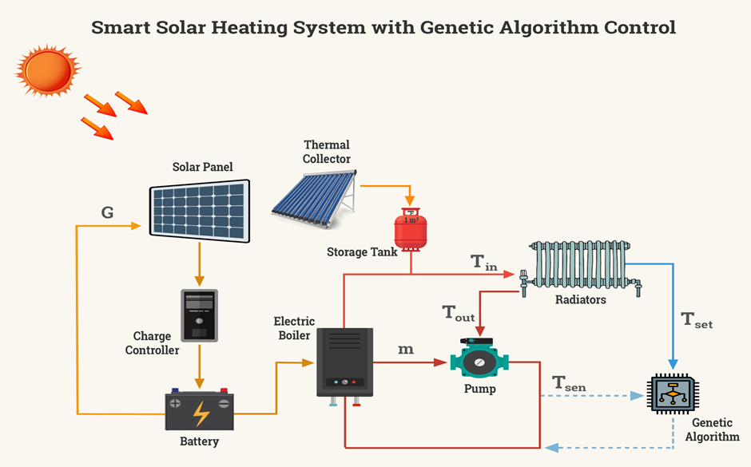
FIGURE 1. Energy-efficient heating system

$$\begin{aligned}С_{th}\frac{dT_{in}}{dt}=-U_{t}\left(T_{in}-T_{out}\right)+Q_{heat},\#\left(1\right)\end{aligned}$$

where C_{th} is the thermal capacity of the building, kWh/°C; U_{t} is the thermal loss coefficient of the building, kW/°C; T_{in} and T_{out} are the indoor and outdoor temperatures, °C; Q_{heat} is the heat flow supplied by the electric boiler or the thermal storage tank, kW.
The electricity generation of the solar panels is expressed, according to [3,7], by the following equation:
$$\begin{aligned}{ P}_{pv}\left(t\right)=P_{nom}·f_{irr}\left(t\right)·η_{inv} , \#\left(2\right)\end{aligned}$$
where P_{nom} is the nominal power of the PV system, kW; f₍_{irr}₎(t) is the relative solar irradiation according to Global Solar Atlas data; η_{inv} is the efficiency of the inverter.
The charging and discharging of the battery energy storage system can be described using the standard SOC model formula presented in [5,18]:
$$\begin{aligned}SOC\left[k+1\right]=SOC\left[k\right]+η_{ch}{·P}_{ch}\left[k\right]∆t-\frac{1}{η_{dis}}·P_{dis}\left[k\right]∆t,\#\left(3\right)\end{aligned}$$
where SOC[k] is the state of charge of the battery at step k, kWh; P_{ch}[k] is the charging power, kW; P_{dis}[k] is the discharging power, kW; η_{ch}, η_{dis} are the charging and discharging efficiencies; Δt is the simulation time step.
The thermal storage tank model is described by the classical single-mass (well-mixed) model [19] using the following equation:
$$\begin{aligned}E_{TES}\left[k+1\right]=E_{TES}\left[k\right]+η_{ch}^{TES}·Q_{in}\left[k\right]-\frac{1}{η_{ch}^{TES}}·Q_{out}\left[k\right],\#\left(4\right)\end{aligned}$$
where Eₜₑₛ is the current energy stored in the tank, kWh; Q_{in} and Q_{out} are the heat supplied from the boiler to the tank and the heat delivered from the tank to the heating system, respectively; η_{ch}^{TES} and η_{dis}^{TES} are the charging and discharging thermal exchange efficiencies.
The thermal energy generated by the electric boiler is defined as follows:
$$\begin{aligned}Q_{boiler}\left(t\right)=η_{ch}·P_{boiler}\left(t\right),\#\left(5\right)\end{aligned}$$
The main energy balance during daytime operation in hybrid systems is characterized as follows [18], [19]:
$$\begin{aligned}E_{pv}=E_{load}+E_{TES}^{ch}+E_{BESS}^{ch}+E_{export},\#\left(6\right)\end{aligned}$$
E_{pv} is the total energy generated by the PV system during the interval Δt; E_{load} is the electrical energy required to supply the boiler and other auxiliary equipment; E_{TES}ᶜʰ is the energy used for heating the water in the storage tank; E_{BESS}ᶜʰ is the energy used to charge the battery storage system; E_{export} is the energy exported to the grid.
At night:
$$\begin{aligned}E_{load}=E_{TES}^{dis}+E_{BESS}^{dis}+E_{grid},\#\left(7\right)\end{aligned}$$
where E_{TES}ᵈⁱˢ is the energy supplied from the thermal storage tank to the heating system; E_{BESS}ᵈⁱˢ is the energy delivered from the battery storage system; E_{grid} is the energy drawn from the electrical grid.
The objective function of the Genetic Algorithm is defined as follows:
$$\min{F=\sum_{k=1}^{96}{E_{grid}[k]}},\# \left(8\right)$$
The initialization of the population consists of randomly generating 𝑁_{pop} feasible solutions that satisfy the operational constraints of the battery state of charge (SOC), the thermal energy storage (TES), and the boiler’s power limits.
The selection stage employs tournament selection, which ensures the preservation of the most promising control strategies and increases their likelihood of propagating into the next generation.The crossover operator utilizes both single-point and uniform crossover with a probability of 𝑃𝑐=0.8, enabling effective recombination of successful solution components and contributing to the creation of higher-quality offspring. The mutation operator applies bitwise mutation with a probability of 𝑃𝑚=0.05, ensuring sufficient exploration of the solution space and preventing premature convergence to local optima. The primary objective of the genetic algorithm is to minimize electricity costs and reduce dependence on the external power grid. Evolutionary optimization methods for hybrid energy systems are extensively discussed in [5,10,12,20].
It should be noted that the equations presented above describe the operation of each subsystem within the PV–BESS–TES architecture individually. However, accurate modeling of a hybrid energy system requires a unified integrated representation that captures the interactions among all energy flows. Therefore, the study additionally introduces a generalized power balance equation, allowing the system to be treated as a single energy-exchange structure.
The overall energy balance at time step 𝑘 is described by the following relation:
$$\begin{aligned}E_{pv}\left[k\right]+E_{grid}\left[k\right]=E_{load}\left[k\right]+E_{TES}^{ch}\left[k\right]+E_{BESS}^{ch}\left[k\right]-E_{TES}^{dis}\left[k\right]+E_{BESS}^{dis}\left[k\right],\#\left(9\right)\end{aligned}$$
This expression represents the distribution of energy among the photovoltaic generation, the battery energy storage system, the thermal energy storage unit, the building load, and the electrical grid. It integrates the individual component models into a unified system framework and serves as the foundation for the optimization algorithms.
For daytime operation, when photovoltaic generation is present, the power distribution can be formulated as follows:
$$\begin{aligned}P_{pv}\left(k\right)=P_{load}\left[k\right]+P_{BESS}^{ch}\left[k\right]+P_{TES}^{ch}\left[k\right]+P_{export}\left[k\right],\#\left(10\right)\end{aligned}$$
and for the evening and nighttime periods, when photovoltaic generation is absent or negligible, the power distribution is expressed as follows:
$$\begin{aligned}P_{load}\left[k\right]=P_{BESS}^{dis}\left[k\right]+P_{TES}^{dis}\left[k\right]+P_{grid}\left[k\right],\#\left(11\right)\end{aligned}$$
These equations ensure the coordinated interaction of the PV module, the battery storage system, and the thermal energy storage unit, thereby forming a complete mathematical framework for analyzing the hybrid heating system. The integrated model captures the synergistic effects among the system components and enables subsequent optimization using artificial intelligence–based methods.

TABLE 1. Comparison between the hybrid and conventional heating systems
Comparison Parameter | Hybrid System (PV + TES + BESS + GA) | Conventional Electric Boiler
Daily electricity consumption from the grid | 4–5 kWh/day | 30–45 kWh/day
Energy savings | 75–90% | 0%
Daytime operating mode | PV → Load → TES → BESS | Grid
Nighttime operating mode | TES (70–80%), BESS (20–30%), Grid (0–5%) | Grid only
Indoor temperature | Stable 20–22°C | Stable 20–22°C
Autonomy level | 60–80% per day | 0%
Peak load on the grid | Low — smoothed by TES and BESS | High — corresponds to demand peaks
Operating cost | Low (PV covers most of the load) | High
Required investment | PV 10 kW: 50 million UZS; TES 1 m³: 12 million UZS; BESS 15 kWh: 18 million UZS. Total: 80 million UZS | Electric boiler 10 kW: ~5 million UZS
Payback period | 3–5 years (depending on tariffs) | No payback

EXPERIMENTAL RESEARCH
A series of simulation experiments was conducted to evaluate the performance of the hybrid heating system, including the operation of the PV–BESS–TES–Boiler configuration under the climatic conditions of a typical winter day in Tashkent. The simulation was performed in discrete time with a 1-hour step over a 24-hour horizon, consistent with widely accepted modeling practices for energy systems with a high share of renewable generation. To ensure reproducibility, multiple simulation runs were carried out, covering representative winter conditions of Tashkent.
The expected daily output of the 10 kW photovoltaic system (PV), estimated at 18–22 kWh/day, was obtained from hourly solar radiation data for January based on IEA datasets [2] and the Global Solar Atlas, where the mean GHI ranges from approximately 4.5 to 4.8 kWh/m²/day [3].
The parameters of all system components were predefined as follows: PV system:
P_{nom}=10 kW, inverter efficiency η_{inv}=0.96;
BESS: capacity = 30 kWh, charge/discharge power = 5 kW;
TES: capacity = 100 kWh, η_{ch}=0.9, η_{dis}=0.9;
Electric boiler: P_{nom}=10 kW;
Building: thermal capacity C_{th}=20 kWh/°C, heat loss coefficient Ut=0.5 kW/°C.
The simulation employed a standard model of solar-to-electric power conversion that accounts for inverter efficiency (η_{inv}=0.96), temperature correction factors, and PV module degradation. The peak generation occurs around midday, creating a significant temporal mismatch between maximum PV output and the peak thermal demand profile. This mismatch makes direct utilization of solar energy for heating impossible without energy storage, which is also emphasized in numerous studies on solar heating systems [4,6].
During the daytime, thermal energy accumulation in TES is the key mechanism enabling system autonomy. A thermal storage tank of 1 m³ can accumulate up to 46.5 kWh of heat, and the simulation results show that it becomes fully charged between 13:00 and 16:00 due to excess solar generation. This amount of stored energy is sufficient to cover 70–80% of the nighttime heating demand. The dominant role of TES in the daily thermal balance aligns with international research demonstrating the high effectiveness of thermal storage in solar-based heating systems. The TES discharge dynamics follow the thermophysical model and maintain indoor temperatures above 20°C until morning, consistent with the results of building thermal RC-models [4].
The performance of the proposed hybrid system is strongly influenced by external factors that affect energy generation, storage, and the overall thermal balance of the building. In this study, the impact of major climatic and operational parameters was analyzed through a sensitivity assessment. The daily output of the PV module is determined by the hourly GHI profile, which exhibits considerable variability in winter. Three representative illumination scenarios were modeled:
Clear sky (100% irradiance): 20–22 kWh/day
Partly cloudy (60–70% irradiance): 12–15 kWh/day
Overcast (20–40% irradiance): 5–8 kWh/day

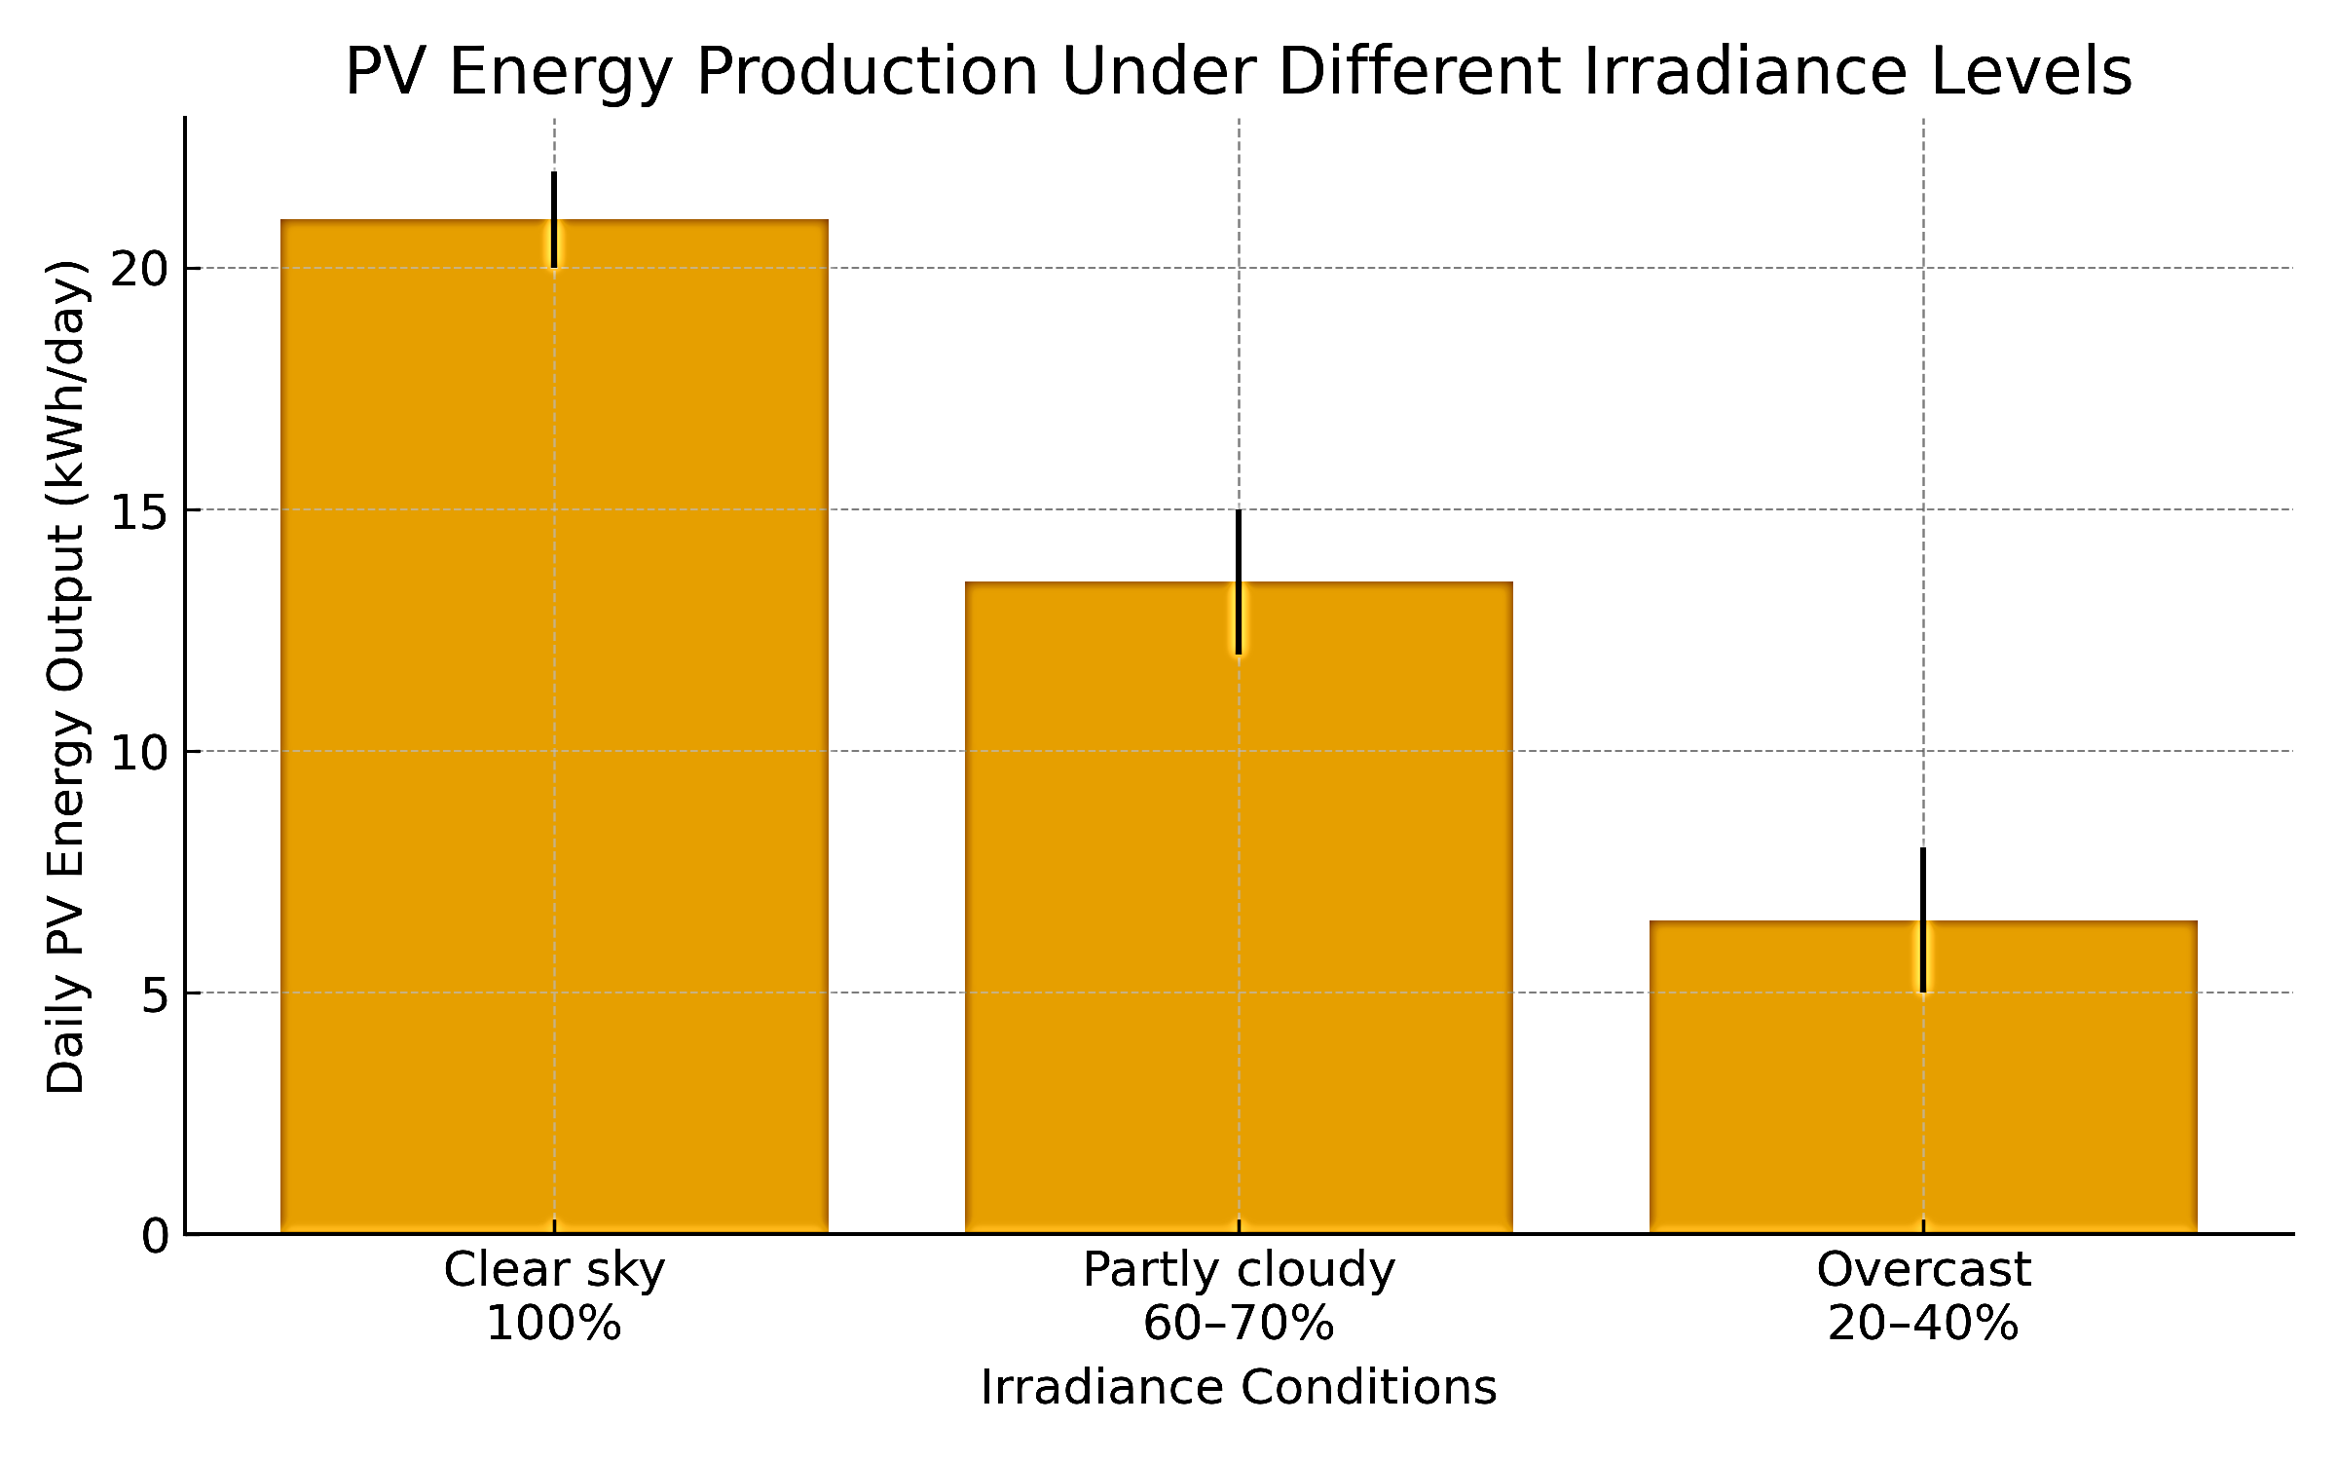
FIGURE 2. Photovoltaic generation performance under different solar irradiance levels
The figure illustrates the hourly PV output profiles under three representative weather conditions—clear sky, partly cloudy, and overcast. Clear-sky conditions yield the highest and most stable generation peak around midday, corresponding to maximum available irradiance. Partly cloudy conditions reduce both the magnitude and duration of peak output due to intermittent shading effects. Under overcast conditions, PV generation is substantially suppressed, resulting in a flattened and significantly lower energy profile. These scenarios highlight the strong dependency of PV production on solar resource variability and demonstrate the need for storage-based compensation within the hybrid PV–BESS–TES system.
As solar irradiance decreases, the share of energy supplied by BESS and TES increases, highlighting the necessity of optimal control strategies for energy allocation among storage units.
The battery system (BESS) in this study serves mainly a supporting role: it compensates for short-term peaks in thermal demand during the evening and late-night periods when the TES approaches its minimum charge level. Under such conditions, BESS provides 2–4 hours of additional load coverage, reducing grid consumption and smoothing demand peaks. The obtained SOC profiles align well with the typical behavior of lithium-ion storage units deployed in hybrid systems and microgrids [11]. However, TES contributes substantially more to the overall energy balance than BESS, reinforcing findings from previous studies that thermal storage is significantly more effective than electrical storage for heating applications [4,6].

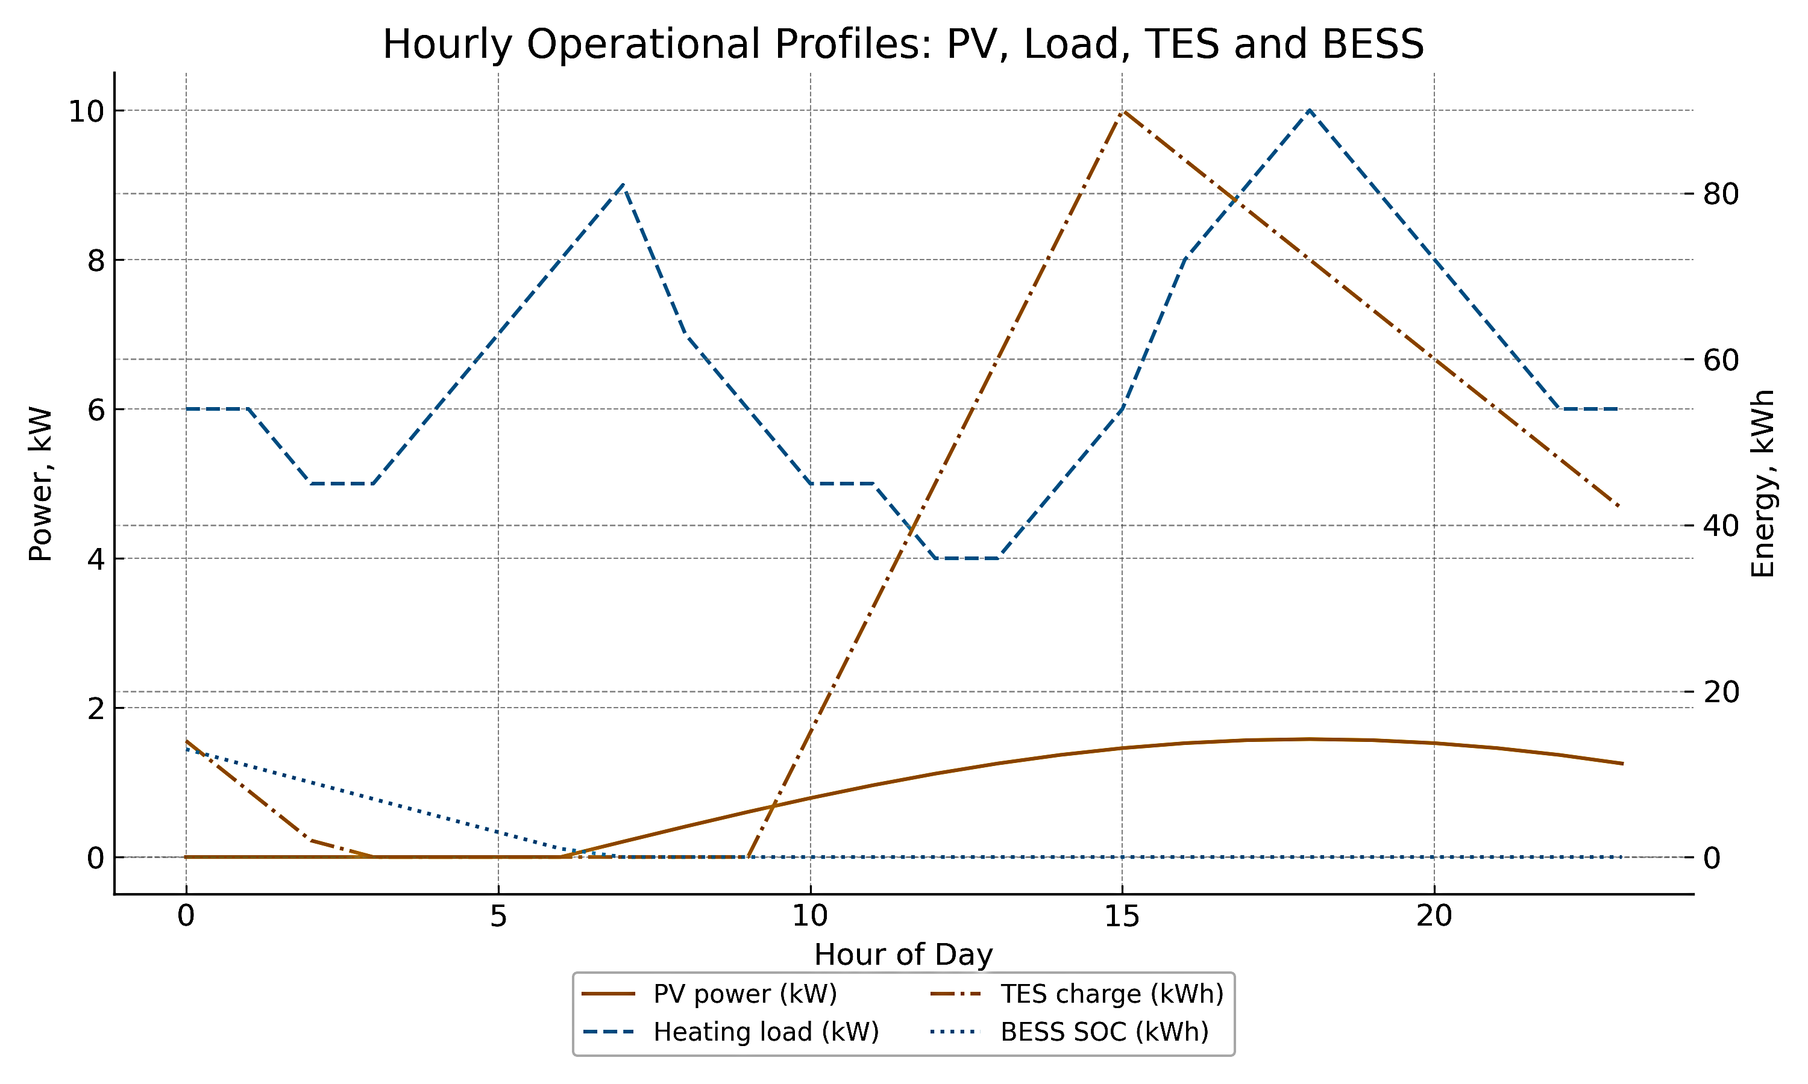
FIGURE 3. Hourly dynamics of PV output, load consumption, TES charge, and BESS SOC

The figure shows the hourly operational behavior of the hybrid heating system, including photovoltaic (PV) generation and building thermal load (left axis, kW) as well as the charge levels of the thermal energy storage (TES) and the battery energy storage system (BESS) (right axis, kWh). The results highlight the midday peak in PV output, the accumulation of thermal energy in the TES during daylight hours, and the coordinated contribution of TES and BESS in supplying the nighttime heating demand.
The figure presents the hourly profiles of building heating load, PV generation, and grid electricity consumption under clear-sky conditions (100% solar irradiance). Strong daytime PV output provides substantial surplus energy, resulting in significantly reduced grid demand. Evening peak demand is partially supported by energy storage, illustrating the high performance of the PV–BESS–TES hybrid system in favorable irradiance conditions.

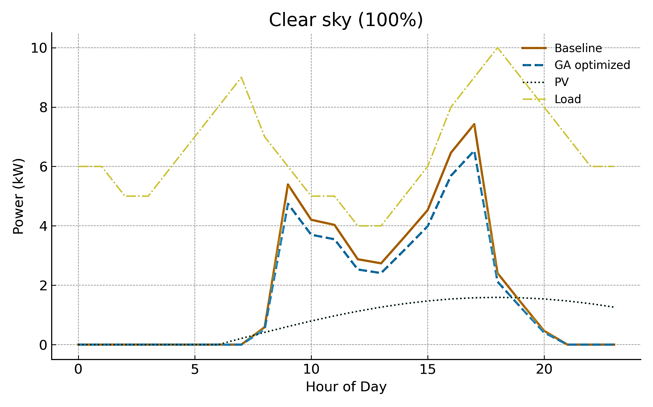
FIGURE 4. Hourly profiles of load, PV generation, and grid consumption under clear-sky conditions
(100% solar irradiance).

A crucial aspect of the analysis is the impact of the genetic algorithm on the overall system performance. The GA objective function minimizes total grid electricity consumption, and the simulation results show that the optimization algorithm reduces grid demand by an additional 10–15% compared to conventional rule-based control. This confirms the effectiveness of evolutionary algorithms for energy flow management and hybrid system optimization [5,10,12]. The GA determines optimal charging schedules for TES and BESS, redistributes PV generation throughout the day, and optimizes the operating schedule of the electric boiler. Similar improvements in performance with optimization-based control methods are reported in domestic research on electric drives and energy facilities [13–15].
RESEARCH RESULTS
The performance of the proposed hybrid PV–BESS–TES heating system was evaluated through a series of simulations representing typical winter conditions for the city of Tashkent. The analysis focused on hourly system behavior, the effectiveness of energy storage coordination, and the contribution of the genetic algorithm (GA) to reducing reliance on the electrical grid.
1. PV Generation and Load Interaction Under Different Irradiance Conditions
Three irradiance scenarios were examined—clear sky, partly cloudy, and overcast.
Results demonstrate that:
Under clear-sky conditions (100% irradiance), daytime PV generation significantly exceeds the heating demand, enabling substantial charging of TES and minimizing grid consumption.
In partly cloudy conditions (60–70%), reduced PV availability increases mid-day grid dependency; however, coordinated storage operation still offsets a major share of evening peak demand.
Under overcast conditions (20–40%), PV output becomes insufficient to meet daytime load, resulting in higher network consumption; even so, TES and BESS mitigate peak loads through strategic discharge.
Across all scenarios, the hybrid architecture consistently demonstrates improved stability and reduced grid stress compared to conventional electric heating systems.
2. Effectiveness of TES and BESS Coordination
Simulation results confirm that:
TES provides up to 70–80% coverage of nighttime heating demand on clear-sky days.
BESS supports short-term deficits, particularly during evening peaks, supplying 2–4 hours of load coverage depending on SOC constraints.
Combined TES+BESS operation reduces peak grid power by smoothing high-demand intervals and storing excess PV energy when available.
The energy-balancing behavior is illustrated through hourly operational profiles, which show coordinated charging during PV surplus hours and controlled discharge during peak loads.
3. Impact of Genetic Algorithm Optimization
The introduction of GA-based control significantly improves the system’s performance relative to rule-based strategies:
Grid energy consumption is reduced by 10–15%, depending on irradiance conditions.
GA effectively schedules TES and BESS charging during periods of maximum solar availability.
Evening grid peaks are reduced through optimized discharge cycles (peak shaving).
The boiler operates in a more efficient mode, avoiding unnecessary activation during high-PV intervals.
The optimization surface demonstrates that GA consistently converges toward schedules that minimize grid dependency while satisfying comfort constraints for indoor temperature.
4. System-Level Benefits
Overall, results indicate that the hybrid PV–BESS–TES system with GA optimization offers:
Substantial energy savings for residential heating applications;
Improved autonomy of up to 60–80% in clear-sky conditions;
Lower operational costs due to reduced electricity withdrawals during peak tariff hours;
Enhanced system resilience under variable irradiance conditions.
These findings confirm the feasibility of deploying GA-optimized hybrid energy systems in cold-climate regions with high solar potential, such as Uzbekistan. The developed methodology offers a scalable framework for intelligent heating control in residential buildings.
REFERENCES
- K. R. Allaev, Modern Energy and Prospects for Its Development, ed. A. U. Salimov (Fan va Texnologiyalar, Tashkent, 2021), 952 pp. https://doi.org/10.1051/e3sconf/202452401006
- International Energy Agency (IEA), Renewables 2023 (IEA, Paris, 2023). Available at: https://www.iea.org/reports/renewables-2023
- World Bank Group, Global Solar Atlas 2.0 (World Bank, 2024). Available at: https://globalsolaratlas.info
- L. Lei and S. Huang, “A mathematical model of the room temperature dynamic response in multi-zone buildings,” E3S Web Conf. 356, 03034 (2022). https://doi.org/10.1051/e3sconf/202235603034
- I. Abdullabekov, M. Mirsaidov, F. Tuychiev, and R. Dusmatov, “Frequency converter–asynchronous motor–pump pressure piping system mechanical specifications,” AIP Conf. Proc. 3152, 040007 (2024). https://doi.org/10.1063/5.0218880
- I. Abdullabekov and K. Sapaev, “An energy-efficient control system for water lifting units of the Ramadan pumping station based on frequency-controlled electric drives,” AIP Conf. Proc. 2552, 040023 (2023). https://doi.org/10.1063/5.0130676
- I. A. Abdullabekov, M. M. Mirsaidov, O. O. Zaripov, S. J. Nimatov, and Y. M. Eralieva, “Reducing reactive energy consumption by optimizing operating modes of irrigation pumping stations,” E3S Web Conf. 486, 06017 (2024). https://doi.org/10.1051/e3sconf/202448606017
- I. Abdullabekov, M. Mirsaidov, S. Umarov, M. Tulyaganov, and S. Oripov, “Optimizing energy efficiency in water pumping stations: A case study of the Chilonzor water distribution facility,” AIP Conf. Proc. 3331, 030107 (2025). https://doi.org/10.1063/5.0305780
- S. Umarov, K. Sapaev, and I. Abdullabekov, “The implicit formulas of numerical integration digital models of nonlinear transformers,” AIP Conf. Proc. 3331, 030105 (2025). https://doi.org/10.1063/5.0305793
- M. Tulyaganov, S. Umarov, I. Abdullabekov, and S. Adilova, “Optimization of modes of an asynchronous electric drive taking into account thermal transient processes,” AIP Conf. Proc. 3331, 030084 (2025). https://doi.org/10.1063/5.0305786
- S. Umarov, M. Tulyaganov, S. Oripov, and U. Boqijonov, “Using a modified Laplace transform to simulate valve converters with periodic topology,” in Proc. IV Int. Sci. Tech. Conf. “Actual Issues of Power Supply Systems” (ICAIPSS 2024) (2024). https://doi.org/10.1063/5.0305792
- M. Tulyaganov and S. Umarov, “Improving the energy and operational efficiency of an asynchronous electric drive,” AIP Conf. Proc. 3152, 050004 (2024). https://doi.org/10.1063/5.0218876
- S. Umarov and M. Tulyaganov, “Peculiarities of simulation of steady modes of valve converters with periodic power circuit structure,” AIP Conf. Proc. 3152 (2024). https://doi.org/10.1063/5.0218869
- H. Chen, X. Wang, C. Liu, A. A. Pulatov, and A. Musolino, “Design of a three-phase high torque density modular linear rotary switched reluctance launcher,” IEEE Trans. Plasma Sci. 53(10), 2653–2661 (2025).
- J. Liu, H. Chen, A. A. Pulatov, V. T. Nguyen, and X. Li, “Fault-tolerant control method for inter-turn short circuit faults of switched reluctance linear motors in rail transit,” IEEE Trans. Transp. Electrification (2025).
- A. Mirisaev, A. Pulatov, and K. Muminov, “Improving the energy efficiency of power supply systems and electrical equipment of induction plants of metallurgical enterprises,” AIP Conf. Proc. 3152, 030004 (2024).
- A. Mirisaev, A. Pulatov, and M. Shamiev, “The impact of the operation of electric drives on the reliability and energy efficiency of power supply systems of industrial enterprises,” AIP Conf. Proc. 3152, 030005 (2024).
- A. D. Petrushin and M. Tulyaganov, “Optimal control of switched reluctance motor for high-speed rail transport,” in Proc. Int. Conf. on Industrial Engineering, Applications and Manufacturing (ICIEAM 2024) (2024). https://doi.org/10.1109/ICIEAM60818.2024.10553741
- Kursiv Media, “Solar PV generation in Uzbekistan reached 875 million kWh,” (2025). Available at: https://www.kursiv.media/
- Kun.uz, “Green energy production in Uzbekistan exceeded 20%,” (2025). Available at: https://kun.uz/
- O. V. Radionova and R. A. Sitdikov, “Demand response in modern power systems,” Problems of Energy and Energy Saving 1, 17–23 (2025). https://doi.org/10.5281/zenodo.15094558
- D. Parra, S. A. Norman, and G. S. Walker, “Optimum community energy storage for renewable energy and demand load management,” Applied Energy 200, 358–369 (2017). https://doi.org/10.1016/j.apenergy.2017.05.048

