Modeling heating and metal melting processes in induction crucible furnaces based on the method of transformed equivalent thermal circuits
Abror Pulatov ^{a)}, Niyoz Makhmudov, Kutbiddin Boboniyozov, Humoyun Muminov
¹Tashkent State Technical University named after Islam Karimov, Tashkent, Uzbekistan
^{a)} Corresponding author: abrorobidovich@mail.ru
Abstract. This paper presents a study on modeling the thermal processes in induction crucible furnaces. The principles of constructing thermal models for structural components and molten metal based on a novel method of transformed equivalent thermal circuits are described. The proposed method is applied to the development of energy-efficient automatic control systems for heating and metal melting processes. New approaches to calculating thermal regimes are introduced, and methods for their computation using transformed thermal circuits are presented.
INTRODUCTION
Due to the complexity of calculating the heating process of the metal being melted and the main structural components of crucible induction furnaces, there is great interest in developing a methodology based on a new approach to transforming equivalent thermal circuits (ETC). This approach involves a relatively small volume of computational operations and a rational calculation algorithm, allowing the results of the stationary heating process to be obtained for the stationary heating process of a crucible induction furnace [1].
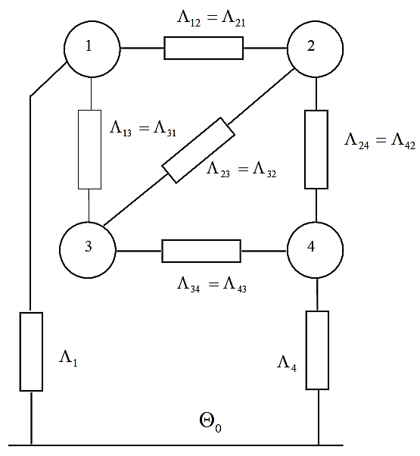
FIGURE 1. Equivalent thermal scheme of induction crucible furnaces.
The specifics of using ETC (Equivalent Thermal Circuit) to study the heating processes of main structural components and molten metal in crucible induction furnaces lie in the fact that, depending on the number of thermal bodies considered and the furnace control law, a system of heat balance equations is compiled according to its thermal replacementcircuit. In this case, variations in electrical and thermal parameters are assumed to be lumped, in accordance with the control frequency. The installation is assumed to be symmetrical and is represented as a thermal system consisting of four thermally interrelated bodies: molten metal, inductor, lining, and housing with internal heat sources (Fig. 1). These thermal bodies are connected to each other by corresponding thermal conductivities. The molten metal and housing also transfer heat to the surrounding environment, and all thermal bodies have their respective heat sources [1,2].
We compose a system of differential equations for the heat balance of the corresponding ETC:
$\left.\begin{matrix}С_{1}\frac{dΘ_{1}}{dt}+Λ_{11}Θ_{1}-Λ_{12}Θ_{2}-Λ_{13}Θ_{3}=P_{1}, \\ С_{2}\frac{dΘ_{2}}{dt}-Λ_{21}Θ_{1}+Λ_{22}Θ_{2}-Λ_{23}Θ_{3}-Δ_{24}Θ_{4}=P_{2}, \\ С_{3}\frac{dΘ_{3}}{dt}-Λ_{31}Θ_{1}-Λ_{32}Θ_{2}+Λ_{33}Θ_{3}-Λ_{34}Θ_{4}=P_{3}, \\ С_{4}\frac{dΘ_{4}}{dt}-Λ_{42}Θ_{2}-Λ_{43}Θ_{3}+Λ_{44}Θ_{4}=P_{4}\end{matrix}\right\}$ (1)
In the heat balance equations and in the conventional designations in the ETC (Figure 1), the same notations are adopted - the indices indicate the serial number of the considered active parts of the ICF:
MATHEMATICAL MODEL
Using this calculation method, it is possible to calculate the thermal heating processes occurring in the molten metal of the induction furnace.
Since the stationary heating mode of an induction furnace is a special case of a transient one, assuming that $\frac{dΘ_{1}}{dt}=\frac{dΘ_{2}}{dt}=\frac{dΘ_{3}}{dt}=\frac{dΘ_{4}}{dt}=0$, we obtain a system of heat balance equations and write it in matrix form:

$\left[\begin{aligned}&Λ_{11}-Λ_{12}-Λ_{13}0 \\ &-Λ_{21}Λ_{22}-Λ_{23}-Λ_{24} \\ &-Λ_{31}-Λ_{32}Λ_{33}-Λ_{34} \\ &0-Λ_{42}-Λ_{43}Λ_{44}\end{aligned}\right]⋅\left[\begin{aligned}&Θ_{1} \\ &Θ_{2} \\ &Θ_{3} \\ &Θ_{4}\end{aligned}\right]=\left[\begin{aligned}&P_{1} \\ &P_{2} \\ &P_{3} \\ &P_{4}\end{aligned}\right]$ (2)

In the equations presented above, thermal conductivities, heat transfer coefficients, and heat capacities are determined based on the given geometric dimensions of the elements and parts of the induction furnace and the thermophysical parameters of the materials used in them [3].
Due to the similarity of thermal circuits to linear electrical circuits, with corresponding assumptions adopted, we use the method of equivalent transformation of linear electrical circuits with the exclusion of unknowns for these circuits, which allows us to reduce the number of thermal bodies under consideration to a minimum. In this case, thermal conductivities and heat transfer coefficients are transformed as passive elements of a linear electrical circuit, while heat losses and heat capacities are transformed as active elements.[6]
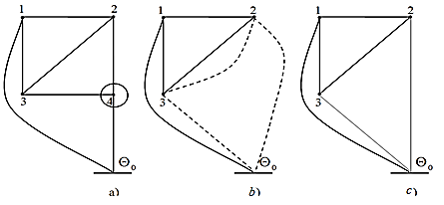
FIGURE 2. Transformed geometric representation of the ETC ITP.
a) Initial geometric representation: the ETC of the ITP showing four thermal bodies and their thermal conductivities; b) Transformed geometric representation: results after applying transformations with new thermal conductivities and heat transfer coefficients; c) Simplified or final transformed representation: the final connections and heat flows after transformation.
ITP is represented as a thermal system consisting of four interconnected thermal bodies (Fig. 2). The transformation procedure of the ETC is considered for transforming the ETC. For convenience and clarity in the transformation of the ETC of the ITP presented in Figure 2, we use its geometric representation (Fig. 2,a), where the points denote the ordinal numbers of the thermal bodies, the connecting lines represent thermal conductivities; Θ₀ is the ambient temperature, and the lines leading to it indicate the heat transfer from thermal bodies, while the dotted lines indicate the results obtained after transformations of new thermal conductivities and heat transfer coefficients [4].
The sequence for determining temperature elevations in the transient and stationary heating modes of the ITP for the sought thermal bodies is established based on the smaller volume of computational operations.[7]
The presented geometric representation of the ETC ITP (Fig. 2,a) is transformed by eliminating thermal body 4-"casing" (Fig. 2,b) and the star of thermal conductances "Λ₄₂-Λ₄₃-Λ₄" by equivalently replacing it with a triangle of thermal conductances, we obtain a new transformed ETC (Fig. 2,c) with the following thermal parameters:
$Λ_{2}=\frac{Λ_{42}⋅Λ_{4}}{Λ_{44}}$, $Λ_{23}^{'}=Λ_{23}+\frac{Λ_{43}⋅Λ_{42}}{Λ_{44}}$, $Λ_{3}=\frac{Λ_{43}⋅Λ_{4}}{Λ_{44}}$, $Λ_{11}=Λ_{12}+Λ_{13}+Λ_{1}$,
$Λ_{22}^{'}=Λ_{21}+Λ_{23}^{'}+Λ_{2}$,$Λ_{33}^{'}=Λ_{31}+Λ_{32}^{'}+Λ_{3}$,$C_{2}^{'}=C_{2}+\frac{Λ_{42}}{Λ_{44}}C_{4}$,$C_{3}^{'}=C_{3}+\frac{Λ_{43}}{Λ_{44}}C_{4}$.
The system of equations for the stationary (temperature reaches the specified value and the holding process occurs) and transient (maximum power) heating modes of the corresponding transformed ETC of the ITP with thermal bodies:
1 - "metal to be melted," 2 - "inductor," 3 - "lining" (Fig. 2, c) has the following form:
$$C_{1}\frac{dΘ_{1}}{dt}+Λ_{11}Θ_{1}-Λ_{12}Θ_{2}-Λ_{13}Θ_{3}=P_{1}, \\ C_{2}\frac{dΘ_{2}}{dt}-Λ_{21}Θ_{1}+Λ_{22}Θ_{2}-Λ_{23}Θ_{3}=P_{2},$$$C_{3}\frac{dΘ_{3}}{dt}-Λ_{31}Θ_{1}-Λ_{32}Θ_{2}+Λ_{33}Θ_{3}=P_{3}.$ (3)
$\left[\begin{aligned}&Λ_{11}-Λ_{12}-Λ_{13} \\ &-Λ_{21}Λ_{22}^{'}-Λ_{23}^{'} \\ &-Λ_{31}-Λ_{32}^{'}Λ_{33}^{'}\end{aligned}\right]⋅\left[\begin{aligned}&Θ_{1} \\ &Θ_{2} \\ &Θ_{3}\end{aligned}\right]=\left[\begin{aligned}&P_{1} \\ &P_{2} \\ &P_{3}\end{aligned}\right]$ (4)
Thus, after equivalent transformations, this ETC is replaced by transformed ETCs for each thermal body, which are not thermally related, and to which the corresponding heat balance equations for the transient heating regime are applied, having first-order differential equations, and for the stationary heating regime - the square matrix of thermal conductances is replaced by a diagonal matrix of transformed heat transfer coefficients [5].
RESULTS AND DISCUSSION
By combining the transformed equivalent thermal circuits the transformed equivalent thermal schemes of the thermal bodies of the induction furnace, we represent them as equivalent to the original ETC (Fig. 3), where a is the geometric representation of the transformed ETC of the thermal bodies of the induction furnace, b is the transformed ETC of the thermal bodies of the induction furnace.[8]

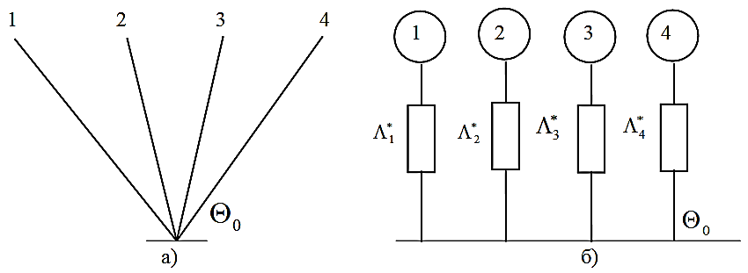
a) b)
FIGURE 3. Transformed ETC of the induction furnace; a - geometric representation of the transformed ETC of the thermal bodies of the induction furnace; b - transformed ETC of the thermal bodies of the induction furnace

Accordingly, for the transformed ETC, we formally combine the heat balance equations for transient and stationary heating regimes, and compose a system of equations for transient and stationary regimes.[10]
$\left[\begin{aligned}&Λ_{1}^{*}000 \\ &0Λ_{2}^{*}00 \\ &00Λ_{3}^{*}0 \\ &000Λ_{4}^{*}\end{aligned}\right]⋅\left[\begin{aligned}&Θ_{1} \\ &Θ_{2} \\ &Θ_{3} \\ &Θ_{4}\end{aligned}\right]=\left[\begin{aligned}&P_{1}^{*} \\ &P_{2}^{*} \\ &P_{3}^{*} \\ &P_{4}^{*}\end{aligned}\right]$ (5)

$\left[\begin{aligned}&Λ_{1}^{*}000 \\ &0Λ_{2}^{*}00 \\ &00Λ_{3}^{*}0 \\ &000Λ_{4}^{*}\end{aligned}\right]⋅\left[\begin{aligned}&Θ_{1} \\ &Θ_{2} \\ &Θ_{3} \\ &Θ_{4}\end{aligned}\right]=\left[\begin{aligned}&P_{1}^{*} \\ &P_{2}^{*} \\ &P_{3}^{*} \\ &P_{4}^{*}\end{aligned}\right]$ (6)
The solution to the equation of the transient thermal regime of the molten metal process has the following form:
$Θ_{1}\left(t\right)=Θ_{1}\left(1-e^{-t/{T_{1}^{*}}}\right)$ (7)
where Θ₁ is the excess temperature of the melting metal during pouring, ⁰C, T*₁ is the calculated constant heating time of the molten metal.
The presented thermal model of the induction steelmaking furnace reflects its main features and allows for the development of measures to ensure energy and resource conservation through mathematical modeling.[9] A functional diagram for regulating the thermal regime of the induction furnace is proposed using the calculated temperature of the molten metal obtained from the mathematical model of the furnace's thermal state, which is presented in Figure 4.
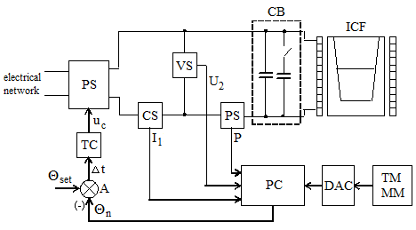
FIGURE 4. Functional diagram of the automatic control system for the operating mode of the induction crucible furnace using the thermal model of the molten metal: PS - power supply, CS, VS and PS - current, voltage, and power sensors, CB - capacitor banks, ICF - induction crucible furnace, A - adder, PC - programmable controller, DAC - digital-to-analog converter, TM MM - thermal model of the molten metal.
CONCLUSIONS
Thus, considering an induction crucible furnace as a thermal system consisting of four thermally interconnected bodies with internal heat sources, the determination of temperature rises in the specified parts of the furnace can be carried out based on the aforementioned methodology for converting the equivalent thermal circuit.
The presented method for calculating the heating of crucible induction furnaces using equivalent thermal circuits and the obtained transformed thermal parameters Λ*i, P*i, C*i are generalized transformed calculation parameters of the considered active parts of the crucible induction furnace. The transformed calculated heat transfer Λ*i of the i-th thermal body is such a heat transfer that accounts for all existing heat exchanges of this thermal body with other bodies and heat transfer to the surrounding environment of the crucible induction furnace housing. The transformed calculated power losses P*i are not only the losses of a given thermal body but also the sum of losses from other considered thermal bodies that contribute to heating the given thermal body of the crucible induction furnace. The transformed calculated heat capacity C*i is not only the heat capacity of a given thermal body but also the sum of heat capacities of other considered thermal bodies that contribute to increasing the heat capacity of the given thermal body of the induction crucible furnace.
REFERENCES
- A. A. Khashimov, A. T. Imamnazarov, and A. A. Pulatov, Thermal Operating Conditions of Induction Crucible Furnaces (Fan va Texnologiyalar, Tashkent, 2013), 118 pp.
- A. Mirisaev, A. Pulatov, and K. Muminov, “Improving the energy efficiency of power supply systems and electrical equipment of induction plants of metallurgical enterprises,” AIP Conf. Proc. 3152(1), 030004 (2024). https://doi.org/10.1063/5.0218879
- A. A. Pulatov, A. A. Khashimov, and A. T. Imamnazarov, “Application of the method of equivalent thermal circuits in calculating thermal modes of induction crucible furnaces in steady-state and transient conditions,” AIP Conf. Proc. 2552, 040014 (2022). https://doi.org/10.1063/5.0111948
- A. A. Khashimov, A. T. Imomnazarov, and A. O. Pulatov, “Mathematical model of metal melting processes in crucible furnaces,” in Proc. Int. Symp. on Heating by Electrothermal Sources, Padua, Italy (2004), pp. 52–55.
- A. A. Pulatov, “Features of developing an equivalent thermal circuit for induction crucible furnaces with a closed lid,” Bull. Tashkent State Technical University 1, 74 (2018).
- M. Tulyaganov and S. Umarov, “Improving the energy and operational efficiency of an asynchronous electric drive,” in Proc. III Int. Sci. Tech. Conf. “Actual Issues of Power Supply Systems” (ICAIPSS 2023) (2023). https://doi.org/10.1063/5.0218876
- S. Umarov, K. Sapaev, and I. Abdullabekov, “The implicit formulas of numerical integration digital models of nonlinear transformers,” AIP Conf. Proc. 3331, 030105 (2025). https://doi.org/10.1063/5.0305793
- S. Umarov, M. Tulyaganov, S. Oripov, and U. Boqijonov, “Using a modified Laplace transform to simulate valve converters with periodic topology,” AIP Conf. Proc. 3331, 030104 (2025). https://doi.org/10.1063/5.0305792
- M. Tulyaganov, S. Umarov, I. Abdullabekov, and S. Sobirova, “Optimization of modes of an asynchronous electric drive,” AIP Conf. Proc. 3331, 030084 (2025). https://doi.org/10.1063/5.0305786
- I. Abdullabekov, M. Mirsaidov, S. Umarov, M. Tulyaganov, and S. Oripov, “Optimizing energy efficiency in water pumping stations: A case study of the Chilonzor water distribution facility,” AIP Conf. Proc. 3331, 030107 (2025). https://doi.org/10.1063/5.0305780
- I. Abdullabekov and K. Sapaev, “An energy-efficient control system for water lifting units of the Ramadan pumping station based on frequency-controlled electric drives,” AIP Conf. Proc. 2552, 040023 (2023). https://doi.org/10.1063/5.0130676

