Ensuring the operational reliability of the Central Asian power system under large scale deployment of renewable energy sources
Shukhrat Khamidov ^{1, a)}, Rasulbek Tanirbergenov ¹, Bakhrom Normuratov²
¹ Academy of Sciences of Uzbekistan, Tashkent, Uzbekistan
² Tashkent State Technical University, Tashkent, Uzbekistan
^{a)} Corresponding author: khamidov_sh@mail.ru
Abstract. Large scale expansion of renewable energy in the Central Asian interconnected power system requires a systematic justification of tools for maintaining power and energy balance. Short term unpredictable fluctuations and daily variability of wind and solar generation may increase stability risks and lead to curtailments or shortages. The article indicates that coordinated integration of ESS with renewable and conventional generation reduces uncompensated imbalances, improves system stability, decreases losses and defers grid reinforcement investments. Scenario estimates of capacity deficit coverage under different renewable growth trajectories are provided.
INTRODUCTION
The energy security of Central Asian countries is vulnerable to resource and price risks, while accelerated integration of renewable energy sources can simultaneously reduce dependence and increase energy system resilience. In Uzbekistan, approximately 85% of annual electricity generation comes from gas-fired power plants, and the Uzbekistan-2030 strategy aims to increase production to 120 TWh and raise the share of renewable energy to 40% [1]. This shifts the task of integrating solar and wind energy systems from pilot projects to a systematic transformation of networks, operational modes, and market mechanisms.
For reliable parallel operation of the region's unified power system, modernization of substations and power lines, implementation of SCADA/EMS, development of emergency control systems, expansion of reserves, and deployment of ESS portfolios are required. Practice shows that without adequate regulation, distributed solar and wind generation leads to voltage fluctuations, frequency deviations, increased forced limitations, and the risk of cascading failures. Therefore, technological integration of renewable energy sources should rely on forecasting, intelligent control, and energy storage as sources of flexibility [2].
The dynamics of installed capacity in Uzbekistan for 2022–2025 and the structure by source types serve as a starting point for framing the system integration task and can be visualized in a diagram for readers.
TABLE 1. Structure of installed capacity of Uzbekistan by generation types and years
Year | TPP, MW | HPP, MW | SPS, MW | WPS, MW
2022 | 14915 | 2033 | 100 | 0
2024 | 17568 | 4067 | 300 | 2247
The historical context emphasizes the importance of inter-system coordination. The transition to energy self-balancing after 1991 weakened the advantages of the Central Asian Unified Power System (UPS), narrowed the scope for mutual assistance, and increased sensitivity to major disturbances. The system-wide failure on 25 January 2022 demonstrated the vulnerability of transit routes during significant imbalances and lack of flexibility [2, 3].
Population and economic growth, rapid introduction of renewable energy sources, and limited maneuverability of thermal generation are creating a chronic shortage of flexible capacity. This is being addressed through a combination of reserves, ESS, and targeted network reinforcements [2, 3]. The geography and scope of renewable energy plans in the Central Asian UPS countries up to 2030 define initial "hot spots" of network integration.
TABLE 2. Solar and wind power projects in the Central Asian IPS countries by 2030
Country | Uzbekistan | Kazahstan | Kirgizstan | Tadjikistan
Power, MW | 6500 | 3000 | 1000 | 200
High rates of renewable energy integration without synchronous flexibility growth create daily imbalances and increase accident risks, especially in narrow intersystem connections. The region needs a market mechanism that stimulates the deployment of ESS and mobile maneuverable capacities to cover primary, secondary, and tertiary reserves.
International experience illustrates both extremes. A quick response from a large battery in South Australia (Hornsdale) stabilized frequency and reduced system costs in its first year of operation [13].
Conversely, excessive wind and solar generation without sufficient reserves and storage led to power imbalances and large-scale disconnections, highlighting the sensitivity of high renewable shares to flexibility deficits [5].
Uzbekistan's installed capacity increased from 17,048 MW in 2022 to 24,182 MW in 2024 and is expected to reach 29,479 MW by the end of 2025, making system integration and management top priorities. The scientific problem is the justification of a flexibility architecture for the Central Asian UPS under accelerated renewable energy growth. The research gap lies in the lack of scenario estimates for ESS portfolios, considering network limitations, gas generation, and intersystem flows, and the absence of a coordinated reserve mechanism linked to development planning [2, 3, 4].
The research questions are formulated as follows: which energy storage configurations and scales minimize uncompensated imbalances with targeted renewable energy shares; how to combine storage location with network bottlenecks and intersystem cross-sections; what requirements for response speed and discharge duration are necessary to ensure frequency and voltage stability in the operational horizon; what design of the regional reserve and imbalance compensation market economically stimulates flexibility without increasing systemic risks [2, 3, 4].
The results of the article aim to create an evidence base for the development plans of the Central Asian Unified Power System, where energy storage facilities act as a central tool for sustainability, reliability, and cost-effectiveness of energy supply while achieving renewable energy targets.
METHODS AND MATERIALS
A synthesis of regional studies indicates an increase in the frequency and magnitude of active power imbalances as the share of RES grows and intersystem transfer capabilities become limited. Significant imbalances can rapidly destabilize key transit routes and trigger cascading outages, as demonstrated by the event on January 25, 2022 [2, 3, 4].
The presence of approximate limits of 700–1000 MW on cross-border interconnections during periods of high generation and consumption gradients necessitates targeted flexibility enhancement and the application of automated control systems, FACTS devices, and energy storage systems [2, 3, 4].
To concisely capture bottlenecks and regulatory conditions, we present a tabular summary of critical intersystem corridors, indicating voltage levels, transfer limits, and seasonal restrictions with references to sources [2, 4].
Global reviews note a consistent shift from purely economic arbitrage towards valuing system-level storage services. Modern energy storage systems are viewed as providers of fast response, frequency regulation, synthetic inertia, and local voltage support [7].
Publicly available analytical and overview publications by Uzbek scientist K.R. Allayev systematically describe the current state of the energy sector, addressing issues of diversification and integration of RES [11]. IRENA's global statistics for 2024 confirm record growth in renewable energy and the dominance of solar and wind power, which reinforces the importance of storage facilities for hourly balancing [12, 16].

TABLE 3. Key intersystem corridors of the Central Asian IPS and approximate transfer limits
Cross-section | Voltage, kV | Flow direction | Limit, MW | Restrictions | Notes
Kazakhstan North-East-South | 500 | North ↔ South | 700–1000 | Current, angular stability | Winter maximum, summer low of renewable energy; frequency coordination
Uzbekistan - Kazakhstan (Shymkent-Syrdarya) | 500 | South of Uzbekistan → South of Kazakhstan | 600–800 | Conductor current, transformer thermal stability | Reverse flows during high solar power generation
Uzbekistan - Kyrgyzstan (Fergana Valley) | 220 | Uzbekistan ↔ Kyrgyzstan | 200–300 | Longitudinal reactivity, emergency automation | Spring flood at hydroelectric power stations increases nighttime flows
Uzbekistan - Tajikistan | 500 | Tajikistan → Uzbekistan | 400–600 | Angle at low damping, current | Summer high hydropower generation; coordination of schedules
Uzbekistan - Turkmenistan | 220 | Bilateral | 150–250 | Current, local voltages | Restrictions during repairs of the Bukhara-Navoi node
Kazakhstan - Kyrgyzstan (North-Chuy Valley) | 220 | Kazakhstan → Kyrgyzstan | 200–300 | Current, angle, Chuy HPP mode | Peak restrictions in winter
Kazakhstan - Uzbekistan (Syrdarya-Zhanakorgan) | 220 | Bilateral | 150–250 | Current, thermal load of transformers | Local balancing of 220 kV nodes
Interstate corridor of Central Asian UPS - CEP | 500 | Central Asian UPS ↔ CEP | 500–800 | Parallel operation, synchronization, emergency automation | Limits depend on agreements and operational conditions

For a comprehensive picture, let's compare energy storage technologies in terms of response time, discharge duration, efficiency, lifespan, and application limitations, which can be conveniently verified in the summary table before proceeding to the methodology.
The purpose of the calculations is to quantitatively assess the effects of energy storage system portfolios and network management tools for the Central Asian Integrated Power System under accelerated growth in the share of renewable energy sources.
The initial setup is based on an hourly quasi-dynamic scheme with load and generation profiles, which takes into account active power balance, primary frequency regulation, network flow constraints, and local voltage support.
The computational problem is formulated through a system of balance equations and constraints. The active power balance at each time step is determined by the following relationship:
$P_{G}\left(t\right)+P_{imp}\left(t\right)+P_{dis}\left(t\right)-P_{ch}\left(t\right)-P_{L}\left(t\right)-P_{loss}\left(t\right)=0$ (1)
where $P_{G}$ is the total generation from traditional sources, $P_{imp}$ is the intersystem power flow, $P_{dis}$ is the storage discharge, $P_{ch}(t)$ is the storage charge, $P_{L}$ is the load, and$P_{loss}$ represents network losses.
To account for the fast-acting response of generation and storage systems to frequency disturbances, a linearized model of frequency dynamics (2) is used, with inertia and damping parameters that are valid for the regional generation structure [2, 4]:
$\frac{d Δf(t)}{dt}=\frac{ΔP_{m}(t)+P_{dis}(t)-P_{ch}(t)-ΔP_{L}(t)-D Δf(t)}{2H S_{base}}$ (2)
Where $Δf$ is the frequency deviation, $ΔP_{m}$ is the change in mechanical power of the units, $ΔP_{L}$ is the load disturbance, D is the damping coefficient, H is the specific inertia constant, $S_{base}$ is the base power.
The energy of the storage device is integrated over time steps based on the discrete energy balance (3), taking into account the efficiency of charging and discharging.
Discrete energy balance of the storage device at the $Δt$
$E(t+Δt)=E(t)+η_{ch} P_{ch}(t) Δt-\frac{P_{dis}(t) Δt}{η_{dis}}$ (3)
where E is the energy reserve, $η_{ch}$ and $η_{dis}$are charge and discharge efficiency.
Constraints on storage state and power
$0≤E(t)≤E_{max},0≤P_{ch}(t)≤P_{ch}^{max},0≤P_{dis}(t)≤P_{dis}^{max}$ (4)
TABLE 4. Comparison of energy storage system technologies by key parameters
Technology | Response Time | Discharge, h | Efficiency, % | Lifespan, cycles/years | Scale, MW | Main Services | Limitations/Risks | Maturity
Li-ion BESS (LFP, NMC) | ms-s | 0.5-4 (up to 8) | 85-94 | 3000-8000 / 6-12 | kW-GW | Frequency regulation, arbitrage, RES, primary reserve | Degradation, fire, raw materials | Commercially mature
Flow batteries (vanadium, Zn-Br) | с | 2-10 | 65-85 | 10 000-20 000 / 10-20 | hundreds of kW-tens of MW | Load leveling, RES integration, secondary and tertiary reserves | Low energy density, CAPEX | Pilot-commercial
PHES | s-min | 4-12+ | 70-85 | 40-60 years | tens of MW-GW | Daily/weekly leveling, inertia, system reserves Terrain | water resources, | Highly mature
CAES | min | 2-24 | 40-70 | 25-40 years | MW-tens of MW | Long-term storage, arbitrage, reserve | Cavern geology, efficiency depends on heat | Commercial niche
LAES | s-min | 2-10 | 50-70 | 20-30 years | MW-tens of MW | Multi-hour balancing, cold/heat utilization | Low efficiency, CAPEX | Demonstration-commercial
Supercapacitors | мс | s-min | 90-98 | up to 1e6 / 10-15 | kW-MW | Instant response, peak shifting | Low energy capacity, high cost | Commercial
Power-to-H2-to-Power | min-h | h-day-season | 25-45 | 10-20 years | MW–GW | Long-term storage, tertiary reserve | Low efficiency, infrastructure, cost | Actively developing
Gravity energy storage | с | 0.5-8 | 70-90 | 20-40 years | MW-tens of MW | Multi-cycle balancing, peak shifting | Sites, mechatronics, scale | Demonstration
SMES | мс | s-min | 90-98 | 20+ years | kW-MW | Instant stabilization, power quality | Cryogenics, cost | Niche, special applications

Active power flows in main transmission links are evaluated using DC approximation according to expression (5), followed by verification of compliance with current limits and permissible phase angle differences. This is necessary due to the limited transfer capacity of inter-system cross-sections, which is typically in the range of 700–1000 MW [2, 4]. DC-approximation of power flow along the i-j line:
$P_{ij}(t)=\frac{δ_{i}(t)-δ_{j}(t)}{X_{ij}}$ (5)
where $P_{ij}$ is the active power across branch i-j, $δ_{i},δ_{j}$are the nodal voltage angles, and$X_{ij}$ is the branch's reactive impedance.
The scenario base includes two classes. The first reflects the current network constraints and the growth of RES share without an ESS portfolio. The second provides for coordinated implementation of ESS at distribution nodes and transmission substations, linked to RES sites and network bottlenecks. Both classes use unified hourly consumption and generation profiles based on regional balances up to 2030 [11].
A summary of initial assumptions and parameters is presented in tabular form for result reproducibility and ease of review.
Local voltage support at the RES connection nodes and in weak sections of the network is provided by the reactive component of inverter sources and compensators according to the reactive power assignment ratio (6), which is consistent with the practice of applying FACTS devices [2, 6-10].
Reactive voltage support at node i by an inverter source or compensator
$Q_{i}^{set}(t)=B_{i}^{add}∣V_{i}(t)∣^{2}$ (6)
where$Q_{i}^{set}$ is the reactive power setpoint at node i, $B_{i}^{add}$ is the adjustable susceptance, and $∣V_{i}∣$ is the voltage magnitude. To compare options, an operational efficiency objective function is formulated, which aggregates the volume of forced RES curtailments, network losses, frequency and voltage deviation metrics, as well as the reduced costs of using energy storage devices.
The calculation algorithm consists of a sequence of steps. At each hourly step, the forecast load and renewable energy generation are set, a simplified economic dispatch is performed, and the residual imbalance is compensated by primary and secondary regulation reserves. This imbalance is distributed between charging and discharging of energy storage systems (ESS) while adhering to power and energy state constraints according to equations (3) and (4).
To formalize the target metric, the operational efficiency objective function is defined as follows:
$\begin{matrix} & J=w_{1}⋅\text{Curt}+w_{2}⋅\text{Loss}+w_{3}⋅∫∣Δf∣dt+w_{4}⋅{\text{Cost}}_{ESS} & & \end{matrix}$ (7)
where $J$is the overall performance indicator in relative units, $\text{Curt}$is the total annual forced renewable energy curtailment (GWh/year), $\text{Loss}$ is the total active power losses (GWh/year), $∫∣Δf∣dt$ is the integral of frequency deviations over the considered time horizon (Hz·h), ${\text{Cost}}_{ESS}$ represents the economic cost of the deployed energy storage systems (million $/year), and $w_{1}$–$w_{4}$ are weighting factors reflecting the relative priority of each term.

TABLE 5. Scenario assumptions and general modeling parameters
Block | Parameter | Scenario A | Scenario B | Notes
Modeling horizon and discretization | Time range / step | Calendar year, 1 h | Same | Representative weeks by seasons
Load and RES | $P_{L}(t)$/ PV and wind profiles | Regional daily/seasonal | Same | Unified set for comparability
Power balance and frequency | eq. (1), $dΔf/dt$ | eq. (1), eq. (2) | eq. (1)+ESS, eq. (2) | Aggregated $P_{\text{loss}}$, linearization
System inertia and damping | $$H,D$$ | Typical | Same | DIgSILENT validation
Network and cross-sections | Power flow / limits | DC eq. (5) / 700–1000 MW | Same | Hourly overload control
Voltage and local support | $$Q_{i}^{\text{set}}(t),V_{i}^{2}$$ | Without support | With support | eq. (6)
ESS | Efficiency / constraints | – | $η_{\text{ch}},η_{\text{dis}}=0.9\text{–}0.95$, $0≤P_{\text{ch}},P_{\text{dis}}≤P_{\text{max}},0≤E≤E_{\text{max}}$ | eq. (3)–(4)
EMS/VPP and target | Coordination / $J$ | – | Centralized dispatch, eq. (7) with $c_{\text{batt}}$ | Priority for overload and curtailment
Calibration and comparability | Approach / input | H, D, losses / unified set | H, D, η, losses / same | Validation in DIgSILENT
Sensitivity and reporting | Test sets / metrics | Without ESS / Curt, Loss, overload | Variation of ESS parameters / same + $∫Δfdt$ | Robustness check

Updated active and reactive power injections are fed into the network model. A DC power flow is performed according to equation (5), and local reactive power support is adjusted according to equation (6) to maintain voltages within acceptable limits.
To evaluate frequency, the response to the residual imbalance is calculated using equation (2), checking against tolerance criteria. Parameters $H$and $D$are calibrated using open sources and DIgSILENT PowerFactory practices [2, 11], while efficiencies $η_{\text{ch}}$, $η_{\text{dis}}$and limits $P_{\text{ch}}^{\text{max}}$ and $P_{\text{dis}}^{\text{max}}$ are set based on typical storage technology specifications [7, 16].
Calibration values and voltage quality tolerances are summarized in a table before the results section for easy reference, facilitating the replication of experiments by independent groups.
The ESS placement methodology combines criteria of nodal vulnerability and impact on main power flows. In the first step, nodes with the highest variability in net injection due to renewable energy sources and load profiles are selected.
The second step assesses the sensitivity of power flows to local injections and voltage tolerances. Candidate nodes are chosen where active power injection during shortage hours reduces the loading of congested lines and stabilizes voltage, while charging during surplus hours minimizes forced curtailment of renewable energy sources. To prevent local concentration of capacity, a penalty is introduced for geographically close placement. The list of candidate nodes and their expected effect on key metrics should be tabulated to link network topology with operational benefits of different scenarios.
The sizing of energy storage devices is calculated based on two coordinated criteria. The required power is determined by the distribution quantile of the residual imbalance after the action of reserves, to ensure coverage of a specified proportion of disturbances within the operational horizon without systematic underutilization of resources. The required capacity is selected based on the condition that the integral difference between charge and discharge profiles on the most challenging day of the year does not exceed the available energy reserve, considering efficiency according to (3), while maintaining the state of charge within an acceptable range to prevent deep cycling. These two criteria are tested on a set of characteristic days, including those with maximum renewable energy source (RES) penetration and days with extreme load.

TABLE 6. Calibration parameters of the frequency dynamics model and voltage quality tolerances
Parameter | Designation | Base Value | Analysis Range | Note
Power base | $$S_{\text{base}}$$ | 10 000 MVA | 5 000–15 000 MVA | Aggregated base of Central Asian UPS
Nominal frequency | $$f_{\text{nom}}$$ | 50 Hz | 50 Hz | For all runs
System specific inertia | $$H$$ | 3.5 s | 2.0–5.0 s | Aggregate based on generation structure
Frequency damping | $$D$$ | 1.0 pu | 0.5–1.5 pu | Relative to $S$
Permissible frequency deviation | – | ±0.2 Hz | ±0.1–±0.5 Hz | Acceptability criterion
RoCoF limit | – | 0.5 Hz/s | 0.25–1.0 Hz/s | Fast dynamics control
Charge efficiency | $$η_{\text{ch}}$$ | 0.95 | 0.90–0.97 | For BESS
Discharge efficiency | $$η_{\text{dis}}$$ | 0.95 | 0.90–0.97 | For BESS
Charge power limit | $$P_{\text{ch}}^{\text{max}}$$ | 1.0·$P_{\text{nom}}$ | 0.8–1.0·$P_{\text{nom}}$ | Per ESS node
Discharge power limit | $$P_{\text{dis}}^{\text{max}}$$ | 1.0·$P_{\text{nom}}$ | 0.8–1.0·$P_{\text{nom}}$ | Per ESS node
Storage capacity | $$E_{\text{max}}$$ | 4 hours at $P_{\text{nom}}$ | 2–6 hours at $P_{\text{nom}}$ | Discharge duration
Nominal node voltage | $$U_{\text{nom}}$$ | 110–500 kV | 110–500 kV | By network class
Voltage tolerance | – | ±5 % | ±3–±7 % | ΔV criterion
DC branch reactance | $$X_{ij}$$ | according to the scheme | ±10 % | For eq. (5)
Susceptance adjustment | $$B_{i}^{\text{add}}$$ | 0–0.3 pu | 0–0.5 pu | For eq. (6), local support
Integration step | Δt | 1 h | 15 min–1 h | Quasi-dynamic profiles

TABLE 7. ESS candidate placement nodes and expected effects on power flows and voltages
Indicator | Unit | Scenario A: without ESS | Scenario B: with ESS + FACTS | Improvement B vs A, %
Forced RES curtailment (Curt) | GWh/year | 820–980 | 520–610 | 30–40
Total active power losses (Loss) | GWh/year | 2350–2550 | 2120–2260 | 10–12
Hours of overload in controlled power flow sections | h/year | 240–310 | 110–160 | 45–60
Hours of voltage violations at RES nodes | h/year | 420–520 | 180–260 | 50–60
Integral of Δf | Hz·h | 95–115 | 60–75 | –
Objective function $J$per eq. (7) | rel. units | 1.00 | 0.62–0.72 | 28–38
CAPEX for ESS (4-hour BESS) | million $ | – | 420–520 | –
OPEX for ESS | million $/year | – | 12–18 | –
Economic effect from reducing Curt+Loss | million $/year | – | 45–70 | –

Stability verification and compliance with network constraints are performed for each scenario according to a unified protocol. Based on hourly calculations, comparisons are made of the total volumes of forced RES curtailment, integral active power losses, the number of hours with overloaded inter-system tie-lines, and the number of hours with voltage requirement violations at RES connection nodes.
Additionally, the frequency deviation magnitude and the number of hours exceeding the permissible threshold are evaluated integrally. These metrics are compared between the base scenario without storage and scenarios with storage portfolios and coordination with FACTS devices, allowing for the identification of each flexibility component's contribution [2-4, 6-11].
RESULTS AND DISCUSSION
The calculation results in aggregated form reveal characteristic effects. In scenarios with energy storage portfolios, peak intersystem flows decrease, the number of hours with overload of controlled cross-sections reduces, the load on thermal power plants is balanced due to partial generation transfer through charge-discharge cycles, and the voltage quality metric improves due to coordinated reactive support at renewable energy source (RES) connection nodes. The extent of forced RES curtailment decreases, which is reflected in the lower value of the Curt component of the target function (7).
For the frequency component, a decrease in deviation amplitude is observed under the same disturbances due to the appearance of an additional fast-acting active power resource according to (2). The combined effects are interpreted as the result of coordinated application of energy storage devices and network management tools under conditions of limited transmission capacity and high generation variability [2-4, 11].
Reliability and reproducibility are ensured by a unified set of input profiles and parameters, a transparent calibration procedure, and the use of widely accepted DigSILENT PowerFactory software tools for validating the network part of the calculation [11].
The methodology's limitations are related to the linear approximation of power flow distribution and the aggregation of frequency dynamics. Therefore, in future work, it is recommended to refine the results with complete nonlinear calculations and expand the analysis to sub-hourly time horizons to assess the speed of automatic controls and inverter controllers.
Based on sources regarding the stability and operating modes of the Central Asian Electric Power System, empirical balance disruption episodes, and scenario power balances for 2030, this computational approach forms a quantitative basis for selecting the topology and parameters of energy storage portfolios, as well as for designing the coordinated use of FACTS devices and reserve mechanisms in conditions of rapidly increasing renewable energy source penetration [2-4, 6-11].
For transparency in the operational management architecture involving RES, energy storage systems, and FACTS, we present the EMS VPP logical scheme with data flows and control signals, which facilitates the transfer of the methodology to other regions and dispatch platforms.
The diagram includes key components:
• Renewable energy generation: PV (solar) and wind power plants with power measurement and generation forecasting;
• ESS (Energy Storage Systems): storage nodes with charge-discharge control and battery status monitoring;
• FACTS: devices for regulating power flows and voltages, connected to key network cross-sections;
• EMS/VPP: a centralized dispatch unit that coordinates generation, storage, and FACTS, with algorithms for priority congestion relief and network balancing;
• Communications and data: data transmission channels for real-time monitoring, forecasting, and control commands.
Scenario calculations demonstrate a consistent reduction in peak intersystem power flows and a decrease in the number of hours when controlled cross-sections are overloaded in the presence of an energy storage system (ESS) portfolio.
A more balanced loading of thermal power plants is observed due to the transfer of part of the generation through charge-discharge cycles. There is also an improvement in voltage quality metrics at renewable energy source (RES) connection nodes thanks to local reactive power support, and a reduction in the volume of forced RES curtailments, which decreases the Curt component in the target function J according to equation (7). In terms of frequency, the amplitude of deviations decreases under identical external disturbances due to the emergence of a fast-acting active power resource.
To visually verify the key effects, time series of flows for a typical week in the control cross-section and distributions of nodal voltages at RES connection points are presented for two scenarios, providing a clear interpretation of the ESS portfolio advantages for reviewers and operators [17].
The summary table of scenario metrics provides a compact comparison and is convenient for inclusion in system operator reports.
It presents the values of forced RES (renewable energy sources) limitations, total active power losses, the number of hours of cross-section overloads and voltage violations, the integral |Δf |, and the final value of the objective function J with a calculation of relative improvement compared to the baseline scenario without ESS (energy storage systems).
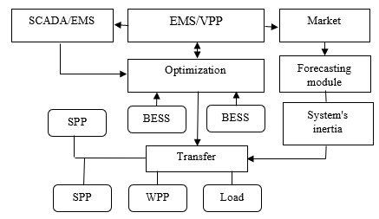
FIGURE 1. EMS/VPP architecture for coordination of PV, wind, ESS and FACTS

Comparison of scenarios confirms that the optimal flexibility architecture for the Central Asian Unified Power System should combine ESS portfolios with varying discharge durations, local reactive power support at RES connection nodes, digital coordination through Energy Management Systems and Virtual Power Plant services, as well as targeted network reinforcements at critical interconnections.
The selection of ESS capacity is based on the quantiles of residual imbalance distribution after the action of reserves, while the storage capacity is determined by the "worst" days of the year, taking into account efficiency and electrochemical degradation [7, 16].
International demonstrations at the Hornsdale level illustrate the economic effect and technological viability of Battery Energy Storage Systems (BESS) as a provider of Frequency Control Ancillary Services and synthetic inertia [13].
TABLE 8. Summary indicators by scenarios and relative improvement
Indicator | Scenario A: without ESS | Scenario B: ESS portfolio | Scenario C: ESS + FACTS | Improvement B vs A | Improvement C vs A
Curtailment, MWh | 900,000 | 565,000 | 480,000 | 37.2% | 46.7%
Active power losses, MWh | 2,450,000 | 2,190,000 | 2,120,000 | 10.6% | 13.5%
Line overload hours, h | 275 | 135 | 95 | 50.9% | 65.5%
Voltage violation hours, h | 470 | 220 | 160 | 53.2% | 66.0%
Δf integral, Hz·h | 105.0 | 67.5 | 62.0 | 35.7% | 41.0%
Objective function J, rel. units | 1.00 | 0.67 | 0.60 | 33.0% | 40.0%

In the absence of energy storage systems (ESS), power flows on 500 kV intersystem transmission lines exhibit significant variability and pronounced fluctuations over a typical week. During certain periods, the flows approach their permissible limits, indicating increased loading of intersystem connections and reduced operational flexibility of the power system.
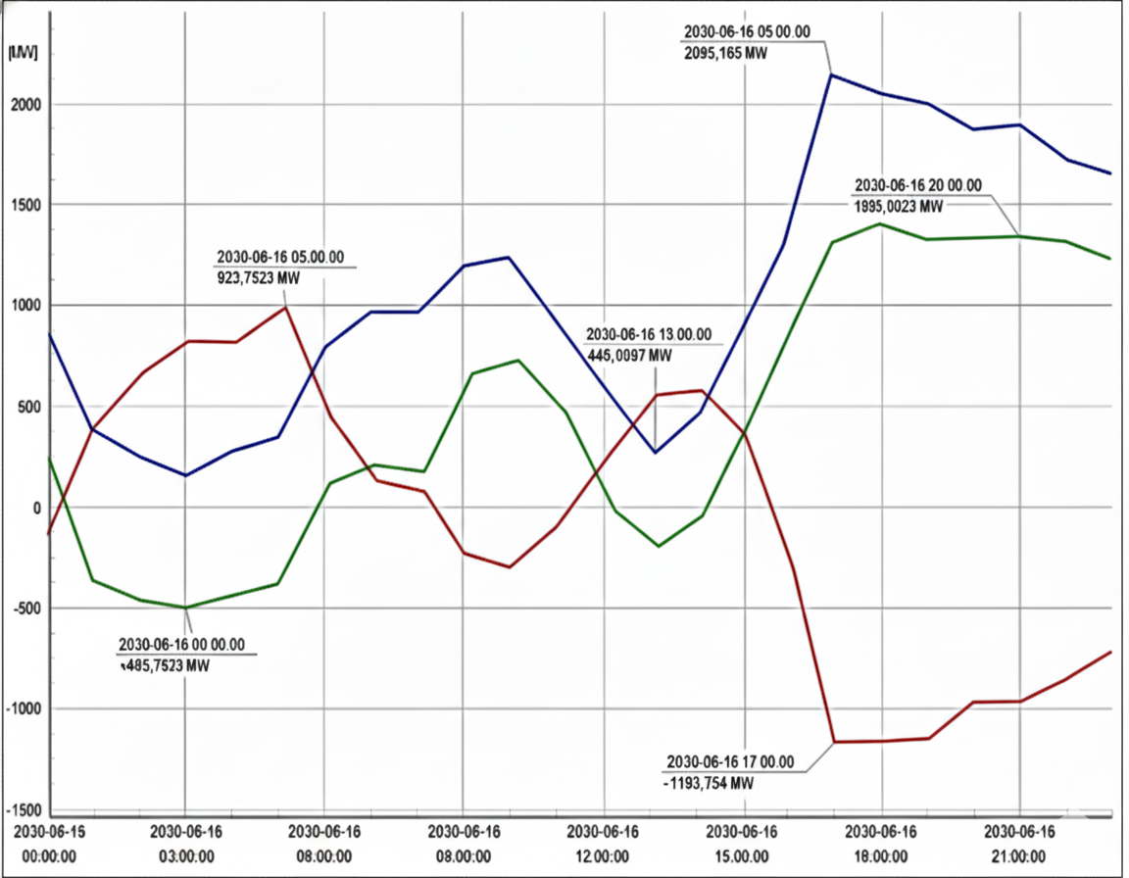
a) 500 kV intersystem line flows without ESS;

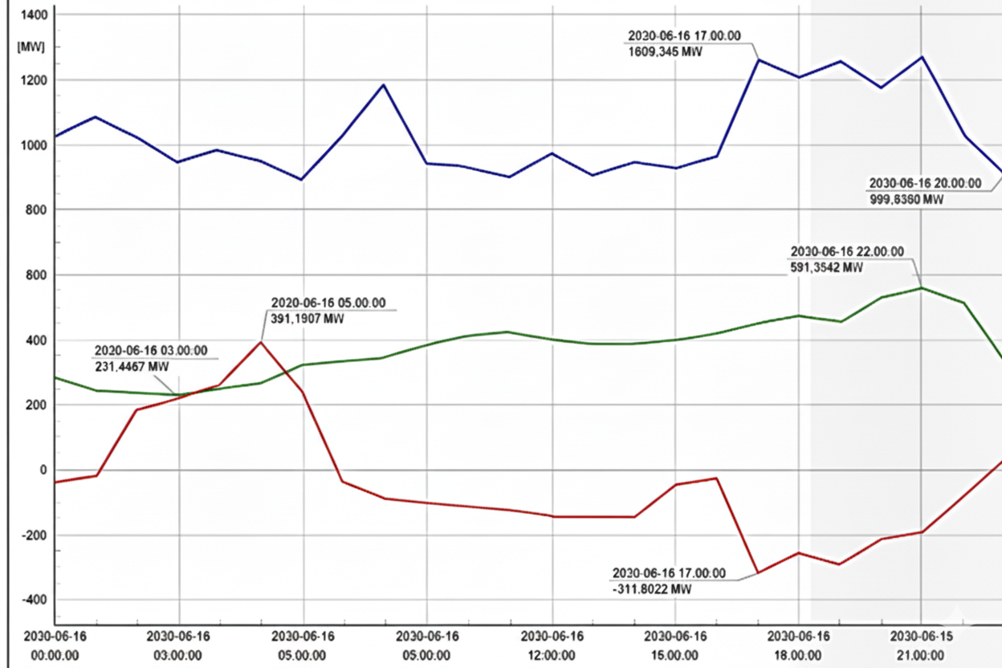
b) 500 kV intersystem line flows with ESS
FIGURE 2. 500 kV intersystem line flows without ESS portfolio and with ESS portfolio for a typical week
The integration of an ESS portfolio results in a noticeable smoothing of power flow profiles. Energy storage enables the absorption of surplus generation during low-demand periods and its release during peak-demand hours. This leads to a reduction in peak power flows on the 500 kV lines and a decrease in daily and weekly flow variability.
Overall, the deployment of ESS enhances the stability of intersystem power flow regimes, mitigates the risk of transmission line overloads, and improves the utilization efficiency of existing transmission infrastructure.
Simultaneously, the importance of long-term storage technologies is growing, including Liquid Air Energy Storage (LAES) cryogenic solutions, which have demonstrated an industrial-scale deployment of 5 MW for 15 MWh [14].
For the region, scaling up BESS as a driver of operational flexibility in combination with potential pumped-storage hydroelectric schemes based on existing reservoirs and improving mechanisms for inter-system coordination is a priority [11, 12].
CONCLUSION
The integration of renewable energy sources into the Central Asian Unified Power System creates opportunities for decarbonization and increased stability but places higher demands on flexibility. The coordinated use of energy storage systems, local reactive power support, and digital control platforms allows for a reduction in forced renewable energy source curtailments, a decrease in transmission line overloads, an improvement in voltage and frequency indicators, and a reduction in operating costs. For Uzbekistan, battery systems are the most promising in the medium term, while in the long term, the combination of Battery Energy Storage Systems with long-term storage solutions and the development of a market architecture for reserves and imbalances contributes to efficiency.
REFERENCES
1. Concept for Ensuring the Electricity Supply of the Republic of Uzbekistan for 2020–2030. Ministry of Energy of the Republic of Uzbekistan.
2. Nasirov T. Kh., Trofimov G. G., Khamidov Sh., R.M. Tanirbergenov. Issues of Reliability and Sustainable Development of the United Power System of Central Asia under Increasing Electricity Consumption. Methodological Issues of Reliability Studies of Large Power Systems, Issue 74, Irkutsk, 2023, pp. 723–732. https://www.e3s-conferences.org/articles/e3sconf/abs/2023/98/e3sconf_rses23_01038/e3sconf_rses23_01038.html
3. Khamidov Sh. V., Shamsiev B. Kh., Shamsiev Kh. A. Increasing the Reliability of the United Power Systems of Central Asia in Conditions of Energy Transition. E3S Web of Conferences 384, 01020, 2023. https://www.e3s-conferences.org/articles/e3sconf/abs/2023/21/e3sconf_rses2023_01020/e3sconf_rses2023_01020.html
4. Shamsiev Kh. A., Shamsiev B. Kh. Lessons from the Blackout in the Central Asian Power System. Problems of Energy and Resource Saving, 2022, No. 1, pp. 29–37.
5. Worku, Y.; Mengistu, T. Large-Scale Renewable Energy Integration: Tackling Technical Obstacles and Exploring Energy Storage Innovations. Sustainability, 2025, 17(3), 1311. https://doi.org/10.3390/su17031311
6. Li, Z.; Wang, J.; Chen, L. Optimal configuration of energy storage considering flexibility requirements and operational risks in a power system. Frontiers in Energy Research, 2024, 12, 1351569. https://doi.org/10.3389/fenrg.2024.1351569
7. World Energy Council. E-storage: Shifting from Cost to Value. Wind and Solar Applications, 2016. https://www.worldenergy.org/publications/entry/e-storage-shifting-from-cost-to-value-2016
8. Zhang, H.; Li, W.; Gao, F. Role of battery energy storage systems: Integration in weak transmission networks and renewable energy zones. Journal of Energy Storage, 2025, 117223. https://doi.org/10.1016/j.est.2025.117223
9. Khatri, R.; Sharma, R.; Kumar, A. Review of energy storage integration in off-grid and grid-connected hybrid renewable energy systems: Structures, optimizations, challenges and opportunities. Journal of Energy Storage, 2025, 116629. https://doi.org/10.1016/j.est.2025.116629
10. Savina N. V., Lisogurskaya L. N., Lisogursky I. A. Electrical Energy Storage Systems as a Means to Increase Reliability and Efficiency of Power Grids. International Research Journal, 2020, No. 2(92), Part 1, pp. 63–70. https://doi.org/10.23670/IRJ.2020.92.2.012
11. Allaev K. R., Toshov J., Toirov O. Modern State of the Energy Sector of Uzbekistan and Issues of Its Development. E3S Web of Conferences, 2023. https://www.e3s-conferences.org/articles/e3sconf/abs/2023/38/e3sconf_conmechydro23_05090/e3sconf_conmechydro23_05090.html
12. International Renewable Energy Agency (IRENA). Renewable Capacity Statistics 2025. IRENA; 2025. https://www.irena.org/-/media/Files/IRENA/Agency/Publication/2025/Mar/IRENA_DAT_RE_Capacity_Statistics_2025.pdf
13. ARENA. Hornsdale Power Reserve Expansion. Operations and Market Performance Report, 2024. https://arena.gov.au/projects/hornsdale-power-reserve-expansion/
14. Highview Power. World’s First Grid-Scale Liquid Air Energy Storage Plant 5 MW/15 MWh, 2018. https://www.highviewpower.com/projects/worlds-first-grid-scale-laes/
15. Australian Energy Market Operator (AEMO), 2024 Integrated System Plan (ISP), Мельбурн, Австралия: AEMO, 2024. https://www.aemo.com.au/-/media/files/major-publications/isp/2024/2024-integrated-system-plan-isp.pdf
16. Worku, Y. Recent Advances in Energy Storage Systems for Renewable Source Grid Integration: A Comprehensive Review. Sustainability, 2022, 14(10), 5985. https://doi.org/10.3390/su14105985
17. Mirzaev A.T., Toshkentbaeva S.I., "Prospective power and electricity balances of the UES of Central Asia and South Kazakhstan, taking into account the integration of renewable energy sources," Research Focus International Scientific Journal, т. 4, № 2, с. 34-44, март. 2025. https://refocus.uz/index.php/1/article/view/1320 refocus.uz Research Focus International Scientific Journal, vol. 4, no. 2, pp. 34-44, Mar. 2025. https://refocus.uz/index.php/1/article/view/1320 refocus.uz

