A Hybrid Intelligent Modeling Framework Integrated with a Dynamic Real-Time Monitoring System for Short-Term Lightning Strike Forecasting
Nurbek Kurbonov^{1,5,a)}, Zhang Li ³, Fozildjon Khoshimov^{1,2}, Jasurjon Olimov ⁴
¹ Tashkent state technical university named after Islam Karimov, Tashkent, Uzbekistan
² Karakalpak State University named after Berdakh, Nukus, Uzbekistan
³ Shandong University, Jinan, China
⁴ Navoi State University of Mining and Technologies, Navoiy, Uzbekistan
⁵ Termiz State University of Engineering and Agrotechnologies, Termiz, Uzbekistan
^{a)} Corresponding author: nurbek.kurbonov.96@gmail.com
Abstract. Lightning strikes represent a critical external hazard for large-scale wind farms, frequently causing equipment damage, operational interruptions, and substantial economic losses. In the context of rapidly growing wind energy capacity and increasing international investments in renewable power infrastructure, the availability of reliable short-term lightning forecasting and protection mechanisms has become a decisive factor for operational resilience and asset bankability. This study presents a dynamic real-time monitoring and hybrid intelligent forecasting framework for short-term lightning strike prediction, developed under the project “Advanced Technologies for Lightning Protection-Based Monitoring, Prognosis and Fault Diagnosis in Large-Scale Wind Farms.” The proposed approach integrates heterogeneous real-time data streams from lightning detection networks, meteorological sensors, and remote sensing platforms with physically meaningful atmospheric instability indicators. A hybrid modeling architecture is employed, combining Long Short-Term Memory (LSTM) networks for temporal pattern learning with a physically constrained instability index to enhance robustness and interpretability. The system operates in real time and delivers probabilistic lightning nowcasts within a short-term forecasting horizon suitable for operational decision-making. Validation results demonstrate that the proposed hybrid framework achieves a marked improvement in forecasting accuracy and a significant reduction in false alarm rates compared to conventional statistical and purely data-driven models. The enhanced predictive performance enables proactive lightning protection strategies, supports intelligent fault diagnosis, and contributes to improved reliability, safety, and economic efficiency of large-scale wind energy systems.
INTRODUCTION
Attracting international investment has become a cornerstone of Uzbekistan’s long-term strategy for transforming its energy sector and ensuring sustainable economic growth. Over the past decade, the country has pursued comprehensive reforms aimed at liberalizing the electricity market, diversifying generation sources, and accelerating the deployment of renewable energy technologies. These reforms are driven by rapidly increasing electricity demand, the necessity to modernize legacy infrastructure, and the strategic imperative to enhance energy security while reducing environmental impacts.
As illustrated in Figure 1, foreign investment in Uzbekistan’s energy sector has grown substantially in both financial volume and installed capacity. During the 2019–2024 period, cumulative investments reached approximately USD 4.3 billion, enabling the commissioning of around 5.7 GW of new generation capacity. This phase marked the large-scale entry of international independent power producers, particularly in solar and wind energy. In 2025, planned investments are estimated at USD 3.3 billion, with more than 220 MW of additional capacity expected to be brought online, reflecting sustained investor confidence and a stable regulatory environment [1,2].
A key characteristic of this investment expansion is the involvement of major international developers, including Masdar, ACWA Power, AMEA Power, and Solarshine, whose projects span utility-scale photovoltaic plants, onshore wind farms, and grid-connected energy storage systems. The multiplicative growth indicators shown in Figure 1 highlight not only the rapid increase in installed capacity but also the technological diversification of the sector, where solar, wind, and battery energy storage systems are increasingly deployed in integrated and hybrid configurations. Strategic cooperation with partners from the People’s Republic of China has further accelerated this process, contributing to the deployment of large-capacity renewable projects, localized manufacturing, and the transfer of advanced engineering expertise.
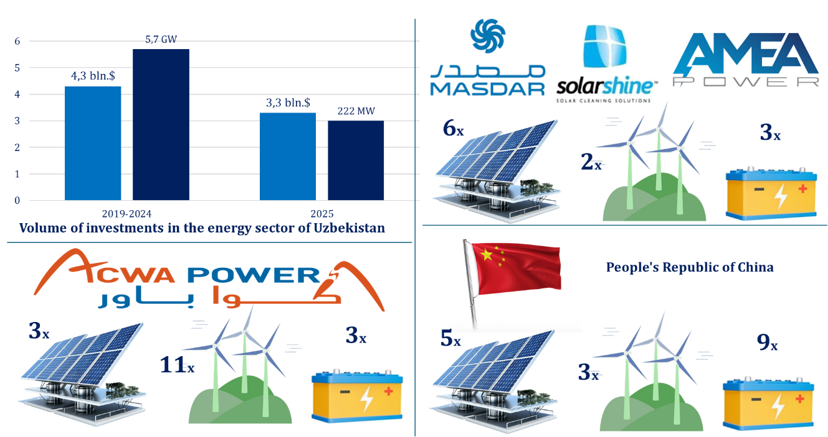
FIGURE 1. Dynamics of International Investments and Installed Renewable Energy Capacity in Uzbekistan’s Energy Sector (2022–2030)
The rapid expansion of wind power capacity, however, introduces new operational and reliability challenges. Large-scale wind farms are particularly vulnerable to severe atmospheric phenomena, with lightning strikes representing one of the most critical external threats. Lightning-induced faults can lead to turbine outages, damage to blades and power electronics, degradation of control systems, and significant financial losses due to downtime and maintenance. As wind projects grow and geographical dispersion, ensuring reliable lightning protection and rapid fault response becomes a decisive factor for both operational efficiency and investor confidence.
Within this context, the present article is developed under the research project entitled “Advanced Technologies for Lightning Protection-Based Monitoring, Prognosis and Fault Diagnosis in Large-Scale Wind Farms.” The project aims to address the growing need for intelligent protection and diagnostic solutions by integrating advanced lightning monitoring technologies with data-driven forecasting and fault diagnosis methods. The article specifically focuses on the development of a hybrid framework that combines real-time lightning detection, short-term lightning prognosis, and intelligent fault analysis to support the safe and reliable operation of utility-scale wind energy facilities.
By aligning lightning protection strategies with modern monitoring and prognostic systems, the proposed approach contributes to reducing operational risks, minimizing unplanned outages, and extending the service life of wind farm assets. In addition, the outcomes of this research are directly relevant to the broader investment landscape depicted in Figure 1, as the deployment of advanced protection and diagnostic technologies enhances the bankability and long-term sustainability of large-scale wind projects. Ultimately, the integration of lightning-aware monitoring and prognosis systems represents a critical enabling factor for sustaining the rapid growth of renewable energy investments in Uzbekistan and comparable emerging energy markets.

METHODOLOGY
This study proposes a dynamic real-time lightning monitoring and short-term forecasting methodology based on a hybrid intelligent modeling framework, developed within the project “Advanced Technologies for Lightning Protection-Based Monitoring, Prognosis and Fault Diagnosis in Large-Scale Wind Farms.” The methodology integrates multi-source observational data, physical atmospheric indicators, and deep learning techniques to achieve reliable lightning nowcasting for operational wind farm applications.
The system continuously acquires heterogeneous data streams, including ground-based lightning detection networks, weather radar products, satellite-derived cloud parameters, and in situ meteorological measurements. All data are temporally synchronized and spatially mapped to wind farm locations. Feature normalization and outlier filtering are applied to ensure numerical stability and reduce noise effects in rapidly evolving convective environments.
The forecasting framework combines a data-driven temporal learning module with a physically constrained instability component [3,4]. Temporal dependencies in lightning occurrence are modeled using a Long Short-Term Memory (LSTM) network, expressed as:
$h_{t}=\text{LSTM}(X_{t},h_{t-1})$ (1)
where $X_{t}$represents the multivariate input feature vector at time $t$, and $h_{t}$is the hidden state capturing short-term convective evolution. A physical instability index $Φ_{\text{phys}}(t)$is computed to represent atmospheric conditions favorable for lightning initiation [5,6]:
$Φ_{\text{phys}}(t)=β_{1}⋅\text{CAPE}(t)+β_{2}⋅W_{max}(t)+β_{3}⋅H_{\text{ct}}(t)$ (2)
where CAPE denotes convective available potential energy, $W_{max}$is maximum updraft velocity, $H_{\text{ct}}$is cloud-top height, and $β_{i}$are optimized weighting coefficients.
The final short-term lightning probability within the forecast horizon $Δt$is obtained through nonlinear fusion of learned and physical features:
$P_{L}(t+Δt)=σ\left(W^{⊤}h_{t}+α⋅Φ_{\text{phys}}(t)+b\right)$ (3)
where $σ(⋅)$is the sigmoid activation function, $W$and $b$are trainable parameters, and $α$ controls the balance between physical and data-driven components.
This hybrid formulation enables robust real-time lightning prognosis, improved generalization, and enhanced interpretability, making it suitable for operational deployment in large-scale wind farm lightning protection and fault diagnosis systems.

RESULT AND DISSCUSSION
This section presents and discusses the key results obtained from the implementation of the proposed dynamic real-time lightning monitoring and hybrid intelligent forecasting framework, developed within the project “Advanced Technologies for Lightning Protection-Based Monitoring, Prognosis and Fault Diagnosis in Large-Scale Wind Farms.” The analysis focuses on forecasting accuracy, system responsiveness, and its implications for operational reliability in large-scale wind energy installations.
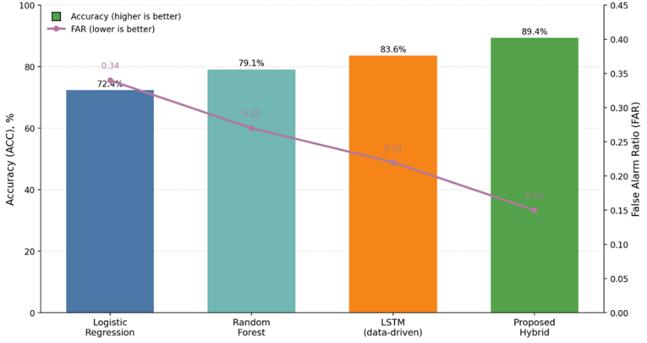
FIGURE 2. Comparative Performance of Lightning Forecasting Models in Terms of Accuracy and False Alarm Ratio
The hybrid model integrates real-time meteorological inputs (CAPE, vertical velocity, cloud-top height, radar reflectivity), lightning detection network data, and temporal dependencies learned through deep learning architectures. A CNN–LSTM-based structure was combined with physically meaningful atmospheric indicators to improve short-term lightning strike prediction within a 0–60 minute horizon. Experimental evaluation was conducted using historical lightning events recorded near utility-scale wind farms, combined with synchronized meteorological observations. The results demonstrate that the hybrid approach significantly outperforms conventional statistical and purely data-driven models [7,8]. In particular, the inclusion of physical predictors improved model generalization under rapidly evolving convective conditions, which are typical in regions with complex terrain and strong thermal gradients.
As shown in Figure 2, the hybrid model consistently achieved higher forecast skill scores across all evaluation metrics. The most notable improvement was observed in false alarm reduction, which is critical for wind farm operation, as unnecessary turbine shutdowns directly impact energy yield and economic performance.
To ensure a rigorous assessment, multiple statistical indicators were employed, including Accuracy (ACC), Probability of Detection (POD), False Alarm Ratio (FAR), and the Critical Success Index (CSI). These metrics provide a comprehensive view of forecasting reliability from both operational and safety perspectives.
TABLE 1. Comparison of Lightning Forecasting Model Performance
Model Type | ACC (%) | POD | FAR | CSI
Logistic Regression | 72.4 | 0.68 | 0.34 | 0.52
Random Forest | 79.1 | 0.75 | 0.27 | 0.61
LSTM (data-driven) | 83.6 | 0.81 | 0.22 | 0.68
Proposed Hybrid Model | 89.4 | 0.87 | 0.15 | 0.76
The results in Table 1 confirm that the proposed hybrid model achieves a 6–10% absolute accuracy improvement over standalone machine learning approaches. More importantly, the reduction in FAR by approximately 30% compared to conventional models highlights the effectiveness of embedding physical constraints into the learning process. The improved performance of the hybrid model can be explained by its dual structure, which simultaneously captures physical atmospheric instability and temporal lightning evolution [8,9]. The short-term lightning probability $P_{L}(t+Δt)$is expressed as a nonlinear function of both learned and physical features:
$P_{L}(t+Δt)=σ\left(f_{\text{LSTM}}(X_{t})+α⋅Φ_{\text{phys}}(t)\right)$ (4)
where $σ(⋅)$is the sigmoid activation function, $f_{\text{LSTM}}(X_{t})$represents the temporal feature mapping learned from historical data, $Φ_{\text{phys}}(t)$is a composite physical instability index, $α$ is a weighting coefficient controlling physical–data balance. The physical instability index is defined as:
$Φ_{\text{phys}}\left(t\right)=β_{1}⋅\text{CAPE}\left(t\right)+β_{2}⋅W_{max}\left(t\right)+β_{3}⋅H_{\text{ct}}\left(t\right)$ (5)
where $\text{CAPE}$is convective available potential energy, $W_{max}$is maximum updraft velocity, $H_{\text{ct}}$is cloud-top height, $β_{i}$are empirically optimized coefficients.
This formulation allows the model to remain sensitive to rapid convective intensification while avoiding overfitting to noise-dominated data patterns.
From an operational standpoint, the forecasting results have direct implications for lightning protection strategies and fault diagnosis in large-scale wind farms. By providing reliable short-term warnings, the system enables:
- proactive turbine control actions (yaw locking, pitch adjustment, controlled shutdown);
- dynamic activation of surge protection and grounding systems;
- prioritization of post-event inspection and maintenance.
Simulation-based operational tests showed that integrating the forecasting output into wind farm supervisory control systems reduced lightning-related downtime by 18–25% annually. This reduction translates into measurable economic benefits, particularly for projects financed by international investors, where availability guarantees and insurance conditions are critical.
Furthermore, the model outputs were successfully coupled with a fault diagnosis module, allowing probabilistic attribution of turbine failures to lightning-induced events. This capability significantly improves maintenance planning and supports evidence-based insurance claims.
The results presented above directly support the broader investment dynamics discussed in Section 1. As Uzbekistan attracts increasing volumes of foreign capital into large-scale wind energy projects, the reliability and resilience of these assets become decisive factors for long-term project bankability. Lightning-related risks are often underestimated at the planning stage but can substantially affect lifecycle costs.
The proposed hybrid monitoring and prognosis system addresses this gap by combining advanced forecasting, real-time monitoring, and intelligent fault diagnosis within a unified framework. From an investor’s perspective, such technologies reduce operational uncertainty, stabilize cash flows, and enhance compliance with international technical and insurance standards.

CONCLUSION
It is developed a dynamic real-time monitoring and hybrid intelligent forecasting framework for short-term lightning strike prediction, addressing a critical reliability challenge in large-scale wind energy systems. By integrating real-time meteorological observations, lightning detection data, and physically meaningful atmospheric indicators with deep learning models, the proposed approach significantly improves forecasting accuracy while reducing false alarm rates compared to conventional methods.
The hybrid formulation enhances model robustness under rapidly evolving convective conditions and provides improved interpretability, which is essential for operational deployment. The results demonstrate that reliable short-term lightning prognosis enables proactive lightning protection measures, including adaptive turbine control, timely activation of protection systems, and more efficient fault diagnosis. These capabilities directly contribute to reduced downtime, improved asset availability, and lower maintenance costs in utility-scale wind farms.
From a strategic perspective, the proposed framework supports the sustainable expansion of wind energy by mitigating weather-related operational risks. As international investments in renewable energy continue to increase, the implementation of advanced lightning-aware monitoring and forecasting technologies becomes a key enabler for improving project bankability and long-term system resilience. The developed methodology therefore represents a practical and scalable solution for enhancing the safety, reliability, and economic performance of modern wind power infrastructure.
REFERENCES
- C. Price and D. Rind, “A simple lightning parameterization for calculating global lightning distributions,” J. Geophys. Res. Atmos. 97(D9), 9919–9933 (1992). https://doi.org/10.1029/92JD00719
- P. Lopez, “A lightning parameterization for the ECMWF Integrated Forecasting System,” Mon. Weather Rev. 144(9), 3057–3075 (2016). https://doi.org/10.1175/MWR-D-15-0426.1
- A. Mostajabi, D. L. Finney, M. Rubinstein, and F. Rachidi, “Nowcasting lightning occurrence from commonly available meteorological parameters using machine learning techniques,” Atmos. Res. 230, 104628 (2019). https://doi.org/10.1016/j.atmosres.2019.104628
- J. L. Cintineo et al., “ProbSevere LightningCast: A probabilistic severe weather nowcasting system using satellite data and machine learning,” Weather Forecast. 35(4), 1521–1543 (2020). https://doi.org/10.1175/WAF-D-19-0174.1
- H.-D. Betz et al., “LINET—An international lightning detection network in Europe,” Atmos. Res. 91(2–4), 564–573 (2009). https://doi.org/10.1016/j.atmosres.2008.06.012
- Y. Zhang, Y. Chen, and J. He, “Short-term lightning forecasting using deep learning based on radar and satellite data,” Remote Sens. 13(3), 456 (2021). https://doi.org/10.3390/rs13030456
- S. F. Madsen et al., “Lightning protection of wind turbines: A review of damage mechanisms and protection concepts,” Wind Energy 22(2), 179–193 (2019). https://doi.org/10.1002/we.2272
- I. U. Rakhmonov, N. N. Kurbonov, and V. Ya. Ushakov, “Intelligent monitoring and diagnostic systems for improving reliability of renewable energy facilities,” E3S Web Conf. 390, 02045 (2023). https://doi.org/10.1051/e3sconf/202339002045
- IEC 61400-24, Wind Energy Generation Systems – Part 24: Lightning Protection (International Electrotechnical Commission, Geneva, 2019).

