Mathematical Modeling of Frequency and Voltage Dynamics in Power Grids with High Penetration of Large-Scale Renewable Energy Sources
Numon Niyozov^{1,5, a)}, Liu Chuang ², Fozildjon Khoshimov^{1,4}, Shakhlo Toshpulatova ³
¹ Tashkent state technical university named after Islam Karimov, Tashkent, Uzbekistan
² Northeast Electric Power University, Jilin, China
³ Nizami Tashkent State Pedagogical University, Tashkent, Uzbekistan
⁴ Karakalpak State University named after Berdakh, Nukus, Uzbekistan
⁵ Termiz State University of Engineering and Agrotechnologies, Termiz, Uzbekistan
^{a)} Corresponding author: nomon.niyozov_2422@mail.ru
Abstract. The increasing penetration of large-scale renewable energy sources significantly affects the dynamic stability of modern power systems. Due to the stochastic nature of solar and wind generation and the absence of mechanical inertia, electrical networks experience amplified frequency oscillations, voltage deviations, and prolonged transient processes. This study presents a mathematical modeling framework for analyzing dynamic frequency and voltage characteristics in power grids with high renewable energy penetration. Classical analytical models are applied to describe frequency dynamics, inertial behavior, transient voltage response, and short-term system reactions to power imbalances. The results show that when the share of renewable generation exceeds critical levels, equivalent system inertia may decrease by up to 40%, leading to increased sensitivity to disturbances. Frequency deviations intensify when renewable penetration exceeds 30%, while voltage deviations of 5–10% are observed in distribution networks. The modeling outcomes confirm that conventional stability margins are insufficient under high renewable penetration. The proposed analytical approach provides a theoretical basis for assessing dynamic stability, identifying vulnerable operating conditions, and supporting the development of stabilization strategies for renewable-rich power systems.
INTRODUCTION
Global electricity generation and consumption have demonstrated a steady upward trend over the past decade, reflecting the continuous growth of industrial activity, urbanization, and electrification across the world. Between 2015 and 2023, global primary energy consumption increased by approximately 13.6%, indicating a persistent rise in energy demand. Although a temporary decline was observed in 2020 due to the COVID-19 pandemic and associated economic disruptions, this reduction proved to be short-lived. As economic activity recovered, energy demand resumed its upward trajectory, increasing by about 2% in 2023 alone. This long-term growth trend highlights the increasing pressure on existing energy infrastructures and the urgent need for sustainable energy solutions.
A key characteristic of this transformation is the growing contribution of renewable energy sources (RES) to global electricity generation. The rapid deployment of solar and wind power technologies has significantly altered the structure of power systems worldwide. Annual global electricity production increasingly reflects the rising share of renewable generation alongside continuously growing consumption. The expanding role of RES is primarily driven by the depletion of fossil fuel resources, concerns related to energy security, and the global commitment to reducing greenhouse gas emissions and mitigating climate change. As a result, renewable energy has become a central component of modern energy strategies in many countries.
Despite their environmental and economic advantages, the large-scale integration of solar and wind generation introduces serious technical challenges for power system operation. Unlike conventional synchronous generators, renewable energy sources are characterized by variable and stochastic power output, which depends on meteorological conditions such as solar irradiance and wind speed. This inherent variability leads to increased frequency oscillations, voltage fluctuations, and a reduction in overall system inertia. The absence of mechanical inertia in most renewable energy technologies significantly weakens the natural stabilizing mechanisms of power systems.
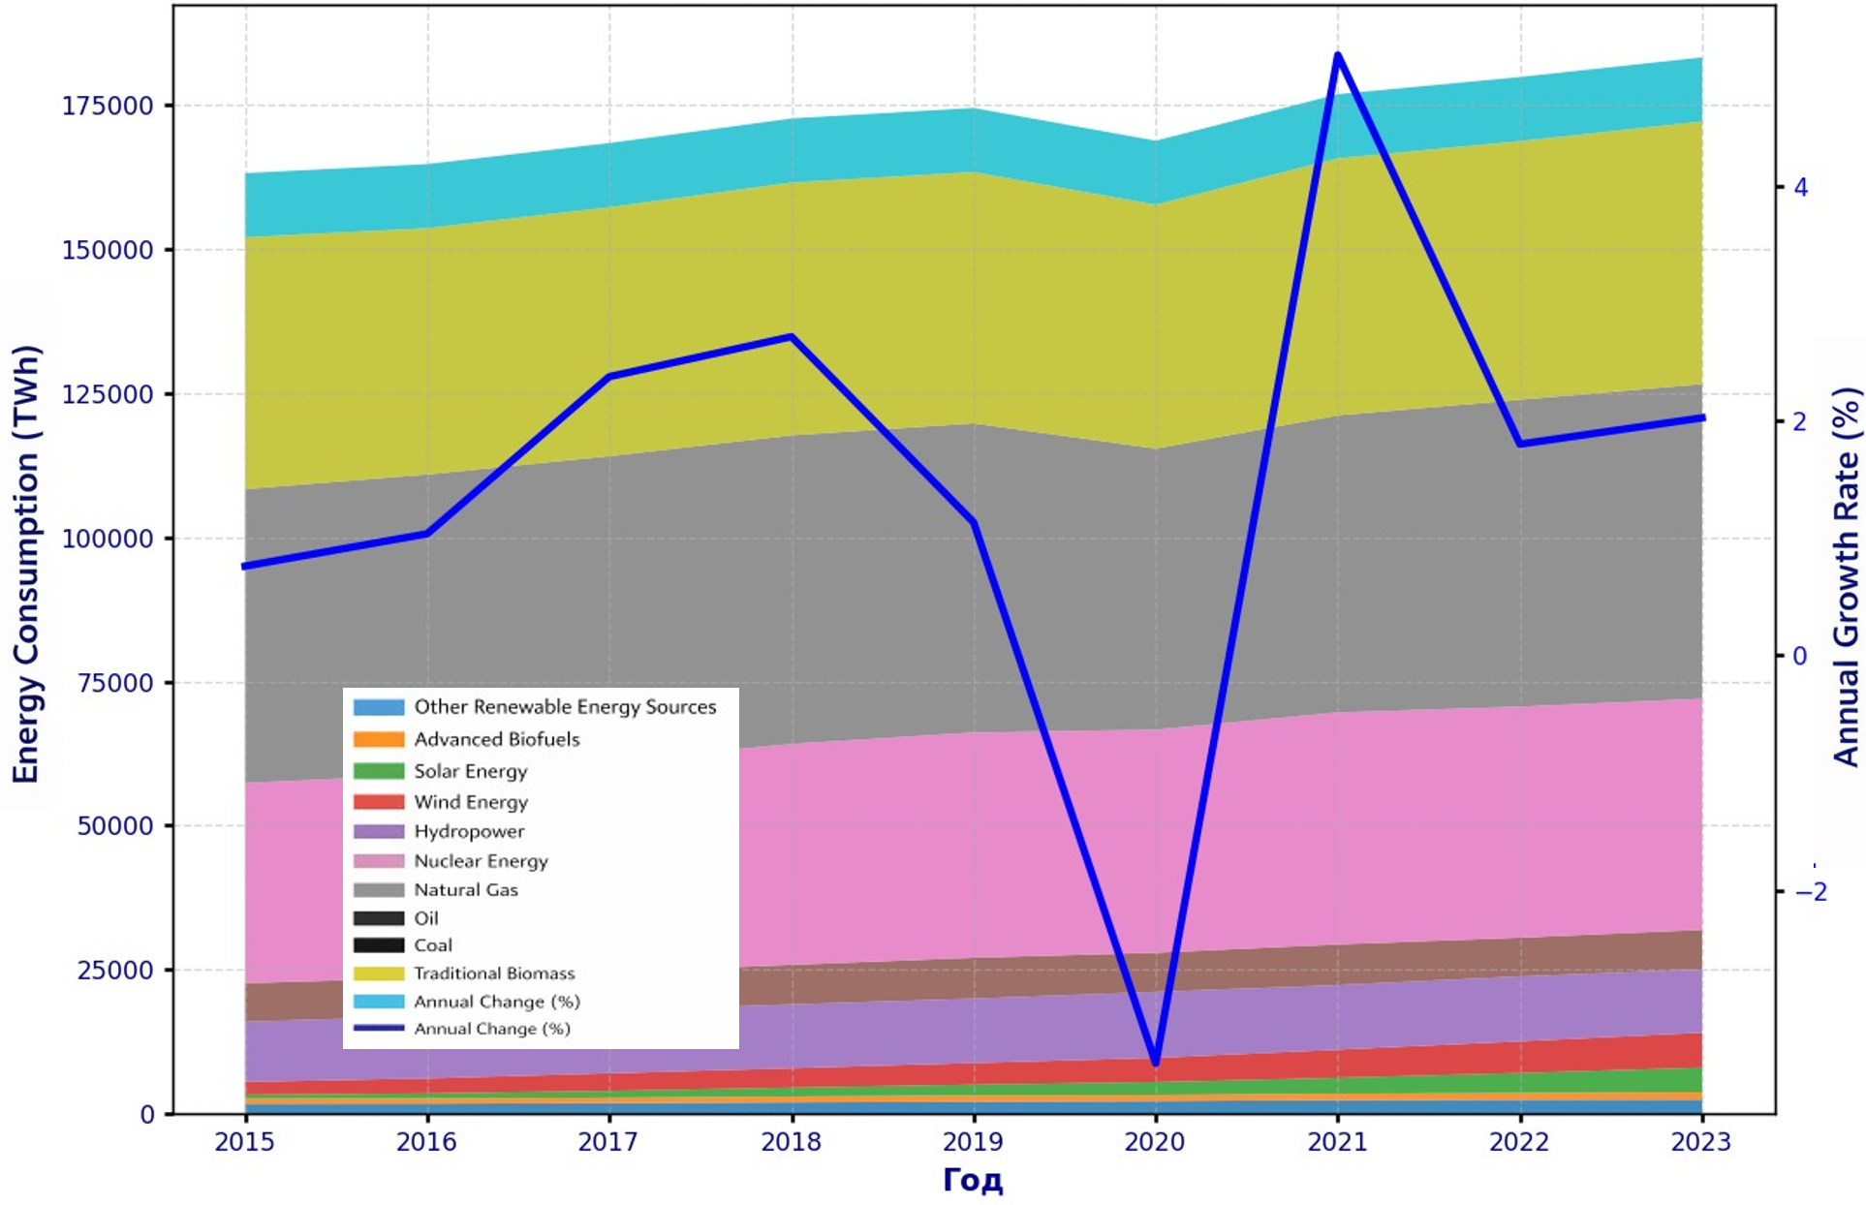
FIGURE 1. Annual electricity generation and the growing demand for electrical energy (World)
When the share of renewable generation exceeds certain critical levels, the dynamic response of the power system becomes increasingly sensitive to disturbances, including sudden load changes, generation outages, or network faults. Under such conditions, even relatively small imbalances between generation and demand can result in rapid frequency deviations and voltage instability, potentially triggering automatic protection systems and causing partial or widespread outages. These effects are particularly pronounced in low- and medium-voltage networks, where voltage regulation margins are limited.

METHODOLOGY
The methodological approach is based on analytical modeling of dynamic processes occurring in electrical power systems with a high share of renewable energy sources. Particular attention is given to frequency stability, voltage behavior, inertial properties, and transient responses, which are significantly influenced by the stochastic nature of solar and wind generation. To describe frequency dynamics, the classical swing equation is applied, linking the rate of change of system frequency to the imbalance between generated and consumed power and the equivalent inertia constant. This formulation enables quantitative evaluation of frequency sensitivity under reduced inertia conditions.
Voltage dynamics are analyzed using transient stability models derived from equivalent circuit representations. These models allow assessment of voltage deviations and recovery processes following disturbances, which are especially critical in low- and medium-voltage networks. In addition, first-order differential equations are used to represent transient responses caused by abrupt changes in load or renewable generation. These equations characterize the speed and stability of system reactions during short-term disturbances.
The integrated use of frequency, voltage, inertia, and transient response models provides a comprehensive framework for evaluating the dynamic stability of power grids under increasing renewable penetration. Simulation-based analysis is performed for various operating scenarios to identify critical thresholds beyond which system stability deteriorates. This methodological foundation supports the identification of vulnerable operating conditions and the formulation of stabilization measures, including virtual inertia and energy storage technologies.

RESULT AND DISSCUSSION
The analytical results confirm that the dynamic stability of electrical power systems is strongly influenced by the level of large-scale renewable energy source (RES) integration. As the proportion of RES increases, the system experiences a noticeable reduction in equivalent mechanical inertia, which weakens its ability to counteract sudden disturbances. According to the obtained results, the overall inertia of the power system may decrease by up to 40% compared to conventional generation-based systems, significantly increasing sensitivity to power imbalances.
Frequency behavior under disturbed conditions is governed by the swing equation, which relates frequency dynamics to generation–load imbalance:
$2H\frac{df}{dt}=P_{g}-P_{L}$ (1)
where $H$is the inertia constant, $P_{g}$is generated power, and $P_{L}$is load demand. Rearranging this expression yields the frequency deviation relationship:
$$Δf=\frac{ΔP}{2Hf_{n}}$$
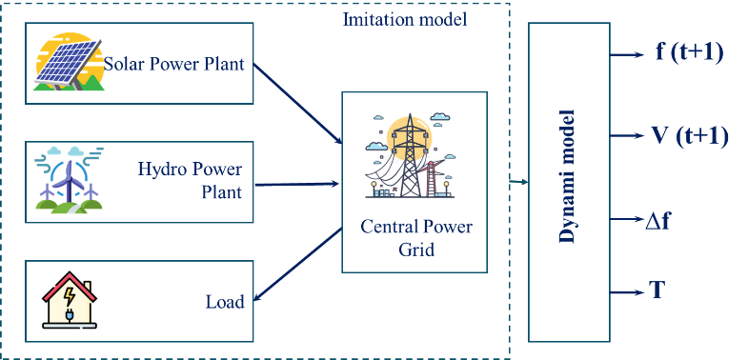
FIGURE. 2. Operational structure of the mathematical model of the dynamic characteristics of an electric power grid integrated with large-scale renewable energy sources.
Modeling results show that as $H$decreases, even small values of $ΔP$result in substantial frequency deviations. When RES penetration exceeds 30%, frequency oscillations become pronounced, while penetration levels above 45% may trigger automatic protection systems within 60 seconds.

TABLE 1. Effect of Inertia Reduction on Frequency Stability
Inertia level | Frequency response | Stability condition
High (conventional generation) | Slow frequency deviation | Stable
Medium (moderate RES share) | Increased oscillations | Reduced margin
Low (high RES share) | Rapid frequency drop | Unstable

Voltage stability analysis reveals that RES variability also causes significant voltage fluctuations, particularly in distribution networks. Voltage dynamics are described using a first-order transient model:
$τ\frac{dV(t)}{dt}+V(t)=K⋅u(t)$ (2)
where $τ$is the time constant, $V(t)$is voltage magnitude, and $u(t)$represents sudden changes in generation or load.
The modeling results indicate voltage deviations in the range of 5–10%, with longer recovery times observed as RES penetration increases.

TABLE 2. Impact of Renewable Energy Penetration on Frequency Stability
RES penetration level | Observed effect on frequency | System response
≤ 30% | Minor frequency oscillations | Stable operation
> 30% | Increased oscillation amplitude | Reduced stability margin
> 45% | Rapid frequency deviations | Protection activation within 60 s

In addition to frequency instability, voltage behavior is significantly affected by variable renewable generation. The relationship between the penetration level of large-scale renewable energy sources (RES) in the generation mix and the corresponding reduction in relative system inertia, as well as the emergence of critical dynamic stability thresholds. The horizontal axis represents the share of RES in total electricity generation, expressed as a percentage, while the vertical axis shows the normalized system inertia $H/H_{0}$, where $H_{0}$corresponds to the inertia of a conventional power system dominated by synchronous generators.
At low levels of RES penetration (0–20%), the system inertia remains close to its nominal value ($H/H_{0}≈1.0$), and the frequency response of the power system is characterized by slow and well-damped deviations following disturbances. As the RES share increases to approximately 30%, a noticeable reduction in inertia is observed, accompanied by an increase in the amplitude of frequency oscillations. This penetration level marks the first critical threshold, beyond which the system becomes more sensitive to generation–load imbalances.
When the RES penetration exceeds 45%, the figure highlights a second critical threshold associated with a substantial decline in inertia ($H/H_{0}≈0.45$). At this stage, the system experiences rapid frequency deviations, and the operation of automatic protection devices may occur within approximately 60 seconds following a disturbance. This behavior reflects the diminished capability of the system to counteract sudden power imbalances due to the absence of mechanical inertia in solar and wind power plants.
At high RES penetration levels approaching 50%, the system inertia may decrease by up to 40% relative to its conventional value ($H/H_{0}≈0.40$). Under such conditions, even small power mismatches can lead to significant frequency excursions, increased voltage instability, and prolonged transient processes. The figure therefore visually summarizes the quantitative relationship between RES penetration, inertia reduction, and stability degradation, providing a clear analytical basis for identifying operating regions where traditional stability margins become insufficient. These results emphasize the necessity of advanced stabilization measures, such as virtual inertia and energy storage systems, in renewable-dominated power grids.
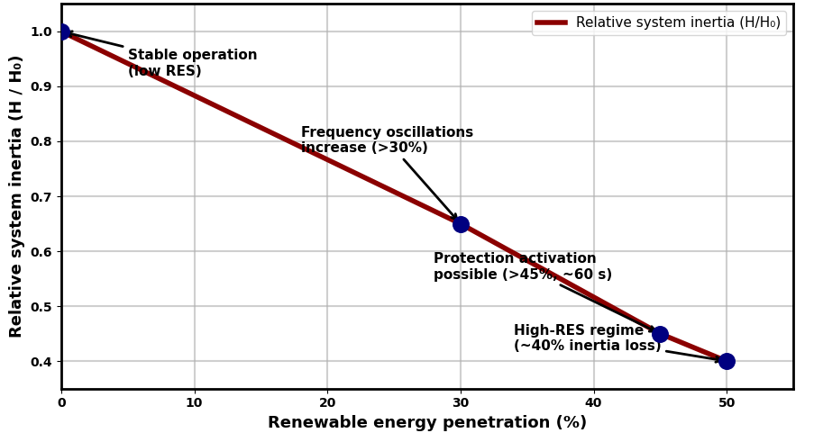
FIGURE 1. Relative System Inertia Reduction and Stability Thresholds under Increasing Renewable Energy Penetration
The modeling results reveal voltage deviations in the range of 5–10%, particularly in low-voltage distribution networks. These deviations are explained using a first-order transient voltage model derived from equivalent RC circuit representations:
$$τ\frac{dV}{dt}+V=K⋅u(t)$$
where $τ$is the time constant, $V$is the voltage magnitude, and $u(t)$represents disturbances such as abrupt changes in generation or load. The results show that higher variability in renewable output increases voltage recovery time and deviation magnitude, making voltage regulation more challenging.

TABLE 3. Voltage Deviation Characteristics under High Renewable Penetration
Network type | Voltage deviation range | Criticality
Transmission networks | < 5% | Moderate
Distribution networks | 5–10% | High
Low-voltage networks | Up to 10% | Critical

Transient process analysis further demonstrates that renewable-dominated systems exhibit slower stabilization following disturbances. The transient response of system variables is expressed as:
$y(t)=K\left(1 − e^{-t/τ}\right)$ (3)
Reduced inertia increases the time constant $τ$, extending the duration of transient processes and raising the risk of cascading instability. Overall, the mathematical modeling results clearly show that traditional stability criteria are insufficient for power systems with high RES penetration. The findings justify the need for enhanced stabilization measures and provide a rigorous analytical foundation for subsequent predictive and intelligent control approaches.
CONCLUSIONS
This study demonstrates that large-scale integration of renewable energy sources fundamentally alters the dynamic behavior of electrical power systems. Analytical modeling results confirm that increasing renewable penetration leads to a significant reduction in system inertia, which directly affects frequency and voltage stability. When the share of renewable generation exceeds critical thresholds, frequency oscillations intensify, voltage deviations increase, and the likelihood of protection system activation rises. The reduction of equivalent inertia by up to 40% makes the system more sensitive to power imbalances, even under relatively small disturbances.
The applied mathematical models, including frequency dynamics, transient voltage behavior, and first-order response equations, provide a comprehensive theoretical framework for evaluating system stability under variable generation conditions. The results highlight that traditional stability margins, developed for conventional generation-dominated systems, are insufficient for renewable-rich grids. Consequently, the findings emphasize the necessity of enhanced stabilization measures, such as virtual inertia and energy storage systems, to ensure reliable operation. Overall, the developed analytical approach offers a solid theoretical basis for understanding dynamic stability challenges and supports informed decision-making in the planning and operation of modern power systems with high renewable energy penetration.
REFERENCES
- Ritchie, H., Rosado, P., & Roser, M. (2020). Energy production and consumption. Our World in Data. Available at: https://ourworldindata.org/energy-production-consumption (accessed May 23, 2025).
- Gonzalez-Longatt, F., & Wall, P. (2019). Impact of high penetration of renewable energy sources on power system stability. Renewable Energy, 135, 1–10. https://doi.org/10.1016/j.renene.2018.11.002
- Niyozov, N., Akhmedov, A., Djurayev, S., Tukhtamishev, B., & Norqulov, A. (2025). Development of a method for forecasting the specific consumption indicator of electric energy. AIP Conference Proceedings. https://doi.org/10.1063/5.0305729
- Visser, L. R., Schuurmans, E. M. B., AlSkaif, T. A., Fidder, H. A., & Van Voorden, A. M. (2022). Regulation strategies for mitigating voltage fluctuations induced by photovoltaic systems in low-voltage grids. International Journal of Electrical Power & Energy Systems, 137, 107695. https://doi.org/10.1016/j.ijepes.2021.107695
- Smith, J. C., Milligan, M., DeMeo, E. A., & Parsons, B. (2007). Utility wind integration and operating impact: State of the art. IEEE Transactions on Power Systems, 22(3), 900–908. https://doi.org/10.1109/TPWRS.2007.901602
- Morren, J., de Haan, S. W. H., Kling, W. L., & Ferreira, J. A. (2006). Wind turbines emulating inertia and supporting primary frequency control. IEEE Transactions on Power Systems, 21(1), 433–434. https://doi.org/10.1109/TPWRS.2005.861956
- Rakhmonov, I. U., Niyozov, N. N., Nimatov, K. B., Ushakov, V. Ya., Omonov, F. B., et al. (2025). Mathematical model for reducing active power losses by regulating reactive power at enterprises with continuous production mode. Bulletin of the Tomsk Polytechnic University. Geo Assets Engineering. https://doi.org/10.18799/24131830/2025/2/4730
- Liu, C., Niyozov, N. N., & Khoshimov, F. A. (2025). Modeling the external characteristics of energy systems with large renewable inputs and investigating their influence on voltage and frequency stability. Problems of Energy and Resource Saving, Special Issue 88, 262–267.
- Niyozov, N., Sattarov, K., Bazarbayeva, A., & Kamalov, U. (2024). Energy efficiency of automated control of artificial lighting. AIP Conference Proceedings. https://doi.org/10.1063/5.0218843Athay, T., Podmore, R., & Virmani, S. (1979). A practical method for the direct analysis of transient stability. IEEE Transactions on Power Apparatus and Systems, 98(2), 573–584. https://doi.org/10.1109/TPAS.1979.319279

