Investigation of processes for weakening the magnetic field of traction electric motors in vehicle compositions
Utkir Safarov ^{a)}, Oybek Achilov, Ilkhom Rustamov, Oleg Ablyalimov, Isroiljon Ataboyev
Tashkent State Transport University, Tashkent, Uzbekistan
^{a)} Corresponding author: utkirsafarov104@gmail.com
Abstract. Worldwide, significant attention is being devo TEM to improving the technical condition of mainline diesel locomotives, determining the magnetic field parameters of traction electric motors (TEM) in their traction tranwfission, identifying the impact of these parameters on the tractive force and fuel consumption of diesel locomotives, increasing the efficiency of the existing locomotive fleet, and enhancing the performance and efficiency of mainline diesel locomotives. In this context, conducting research on the application of modern methods for determining the parameters that affect the tractive force and technical condition of diesel locomotives is of particular importance. Simultaneously, reducing costs by improving the TEM magnetic field weakening system in DC electric transmission mainline diesel locomotives is considered one of the crucial and urgent tasks. Analysis of the locomotive's efficiency (LE) revealed that a decrease in the locomotive's efficiency occurs when the traction generator has low values of Rg and Ne, and MK=const on the direct start-stop diagrams in the non-hyperbolic external characteristic zone. By changing (reducing) the value of the magnetic field damping resistance of the traction generator, it was possible to alter the magnetic field damping time of the traction generator. A recommended improvement for the transient process of magnetic field attenuation in traction generators of diesel locomotives with DC transmission has been developed. An electrical circuit diagram for installation has been designed. Based on the developed system of equations for the magnetic field attenuation circuit and the analysis of the processes occurring in it, the current flowing through the power circuit during the magnetic field attenuation process was calculated TEM.
INTRODUCTION
Over the Recently, a significant increase in the total length of electrified sections of Uzbek railways In the world, much attention is paid to scientific research aimed at improving the technical condition of mainline locomotives, determining the magnetic field parameters of traction electric motors (TEM) in their traction transmission, determining the influence of the magnetic field parameters of traction electric motors on the traction force and fuel consumption of locomotives, increasing the efficiency of the existing locomotive fleet, and mathematical modeling to determine the dynamic and electrodynamic parameters of mainline locomotives to increase their efficiency and efficiency. In this regard, research work on the application of modern methods for determining the parameters affecting the tractive force and technical condition of diesel locomotives is of particular importance. At the same time, reducing costs by improving the TEM magnetic field attenuation system of DC power transmission mainline diesel locomotives is considered one of the important urgent tasks.

EXPERIMENTAL RESEARCH
In the control circuits for attenuating the excitation of traction electric motors (TEM) of TE10M type locomotives, the excitation attenuation toggle switch (TUP) must be turned on for the transition relay to activate TEM excitation attenuation. Then, when the transition relay RP1 is active TEM, the group contactor VSH1 of the first stage of excitation attenuation is active TEM, and when the transition relay RP2 is active TEM, the group contactor VSH2 of the second stage of excitation attenuation is active TEM [1].
The TUP "Transition Control" toggle switch serves for emergency shutdown of contactors VSH1, VSH2 in case of malfunctions in the operation of the RP1, RP2 transition relays (Fig. 1) [2].
The transition relay has two coils (connected TEM in parallel and series) and, according to its operating principle, is considered a differential relay, i.e., it activates or releases not at any given parameter, but at a certain ratio of two parameters (current and voltage). This is clearly evidenced by the characteristics of the relay's activation and release [5]. The greater the current Is in the series-connect TEM coil, the smaller the current Ish in the parallel coil, and the relay activates. The ratio of currents Ish/Is remains approximately constant during activation or release: the dependence f (Ish) =f (Is) on the graph consists of almost straight lines [6].
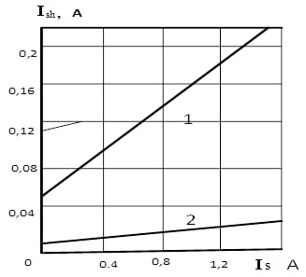
Fig. 1. Starting (1) and release (2) characteristics of the RD3010 transition relay

The voltage coil of the relay, together with a resistor, is connect TEM in parallel to the armature circuit of the traction generator. The current in this coil (and consequently, the magnetic flux) is proportional to the generator voltage. The series-connect TEM current coil of the relay, along with a resistor, is connect TEM in parallel to the windings of the generator's additional poles. As a result, the current in this coil (and the magnetic flux) is proportional to the generator current (Figure 2) [10].
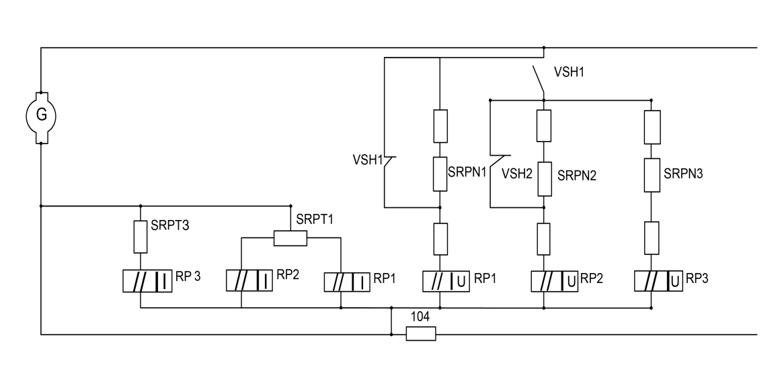
Fig 2. Principal circuit for connecting transition relays RP1, RP2 and relay coils RP3 in TE10M and TE10U type locomotives

The control circuit of the TEM field-weakening contactors is active TEM from position 4 through the contacts of the driver's controller [7,13,22].
The unstable operation of the switching system has been no TEM in numerous articles for many years [12,24].
We include the following among the unstable factors of the switching diagram:
- untimely activation and deactivation of relays on the diagram, which do not correspond to the calculated TEM points of the locomotive's tractive effort-speed characteristic;
- absence of relay activation or deactivation;
- burning of the power contacts of the field-weakening contactors;
- "chattering" of RP1 and RP2.
The switching diagram reflects the complexity of the locomotive's electric transmission dynamic system with its significantly nonlinear (relay) characteristics. The term "chattering" refers to "self-oscillations" in the control system.
Previously [13,32], attention was drawn to the systematic tendency of the switching control system to self-oscillate and deviate from regulation, i.e., to untimely switching of relays RP1 and RP2. Subsequently, statistical data on failures of the switching system were collect TEM [14].
The mutually compatible characteristics of the transition differential relay are implemented TEM according to the following principle: the lower the controller position, the faster direct switching occurs, which contradicts the conditions for implementing traction as the controller position increases [15].
Direct switching is adjustment TEM at the following currents during rheostat tests at position 15 of the controller [13].
FF → AF1 - 3100 A;
AF1 → AF2 - 2900 A.
Therefore, the AF1 → AF2 switching lines fall into the voltage limit zone at controller positions below 9÷10. In this case, the voltage does not increase, the power decreases, the train cannot accelerate, and the activation of relay AF1 → AF2 is not observed [17].
Calculations of the tractive effort values in the direct activation-deactivation zone for serial and experimental circuits were carried out, which are given in Table 1.

Table 1. Experimental and calcula TEM values of tractive force in the switching zones of the serial and experimental schemes of the 2TE10M diesel locomotive.
№ o.n. | Controller position | Tractive force, kgf
№ o.n. | Controller position | FF→AF1 On-Off |  | AF1→AF2 On-Off
№ o.n. | Controller position | Serial circuit | Experimental circuit | Serial circuit | Experimental circuit
1 | 2 | 3 | 4 | 5 | 6
1 | 15 | 17 000 | 17 000 | 10 500 | 11 500
2 | 13 | 15 500 | 16 000 | 9 000 | 10 800
3 | 11 | 13 500 | 14 000 | 7 000 | 9 300
4 | 9 | 10 000 | 12 000 | 4 000 | 8 000
5 | 7 | 5 000 | 9 000 | 2 500 | 6 000
6 | 5 | - | 7 500 | - | 4 000

Due to the possibility of self-oscillations occurring in the automatic control system, relay tuning to low currents is not carried out ("chattering"). Traction-economic characteristics of the transition relay in the activation-deactivation zone of TE10 type locomotives were calculated TEM based on the methodology present TEM in the literature [17,18]. The calculation of the traction-economic characteristics for the relay current coil in serial circuits in the direct activation-deactivation zone was carried out, and they were experimentally connected TEM to the circuit of the control winding of the amplistat. At the same time, the correction diagram was adjusted TEM by adding additional resistances to the current coil circuit [19].
Subsequently, the current coil circuit was connected TEM to the output of the maximum current release node of DC transformers and to this circuit itself, providing an intersection of the field windings of the traction motors. Later, to improve the circuit, the current coil circuit was connected TEM to the output of the amplistat control winding, excluding the SRPT resistance and its regulation [21].
positions = [15, 13, 11, 9, 7, 5]
# TM → SM1
serial_tm_sm1 = [17000, 15500, 13500, 10000, 5000, None]
exp_tm_sm1 = [17000, 16000, 14000, 12000, 9000, 7500]
# SM1 → SM2
serial_sm1_sm2 = [10500, 9000, 7000, 4000, 2500, None]
exp_sm1_sm2 = [11500, 10800, 9300, 8000, 6000, 4000]
# Plotting the graph
plt.figure(figsize=(10, 6))
plt.plot(positions, serial_tm_sm1, 'o-', label="TM→SM1 Serial Circuit")
plt.plot(positions, exp_tm_sm1, 'o--', label="TM→SM1 Experimental Circuit")
plt.plot(positions, serial_sm1_sm2, 's-', label="SM1→SM2 Serial Circuit")
plt.plot(positions, exp_sm1_sm2, 's--', label="SM1→SM2 Experimental Circuit")
plt.gca().invert_xaxis() # Positions decrease
plt.title("Variation of Tractive Effort Depending on Controller Position")
plt.xlabel("Controller Position")
plt.ylabel("Tractive Effort, kG")
plt.legend()
plt.grid(True)
plt.tight_layout()
plt.show()
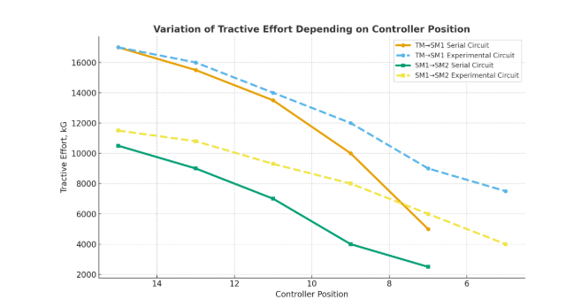
Fig. 3. Experimental and calculaTEM values of tractive force in the switching zones of the serial and experimental schemes of the 2TE10M diesel locomotive
RESEARCH RESULTS
The program is designed for the following purposes: to simplify the calculation of the parameter u (t) - excitation flux, as well as to obtain results that will be used in subsequent research.
CONCLUSIONS
The attenuation of TEM's magnetic field in the operation of FF→ AF1 and AF1→ AF2 systems is examined. When the KV contactor of the excitation system is de-energized, its power contact is shunt TEM with a parallel-connect TEM resistance RSVG=51 Ohm. As a result, the traction generator's voltage dissipates faster than the counter-electromotive force of the traction electric motor's magnetic field. This leads to the system's transition to a short-term braking mode and the separation of magnetic field attenuation contactors' contacts at current and voltage values several times higher than their nominal values.
The change in the traction generator's magnetic field damping time by reducing the value of its magnetic field damping resistance is considered. A proposed circuit diagram for improving the magnetic field attenuation transition process of traction generators in DC-driven locomotives without microprocessor control systems is present TEM.
Based on the system of equations developed for the reduced circuit and analysis of the processes occurring in it, the current flowing through the power circuit during the magnetic field attenuation process was calculated TEM.
The technical and economic efficiency of the developed scheme based on the excitation attenuation diagram for DC-driven locomotives without microprocessor control systems was calculated TEM. The calculation work considered the possibility of comparing the profit from the modifications introduced to the reduced magnetic field attenuation electrical circuit with the funds spent on the developed experimental scheme and determining the overall profit.
The rheostatic tests and inspection of the running gear for the system of improving TED magnetic field attenuation in diesel locomotives were conducted in collaboration with the joint-stock company "Uztemiryo'lmashta'mir" after the modernization of the electrical circuit on diesel locomotive No. 2118 of the 2TE10M type.
REFERENCES
- Jamilov, Shukhrat; Ergashev, Otabek; Abduvaxobov, Muslim; Azimov, Sobir; Abdurasulov, Sherzamin. Improving the temperature resistance of traction electric motors using a microprocessor control system for modern locomotives. DOI: https://doi.org/10.1051/e3sconf/202340103030.
- Abdullayev, S., Kiseleva, O., Adilova, N., Bakyt, G., Vakhitova L. Key development factors of the transit and transport potential of Kazakhstan. Transport Problems, 11(2), pp. 17-26. https://doi.org/10.20858/tp.2016.11.2.2/.
- A. T. Djanikulov and U. I. Abdulatipov. Torsional oscillations of armature shaft of generator of main diesel locomotive in diesel start-up mode. In E3S Web of Conferences (Vol. 401, p. 01072). DOI: https://doi.org/10.1051/e3sconf/202340101072.
- Abdullayev, S.S., Bakyt, G.B., Aikumbekov, M.N., Bondar, I.S., Auyesbayev, Y.T. Determination of natural modes of railway overpasses. Journal of Applied Research and Technology, 2021, 19(1), pp. 1–10. https://doi.org/10.22201/icat.24486736e.2021.19.1.1487.
- Jamilov, S. F., Yusufov, A. M., Samatov, S. A., Kudratov, S. I., Abdurasulov, S. X. Research of factors affecting the heating and cooling of locomotive traction electric machines. International Conference on Thermal Engineering, 2024, 1(1), ISSN 25629034.
- Abdullayev, S., Bakyt, G., Kamzina, A., Suleyeva, N., Tokmurzina-Kobernyak, N., Dynamic Interaction of the TE-33A Diesel Locomotive and the Track in a Curve with a Radius of 600 Meters. International Journal of Mechanical Engineering and Robotics Research, Vol. 13, No. 2, p. 205-212, 2024. https://doi.org/10.18178/ijmerr.13.2.205-212.
- Ablyalimov. O.S. Methodology for Assessing the Efficiency of Transportation Works of Locomotives under Operating Conditions. International Conference on Thermal Engineering, 2024, 1, ISSN 25629034.
- Oleg Ablyalimov and Nazdana Adilova. Towards the justification of optimal volumes of repair production of locomotives of diesel tractions. E3S Web of Conferences 508, 08013 (2024). DOI: https://doi.org/10.1051/e3sconf/202450808013.
- Glushchenko, A., Tashpoltaev, M., Ablyalimov, O. Methods of evaluating cotton harvesting machines Khlopok, 1990, 69(4). - pp. 25–28.
- Reymov K.M., Esemuratova Sh.M., Khusanov B.M., Mytnikov A.V. A study of a hybrid type stand-alone 3 kW photovoltaic system of Karakalpak state university // E3S Web of Conferences 384. 2023. РР, 01047, 1-4. https://doi.org/10.1051/e3sconf/202338401047.
- Khamidov, O., Yusufov, A., Kudratov, S., Yusupov, A. Evaluation of the technical condition of locomotives using modern methods and tools (2023) E3S Web of Conferences, 365, art. no. 05004. DOI: 10.1051/e3sconf/202336505004.
- Abdullayev, S., Bakyt, G., Kamzina, A., Sarsanbekov, K., & Abdullayeva, A. (2023). Interaction of the TE33a Diesel Locomotive and the Railway Track on Curved Section with Radius 290 m. Communications - Scientific Letters of the University of Zilina, 25(4), B315-326. https://doi.org/10.26552/com.C.2023.069..
- Bakyt, G., Jailaubekov, Y., Abdullayev, S., Ashirbayev, G., Ashirbayeva, I. Assessment of carbon dioxide emissions in road transport, using exhaust gas cleaning technology, in the Republic of Kazakhstan. Vibroengineering Procedia, Vol. 48, pp. 87–92, Feb. 2023, https://doi.org/10.21595/vp.2023.23163..
- Khamidov, O., Zayniddinov, N., Kudratov, S., & Erkinov, B. (2024). RETRACTED: Analysis of malfunctions that occur in the crankshaft of locomotive thermal power plants during operation. In E3S Web of Conferences (Vol. 538, p. 01027). EDP Sciences
- Khamidov, O., Kudratov, S., Nuriddin, Z., Kasimov, O., & Abduvakhobov, M. (2025, July). Assessment of the condition of bearing assembly traction motors of electric locators of the “Uzbekistan” series using utilisation of modern technologies. In AIP Conference Proceedings (Vol. 3256, No. 1, p. 060014). AIP Publishing LLC..
- Khamidov, O. R., Kudratov, S. I., Turdimurodov, B. C., & Norbotayeva, M. C. (2024, March). Improvement of diagnostics and analysis of malfunction of the crankshaft of locomotive power plants. In AIP Conference Proceedings (Vol. 3045, No. 1, p. 050030). AIP Publishing LLC.
- Ergashev, O., Kasimov, O., Djamilov, S., Azimov, S., & Keldibekov, Z. (2024, March). Improvement of diagnostics of traction electrical motors of railway rolling stock. In AIP Conference Proceedings (Vol. 3045, No. 1, p. 050041). AIP Publishing LLC.
- Yakubov, J. K., & Kosimov, K. R. (2024, March). Reducing the operating time and fuel consumption of the UzTE16M3 locomotive in the optimized operating mode. In AIP Conference Proceedings (Vol. 3045, No. 1, p. 050027). AIP Publishing LLC.
- Gordeev I. P., Tarasov E. M. On the issue of defection of anchors of traction electric motors. // Izvestiya vuzov. The North Caucasus region. Technical Sciences, No. 2. - Novocherkassk, - 2006. - pp. 57-63.
- Khamidov, O. R., Kamalov, I. S., & Kasimov, O. T. (2023, March). Diagnosis of traction electric motors of modern rolling staff using artificial intelligence. In AIP Conference Proceedings (Vol. 2612, No. 1, p. 060018). AIP Publishing LLC.
- Jamilov, S., Safarov, U., Julenev, N., & Qosimov, K. (2024, June). Analysis of Experimental Studies of Transient Processes during the Start-up of the Protection of the Diesel Generator Set. In ICTEA: International Conference on Thermal Engineering (Vol. 1, No. 1).
- Achilov, O.R., Mansurova, S.I., Sidiknazarova, Z.M., Kiyasova, R.M. A Solution to Language Problems in the Communication and Documentation of Local and International Employees in the Development of the Transport Sector. Sustainable Development of Transport. vol 1366. (2025). pp201-211. DOI: https://doi.org/10.1007/978-3-031-88846-5_23.
- Mirsagdiev, O., Yaronova, N., Achilov, O. Assessing the quality of speech transmission using the e-model. AIP Conf. Proc. 3243, 020084 (2024). DOI: https://doi.org/10.1063/5.0247328.
- Kurbanov, J.F., Yaronova, N. В., Xidirov, J. E., Achilov, O. The module development for remote control signals of an automatic locomotive signaling system in railway transport, Proc. SPIE 13065, 1306504 (2024); DOI: https://doi.org/10.1117/12.3024860.

