Maximum and minimum values of multivariable functions and their application to electrical energy problems
Shokhrukh Rajabov^{1,a)}, Uktam Rakhmonov², Khamdam Kuromboev³, Egamberdi Esanov²
¹Tashkent State Transport University, Tashkent, Uzbekistan
²Tashkent State Technical University, Tashkent, Uzbekistan
³Chirchik State Pedagogical University, Chirchik, Uzbekistan.
^{a)}Corresponding author: sh.sh.rajabov@gmail.com
Abstract. Electric energy is far away in the form of direct current distance transmission, unlike alternating current, is reactive is carried out without resistance. The network is variable since there is no electromagnetic field, it is only active will have resistance, that is, in this case, waste will be reduced. It is only to increase or decrease the voltage is transferred to alternating current. Inverters for this is used. Alternating current received in the generator amplified in a transformer, rectified in a rectifier, is transmitted to the required distance on the direct current line. Alternating current reaches the consumer and in the inverter is transferred to the view and its voltage is reduced again. Below we will try to mathematically justify the issue of reducing power consumption in the process of power transmission.
INTRODUCTION
Let's assume
$$u=f\left(x_{1},x_{2 ,… ,}x_{m}\right) (1)$$
the function D is defined in the domain and ($x_{1}^{0}, x_{2}^{0},…,x_{m}^{0})$ be an interior point of this field.
If ($x_{1}^{0}, x_{2}^{0},…,x_{m}^{0})$point $(x_{1}^{0}-δ_{1},x_{1}^{0}+δ_{1},x_{2}^{0}-δ_{2},x_{2}^{0}+δ_{2};…;x_{m}^{0}-δ_{m},x_{m}^{0}+δ_{m})$ it can be wrapped around and at all points of this circle
$f\left(x_{1},x_{2,…,}x_{m}\right)≤f\left(x_{1}^{0}, x_{2}^{0},…,x_{m}^{0}\right)$($f\left(x_{1},x_{2,…,}x_{m}\right)≥f\left(x_{1}^{0}, x_{2}^{0},…,x_{m}^{0})\right) (2$)
if the inequality holds, in that case $f\left(x_{1},x_{2,…,}x_{m}\right)$ function $f\left(x_{1}^{0}, x_{2}^{0},…,x_{m}^{0}\right)$ is said to have a maximum (minimum) at the point.
If this area can be made so small that the equal sign is inappropriate, i.e. ($x_{1}^{0}, x_{2}^{0},…,x_{m}^{0})$ at points other than the point
$f\left(x_{1},x_{2,…,}x_{m}\right)<f\left(x_{1}^{0}, x_{2}^{0},…,x_{m}^{0}\right)$ ($f\left(x_{1},x_{2,…,}x_{m}\right)>f\left(x_{1}^{0}, x_{2}^{0},…,x_{m}^{0}\right)) (3)$
if the inequality is strictly fulfilled, in that case ($x_{1}^{0}, x_{2}^{0},…,x_{m}^{0})$ it is said that a characteristic maximum (minimum) occurs at a point, otherwise an characteristic maximum (minimum) occurs [1-5].
The maximum and minimum values of the function are called extremum of the function.
Let us assume that our function (1) has an extremum at some point ($x_{1}^{0}, x_{2}^{0},…,x_{m}^{0})$.
Theorem. If our function (1) has an extremum at a point ($x_{1}^{0}, x_{2}^{0},…,x_{m}^{0})$ and is finite at this point
$${ f}_{x_{1}}^{'}\left(x_{1}^{0}, x_{2}^{0},…,x_{m}^{0}\right),…,f_{x_{m}}^{'}\left(x_{1}^{0}, x_{2}^{0},…,x_{m}^{0}) (4\right)$$
if there are particular derivatives, then all these derivatives are equal to zero.
Proof. For the purpose of proof, if we take $x_{1}$ as a variable and assign the rest as $x_{2}=x_{2}^{0}, . . .,{ x}_{m}{=x}_{m}^{0}$ then that function remains a function of one variable $x_{1}$:
$$u= f\left(x_{1}, x_{2}^{0},…,x_{m}^{0}\right) (5)$$
We since assume that the multivariable function has an extremum ($x_{1}^{0}, x_{2}^{0},…,x_{m}^{0})$ at the point (let it be a maximum for clarity) in particular, where $x_{1}=x_{1}^{0}$ is point $(x_{1}^{0}-δ_{1},x_{1}^{0}+δ_{1})$ around any point
$$f\left(x_{1}, x_{2}^{0},…,x_{m}^{0}\right)≤f\left(x_{1}^{0}, x_{2}^{0},…,x_{m}^{0}\right) (6)$$
it follows that it is necessary to fulfill the inequality. So, the one-variable function given above has a maximum at the point $x_{1}=x_{1}^{0}$, from which according to Fermat's theorem
$$f_{x_{1}}^{'}\left(x_{1}^{0}, x_{2}^{0},…,x_{m}^{0}\right)=0 (7)$$
must be. Similarly, it can be shown that the remaining derivatives at the point ($x_{1}^{0}, x_{2}^{0},…,x_{m}^{0})$are equal to zero [6-8]. The theorem was proved.
It follows from this that the existence of the extremum is a necessary condition for the first-order special derivatives to be equal to zero.
Thus, the points at which the first-order specific derivatives of the function are equal to zero are taken as "doubtful" for the extremum [9, 10]. Their coordinates are:
$$\left\{\begin{aligned}f_{x_{1}}^{'}\left(x_{1},x_{2,…,}x_{m}\right)=0 \\ ……………………… \\ f_{x_{m}}^{'}\left(x_{1},x_{2,…,}x_{m}\right)=0\end{aligned}\right. (8)$$
the system of equations is solved.
Like functions of one variable, such points are called stationary points.
Let our function (1) be defined and continuous in any finite closed domain D and have finite special derivatives in this domain. According to the Weierstrass theorem, the point $\left(x_{1}^{0}, x_{2}^{0},…,x_{m}^{0}\right)$ is found in this area where the function takes the largest (smallest) value among all values. If the point $\left(x_{1}^{0}, x_{2}^{0},…,x_{m}^{0}\right)$ lies inside the area D, then the point we are interested in may be among the "doubtful" points in terms of extremum [11]. However, the function (1) can reach its maximum (minimum) value at the boundary of the domain [12]. Therefore, in order to find the largest (smallest) value of the function (1) in area D, it is necessary to find all internal "doubtful" stationary points on the extremum, calculate the values of the function at these points and compare them with its values at the limit: among these values, the most the largest (smallest) is the largest (smallest) value of the function in this field [13-15].

PRACTICAL RESEARCH
Now let's explain the above with examples:
- $x$ axis, $y$ axis and $x+y=2π$ in a triangle bounded by a straight line (figure 1)
$$u=\sin{x}+\sin{y}-\sin\left(x+y\right) (9)$$
let it be required to find the maximum value of the function. Let's find the derivatives for this:
$$u_{x}^{'}=\cos{x}-\cos\left(x+y\right), u_{y}^{'}=\cos{y}-\cos\left(x+y\right) (10)$$
At a single point $\left(\frac{2π}{3},\frac{2π}{3}\right)$ inside the sphere, the derivatives become zero, then $u=\frac{3\sqrt{3}}{2}.$Since our function is equal to zero at the boundary of the field, i.e. at the straight lines $x=0, y=0$ and $x+y=2π$, it is clear that the function reaches its maximum value at the point $\left(\frac{2π}{3},\frac{2π}{3}\right)$ found above.
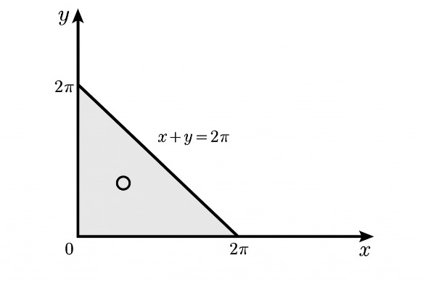
FIGURE 1. The shape formed using the graph of the function $x+y=2π$

Many problems in mathematics and other fields of science and technology are brought to the problem of finding the largest and smallest value of a function [16]. Here are some examples
- Find the largest face of the triangles inscribed in the given circle of radius R (figure 2).
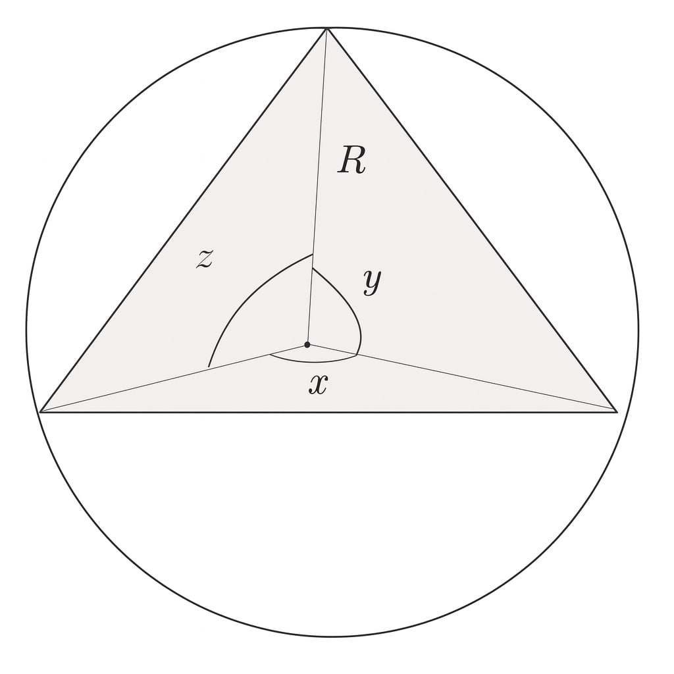
FIGURE 2. Triangle inscribed in a circle of radius R

Solution. If x, y, z denote the central angles drawn on the sides of the triangle, then they are connected by the relationship $x+y+z=2π$, from which $z=2π-x-y.$ Through them, the face S of the triangle is found as follows:
$$S=\frac{1}{2}R^{2}∙\sin{x}+\frac{1}{2}R^{2}∙\sin{y}+\frac{1}{2}R^{2}∙\sin{z}=\frac{1}{2}R^{2}∙\left[\sin{x}+\sin{y}-sin\left(x+y\right)\right] (11)$$
Here, the area of change of variables x,y is determined by the conditions $x≥0 , y≥0, x+$y$≤2π.$Let's find the values of the variables for which the expression inside the parentheses becomes the largest. We found this value to be $x=y=\frac{2π}{3}$ in the example above. Therefore, $z=\frac{2π}{3}$and the requested triangle is an equilateral triangle.
RESEARCH RESULTS
When power lines are stretched over long distances high reactive power of power transmission networks possible, reactive power in power transmission networks (restriction) compensator for reduction devices (RD) are installed. They are network reactivitydepending on the character, it is capacitive or inductive it can.
If the network wires are close enough, they are capacitive reactance due to capacitive resistance between there will be power, they are compensated by means of reactors will be done. Consumers and inductive loads in the network inductive reactive powers flowing into account by means of capacitor compensating devices (CCD) will be compensated [17].
Electric energy is far away in the form of direct current distance transmission, unlike alternating current, is reactive is carried out without resistance. The network is variable since there is no electromagnetic field, it is only active will have resistance, that is, in this case, waste will be reduced. It is only to increase or decrease the voltage is transferred to alternating current. Inverters for this is used [18,19]. Alternating current received in the generator amplified in a transformer, rectified in a rectifier, is transmitted to the required distance on the direct current line. Alternating current reaches the consumer and in the inverter is transferred to the view and its voltage is reduced again.
Below we will try to mathematically justify the issue of reducing power consumption in the process of power transmission.
Problems. A parallel connected network providing electricity is given. Figure 3 shows the scheme of the network, where A, B are the clamps of the current source, and , $P_{1},P_{2},… ,P_{n}$ are the devices (consumers) consuming currents $i_{1},i_{2}, …,i_{n}$ respectively. The amount of potential difference (voltage) in the chain is equal to e, find the cross section of the wires so that the minimum amount of miss is spent on the entire trunk (figure 3).
Solution. It is known that it is enough to check one of the wires, for example, $AA_{n}$ because another similar situation is in the same condition. $AA_{1},A_{1}A_{2}$,…,$A_{n-1}A_{n}$ with $l_{1},l_{2}, …,l_{n}$ are the lengths (in meters), and $q_{1},q_{2}, …,q_{n}$ are the faces of their cross sections (in sq. mm.) [20,21].
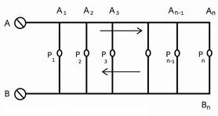
FIGURE 3. Minimum distribution of voltages in the chain

In that case,
$$u=l_{1}q_{1}+l_{2}q_{2}+…+l_{n}q_{n} (12)$$
expression gives the volume (measured in ${sm}^{3}$) of the entire wire used. Taking into account that the amount of the total potential difference (voltage) in the $AA_{n}$ wire is , it is necessary to achieve the smallest amount of this volume.
It is possible to calculate what $J_{1},J_{2}, …,J_{n}$ currents pass through $AA_{1},A_{1}A_{2}$,…,$A_{n-1}A_{n}$ parts of the chain:
$J_{1}=i_{1}+i_{2}+…+i_{n}$,$J_{2}=i_{2}+i_{3}+…+i_{n}$,…,$J_{n}=i_{n}. (13)$
If r is the specific resistance of a copper wire with a length of 1 m and a section of 1${mm}^{2}$then the electrical resistance of these sections
$$R_{1}=\frac{ρl_{1}}{q_{1}}, R_{2}=\frac{ρl_{2}}{q_{2}},…, R_{n}=\frac{ρl_{n}}{q_{n}}. (14)$$
So, in these sections, according to Ohm's law, the corresponding potential difference (voltages):
$e_{1}=R_{1}J_{1}=\frac{ρl_{1}J_{1}}{q_{1}}$ , $e_{2}=R_{2}J_{2}=\frac{ρl_{2}J_{2}}{q_{2}}$ , … , $e_{n}=R_{n}J_{n}=\frac{ρl_{n}J_{n}}{q_{n}} (15)$
is represented by.
In order to avoid complex calculations, we replace the variables $q_{1},q_{2},…,q_{n}$ with $e_{1}+e_{2}+…+e_{n}=e$, from which $e_{n}=e-e_{1}-e_{2}-…-e_{n-1}$ is connected by the simple relation introduce the variables $e_{1},e_{2},…,e_{n}$ Then, in turn,
$q_{1}=\frac{ρl_{1}J_{1}}{e_{1}},q_{2}=\frac{ρl_{2}J_{2}}{e_{2}}$,…,$q_{n}=\frac{ρl_{n}J_{n}}{e_{n}}=\frac{ρl_{n}J_{n}}{e-e_{1}-e_{2}-…-e_{n-1}} (16)$
and
$$u= ρ\left[\frac{{l_{1}}^{2}J_{1}}{e_{1}}+\frac{{l_{2}}^{2}J_{2}}{e_{2}}+…+\frac{{l_{n-1}}^{2}J_{n-1}}{e_{n-1}}+\frac{{l_{n}}^{2}J_{n}}{e-e_{1}-e_{2}-…-e_{n-1}}\right] (17)$$
at the same time, the field of variation of arbitrary variables $e_{1},e_{2},…,e_{n-1}$, $e_{1}>0$,$e_{2}>0,…, e_{n-1}>0$,$e_{1}+e_{2}++…+e_{n-1}<e$ are determined by the inequalities.
Now, by setting the specific derivatives of that function$u$ to zero, we get this system of inequalities [22]:
$$\left\{\begin{aligned}-\frac{{l_{1}}^{2}J_{1}}{{e_{1}}^{2}}-\frac{{l_{n}}^{2}J_{n}}{{\left(e-e_{1}-e_{2}-…-e_{n-1}\right)}^{2}}=0 \\ …………………………………………… \\ -\frac{{l_{n-1}}^{2}J_{n-1}}{{{(e}_{n-1})}^{2}}-\frac{{l_{n}}^{2}J_{n}}{{\left(e-e_{1}-e_{2}-…-e_{n-1}\right)}^{2}}=0\end{aligned} (18)\right.$$
from this (ie by inserting $e_{n}$): $\frac{{l_{1}}^{2}J_{1}}{{e_{1}}^{2}}=…=\frac{{l_{n}}^{2}J_{n}}{{e_{n}}^{2}}$.
For convenience, let's define the total amount of these ratios as $\frac{1}{a^{2}}(a>0)$. In that case: $e_{1}=al_{1}\sqrt{J_{1}}$, $e_{2}=al_{2}\sqrt{J_{2}},…$,$e_{n}=al_{n}\sqrt{J_{n}}$ together with a quantity $e_{1}+e_{2}+…+e_{n}=e$ is easily found from the condition:
$$a=\frac{e}{l_{1}\sqrt{J_{1}}+l_{2}\sqrt{J_{2}}+l_{n}\sqrt{J_{n}}}. (19)$$
Finally, passing to the main variables $q_{1},q_{2},…,q_{n}$,
$$q_{1}=\frac{ρ}{a}\sqrt{J_{1},}q_{2}=\frac{ρ}{a}\sqrt{J_{2}},…, q_{n}=\frac{ρ}{a}\sqrt{J_{n}} (20)$$
we find. So, this shows that the most favorable cross-sectional areas of wires are proportional to the square roots of the corresponding currents.
It is possible to calculate what $J_{1},J_{2}, …,J_{n}$ currents pass through $AA_{1},A_{1}A_{2}$,…,$A_{n-1}A_{n}$ parts of the chain:
$J_{1}=i_{1}+i_{2}+…+i_{n}$,$J_{2}=i_{2}+i_{3}+…+i_{n}$,…,$J_{n}=i_{n}. (21)$
If r is the specific resistance of a copper wire with a length of 1 m and a section of 1${mm}^{2}$then the electrical resistance of these sections
$$R_{1}=\frac{ρl_{1}}{q_{1}}, R_{2}=\frac{ρl_{2}}{q_{2}},…, R_{n}=\frac{ρl_{n}}{q_{n}}. (22)$$
So, in these sections, according to Ohm's law, the corresponding potential difference (voltages):
$e_{1}=R_{1}J_{1}=\frac{ρl_{1}J_{1}}{q_{1}}$ , $e_{2}=R_{2}J_{2}=\frac{ρl_{2}J_{2}}{q_{2}}$ , … , $e_{n}=R_{n}J_{n}=\frac{ρl_{n}J_{n}}{q_{n}} (23)$
is represented by.
CONCLUSIONS
Using the extrema of multivariable functions, that is, their maxima and minima, we applied them from solving applied mathematical problems to solving energy problems of our object of study. We used the mathematical basis to minimize energy waste in power transmission using direct physical concepts and laws. We set ourselves the goal of using the applications of extrema of multivariable functions in our further scientific research. It should be noted that today there is a high demand for energy-saving equipment for efficient and long-term use of limited resources, so we are forced to focus on the production of more energy-saving electrical equipment. This is directly related to the problem of minimization, that is, it is equivalent to the problem of finding the minimum of a multivariable function. From this we can conclude that the issues we are considering are currently very relevant and important
REFERENCES
- Cartan E. Sur les domaines bornes homog´enes de l’espace den variables complexes, `Abhandlungen aus dem Mathematischen Seminar der Universitat Hamburg, 1935, vol. 11, issue 1, pp. 116–162. https://doi.org/10.1007/BF02940719
- Siegel C. L. Symplectic geometry. American Journal of Mathematics, (65), pp.1-86, 1943
- Hua L. K. Harmonic analysis of functions of several complex variables in classical domains, AMS, 1963.
- Barbaresco, F. Information Geometry of Covariance Matrix: Cartan-Siegel Homogeneous Bounded Domains, Mostow/Berger Fibration and Fréchet Median. In: Nielsen, F., Bhatia, R. (eds) Matrix Information Geometry. (2013). Springer, Berlin, Heidelberg. https://doi.org/10.1007/978-3-642-30232-9_9
- U. S. Rakhmonov, Z. K. Matyakubov, “Carleman's formula for the matrix domains of Siegel”, Чебышевский сб., 23:4 (2022), 126–135. https://doi.org/10.22405/2226-8383-2022-23-4-126-135
- Rakhmonov U. S., Abdullayev J. Sh. “On volumes of matrix ball of third type and generalized Lie balls”, Vestn. Udmurtsk. Univ. Mat. Mekh. Komp. Nauki, 29:4 (2019), 548–557. DOI: https://doi.org/10.20537/vm190406
- Khudayberganov G., Rakhmonov U.S. Carleman formula for matrix ball of the third type. Springer Proceedings in Mathematics and Statistics, 2018, 264, стр. 101–108. DOI: 10.1007/978-3-030-01144-4_9
- 8. Khudayberganov G. Kh., Rakhmonov U. S. The Bergman and Cauchy–Szego kernels for matrix ball ˝ of the second type, Journal of Siberian Federal University. Mathematics and Physics, 2014, vol. 7, issue 3, pp. 305–310.
- http://mi.mathnet.ru/eng/jsfu375
- Khudayberganov G., Rakhmonov U. S., Matyakubov Z. Q. Integral formulas for some matrix domains, Contemporary Mathematics, 2016, pp. 89–95. https://doi.org/10.1090/conm/662/13318
- Khudayberganov G. Kh., Otemuratov B. P., Rakhmonov U. S. Boundary Morera theorem for the matrix ball of the third type, Journal of Siberian Federal University. Mathematics and Physics, 2018, vol. 11, issue 1, pp. 40–45. https://doi.org/10.17516/1997-1397-2018-11-1-40-45
- Khudayberganov G., Rakhmonov U. S. Carleman formula for matrix ball of the third type, USUZCAMP 2017: Algebra, Complex Analysis, and Pluripotential Theory, Springer Proceedings in Mathematics & Statistics, 2017, pp. 101–108. https://doi.org/10.1007/978-3-030-01144-4_9
- Rakhmonov U. S., Abdullayev J. Sh. On volumes of matrix ball of third type and generalized Lie balls, Vestnik Udmurtskogo Universiteta. Matematika. Mekhanika. Komp’yuternye Nauki, 2019, vol. 29, issue 4, pp. 548–557. https://doi.org/10.20537/vm190406
- Khudayberganov G. K., Abdullayev J. Sh. Relationship between the kernels Bergman and Cauchy– Szego in the domains ˝ τ + (n − 1) and , Journal of Siberian Federal University. Mathematics and Physics, 2020, vol. 13, issue 5, pp. 559–567. https://doi.org/10.17516/1997-1397-2020-13-5-559-567
- Abdukarimov A., Rakhmonov U.S., Turaev F.Z. Dynamic response of the system to external influences. AIP Conference Proceedings, 2023, 2612, 030017. DOI: 10.1063/5.0117527
- Rakhmonov U.S., Abdukarimov A., Rajabov Sh. Calculation of Inherently Deformable Pipelines Lying on a Solid Viscoelastic Base with Random Characteristics. AIP Conference Proceedings, 2023, 2612, 030016. DOI: 10.1063/5.0117526
- Pinchuk S., Shafikov R., Sukhov A. Some aspects of holomorphic mappings: a survey, Proceedings of the Steklov Institute of Mathematics, 2017, vol. 298, no. 1, pp. 212–247. https://doi.org/10.1134/S0081543817060153
- Yurieva E. V. On the extension of analytic sets into a neighborhood of the edge of a wedge in nongeneral position, Journal of Siberian Federal University. Mathematics and Physics, 2013, vol. 6, issue 3, pp. 376–380. http://mi.mathnet.ru/eng/jsfu324
- J. Abdullayev, U. Rakhmonov, and N. Mahmudova, “Orthonormal system for a matrix ball of the second type and its skeleton (Shilov’s boundary),” Asia Pac. J. Math.10, 27 (2023). https://doi.org/10.28924/APJM/10 -27.
- Damin Shamsiev, Abdali Abdukarimov, Uktam Rakhmonov, Ruslan Duisenbayev. Solution of a dynamic problem of a hereditary deformable cylinder with a variable. AIP Conf. Proc.3331, 030088 (2025). https://doi.org/10.1063/5.0307049
- Uktam Rakhmonov; Abdali Abdukarimov; Jonibek Abdullaev; Shokhruh Rajabov, “Siegel domains and Cartan-Siegel homogeneous domains: Siegel disk”, AIP Conf. Proc. 3256, 040019 (22–23 February 2024. Tashkent, Uzbekistan), AIP Conf. Proc., 2025, 040019. https://doi.org/10.1063/5.0267027
- U. S. Rakhmonov, “Automorphisms for a matrix ball of the third type B(3)m,n from space Cn[m×m]”, Bulletin of the Institute of Mathematics, 2022, no. No5, 60–69.
- G. Kh. Khudayberganov, J. Sh. Abdullayev, and U. S. Rakhmonov, “Functional Properties of the Bergman Kernel in the Space Cn[m×m]”, Lobachevskii Journal of Mathematics, Vol. 46, No. 3 (2025), 1322-1335. https://doi.org/10.1134/S1995080225605247

