Theoretical analysis of an improved aspiration system for the cotton cleaning aggregate
Rakhmatjon Nazirov¹, Abdulhakim Usanov ^{2,a)}, Alisherjon Mirzaev²
¹ Research Institute of Fiber Crops, Tashkent, Uzbekistan
² Termez state university of engineering and agrotechnologies, Termiz, Uzbekistan
^{a)} Corresponding author: abdulxakimusanov@gmail.com
Abstract. An optimal structural configuration of an aspiration system designed to extract impurities released from the UCCC cotton cleaning aggregate is proposed. The pressure loss patterns in the pneumatic duct were theoretically and experimentally investigated as a function of the concentration of dust-laden air. Theoretical results are presented for determining the optimal expansion angle of the fan diffuser within the system. Through the development of an improved aspiration system, measures were implemented to reduce the concentration of dust emitted into the atmosphere. As a result, improvements are expected in protecting the health of enterprise workers and residents living in surrounding areas, as well as in ensuring high cleaning efficiency of dust collection devices (cyclones).
INTRODUCTION
At present, approximately 80% of the cotton cultivated in our republic belongs to selectively bred varieties that are difficult to clean. In addition, in order to reduce manual labor and minimize additional costs, the volume of cotton harvesting using mechanical methods has been increasing from year to year. During mechanical harvesting, the level of impurities in cotton is on average 10–15% higher than that of manually harvested cotton [1]. For this reason, the concentration of dust in the dust-laden air extracted by the aspiration system from the fine-impurity cleaning sections of the UCCC cotton cleaning aggregate is inevitably relatively high.
It is well known that the efficiency of an aspiration system designed for dust-laden air purification is significantly influenced by the concentration of the separated dust particles [2].
The degree of efficiency reduction depends on the airtightness of the aspiration system and the dispersion level of the dust. Previous studies have shown that if approximately 1% of additional air is drawn into the aspiration system due to loss of airtightness, the dust collection efficiency of the system may decrease by 5–10%, and this can subsequently lead to clogging of the dust-collecting cyclone [3].
Considering that the release of excessive amounts of dust into the atmosphere from aspiration systems of cotton cleaning enterprises leads to deterioration of the environmental condition, it becomes evident that the development of an aspiration system capable of eliminating these shortcomings represents a highly relevant and pressing problem.

EXPERIMENTAL RESEARCH
As the experimental object, the aspiration system of the UCCC aggregate used for cleaning raw cotton at the “Angor” cotton cleaning enterprise, belonging to ANGOR ZAMIN CLUSTER LLC and located in Surkhandaryo region, was selected (see Figure 1).
As shown in Figure 1, the suction ducts connected to each section of the existing aspiration system of the UCCC cotton cleaning aggregate are sequentially connected—from the cotton inlet side of the aggregate—to a main pneumatic duct whose diameter gradually increases. For analytical purposes, the aspiration system illustrated in Figure 1 was conditionally divided into four sections. The first section corresponds to the pneumatic duct connected to the bunker for fine impurities separated by the 1HK cleaner located at the front part of the Universal Cotton Cleaning Complex (UCCC) aggregate. The second, third, and fourth sections correspond to the pneumatic ducts connected to the bunkers for fine impurities located in the intermediate zones of the UCCC aggregate’s large-impurity cleaning sections.
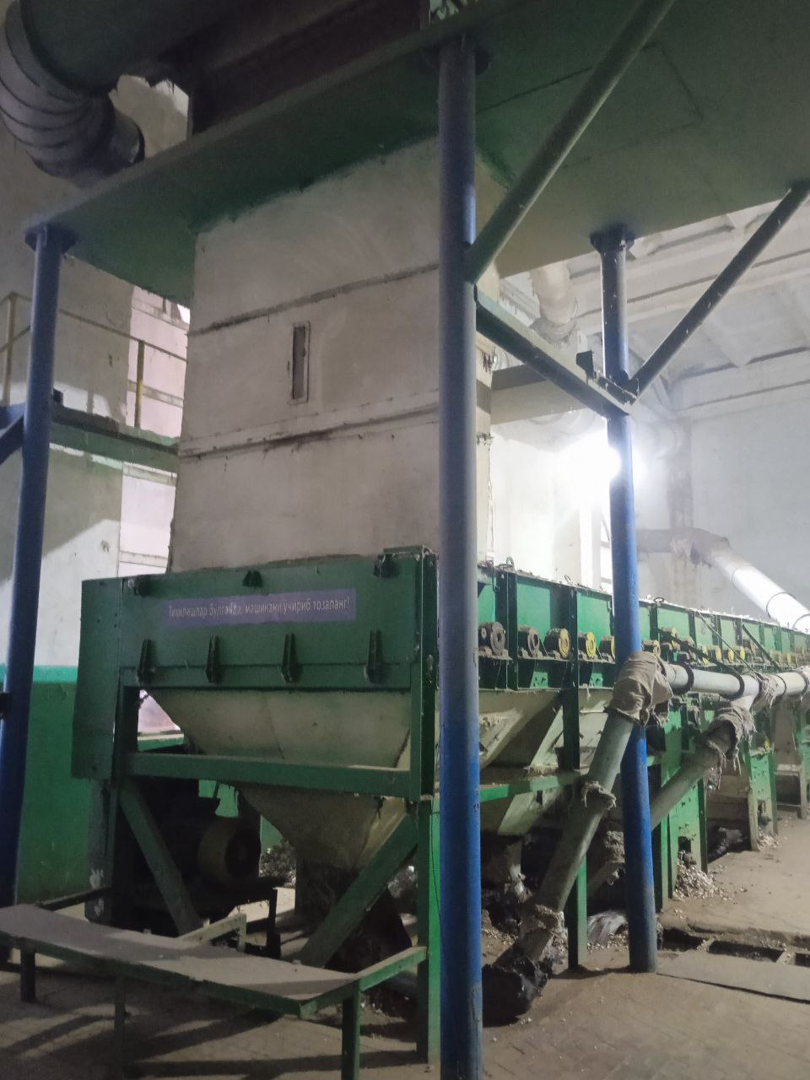 | 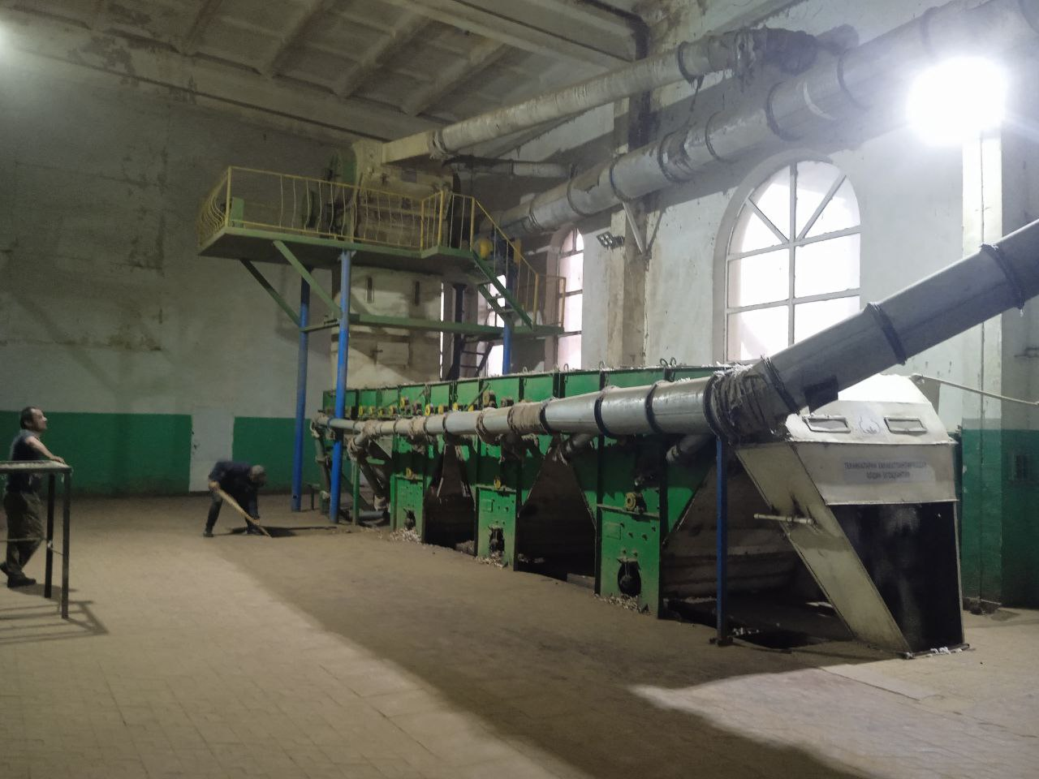 | 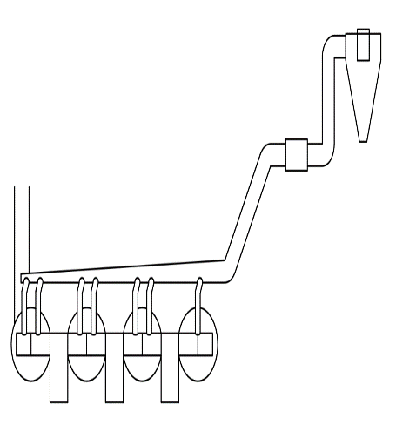
a) | b) | c)
FIGURE 1. General view and schematic diagram (right) of the existing aspiration system of the UCCC aggregate at the “Angor” cotton cleaning enterprise selected as the experimental object. a) Existing aspiration system; b) Arrangement of the pneumatic conveying duct with respect to the UCCC unit; c) General layout diagram of the UCCC unit.

At the initial stage of the experiments, we took into account the recommendations of TsNIIIKhProm, according to which the required air flow rate to be extracted from each waste bunker of the cleaning aggregate should be 0.5 m³/s, and the diameter of the pneumatic duct should be 160 mm [4].
Experiments were conducted at the “Angor” cotton cleaning enterprise, belonging to ANGOR ZAMIN CLUSTER LLC and located in Surkhandaryo region, in order to determine the concentration of dust-laden air generated under actual production conditions in the aspiration system of the UCCC cotton cleaning aggregate.
Based on the experimental results, the amount of fine impurities transferred from the sections of the UCCC cotton cleaning aggregate to the aspiration system at the selected “Angor” cotton cleaning enterprise was determined (see Figure 1).
In the schematic diagram shown in Figure 1, the sections enclosed by circles represent fine-impurity cleaning units consisting of four spiked drums each. Since the section marked with the number four at the final part of the UCCC aggregate contains only two spiked drums, the amount of waste collected from this section was doubled for comparison purposes.
During the experiments, raw cotton of the C-6524 selective variety (second industrial grade) with an impurity content of 6.8% and a moisture content of 9.2% was processed. The quantities of fine impurities separated from the first, second, third, and subsequent sections of the UCCC aggregate—counting from the cotton inlet side—were determined. For this purpose, the aspiration ducts of the fine-impurity cleaning sections were disconnected, and the impurities released during the cleaning process were collected from the lower part of the aggregate.
The processing capacity of the UCCC cotton cleaning aggregate was 6,800 kg/h. The duration of each experimental run was set at 20 minutes. The obtained results are presented in Table 1 [5].

TABLE 1. Amount of impurities separated from the fine-impurity cleaning sections of the UCCC aggregate
Experiment repetition | Amount of impurities separated in UCCC aggregate sections, kg/% |  |  |  | Total amount, kg/%
Experiment repetition | First | Second | Third | Fourth | Total amount, kg/%
1 | 22/38,6 | 16/28,1 | 11/19,3 | 8/14,0 | 57/100
2 | 24/43,6 | 14/25,4 | 10/18,2 | 7/12,8 | 55/100
3 | 20/35,7 | 15/26,8 | 12/21,4 | 9/16,1 | 56/100
Average | 22/39,3 | 15/26,8 | 11/19,6 | 8/14,3 | 56/100

As can be seen from the experimental results presented in Table 1, the amount of fine impurities separated from the fine-cleaning sections of the UCCC cotton cleaning aggregate is highest at the cotton inlet section of the aggregate and then gradually decreases along its length, as shown in Table 1. Thus, it was determined that the sections located at the front part of the UCCC aggregate account for 39.3% of the total amount of separated fine impurities due to the intensive release of contaminants at this stage.
From these results, it can be concluded that the concentration of dust in the dust-laden air extracted by the aspiration system from the inlet sections of the UCCC cotton cleaning aggregate is higher than that in the subsequent sections. This is because, according to the recommendations [4], the volume of air extracted from the waste bunker of each section of the UCCC aggregate (0.5 m³/s) is the same. Consequently, at equal air flow rates, a relatively larger amount of dust (waste particles) is transported from the inlet sections.
Unfortunately, the aspiration system shown in Figure 1 is inevitably less efficient, since the large-diameter connecting pneumatic duct is installed at the final cleaning section of the UCCC aggregate. If the concentration of dust-laden air increases progressively along the length of the aggregate and additional air is drawn in due to loss of airtightness of the pneumatic duct, the efficiency of the cleaning system may decrease significantly or clogging may occur within the pneumatic duct. This is because the degree of efficiency reduction depends on the airtightness of the aspiration system and the dispersion or fractional composition of the dust (see Figure 2).
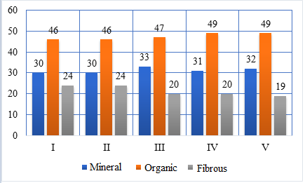
FIGURE 2. Fractional composition of waste separated during the cotton cleaning process by industrial cotton grades.

As can be seen from the histogram in Figure 2, during the cotton cleaning process the proportion of mineral impurities varies within the range of 30–32%, while the content of organic impurities ranges from 46% to 49%, and fibrous impurities vary from 24% to 19%, depending on the industrial cotton grade. The predominance of organic impurities released during the cleaning process is directly related to cleaning efficiency; therefore, these data must be taken into account when adjusting the aerodynamic regime of the aspiration system.
Significant improvements in addressing the environmental challenges of cotton cleaning enterprises can be achieved by optimizing the operation of pneumatic conveying and aspiration systems aimed at reducing the consumption of technological air. This approach enables the development of aspiration systems with optimal technological parameters for cotton cleaning equipment, eliminates mismatches between the performance characteristics of cyclones and centrifugal fans, and ultimately increases dust separation efficiency.
In particular, a centrifugal fan is used to transport dust-laden air through the aspiration system to the cyclone. The air-handling capacity of the centrifugal fan must correspond to the hydraulic resistance of the cyclone, which depends on its volume. In addition, the velocity of the dust-laden air at the cyclone inlet, as delivered by the centrifugal fan, must be such that maximum separation of dust particles from the air stream is achieved upon entering the cyclone.
In the existing aspiration system of the UCCC aggregate, the discharge duct of the suction fan has a rectangular cross-section F₀, to which a cylindrical diffuser of length l and cross-sectional area F₁ is connected. As the diffuser expands at an angle α, the air velocity changes from V₀ to V₁ before entering the air duct.
In the diffuser, due to its gradual expansion, a portion of the dynamic pressure is converted into static pressure, resulting in a reduction of the airflow velocity from V₀ to V₁. Consequently, the additionally generated static pressure H¹_{st} is determined by the difference between the dynamic pressures at the narrow cross-section H¹_{g} and the wide cross-section H¹¹_{g} of the diffuser, taking into account the pressure loss ΔH [6, 7, 8] (see Figure 4).
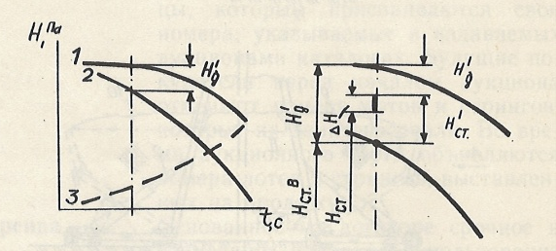
FIGURE 4. Aerodynamic characteristics of the centrifugal fan and pressure variation
Pressure: 1 – total; 2 – static; 3 – dynamic

From the above analysis, it can be concluded that the efficiency of dust-laden air purification in the aspiration systems of existing UCCC aggregates is low. In many cotton cleaning enterprises, the discharge of dust-laden air rising upward from the outlet ducts of centrifugal cyclones can be observed. In order to eliminate these shortcomings, a scientific research direction was selected, and a plan for conducting practical experiments was developed.
The dust collection efficiency of the aspiration system of the UCCC aggregate was determined based on the difference between the air impurity levels at the inlet and outlet of the dust collector (cyclone), using the following expression:
$η=\frac{d_{1}-d_{2}}{d_{1}}⋅100$, % (1)
where: d₁–dust concentration of the air entering the dust collector, mg/m³;
d₂– dust concentration of the air leaving the dust collector, mg/m³.
The hydraulic resistance of the cyclone is determined using the following expression:
$Р=\frac{ρ*V^{2}*f}{2}$ (2)
where: ρ – air density at the calculated section of the cyclone, kg/m³;
V – air velocity, m/s;
f – hydraulic resistance coefficient.
The air velocity is determined using the following expression:
$V=\sqrt{\frac{2g}{γ}P_{d}}$ (3)

where: P_{d}– dynamic pressure, Pa;
g – acceleration due to gravity, m/s²;
γ– air density, kg/m³
The air density, when its pressure and temperature are known, is determined according to the Clapeyron equation using the following expression [61]:

$ρ_{0}=\frac{ρ}{RT} kg/m^{3}$ (4)
where: $ρ$– absolute air pressure, mm Hg;
T – absolute temperature, °C;
R – specific gas constant, which has different values for different gases but does not depend on temperature or pressure (for air, R=287 J/(kg·K)).
Under standard conditions, when T=20°C, p=101,325 Pa, and R=287 J/(kg·K), the air density calculated using equation (4) is:
$ρ_{0}=\frac{101,325}{287(273+20)}=1,2 kg/m^{3}$.
The air flow rate is determined using the following expression:
$$M_{c}=\frac{56,000}{20∙60}=46,6 g/s.$$
In this case, the concentration of dust-laden air drawn into the aspiration system of the UCCC aggregate is determined as follows:
$$\frac{46,6 g/s}{6,0 m^{3}/s }=7,76 g/m^{3}=77,6 mg/m^{3}.$$
Using the same approach, the concentrations of dust-laden air drawn into the aspiration system for each selected section of the UCCC cotton cleaning aggregate can be determined based on the experimental results presented in Table 3. In these calculations, it was taken into account that each section is connected to two suction ducts and that the air flow rate in each suction pneumatic duct is equal to 0,5 m³/s.
The results of the calculations are presented in graphical form in Figure 5.

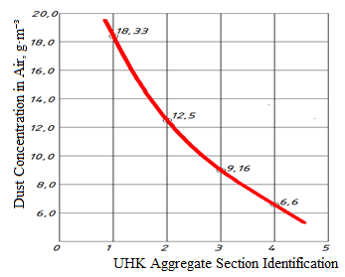
FIGURE 5. Concentration of waste-laden air extracted from each selected section of the UCCC cotton cleaning aggregate

Analysis of the graph presented in Figure 5 shows that the concentration of dust-laden air extracted into the aspiration system varies significantly among the selected sections of the UCCC aggregate. Due to the relatively high amount of dust released from the first section located on the cotton inlet side of the UCCC cotton cleaning aggregate, the concentration of dust-laden air extracted from this section is the highest, reaching 18,33 g/m³ (183,3 mg/m³).
In contrast, in the section located closer to the outlet of cleaned cotton—namely, the selected fourth section – the concentration of dust-laden air extracted into the aspiration system is the lowest, amounting to 6,66 g/m³ (66,6 mg/m³). This indicates that a comparatively smaller amount of dust is released from this section.
From the above analysis, it can be concluded that installing pneumatic ducts of identical diameter and extracting equal volumes of air from all sections of the UCCC cotton cleaning aggregate selected as the experimental object inevitably leads to inefficient operation of the aspiration system.
The validity of the above conclusions can also be demonstrated using the following formula:
${ H}_{p}=H_{0}\left(1+kμ\right),$ (6)
where: H_{p} – pressure loss due to the movement of dust-laden air in the pneumatic duct;
H₀ – pressure loss due to the movement of clean air in the pneumatic duct;
K – resistance coefficient for the movement of dust-laden air in the pneumatic duct, determined experimentally;
μ – concentration of dust-laden air in the pneumatic duct.
The pressure loss of clean air during its movement in the pneumatic duct, H₀ is determined using the following expression:
$H_{0}=λ\frac{l}{D}∙\frac{ρV^{2}}{2}.$ (7)
where: λ – friction coefficient;
l – length of the pneumatic duct, m;
D – diameter of the pneumatic duct, m;
ρ – air density, kg/m³;
V – air velocity, m/s.
If the pressure loss of clean air during its movement in the pneumatic duct, H₀ is assumed to be identical for all selected sections of the UCCC aggregate, then, according to Equation (9), it can be observed that the pressure loss associated with the movement of dust-laden air in the pneumatic duct is primarily influenced by the concentration of dust in the air, provided that the duct diameter is taken as constant.
First, calculations were performed for the aspiration system of the selected Angor cotton cleaning enterprise under existing operating conditions. Taking into account that the diameter of the initial pneumatic ducts in each section of the UCCC cleaning aggregate is 160 mm, the pressure losses during the transport of clean air were determined using Equation (10). During the calculations, the length of the initial pneumatic duct in each section was assumed to be approximately 2000 mm. The friction coefficient was taken as 𝜆=0,008 and the air density was assumed to be 1,2 kg/m³.
Subsequently, using equation (6) and considering the experimentally determined concentrations of dust-laden air in each section of the UCCC cleaning aggregate, the pressure losses associated with the movement of dust-laden air in the pneumatic duct were also calculated [11-29].
The calculated results are presented in Table 2. As can be seen from the data presented in Table 2, the pressure loss in the aspiration system of the UCCC cleaning aggregate is directly dependent on the concentration of dust-laden air released during the cleaning of raw cotton in the selected sections. According to the experimental results, while the pressure loss during the movement of clean air in the pneumatic duct remained constant across all sections at 1,5 kgs/m³, the pressure loss associated with dust-laden air varied from 1,72 to 1,58 kgs/m³, depending on the dust concentration.

TABLE 2. Calculated pressure losses during the movement of dust-laden air in the pneumatic duct of the existing selected aspiration system
UCCC aggregate sections | Pneumatic duct diameter, mm | Pneumatic duct length, mm | Pressure loss during clean air transport, Н_{0,} kgf/m³ | Pressure loss during dust-laden air transport,Н_{р,} kgf/m³ | Difference, Н_{р}- Н_{0,} kgf/m³
1 | 160 | 2000 | 1,5 | 1,72 | 0,22
2 | 160 | 2000 | 1,5 | 1,65 | 0,15
3 | 160 | 2000 | 1,5 | 1,61 | 0,11
4 | 160 | 2000 | 1,5 | 1,58 | 0,08
Total: |  |  |  |  | 0,56

Thus, in the existing selected aspiration system of the UCCC cotton cleaning aggregate, the total pressure loss associated with the movement of dust-laden air in the pneumatic ducts across its four sections amounts to 0.56 kgf/m³, compared with the pressure loss during the movement of clean air. The pressure losses are relatively higher in the first and second sections located on the cotton inlet side of the UCCC aggregate, which is due to the greater amount of dust released during the cotton cleaning process in these sections.
When the additional air intake caused by loss of airtightness in the aspiration system is not taken into account, and considering the experimentally determined dust concentrations in each section, the efficiency of the aspiration system can be improved by increasing the diameter of the suction pneumatic ducts for each section. For example, let us calculate the pressure losses assuming that the diameter of the suction pneumatic ducts for each section of the UCCC cleaning aggregate is increased to 200 mm.
The results of these calculations are presented in Table 3.

TABLE 3. Calculated pressure losses during the movement of dust-laden air in the pneumatic duct of the recommended aspiration system
UCCC aggregate sections | Pneumatic duct diameter, mm | Pneumatic duct length, mm | Pressure loss during clean air transport, Н_{0,} kgf/m³ | Pressure loss during dust-laden air transport,Н_{р,} kgf/m³ | Difference, Н_{р}- Н_{0,} kgf/m³
1 | 200 | 2000 | 0,76 | 0,87 | 0,11
2 | 200 | 2000 | 0,76 | 0,83 | 0,076
3 | 200 | 2000 | 0,76 | 0,81 | 0,055
4 | 200 | 2000 | 0,76 | 0,80 | 0,04
Total: |  |  |  |  | 0,28

As can be seen from the data presented in Table 3, when the additional air intake caused by loss of airtightness in the aspiration system of the UCCC cotton cleaning aggregate is not taken into account, and when the experimentally determined dust concentrations in each section are considered, it is advisable to increase the diameter of the suction pneumatic ducts for each section from 160 mm to 200 mm in order to improve the efficiency of the aspiration system.
Accordingly, it is recommended that the diameters of the aspiration ducts connected to the waste bunkers of the first, second, third, and fourth sections—starting from the cotton inlet side of the UCCC aggregate—be selected as 200 mm. Under these conditions, due to the increase in duct diameter, the pressure loss in the aspiration system for the experimentally determined dust concentrations is reduced by approximately two times compared to the existing system with 160 mm pneumatic ducts. Based on the experimental data and calculation results obtained in this study, it can be concluded that, for UCCC-type cotton cleaning aggregates, increasing the diameter of the aspiration pneumatic ducts designed to transport waste separated from each initial section from 160 mm to 200 mm is technically justified and effective. In addition, it is considered optimal to place the large-diameter connecting pneumatic duct (with a diameter of 500 mm) at the midpoint along the length of the UCCC cotton cleaning aggregate, thereby dividing it into two equal sections. In this configuration, dust-laden air extracted from each section is conveyed to the main pneumatic duct without mixing with air streams from other sections, meaning that the dust concentration remains unchanged until it enters the main duct.
In contrast, in the existing UCCC cotton cleaning aggregate used as the experimental object, dust-laden air extracted from each section starting from the cotton inlet side sequentially mixes with dust-laden air from subsequent sections. As a result, the dust concentration increases progressively along the length of the aggregate. As established earlier, an increase in dust concentration leads to an increase in the resistance coefficient to airflow in the pneumatic duct, which in turn results in higher pressure losses. Under such conditions, an increase in the power of the fan in the aspiration system becomes necessary, a fact that is confirmed by practical observations. Indeed, in many cotton cleaning enterprises, the aspiration systems of existing UCCC cotton cleaning aggregates are equipped with 1VC centrifugal fans driven by 75 kW electric motors.
RESEARCH RESULTS
Let us assume that the air is initially at rest and that it resists the falling particle only due to viscous drag, which generates a frictional force. At the initial stage, the particle falls with uniform acceleration; subsequently, under the influence of frictional forces, its motion gradually slows down. After a certain period of time, the falling velocity becomes constant (terminal velocity), which can be determined as follows [9]:
$R=\text{G= mg = k}ϑ^{2 }$ (8)
where: 𝑘 – proportionality coefficient.
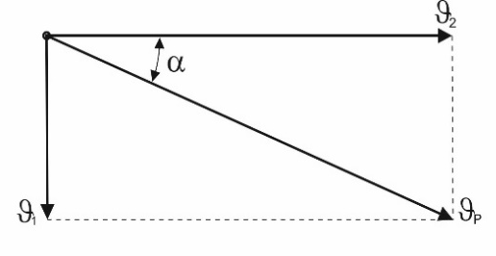  a) | 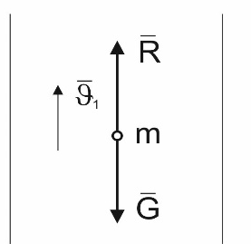  b)
FIGURE 6. Motion of impurity particles in the pneumatic duct of the aspiration system at the resultant velocity ϑ_{р} (a) and the system of forces acting on the particle (b)

From Equation (8), the following relationships can be obtained:
$\text{k}ϑ^{2 }$= R and $R=\frac{\text{mg}}{ϑ^{2 }}$
hence:
$ϑ=\sqrt{\frac{\text{mg}}{R}}$ (9)
Equation (9) is based on experimental data corresponding to average values of the velocity 𝜗 [9]. At low particle velocities, a linear relationship exists between the resistance force 𝑅 and the velocity ϑ. If the air begins to rise with a velocity equal to 𝜗 relative to the particle, the particle ceases to fall and remains in equilibrium (suspension condition). In this case, the particle velocity is defined as the lifting (or terminal) velocity.
$R=cF\frac{{ρϑ}^{²}}{2}$ (10)
where: c – drag (resistance) coefficient;
F – projected area of the solid body normal to the direction of motion;
ρ – density of the medium;
ϑ – velocity of the falling solid body.
By comparing Equations (8) and (10), the following relationship can be obtained:
$\text{R}ϑ^{²}= cF\frac{{ρϑ}^{²}}{2}; R=cF\frac{{ρϑ}^{²}}{2}=\frac{\text{mg}}{ϑ^{²}}$
From this, the velocity of motion of an impurity particle in the pneumatic duct can be expressed as:
$ϑ=\sqrt{\frac{\text{2mg}}{cFρ}}$ (11)
If the impurity particle is assumed to be spherical, its mass can be expressed as:
$\text{G= mg =}{\text{V}}_{s}γ_{s}=\frac{4}{3}πR_{s}^{3}γ_{s}; \text{m}=\frac{4 }{3} \frac{πR_{s}^{3}γ_{s}}{g}$,
where: V_{s} – particle volume;
– volumetric weight (specific weight) of the particle, N/m³.
The projected area of the particle is determined as:
$$F= πR_{s}^{2}$$
At an air temperature of 𝑡 = 20∘C, the air density is:
$$ρ=\frac{γ}{g}=\frac{1,2}{9,81}=0,122 kgf/m³$$
Substituting the values of 𝑚, 𝐹 and 𝜌 into Equation (11) and performing several transformations yields:
$ϑ=3,33\sqrt{\frac{{\text{d}}_{s}γ_{s}}{c}}$ (12)
where: d_{s} – particle diameter, m.
If the temperature differs from the adopted value of 𝑡 = 20∘C, the density of the medium 𝜌 must be recalculated accordingly. In practice, impurity particles are not always spherical; however, for irregularly shaped particles, an equivalent spherical diameter 𝑑_{𝑒𝑞} corresponding to a particle of equal mass may be used.
${\text{d}}_{eq}=1,24\sqrt[3]{\text{V}}$ (13)
where: V – particle volume.
The value of the drag coefficient 𝑐 in Equation (10) depends on the Reynolds number 𝑅_{𝑒} and can be determined using the following empirical relationships [9,10]:
If R_{е}˂1 , $c ≈ \frac{24}{R_{е}}$ (14)
If$1<R_{с}<800 , c =\frac{24}{R_{е}}(1+0,15R_{е}^{0,687})$ (15)
If R_{е}˂2000, $c =\frac{24}{R_{е}}+\frac{4}{\sqrt{R_{е}}}$ (16)
In the aspiration system of the UCCC aggregate, the initial pneumatic ducts with smaller diameters are connected to subsequent pneumatic ducts of larger diameter. In the downstream pneumatic duct, the change in airflow velocity is associated with the merging of two separate flows into a single flow. To determine the direction and velocity of the combined flow, a parallelogram is constructed using the momentum vectors 𝑚₁𝜗₁ and 𝑚₂𝜗₂ (see Figure 7). The diagonal 𝑄 of this parallelogram defines the direction of the combined flow.
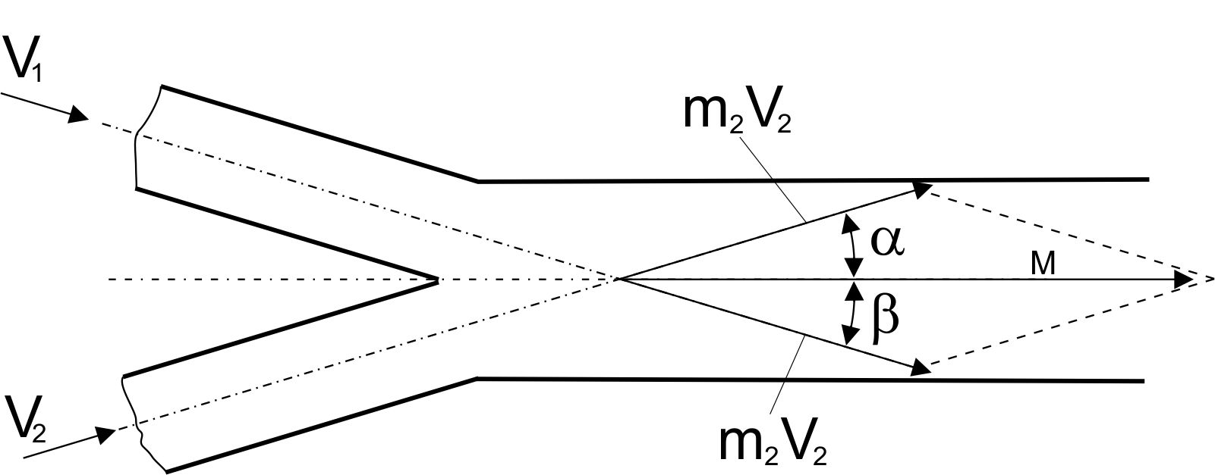

FIGURE 7. General case of the merging of airflows moving at an angle to each other

The magnitude of the resultant momentum can be determined as follows:
$$М=m_{1}ϑ_{1}\cos{α}+m_{2}ϑ_{2}cos{β}$$
The average velocity of the merged flow is given by:
$ϑ_{Q=}\frac{m_{1}ϑ_{1}\cos{α}+m_{2}ϑ_{2}cos{β}}{m_{1}+m_{2}}$ (17)
If the directions of the merging airflows are parallel to each other (as in the present case), then 𝛼=0 and 𝛽=0 and consequently cosα=1 and cosβ=1. In this case, the average velocity of the combined flow, depending on the mass flow rates, is determined as:
$ϑ_{Q=}\frac{m_{1}ϑ_{1}+m_{2}ϑ_{2}}{m_{1}+m_{2}}$ (18)
Under these conditions, the direction of the combined flow remains unchanged, and only the velocity associated with the combined mass flow changes. In the proposed aspiration pneumatic duct connection design for the UCCC cotton cleaning aggregate, the airflow enters the main large-diameter pneumatic duct in a direction parallel to it. As a result, lower resistance to the dust-laden air is expected, leading to reduced pressure losses [11-29].
Dust-laden material separated from the fine-impurity cleaning section of the UCCC aggregate is drawn into a pneumatic duct having a certain curvature or bend and is conveyed to the main large-diameter duct while traveling a distance 𝐿. Treating the dust-laden material as a collection of dust particles, its motion within the airflow is analyzed under the action of external forces. First, the transport of dust-laden material along the arc segment $\overset{∪}{AB}=L_{1}$is examined, taking into account the masses of the impurity particles during their transfer to the main large-diameter pneumatic duct.
Figure 8 illustrates the schematic diagram of the external forces acting on a fine impurity particle during its motion along the arc segment $\overset{∪}{AB}=L_{1}$ in the initial pneumatic duct of the aspiration system.
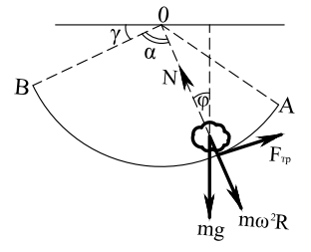
FIGURE 8. Schematic diagram of the motion of impurity particles along the arc $\overset{∪}{AB}$ in the initial pneumatic duct

The differential equation describing the motion of fine impurity particles along the arc $\overset{∪}{AB}=S_{1}$ can be expressed as follows [11, 12].
$\left\{\begin{aligned}&m{\ddot{L}}_{1}=mg\sin{ϕ}-F_{\text{тр}} \\ &mω^{2}R=N-mg\cos{ϕ}\end{aligned}\right.$ (19)
$$-{\left\{\begin{aligned}&ϕ+90^{0}+x=180 \\ &x+α+γ=180^{0}\end{aligned}\right.}^{0} ⇒\left\{\begin{aligned}&ϕ+90^{0}=α+γ \\ &ϕ=-90^{0}+α+γ\end{aligned}\right.$$
$\left\{\begin{aligned}&m{\ddot{L}}_{1}=mg\sin{(}-(90^{0}-(α+γ)))-f-N \\ &mω^{2}R=N-mg\cos{(}-(90^{0}-(α+γ)))\end{aligned}\right.⇒\left\{\begin{aligned}&m{\ddot{L}}_{1}=-mgs\cos{(}α+γ)-f-N \\ &mω^{2}R=N-mg\sin{(}α+γ)\end{aligned}\right.$ (20)
From Equation (20), the normal pressure force exerted by fine impurity particles on the surface of the pneumatic duct is determined:
$N=mω^{2}R+mg\sin{(}α+γ)$ (21)
By substituting the value of the normal pressure force 𝑁 from Equation (21) into Equation (20), the following expression is obtained:
$m{\ddot{L}}_{1}=-mg\cos{(}α+γ)-f(mω^{2}R+mg\sin{(}α+γ))$ (22)
Equation (22) is then reduced to a simplified form:
$m⋅{\ddot{L}}_{1}+\frac{f⋅m}{R}{\dot{L}}_{1}^{2}=-m⋅g⋅\cos{(}α+γ)-f⋅m⋅g⋅\sin{(}α+γ)$ (23)
Equation (23) represents a second-order nonhomogeneous differential equation, which can be expressed as the sum of its homogeneous and particular components in the following form:
${\ddot{L}}_{1}=\frac{dL_{1}}{dt}⋅\frac{2dL_{1}}{2dL_{1}}=\frac{d({\dot{L}}_{1})^{2}}{2dL_{1}}$ or
$\frac{d({\dot{L}}_{1})^{2}}{2dL_{1}}+\frac{f}{R}⋅{\dot{L}}_{1}^{2}=-f⋅g⋅\sin{(}α+γ)-g⋅\cos{(}α+γ)$ (24)
To determine the general solution of the differential equation (24), we first solve its homogeneous part. For simplification, the substitution α + γ = β is introduced.
The solution is expressed as:
Z =Z₁ +Z₂
where: 𝑍1 – solution of the homogeneous equation;
𝑍2 – particular solution of the nonhomogeneous equation.
$\frac{d({\dot{L}}_{1})^{2}}{2dL_{1}}+\frac{f}{R}{\dot{L}}_{1}^{2}=0{\dot{L}}_{1}^{2}=Z_{1}$ we introduce the substitution
then, $\frac{dz_{1}}{2dL_{1}}+\frac{f}{R}z_{1}=0⇒\frac{dz_{1}}{z_{1}}=-\frac{2f}{R}dL_{1}⇒$
$\ln{z_{1}}=-\frac{2⋅f}{R}⋅L_{1}⇒z_{1}=e^{-\frac{2f}{R}L_{1}}⋅c_{1}$ (25)
Substituting$z_{1}={\dot{L}}_{1}^{2}$ into equation (25), we have
$${\dot{L}}_{1}^{2}=e^{-\frac{2f}{R}S_{1}}⋅c_{1}⇒{\dot{L}}_{1}=e^{-\frac{f⋅L_{1}}{R}}⋅c_{1}$$

Using the initial condition for the motion of fine impurity particles, t=0 ${\dot{L}}_{1}=v_{0}$we obtain $L_{1}=0⇒c_{1}=v_{0}$
$${\dot{L}}_{1}=e^{-\frac{f⋅S_{1}}{R}}⋅v_{0}$$
Rewriting this expression in integral form:
$$\frac{dL_{1}}{dt}=e^{-\frac{f⋅L_{1}}{R}}⋅v_{0}⇒e^{-\frac{f⋅L_{1}}{R}}⋅dL_{1}=v_{0}dt$$
Integrating both sides gives
$$\frac{dL_{1}}{dt}=e^{-\frac{f⋅L_{1}}{R}}⋅v_{0}⇒e^{-\frac{f⋅L_{1}}{R}}⋅dL_{1}=v_{0}dt$$
or
$\frac{R}{f}e^{-\frac{fL_{1}}{R}}=v_{0}⋅t+c_{2}$ (26)
Applying the initial condition Using the initial condition, the integration constant c₂ is determined as follows:
t=0 ${\dot{S}}_{1}=0⇒c_{2}=\frac{R}{f}$. Substituting the determined value of 𝑐₂ into Equation (26), we obtain:
$$\frac{R}{f}e^{-\frac{f}{R}⋅L_{1}}=v_{0}⋅t+\frac{R}{f}$$
$$e^{-\frac{f}{R}⋅L_{1}}=\frac{R}{f}v_{0}⋅t+1$$
$$\frac{f}{R}L_{1}=\ln\left(\frac{f}{R}v_{0}⋅t+1\right)⇒L_{1}=\frac{R}{f}\ln\left(\frac{f}{R}v_{0}⋅t+1\right)$$
$L_{1}=\frac{R}{f}\ln\left(\frac{f}{R}v_{0}⋅t+1\right)$ (27)
To determine the general solution of the differential Equation (25), we now calculate its nonhomogeneous (particular) part. The particular solution is assumed in the form:
$z_{2}=A\sin{β}+B\cos{β}$ (28)
The first and second derivatives of 𝑍₂ are:
$${\dot{z}}_{2}=A\cos{β}-B\sin{β}$$
$${\ddot{z}}_{2}=-A\sin{β}-B\cos{β}$$
Substituting this expression into Equation (25), we obtain:
$$-\frac{A}{2}\sin{β}-\frac{B}{2}\cos{β}+\frac{f}{R}⋅A\cos{β}-\frac{f}{R}⋅B\sin{β}=-fg\sin{β}-g\cos{β}$$
$$\left\{\begin{aligned}&-\frac{A}{2}-\frac{f}{R}B=fg \\ &\frac{f}{R}A-\frac{B}{2}=-g\end{aligned}\right.$$

From this expression, the constants AAA and BBB are determined by solving the resulting system of equations:
$$Δ=\left|\begin{aligned}&\begin{matrix}-\frac{1}{2} & -\frac{f}{R}\end{matrix} \\ &\begin{matrix}\frac{f}{R} & -\frac{1}{2}\end{matrix}\end{aligned}\right|=\frac{1}{4}+\frac{f}{R^{2}}=\frac{R^{2}+4f^{2}}{4R^{2}};$$
$$Δҳ=\left|\begin{aligned}&\begin{matrix}-fg & -\frac{f}{R}\end{matrix} \\ &\begin{matrix}-g & -\frac{1}{2}\end{matrix}\end{aligned}\right|=\frac{f⋅g}{2}-\frac{f⋅g}{R}=\frac{f⋅g⋅(R-2)}{2R};$$
$$Δ=\left|\begin{aligned}&\begin{matrix}-\frac{1}{2} & -fg\end{matrix} \\ &\begin{matrix}\frac{f}{R} & -g\end{matrix}\end{aligned}\right|=-\frac{f^{2}g}{R}-\frac{g}{2}=\frac{-g(2f^{2}+R)}{2R}.$$
$A=\frac{Δ_{A}}{Δ}=\frac{2Rfg(R-2)}{R^{2}+4f^{2}}$ ,$B=\frac{Δ_{B}}{Δ}=\frac{2Rg(2f^{2}+R)}{R^{2}+4f^{2}}$
$z_{2}=\frac{2⋅R⋅f⋅g⋅(R-2)}{R^{2}+4⋅f^{2}}\sin{β}-\frac{2⋅R⋅g⋅(2⋅f^{2}+R)}{R^{2}+4⋅f^{2}}\cos{β}$ (29)
As a result, the general form of the equation describing the motion of fine impurity particles along a small curved section in the initial pneumatic duct is obtained as:
$L=\frac{R}{f}\ln\left(\frac{f}{R}⋅v_{0}⋅t+1\right)+\frac{2⋅R⋅f⋅g⋅(R-2)}{R^{2}+4⋅f^{2}}\sin{(}α+γ)-\frac{2⋅R⋅g⋅(2⋅f^{2}+R)}{R^{2}+4⋅f^{2}}\cos{(}α+γ)$ (30)
The improved Equation (30) makes it possible to calculate the motion parameters of fine impurity particles separated from cotton during cleaning in UCCC-type cotton cleaning aggregates, depending on the curvature angle of the inlet pneumatic duct, the friction coefficient of the waste pneumatic duct, and the mass of dust particles.
Using Equation (30), the trajectories of dust-laden airflow were determined in the Maple-6 software environment, and the corresponding graphical results are presented in Figure 9.
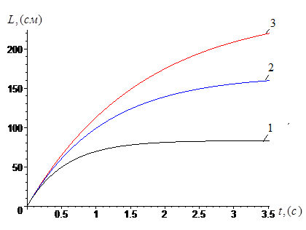 | 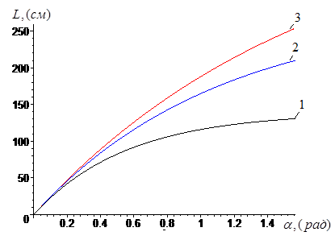
FIGURE 9. Vectors of electromotive force (EMF) Motion of dust-laden material in the pneumatic duct during the transfer of impurity particles with different masses—1: 𝑚₁=0,5g, 2: 𝑚₂=1,0 g, and 3: 𝑚₃=1,5 g – into the main large-diameter pneumatic duct, showing the dependence on arc length (left) and on the central angle during transfer to the main duct (right).

From the graphs presented in Figure 9, it can be observed that, during the motion of mineral and organic waste separated from the UCCC cleaning aggregate through the initial pneumatic duct, it is necessary to take into account the particle mass, the friction coefficient between the particles and the duct surface, as well as the external forces acting on the particles.
CONCLUSIONS
Based on the resultant motion of impurity particles in the pneumatic duct of the aspiration system at the resultant velocity 𝜗_{𝑝} and the forces acting on them, the governing equations describing the motion of dust-laden airflow were derived.
It was established that when impurity particles separated from the fine-impurity cleaning section of the UCCC cotton cleaning aggregate enter the initial pneumatic duct with an initial velocity of 0,25 m/s, the coordinates at which the particles impact the conical surface of the pneumatic duct are 𝑋=1,26×10⁻³ m and 𝑌=3,64×10⁻¹ m. When the initial velocity increases to 1,0 m/s, the impact coordinates shift to X=1.,4×10⁻¹ m and Y=2,84×10⁻¹ m. Therefore, in order to improve the transport of fine impurity particles into the pneumatic duct, it is advisable to ensure a higher initial particle velocity.
In the fine-impurity cleaning section of the UCCC aggregate, when the mass of a fine impurity particle separated from the cotton flow is equal to 𝑚, the corresponding coordinates of impact on the conical surface are 𝑥₃ and 𝑦₃. Taking into account the mass-based fraction distribution of the main fine impurity particles, it is recommended to select the positioning coordinates of the conical surface of the initial pneumatic duct as 𝑥 =𝑥_{opt} and 𝑦=𝑦_{opt}, which ensures more efficient transfer of impurity particles into the main pneumatic duct.
In the fine-impurity cleaning section of the UCCC aggregate, when the mass of a fine impurity particle separated from the cotton flow is $m_{m}=0,25×10^{-3}$ kg, the coordinates of impact on the conical surface are X=1,71×10⁻¹ m and Y=2,62×10⁻¹ m. Considering that the mass-based fraction of the main fine impurity particles lies within the range $M_{m}≤(0,25-1,0)×10^{-3}$ kg, it is recommended to select the positioning coordinates of the conical surface of the initial pneumatic duct within the ranges 𝑌_{k}=0,35–0,40 m and X=(1,3–1,6)×10⁻¹ m, which ensures more efficient transfer of impurity particles into the main pneumatic duct.
REFERENCES
- Jumaniyazov, K., & Madrakhimov, D.U. (2019). Development of an automated 90-saw gin and a two-drum fiber cleaner based on an alternative aerodynamic mode for efficient ginning and fiber cleaning processes. Scientific and Technical Association (NTO), “Paxtasanoat Scientific Center” JSC, Tashkent, 36 p.
- Khojiev, M.T., & Abbazov, I.Z. (2017). Analysis of the composition of dust-laden air emitted from cotton cleaning enterprises and technologies for its purification. Monograph. Science and Innovation Publishing House, 130 p.
- Jamalov, R.K., Nazirov, R.R., & Sheraliev, Sh.E. (2019). Study and selection of an optimal dust-laden air purification system at experimental cotton ginning plants of JSC “Paxtasanoat Scientific Center” aimed at improving environmental conditions at cotton plants. NTO, Tashkent, 71 p.
- Handbook of Primary Cotton Processing. (1994–1995). Volumes I–II. Tashkent: Mehnat Publishing House.
- Usanov, A. (2024). Investigation of the efficiency of dust-laden air purification from the aspiration system of the UCCC cleaning unit. In Agricultural Mechanization: Science and Innovation, 367 p.
- Khodzhiev, M.Kh. (1991). Substantiation of diffuser parameters for an external pneumatic transport system. Cotton Industry, No. 5, pp. 11–13.
- Usanov, A., & Shomirzaev, E. (2024). Methods of increasing the efficiency of dust-laden air cleaning from the aspiration system of the UCCC cleaning unit. E3S Web of Conferences.
- Kalinushkin, M.P. (1987). Pumps and Fans. Moscow: Vysshaya Shkola Publishing House.
- Kostryukov, V.A. (1975). Fundamentals of Hydraulics and Aerodynamics. Moscow: High School, 220 p.
- Altshul, A.D., & Kiselev, P.G. (1975). Hydraulics and Aerodynamics. Moscow: Stroyizdat, 375 p.
- Shohaidarova, P., Shoziyev, Sh., & Zoirov, J. (1991). Theoretical Mechanics. Tashkent: Teacher Publishing House.
- Rashidov, T.R., & Shoziyev, Sh. (1990). Fundamentals of Theoretical Mechanics. Tashkent: Teacher Publishing House.
- Toshbekov, O., Urazov, M., Yermatov, S., & Khamraeva, M. (2023). Efficient and economical energy-use technology in the processing of domestic coarse wool fiber. E3S Web of Conferences, Vol. 461, Article 01068.
https://doi.org/10.1051/e3sconf/202346101068
- Jumaniyozov, K., Urozov, M., Toshbekov, O., Salimova, M., Raximova, K., & Khursandova, B. (2025). Enhancement of energy-efficient cleaning equipment. AIP Conference Proceedings, Vol. 3331, No. 1, Article 050007. https://doi.org/10.1063/5.0307149
- Sultonova, F., Toshbekov, O., Urozov, M., Boymurova, N., Mustanova, Z., & Boltaeva, I. (2025). Enhancing and evaluating the characteristics of specialized workwear for employees in the electric power supply sector. AIP Conference Proceedings, Vol. 3331, No. 1, Article 050006 https://doi.org/10.1063/5.0306350
- Ma’ruf, K., Tursoat, A., Dilnavoz, K., Bekmurodjon, R., Ra'no, A., Saida, T., ... & Toshbekov, B. (2025). ZnO Nanoparticles Incorporated on Multi-Walled Carbon Nanotubes as A Robust Heterogeneous Nano-catalyst for Biodiesel Production from Oil. Journal of Nanostructures, 15(3), 1050-1060.
- Safarov J., Khujakulov A., Sultanova Sh., Khujakulov U., Sunil Verma. Research on energy efficient kinetics of drying raw material. // E3S Web of Conferences: Rudenko International Conference “Methodological problems in reliability study of large energy systems” (RSES 2020). Vol. 216, 2020. P.1-5. doi.org/10.1051/e3sconf/202021601093
- Safarov J., Sultanova Sh., Dadayev G.T., Zulponov Sh.U. Influence of the structure of coolant flows on the temperature profile by phases in a water heating dryer. // IOP Conf. Series: Materials Science and Engineering. Dynamics of Technical Systems (DTS 2020). Vol.1029, 2021. №012019. P.1-11. doi:10.1088/1757-899X/1029/1/012019
- Sultanova Sh.A., Artikov A.A., Masharipova Z.A., Abhijit Tarawade, Safarov J.E. Results of experiments conducted in a helio water heating convective drying plant. // International conference AEGIS-2021 «Agricultural Engineering and Green Infrastructure Solutions». IOP Conf. Series: Earth and Environmental Science 868 (2021) 012045. P.1-6. doi:10.1088/1755-1315/868/1/012045
- Sultanova Sh., Safarov J., Usenov A., Samandarov D., Azimov T. Ultrasonic extraction and determination of flavonoids. XVII International scientific-technical conference “Dynamics of technical systems” (DTS-2021). AIP Conference Proceedings 2507, 050005. 2023. P.1-5. doi.org/10.1063/5.0110524
- Saparov Dj.E., Sultonova S.A., Guven E.С., Samandarov D.I., Rakhimov A.M. Theoretical study of characteristics and mathematical model of convective drying of foods. // RSES 2023. E3S Web of Conferences 461, 01057 (2023). P.1-5. https://doi.org/10.1051/e3sconf/202346101057
- Safarov J.E., Sultanova Sh.A., Dadayev G.T., Samandarov D.I. Method for drying fruits of rose hips. // International Journal of Innovative Technology and Exploring Engineering (Scopus). Volume-9, Issue-1, November, 2019. Р.3765-3768. doi: 10.35940/ijitee.A4716.119119
- Safarov J.E., Sultanova Sh.A., Dadayev G.T., Samandarov D.I. Method for the primary processing of silkworm cocoons (Bombyx mori). // International Journal of Innovative Technology and Exploring Engineering (Scopus). Volume-9, Issue-1, November, 2019. Р.4562-4565. DOI: 10.35940/ijitee.A5089.119119
- Sultanova Sh., Safarov J., Usenov A., Raxmanova T. Definitions of useful energy and temperature at the outlet of solar collectors. // E3S Web of Conferences: Rudenko International Conference “Methodological problems in reliability study of large energy systems” (RSES 2020). Vol. 216, 2020. P.1-5. doi.org/10.1051/e3sconf/202021601094
- Usenov A.B., Sultanova Sh.A., Safarov J.E., Azimov A.T. Experimental-statistic modelling of temperature dependence of solubility in the extraction of ocimum basilicum plants. // International conference AEGIS-2021 «Agricultural Engineering and Green Infrastructure Solutions». IOP Conf. Series: Earth and Environmental Science 868 (2021) 012047. P.1-5. doi:10.1088/1755-1315/868/1/012047
- 1Sultanova Sh.A., Safarov J.E., Usenov A.B., Muminova D. Analysis of the design of ultrasonic electronic generators. // Journal of Physics: Conference Series. International Conference "High-tech and Innovations in Research and Manufacturing" (HIRM 2021). 2176 (2022) 012007. doi:10.1088/1742-6596/2176/1/012007
- Zulpanov Sh.U., Samandarov D.I., Dadayev G.T., Sultonova S.A., Safarov J.E. Research of the influence of mulberry silkworm cocoon structure on drying kinetics. // IOP Conf. Series: Earth and Environmental Science (AEGIS-2022). 1076 (2022) 012059. Р.1-6.
- doi:10.1088/1755-1315/1076/1/012059
- Tarawade A., Samandarov D.I., Azimov T.Dj., Sultanova Sh.A., Safarov J.E. Theoretical and experimental study of the drying process of mulberry fruits by infrared radiation. // IOP Conf. Series: Earth and Environmental Science (ETESD). 1112 (2022) 012098. P.1-9. doi:10.1088/1755-1315/1112/1/012098

