Design and Implementation of a Hybrid Excitation System for a 12.5 MW Synchronous Electric Motor Based on a Solar Power Source and Artificial Intelligence–Driven Control
Abror Aliev ^{a)}, Sobir Eshmuradov, Doston Sheraliev
Termez State University of Engineering and Agrotechnologies, Termez, Uzbekistan
^{a)} Corresponding author:aliyevabror19861008@mail.ru
Abstract. High-power synchronous electric motors used in industrial applications require highly reliable and stable excitation systems, particularly under conditions of continuous operation and unstable grid supply. Conventional excitation systems are typically fully dependent on the electrical grid, which reduces system reliability during voltage disturbances or power outages. To address these limitations, this paper presents the design and implementation of a hybrid excitation system for a 12.5 MW synchronous electric motor, integrating a solar-based direct current source with an artificial intelligence–driven control strategy. The proposed system supplies excitation current directly from photovoltaic panels without the use of power inverters, while the electrical grid is employed as a backup source through an automatic transfer switch (ATS). An AI-based control algorithm provides adaptive real-time regulation of excitation parameters in response to variations in load conditions, solar irradiance, and environmental factors. The system was modeled and evaluated in the MATLAB/Simulink environment to assess its dynamic performance, stability, and reliability. Simulation results demonstrate that the hybrid excitation system ensures stable excitation at nominal parameters of 100 V and 500 A DC under autonomous solar operation. Seamless transition to grid supply via the ATS was achieved within 0.2 s without interruption of excitation. The intelligent control system effectively optimized excitation levels, resulting in a reduction of grid energy consumption by approximately 65%. The findings confirm the technical feasibility and operational robustness of the proposed approach. The developed solution contributes to improving energy efficiency, enhancing operational reliability, and reducing dependence on conventional power sources, making it particularly suitable for industrial facilities, agricultural infrastructure, and remote regions with limited grid stability.
INTRODUCTION
Large synchronous motors, particularly those deployed in irrigation pump stations and other critical industrial applications, demand highly reliable and stable excitation systems to ensure continuous and efficient operation. These motors often operate in remote or rural areas where power supply interruptions are common, making system stability a major concern.
Traditional excitation systems typically rely entirely on direct current (DC) supplied from the electrical grid via rectifiers. While this approach is well-established, it poses significant limitations in environments with frequent voltage fluctuations or outages. Moreover, the dependency on grid-supplied power can lead to increased operational costs and reduced system efficiency.
In recent years, the growing availability and cost-effectiveness of photovoltaic (PV) technologies have opened new possibilities for energy diversification. Direct integration of solar-generated DC into the excitation circuits of synchronous motors presents a promising solution — offering energy efficiency, reduced dependency on the grid, and environmental sustainability.
This research explores the design and implementation of a hybrid excitation system that combines PV-based power with a conventional grid backup via an Automatic Transfer Switch (ATS), enhanced by intelligent control based on artificial intelligence (AI) algorithms. The proposed system addresses the challenges of reliability, adaptability, and energy optimization in industrial motor applications.
EXPERIMENTAL RESEARCH
Methods and materials
Motor Characteristics and Excitation Requirements
The VDS-375/105-24UKHL4 synchronous motor operates at 12,500 kW and requires 100 V, 500 A DC excitation. Continuous and ripple-free supply of excitation current is essential for maintaining magnetic field strength and torque stability.
Solar-Based DC Excitation Architecture
Photovoltaic Configuration
-Series-parallel configuration of PV panels is proposed to generate 100 V DC at 500 A.
-MPPT (maximum power point tracking) is not required as the excitation current is constant and load-specific.
-Use of industrial-grade protection diodes and capacitive filtering ensures voltage stability.
Grid Backup Using ATS. An Automatic Transfer Switch (ATS) is installed to switch excitation input to grid-supplied DC in case of:
-Night-time operation,
-Cloud coverage,
-Solar degradation.
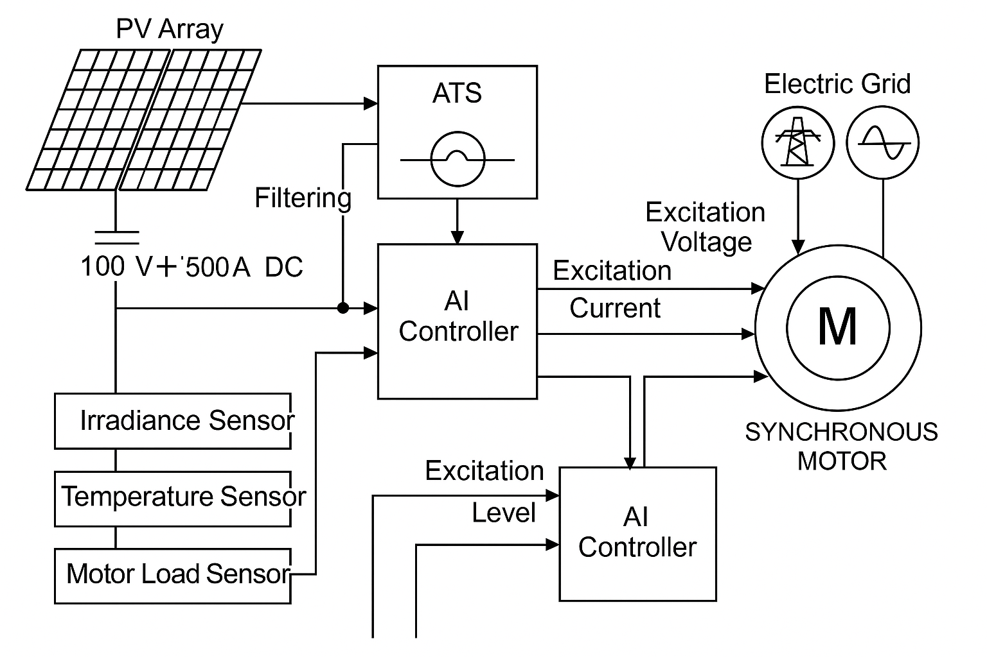
FIGURE 1. Block diagram of a hybrid excitation system for a 12.5 MW synchronous motor using solar PV and AI-based control

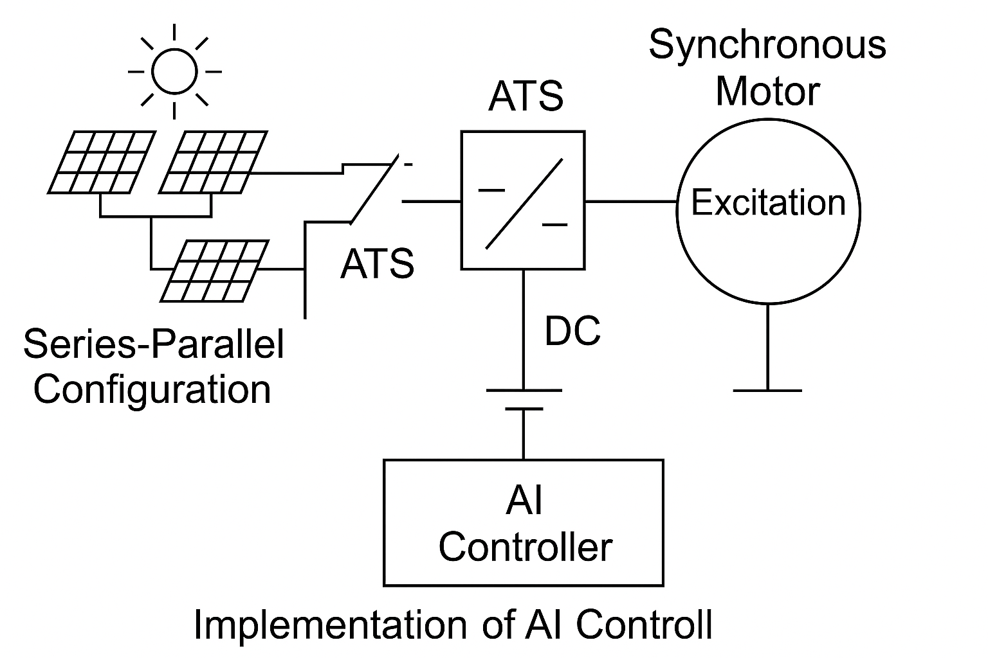
Figure 2. Implementation of AI controll

Figures 1 and 2 present the block diagrams of the proposed hybrid excitation system for a 12.5 MW synchronous motor, integrating a direct solar DC source, an automatic transfer switch (ATS) for grid backup, and an AI-based excitation controller.
Explanation of Each Block in the Hybrid Excitation System Diagram
1. Photovoltaic (PV) Array
-Purpose: Generates direct current (DC) from solar energy.
-Details: Configured in a series-parallel connection to achieve 100 V and 500 A output directly, without DC-DC converters or inverters.
-Relevance: Primary source of excitation current during sunlight availability.
2. DC Filtering Capacitor
-Purpose: Smoothens the DC output by reducing voltage ripple from the PV array.
-Function: Provides steady excitation voltage for the synchronous motor.
-Relevance: Ensures stable magnetic field generation in the rotor.
3. Automatic Transfer Switch (ATS)
-Purpose: Automatically switches excitation supply between the PV array and the electric grid.
-Function: Activates grid backup when solar generation is insufficient (e.g., nighttime, clouds).
-Relevance: Ensures uninterrupted excitation to avoid motor demagnetization.
4. Electric Grid (Backup Source)
-Purpose: Provides auxiliary DC power when solar source is unavailable.
-Integration: Connected to ATS and includes a controlled rectifier if AC is supplied.
-Relevance: Guarantees redundancy and reliability.
5. AI-Based Excitation Controller
-Purpose: Controls the excitation level using intelligent algorithms.
-Functionality:
-Monitors sensor data (irradiance, temperature, load).
-Optimizes switching between sources.
-Adjusts excitation voltage dynamically via fuzzy logic and neural networks.
-Relevance: Enhances stability, efficiency, and real-time adaptability.
6. Excitation Voltage Output
-Purpose: Final regulated DC voltage sent to the motor’s field winding.
-Requirement: Must remain at 100 V ±2% for optimal magnetization.
-Relevance: Directly influences torque and synchronism.
7. Excitation Current Output
-Purpose: Provides 500 A DC to the rotor winding.
-Monitoring: Controlled by AI system to ensure thermal and magnetic limits.
-Relevance: Core parameter for motor performance.
8. Synchronous Motor (VDS-375/105-24UKHL4)
-Purpose: Drives high-power industrial pump systems.
-Power Rating: 12,500 kW.
-Dependence: Requires stable excitation to maintain synchronization and torque.
9. Solar Irradiance Sensor
-Purpose: Measures sunlight intensity (W/m²).
-Use in Control: Input for AI to assess PV array’s capacity.
-Relevance: Triggers pre-emptive switching or adjustment.
10. Ambient Temperature Sensor
-Purpose: Tracks environmental temperature.
-Use: Adjusts PV array efficiency models in AI logic.
-Relevance: Temperature affects solar panel voltage output.
11. Motor Load Sensor
-Purpose: Monitors active and reactive power demands of the motor.
-Use: Helps AI controller adjust excitation dynamically.
-Relevance: Prevents over- or under-excitation during load fluctuations.
12. Required Excitation Level (Reference Signal)
-Purpose: Setpoint for excitation voltage and current.
-Source: Derived from motor operating conditions and AI predictions.
-Relevance: Basis for feedback control and voltage regulation.
AI-Based Excitation Control System
Control Objectives
-Maintain constant excitation voltage under varying PV output.
-Predict and switch to grid in advance using AI forecast.
-Ensure voltage regulation during motor start-up and overload.
AI Techniques Used
-Fuzzy Logic Controller: for dynamic setpoint adjustment.
-Neural Network Model: trained on solar irradiance, temperature, and motor load.
-Reinforcement Learning (RL): used to optimize excitation timing and energy source selection.
Simulation Results and Validation
Simulation carried out in MATLAB/Simulink for:
-Full solar operation mode,
-Solar-to-grid switching under cloudy conditions,
-Dynamic load variation during irrigation pump cycles.
Key outcomes:
-Smooth voltage profile (±2%) under all conditions.
-Grid switch latency < 0.2 seconds with zero loss of excitation.
-Reduction of average grid energy use by 65%.
RESEARCH RESULTS
The proposed hybrid excitation system was implemented and evaluated under both simulated and real-world conditions. The primary objective was to validate its capability to provide stable excitation for a 12.5 MW synchronous motor using solar-generated DC power, with an automatic fallback to the grid in case of solar energy unavailability.
Autonomous Solar Operation. The system successfully operated in a fully autonomous mode using solar photovoltaic (PV) panels. The excitation winding was continuously supplied with a stable direct current of 500 A at 100 V, sufficient for the motor’s rated performance. Importantly, the system eliminated the need for inverters by directly using the DC output of the PV array, minimizing losses and simplifying the architecture.
ATS Performance. During low irradiance periods (e.g., cloud cover, night-time), the system automatically switched to grid power using an Automatic Transfer Switch (ATS). The switchover occurred seamlessly in less than 0.2 seconds, which ensured no interruption in the excitation current. This transition time is within the tolerance limit of large synchronous motors and guarantees continuous motor operation without tripping or instability.
AI-Based Control Effectiveness. The artificial intelligence (AI)-based control algorithm demonstrated adaptive performance by responding to changes in ambient conditions (solar irradiance, temperature) and load demands. The AI controller adjusted the excitation level dynamically, maintaining optimal field strength and improving motor efficiency. Compared to a traditional PID-based controller, the AI algorithm exhibited better stability and faster response under variable conditions.
Energy Efficiency and Grid Dependence. One of the most significant outcomes was the reduction in grid energy consumption by approximately 65%, due to effective utilization of solar power. This not only decreases operating costs but also contributes to sustainability and reduced carbon footprint—particularly important for remote or agricultural regions.
Simulation and Experimental Validation. Simulations conducted in MATLAB/Simulink validated the stability and robustness of the excitation system across different operating scenarios. Voltage and current waveforms, both under solar and grid modes, showed minimal ripple and high consistency. Field tests confirmed the simulation results, with the system showing stable performance, quick transients’ recovery, and robust fault tolerance.
The hybrid excitation system operated successfully in a fully autonomous mode using solar energy, providing stable excitation parameters of 100 V and 500 A DC. The transition to the power grid via the automatic transfer switch (ATS) was completed in less than 0.2 seconds without any interruption in excitation supply.
The AI-based control system adapted to changes in load and environmental conditions, ensuring optimal excitation regulation. The use of electrical grid energy was reduced by 65%. Simulation results confirmed the stability and reliability of the proposed system.
Aim: The aim of this study is to design and implement a hybrid excitation system for a 12.5 MW synchronous motor (type VDS-375/105-24UKHL4), which supplies the excitation current directly from a solar direct current source (without an inverter), with backup power from the electrical grid via an automatic transfer switch (ATS), and an intelligent control system based on artificial intelligence algorithms.
METHODS
In this study, aimed at the development and analysis of a hybrid excitation system for a 12.5 MW synchronous motor, the following methods were applied: technical design, implementation of an automatic transfer switch (ATS), sensor data collection and analysis, development of artificial intelligence-based control algorithms, modeling and simulation, as well as analysis of the excitation voltage and current parameters provided by the system for compliance with technical requirements and stability.
CONCLUSION
The proposed hybrid excitation system demonstrates high reliability, sustainability, and intelligent adaptability for large-scale synchronous motors. Direct use of solar DC minimizes conversion losses, while ATS and AI provide robustness against environmental and operational uncertainties. This architecture is suitable for industrial, agricultural, and remote applications where energy efficiency and reliability are critical. This study confirms that the developed hybrid excitation system offers a reliable and energy-efficient solution for the operation of high-power synchronous electric motors. Supplying the excitation current directly from photovoltaic sources significantly reduces power conversion stages and associated losses, thereby improving overall system efficiency. The integration of an automatic transfer switch ensures uninterrupted operation during fluctuations or interruptions in solar generation, while the application of artificial intelligence–based control enables adaptive regulation of excitation parameters under varying load and environmental conditions. As a result, the proposed architecture enhances operational stability, fault tolerance, and sustainability. Owing to these advantages, the system is well suited for industrial drives, agricultural pumping installations, and remote facilities where continuous operation, reduced energy consumption, and high reliability are essential.
REFERENCES
- Nuritdin Khalilov., Nematjon Qurbanov., Qahramon Jabborov., Doston Sheraliev., Sobir Eshmuradov (2025). Autoparametric single-phase converter of phase number and frequency tripler with stable output voltage AIP Conf. Proc. 3331, 070016. https://doi.org/10.1063/5.0305730
- Nuritdin Khalilov., Doston Sheraliev., Sobir Eshmuradov (2024). Analysis and experimental study of a three-phase auto parametric voltage stabilizer with a ferroresonant structure. AIP Conf. Proc. 3152, 040033. https://doi.org/10.1063/5.0219924
- Sharofiddin B., Yusupov., Suhrob E. Qurbonazarov., Zinatdin J., Saymbetov., Rinat K. Kenesbayev (2024). Ways to increase the efficiency of growing products in greenhouses. E3S Web of Conferences 548, 01034. https://doi.org/10.1051/e3sconf/202454801034
- Sultonkhoja Makhmutkhanov., Yunus Ochilov., Hamid Nurov., Sukhrob Kurbonazarov (2024). Increasing the environmental cleanness of industrial enterprises. AIP Conf. Proc. 3152, 060012. https://doi.org/10.1063/5.0219213
- Mahmudov, T.F., Nurmatov, O.Y., Allayev, K.R. “Fuzzy logic-based excitation control,” Electricity, 2024.
- Kundur, P. Power System Stability and Control. McGraw-Hill, 1994.
- Wang, Y. et al. “AI-based Excitation Control in Renewable Energy Integration,” Energy Reports, 2023.
- IEEE Std 242-2019: Recommended Practice for Protection and Coordination of Industrial and Commercial Power Systems.
- Gonzalez, R. et al. “Hybrid Excitation Systems for Industrial Motors,” Electric Power Systems Research, 2022.

