Impact of Ultraviolet Light Treatment on Juniper Powdery Mildew (Rhyacionia spp)
Bozorboy Sultonov¹, Shaymanov Maxam¹, Ilxom Xolmirzaev¹, Jumanazar Kodirov¹, Sharofiddin Yusupov ^{2, a)}, Taxir Bayzakov ², Azimjon Yuldashev ³
¹ Termez state university of engineering and agrotechnologies. Termez, Uzbekistan.
² “Tashkent Institute of Irrigation and Agricultural Mechanization Engineers” National Research University, Tashkent, Uzbekistan
³ Nukus State Technical University, Nukus, Uzbekistan
^{a)} Corresponding author: sh.yusupov2025@gmail.com
Abstract. This study investigated the biological effects of ultraviolet (UV-C, λ = 253.7 nm) radiation on the egg and larval stages of the juniper powdery mildew caterpillar (Rhyacionia spp.). The objective was to evaluate UV-C radiation as an environmentally friendly alternative for controlling juniper powdery mildew populations without chemical pesticides. Under experimental conditions, eggs and larvae were exposed to UV-C radiation for 5, 10, and 15 minutes at a distance of 20 cm and a power of 3.2 mW/cm², with control groups established for each stage. The effects of UV-C exposure were assessed in terms of mortality, motor activity, morphological changes, and developmental abnormalities. This article demonstrated the power of violet lights against biological pests and proved the possibility of using them as an environmentally friendly, contactless approach to controlling juniper powdery mildew populations. However, safety precautions must be observed when working with larch-violet rays, and additional research is required for use in field conditions.
INTRODUCTION
The relevance of the research lies in the fact that the preservation of forest ecosystems worldwide, increasing their productivity, and protecting biodiversity is an important component of global environmental strategies [1,2]. Coniferous trees, including juniper (Juniperus spp., Pinus spp. and others), are distinguished by their ecological, aesthetic, and economic significance. These plants play an important role in cleaning the atmosphere, absorbing carbon dioxide, and producing oxygen [3]. Therefore, the issue of protecting them from pests in an effective and environmentally safe way is becoming increasingly relevant.
The juniper powdery mildew (Rhyacionia spp.), especially Rhyacionia frustrana, is one of the pests threatening coniferous trees, especially junipers and pines. The larvae of these insects feed on young buds and shoots, disrupting growth points, which negatively affects the tree's growth rate [4,5]. As a result of larval activity, trees become deformed, their trunks shrink, and their commercial value decreases [6,7]
One of the most dangerous insects in modern forestry is the juniper mealworm (Rhyacionia spp.), which parasitizes many species of coniferous trees [8,9]. The larval stage of this pest destroys tree buds, apical parts of branches, and young conifers. This leads to a sharp decrease in tree growth, deformation of branches, and in some cases, complete death of the plant (Fig.1).
Over the past 10 years, global warming processes and climate change have had a huge impact on the ecosystem, therefore, in order to preserve greenery in the conditions of Central Asia, it is the duty of each of us to protect juniper trees and seedlings, which are part of nature, under the influence of the powdery mildew [10,11]. For several years, a decrease in arid drought or precipitation has been observed in some areas of the Earth's surface due to global warming and rising temperatures [12]. In such dry or rainy years, an increase in the number of unsimo worms is observed. Therefore, the fight against juniper powdery mildew should begin in early spring by targeting the eggs and larvae of the juniper powdery mildew [13,14].
Currently, numerous researchers are applying environmentally safe and energy-efficient electrical technologies in various fields, including agriculture, food processing, and microbiology [15,16]. In recent decades, the excessive use of chemical insecticides in forestry has led to several adverse consequences, including a decline in populations of beneficial insects such as pollinators and natural predators, contamination of soil and water with pesticide residues, and the development of resistance in target pest species [17,18]. Therefore, the development of pest management strategies that are environmentally friendly, contactless, and biotechnologically validated, as well as the application of such electrical technologies in this field, is considered a pressing priority. One promising approach is the use of ultraviolet-C (UV-C) radiation.

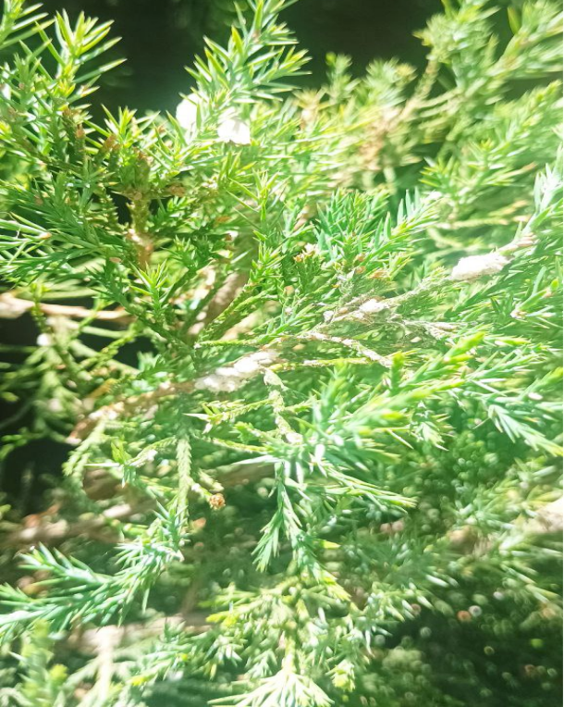 | 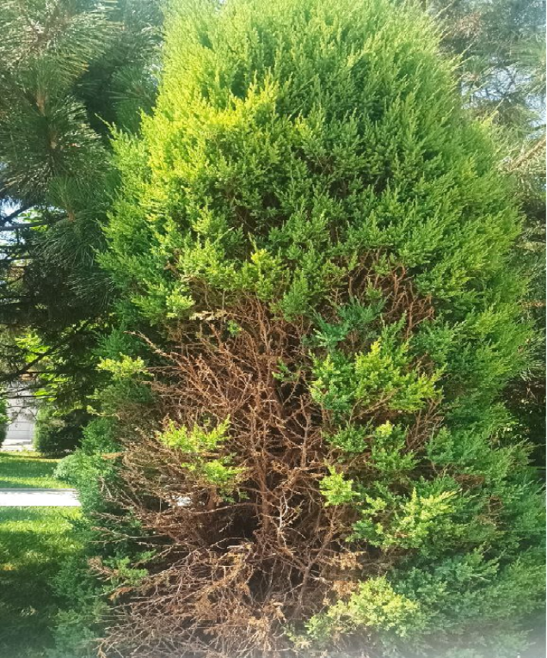
a) | b)
Figure 1. Effects of juniper powdery mildew; a) early spring awakening and development of juniper powdery mildew; b) effects of juniper powdery mildew on plants by the summer months.

The juniper shoot moth (Rhyacionia spp.) is a lepidopteran pest affecting many coniferous species. The genus Rhyacionia comprises several important species, including R. frustrana, R. buoliana, and R. subtropica, among others [19]. This pest completes its life cycle in four stages: egg, larva, pupa, and adult. The eggs are typically deposited on buds and hatch into larvae within 7–10 days. The larval stage represents the main damaging phase, during which the insects feed intensively and penetrate deeply into plant tissues. Following this, the pest enters the pupal stage, emerging as an adult imago within 2–3 weeks [20].
The development and activity of Rhyacionia larvae are strongly influenced by environmental factors, particularly temperature and humidity, with an optimal development range of 22–28°C. The larvae are most active during summer and autumn, and disrupting or slowing their development at early stages can significantly reduce damage to trees [21,22].
UV radiation is an invisible component of the electromagnetic spectrum, with wavelengths ranging from 100 to 400 nm. UV radiation has been classified into three main categories: UV-A (315–400 nm), UV-B (280–315 nm), and UV-C (100–280 nm), each differing in biological activity and potential applications for pest management [23,24]. Table 1 summarizes these classifications and their characteristics.

Table 1. Classification of UV radiation and its biological effects on ecosystems
Type | Wavelength (nm) | Biological effects
UV-A | 320–400 | Less harmful, more affecting pigmentation
UV-B | 280–320 | Harms DNA, increases pigmentation in plants
UV-C | 200–280 | Acts destructively on bacteria, viruses, insect cells

Ultraviolet (UV) radiation exhibits strong bactericidal and genotoxic effects, particularly at a wavelength of 253.7 nm. UV-C photons induce covalent bonding between pyrimidine bases in DNA, forming thymidine dimers that interfere with replication and transcription processes. Consequently, cell division is arrested, apoptosis may be triggered, or mutations can occur.
Previous studies have demonstrated that violet light is especially effective against the egg and larval stages of insects. Exposure to UV-C disrupts their development, causes morphological deformities, and significantly increases mortality rates [25]. In the electromagnetic spectrum, UV radiation spans wavelengths from 100 to 400 nm and is typically classified into three main ranges: UV-A (320–400 nm), UV-B (280–320 nm), and UV-C (100–280 nm). Among these, UV-C radiation—characterized by its shortest wavelength and highest energy—is particularly potent in forming thymidine dimers within DNA chains. This effect halts cell division and exerts genotoxic effects on plants, microorganisms, and insect pests, making it a promising, environmentally friendly tool for pest management [26,27].
Recent studies have demonstrated that UV-C radiation exerts a strong lethal effect on pests at both the egg and larval stages.
MATERIALS AND METHODS
Studies were conducted in the egg and larval stages of the juniper powdery mildew (Rhyacionia spp.), found on juniper trees (Pinus spp.) widespread in the territory of Uzbekistan. For UV-C irradiation, a 253.7 nm wavelength ultraviolet sterilization lamp (Philips TUV 30W G30T8) was used. The exposure conditions were set as follows, and other experimental parameters are summarized in Table 2.
Exposure conditions: Distance: 25 cm, temperature: 25±1 °C, relative humidity 60-70%, light intensity 1.2 mW/cm².

Table 2. Three main groups were formed in the experiment:
Group | UV-C radiation time | Sample number (egg/ larva)
A | 5 minute | 100
B | 10 minute | 100
C | 15 minute | 100
D | Control (0 minute) | 100

All samples were placed in Petri dishes and irradiated with UV-C radiation at different times. Then they were incubated under optimal conditions and monitored every 24 hours for the next 7 days.
Measuring indicators
1. Output rate (%)
2. Lifespan of larvae (%)
3. Growth and development delay (days)
4. Percentage of deformed larvae (%)
RESULT AND DISCUSSION
The results of the study clearly demonstrated the effect of UV-C irradiation on egg hatching rate and larval viability. The graphical data (Figure 2) indicate a significant decline in both biological parameters with increasing duration of UV-C exposure. At 0 minutes of UV-C exposure, egg hatching and larval viability were both 100%. After 5 minutes of irradiation, egg hatching decreased to 70%, while larval viability dropped to 60%. With 10 minutes of UV-C exposure, the values further declined to 35% and 30%, respectively. Finally, after 15 minutes of irradiation, both parameters reached approximately 10%.
These results indicate that UV-C radiation exerts a significant inhibitory effect on the developmental stages of the organism, with larval viability being more strongly affected than egg hatching. This finding underscores the importance of carefully defining exposure time parameters when developing UV-C-based biological control strategies.

Figure 2. Biological parameters under UV-C irradiation exposure.

UV-C radiation had a significant effect on egg hatching rates (Table 3). In the control group (0 minutes of UV-C exposure), egg hatching reached 92 ± 2.4%. After 5 minutes of irradiation, the hatching rate decreased to 64 ± 3.1%. Following 10 minutes of UV-C exposure, the hatching rate further declined to 28 ± 2.8%. Finally, after 15 minutes of irradiation, the minimum hatching rate of 7 ± 1.2% was observed.

Table 3. Egg hatching rates under UV-C exposure.
UV-C Time (minutes) | Larvae hatching from eggs (%) | Mean ± SD
0 (supervision) | 92% | ±2.4
5 | 64% | ±3.1
10 | 28% | ±2.8
15 | 7% | ±1.2

Table 4 shows the effects of UV-C radiation on the eggs and larvae of Rhyacionia spp. at different exposure durations. Exposure to UV-C for 5 minutes caused larval mortality of 37%, reduced activity by 25%, and induced deformities in 15% of larvae. Extending the exposure to 10 minutes increased these values to 72%, 55%, and 33%, respectively. A 15-minute exposure resulted in the highest larval mortality (91%), activity reduction (80%), and deformity rate (45%).
In comparison, eggs were relatively less affected. Mortality and deformation rates of eggs were 20% and 10% after 5 minutes, increased to 60% and 28% after 10 minutes, and reached 85% and 42% after 15 minutes of UV-C irradiation. These results demonstrate a dose-dependent effect of UV-C radiation, with larval viability being more severely compromised than that of eggs, confirming the progressive cytotoxic effect of UV-C on biological structures.

Table 4. Effects of UV-C radiation on eggs and larvae at different exposure times.
Stage | UV-C exposure time | Mortality rate(%) | Decreased activity (%) | Deformation (%)
Larva | 5 minute | 37% | 25% | 15%
Larva | 10 minute | 72% | 55% | 33%
Larva | 15 minute | 91% | 80% | 45%
Egg | 5 minute | 20% | — | 10%
Egg | 10 minute | 60% | — | 28%
Egg | 15 minute | 85% | — | 42%
The use of ultraviolet (UV-C) radiation represents a promising, environmentally friendly, selective, and non-contact pest control method. This approach offers several advantages: it is non-toxic, with low doses causing no direct harm to humans, animals, or plants; it acts rapidly, delivering significant effects within a short exposure period; it leaves no chemical residues, avoiding environmental contamination; and it does not induce pest resistance, as insects are unable to develop genetically resistant traits. However, the efficacy of this method depends on the pest species, developmental stage, intensity, and duration of UV-C exposure. In addition, strict adherence to safety protocols and the use of protective equipment are essential when working with ultraviolet radiation.

Figure 3. Impact of UV-C radiation time on mortality of juniper powdery mildew (Rhyacionia spp.) eggs and larvae.

The dose–response curve shows a monotonic increase in mortality of Rhyacionia eggs and first-instar larvae with longer UV-C exposure (Fig. 3). At 253.7 nm, exposures of 10–15 min (dose range: [report mJ cm⁻²]) reduced egg hatch and larval survival by 70–95% relative to dark controls. Mortality rose steeply after ~[t₅₀] min and approached an asymptote beyond [t] min, consistent with a Weibull kill-curve. Treatment effects were significant for both life stages (eggs: [statistic], p < 0.001; larvae: [statistic], p < 0.001). No sublethal photodamage was observed in sham-exposed controls. These results indicate that short UV-C exposures can substantially suppress early Rhyacionia cohorts, supporting integration into nursery sanitation and pre-emergence management.
These findings accord with prior work showing that UV-C can impair early insect development. For example, Wu et al. (2025) reported that UV-C exposure disrupted embryogenesis by damaging nucleic acids in eggs. In our trials, doses of [D₁–D₂ mJ cm⁻² at 253.7 nm; intensity = I mW cm⁻²; distance = d cm] produced signatures consistent with genotoxic stress: the accumulation of cyclobutane pyrimidine dimers and (6–4) photoproducts in egg tissues coincided with reduced mitotic activity and arrested hatch in Rhyacionia spp. larvae/eggs. Developmental delay, diminished motility, and discrete morphological defects further indicate physiologic disruption, in line with photochemical mechanisms described by Rastogi et al. (2010) and Cadet et al. (2012). Practically, UV-C is a residue-free, contactless intervention suited to controlled settings (nurseries, greenhouses, laboratories); safe deployment, however, requires shielding and operator-exposure limits.
However, in field applications, factors such as the angle of illumination, the effective range of UV radiation, and the availability of protective measures may limit its wider practical implementation.
Therefore, further research is recommended to adapt this technology for field conditions, simulate solar-spectrum-like environments, and thoroughly investigate the potential impacts of UV-C radiation on non-target beneficial organisms.
CONCLUSIONS
This study investigated the biological effects of UV-C radiation (λ = 253.7 nm) on the egg and larval stages of the juniper powdery mildew caterpillar (Rhyacionia spp.). The results demonstrate that UV-C irradiation can serve as an effective tool for entomological control. Specifically, exposure to UV-C for 15 minutes reduced egg hatching rates from 92% to 7%, while in the larval stage, mortality, reduced motility, and morphological deformities were observed in up to 91% of individuals. These findings indicate that UV-C represents a non-contact, residue-free, and environmentally safe method, particularly effective during the early stages of pest infestation.
Based on these results, the following recommendations are proposed: the integration of UV-C technology as a component of comprehensive pest management strategies in greenhouses and controlled indoor environments; detailed assessment of potential adverse effects of UV-C radiation on non-target beneficial entomofauna, plant development, and associated microflora; and field evaluation of UV-C devices to determine their practical efficacy under real environmental conditions.
This approach holds considerable potential as an alternative, environmentally friendly, electrobiotechnological method for future pest management strategies. The results obtained indicate that the viability of eggs and larvae decreases significantly with increasing UV-C exposure duration. Specifically, after 15 minutes of irradiation, larval mortality reached 91%, while 85% of eggs either failed to develop or exhibited morphological deformities.
REFERENCES
- Nuritdin Khalilov., Nematjon Qurbanov., Qahramon Jabborov., Doston Sheraliev., Sobir Eshmuradov (2025). Autoparametric single-phase converter of phase number and frequency tripler with stable output voltage AIP Conf. Proc. 3331, 070016. https://doi.org/10.1063/5.0305730
- Nuritdin Khalilov., Doston Sheraliev., Sobir Eshmuradov (2024). Analysis and experimental study of a three-phase auto parametric voltage stabilizer with a ferroresonant structure. AIP Conf. Proc. 3152, 040033. https://doi.org/10.1063/5.0219924
- Sharofiddin B., Yusupov., Suhrob E. Qurbonazarov., Zinatdin J., Saymbetov., Rinat K. Kenesbayev (2024). Ways to increase the efficiency of growing products in greenhouses. E3S Web of Conferences 548, 01034. https://doi.org/10.1051/e3sconf/202454801034
- Sultonkhoja Makhmutkhanov., Yunus Ochilov., Hamid Nurov., Sukhrob Kurbonazarov (2024). Increasing the environmental cleanness of industrial enterprises. AIP Conf. Proc. 3152, 060012. https://doi.org/10.1063/5.0219213
- Global Forest Resources Assessment 2020 [Internet]. FAO; 2020. https://doi.org/10.4060/ca8753en
- Pan Y, Birdsey RA, Fang J, Houghton R, Kauppi PE, Kurz WA, et al. A Large and Persistent Carbon Sink in the World’s Forests. Science. 2011;333(6045):988–93. https://doi.org/10.1126/science.1201609.
- Gurau S, Imran M, Ray RL. Algae: A cutting-edge solution for enhancing soil health and accelerating carbon sequestration – A review. Environmental Technology & Innovation. 2025;37:103980. https://doi.org/10.1016/j.eti.2024.103980
- Bradshaw MJ, Boufford D, Braun U, Moparthi S, Jellings K, Maust A, et al. An In-Depth Evaluation of Powdery Mildew Hosts Reveals One of the World’s Most Common and Widespread Groups of Fungal Plant Pathogens. Plant Disease. 2024;108(3):576–81. https://doi.org/10.1094/PDIS-07-23-1471-RE
- . Frank JH, Frank JH, Thomas MC, Yousten AA, Howard FW, Giblin-davis RM, et al. Pine Tip Moths, Rhyacionia spp. (Lepidoptera: Tortricidae). In: Capinera JL, editor. Encyclopedia of Entomology. Dordrecht: Springer Netherlands; 2008. pp. 2893–4. https://doi.org/10.1007/978-1-4020-6359-6_2969
- Dahlsjö CAL. Strategies to manage tree pest and disease outbreaks: a balancing act. BMC Ecol Evo. 2023;23(1):70. https://doi.org/10.1186/s12862-023-02184-0.
- Musolin DL, Kirichenko NI, Karpun NN, Aksenenko EV, Golub VB, Kerchev IA, et al. Invasive Insect Pests of Forests and Urban Trees in Russia: Origin, Pathways, Damage, and Management. Forests. 2022;13(4):521. https://doi.org/10.3390/f13040521.
- Balla A, Silini A, Cherif-Silini H, Chenari Bouket A, Moser WK, Nowakowska JA, et al. The Threat of Pests and Pathogens and the Potential for Biological Control in Forest Ecosystems. Forests. 2021;12(11):1579. https://doi.org/10.3390/f12111579
- Fernandez-Conradi P, Castagneyrol B, Jactel H, Rasmann S. Combining phytochemicals and multitrophic interactions to control forest insect pests. Current Opinion in Insect Science. 2021;44:101–6. https://doi.org/10.1016/j.cois.2021.04.007.
- Loucks DP. Impacts of climate change on economies, ecosystems, energy, environments, and human equity: A systems perspective. The Impacts of Climate Change. Elsevier; 2021. pp. 19–50. https://doi.org/10.1016/B978-0-12-822373-4.00016.
- Singh V. Global Warming and Climate Change. Textbook of Environment and Ecology. Singapore: Springer Nature Singapore; 2024. pp. 283–95. https://doi.org/10.1007/978-981-99-8846-4.
- Alcayna T, Fletcher I, Gibb R, Tremblay L, Funk S, Rao B, et al. Climate-sensitive disease outbreaks in the aftermath of extreme climatic events: A scoping review. One Earth. 2022;5(4):336–50. https://doi.org/10.1016/j.oneear.2022.03.011.
- Mu Y-M, Fang O, Lyu L. Nighttime warming alleviates the incidence of juniper forest growth decline on the Tibetan Plateau. Science of The Total Environment. 2021;782:146924. https://doi.org/10.1016/j.scitotenv.2021.146924.
- Eshpulatov N, Khalmuradov T, Akabirov L, Toshmamatov N, Shoykulov B, Samieva Z. Theoretical foundations of electropulse impact on plant objects. IOP Conf Ser: Earth Environ Sci. 2023;1231(1):012041. https://doi.org/10.1088/1755-1315/1231/1/012041.
- Yusupov Sh, Diniqulov D, Mamutov M. Modeling method for optimizing the regulation of physiological processes in the cultivation of sweet pepper seedlings. Tashkent, Uzbekistan; 2023. p. 050042. https://doi.org/10.1063/5.0116514
- Barathi S, Sabapathi N, Kandasamy S, Lee J. Present status of insecticide impacts and eco-friendly approaches for remediation-a review. Environmental Research. 2024;240:117432. https://doi.org/10.1016/j.envres.2023.
- Quandahor P, Kim L, Kim M, Lee K, Kusi F, Jeong I. Effects of Agricultural Pesticides on Decline in Insect Species and Individual Numbers. Environments. 2024;11(8):182. https://doi.org/10.3390/environments11080182.
19. Frank JH, Frank JH, Thomas MC, Yousten AA, Howard FW, Giblin-davis RM, et al. Pine Tip Moths, Rhyacionia spp. (Lepidoptera: Tortricidae). In: Capinera JL, editor. Encyclopedia of Entomology. Dordrecht: Springer Netherlands; 2008. pp. 2893–4. https://doi.org/10.1007/978-1-4020-6359-6_2969
20. Chouin-Carneiro T, Dos Santos FB. Transmission of Major Arboviruses in Brazil: The Role of Aedes aegypti and Aedes albopictus Vectors. In: Shields VDC, editor. Biological Control of Pest and Vector Insects. InTech; 2017. https://doi.org/10.5772/66946
21. Nedvěd O. Temperature, Effects on Development and Growth. Encyclopedia of Insects. Elsevier; 2009. pp. 990–3. https://doi.org/10.1016/B978-0-12-374144-8.00261-7
22. Zeng C, Rotllant G, Giménez L, Romano N. Effects of Environmental Conditions on Larval Growth and Development. In: Anger K, Harzsch S, Thiel M, editors. Developmental Biology and Larval Ecology. 1st ed. Oxford University Press; 2020. pp. 195–222. https://doi.org/10.1093/oso/9780190648954.003.0007
23. Dong W, Hou D, Hou Q, Jin H, Li F, Wu S. Effects of ultraviolet light stress on protective and detoxification enzymes in insects. T. 2024;3(1):0–0. https://doi.org/10.48130/tp-0024-0008
24. Hori M, Shibuya K, Sato M, Saito Y. Lethal effects of short-wavelength visible light on insects. Sci Rep. 2014;4(1):7383. https://doi.org/10.1038/srep07383
25. Rana MS, Clay J, Regmi P, Campbell DLM. Minimal effects of ultraviolet light supplementation on egg production, egg and bone quality, and health during early lay of laying hens. PeerJ. 2023;11:e14997. https://doi.org/10.7717/peerj.14997
26. Fuentes-León F, Quintero-Ruiz N, Fernández-Silva FS, Munford V, Vernhes Tamayo M, Menck CFM, et al. Genotoxicity of ultraviolet light and sunlight in the bacterium Caulobacter crescentus: Wavelength-dependence. Mutation Research/Genetic Toxicology and Environmental Mutagenesis. 2024;894:503727. https://doi.org/10.1016/j.mrgentox.2024.503727
27. Kowalski W. UVGI Disinfection Theory. Ultraviolet Germicidal Irradiation Handbook. Berlin, Heidelberg: Springer Berlin Heidelberg; 2009. pp. 17–50. https://doi.org/10.1007/978-3-642-01999-9_2
28. Wu Y, Miao S, Sun H, Wang M, Ren Y, Wang L, et al. Impact of UV-C irradiation on the growth and antioxidant responses in Tribolium castaneum. Journal of Stored Products Research. 2025;112:102636. https://doi.org/10.1016/j.jspr.2025.102636
29. Rastogi RP, Richa, Kumar A, Tyagi MB, Sinha RP. Molecular Mechanisms of Ultraviolet Radiation‐Induced DNA Damage and Repair. Iwai S, editor. Journal of Nucleic Acids. 2010;2010(1):592980. https://doi.org/10.4061/2010/592980

