Geological characteristics and lithological composition of mezoic cenozoic deposits and their significance in regional studies
Аlisher Samiev^{1,a)}, Isamiddin Togaev¹, Turman Saxibov¹, Shoxruxjon Toshtemirov¹, Ilkhom Ruziyev²
¹ National University of Uzbekistan named after Mirzo Ulugbek, Tashkent, Uzbekistan
²“Tashkent Institute of Irrigation and Agricultural Mechanization Engineers” National Research university, Tashkent, Uzbekistan
^{a)} Corresponding author: samiyevalisher1993@gmail.com
Abstract. The relevance of the research lies in stratifying sections in the region, identifying mapped local stratigraphic units, correlating them, and determining the stratigraphic intervals of ore-bearing rocks associated with mineral deposits. This is important for the study area. The aim of the research is to develop an updated regional stratigraphic scheme for Upper Cretaceous and Paleocene deposits in the Zirabulak-Ziyovuddin area. The research methods included the use of paleontological, lithological, ecological, facies, and phenomenological methods of stratigraphy, as well as methods of dissection and correlation of sections. Laboratory methods analyze microfaunistic (700 specimens) and macrofaunistic (200 specimens) faunal stocks collected from the boundaries of Upper Cretaceous and Paleogene deposits during the field season. The research results led to a detailed division of Upper Cretaceous and Paleocene deposits in the region into local stratigraphic units - suites, subsuites, and packets, based on biostratigraphic studies. This division, established in reference sections, allows for the identification of facial changes in the composition and structure of contemporaneous suites based on the stratigraphic sequence of local stratons. The practical significance of the research lies in the detailed stratification of reference sections based on lithological, paleontological, and ecological characteristics, the identification of local stratigraphic units, and the substantiation of the age and composition of these identified local units. Furthermore, it is explained by the determination of the depositional conditions of sedimentary rocks, which enables the development of reliable interpretation variants for large-scale geological maps on a lithobiofacial basis. The obtained results can be used to develop an updated scheme and establish an effective system for the stratigraphy of the Upper Cretaceous and Paleogene boundary deposits in the Zirabulak-Ziyovuddin region. This area is characterized by refined and paleontologically substantiated boundaries of general and regional stratigraphic units.
INTRODUCTION
The level of the boundary between the Cretaceous and Paleogene has not been sufficiently studied in the Zirabulak-Ziaetdin region. To solve this problem, changes in the taxonomic composition of faunal complexes, as well as changes in the lithological composition of rocks associated with the transformation of facial settings, are of primary importance (Abduazimova Z.M, et al, 2024) [1-4].
In the Cretaceous and Paleogene deposits of the Zirabulak-Ziaetdin region, three reference sections were identified based on stratigraphic completeness, paleontological and facial characteristics, and thickness values (Jovliyev B.A, et al, 2022). The Auzikarasai section is widespread within the Ziaetdin Mountains, the Kurgancha section is located on the western, north and southwestern slopes of the Zirabulak Mountains, and the Tym section combines deposits located on the southeastern and eastern slopes of the Zirabulak Mountains (Fig. 1).
In these sections, in the Cretaceous and Paleogene boundary interval, the Tym, Akdzhar and Bukhara formations were identified. These formations are characterized by complexes of bivalves and gastropods, which made it possible to correlate them with the divisions of the General Stratigraphic Scale of Uzbekistan (GSS RUz, 2020) and the International Stratigraphic Scale (ISS). Faunal remains from these deposits were identified by I.M. Abduazimova, B. Zhovliev, A. Samiev.
The Tym Formation, which lies in the upper horizons of the Cretaceous was identified by O.S. Vyalov (1947, p. 22), named after the Tym Village [4-8]. The stratotype of the formation is not indicated by the author.

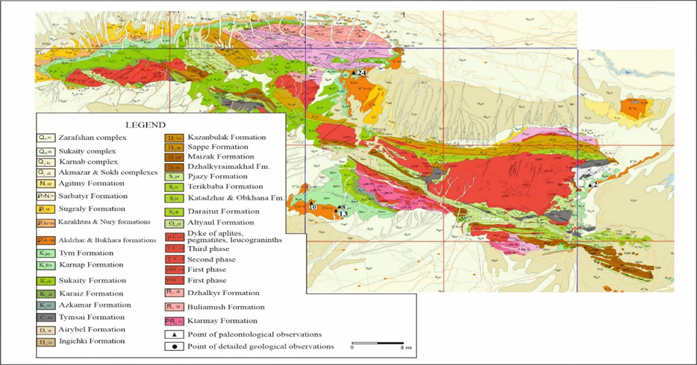
FIGURE 1. Geological map of the Zirabulak-Ziaetdin regionby R.S. Khan and A.D. Ravshanov (2006)

In the Auzikarasai stratotype section, the Tym formation is well exposed and has a wide lateral spread. Its characteristic feature is the predominance of fine-grained yellow, brown, grayish-yellow sands and sandstones in the section. The Tym formation is divided into lower and upper formations. The Lower Tym Formation is composed of gray, greenish-gray, green sands with interlayers of yellowish-red clays in the lower part. In the middle part are grayish-green clays predominate, green with interlayers of sandstones and dark brown, crimson siltstones; in the upper part there is interlayering of variegated grayish-green, red clays and brown sandstones. The thickness of the Lower Tym Formation is 30.0 m. The Tym Formation lies with erosion on the Upper Karnap Formation of the Santonian. No faunal remains were found in the Lower Tym Formation [8-10]. The Upper Tym Formation consists of grayish-yellow, gray, variegated, calcareous-clayey sandstones, greenish-yellow sands and thin layers of clay [11-13]. The thickness is 11.0 m. These rocks contain numerous thin-walled oysters - Liostrea lehmannii Rom. and forms with a coarser thick wall - Amphidonta pyrenaica (Leym.), Ceratostreon spinosum (Math.); other bivalves - Chlamys dujardini Rom., Megatrigonia sp., Spondylus sp. and the shells of the right sea urchins - Cassidulus sp. At the top of the Upper Tym Formation there are calcareous yellowish gray, light gray sandstones with cores and imprints of rudists - Gyropleura sp., Biradiolites sp., Apricardia sp., Orbinyana vlasovi Bobk. In the Shorkuduk section (northeastern slopes of the Ziaetdin Mountains), large rudists - Apricardia mediasiatica Bobk were identified at this stratigraphic level. The complex of bivalve mollusks found in the Tym Formation is spread in Maastrichtian deposits (Karakata Formation) of the Central Kyzylkum (Kuldzhuktau-Auminzatau and Tamdytau types) (Abduazimova, 2022). These are, in particular, the shells of the rudist - Apricardia mediasiatica Bobk., which are characteristic of the Maastrichtian deposits of the southern foothills of South Nuratau mountains, East Kopetdag mountains and the Zeravshan-Hissar mountain region. The wide spreading of rudists - Apricardia mediasittica Bobk. and their association with a specific stratigraphic horizon allows to consider this species as an index species for the Upper Cretaceous horizons. Foraminifera - Reophax aff. texanus Cushm. et Wat., Haplophramoides excavatus Cushm. et Wat., Ammobaculites aff. jetymensis Tzatz. were identified from the clayey layers of the Upper Tym Formation (definitions by A.M. Bogomolova), developed in the Maastrichtian deposits of the Central Kyzylkum and the southern foothills of South Nuratau mountains (Kim A.I, et al, 2020) [4-7].

MATERIALS AND METHODS
The Tym Formation is erosive overlain by deposits of the Akdzhar and Bukhara formations. The Akjar Formation was described in the Tajik Depression by K.V. Babkov, G.P. Kreidenkov. The stratotype is located along the Akdzhar Ravine. In the stratotype, the formation is represented by white sugar-like gypsum, oolitic limestones, dolomites with a complex of bivalves and gastropods. Thickness up to 206.0 m (A dictionary of Stratigraphy of Uzbekistan, 2001 pp. 45-46) (HYDROINGEO., et al, 2001).
In the area of spreding of the Auzikarasai section in the Chingiztau Mountains, the Akdzhar Formation is represented by sandstones, white brecciated calcareous shell rocks with interlayers of marls. The thickness is up to 6.0 m. The Akdzhar Formation lies with erosion on the Tym Formation of the Maastrichtian and contains bivalves - Barbatia (Acar) lamellosa tabulata Vinc., Spondylus dutempleanus (Orb.), S. faxensis Lund., Modiolus jeremejewi Rom., M.karabilensis Vial., Cardita minutula Rom., C.turcomanica Vial.; gastropods - Bitium malaise (Br.et Corn), Rhinoclavus unisulcatus (Lam.) (definitions by R.K. Makarova A.A. Abdusamatov), characteristic of the Lower, Middle Paleocene - Danish, Zealandian stages. In the Ziaetdin section (northeastern foothills of the Ziaetdin Mountains), the Akdzhar formation is represented by white, grayish-white sandstones with interlayers of marls. The thickness is 8.5 m. The Akdzhar formation lies with erosion on the Tymskaya (Abduazimova I.M, et al, 2007.).
The marls of the Ziaetdin section contain bivalves and gastropods - Barbatia tennidentata Hng., B.praescabra (Koen.), Cucullalea cf. arcoeformis Neschaev, C.danica Ravn, Lima holzapfeli Hng., Spondylus cf. dutempleanus (Orb.) Modiolus cotteae (Roem.), Miltha passelequi (Vine.), Corbula (Cuneocorbula) makarovae Abdusam; Grommium ciplyensis (Vine.), Tornatella paresiensis (Desh.), etc. This complex is typical for the Danish and Zealandian stages of Denmark, Sweden, Belgium and the Akdzhar formation, developed in the Bukhara depression and Central Kyzylkum (Makarova, Abdusamatov, 1987, pp. 82- 85).
Bukhara Formation, identified by O.S. Vyalov in the rank of limestone horizon with Cuneocorbula. The stratotype is located near the city of Isfara, Fergana. In the stratotype, the formation is represented by limestones, oolitic, marls, gypsumed sandstones with gypsum interlayers. The thickness is up to 300.0 m. Contains marine bivalves. (Stratigraphic Dictionary of Uzbekistan, 2001. p. 121) (HYDROINGEO., et al, 2001).
RESULTS AND DISCUSSION
In the Ziaetdin section, the Bukhara Formation conformably overlies the Akdzhar Formation. The Bukhara Formation is composed of strong siliceous, grayish-white limestones. The partial thickness is 2.0 m. The limestones contain bivalves: Gari edwardsi Morris, Cardita minutula Roem., Corbula (Cuoneocorbula) asiatica Vial.
Bukhara Formation is identified by O.S. Vyalov in the rank of limestone horizon with Cuneocorbula. The stratotype is located near the Isfara city, Kyrgyzstan. In the stratotype, the formation is represented by limestones, oolitic, marls, gypsumed sandstones with gypsum interlayers. Thickness is up to 300.0 m. The Bukhara Formation contains sea bivalves (A dictionary of Stratigraphic of Uzbekistan, 2001, p. 121) (HYDROINGEO., et al, 2001).
In the Auzikarasai key section (western foothills of the Ziaetdin Mountains), the Bukhara Formation overlies the Tym Formation with erosion, and is composed of light gray, finely and medium-layered, sandy limestones (up to 12.0 m thick) with cores and imprints of bivalves and gastropods - Modiolus jeremejewi Vial., Cardita minutula Rom., C. aeqyptiaca orientalis Vial., Lucina lamellicardia (Cossm.), Cyrena (Corbicula) forbesi Desh., Pitar similis (Leym.), Corbula (Cuoneocorbula) asiatica Vial., Potamides romanovsky Vial., Rhinoclavus sp., Natica sp.
In the Shorkuduk section at this stratigraphic level the following species Lucina gravesi Desh., L. prevosti Desh., Corbula (Cuneocorbula) asiatica Vial., Cardita bucharensis Vial., Gari debilis Desh., Tracia prestrashi Desh., Mathilda bimorpha Br.et Corn. (I.M. Abduazimova, A.A. Abdusamatov et al., 2007 f.). The complex of mollusks is similar to the complex found in the Bukhara Formation of the Central Kyzylkum, Fergana Depression, and southern foothills of Southern Nuratau. Most of the species found here are known from the Upper Paleocene, Thanetian Stage of Belgium, France and Denmark. The foraminiferal complex is represented by the following species - Annectina paleocenica Suleym., Lochartia aff. luppovi Bugr., Triloculina sphaerica Ser., Bolivina wilcoxensis (Cushm.), Morozovella perclara (Chal.), Gaudryina gigantica (Subb.) (definitions by A.M. Bogomolova), that are common in the Late Paleocene, Thanetian Stage of Uzbekistan and Turkmenistan.
In Chingiztau, the Bukhara Formation consists mainly of white, strong, friable, oolite-like sandstones. The thickness is 5.1 m. The Formation concordantly overlies Akdzhar Formation. In the roof there are dolomitized limestones containing bivalves - Arca montensis Cossm., Glycymeris corneti (Koen)., Modiolus jeremejewi Rom., M. karabilensis Vial., Crassatella korobkovi Dzbabar., Cardita bucharensis Vial., Lucina prevosti Desh., Corbula (Cuneocorbula) asiatica Vial., C. (C.) biangulata Vial., Tracia prevosti Desh.; they are typical in the Late Paleocene-Thanetian. The thickness is 5.0 m (Abduazimova I.M, et al, 2022).
In the Ziaetdin section, the Bukhara Formation conformably overlies the Akdzhar Formation. The Bukhara Formation is composed of strong siliceous, grayish-white limestones. The partial thickness is 2.0 m. The limestones contain bivalves - Gari edwardsi Morris, Cardita minutula Roem., Corbula (Cuoneocorbula) asiatica Vial.
More abundant faunal complex from this area is given by A.A. Abdusamatov (I.M. Abduazimova, A.Kh. Abdusamatov, 2007 f). It is represented by species Astarte netshaevi Makaz, Crassatella exelsa Cossm., Modiolus jeremjewi Rom., M. karbilensis Vial. Glycymeris corneti (Koen.), Corbula malaisei (Briar et Cornet) that are common in England, France, Turkmenistan and Uzbekistan.
In the Kurgancha key section, the Lower Tym Formation is composed of greenish-gray, gray sands, gray, greenish-gray clays; grayish-yellow siltstones with gravel grains. The thickness is 25.5 m. It lies with erosion on the Upper Karnap Formation. The Upper Tym Formation in the area of spreading of the key section is most studied to the northwest of the Kurgancha Village (24.0 km) and is represented by calcareous gray, greenish-gray sandstones containing oysters - Liostrea lehmannii Rom., Аmphidonta pyrenaica (Leym.), Ceratostreon spinosum (Math.), Lopha cf. sotiriadi Muzaph; rudists - Apricardia cf. mediasiatica Bobk., Gyropleura cf. gaurdakensis Bobk., Orbignyana cf. vlasovi Bobk., Praeradiolites cf. boucheroni Bayle et Toucas. The upper part of the Tym Formation section is composed of gray limestones with rudists Biradiolites sp. (cf. boldjuanensis Bobk.) (Jovliyev B.A, et al, 2023). The faunal complex is characteristic of the Maastrichtian deposits of Uzbekistan and adjacent territories [14-16].
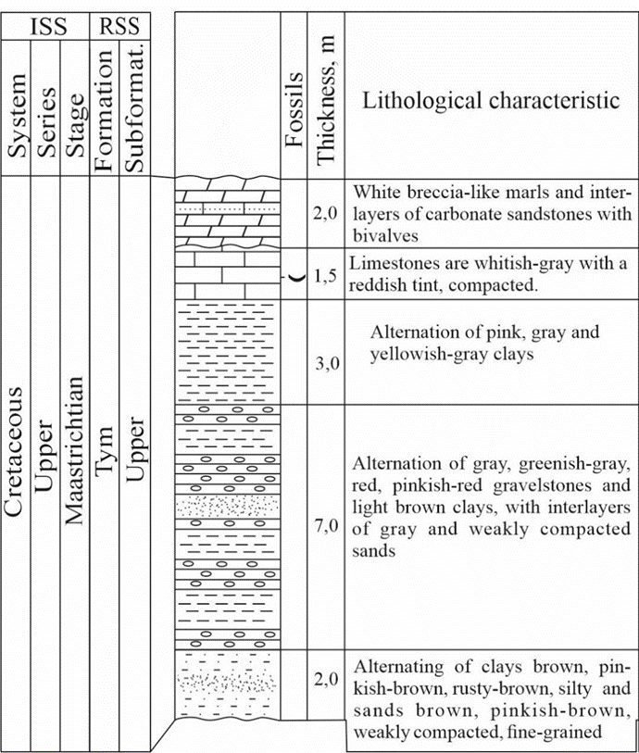
FIGURE 2. Lithostratigraphy and range of selected bivalves taxa through the
Upper Tym Formation in the Tym key section (ТПН-2). Scale 1:200
The Akdzhar Formation spread to the south and west of the Kurgancha Village and lies on the limestones of the Tym Formation with erosion. The Akdzhar Formation is represented by white clays with a thickness of 5.0 m and white limestones (about 2.0 m thick) with traces of faunal remains (Jovliev B.A, et al, 2023).
The Bukhara Formation, which lies above, is represented by white, grayish-white, compacted limestones, It conformably overlies the Akdzhar Formation. The limestones are characterized by bivalves - Glcymeris corneti (Koenen), Cardita minutula Rom., Pitar duponti (Cossman), Corbula (Cuneocorbula) asiatica Vial. The complex is characteristic of the Upper Paleocene, Thanetian stage (TPN-10, TDGN-8) (Samiyev A.A., et al, 2024).
The Bukhara Formation in the Kurgancha type of section lies with erosion on the Tym Formation; it consists of gray, light gray sandstones, harder in the lower part and weakly compacted in the upper. The sandstones contain numerous bivalves - Modiolus jeremejewi (Rom.), Cardita minutula Rom., Corbula (Cuneocorbula) asiatica Vial. (TPN-24) (Text-fig. 2), characteristic of the Upper Paleocene, Thanetian stage (Jovliev B.A, et al, 2023).
In the Tym key section, the Lower Tym Formation is characterized by greenish-gray, pinkish-gray sandstones, light gray, banded siltstones. The thickness is 11.0 m. The formation lies with erosion on the Karnap Formation. The Upper Tym Formation consists of light gray sandy limestones. The thickness is 7.0 m. The limestones contain oysters - Liostrea lehmannii Rom., Exogyra ostracina Lam., Lopha sotiriadi Muzaph., Amphidonta pyrenaica (Leym.) (ТПН -2), characteristic of the Maastrichtian deposits of Uzbekistan and adjacent areas (Jovliyev B.A, et al, 2022) [16-21].
The Tym Formation with erosion is overlap by the Bukhara Formation. The latter is represented from bottom to top by white brecciated marls with interlayers of carbonate sandstones including bivalves - Cardita minutula (Roem.), Corbula (Cunecorbula) asiatica Vial. (ТПН-13, sample 13/1), thickness 2.0 m; organogenic-detrital limestones, yellowish-gray, 0.5 m thick; white limestones, weakly compacted with interlayers of yellowish-gray limestones, 3.0 m thick; organic-detrital limestones, 0.5 m thick. The rocks contain bivalves - Modiolus jeremjewi (Rom.), Cardita minutula (Rom.), Corbula (Cunecorbula) asiatica Vial., characteristic in the Thanetian Stage. (Text-fig. 3) (Samiyev A.A., et al, 2024). The rocks lying above are calcareous, white, medium-grained, weakly compacted sandstones, 1.5 m thick; chemogenic limestones, yellowish-gray, thin and medium-layered, strong, 1.0 m thick; brecciated limestones, thin-layered marls, 3.0 m thick. The total thickness of the Bukhara Formation is 11.5 m [2-6].
CONCLUSION
The boundary between the Cretaceous and Paleogene in the Zirabulak-Ziaetdin region is identified at the top of the Tym Formation. In some sections it coincides with the base of the Akdzhar Formation, in others - with the Bukhara Formation. The extinction of the Maastrichtian bivalves and foraminifera community is observed at this level. Bivalves - Liostrea lehmannii Rom., Amphidontu pyrenaica (Leym.), Chlamys dujardini Roem., rudists of the genera Orbiynyana, Biradiolites, Apricardia developed in the Tym Formation suddenly disappear everywhere. Above in the Akdzhar Formation, species appears - Modiolus jeremejewi Rom., Cardita minutula Rom., characteristic of the Danish and Zealandian stages. In places where the Akdzhar Formation is absent, the boundary passes at the base of the Bukhara Formation with Lucina gravesi Desh., L. prevosti Desh., Corbula (Cuneocorbula) asiatica Vial. of the Thanetian age. A foraminiferal complex with Annectica paleocenica Suleym., widespread in the Thanetian Stage, appears here.
REFERENCES
- A. A. Samiyev, “Substantiation of the boundaries of the Cretaceous and Paleogene systems in the Zirabulak–Ziatdin region (Uzbekistan),” Int. J. Geol. Earth Environ. Sci. 12, 286–292 (2023).
- B. A. Jovliyev, “New Late Cretaceous trigony (Bivalvia) of the foothills of the Zirabulak Mountains (Uzbekistan),” Int. J. Geol. Earth Environ. Sci. 12, 249–255 (2022).
- Z. M. Abduazimova, I. M. Abduazimova, B. A. Jovliyev, and A. A. Samiyev, “Abiotic and biotic global and regional events at the boundary of the Mesozoic and Cenozoic and their significance for mineral exploration,” Geol. Miner. Resour. 6, 3–12 (2024) (in Russian).
- I. M. Abduazimova, Atlas on Stratigraphy, Paleogeography and Paleoecology of Cretaceous Deposits of Uzbekistan (GNPP “Cartography,” Tashkent, 2022), 331 p. (in Russian).
- I. M. Abduazimova, “Bivalve mollusks of the Cretaceous,” in Atlas of Fossil Fauna and Flora of the Phanerozoic of Uzbekistan, Vol. II (Tashkent, 2007), pp. 101–120 (in Russian).
- I. M. Abduazimova and B. A. Jovliyev, “Supporting age levels and their paleontological justification in the Cretaceous deposits of the Zirabulak–Ziaetdin region (Uzbekistan),” Geol. Miner. Resour. 4, 3–12 (2022) (in Russian).
- B. A. Jovliyev, “Faunistic and facial features of the Azkamar suite of the Zirabulak–Ziaetdin region,” in Current Problems of Earth Sciences, Proc. Sci. Conf. (Tashkent, 2022), pp. 122–128 (in Russian).
- B. A. Jovliyev and A. A. Samiyev, “Faunistic characteristics of boundary deposits of the Cretaceous and Paleogene in the Ziaetdin region,” in Proc. Int. Sci. Conf. (Manchester, 2023), pp. 53–58 (in Russian).
- B. A. Jovliyev, A. A. Samiyev, and Zh. M. Abdirayimov, “Stratigraphic affiliation of rare-earth elements in the Cretaceous deposits of the Zirabulak region,” in Actual Problems of Earth Sciences (Tashkent, 2023), pp. 179–183 (in Russian).
- B. A. Jovliyev, A. A. Samiyev, and Zh. M. Abdiraimov, “Paleocene deposits of the Zirabulak–Ziaetdin Mountains (Uzbekistan),” in Int. Sci. Pract. Conf. (Republic of Kazakhstan, 2024), pp. 79–84 (in Russian).
- B. A. Jovliyev and A. A. Samiyev, “Litho- and faunistic characteristics of the boundary deposits of the Cretaceous and Paleogene in the Auzikarasai support section (Ziaetdin Mountains),” in Actual Problems of the Western Tien Shan (Tashkent, 2023), pp. 221–224.
- Stratigraphic Code of Uzbekistan, Editor-in-Chief A. I. Kim (MSK of the Republic of Uzbekistan, 2020), pp. 70–77 (in Russian).
- Stratigraphic Dictionary of Uzbekistan, Tr. IMR (Hydroingeo, Tashkent, 2001), pp. 11–31 (in Russian).
- L. Sharafutdinova, G. Jalilov, and I. Togaev, “Stratigraphic, lithological and petrographic characteristics and oil and gas potential of the pre-Jurassic deposits of the Barsakelmessky trough and adjacent territories,” IOP Conf. Ser.: Earth Environ. Sci. 1231, 012076 (2023). https://doi.org/10.1088/1755-1315/1231/1/012076
- G. Jalilov, I. Togaev, and M. Alimov, “Systematic composition of the Middle Jurassic flora and its stratigraphic distribution (Ustyurt region, Uzbekistan),” E3S Web Conf. 452, 01044 (2023).
- I. Togaev, A. Nurkhodjaev, S. Akmalov, L. Samiyev, M. Otakhonov, and D. Ataqulov, “Structural interpretation of allocated complexes based on remote sensing data and their application in geological research (southern Nurata Mountains),” in Proc. Int. Conf. ICPPMS-2022 (AIP Publishing, 2022).
- T. Shoymurotov, I. Togaev, S. Akmalov, L. Samiev, M. Otakhonov, and T. Apakhodjaeva, “Patterns of location and conditions of formation and accumulation of natural bitumen and high-viscosity oils in the geology of Uzbekistan,” AIP Conf. Proc. 2432, 030002 (2022). https://doi.org/10.1063/5.0089882
- L. Sharafutdinova, G. Jalilov, I. Togaev, L. Samiev, T. Rakhimov, and T. Apakhodjaeva, “Stratigraphic, lithological and petrographic characteristics and oil and gas potential of the pre-Jurassic deposits of the Barsakelmessky trough and adjacent territories,” IOP Conf. Ser.: Earth Environ. Sci. 1231, 012076 (2023).
- G. Jalilov, I. Togaev, M. Alimov, Z. Ibragimova, and S. Melikuziyev, “Systematic composition of the Middle Jurassic flora and its stratigraphic distribution (Ustyurt region, Uzbekistan),” E3S Web Conf. 452, 01044 (2023).
- I. Togaev, A. Nurkhodjaev, K. Khusainov, M. Alimov, and A. Yusupov, “Geological structural and tectonic features of the Chatkal–Kuramin region according to Earth remote sensing data,” in Proc. Int. Conf. Adv. Innov. Recycling Eng. (AIR-2023), pp. 219–226.
- T. Shoimurotov, I. Togaev, S. Akmalov, Sh. Akmalov, S. Melikuziyev, and S. Kasimov, “Oil-bitumen saturation of Mesozoic and Cenozoic deposits in Central Asia,” E3S Web Conf. 508, 07007 (2024).

