Modern geodynamics of the southwestern Tien Shan (using the example of the Dehkanabad depression)
Bobur Ziyomov¹, Bobur Jonibekov², Fazliddin Zayniddinov^{1,a)}, Zuxra Akbarova¹, Ilkhom Ruziev³
¹ National University of Uzbekistan named after Mirzo Ulugbek, Tashkent, Uzbekistan
²Taskent state technical university named after Islam Karimov, Tashkent, Uzbekistan
^{3“}Tashkent Institute of Irrigation and Agricultural Mechanization Engineers” National Research university, Tashkent, Uzbekistan
^{a)} Corresponding author: zayniddinovfazliddin93@gmail.com
Abtract. The article deals with the issue of studying the geodynamic situation of the Dehkanabad trough, confined to the transition zone between the platform oil and gas-bearing territory and the orogenic region of the Southern Tien Shan. It is shown that the influence of external tectonic forces determines the current geodynamics of the deflection, expressed by the activity of north-eastern faults, the formation of small folded dislocations and the concentration of tension in the zones of curvature, intersections and interfaces of faults.
INTRODUCTION
Based on data from geology, geophysics, tectonics, geodynamics, and seismology of Central Asia (particularly the Southwestern Tien Shan and the southern region of the Southern Tien Shan), it has been established that the Dehkanabad Depression is a tectonically active zone.[21]
A tectonically active zone is the territory of the Earth's crust activated by external and internal forces. As a result, complex tectonic elements are formed with the renewal of previously formed structures and the formation of new ones. Simultaneously, deformation also intensifies.[23]
According to geological and geophysical studies of the Central Asian tectonosphere (B.B. Tal-Virskiy, V.V. Gordienko, F.Kh. Zunnunov, I.Kh. Khamrabaev, Sh.D. Davlyatov, et al.), an increase in deformation is observed in the intersection and junction zones of regional faults of the Earth (crawler fold). The degree of deformation depends on many factors, among which the main ones are the composition and physical dimensions of geological formations.
Another important feature of tectonically active zones, in our opinion, is their seismic hazard [1-15].
MATERIALS AND METHODS
According to our data, the Dehkanabad Depression is located between the platform zone of the Southwestern Tien Shan and the transitional zone of the orogenic region. Naturally, in terms of its scale, it is significantly smaller than the tectonically active zones between continents and oceans. However, despite this, there are also common features reflected in tectonics and seismic activity, as evidenced by data from M.A. Akhmedjanov, O.M. Borisov, B.B. Tal-Virskiy, F.Kh. Zunnunov, Sh.D. Davlyatov, A.A. Abidov, F.G. Dolgopolov, G.S. Abdullayev, K.N. Abdullabekov, R.N. Ibragimov, T.U. Artikov, R.S. Ibragimov, and others. These and the above geological data serve as the basis for studying the modern geodynamics of the Dehkanabad Depression to solve problems related to seismic activity and mineralization.[24]
The reconstruction of the modern geodynamics of the Dehkanabad Depression is based on: the modern structural and tectonic structure of the depression and the influence of external tectonic forces on it. The main characteristic of geodynamics studied is movement, that is, the Earth moves both vertically and horizontally along tectonic blocks, cracks, and depressions.
The question of the structural and tectonic structure of the Dehkanabad Depression has been resolved within the framework of studying the tectonics, geophysics, and oil and gas content of the Mesozoic-Cenozoic deposits. However, there are various opinions regarding the determination of the direction of external tectonic forces acting on the depression.
The study of the modern geodynamics of the Dehkanabad Depression was carried out based on the geological methods described below.
First of all, the collected data on the geology, tectonic structure, geophysical, cosmogeological, and other features of the territory were analyzed. As a result of these studies, the role of the Dehkanabad Depression in geological, tectonic, cosmogeological, geophysical, and seismological models was determined.
To study the tectonic structures, kinematics, tectonic stresses, and deformations caused by the movement of lithospheric plates, the physical modeling method of tectonophysics was used. Based on this, a model of depressive tectonic structures was developed, which allowed us to observe the distribution of tectonic stresses and deformations [27].
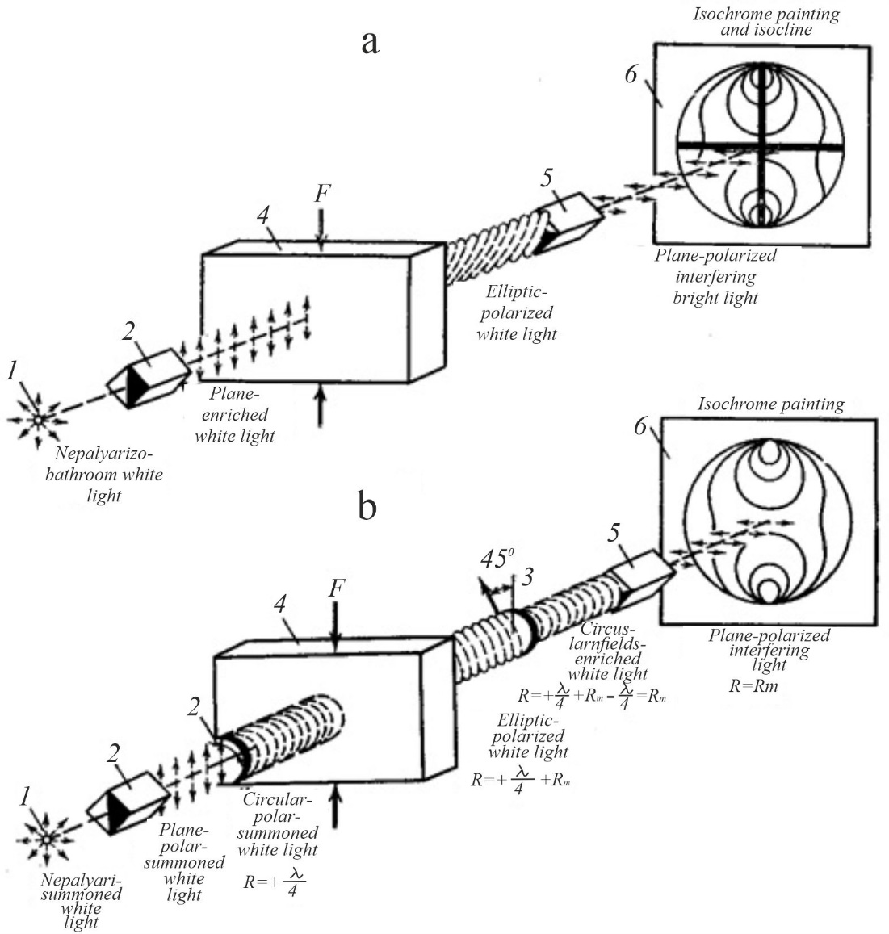
FIGURE 1. Optical polarization schemes for checking the stress state of transparent models: Conditional designations a - for plane polarization of light; b - for circular polarization of light;. 1 - light source; 2 - polarizer;
3 - quarter of the plate; 4 - model; 5 - analyzer; 6 - screen. F - forces acting on the model: R - path difference of the rays; Rm - path difference of rays arising in the model; λ - wavelength of light.

Under the influence of external forces, it is possible to track the kinematics of the model elements representing the faults of the Earth's crust, as well as the distribution of tectonic stresses and related deformation changes. These two main factors, as well as the results of experimental studies based on them, became the basis for studying the current geodynamic situation of the Dehkanabad Depression.
The optical method of investigating stresses in models - studying the patterns of stress distribution in deformable areas of the Earth's crust and their models - is of great importance for understanding the mechanism of fold formation and the patterns of fault development. However, the distribution of stresses during the tectonic modeling of the studied territory has not been previously studied.
The best way to study stresses in models is based on recording changes in the physical properties of model substances under the influence of stresses [26; 16-20]. The simplest and most visual method is the optical method.
To develop the optical method for studying tectonic stresses in models, numerous studies have been conducted by scientists from England (D. Breuser, C. Maxwell, L. Faillon, E. Cocker), France (M. Levi, M. Menaje), Russia (V.L. Kirpichev, A.K. Zaitsev, D.E. Prokofieva-Mikhailovskaya), and America (M.P. Frocht). Academician F.Yu. Levinson-Lessing and A.N. Dinnik were the first to apply the optical method to study the distribution of stresses in mine workings models.
In tectonics, the study of the stress state of models using the optical method began in 1953 by M.V. Gzovsky. As a result of research by D.N. Osokina and M.V. Gzovskaya, a plastic optically active material that meets the requirements of elasticity and elasticity modules in modeling tectonic processes was developed for the first time.
This material is ethylcellulose in benzyl alcohol with dibutyl phthalate (30-35%). During their joint work, other plastic materials with high optical activity were also created.[25]
Special studies were conducted to determine the optical and mechanical properties of the gelatin-glycerin mixture (Figure 1).
The physical basis of the method and the methodology of optical modeling were developed by M.V. Gzovsky [3; 94-97 p.] consists of the following: a transparent flat model made of equivalent material under the influence of deformation is illuminated by polarized light in a device similar to a petrographic microscope, but with a working diameter from 10 cm to 40 cm (Fig. 1).
The model is made of optically sensitive material. In the absence of tangential stresses in such materials, the indicator n (which shows how many times the speed of light υ in the cavity s is less than the speed of light in this material) will be the same in all directions. If tangential stress acts on such a material, then artificial (or temporary) birefringence occurs. It depends on the propagation and position of light and, accordingly, on the direction of light propagation and the position of the surface in which the oscillation of the electric vector occurs, i.e., the surface.[26]
In the case of optical anisotropy of the model, the plane-polarized light oscillation, falling on a particular point of the model, splits into two rays, two mutually perpendicular components, the refractive indices of which oscillate in the direction of the main axes of the ellipsoid lying on the surface of the model.
These two rays propagate in the model with velocities υ1 = s/n1 i υ2 = s/n2 = s/n2, where n1 and n2 are the main refractive indices at this point of the model. Passing through a model of thickness d, these rays have a difference in passage, where n is the refractive index of the double ray.

R=(N₁-N₂) d = nd, (1)

The analyzer transmits only the component of the oscillations of both rays that is parallel to its polarization surface, and depending on the difference in transitions (or phase difference), interference between them either intensifies or weakens each other [28].
In the model image, colored stripes appear on the screen corresponding to model sections equal to n1-n2 or R. These paths are called isochromes. Additionally, this image shows dark stripes belonging to the model sections, one of which is one of the light polarization surfaces falling on the model. These lines are called isoclines.
When the cross-polarizer and analyzer rotate, the isochromes remain unchanged, and the isoclines change their position in space. In addition to the isoclines, there are other black areas that retain their position when the polarizer and analyzer rotate. They correspond to the parts of the model where optical anisotropy is absent (n1=n2). This occurs either due to the absence of tension or only due to the presence of a comprehensive attraction or compression. Such areas are called isotropic.
If for a given material the relationship between the magnitude of the double refraction n=n1-n2 and the magnitude of the tangential stress τmak= (σ1 - σ2) /2 is known, then it is possible to determine the magnitude of the stress τmak acting on the surface of the model, arising in different sections of the double refraction model [29,30].
Modeled sections of the Earth's crust, undergoing more or less simple deformation, usually vary from several to tens of kilometers. In rare cases, they decrease to several meters or rise hundreds of kilometers. Therefore, for models, the geometric similarity coefficient C 1 should often be taken from 1:10,000 to 1:100,000, less often 1:1,000,000. According to the similarity conditions of the models, it is sufficient to indicate the necessary values of all properties of the mechanical properties of the materials from which they should be made. Using the term introduced by G.N. Kuznetsov, we call these materials equivalent. (Fig. 2).
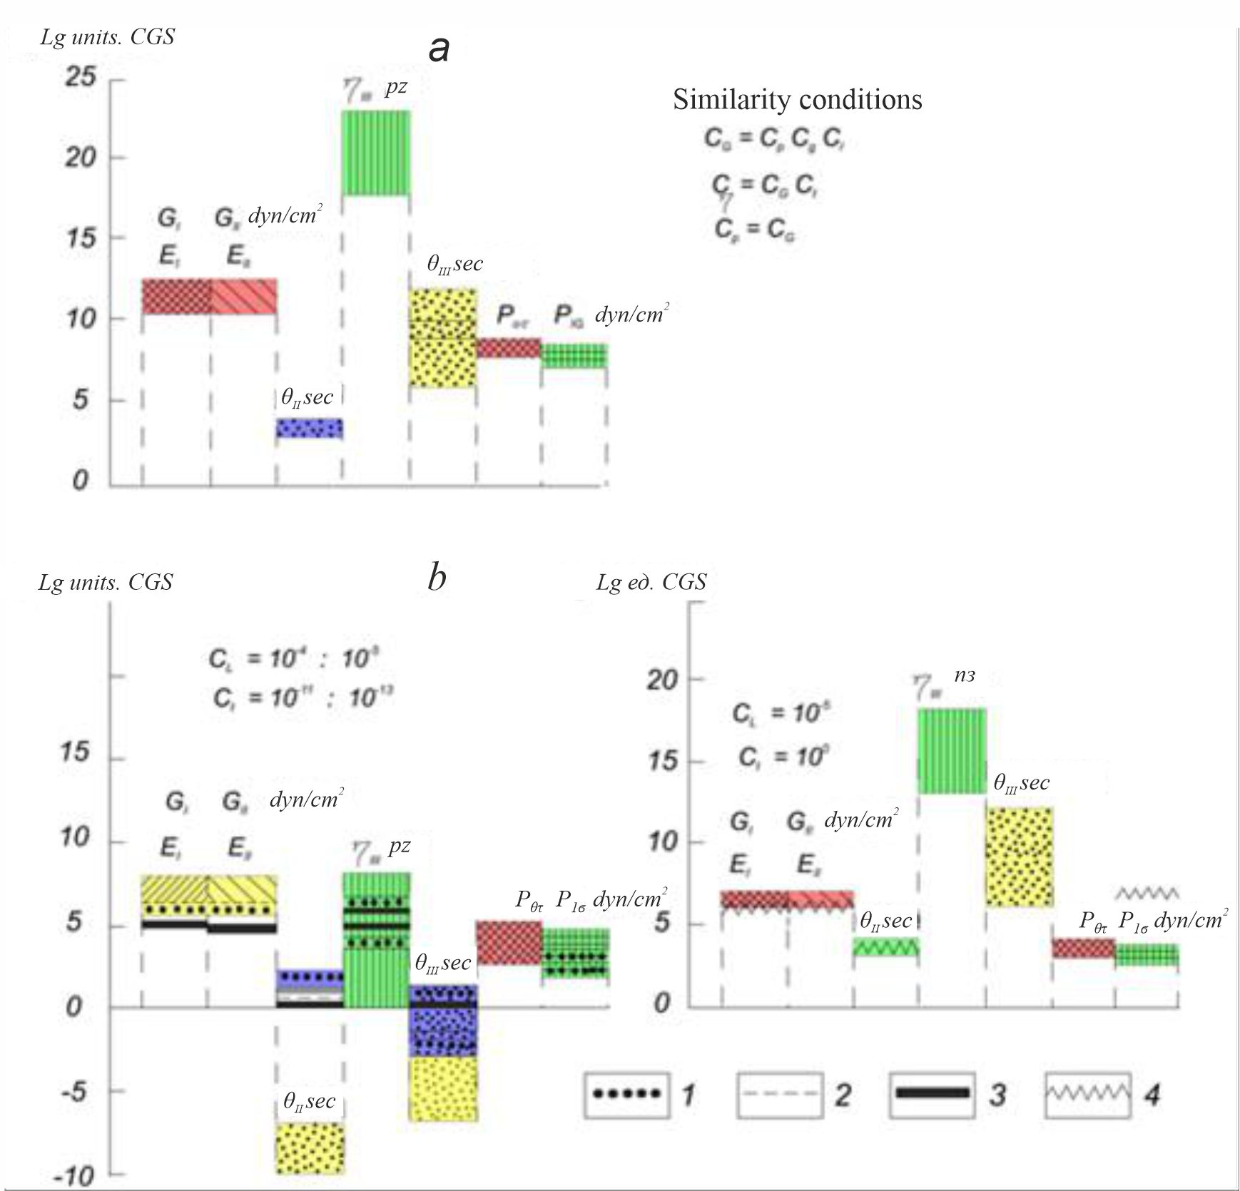
FIGURE 2. Diagram of the mechanical properties of rocks (a) and equivalent materials for modeling tectonic phenomena (b). 1 - clays (moisture content 43%); 2 - Baku Petrolatum; 3 - a solution of ethylcellulose acid (30%) in benzyl alcohol at a temperature of 200; 4 - gelatin (25%) at 200°C. Determines the linear properties of rocks determined in laboratories; for equivalent materials - is a theoretically required property.

For practical application of the relationship between two fractures and stresses, there are convenient methods that are linear and time-independent. However, determining stresses by birefringence is a more complex task.[24]
For each equivalent material used in the models, a dynamometric-optical table was compiled, allowing for a transition from birefringence indicators to relative and absolute values of shear stresses (Fig. 3).
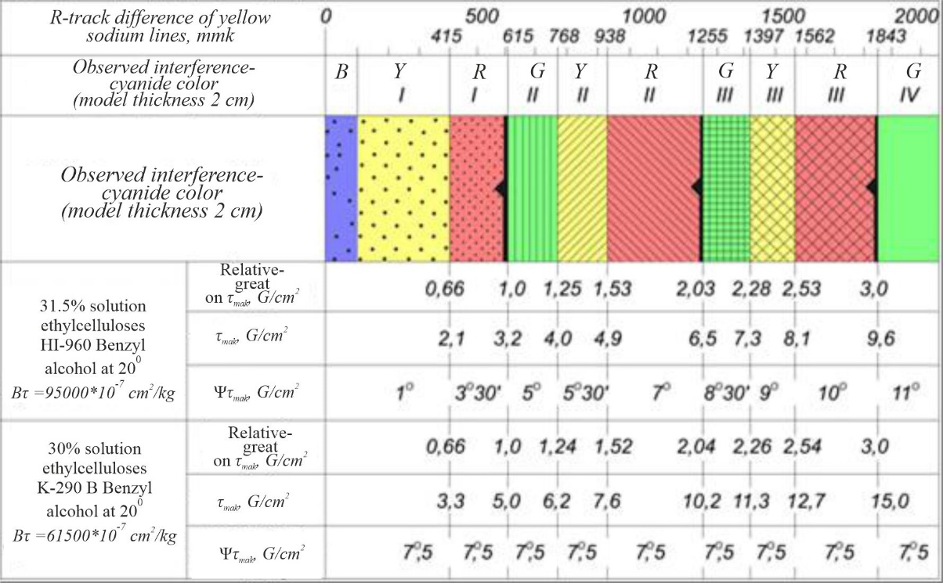
FIGURE 3. M.V. Gzovsky, D.N. Osokina and I.M. Kuznetsova. A dynamo-optical table has been developed. K - gray; J - yellow; Q - red; I am green.
RESULTS AND DISCUSSION
Reconstruction of the model of modern geodynamics of the Dehkanabad Depression was carried out in two variants: in the first variant, V.G. Trifonov's data on the modern movements of lithospheric plates as a result of geological studies were taken into account; in the second variant, G.S. Abdullayev and F.G. Dolgopolov based on the results of geodynamic, external tectonic forces, and oil and gas research of the Republic of Uzbekistan were used [22].
The reconstruction of depression geodynamics under the influence of external tectonic forces, the description of the mechanism of tectonic structure development, is based on the physical modeling of tectonic processes occurring in the Earth's crust, with the main attention paid to the stresses of depression, deformation, and activity of fault and block structures [6; P. 33-35, 7; P. 242-245, 18]. (Fig. 4).
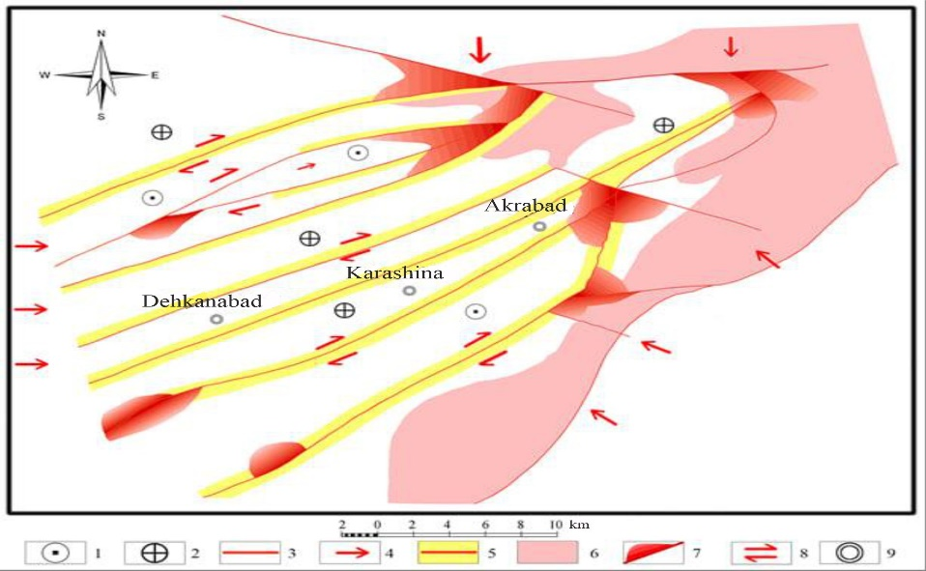 | FIGURE 4. Model of modern geodynamics of the Dehkanabad Depression.  Variant 1. (Direction of external forces based on G.V. Trifonovs materials) B.Z. Ziyomov 2019 Conditional Notations. 1 - rise,  2 - depression, 3 - faults,  4 - shift of blocks, 5 - zones of differentiation of tangential stresses, 6 - Paleozoic outcrops,  7 - zones of maximum manifestation of tangential stresses associated with sections of bending, intersecting and conjugate faults, 8 - shift,  9 - settlements.

In the first variant of the model of modern geodynamics of the Dehkanabad depression (Fig. 4), external forces act on the depression, leading to displacement from the southeast from the Indian Plate (Himalayan); from the north - the Kazakh Microplate; from the west - the western region of Central Asia from the west to the east. Currently, the external tectonic forces coming from the south-east (Indian plate), according to researchers, and their data on the displacement of the Earth's plate have had a very strong influence on the region we are studying.
Recent external tectonic forces that caused the displacement and compression of the depression were identified during the analysis of data from space studies of modern tectonic movements of the Earth's lithosphere. Analyzing these data, V.G. Trifonov notes the following: the horizontal displacement of tectonic plates occurs with different speeds and directions.[26]
According to him, these differences are manifested in the tectonic lithosphere under the granite-metasomatic layer before the continents [13; 145-161-b.] most of the modern deformations in the collisional belts at the boundaries of oceans and continents and in the absorption of the lithosphere extend to vast distances from the boundary of the plates, forming a complex scheme of directions and velocities of horizontal shifts. V.G. Trifonov's definition explains the emergence of modern external tectonic forces (causing the shift of the western part of Central Asia eastward) affecting the territory of Central Asia, including the territory of the Dehkanabad Depression from west to east. It is known that the Dehkanabad and Beshkent depressions are intersected from the west by deep faults, and from the east and southwest by the Hissar orogenic faults.
The axis of the Dehkanabad depression with parallel fault structures (uplift faults, landslides) is directed northeast, in the south they extend beyond Uzbekistan, and in the north they rest on the orogenic structures of the Southern Tien Shan.
The influence of external tectonic forces on the Dehkanabad depression from the south-east, from the Indian plate, is characterized by the fact that the direction of external forces is perpendicular to the directions of the north-eastern fault system.
In this case, when the structure is subjected to compression directed perpendicular to its direction, the Earth's fault zone becomes denser and its thickness decreases. Displacement of the fault along the horizontal surface does not occur. Depending on the angle of incidence of the faults, vertical movement occurs with the formation of small-sized folded structures resting on one edge of the fault structure. In the fault zone, especially at bends and turns, a concentration of compressive tangential stresses occurs.[27]
The Dehkanabad depression is influenced by tectonic forces directed from the west along the latitude and shifting it at an angle of 400-450 relative to the fault faults. According to experimental data on modeling the structures of a section of the Earth's crust, when external forces act on the rupture destruction at angles of 400-450 degrees, a maximum type of activity is observed due to displacement, lifting rupture, or their combination [2; 56-61]. In the studied territory, it is necessary to note the tectonic activity of external forces acting from the western side and rupture structures in the form of clockwise shifts. According to tectonic studies, most fault disruptions in the Dehkanabad Depression relate to faults. The intensity of tectonic activity manifestation in the Dehkanabad depression structures depends not only on the external forces acting on them but also on their morphology and internal structure.
Data on the morphology and structure of the rupture structures of the Dehkanabad Depression are absent. The schemes of the geological and structural structure of the depression and faults in individual oil and gas areas have a linear morphology.
Large fault structures of northeastern strike are divided into blocks that determine the type of stepped structure in the depression zone.
Sh.D. Davlyatov, F.Kh. Zunnunov, B.B. Tal-Virskiy, G.S. Abdullayev, F.G. Dolgopolov consider these structures to be signs of the Paleozoic foundation. Their activity is synchronous with the activity of the foundational structures, i.e., external forces of a planetary scale act on all spheres of the lithosphere of Central Asia with the same force of direction, including the Dehkanabad Depression.
The activity of foundation structures determines the concentration of tectonic stresses in the zones of morphologically altered bends. It is believed that the predominance of tangential stresses over internal stresses in these zones can lead to earthquakes.
I.V. Ulomov, K.N. Abdullabekov, T.U. Artikov, R.S. Ibragimov and others believe that the Dehkanabad Depression is a tectonically active zone, and the rupture breaches penetrating deep into the Paleozoic foundation also confirm its seismic hazard, indicating the need to develop the infrastructure of the Southwestern Tien Shan [8; P. 129-131, 5; 79-80-p.], which is an important element in the seismic zoning of the platform part of the territory and earthquake prediction. A characteristic feature is the unevenness of the stress state and deformation in the space before the fracture, their sharp difference.
Tension and deformation intensify in areas with altered fracture morphology, and the dynamics of the structure are weakly expressed. In linear fault sections, on the contrary, their dynamics are high, and the stress and deformation are slowed due to the energy expenditure of external forces on displacement.
The second version of the model (Fig. 5). G.S. Abdullayev and F.G. Dolgopolov [1; P. 64-84]. The lithosphere of Central Asia is subject to the influence of three-sided external tectonic forces. Dynamic forces acting from the south-east (passing through the Surkhandarya megasyncline) exert a perpendicular influence on the fault faults in the eastern part of the Dehkanabad depression, leading to the maximum compaction of their zones.[30]
In such a tectonic-geodynamic situation, these structures are very passive in the area of horizontal movements and, conversely, active in vertical displacements (uplift displacements, landslides). The migration and energy of dynamic forces weaken as they penetrate the depression, as there are natural obstacles in their path of movement.

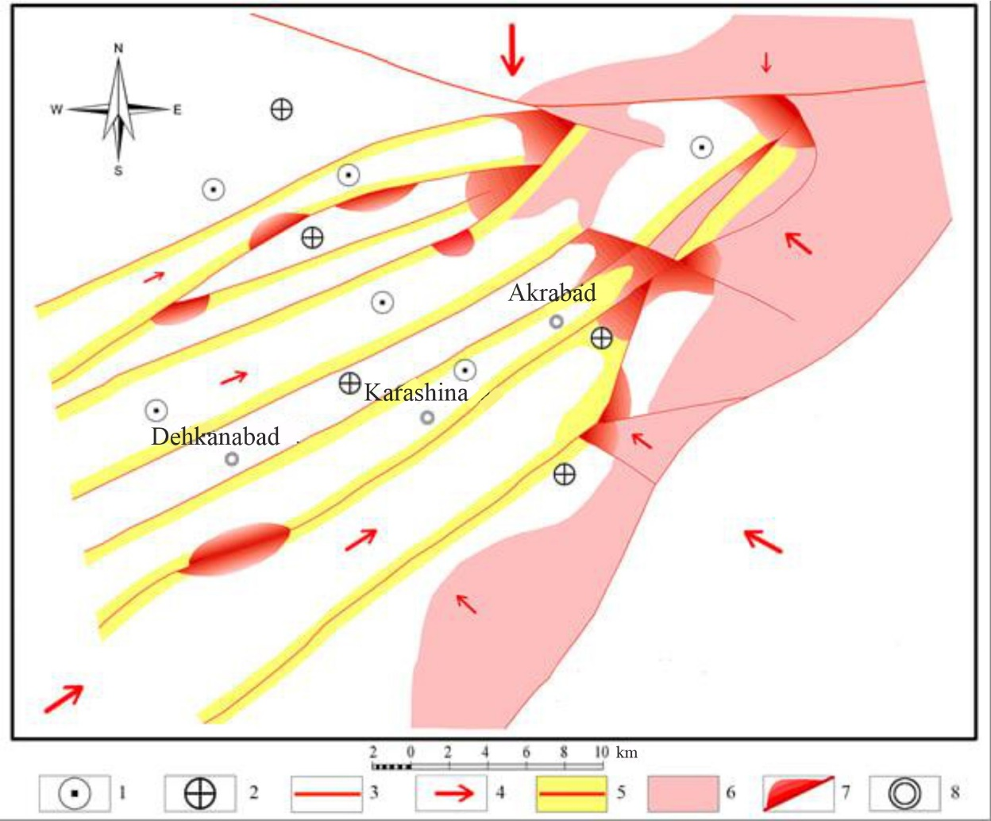
FIGURE 5. Model of modern geodynamics of the Dehkanabad Depression.
Variant 2. (Direction of external forces, based on materials by G.S. Abdullaev and F.G. Dolgopolov)
B.Z. Ziyomov 2019 Conditional Notations. 1 - rise, 2 - depression, 3 - faults, 4 - block displacement,
5 - tangential stress differentiation zones, 6 - Paleozoic outcrops, 7 - zones of maximum tangential stress manifestation associated with sections of bending, intersecting, and conjugate faults, 8 - settlements.

The passage of each of them is accompanied by a decrease in the energy of dynamic forces and a weakening of migration properties. Therefore, the northeastern faults in the eastern part of the depression are tectonically tense, and local zones of deformation or tension changes are observed in their surrounding zones. Upward-breaking-displacement movements cause vertical movement of tectonic blocks. Here, the boundaries of the blocks are the northeastern structures. Vertical displacement of blocks forms positive and negative relief shapes.
In the western part of the Dehkanabad depression, another dynamic situation has formed, where external geodynamic forces act in a northeastern direction, in the direction of the main fault faults. Under these tectonic-dynamic conditions, the dynamics of northeastern faults are characterized by vertical movements in individual sections and the manifestation of insignificant local activity in the horizontal direction. Local stretching deformation and local compression deformation are observed in these areas.
Local horizontal movements are caused by the morphological features of faults (deviation, bending, conjugation). In these areas, the opening or closing of cracks is observed. In the first case, complete neutralization of tangential stresses is observed, in the second - their high concentration [4; P. 73-75, 9; P. 32-36, 14; P. 24-26]. The migration of external dynamic forces in the northeastern direction occurs mainly in the northeastern zones of faults, as well as in the interfacial zones. At the same time, the tectonic stresses are distributed unevenly, concentrating in contrast in the fault zone and in the areas where the north-eastern structures converge with the Southwest Tian Shan deep fault.
Thus, as in the first model of modern geodynamics of the Dehkanabad Depression, in the second model, the main fault faults of the north-eastern strike are in the active phase of tectonic-dynamic development. The geodynamic situation across the entire territory of the Dehkanabad depression manifests itself unevenly. Structures located east of the Dehkanabad depression axis are characterized by compression-related dynamics. As a result, the Earth's fault zone compresses, its thickness decreases with increasing density, and their permeability decreases synchronously. The geodynamics of these structures is characterized by elevated-tearing processes, with virtually no horizontal movement. Increasing the concentration of stresses and deformations is characteristic of the fractured space along its entire length. The geodynamics of the territory west of the Dehkanabad depression axis differs from the eastern one.
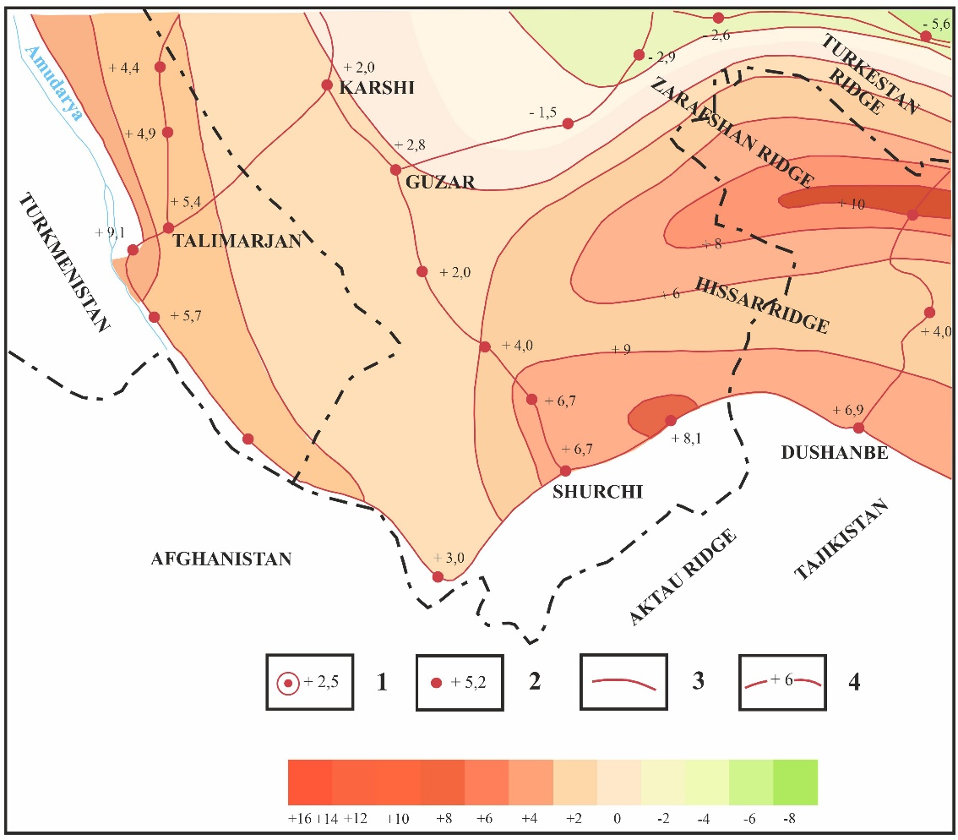
FIGURE 6. A fragment of the modern map of vertical movements of the Earth's crust in the territory of Uzbekistan. (Compilers: D.A. Toshxodjayev, K.N. Kiktev, R.A. Yarmukhamedov, 1995). Symbols: 1) initial points and their velocity (mm/year). 2-speed of joint velocity values (mm/year). 3-long leveling networks. 4-vertical velocity isolines (mm/year).

All geological, tectonic, and geodynamic phenomena mainly depend on the direction and intensity of the dynamic forces acting on the depression. In one case (model's first variant), these forces act in a latitudinal direction from the west of the depression, and in the second (model's second variant), from the southwest. In both cases, tectonically, the structures of fault disruptions in the western depression zone are activated. The dynamics of faults, structures, and tectonic blocks, which are boundary elements, are mainly characterized by horizontal movement in a north-eastern direction, which depends on external dynamic forces relative to the direction of faults and blocks, as well as their morphology and structure. The morphological and internal structural features of faults influence the degree of concentration and deformation of tangential stresses through horizontal movements in their zones and in the faultside space. The migration of dynamic forces, their energy, occurs in the northeastern direction. They are concentrated along the Southwestern Tian Shan along the deep regional structure and along the junctions of openings of orogenic structures. Vertical movements along faults form new rupture structures with small peaks, with a small amplitude along the vertical. The axial part of the Dehkanabad depression is lowered compared to the western and eastern regions. According to data obtained by the Institute of Seismology of the Academy of Sciences of the Republic of Uzbekistan during the study of modern vertical movements of the Earth's crust in the territory of Uzbekistan [12] (a fragment of the map of modern vertical movements of the Earth's crust in the territory of Uzbekistan), this occurs against the background of an annual rise of the depression zone by 2-6 mm (Figure 3). All external forces acting on the territory of Central Asia and the Dehkanabad Depression and their dynamics are the result of the modern movement of lithospheric tectonic plates.
CONCLUSION
Therefore, the tectonic-geodynamic features of external forces acting on the Mezozoic-Cenozoic complex of geological formations of the Dehkanabad Depression are also characteristic of other tectonospheres located below the Mesozoic-Cenozoic deposits. The tectonogeodynamic processes occurring on Earth under the influence of external forces are reflected to a certain extent in the modern geodynamics of the Dehkanabad Depression. One of the reasons for this phenomenon is that the Dehkanabad Depression is a sign of Paleozoic foundation structures.
REFERENCES
- G. S. Abdullaev and F. G. Dolgopolov, Geodynamics and Oil and Gas Content of the Lithosphere of Uzbekistan (Uz NIO NGP, Tashkent, 2016), 362 p.
- T. U. Artykov, R. S. Ibragimov, T. L. Ibragimova, and M. A. Mirzaev, “Some patterns of manifestation of seismic impacts during strong earthquakes of the Central Asian region,” Geology and Mineral Resources, No. 5, 56–61 (2019).
- M. V. Gzovsky, Fundamentals of Tectonophysics (Nauka, Moscow, 1975), 536 p.
- B. Z. Ziyomov, “Influence of external tectonic forces on the modern geodynamics of the depressions of the platform regions of the Southern Tien Shan (on the example of the Dehkanabad depression),” Geology and Mineral Resources, 73–75 (2021).
- B. Z. Ziyomov, “Seismotectonic methods for assessing seismic hazard,” in Proceedings of the Republican Scientific and Practical Conference of Young Scientists “Science Development and Innovative Development of the Economy” (Tashkent, 2012), pp. 79–80.
- B. Z. Ziyomov and M. K. Turapov, “On the question of modern geodynamics of platform regions of the Central Asian folded belt (on the example of the Dehkanabad depression),” Mountain Herald of Uzbekistan 2, 33–35 (2021).
- B. Z. Ziyomov, M. K. Turapov, and A. S. Khusomiddinov, “On the problem of studying the modern geodynamics of platform regions of Central Asia (on the example of the Dehkanabad Depression),” in Proceedings of the XIII International Conference of Young Scientists and Students (Tashkent, 2021), pp. 242–245.
- B. Z. Ziyomov and L. A. Hamidov, “Features of seismic-tectonic processes in the Boysun-Hissar zone of the Southwestern Tien Shan,” in Proceedings of the Annual International Conference of Young Scientists and Students “Modern Technology in Scientific Research” (Bishkek, 2013), pp. 129–131.
- B. Z. Ziyomov, A. S. Khusomiddinov, F. Kh. Sadirov, and Sh. B. Akhmedov, “On the problem of tectonics of the southwestern territory of the Hissar Mountains of Southern Uzbekistan,” Exploration and Protection of Subsoil, 32–36 (2021).
- L. I. Krasny, O. V. Petrov, and B. A. Blyuman, Planet Earth. Encyclopedic Guide. Tectonics and Geodynamics (VSEGEI Publishing House, St. Petersburg, 2004), 652 p.
- Yu. M. Pushcharovsky, Fundamental Problems of General Tectonics (Scientific World, Moscow, 2001), 520 p.
- D. A. Tashkhodzhaev, L. P. Yun, N. K. Kikteva, and A. R. Yarmukhamedov, Map of Horizontal Velocity Gradients of Modern Vertical Movements of the Earth’s Crust in Uzbekistan, Scale 1:2,500,000 (Tashkent, 1995).
- V. G. Trifonov, Late Quaternary Tectogenesis (Nauka, Moscow, 1983), 224 p.
- M. K. Turapov, B. Z. Ziyomov, A. S. Khusomiddinov, and M. T. Karimova, “The relationship between stress and deformation with the modern geodynamics of the Dehkanabad depression (Southwestern Tien Shan),” Exploration and Protection of Subsoil, 24–26 (2022).
- V. E. Khain, “Dynamics and evolution of the planet Earth—internal and external energy sources,” in Proceedings of the XLI Tectonic Conference “General and Regional Problems of Tectonics and Geodynamics”, Vol. 2 (GEOS, Moscow, 2008), pp. 388–393.
- V. E. Khain, Tectonics of Continents and Oceans (Scientific World, Moscow, 2001), 605 p.
- V. E. Khain and M. A. Goncharov, “Geodynamic cycles and geodynamic systems of different ranks: their relationship and evolution in the history of the Earth,” Geotectonics, 3–24 (2006).
- B. Z. Ziyomov, M. K. Turapov, Sh. R. Khalimova, and A. S. Khusomiddinov, “On the issue of modern geodynamics of platform areas of the Central Asian fold belt (on the example of the Dekhkanabad trough),” International Journal of Geology, Earth & Environmental Sciences 11, 59–64 (2021).
- A. A. Khalilov, Z. T. Akbarova, A. Z. Umarov, F. A. Zayniddinov, and I. M. Ruziev, “The method of searching for hidden uranium deposits of Kyzylkum based on integration of geophysical, geochemical and cosmogeological studies,” AIP Conference Proceedings 3256, 060031 (2025). https://doi.org/10.1063/5.0267271
- K. Khaliyorov, K. Khoshjanova, N. Atabaeva, G. Karamatova, I. Ruziev, and S. Nurjanov, “Distribution of copper in intermediate rocks of the Shaugaz–Kandyrsay interfluve (Eastern Almalyk),” E3S Web of Conferences 401, 01003 (2023). https://doi.org/10.1051/e3sconf/202340101003
- B. Ziyomov, A. Panchenko, E. Usmanaliyev, B. Mukhammadiyev, and I. Ruziev, “Strong earthquakes and their relation to active faults (Southern Uzbekistan),” AIP Conference Proceedings 3286, 060005 (2025). https://doi.org/10.1063/5.0281014
- J. Djumanov, A. Mirsoatov, E. Anorboev, F. Mamirov, B. Abdullaev, and I. Ruziev, “Navigating innovation: The experience of developing the HydroUz information and reference system,” E3S Web of Conferences 590, 07004 (2024). https://doi.org/10.1051/e3sconf/202459007004
- F. Gapparov, S. Yakhshiev, A. Khaydarov, S. Nortaev, and T. Apakhodjaeva, “Filtration flow gradients in dam bodies: Case study of Tudakul reservoir,” AIP Conference Proceedings 3256, 020056 (2025). https://doi.org/10.1063/5.0267150
- F. Gapparov, G. Mushtariybonu, and S. Yakhshiev, “Studies of water flow adjustment in mountain small river basins,” AIP Conference Proceedings 3256, 020053 (2025). https://doi.org/10.1063/5.0267149
- F. Gapparov, A. Khaydarov, Z. Raimbekova, U. Uzbekov, M. Gafforova, and S. Yakhshiyev, “Assessment of aggressiveness of some indicators of chemical elements on reservoir water quality,” AIP Conference Proceedings 3286, 040007 (2025). https://doi.org/10.1063/5.0280078
- F. Gapparov, D. Abduraimova, A. Khaydarov, D. Atakulov, M. Gafforova, and S. Yakhshiev, “Assessment of changes in vegetation cover of reservoir banks using GIS technologies,” BIO Web of Conferences 141, 03020 (2024). https://doi.org/10.1051/bioconf/202414103020
- A. Tukhtasinov, D. Khusanbayev, D. Atabayev, N. Abdullaev, and I. Ruziev, “Forecast of provisional earthquake fields in the territory of Uzbekistan,” AIP Conference Proceedings 3256, 030006 (2025). https://doi.org/10.1063/5.0266995
- I. Ruziev, L. Samiev, D. Mustafoyeva, S. Nortaev, and S. Yakhshiev, “Geographic information system for changing the level of soil salinity in Jizzakh province, Uzbekistan,” E3S Web of Conferences 371, 01013 (2023). https://doi.org/10.1051/e3sconf/202337101013
- A. Umarov, A. Shukurov, A. Djurabayev, M. Ruziev, I. Ruziev, and S. Nurjanov, “Minerals of bismuth and antimony in original deposits of the Zarmitan gold zone, Uzbekistan,” E3S Web of Conferences 401, 01002 (2023). https://doi.org/10.1051/e3sconf/202340101002

