Issues of prospectivity of jurassic deposits in the territory of Ustyurt
Akmal Аbzalov¹, Isomiddin Togaev², Fazliddin Zayniddinov^{2, a)}, Ma’rufjon Alimov², Ilkhom Ruziyev³
¹ Tashkent State Technical University named after Islam Karimov, Tashkent. Uzbekistan
² National University of Uzbekistan named after Mirzo Ulugbek, Tashkent, Uzbekistan
³ “Tashkent Institute of Irrigation and Agricultural Mechanization Engineers” National Research university, Tashkent, Uzbekistan
^{a)} Corresponding author: zayniddinovfazliddin93@gmail.com
Abstract. Taking into account new data on the geological structure of oil and gas bearing complexes and those with hydrocarbon potential, this article presents the results of constructing structural maps. These maps formed the basis for developing a three-dimensional geological model of the Shege field. The model was created by identifying and tracing tectonic disturbances, as well as zones of local uplifts and subsidence that control the formation of oil and gas shows and hydrocarbon accumulations in Jurassic deposits.

INTRODUCTION
Currently, the development of the oil and gas industry is accompanied by an expansion of exploration activities, which is associated with the active implementation of new methodological approaches to searching for hydrocarbon deposits in unconventional local objects confined to the productive horizons of the sedimentary cover. In this context, one of the priority tasks within the Ustyurt oil and gas region is to study the patterns of horizontal block displacements that are accompanied by the formation of fault-block local structures promising for oil and gas [1-4].
In global practice, special attention is given to the study of structural plans, rock composition, shear faults, zones of increased fracturing, and other geodynamic factors. To address these tasks, various methods are employed, including numerical modeling of horizontal mechanical stresses using data from deep well drilling and geophysical observations, as well as examining the geodynamic patterns of horizontal displacements of individual territorial blocks.
Furthermore, research is conducted to substantiate the role of the Mesozoic geodynamic regime in the formation of structural plans of Jurassic deposits and lower horizons of the sedimentary cover, as well as the characteristics of oil and gas formation development, which represents a relevant scientific and practical problem [2-5]
MATERIALS AND METHODS
Geological structure of the Jurassic complex. In the southern part of the Sudoche depression, within the Takhtakair swell, the Shege gas field has been discovered, with deposits confined to terrigenous reservoirs of Upper and Middle Jurassic age.
Analysis of previous studies has shown that the Upper and Middle Jurassic complex deposits have not been sufficiently investigated. At the same time, seismic exploration and deep drilling data indicate the potential for oil and gas in the Lower Jurassic deposits. It should be noted that this part of the Ustyurt region remains poorly studied.
In the sedimentary cover of the territory, Mesozoic-Cenozoic deposits have been penetrated by wells in the Berdakh, Shagyrlyk, Takhtakair, and Arka-Kungrad areas. A regional pattern has been established: in the southern direction, there is an uplift of boundaries and a decrease in the thickness of the supra-Jurassic strata, while the thickness of the Jurassic rocks does not change significantly. At the Shege field, the Jurassic deposits are productive.
Lower Jurassic Series – (J₁). The Lower Jurassic section at the Shege deposit contains Toarcian deposits. The Toarcian strata are composed predominantly of sandstones with interlayers of siltstones and mudstones. Lithologically, these are gray, medium to fine-grained sandstones with grains of coarse sand fraction and gravel, polymictic with mixed pore-lining cement, containing inclusions of carbonized plant detritus.
Middle Jurassic Series - (J₂). Middle Jurassic deposits are widespread within the studied field. Lithologically, these sediments are represented by a terrigenous sequence of interbedded gray-colored sandy-silty-clayey rocks of alluvial and lacustrine-palustrine continental genesis, gradually transitioning into shallow marine deposits.
Upper Jury Department - (J₃). Upper Jurassic deposits, conformably overlying the Middle Jurassic rocks, are represented by the Callovian-Oxfordian and, most likely, Tithonian stages. The Callovian-Oxfordian deposits are predominantly clays with interbedded siltstones and sandstones, accumulated in shallow marine conditions. The clays are gray, greenish-gray, and brownish-brown in the upper part of the section. They are silty, dense, finely dispersed, with rare carbonized plant remains, on which pyrite pseudomorphs develop. Iron hydroxides are widely present in the upper part of the section. The rock texture is horizontally layered.
Aleurolites are greenish-gray, clayey and sandy, dense, and strong. The sandstones are greenish-gray, fine to very fine-grained, often silty, dense, hard, massive, quartz-feldspar, with clay cement, containing rare grains of glauconite. Tithonian deposits lie on Callovian-Oxfordian deposits without visible angular unconformity, but with erosion. Regionally, these deposits are not consistent: in the south of the Sulochiy depression (Kungrad and Raushan areas), gray and greenish-gray, fine-crystalline, organogenic-detrital, very hard limestones with interlayers of calcareous sandstones have been discovered, while at the Shege deposit, the limestones are replaced by a sequence of gray calcareous fine-grained sandstones with high specific resistance [8-12].
In light of this, the features of the geological structure of the studied area have been clarified, based on the construction of a three-dimensional geological model of the Shege gas field. This was achieved by identifying and tracking submerged zones of local extension, which control gas occurrences and hydrocarbon deposits in the Jurassic sediments. The discovery and tracking of such zones will enable the identification of new gas and condensate deposits in the Mesozoic. The analysis was based on the entire complex of available geological and geophysical information: well data (core samples, well logs), 2D CDP seismic survey materials, VSP data, and a priori data (and interpretations) on geological cross-sections (Figures 1 and 2), main seismic horizons, and the nearest regional tectonic faults, which may have branches in the studied area [6,7].

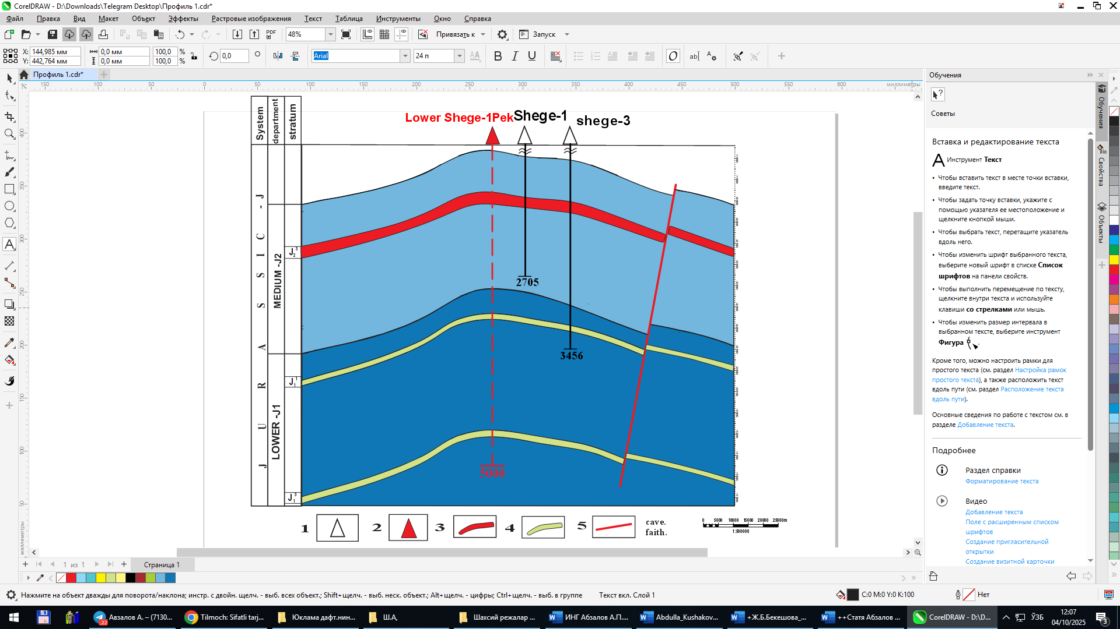
FIGURE 1. Geological profile along line I-I (Compiled by: A.P. Abzalov, 2023): 1-exploration well; 2-recommended well; 3-productive sand horizon; 4-potentially productive sand horizon; 5-tectonic faults

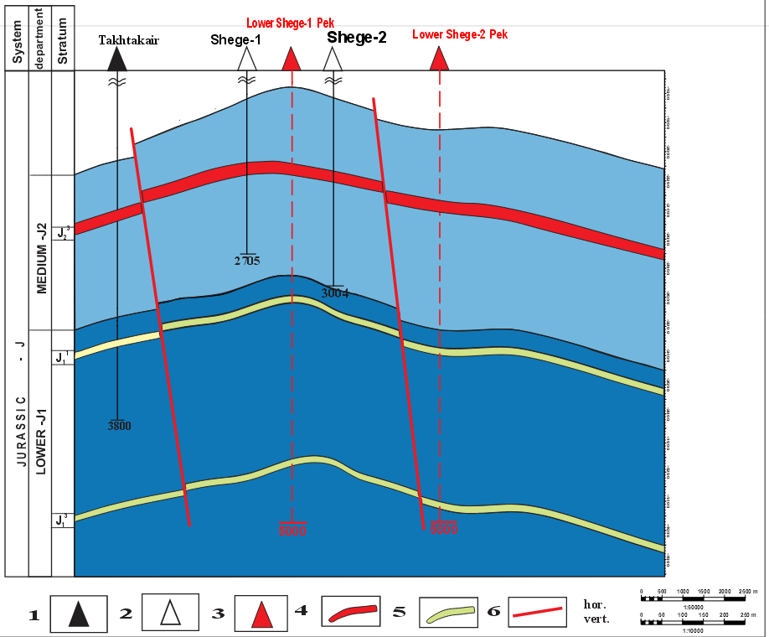
FIGURE 2. Geological cross-section along line II-II (Compiled by: A.P. Abzalov, 2023). 1 - parametric well;
2 - exploratory well; 3 - recommended well; 4 - productive sand horizon; 5 - potentially productive sand horizon;
6 - tectonic faults
RESULTS AND DISCUSSION
In the Ustyurt oil and gas region, numerous wells have currently penetrated Jurassic deposits. Some wells have reached the Jurassic layer, others have not penetrated the Middle Jurassic, while some have stopped within Middle Jurassic deposits. Given this situation, it is necessary to construct a new three-dimensional geological model for the search and exploration of reservoirs in Jurassic deposits, to identify new deposits in Jurassic formations without incurring costs for parametric drilling. For this purpose, a well drilled to a greater depth in the Jurassic deposits at the field under consideration is selected. Well logging diagrams, vertical seismic profiling (VSP) data, and stratigraphic breakdown are studied for this well. Productive basal sand horizons must be identified in the well logging diagrams [4].
A structural map is constructed based on the top of a specified true depth of basal sand horizons to refine the structure itself. To determine the true depth of productive basal sand horizons, the altitude of the studied well and the thickness of the identified productive horizon are subtracted from the depth values of the elevated productive horizons' top. The constructed structural maps allow us to observe the surface areas, directional azimuth, cross-section of tectonic disturbances, as well as the structural arrangement of the Lower Jurassic deposits in the Shege field. Based on the structural reconstructions, it can be concluded that the dome parts of all constructed structural maps converge with each other. This indicates that all structures (deposits) lie conformably (Figures 3 and 4).
To construct a three-dimensional model of Jurassic deposits promising for hydrocarbon exploration and prospecting in the Ustyurt region, a study of local zones controlling hydrocarbon accumulations in Jurassic deposits was conducted using the Shege field as an example. In the adjacent territory within the Berdakh swell, there are structures that have yielded hydrocarbon inflows from Middle Jurassic terrigenous deposits, which have been stratigraphically subdivided [2,3]: Shagyrlyk, Berdakh, East Berdakh, and Kuyi Sharkiy Berdakh [13-15]
Lower Jurassic deposits have also been studied in this area, but the stratigraphic correlation and exposure of their sections have not been fully completed. In recent years, 3D seismic surveys (by "Uzbekgeophysics" JSC) and scientific research (by "IGIRNIGM" State Institution) have been and are being conducted in the Ustyurt region. The work carried out indicates the presence of promising targets for oil and gas exploration in Jurassic deposits within the Berdakh and Takhtakair swells. An oil influx was observed during the drilling of well No. 1 East Muinak, while gas flows were obtained during the drilling of well No. 1 North Urga, and a weak gas influx was detected in well No. 1 Arka-Kungrad in Lower Jurassic deposits. Moynaq, and gas streams were obtained during the drilling of well No. 1 North. Urga and a weak gas inflow into the square [16-18]
To study local zones in the Jurassic deposits, structural mapping was carried out, and the effective thickness and top (Kuanysh and Berdakh) of basal sandstones in the Lower Jurassic deposits were analyzed (Figures 3 and 4). These maps were constructed based on the results of well logging surveys, 2D seismic data, and drilling information from the Shege field and the Takhtakair area.
.
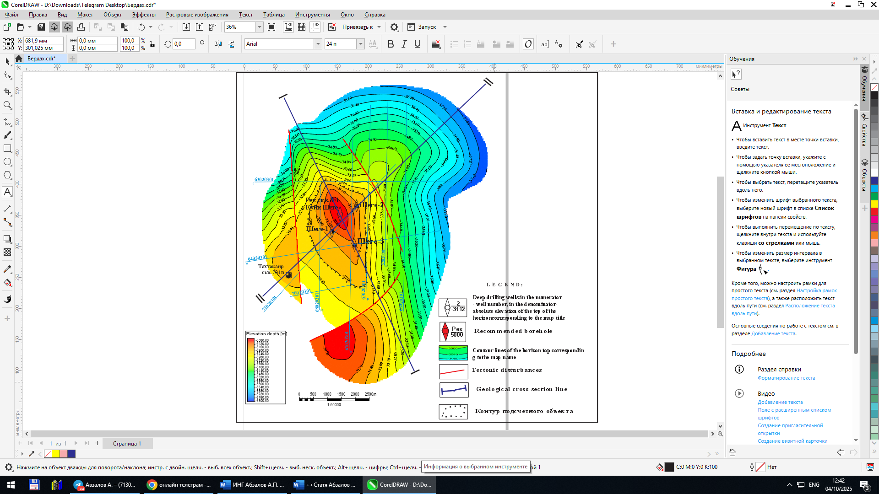
Contour of the counting object
FIGURE 3. Structural map of the top of the J₁¹ bed of the Lower Jurassic Shege field
(Compiled by: A.P. Abzalov, K.R. Galieva, 2022)

Analysis of the currently available geological and geophysical information indicates a block structure of the Jurassic complex in the Shege deposit. Four blocks are distinguished here. In constructing structural maps of the basal sandstone roof, it was established that the first block is located in the elevated northwestern part of the deposit, the second block is situated in the western part and is 140 meters lower than the first, while the third and fourth blocks are also located in the lower parts of the area under consideration, and are 120 and 100 meters lower than the first block, respectively. They are bounded by three deep faults. Here, the main role in the formation of structures belongs to faults, which limit and contribute to their placement at different hypsometric levels. These faults represent fracture zones and serve as conduits for fluid inflow from depth.

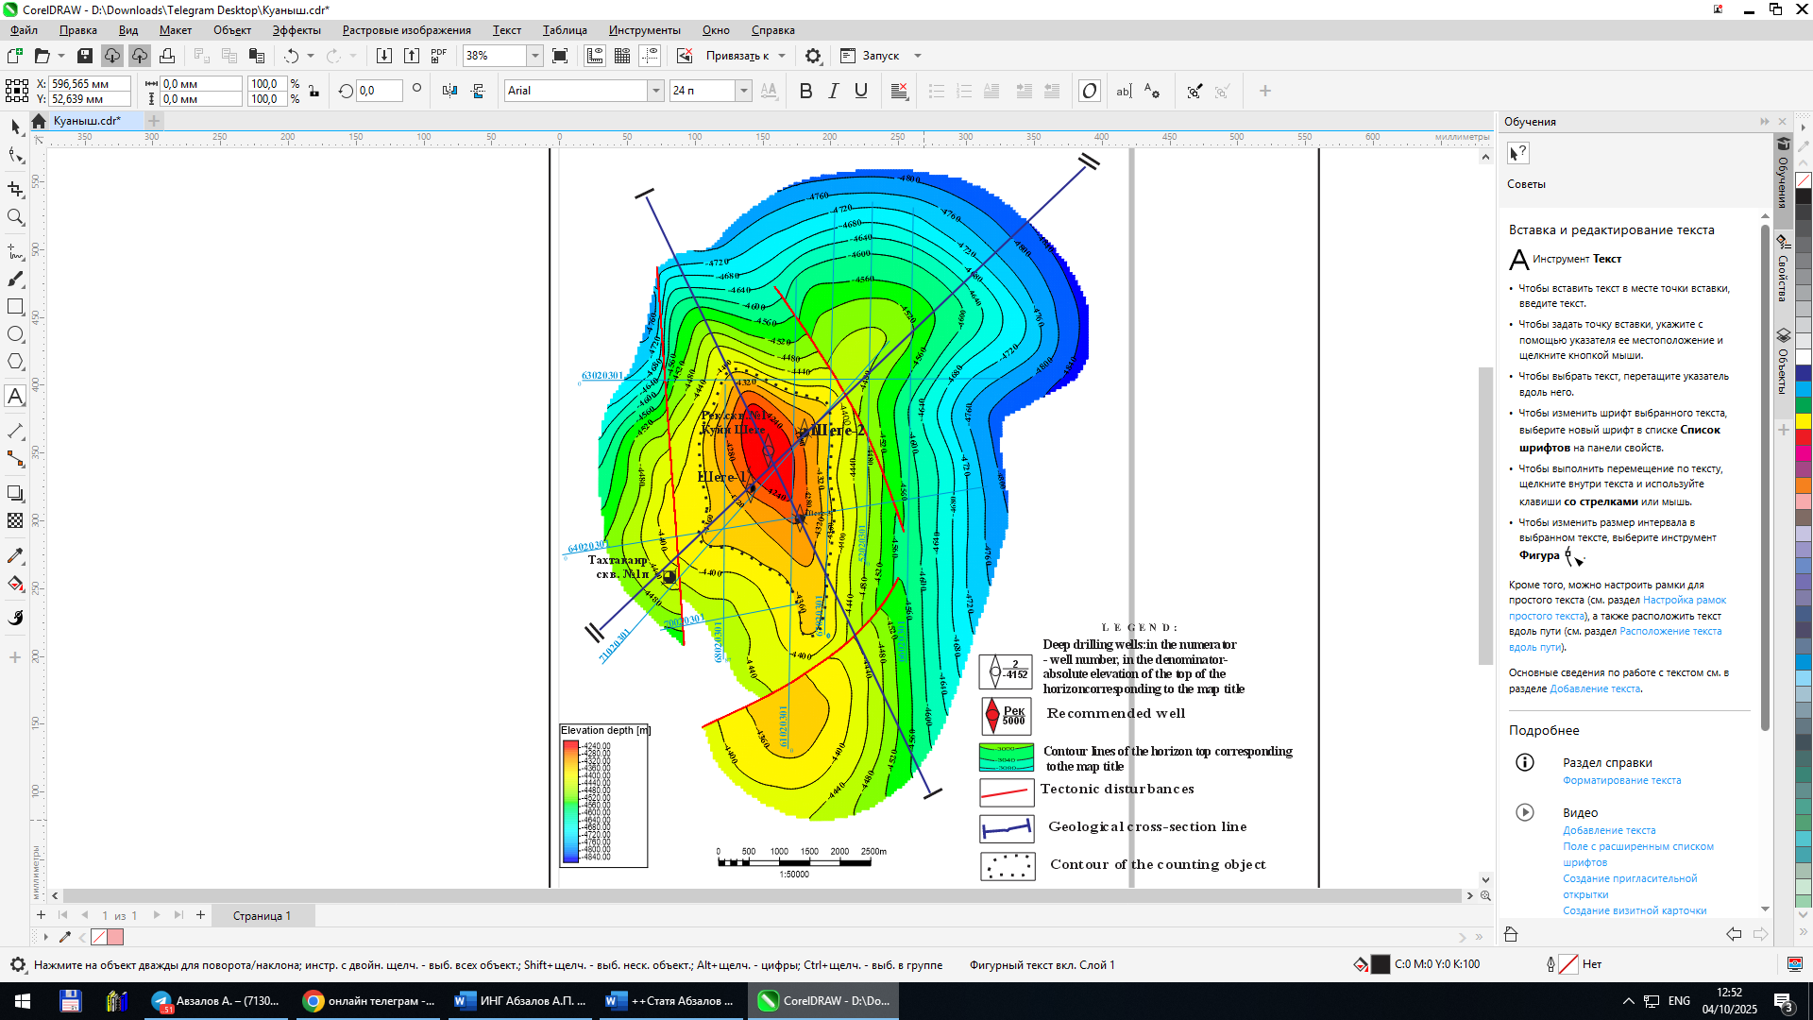
FIGURE 4. Structural map of the top of the J₁³ bed of the Lower Jurassic Shege field
(Compiled by: A.P. Abzalov, K.R. Galiyeva, 2023)

Thus, the study of data from the Shege field and 2D CDP seismic survey materials allows us to conclude that there are Jurassic surface uplifts near this field. Sand horizons associated with Lower Jurassic deposits have been discovered. These sandy horizons border a submerged zone of local extension, which controls small hydrocarbon accumulations in the Jurassic deposits of the Shege field (Lower Jurassic). The Takhtakair area represents flank and periclinal sections and is defined as a structure in Jurassic deposits formed above Paleozoic uplifts [14-16]
Based on structural construction materials, a three-dimensional digital structural model of the Shege deposit was developed (Figure 5). This three-dimensional model reflects the movements and positions of tectonic faults, the total thickness of Lower Jurassic deposits, and the thickness of the identified basal sandstone horizons (Berdakh and Kuanysh). The three-dimensional geological model enables us to conclude that the Shege deposit has a block structure, and visually demonstrates which blocks have subsided and which areas have been uplifted. This allows for the creation of a new geological and geodynamic model of the Shege deposit.
The constructed three-dimensional digital structural model of the Shege deposit provides a clear visual representation of the geological structure of the studied area, as well as enables decision-making regarding further plans for geological exploration work at the Shege deposit [17,18].

CONCLUSION
A three-dimensional model is proposed for locating promising oil and gas-bearing sandy horizons by identifying and tracking zones of local uplifts and subsidence that control the formation of oil and gas occurrences and hydrocarbon deposits in Lower Jurassic sediments.
When identifying sandy horizons and hydrocarbon deposits associated with basal sandstones, it should be noted that oil and gas-bearing formations are found in lenses of Jurassic sandstones with high porosity (12-15%) and good permeability (Berdakh, Kuanysh). These productive horizons are characterized by a complex morphological structure
In this regard, to identify and discover new deposits in Lower Jurassic formations without conducting costly parametric drilling, it is proposed to drill exploratory wells No. 1 and No. 2 in the Shege area (Lower Jurassic). The development of these horizons will enable the identification of gas and gas condensate deposits at the Shege field.
It is also recommended to conduct detailed 3D seismic surveys to refine the geological and geodynamic model. The results of these surveys will serve as the basis for planning further exploration activities in the Takhtakair swell area

REFERENCES
1.Abdullaev G.S., Iskandarov M.Kh., Ishnazarov R.I., Devyatov R.R. "Intensification of Geological Exploration for Hydrocarbon Deposits in Jurassic and Paleozoic Sediments of the Central Part of the Kuanysh-Koskalin Swell" Uzbekiston Neft va Gaz Zhurnali [Uzbekistan Oil and Gas Journal] - 2017. - No. 3. P. 20-25.
2. Abdullayev G.S., Yuldashev Zh.Yu., Iskandarov M.Kh., Khudayberganov B.I. Features of the geological structure and oil and gas potential of the Aral-Ustyurt region // VI International Scientific and Practical Conference. - Ufa, 2006. - pp. 238-241
3.Abdullaev G.S., Khayitov N.Sh., Sharafutdinova L.P. Jalilov G.G. Features of the structure of the Lower Permian deposits uncovered on the Satbai area by well No. 1 (Southern Ustyurt) // Oil and gas geology. Theory and practice.- St. Petersburg.-2017.- No.4. –p.1-15
4. Abidov A.A., Abdullaev G.S., Mirkamalov Kh.Kh., Yuldashev Zh.Yu., Iskandarov M.Kh., Khudayberganov B.I. On the problem of biostratigraphy of Jurassic deposits in the Aral-Ustyurt region // Journal of Oil and Gas of Uzbekistan. 2004. No. 4. P. 10-12
5. Iskandarov M.Kh. Fault-block model of the Shegin structure of the Takhta-Kair swell based on analysis and interpretation of seismic exploration and drilling data (Republic of Karakalpakstan) // Oil and Gas Geology, Theory and Practice. St. Petersburg - 2020. - No. 4. Volume 15. pp. 14-17
6. Tukhtaev K.M., Safarov Z.Kh., Yuldasheva M.G. Oil and Gas Prospects of the Ustyurt Region. // Proceedings of the Republican Scientific and Practical Conference "Modern Forecast of the Hydrocarbon Potential of Subsoil and Progressive Technologies for Oil and Gas Exploration." - Tashkent: JSC "IGIRNIGM," 2016. pp. 3-6
7.Тоgaev I.S., Nurkhodjaev A.K., Akmalov Sh. //Journal EЗS Web of Conferences. -2020.- V.2. - №63.- P.2-8. DOI: 10.1051/e3sconf/202016407027
8.Shoymurotov T, Togaev I, Akmalov Sh, Samiev L, Otakhonov M, Apakhodjaeva T. Patterns of Location and Conditions of Formation and Accumulations of Natural Bitumen and High-Viscosity Oils in Geology of Uzbekistan. // AIP Conference Proceedings, 2432, №030002 (2022). Conference Paper. https://doi.org/10.1063/5.0089882. (Scopus). P.-1-6
9.Sharafutdinova L, Jalilov G, Togaev I, Samiev L, Rakhimov T, Apakhodjaeva T. Stratigraphic, lithological and petrographic characteristics and oil and gas potential of the pre-Jurassic deposits of the Barsakelmessky trough and adjacent territories // IOP Publishing IOP Conf. Series: Earth and Environmental Science 1231 AEGIS-III-2023. 012076 doi:10.1088/1755-1315/1231/1/012076
10.Jalilov, G., Togaev, I., Alimov, M., Ibragimova, Z., Melikuziyev, S. Systematic composition of the middle Jurassic flora and its stratigraphic distribution (Ustyurt region, Uzbekistan) // E3S Web of Conferences 452, 01044 (2023). DOI: 10.1051/e3sconf/202345201044
11.Shoimurotov, T. Togaev, I. Akmalov, S. Akmalov Sh., Babajanov F., Melikuziyev, S. Оil- bitumum saturation Mesozoic and cenozoic deposits in central Asia // E3S Web of Conferences, DOI: 10.1051/e3sconf/202450807007
12.Djalilov G., Ratov B. and other Economic assessment of hydrocarbon resources and enhancement of the efficiency of geological exploration in the Ustyurt region // Naukovyi Visnyk Natsionalnoho Hirnychoho Universytetu. Article2025, DOI: 10.33271/nvngu/2025-4/005
13.Juliev, M., Jumaniyazov, I., Togaev, I., Usmanov, K., Saidova, M. Land degradation in Central Asia: a review of papers from the Scopus database published in English for the period of 2000-2020 // E3S Web of Conferences, 2023, 462, 03020 DOI: 10.1051/e3sconf/202346203020
14.Jalilov G.G., Wu T.T., Nguyen C.Z., Wu N.K., A new idea of the tectonic structure of the central and northern parts of Southern Ustyurt and their prospects for oil and gas potential // Uzbek Journal of Oil and Gas–Tashkent. 2012.– No. 3.– pp.39-43
15.Joltaev G.J. Geodynamic model and prospects of oil and gas potential of the Aral region (from the perspective of plate tectonics). // Geological structure and prospects of oil and gas potential of the Aral Sea. 4 International Geological Seminar. - Almaty, 1997. - pp.95-108.
16.Kirshin A.V., Abetov A.E., Plotnikov S.V. Dynamics of realization of genetic potential of productivity of organic matter of Upper Paleozoic rocks of Ustyurt /Oil and gas geology of Uzbekistan. Tr. JSC IGIRNIGM. 1998, issue 77, pp.22-33.
17.Sharafutdinova L.P., Jalilov G.G., Khayitov N.S. The main results of drilling of exploratory well No. 1 on the Jel area (Western Shakhpakhty, Ustyurt region, Uzbekistan) // Oilfield business. - Moscow. - 2010. – No. 12 – pp. 30-33
18. Shoimurotov T.Kh., & Eshonkulov K.I. (2023). Geological features and petroleum potential of the Jurassic terrigenous formation of the Chardzhou step. International Scientific-Online Conference, Turkey: Theory and Analytical Aspects of Recent Research, Part 12, February 9th, Collection of Scientific Works, Istanbul, 68-71.

