Mathematical modeling of inductive neutral growth processes in 6-35 kV distribution networks to increase the reliability of electricity supply to agro-industrial regions of the Republic of Uzbekistan
Amankeldi Ismailov ¹, Ulbosin Saparova ², Ayzada Djumabekova ^{2 a)}, Kundizay Joldasova ², Kuanish Serjanov ², Roza Dauletmuratova ²
¹Almaty Technological University, Almaty, Kazakhstan
² Nukus State Technical University, Nukus, Uzbekistan
^{a)} Corresponding author: ayzada673@gmail.com
Abstract. The work examines the issues of increasing the reliability of electricity supply to the agro-industrial regions of the Republic of Uzbekistan based on the implementation of inductive neutral grounding systems in 6-35 kV distribution networks. A mathematical model of transient processes in a single-phase ground fault has been developed, taking into account the network parameters, capacitive currents, and the inductive reactance of the arc suppression reactor. Based on the model, simulation modeling was performed in MATLAB with the construction of I_{OGROUND} currents (t) and neutral voltage UN (t) graphs in various modes. An interactive control panel (GUI) has been created, which provides visualization of results and optimization of parameters. Numerical data confirming the effectiveness of the chosen inductance in minimizing the closing current and overvoltages are presented.
INTRODUCTION
Modern 6-35 kV distribution networks in rural areas of the Republic of Uzbekistan are characterized by a large length of overhead lines, high capacity relative to the ground, and frequent single-phase short circuits.
The problem of stability and quality of electricity supply to agro-industrial consumers (pumping stations, farms, greenhouse complexes) requires the implementation of technologies that increase the network's resistance to short circuits and overvoltages.
Damage to distribution networks often leads to significant losses in production and disruptions in people's lives due to power outages. Therefore, to ensure a more reliable power supply to consumers, such networks typically operate in isolated neutral mode. [1]
The nature of the change in the overvoltage multiplicity depending on the magnitude of the capacitive ground fault current in 35 kV electrical networks, according to Petersen's theory, must be considered when designing such electrical networks. The expected maximum overvoltage value in the new network (determined by simple calculations) allows optimizing measures to ensure reliable insulation of electrical equipment at the design stage. [2]
One of the effective solutions is the inductive grounding of the neutral through an arc-extinguishing reactor (Petersen reactor). The correctly selected inductance allows for the compensation of capacitive closing currents and ensures self-extinction of the arc at the damaged point. However, for 6-35 kV networks with variable configuration and load, adaptive determination of reactor parameters and analysis of transient processes are required.
The works [2-10] present the results of theoretical and experimental studies, as well as the numerical modeling of the operating modes of 6-35 kV distribution electrical networks with single-phase grounding. These articles describe the processes of occurrence and flow of arc overvoltages during such damage in distribution networks, and also provide the probable values of the multiplicity of these overvoltages.

EXPERIMENTAL RESEARCH
Research objectives To develop a mathematical model and a computer system for analyzing and optimizing the processes of inductive neutral grounding, as well as to build an interactive control model using MATLAB.
Task setting
During single-phase grounding, a current flows through the inductance Lground and the network capacitance
CΣ:$i\left(t\right)=i_{L}\left(t\right)+i_{C}\left(t\right)$ (1)

Where $i_{L}=\frac{1}{Lground}\int{u\left(t\right)dt,}$ (2)

$i_{C}=C_{Σ}\frac{du(t)}{dt}$ (3)

For stable arc damping, the total current must be minimal:
$i_{033}=\frac{1}{3w^{2}C_{Σ}}$ (4)

$i_{o33}=i_{l}+i_{C}≈0$, (5)

which is performed at optimal inductance:
$L_{opt}=\frac{1}{3w^{2}C_{Σ}}$ (6)

The modeling task is to find the time dependencies i_O_{ground} and U_N (t) for various values of Lzaz, with known network parameters R_Σ,C_Σ,U_φ,ω
Mathematical model of the transient process
The transient process is described by a system of differential equations:

$\left\{\begin{aligned}\frac{dI}{dt}=\frac{U_{ϕ}-R_{Σ}I-U_{C}}{L_{заз}}, \\ \frac{dU_{C}}{dt}=\frac{I}{C_{Σ}} \end{aligned}\right.$ (7)
Initial conditions: I(0)=0, $U_{C}\left(0\right)=0$,
For the numerical solution, the Euler method is used:
$I_{k+1}=I_{k}+∆t∙\frac{U_{ϕ}-R_{Σ}I_{k}-{U_{C}}_{k}}{L_{заз}},$ (8)

${U_{C,}}_{k+1}={U_{C}}_{k}+∆t∙\frac{I}{C_{Σ}}$ (9)

Network parameters: $U_{f}=3.6 kB,$
f=50 Hz,
$R_{Σ}=$100, Omh
$C_{Σ}=2.5 mkF,$
$L_{opt}=0,43 Gn.$
Simulation modeling and digital visualization
The calculation is carried out in three modes:
1. Isolated neutral - L→∞;
2. Inductive neutral - L=L_{opt};
3. Overcompensated neutral - L=1.3L_{opt}
The integration step Δt=10⁻⁴s and modeling duration t_{max}=0.2 are used.
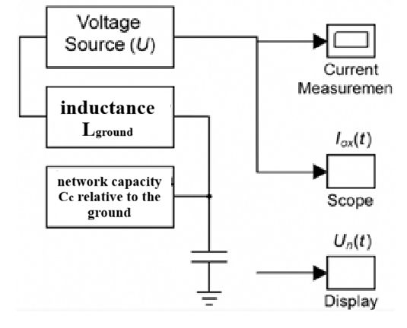
FIGURE 1. Structural diagram of the simulation model of the processes of inductive grounding of the neutral in MATLAB/Simulink

The model includes a phase voltage source, a network resistance and capacitance equivalent, a regulated arc-extinguishing reactor inductance, and current and voltage measuring units.
Program implementation.
The program is implemented in MATLAB
Digital modeling results (Table 1):

TABLE 1. Digital modeling results
Mode | L, Gn | $$I_{OX, }A$$ | $$U_{n},kB$$ | Time, ms
Isolated | 1е+06 | 25.8 | 8.9 | 180
Inductive () | 0.43 | 0.62 | 3.1 | 55
Overcompensated | 0.56 | 9.7 | 4.5 | 70

RESEARCH RESULTS
Comparison of the three modes shows:
• When the neutral is isolated, the current and voltage of the neutral are prolonged and do not die out.
• At optimal inductance Lopt, exponential attenuation is observed for 50-60 ms.
• During overcompensation (L>L_{opt}), fluctuations appear, but the process remains stable.
The graphs (Fig. 2-3) confirm that at L = L_{op}t, the best relationship between the closing current and the arc extinction time is achieved.
Graphics Control Panel (GUI)
To visualize the modeling results, an interactive control panel was created, implemented based on the uifigure and uiaxes components in the MATLAB software environment.
The user can change:
• voltage Uφ
• frequency f,
• resistance RΣ,
• capacitance CΣ,
• modeling duration: tmaxt_{max}tmax,
• choose neutral mode (isolated / optimal overcompensated).
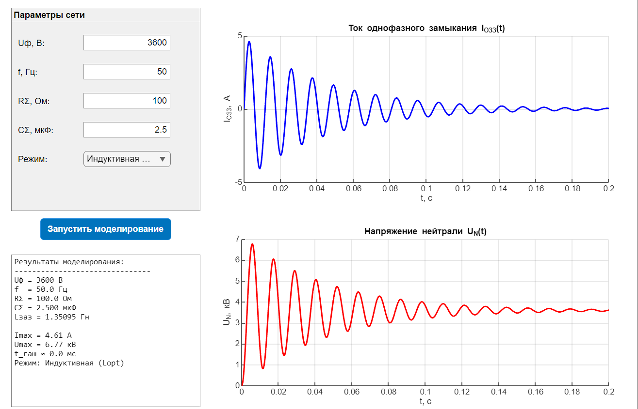
FIGURE 2. Interface of the program for modeling transient processes during single-phase grounding in 6-35 kV networks.

By pressing the "Start Modeling" button, the calculation, graph construction, and display of the results are performed:
Mode: Inductive (L_{opt})
Imax = 6.2 A
Umax = 3.1 kV
tgas = 55 ms
The interface includes two graph windows (I_{ox} (t), U_{n} (t)) and a table of numerical results, making it a convenient tool for both the researcher and the teacher.
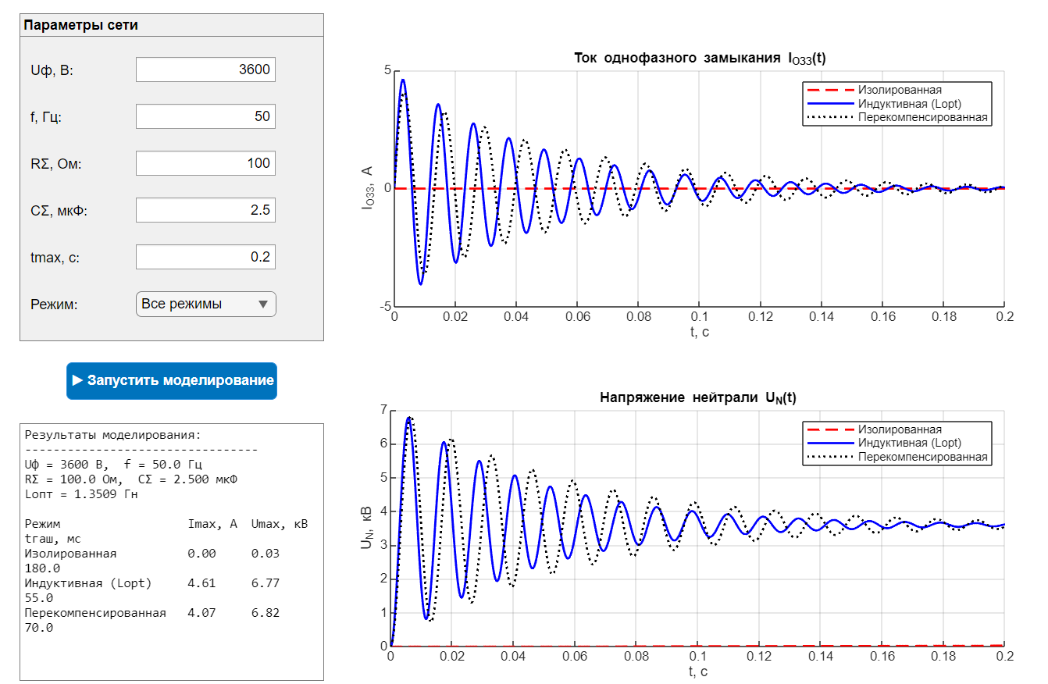
FIGURE 3. Results of modeling transient processes in 6-35 kV networks under different neutral grounding modes

Optimization and forecasting. To improve operational reliability, an automatic control algorithm L_{ground} (t) is proposed, based on measuring capacitive current IC (t) and maintaining the condition:

IL(t)≈−IC(t), (10)
which can be implemented using a PID controller controlled by a Siemens/ABB microcontroller or digital controller.
The model in MATLAB allows for predicting network modes when the load and line parameters change, as well as developing adaptive neutral grounding systems.
Practical significance
Results can be used for:
• design of 6-35 kV substations for rural electricity supply;
• modernization of existing networks with isolated neutral;
• development of laboratory stands for the disciplines "Electrical Networks and Systems" and "Digital Modeling of Electrical Networks";
• training of engineers and students in energy fields.
CONCLUSIONS
The developed mathematical and simulation model allows for the quantitative assessment of the processes of inductive grounding of the neutral in single-phase grounding.
The optimal inductance Lopt ensures the minimization of currents and accelerated arc self-extinction.
The created MATLAB graphical interface allows not only modeling but also managing network parameters in real-time, making the system an effective tool for digital analysis and learning.
The implementation of the proposed solutions in rural power grids of the Republic of Uzbekistan will increase the reliability of electricity supply to agro-industrial facilities and reduce accidents.
REFERENCES
- Shishkalov V.A., Yurov A.A., Groshev A.E., Levchuk V.E., Antonov M.A. Mathematical modeling and comparison of neutral modes in 6-35 kV distribution networks // E3S Web of Conferences. - 2024. - Vol. 549. - P. 05014. - DOI: 10.1051/e3sconf/202454905014. (Don State Technical University, Rostov-on-Don, Russia) https://doi.org/10.1051/e3sconf/202454905014
- Bakhor Z., Yatseiko A., Ferensovych R. Multiplicity of Overvoltages during Arc Single Phase Earth Faults in 35 kV Electrical Grids. Energy Engineering and Control Systems, 2021, Vol. 7, No. 2, pp. 111–116. https://doi.org/10.15407/publishing2021.60.038
- N. N. Beljakov, “Investigation of overvoltages during the arc earth faults in 6 kV and 10 kV electrical grids with an isolated neutral”, Electricity, No. 5, 1957, pp. 31-36. (in Russian)
- Varetsky, Y. (2019) Overvoltages in MV industrial grid under ground faults. Energy Engineering and Control Systems, 5(2), 75-80. https://doi.org/10.23939/jeecs2019.02.075
- F. A. Lihachev, “Earth faults in the electrical grids with an isolated neutral and capacitive current compensation”, Publishing House “Energy”, Moscow, 1971. (in Russian) https://www.studmed.ru/lihachev-fa-zamykaniya-na-zemlyu-v-setyah-s-izolirovannoy-neytralyu-i-s-kompensaciey-emkostnyh-tokov_1b76823d28b.html
- F. A. Gindullin, V. G. Gol'shtejn, A. A. Dul'zon, F. H. Halilov, “Overvoltages in 6-35 kV electrical grids”, Publishing House “Jenergoatomizdat”, Moscow, 1989, 192 p. (in Russian) https://unilibrary.uz/literature/157763
- Varetsky, Y., Bakhor, Z., Ravlyk, A. (1996) Transients in 10-35 kV electric networks with ungrounded neutrals under earth faults. Proceedings of VII International Symposium “Short Circuit Currents in Power Systems”, Warsaw, 1.20.1-1.20.4. https://doi.org/10.15407/publishing2021.60.038
- Yu. O. Varetskyi, O. M. Ravlyk, Z. M. Bakhor, “Features of simulation of processes during the earth faults in the electrical grids with an isolated neutral”, Technical Electrodynamics, No. 2, 1994, pp. 61-63. (in Ukrainian)
- A. Ya. Yatseiko, K. V. Kozak, O. B. Horoshko, “Investigation of the influence of a neutral mode in the 35 kV electrical grid at the values of arc overvoltages”, Scientific papers of Donetsk National Technical University. Series: “Electrical Engineering and Power Engineering”, No. 2(15), 2013, pp. 314-318. (in Ukrainian)
- A. Ya. Yatseiko, K. V. Kozak, “Influence of a neutral mode in 6-35 kV electrical grid at the values of internal overvoltages”, Bulletin of Lviv Polytechnic National University: Electric power and electromechanical systems, No. 763, 2013, pp. 113-119. (in Ukrainian) https://ena.lpnu.ua/items/3fd6ecc1-b888-4d8e-b7ae-98431a49ddf

