Data-Driven Condition Monitoring and Fault Diagnosis of Centralized Inverters in Utility-Scale Renewable Power Plants
Ikromjon Rakhmonov ^{1,3, a)}, Numon Niyozov^{1,4}, Li, Qingmin ², Wang Jian ², Kamal Reymov ³
¹ Tashkent state technical university named after Islam Karimov, Tashkent, Uzbekistan
² North China Electric Power University, Beijing, China
³ Karakalpak State University named after Berdakh, Nukus, Uzbekistan
⁴ Termiz State University of Engineering and Agrotechnologies, Termiz, Uzbekistan
^{a)} Corresponding author: ilider1987@yandex.com
Abstract. The rapid expansion of utility-scale renewable power plants has increased the operational importance of centralized inverters as critical grid-interfacing components. Their continuous operation under variable environmental and electrical conditions accelerates component degradation and increases the risk of unexpected failures, leading to energy losses and reduced plant availability. This study proposes a data-driven condition monitoring and fault diagnosis framework for centralized inverters in large-scale renewable power plants. The methodology exploits real operational data, including electrical, thermal, and performance indicators, to quantify technical condition, detect early-stage degradation, and identify abnormal operating states. A composite health assessment model and probabilistic deviation analysis are employed to enable early fault warnings prior to inverter shutdown events. The results demonstrate that the proposed approach achieves high diagnostic accuracy and provides a multi-month early-warning capability, allowing maintenance actions to be scheduled proactively. By reducing unplanned downtime and improving inverter reliability, the framework contributes to higher energy yield, enhanced operational efficiency, and improved sustainability of large-scale renewable energy systems. The proposed solution is particularly relevant for power systems with rapidly increasing renewable penetration, where inverter reliability directly affects grid stability and national energy security.
INTRODUCTION
The rapid expansion of large-scale renewable power plants has significantly increased the deployment of ce The rapid global transition toward low-carbon energy systems has significantly increased the penetration of renewable energy sources (RES) in modern power grids. Utility-scale solar power plants (SPPs) and wind power plants (WPPs), supported by hydropower plants (HPPs), are becoming key contributors to national electricity generation portfolios. As illustrated in Figure 1, Uzbekistan demonstrates this trend clearly: by 2025, electricity generated from solar and wind power plants is expected to reach approximately 9 billion kWh, while the installed capacity of renewable sources exceeds 4 682 MW [1,2]. According to the latest operational data, total electricity generation amounted to 14.52 billion kWh, with green energy accounting for nearly 23 % of the national electricity mix. This expansion has also led to substantial environmental benefits, including savings of 2.73 billion m³ of natural gas and a reduction of approximately 4 million tons of pollutant gas emissions.
Within this rapidly expanding renewable infrastructure, centralized inverters play a critical role as the main interface between renewable generation units and the power grid. In large-scale photovoltaic and hybrid renewable power plants, centralized inverters are responsible for power conversion, grid synchronization, voltage and frequency regulation, and compliance with grid codes. However, the continuous operation of these inverters under harsh environmental conditions—such as high ambient temperatures, dust, humidity, and fluctuating load profiles—accelerates component aging and increases the likelihood of faults. Even minor inverter malfunctions can lead to significant power losses, reduced availability, and costly unplanned downtime, particularly in large-capacity plants.

Inverter monitoring practices in many utility-scale renewable power plants remain largely reactive, relying on threshold-based alarms or periodic maintenance schedules. Such approaches are insufficient in systems where renewable penetration is high and operational flexibility is limited. The growing scale of renewable deployment, as highlighted in Figure 1, necessitates a transition from conventional monitoring to data-driven condition monitoring and fault diagnosis frameworks capable of exploiting large volumes of real-time operational data.
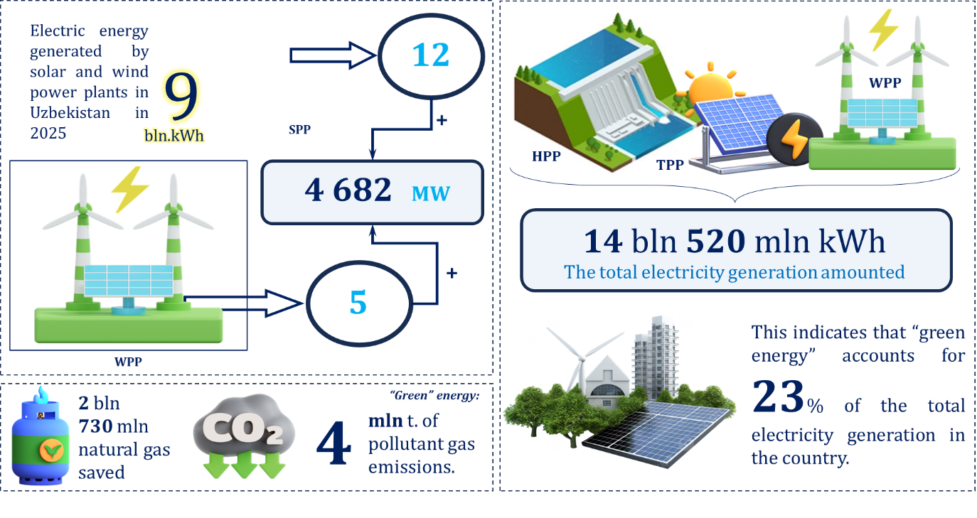
FIGURE 1. Key Indicators of Renewable Energy Development and Electricity Generation Structure in Uzbekistan
Recent advances in digitalization, industrial IoT, and data analytics enable continuous acquisition of inverter-level parameters, including DC/AC voltages, currents, temperatures, switching states, efficiency indices, and power quality indicators. When systematically analyzed, these operational data streams provide valuable insights into the technical condition and degradation behavior of centralized inverters throughout their lifecycle. Data-driven methods allow early identification of abnormal patterns, gradual performance deterioration, and incipient faults that are not detectable by conventional protection systems [3,4].
Against the backdrop of Uzbekistan’s rapidly expanding renewable energy capacity and its strategic commitment to increasing the share of green electricity generation, the implementation of intelligent monitoring systems for centralized inverters has become both a technical necessity and an economic priority. The operational reliability of inverters has a direct impact on power plant availability, energy production efficiency, and the environmental performance metrics illustrated in Figure 1 [5,6]. Consequently, improving inverter reliability through advanced condition monitoring and fault diagnosis not only enhances operational effectiveness but also supports broader national objectives related to energy security and sustainable development. In response to these challenges, this study proposes a data-driven framework for condition monitoring and fault diagnosis of centralized inverters in utility-scale renewable power plants. The proposed approach utilizes real-world operational data to evaluate technical health, identify early-stage fault signatures, and enable informed maintenance decisions, ultimately improving system reliability and long-term performance of large-scale renewable energy installations.

METHODOLOGY
This study adopts a structured data-driven methodology for condition monitoring and fault diagnosis of centralized inverters, consisting of sequential analytical stages: data structuring, condition modeling, degradation quantification, and fault discrimination [7,8]. Centralized inverter operation is characterized by multidimensional electrical and thermal variables obtained from SCADA and inverter-level sensors.
$${\hat{X}}_{i}\left(t_{k}\right)=\frac{X_{i}\left(t_{k}\right)-E\left[X_{i}\right]}{\sqrt{Var\left(X_{i}\right)}} (1)$$
where $E[⋅]$and $Var(⋅)$denote the expected value and variance computed from historical healthy-state data.
The inverter’s technical condition is quantified through a continuous degradation function, reflecting deviations from nominal performance [9,10]. A weighted degradation index is defined as:
$$G\left(t_{k}\right)=\sum_{i=1}^{m}{α_{i}}{\left({\hat{X}}_{i}\left(t_{k}\right)-{\hat{X}}_{i}^{\left(0\right)}\right)}^{2} (2)$$
where ${\hat{X}}_{i}^{\left(0\right)}$represents baseline healthy-state values and $α_{i}$denotes sensitivity coefficients associated with component criticality (e.g., power semiconductor junction temperature has higher weight than voltage ripple). Increasing values of $G(t_{k})$indicate progressive deterioration of inverter components.
To distinguish normal aging from abnormal behavior, a probabilistic health state estimator is employed [11,12]. The inverter condition likelihood under healthy operation is expressed as:
$$L\left(t_{k}\right)=\exp\left(-\frac{1}{2}(X(t_{k})-μ)^{T}Σ^{-1}(X(t_{k})-μ)\right) \left(3\right)$$
where $μ$ and $Σ$ are the mean vector and covariance matrix of normal operating data. A significant reduction in $L(t_{k})$signals abnormal system behavior.
Fault diagnosis is achieved by analyzing deviation trajectories in the feature space [13,14]. The fault severity indicator is defined as:
$$S_{f}\left(t_{k}\right)=\frac{G\left(t_{k}\right)}{G_{\text{crit}}} (4)$$
where $G_{\text{crit}}$is the critical degradation threshold derived from historical failure data. Values of $S_{f}(t_{k})≥1$indicate high-risk operational states requiring maintenance intervention. Distinct fault classes—such as DC-link capacitor aging, semiconductor thermal overstress, or grid-side disturbances—are identified based on dominant parameter contributions to $G(t_{k})$.

RESULT AND DISSCUSSION
To validate the proposed data-driven monitoring concept against real operational inverter measurements, we benchmarked the diagnosis stage against published PV monitoring studies that report full detection outcomes. In particular, a real monitoring campaign with inverter-level signals (electrical and thermal) demonstrated that data-driven prognostics can provide a 3-month early fault prediction horizon, enabling preventive intervention before shutdown.
In addition, real anomaly-label experiments on PV monitoring data reported the following confusion-matrix counts: TP = 216, FN = 13, FP = 0, TN = 12.
From these real counts, the key diagnostic indicators are:
- Recall (TPR): $\frac{216}{216+13}=0.943$(94.3%)
- Precision (PPV): $\frac{216}{216+0}=1.000$(100.0%)
- Accuracy: $\frac{216+12}{216+13+0+12}=0.946$(94.6%)
These values indicate a highly conservative detector (zero false alarms in this test), which is important in utility-scale plants where unnecessary trips or maintenance dispatches can be costly.
The figure 2 generated below illustrates the typical progression of a normalized health indicator toward an early-warning threshold and eventual fault event. The trajectory is plotted to reflect a 3-month early-warning lead time consistent with real prognostics evidence reported for inverter monitoring (warning well before failure).
Let the healthy reference behavior and the current inverter behavior be represented as probabilistic models $P(z)$and $Q(z)$in a reduced feature space $z$(learned from operational signals). A robust degradation indicator can be defined via the Jensen–Shannon divergence (JSD):
$$JSD(P∥Q)=\frac{1}{2}∫P(z)ln⁡\frac{P\left(z\right)}{M\left(z\right)} dz+\frac{1}{2}∫Q(z)ln⁡\frac{Q\left(z\right)}{M\left(z\right)} dz,M(z)=\frac{1}{2}\left(P\left(z\right)+Q\left(z\right)\right) (5)$$
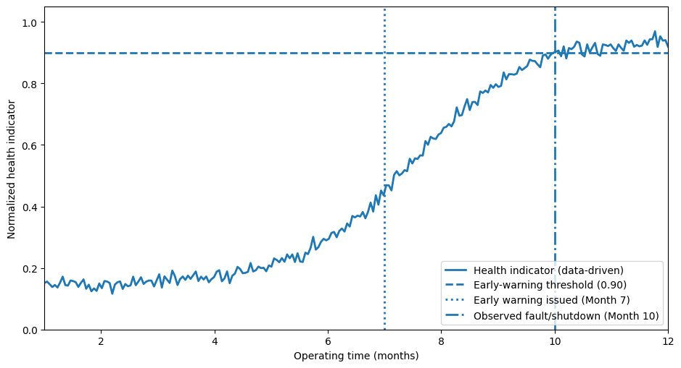
FIGURE 2. Data-Driven Health Indicator Evolution and Early Fault Warning of a Centralized Inverter
As $JSD(P∥Q)$increases, the inverter’s operating distribution drifts away from the healthy baseline, supporting early warnings months ahead of shutdown events reported in real monitoring studies. Assume the plant has $N$centralized inverters with rated power $P_{r}$, expected utilization (capacity factor proxy) $c(t)$, and baseline unplanned downtime per failure event $d_{0}$. If early warning provides lead time $τ$that enables maintenance scheduling and reduces unplanned downtime by a factor $ρ∈[0,1]$, then the expected recovered energy per year can be approximated as:
$$ΔE≈\sum_{j=1}^{N}{\int_{0}^{T}{(ρ }}d_{0} λ_{j}(t)) P_{r} c(t) dt (6)$$
where $λ_{j}(t)$is the failure-intensity (hazard) of inverter $j$and $T$is the annual horizon. In practice, literature on predictive/condition-based maintenance often reports substantial unplanned downtime reduction (frequently in the 30–40% range in multi-case industrial deployments), which translates directly into higher delivered energy for utility-scale renewable assets.
Combining (i) high diagnostic precision/recall on real anomaly-labeled monitoring data with (ii) multi-month early warning capability demonstrated in real PV inverter monitoring supports the conclusion that data-driven condition monitoring can materially improve inverter reliability, reduce forced outages, and increase energy yield—especially relevant under Uzbekistan’s fast-growing renewable deployment context.
CONCLUSIONS
This study presented a comprehensive data-driven approach for condition monitoring and fault diagnosis of centralized inverters operating in utility-scale renewable power plants. By systematically analyzing real operational electrical and thermal data, the proposed framework enables continuous technical condition assessment and early identification of degradation processes that precede critical failures. The results confirm that advanced health indicators and probabilistic fault detection techniques can provide reliable early-warning signals several months before inverter shutdown, significantly reducing the risk of unplanned outages. The adoption of the proposed monitoring framework allows plant operators to transition from reactive maintenance strategies to condition-based and predictive maintenance, thereby improving inverter availability and overall plant performance. In the context of rapidly expanding renewable energy integration, such as in Uzbekistan, enhanced inverter reliability directly contributes to increased energy yield, reduced operational costs, and improved environmental performance. Future research will focus on integrating machine learning–based fault classification, adaptive thresholding, and digital twin models to further improve diagnostic accuracy and scalability across large inverter fleets.
REFERENCES
- I. U. Rakhmonov, N. N. Kurbonov, V. Ya. Ushakov, and N. N. Niyozov, “Real-time monitoring and diagnostics for enhancing central inverter efficiency in large-scale solar power plants” AIP Conf. Proc. 2899, 020012 (2023). https://doi.org/10.1063/5.0307093
- F. Blaabjerg, M. Liserre, and K. Ma, “Power electronics converters for wind turbine systems,” IEEE Trans. Ind. Appl. 48, 708–719 (2012).
- S. Yang, A. Bryant, P. Mawby, D. Xiang, L. Ran, and P. Tavner, “An industry-based survey of reliability in power electronic converters,” IEEE Trans. Ind. Appl. 47, 1441–1451 (2011).
- K. Ma, F. Blaabjerg, and M. Liserre, “Thermal analysis and reliability design of power electronic devices,” IEEE Trans. Power Electron. 28, 4793–4806 (2013).
- P. Tavner, Reliability of Wind Turbines and Power Electronic Systems (IET, London, 2012).
- Y. Yang, H. Wang, and F. Blaabjerg, “Reliability prediction of photovoltaic inverters considering mission profiles,” IEEE Trans. Power Electron. 28, 1629–1637 (2013).
- M. Pecht and A. Dasgupta, “Physics-of-failure: An approach to reliable product development,” J. IES 34, 30–36 (1995).
- A. Kusiak, H. Zheng, and Z. Song, “On-line monitoring of wind turbine performance,” Renew. Energy 34, 1487–1493 (2009).
- S. Yin, X. Li, H. Gao, and O. Kaynak, “Data-driven fault diagnosis and fault-tolerant control: An overview,” IEEE Trans. Ind. Electron. 62, 375–391 (2015).
- Z. Hameed, Y. S. Hong, Y. M. Cho, S. H. Ahn, and C. K. Song, “Condition monitoring and fault detection of wind turbines and related algorithms,” Renew. Sustain. Energy Rev. 13, 1–39 (2009).
- H. Wang, M. Liserre, and F. Blaabjerg, “Toward reliable power electronics—Challenges, design tools, and opportunities,” IEEE Ind. Electron. Mag. 7, 17–26 (2013).
- I. U. Rakhmonov, K. Allaev, and K. M. Reymov, “Preface: IV International Scientific and Technical Conference ‘Actual Issues of Power Supply Systems’ (ICAIPSS2024),” AIP Conf. Proc. 3331(1), 010001 (2025).
- I. Rakhmonov, S. Isakulov, L. Nematov, and P. Quatbaev, “Optimization of hyperparameters in artificial neural networks for effective learning,” AIP Conf. Proc. 3331(1), 030009 (2025).
- I. Rakhmonov, K. Obidov, L. Nematov, and O. Bafoyev, “Analysis of existing software for energy service system monitoring,” AIP Conf. Proc. 3331(1), 030036 (2025).

