Features of a teacher’s activity in managing the educational process in a modern school
Iskender Pirniyazov, Natalya Pirniyazova^{a)}, Guljakhan Aldjanova
Karakalpak State University named after Berdakh, Nukus, Uzbekistan
^{a)} Corresponding author: pirniyazovanatalya@gmail.com
Abstract. This article examines and analyzes teachers' readiness to manage the educational process in schools in Uzbekistan. Within the context of the current requirements of the Law on the Status of Teachers, the components of teachers' activities—subject-based and personal—are examined.
INTRODUCTION
The need to improve management activities is caused by updating the content of education in accordance with the needs of students and changes in society, science and technology. This task was designated in 2019 as a priority in the Concept of development of the public education system of the Republic of Uzbekistan until 2030 [1].
The teacher defines and formulates the goals and objectives of educational activity, plans and organizes it, analyzes the results of the educational process, corrects the activities of students, who manages the process of achieving the intended goals.
MATERIALS AND METHODS
Within the framework of the conducted research, the management of the organization of the educational process is considered. The analysis of the concept of “educational process” has been carried out and it has been established that the study of the educational process can be carried out at different levels: theoretical, project and real. These levels define the structure of the educational process management analysis.
In order to determine the real state of management of the educational process in schools and to choose the basic model of this type of activity, a corresponding study was conducted based on the methods of questionnaires, free interviewing of teachers, school principals and their deputies (Table 1) [2].
TABLE 1. Knowledge and application of management ideas in teaching (in % of the total number)
The surveyed group  answers | Experienced teachers
The surveyed group  answers | up to 10 y.o. (n=240) | up to 10 y.o.  (n=210)
They know, understand and always use | 5,6 | 18,9
They understand and apply something. | 19,3 | 34,8
They know, but they find it difficult to apply | 40,4 | 33,3
They don’t attach importance | 34,7 | 23,0

Clarifying the understanding of the functions of pedagogical management allowed us to establish that in 65-67% of cases it is only about the control of students' knowledge or the organization of the most common forms of interaction with them in the educational process.
The data obtained on the basis of the questionnaire on the role of planning in ensuring the effectiveness of the educational process (Table.2) showed that the majority of respondents consider planning to be a prerequisite for the success of the educational process, although its role varies.

TABLE 2. The importance of planning in ensuring the effectiveness of the educational process (in percentage of the total number)
The surveyed group  answers | Experienced teachers
The surveyed group  answers | up to 5 y.o.  (n=240) | Up tо 10 y.o.  (n=210)
Protects against accidents and randomness | 36,0 | 42,7
It does not allow you to miss the main thing - learning goals | 22,7 | 31,0
Allows you to predict the results | 23,2 | 6,3
Provides a systematic approach to learning | 11,1 | 20,0
Couldn't respond | 7,0 | -

In the course of the research, it was found out what knowledge and skills a teacher should possess in order to effectively manage the educational process. The materials we obtained showed that teachers among the dominant ones indicate special knowledge (94.5% of respondents) and communication skills (98.5%).
It is noted that none of the respondents identified their initial readiness for managerial activity as sufficient. The ascertaining stage of the study showed that teachers and school leaders, while implementing the content and technological aspects of management to one extent or another, nevertheless find it difficult to implement it. This gave us a reason to turn to a more detailed consideration of the structural, substantive and procedural aspects of the teacher's activities in managing the educational process at school [3].
The activity model of a specialist teacher in managing the educational process at school includes:
- a set of features reflecting the level of professional qualifications of the teacher in accordance with the requirements of the State Educational Standard of the Republic of Uzbekistan;
- the level of development of psychological and pedagogical knowledge and theory and practice of management.
The analysis of the component composition of a specialist's activity allows us to identify two components in it - the subject and the personal. Taking into account the nature of the teacher's activity in managing the educational process, we have identified substantive and technological components in the subject component, and a system of value orientations, a set of special knowledge and skills, and a set of professional and personal qualities in the personal component. All components are interconnected with each other, and the leading role among them is played by the orientation of personality as a set of personal properties, motives of behavior and activity [4].

TABLE 3. Qualities of the teacher's personality in accordance with professional functions
Based on the research materials, we have proposed the following system of teacher skills in the field of educational process management: 1) gnostic; 2) constructive; 3) organizational; 4) communicative.
The qualities of the teacher's personality in accordance with professional functions
Information  and analytical services | Motivational  and targeted | Organizational  and executive | Control  and diagnostic | Reflexive correction
- objectivity;  - energy;  - analytical  - mindset;  - the ability to  systematize  and generalize | -purposefulness;  -erudition;  -initiative;  -the ability to  predict;  -creativity;  -independence;  -competence | -discipline;  - demanding;  - determination;  - Perseverance;  - self-organization;  - attention to  people | -objectivity;  - justice;  -observation skills  - self-criticism | -emotional  balance;  - sociability;  -communication skills;  -responsiveness;  - loyalty
THE RESULTS OF THE STUDY
The verification of the identified conditions was carried out in the work experience of secondary school №34 in Nukus. A group of teachers from a similar school №17 in Nukus, the Republic of Uzbekistan, was identified as the control group.
The objective of the experimental work was to check the readiness of teachers of both schools to implement the identified conditions. In the framework of the study, the teacher's willingness to manage the educational process was understood as follows: a factor that reduces mental tension and increases emotional stability, self-regulation of personality; a mechanism that promotes operational self-correction of the results of managerial activities.
For the teachers who made up the experimental group, a modular program of advanced training courses was compiled and implemented, the main purpose of which was to prepare a practicing teacher for effective management of the educational process at school. The central place in the program is given to the module “Management of the educational process at school”. A special role in the process of teacher training was assigned to the performance of practical tasks in the context of the entire school management system [2].
Updating the activities of the school's methodological service played a significant role in the experimental work. For example, school №34 worked on a single methodological topic “Management of the educational process in schools in the context of the implementation of personality-oriented learning and education of students.” The following were chosen as priority areas for the development of the topic: modern approaches to the management of educational systems and processes; the activity of a teacher in the management of the educational process at school; pedagogical conditions for effective management of the educational process at school; the quality of the educational process and educational monitoring (Figure 1).
Teachers' readiness to effectively manage the educational process was ensured through their participation in various forms of collective activity: theoretical seminars; workshops; discussions; business games; discussion of the latest techniques, technologies, mutual classes, author’s programs; public reports on self-education; contests; pedagogical readings.
The form of implementation of the teacher's managerial activity in experimental work was chosen by the management cycle, the structural elements of which were blocks and modules [6-9]. Their use made it possible to fix the teachers attention on the main thing. Each unit provided solutions to specific management tasks [9]:
Block 1. Goal setting - building strategic, tactical and operational goals;
Block 2. Management examination - determination of the initial level of knowledge, skills and abilities of students, the level of their mental development, as well as the individual characteristics of schoolchildren;
Block 3. Defining the learning strategy - choosing the leading type of learning, analyzing educational information, planning interdisciplinary connections, determining the place and types of independent work;
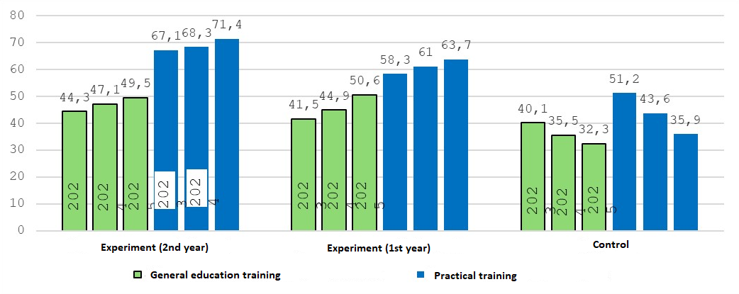
FIGURE 1. The quality of students' education

Block 4. Organization of educational activities - selection and implementation of organizational forms, methods and means of teaching;
Block 5. Organization of control, feedback and self-control - development of a control system, creation and implementation of monitoring and diagnostic tests;
Block 6. Analysis of the results of educational and pedagogical activities - collection and study of information about the results of the educational process and its management.
At the final stage of the study, a final experiment was conducted, the task of which was to determine the effectiveness of the proposed measures to improve pedagogical management and its impact on the main results of the educational process at school.
CONCLUSIONS
The study made it possible to establish that the teacher’s management of the educational process at school will be effective if the pedagogical management system is based on the professional competence and personal qualities of the teacher.
REFERENCES
- The concept of development of the public education system of the Republic of Uzbekistan until 2030, Decree of the President of the Republic of Uzbekistan dated 04/29/2019 N UP-5712
- Kurbaniiazov, R.K., Reimov, A.M., Namazov, Sh.S., Beglov, B.M. Nitrogen-phosphoric fertilizers obtained by interaction of the concentrated solutions of ammonium nitrate with the mineralized mass of the phosphorites of Central Kyzylkum. Russian Journal of Applied Chemistry. Russ J Appl Chem (2009) 82: 1123. https://link.springer.com/journal/11167
- Holistic educational process and professional competencies of school teachers World Science International Scientific Publication Issue No. 6 (51) (June, 2021). Website:http:www.science-j.com
- Namazov, Sh.S., Kurbaniyazov, R.K., Reimov, A.M., Beglov, B.M. Hardness of the granules of ammonium nitrate doped with the Central Kyzylkum Phosphorite. Russian Journal of Applied Chemistry. Russ J Appl Chem (2007) 81(6): 1103–1106. http://dx.doi.org/10.1134/s1070427208060402.
- Pirniazova N.V. //Problems and development of modern educational technologies by teachers at advanced training courses "Science and education in Karakalpakstan" ISSN 2181-9203 №2/2 2024.
- R. K. Kurbaniyazov, A. M. Reimov, A.T. Dadakhodzhaev, Sh. S. Namazov, B. M. Beglov. Nitrogen-phosphoric fertilizers produced by introduction of Central Kyzylkum phosphate raw material into ammonium nitrate melt. Russian Journal of Applied Chemistry. Russ J Appl Chem (2007) 80(11): 1984-88. https://doi.org/10.1134/S1070427207110456
- Pirniazova N.V. // Innovative experience of the best teachers as a form of work in advanced training of teaching staff International Conference of Academic Sciences (Russia) (Vol. 3, Issue 5, May 2024. pp. 145-152). Zenodo. ttps://doi.org/10.5281/zenodo.11273533
- Pirniyazov I.K. Modern approach in school management. // Scientific and methodological journal "Teacher and continuing education" of Preschool and school education of the Republic of Karakalpakstan. Karakalpak branch of the Kari Niyazi National Institute of Educational Pedagogy. No. 5/2, 2025, pp.373-380
- Alimov, U.K., Reimov, A.M., Namazov, Sh.S., Beglov, B.M. The insoluble part of phosphorus fertilizers, obtained by processing of phosphorites of central kyzylkum with partially ammoniated extraction phosphoric acid. Russian Journal of Applied Chemistry. Russ J Appl Chem (2010) 83(3): 545–552. https://doi.org/10.1134/S107042721030328

