Analysis of Mineral Content in Groundwater of the Amudarya Delta: A Case Study of Khodjeli District, Karakalpakstan
Izzet Aimbetov¹, Rakhim Dospanov^{1,a)}, Akhmet Allambergenov², Murat Eshmuratov², Kizdanay Bektursinova²
¹ Karakalpak Scientific Research Institute of Natural Sciences, Nukus, Uzbekistan
² Karakalpak State University, Nukus, Uzbekistan
^{a)} Corresponding author: raxim.dospanov@gmail.com
Abstract. The article presents the results of studies of the hydrogeological conditions of the Khodjeli district of the Republic of Karakalpakstan. Schematic maps of groundwater mineralization have been constructed. The results of studies on the salinity of groundwater in the Khodjeli district of the Republic of Karakalpakstan showed that the mineralization of groundwater varies within 0.5-25 g/l. The lowest mineralization of groundwater is observed where the channels of the Amu Darya flowed. The groundwater of the studied area belongs mainly to sulfate (72%) and chloride-sulfate (22%) types of salinization. According to Shchukarev’s classification, groundwater mainly belongs to the sulfate and sulfate-chloride classes of salinity. To use the groundwater of the Khodjeli district, it is necessary to purify the water from salts. The compiled schematic maps can be used in archaeological excavations of ancient cities and settlements of the Khodjeli district.
INTRODUCTION
It is known that the formation of groundwater in the delta originates from the Amu Darya River. Currently, the waters of the Amu Darya are mainly used in agriculture. To develop the lands in the Amu Darya delta, numerous channels were dug into which its waters were diverted. Due to the expansion of irrigated areas and the irrational use of Amu Darya water, there is a shortage of water in the lower reaches of the river delta. One of the ways to reduce water scarcity is to use relatively fresh groundwater.
MATERIALS AND METHODS
To determine the location of freshwater lenses, maps of groundwater salinity in the Khodjeli district were compiled. Data from archival materials of engineering-geological and hydrogeological survey organizations were used to compile the maps. The maps are compiled using the ArcGIS computer program. When making maps, the results of determining the salinity of groundwater from 59 workings were processed. The research covered 110 km² of the territory of the Khodjeli district.
RESULTS AND DISCUSSION
The results of research on historical materials showed that for the first time the water body of the Amu Darya delta in the Khodjeli district of Karakalpakstan was reflected in a painting that was painted in 1842 [1]. Figure 1 shows the work of the Russian artist N.N. Karazin, which depicts the bazaar in Khodjeli (1886) [2]. The bazaar of that time resembles modern Venice (Italy). The waters of the Amu Darya’s channels were fresh, as it feeds mainly on melted snow and glacial waters. Naturally, due to the infiltration of surface waters, lenses of fresh groundwater are formed along the channels. In other places, groundwater is more saline, since the analysis of the geological structure shows that under the alluvial rocks there are layers of rocks of earlier age, which contain a lot of water-soluble salts [5].
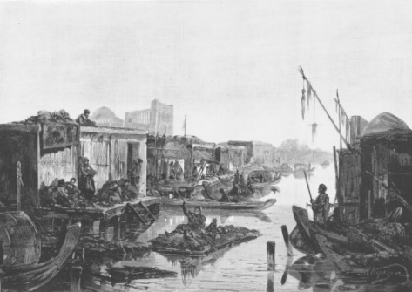 | 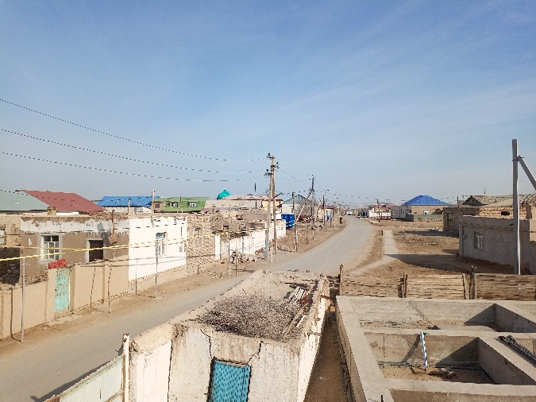
FIGURE 1. The Amu Darya basin. The market in Khodjeli. N.N. Karazin’s orginal drawing (Niva Magazine No. 3, 1886 | FIGURE 2. Modern view of the part of the city of Khodjeli shown in Fig.3 (2023, photo by the authors)

The picture shows a photo taken in 2024 of the same place, according to which the painting shown in Fig.1. As a comparative analysis of the drawings shows, 1,2 the Amu Darya duct dried up in 2024, and houses were built on the site of the duct.
Figure 3.4 shows maps of the water bodies of the Amu Darya Delta, compiled in 1842 and 2024. In 1842, the Aral Sea was full-flowing, and there were many lakes and channels of the Amu Darya in the delta of the Amu Darya. In the western part of the Amu Darya delta there was a large lake “Aybugir”, in the eastern part Lake Dau Kara, which was connected to the Aral Sea, numerous channels of the river in the lower reaches of the Amu Darya were used by the population for trade and farming (Fig.4). Due to changes in natural conditions and human economic activity, lakes and numerous river channels have dried up [10].

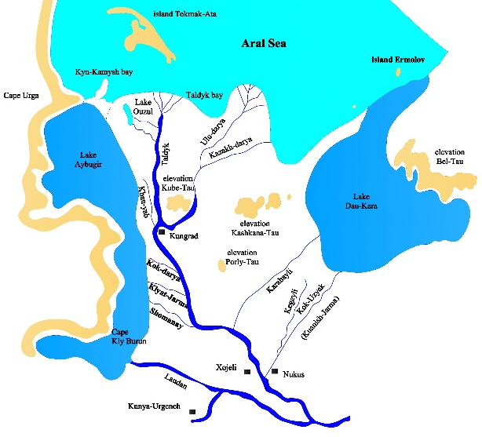 | 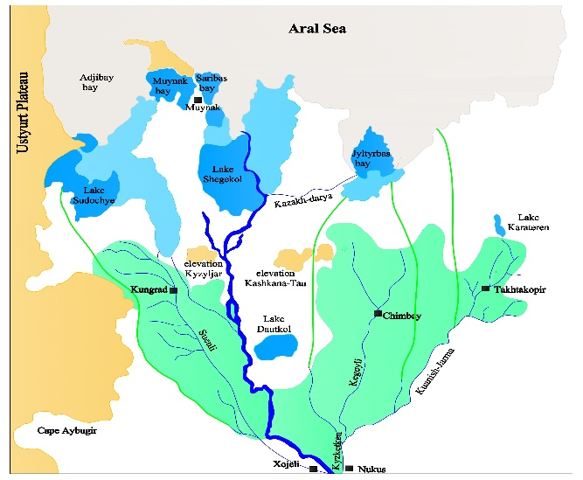
FIGURE 3. Map of the water bodies of the Amu Darya River delta (1842) | FIGURE 5. Schematic map of the Amu Darya River delta (2023)

Regular monitoring of the groundwater level of the Khodjeli district began in the early 1960s, when intensive development of land for growing crops began. Figure 5 shows a graph of changes in the groundwater level of the Khodjeli district by year, a comparative analysis of which shows that compared to the 1960s, there was an increase in the groundwater level. This is primarily due to the inefficient use of irrigation water in agriculture. Under certain conditions, salts that occur at a depth in the composition of soil strata of earlier age migrate to the surface and increase the salinity of groundwater and soils. Near fresh water channels, the mineralization of groundwater decreases due to salt washing by water flows of the irrigation system [11-14].
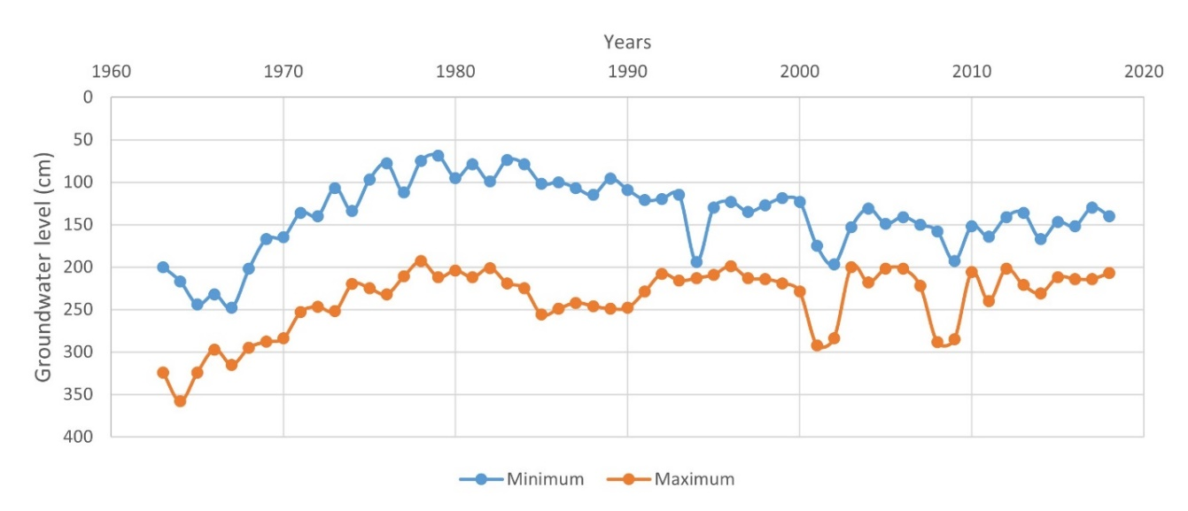
FIGURE 5. Dynamics of changes in the groundwater level of the Khodjeli district

Figure 6 shows a schematic map of groundwater salinization with water-soluble salts [3; 6; 7; 8], the analysis of which shows that the salinity of groundwater depends on the sampling site [9]. For example, groundwater lenses with relatively low mineralization (0.5-2.5 g/l) were found in the central and northeastern parts of the research area. The analysis showed that the most mineralized groundwater with a salt content of 6-25 g/l is located in the elevated part of the studied area. This indicates that there were no channels of the Amu Darya in these places [4].

(а)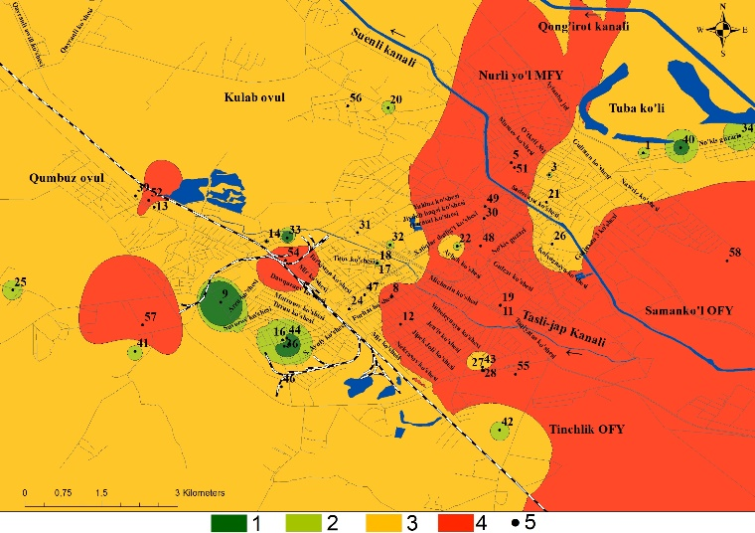 | (b)  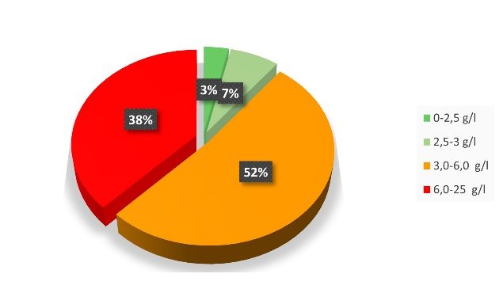
FIGURE 6. Schematic map (a) and percentage distribution (b) of groundwater salinity in the Khodjeli district with water-soluble salts (by dense residue), g/l: 1- 0,5-2,5 g/l; 2- 2,5-3 g/l; 3- 3-6 g/l; 4- 6-25 g/l; 5- well.

Figure 7 shows a schematic map of the chemical classification of groundwater composition according to S.A. Shchukarev’s classification, the analysis of which shows that groundwater in almost the entire territory belongs to group “B”. Small areas of groundwater according to the chemical classification of S.A. Shchukarev belong to groups “A” and “C”.
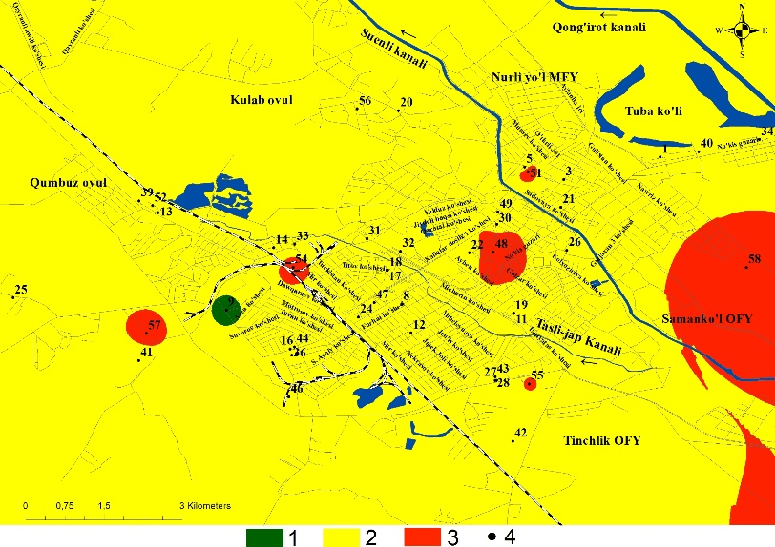
FIGURE 7. Schematic map of the chemical classification of the groundwater composition of the Khodjeli district (compiled according to the classification of S.A.Shchukarev) 1-group “A”; 2- group “B”; 3- group “C”; 4- wells

Figure 8 shows a schematic map that shows the qualitative nature of groundwater salinization in the Khodjeli district.
(а)  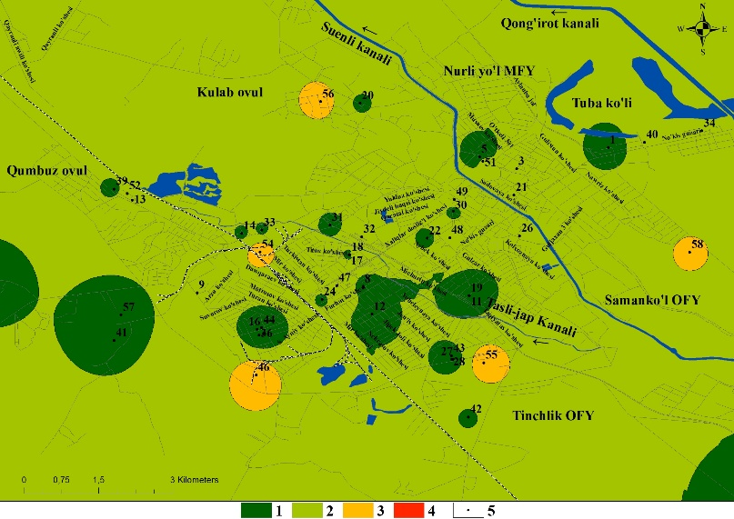 | (b)  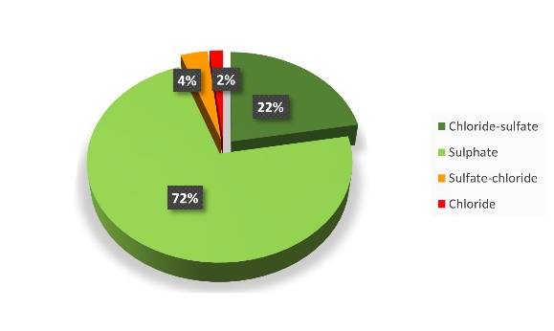
FIGURE 8. Schematic map (a) and percentage distribution (b) of the types of groundwater salinization in the Khodjeli district with water-soluble salts (by dense residue): 1- chloride-sulfate; 2- sulfate; 3- sulfate-chloride; 4- chloride; 5- wells

As Figure 8 shows, the groundwater of the studied area belongs mainly to sulfate (72%) and chloride-sulfate (22%) types of salinization. According to S.A. Shchukarev’s classification, groundwater mainly belongs to the sulfate and sulfate-chloride classes of salinity.
CONCLUSION
1. The results of studies on the salinity of groundwater in the Khodjeli district of the Republic of Karakalpakstan showed that the mineralization of groundwater varies within 0.5-25 g/ l, which is associated with the location of ancient channels of the Amu Darya. The lowest mineralization of groundwater is observed in those places where previously there were fresh water channels of the Amu Darya. According to S.A. Shchukarev’s classification, groundwater mainly belongs to the sulfate and sulfate-chloride classes of salinity. According to the chemical classification of the composition, the groundwater of almost the entire territory belongs to group “B”. Small areas of groundwater according to the chemical classification of S.A. Shchukarev belong to groups “A” and “C”.
2. Groundwater can be used to reduce the shortage of water resources in the lower reaches of the Amu Darya. At the same time, for drilling exploratory hydrogeological wells, it is necessary to study historical materials that describe hydrological objects.
3. To use the groundwater of the Khodjeli district, it is necessary to purify the water from salts, while selecting filters depending on the level of mineralization of the types of salts. The absence of industrial enterprises polluting groundwater allows the use of filters only to purify water from water-soluble salts.
4. The compiled schematic maps can be used in archaeological excavations of ancient cities and settlements of the Khodjeli district
REFERENCES
- Limarev V.I. The shores of the Aral Sea - an internal reservoir of the arid zone. Leningrad: Science 1967. –254 p.
- Karazin N.N // Niva. (Journal of Literature, Politics and Contemporary Life). 1886. № 1–26. p. 79.
- Aimbetov I., Bekimbetov R. Engineering and geoecological assessment of soils salinity in Nukus using GIS technologies. // E3S Web of Conferences. – EDP Sciences, 2021. – Т. 265. – С. 03006.
- Reymov, A.M., Namazov, S.S., Beglov, B.M. Effect of phosphate additives on physical-chemical properties of ammonium nitrate. Journal of Chemical Technology and Metallurgy 2013 48(4), 391-395. http://dl.uctm.edu/journal/
- Aimbetov I.K., Dospanov R.R. Engineering-geological and hydrogeological conditions of the Khojeyli district. //Vestnik KK ОАN RUz.- Nukus.- 2023.- № 3.- P.20-25.
- Reymov Akhmed, Namazov Shafoat. Nitrogen-phosphorous fertilizers on the base of concentrated ammonium nitrate solution and Central Kyzylkum phosphate raw material. Polish Journal of Chemical Technology 16(3), Sep 2014, 30-35. https://doi.org/10.2478/pjct-2014-0046
- Brassington R. Field hydrogeology. – John Wiley & Sons, 2023.
- Alisher Eshimbetov, Shahobiddin Adizov, Inderpreet Kaur, Akhmed Reymov. Is it possible to differentiate between 2-phenylaminodihydro-1,3-thiazine from 2-phenyliminotetrahydro-1,3-thiazine by spectral methods? New glance to the old problem. European Journal of Chemistry 12 (1) (2021). https://doi.org/10.5155/eurjchem.12.1.77-80.2068
- Schwartz F. W., Zhang H. Fundamentals of groundwater. – John Wiley & Sons, 2024.
- Kurbanbaev E., Artikov O., Kurbanbaev S. Integrated Water Resources Management in the Amudarya River Delta //Tashkent: Global water partnership Central Asia and Caucasus. – 2010. – Т. 57.
- A.Ahmadjonov, U.Alimov, P.Tuychi, A.Seitnazarov, A.Reimov, Sh.Namazov, S.Sadullayev. Effect of temperature on the kinetics of the process of nitric acid decomposition of Arvaten serpentinite. IOP Conf. Series: Earth and Environmental Science 1142 (2023) 012034. https://www.scopus.com/pages/publications/85151285667
- Gledko Yu. Hidrogeology. – Litres, 2021.
- Karamouz M., Ahmadi A., Akhbari M. Groundwater hydrology: Engineering, planning, and management. – Crc Press, 2020.
- Izzet A., Rakhim D. Assessment of salinization of soils and groundwater of the Khojaly district (Southern Aral sea region) //E3S Web of Conferences. – EDP Sciences, 2023. – Т. 407. – С. 02013.

