Classification and Hierarchical Structuring of Factors Influencing CO₂ Emissions: A Systems-Based Analytical Framework
Ikromjon Rakhmonov ^{1, 5, a)}, Laziz Nematov ², Dilnaz Esnazarova ³, Farrukh Rakhimov ⁴
¹Tashkent state technical university named after Islam Karimov, Tashkent, Uzbekistan
² Bukhara State Technical University, Bukhara, Uzbekistan
³Karakalpak State University named after Berdakh, Nukus, Uzbekistan
⁴ Navoi State University of Mining and Technologies, Navoiy, Uzbekistan
⁵Termez State University of Engineering and Agrotechnology, Termez, Uzbekistan
^{a)} Corresponding author: ilider1987@yandex.com
Abstract. Effective mitigation of carbon dioxide (CO₂) emissions demands analytical frameworks that reflect the structural and technological complexity of contemporary energy systems. This study introduces a novel multiscale classification and hierarchical structuring of CO₂ emission factors designed to support sustainable energy system planning. Instead of analyzing emission drivers in isolation, the proposed approach organizes them into interconnected macroeconomic, meso-level structural, and micro-level technological layers, enabling a more comprehensive interpretation of emission dynamics. The framework combines hierarchical modeling with quantitative decomposition techniques to distinguish between factors that primarily determine emission pressure and those that provide the greatest mitigation leverage. The results indicate that although macro-level drivers largely shape overall emission trajectories, the most effective and controllable reduction potential is concentrated at the meso and micro levels, particularly through power-sector decarbonization, improvements in energy intensity, and accelerated electrification of end-use sectors. Furthermore, cross-cutting enablers such as digital monitoring, demand-side management, and coordinated regulatory instruments significantly enhance system flexibility and mitigation efficiency. By integrating structural classification with numerical assessment, the proposed methodology offers both conceptual clarity and practical relevance. It enables policymakers and energy planners to prioritize interventions, evaluate strategic trade-offs, and design coherent long-term decarbonization pathways. Consequently, the study contributes a scalable and analytically robust tool for evidence-based decision-making in low-carbon energy transitions.
INTRODUCTION
The rapid growth of anthropogenic carbon dioxide (CO₂) emissions remains one of the most critical challenges confronting the global energy system. According to widely reported international assessments, global energy-related CO₂ emissions reached approximately 37–38 Gt in 2023–2024, exceeding pre-pandemic levels and highlighting the persistent dependence of modern economies on fossil fuels. More than 70 % of total greenhouse gas emissions are directly linked to energy production and consumption, with electricity and heat generation alone accounting for about 40 % of energy-related CO₂ emissions, followed by industry (≈25 %) and transport (≈20–22 %). These figures clearly demonstrate that sustainable energy system planning is central to achieving international climate targets, including the goal of limiting global warming to 1.5–2 °C above pre-industrial levels. Despite significant progress in renewable energy deployment—global installed renewable power capacity exceeded 3.8 TW in 2023, with annual additions above 500 GW—overall CO₂ emissions have not yet entered a sustained decline [1,2]. This apparent paradox is largely explained by continued growth in electricity demand (around 2.5–3 % per year globally), rising industrial output in developing economies, and structural inertia within existing energy infrastructures. Consequently, emission mitigation cannot rely solely on single-sector solutions; instead, it requires a comprehensive understanding of the multiple drivers influencing CO₂ emissions across different scales of the energy system.
Traditional approaches to emission analysis often focus on isolated indicators, such as energy intensity or fuel substitution, without adequately capturing their interdependencies. However, CO₂ emissions are inherently the result of interactions between macroeconomic factors (population growth, economic development), meso-level structural characteristics (sectoral composition, energy intensity, infrastructure), and micro-level technological and operational factors (generation technologies, end-use efficiency, process optimization). For example, improvements in end-use efficiency may be partially offset by increased economic activity, while large-scale electrification yields meaningful emission reductions only if accompanied by substantial decarbonization of the power sector. A multiscale classification and hierarchical structuring of CO₂ emission factors offers a more robust analytical basis for sustainable energy system planning [3,4]. Such an approach enables the systematic decomposition of emission dynamics, identification of dominant drivers at each scale, and quantitative assessment of mitigation potentials. Hierarchical models are particularly valuable for policy and planning because they clarify which factors primarily define emission pressure (macro level) and which provide the most effective control levers (meso and micro levels).
The growing role of digital technologies, including advanced monitoring systems, data analytics, and demand-side management, introduces new cross-cutting mechanisms that influence emission trajectories across all scales. Digitalization can improve system flexibility, reduce losses, and enhance the integration of variable renewable energy sources, thereby amplifying the effectiveness of conventional mitigation measures.

RESULT AND DISSCUSSION
The proposed multiscale taxonomy groups CO₂ drivers into macro, meso, and micro layers, complemented by cross-cutting enablers (digitalization, finance, regulation). This structure is consistent with the evidence that emissions are simultaneously shaped by (i) overall activity growth, (ii) sectoral structure and energy intensity, and (iii) technology/fuel choices and operational efficiency. In recent global assessments, energy-related CO₂ emissions reached 37.8 Gt in 2024, indicating that system-level planning remains decisive for mitigation trajectories [3,6].
At the macro level, emissions scale with population and economic output (activity). At the meso level, the system reallocates energy demand across sectors (industry, power, transport, buildings) and changes energy intensity through infrastructure and efficiency programs. At the micro level, emissions respond to technology portfolios: renewable penetration, coal displacement, electrification of end-uses, and industrial process modernization. This layered view is particularly important because sectoral dynamics are heterogeneous: for example, transport accounts for a substantial fraction of energy-related CO₂ (often cited around the low-20% range globally), and its growth trends have differed from power and industry in recent decades.
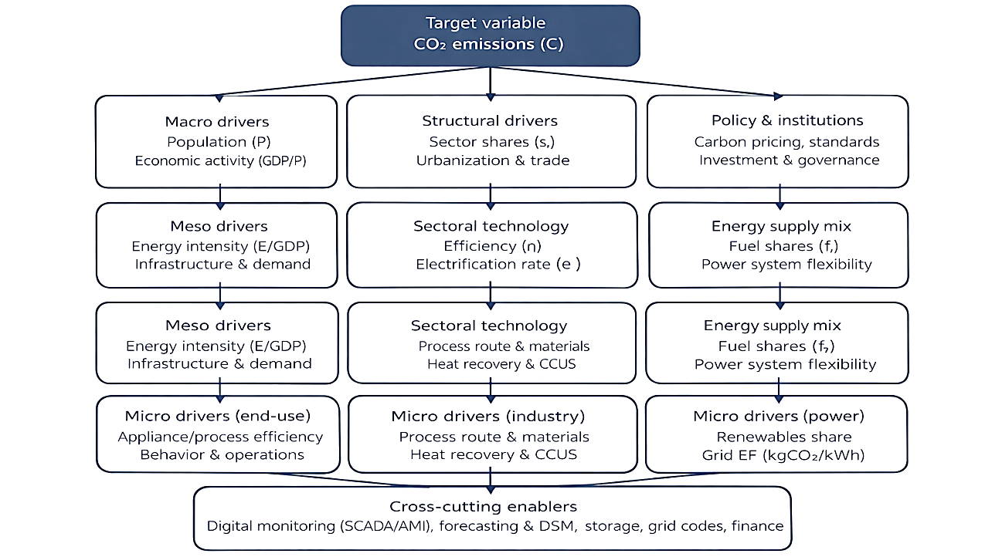
FIGURE 1. Multiscale Hierarchical Structure of CO₂ Emission Drivers

The hierarchical structure can be formalized by a multiscale extension of the Kaya identity, which is convenient for energy-system planning [4,5]:
$C = P⋅\frac{GDP}{P}⋅\frac{E}{GDP}⋅\frac{C}{E}$ (1)
To explicitly represent fuel mix and emission factors, the carbon intensity term can be expanded:
$\frac{C}{E} = \sum_{j∈\{coal,gas,oil,… \}}{f_{j}}⋅EF_{j}⇒C = P⋅\frac{GDP}{P}⋅\frac{E}{GDP}⋅\sum_{j}{f_{j}}EF_{j}$ (2)
where $f_{j}$is the share of fuel $j$in final/primary energy and $EF_{j}$is its CO₂ emission factor (typical values are available in standardized conversion-factor databases used for reporting).
For policy evaluation, additive decomposition is particularly informative because it yields “how many MtCO₂” each driver explains [5,6]. A widely used additive log-mean Divisia index (LMDI) form can be applied to the driver set $\left\{P , GDP/P , E/GDP , C/E\right\}$:
$ΔC=\sum_{k}{L(}C^{T},C^{0})⋅ln\left(\frac{x_{k}^{T}}{x_{k}^{0}}\right),L(a,b)=\frac{a-b}{ln⁡a-ln⁡b}$ (3)
where $x_{k}$denotes each driver, and $0$and $T$are baseline and target years. This connects directly to hierarchical planning: macro terms typically dominate “activity pressure,” while micro terms dominate mitigation leverage. To prioritize interventions across hierarchy nodes, we compute a sensitivity-style ranking via elasticities:
$ε_{i}=\frac{∂ln⁡C}{∂ln⁡x_{i}}≈\frac{ln⁡C( x_{i}(1+δ) )-ln⁡C( x_{i} )}{ln⁡(1+δ)}$ (4)
To demonstrate the framework’s use in sustainable energy system planning, we constructed a planning case over 2024–2030 with two pathways: a baseline (activity growth with moderate efficiency gains) and a policy pathway (accelerated efficiency, power-sector decarbonization, electrification, and digital DSM). The baseline rises from 100 to 112 MtCO₂, while the policy pathway declines to 82 MtCO₂ by 2030 (a 30 MtCO₂ gap in 2030).
Figure 2 shows the divergence emerging after 2026, consistent with the lagged effects of infrastructure and grid investments (renewables, networks, electrification). The magnitude is plausible relative to the global challenge highlighted by recent IEA assessments, where clean-energy growth can limit emission growth but does not automatically deliver sustained decline without structural policy and investment shifts.
The 2030 reduction ($30$ MtCO₂) was decomposed across hierarchy nodes:
- Micro: power mix decarbonization is the largest single lever (9.5 MtCO₂; 31.7%). This aligns with the empirical observation that electricity/heat systems are major contributors to global emissions and therefore a primary mitigation lever.
- Meso: sectoral energy-intensity improvement contributes 6.8 MtCO₂ (22.7%), reflecting efficiency retrofits, industrial upgrading, and better network performance.
- Micro: electrification of end uses (transport/buildings) contributes 4.7 MtCO₂ (15.7%), consistent with the idea that decarbonized electricity enables indirect mitigation across sectors.
- Remaining reductions come from process optimization, macro structural dampening, and digital monitoring/DSM.
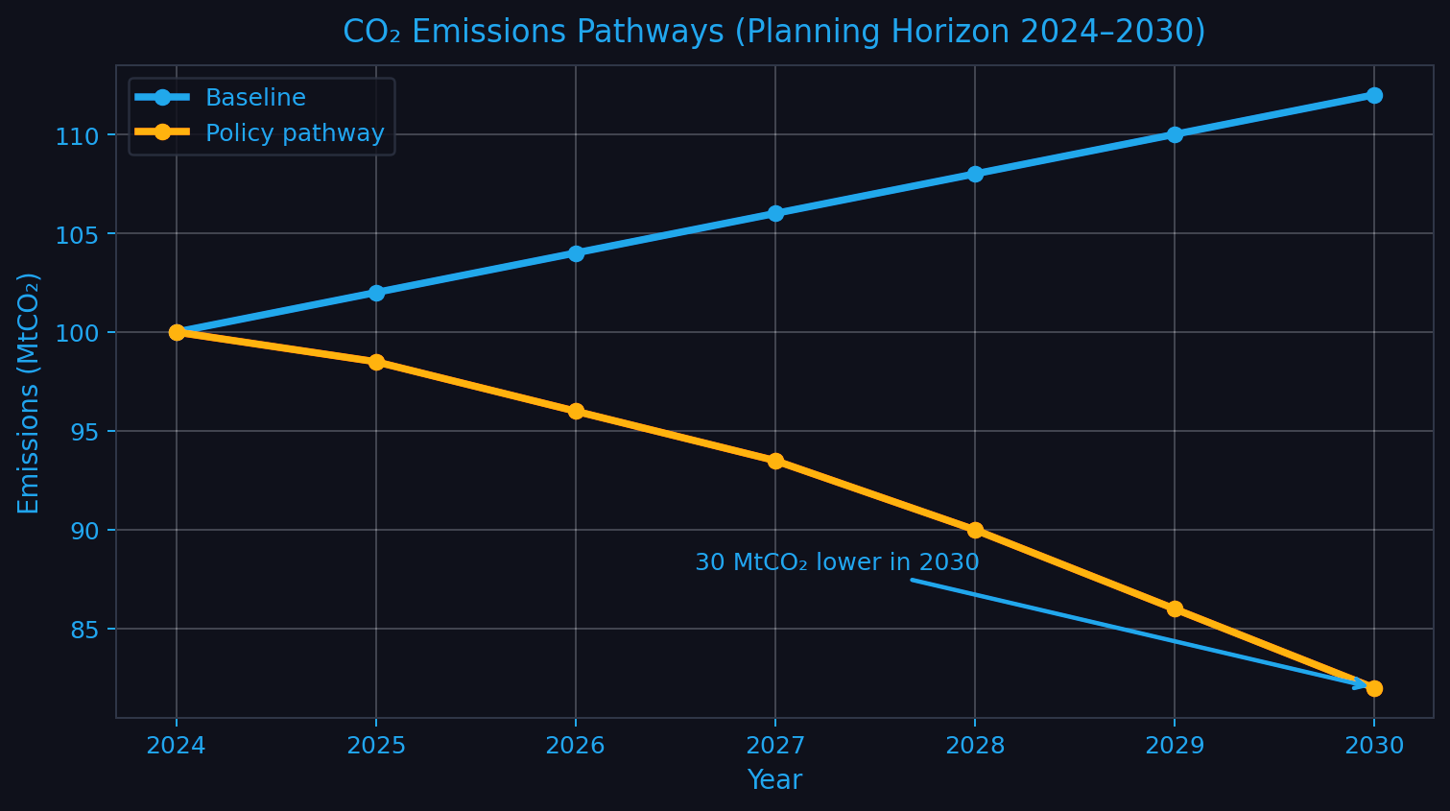
FIGURE 2. CO₂ Emissions Trajectories under Baseline and Policy Scenarios (2024–2030)
This decomposition matters for planning because it clarifies sequencing: grid cleaning must occur early enough to ensure that electrification yields net CO₂ reductions rather than merely shifting emissions upstream.
Driver ranking (elasticities)
The elasticity ranking identifies the most responsive levers:
- Grid carbon intensity shows the highest elasticity (≈0.74), indicating that lowering kgCO₂/kWh has outsized system impact once electrification expands.
- Final energy intensity (MJ/$) is the next strongest (≈0.58), consistent with the role of efficiency standards and industrial modernization.
- Coal share in power remains a high-impact discrete lever due to its carbon intensity.
These rankings are consistent with standardized reporting frameworks and sector evidence that power, industry, and transport are central in mitigation pathways.
The multiscale hierarchy avoids a common planning failure: treating CO₂ drivers as flat lists. Instead, it distinguishes pressure variables (macro activity), transmission variables (meso structure/intensity), and control variables (micro technology choices). In practice:
- Macro layer is useful for bounding scenarios (growth, urbanization), but offers limited direct control.
- Meso layer translates growth into energy demand via infrastructure choices (public transport, district heating, industrial clustering).
- Micro layer delivers most measurable mitigation—fuel switching, renewable build-out, electrification, efficiency, and process change.
- Cross-cutting digitalization (SCADA/AMI, forecasting, DSM) increases “system agility,” reducing peak-driven fossil dispatch and improving the effective utilization of low-carbon generation.
The results confirm that a multiscale, hierarchical classification of CO₂ emission factors provides a robust and transparent framework for sustainable energy system planning. By systematically distinguishing macro, meso, and micro-level drivers, the proposed structure enables clear attribution of emission changes to specific economic, technological, and policy-related factors. The quantitative decomposition and sensitivity analysis demonstrate that power-sector decarbonization and energy-intensity improvements offer the highest mitigation potential, while digital and cross-cutting enablers enhance overall system effectiveness. Consequently, the hierarchical approach supports evidence-based prioritization of decarbonization measures and improves the coherence of long-term low-carbon energy strategies.
CONCLUSIONS
This study developed a rigorous multiscale classification and hierarchical structuring of CO₂ emission factors to support advanced sustainable energy system planning. By coherently integrating macroeconomic pressures, meso-level structural characteristics, and micro-level technological drivers within a unified analytical framework, the research demonstrates how intrinsically complex emission dynamics can be systematically decomposed, quantified, and interpreted. The findings clearly indicate that although macro drivers largely determine the overall magnitude and growth trajectory of emissions, the most substantial and controllable mitigation potential resides at the meso and micro levels. Power-sector decarbonization, sustained reductions in energy intensity, and the accelerated electrification of end-use sectors emerge as the dominant levers for achieving meaningful and durable emission reductions. Moreover, the incorporation of cross-cutting enablers—such as digital monitoring infrastructures, demand-side management mechanisms, and coherent regulatory and policy instruments—significantly enhances system flexibility, coordination, and overall mitigation effectiveness. Beyond its conceptual coherence, the proposed framework offers strong practical relevance, enabling policymakers and energy planners to systematically identify priority intervention points, evaluate trade-offs among competing strategies, and design internally consistent decarbonization pathways aligned with long-term climate objectives. Consequently, this work contributes a scalable, analytically robust tool for evidence-based decision-making in low-carbon energy transitions and establishes a solid foundation for future research integrating region-specific data, uncertainty assessment, and coupled energy–economic modeling approaches.
REFERENCES
- International Energy Agency, World Energy Outlook 2024 (IEA, Paris, 2024).
- G. Peters, R. M. Andrew, J. G. Canadell, et al., “Carbon dioxide emissions continue to grow amidst slowly emerging climate policies,” Nat. Clim. Change 10, 3–6 (2020). https://doi.org/10.1038/s41558-019-0659-6
- K. Hubacek, F. Baiocchi, J. Feng, and K. Patwardhan, “Global carbon inequality,” Energy Policy 107, 130–139 (2017). https://doi.org/10.1016/j.enpol.2017.04.017
- M. Grubb, P. Drummond, and T. Hughes, “The role of energy system transformation in limiting global warming,” Energy Policy 126, 19–29 (2019). https://doi.org/10.1016/j.enpol.2018.11.003
- I. Rakhmonov, M. Korjobova, B. Kholikhmatov, and K. Nimatov, “The role of digitalization in improving energy efficiency in steel smelting in Uzbekistan,” AIP Conf. Proc. 3331(1), 060006 (2025).
- I. Rakhmonov, S. Usmanaliev, Z. Shayumova, and M. Ruzinazarov, “Carbon dioxide (CO₂) filtering, capture, and storage technologies,” AIP Conf. Proc. 3331(1), 040024 (2025).

