Process-Based Assessment of CO₂ Emissions and Energy Efficiency in Industrial Enterprises Considering Power Supply Structure and Fuel Mix
Ikromjon Rakhmonov ^{1, 5}, Laziz Nematov ^{2, a)}, Aqmaral Keunimjaeva ³, Khasan Murodov ⁴
¹Tashkent state technical university named after Islam Karimov, Tashkent, Uzbekistan
² Bukhara State Technical University, Bukhara, Uzbekistan
³Karakalpak State University named after Berdakh, Nukus, Uzbekistan
⁴ Navoi State University of Mining and Technologies, Navoiy, Uzbekistan
⁵Termez State University of Engineering and Agrotechnology, Termez, Uzbekistan
^{a)} Corresponding author: muhammadxon.toirov@gmail.com
Abstract. Energy efficiency assessment in industrial enterprises increasingly requires the integration of environmental indicators, particularly those related to carbon dioxide (CO₂) emissions. This study presents a process-based methodology for evaluating CO₂ emissions and energy efficiency in industrial facilities by explicitly considering the structure of power supply systems and the composition of the fuel mix. The proposed approach quantifies indirect emissions associated with electricity, heat, and steam consumption by linking product-specific energy demand with upstream thermal power plant characteristics, including fuel type, conversion efficiency, and transmission losses. A copper beneficiation plant is used as a representative case study to demonstrate the applicability of the methodology. The results reveal that electricity consumption constitutes the dominant source of CO₂ emissions and that significant variations in emission intensity arise from differences in fuel composition and power plant efficiency. The findings further indicate that reliance on average grid emission factors can lead to substantial underestimation or overestimation of actual emissions. By incorporating supply-specific emission factors and process-level energy balances, the proposed framework enables a more accurate identification of emission drivers and supports informed decision-making for industrial decarbonization. The methodology can be applied to other energy-intensive industries to enhance environmental performance under increasingly stringent climate and carbon regulation policies.
INTRODUCTION
Energy efficiency has increasingly evolved from a purely technical concept into a multidimensional performance indicator that integrates economic, environmental, and regulatory dimensions. Among these dimensions, environmental indicators, particularly those related to carbon dioxide (CO₂) emissions, have become central to assessing the sustainability of industrial enterprises. The ecological effectiveness of energy consumption is now predominantly evaluated through the quantification and control of CO₂ emissions released into the atmosphere as a result of fuel combustion and electricity generation. From a global perspective, the Earth possesses a limited natural capacity to absorb anthropogenic CO₂ emissions. Oceans and forest ecosystems collectively sequester approximately 100 billion tons of atmospheric carbon annually. Assuming an idealized uniform distribution of forests and marine areas, this corresponds to an average absorption potential of roughly 10⁻⁵ tons of CO₂ per square meter per year. Under natural conditions, the volumetric concentration of CO₂ in the atmosphere is approximately 0.04%, a level that is critical for sustaining photosynthesis [1,2]. Concentrations significantly below this threshold impede plant growth, whereas elevated concentrations intensify radiative forcing and accelerate global warming processes. This delicate balance highlights the necessity of maintaining atmospheric CO₂ within scientifically justified limits.
The urgency of mitigating industrial CO₂ emissions has been internationally recognized through the Paris Agreement, which currently encompasses 195 countries and the European Union. Uzbekistan formally acceded to this agreement in April 2017, thereby committing to long-term decarbonization objectives and the implementation of climate-oriented energy policies. In this context, industrial enterprises are increasingly subjected to regulatory mechanisms aimed at reducing carbon intensity, promoting energy-efficient technologies, and internalizing environmental externalities associated with fossil fuel consumption [3,4].
One of the most effective policy instruments introduced in several developed economies is the carbon tax, which assigns a monetary cost to each ton of CO₂ emitted. Countries such as Sweden and France have implemented differentiated carbon taxation schemes that directly link industrial emissions to financial liabilities, thereby incentivizing cleaner production and structural shifts in energy supply.
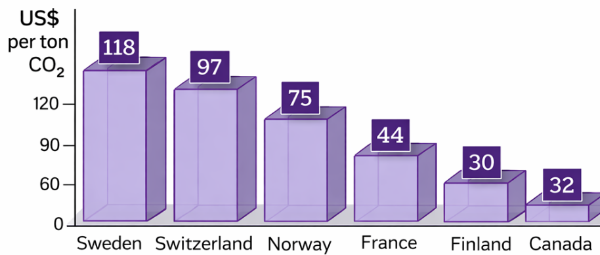
FIGURE 1. Carbon tax levels applied to one ton of CO₂ emissions in selected countries
As shown in Figure 1, the progression toward 5D simulators is characterized by the integration of real-time data, digital twin intelligence, and pedagogical feedback mechanisms, resulting in significantly higher educational value. Recent pilot implementations in technical universities demonstrate that students trained using intelligent VR-based simulators achieve up to 20–35% higher performance in problem-solving and system analysis tasks compared to peers trained using traditional methods [4,5]. The present study aims to develop and analyze a structured framework for the design, development, and validation of 5D educational simulators in engineering training. The proposed approach seeks to combine technological realism with pedagogical rigor, ensuring that advanced simulation tools effectively support competency-based education and align with global best practices in technical higher education.
As illustrated in Figure 1, the magnitude of CO₂ taxation varies considerably across countries, reflecting differences in national climate strategies, energy structures, and industrial profiles. Nevertheless, a common trend is evident: carbon-intensive energy systems are becoming economically disadvantageous, particularly for electricity-dependent industrial enterprises.
Against this background, the accurate and continuous assessment of CO₂ emissions has become a critical operational task. In industrial practice, CO₂ emissions are most reliably quantified using process-based methodologies, where emissions are calculated as a function of product output, energy consumption structure, fuel mix, and conversion efficiencies. This approach enables the attribution of emissions not only to final products but also to upstream energy supply systems, including thermal power plants operating on gas, coal, or fuel oil. Consequently, process-based assessment provides a robust analytical framework for identifying emission hotspots, evaluating the environmental impact of power supply structures, and formulating targeted energy efficiency and decarbonization measures.

RESULT AND DISSCUSSION
The obtained results confirm that process-based CO₂ accounting, when integrated with a detailed analysis of the power supply structure and fuel mix, provides a significantly more accurate representation of the environmental efficiency of industrial enterprises than aggregate or average-based approaches. In the case of the copper beneficiation plant (CBP), CO₂ emissions are not generated directly by the technological process itself but arise predominantly from indirect energy consumption, primarily electricity, heat, and steam supplied by external thermal power plants (TPPs) [6,7].
As illustrated in Figure 2, the copper beneficiation plant receives electricity from several thermal power plants, each characterized by different fuel compositions and conversion efficiencies. This heterogeneity in upstream energy generation leads to pronounced differences in the specific CO₂ emissions associated with the electricity consumed by the plant, even when the delivered electrical energy remains identical in quantity. The total CO₂ emissions associated with industrial production are determined as the product of the specific emission intensity of a unit of output and the total volume of production:
$M_{CO_{2}}=m_{0}⋅Q$ (1)
where $m_{0}$represents the specific CO₂ emission per unit of product and $Q$denotes the total production volume. The results indicate that the value of $m_{0}$is highly sensitive to the energy intensity of production and, more importantly, to the carbon intensity of the energy supply system.
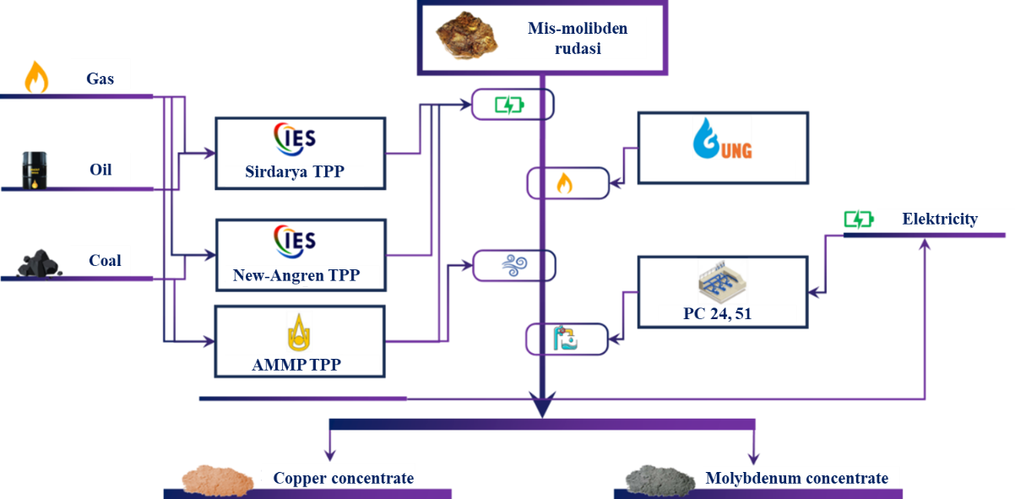
FIGURE 2. Energy resource supply structure of the copper beneficiation plant.
To allocate emissions generated at thermal power plants among electricity, heat, and steam outputs, a weighted energy balance approach was applied. The proportional contribution of electricity to the total useful energy output is expressed as:
$k_{E}=\frac{(E⋅k_{1})/η_{E}}{(E⋅k_{1})/η_{E}+(IE⋅k_{2})/η_{IE}+(SB⋅k_{3})/η_{SB}}$ (2)
Analogous expressions were used to determine the shares of heat and steam production. The analysis shows that electricity accounts for the dominant share of emissions due to its comparatively low average conversion efficiency relative to heat and steam generation. Therefore, electricity consumption emerges as the principal driver of indirect CO₂ emissions at the beneficiation plant.
The total CO₂ emissions generated at each thermal power plant were calculated as the sum of emissions associated with individual fuel types:
$m=G⋅k_{G}^{CO_{2}}+K⋅k_{K}^{CO_{2}}+M⋅k_{M}^{CO_{2}}$ (3)
where natural gas, coal, and fuel oil consumption are considered separately. The results clearly demonstrate that coal-based electricity generation exhibits the highest carbon intensity, followed by fuel oil and natural gas. Consequently, power plants with a higher share of coal in their fuel mix contribute disproportionately to the overall CO₂ footprint of the industrial consumer.
The specific CO₂ emissions associated with electricity, heat, and steam production were derived by normalizing total emissions to useful energy output. The findings reveal that the carbon intensity of electricity supplied to the beneficiation plant can vary by more than 25–30% depending solely on the fuel structure of the supplying power plants. This variability highlights the limitations of using uniform grid-average emission factors in industrial environmental assessments.
Because the copper beneficiation plant is supplied by multiple thermal power plants, the overall CO₂ emission intensity of electricity was determined as a capacity-weighted average:
$m^{IES}=\frac{∑(m_{E}⋅P)}{∑P}$ (4)
where $P$denotes the installed capacity of each supplying power plant. The results confirm that power plants with larger installed capacities exert a dominant influence on the final emission factor applied to industrial electricity consumption. This finding emphasizes the importance of considering power supply topology in environmental performance evaluations.
Transmission and distribution losses were incorporated through an efficiency correction factor:
$m=\frac{m^{IES}}{η}$ (5)
Accounting for network losses increases the effective CO₂ emissions attributed to electricity consumption by approximately 8–12%, depending on grid conditions. This adjustment proves essential for avoiding systematic underestimation of indirect emissions.
Finally, the specific CO₂ emission per unit of processed concentrate was calculated as:
$m_{0}=\frac{∑(m_{i}⋅IR_{i})}{M}$ (6)
where $IR_{i}$represents the consumption of individual energy resources and $M$denotes the total mass of processed concentrate. The results demonstrate that energy supply characteristics exert a stronger influence on product-specific emissions than production volume alone.
The analysis confirms that improving energy efficiency within the beneficiation process, while necessary, is insufficient to achieve substantial emission reductions without parallel optimization of the upstream power supply system. Even moderate changes in fuel mix—such as increased reliance on natural gas or low-carbon electricity—can significantly reduce the CO₂ intensity of final products. Therefore, effective decarbonization of industrial enterprises requires an integrated approach that combines process optimization, power supply restructuring, and energy policy interventions.
CONCLUSIONS
The results of this study underline the importance of evaluating CO₂ emissions in industrial enterprises through a process-based perspective that incorporates the characteristics of power supply systems and fuel composition. The analysis shows that, for a copper beneficiation plant, indirect emissions linked to electricity, heat, and steam consumption represent the dominant portion of the overall carbon footprint, while direct process-related emissions remain limited. As a result, simplified approaches relying on average grid emission factors fail to capture the true scale and origin of industrial CO₂ emissions.
A key outcome of the analysis is the identification of the power generation stage as a critical determinant of emission intensity. Variations in fuel mix and energy conversion efficiency at upstream thermal power plants lead to substantial differences in the carbon intensity of electricity delivered to industrial consumers. Coal-based generation pathways exhibit the highest CO₂ emissions, whereas natural-gas-based generation offers a comparatively lower-carbon alternative. When transmission losses are taken into account, these differences become even more pronounced at the level of final products.
The findings further suggest that measures aimed solely at reducing energy consumption within the production process are not sufficient to achieve significant emission reductions. Meaningful progress toward decarbonization requires coordinated actions that combine process-level efficiency improvements with structural changes in the power supply system, including cleaner fuel substitution and higher overall conversion efficiencies.
REFERENCES
- IPCC, 2006 IPCC Guidelines for National Greenhouse Gas Inventories, Vol. 2: Energy (Intergovernmental Panel on Climate Change, Geneva, 2006).
- M. Fischedick, R. Roy, A. Abdel-Aziz, et al., “Industry,” in Climate Change 2014: Mitigation of Climate Change, Contribution of Working Group III to the Fifth Assessment Report of the IPCC (Cambridge University Press, Cambridge, 2014), pp. 739–810.
- J. J. Klemeš, P. S. Varbanov, and D. Huisingh, “Recent cleaner production advances in process monitoring and optimization,” Journal of Cleaner Production 34, 1–8 (2012). https://doi.org/10.1016/j.jclepro.2012.04.026
- I. Rakhmonov, Z. Shayumova, K. Reymov, and L. Nematov, “Energy efficiency indicators,” AIP Conference Proceedings 3152(1), 020002 (2024).
- L. Schipper, S. Meyers, and L. J. Price, “Energy efficiency and human activity: Past trends, future prospects,” Energy Policy 25, 273–290 (1997). https://doi.org/10.1016/S0301-4215(97)00007-5
- A. W. van den Bos, E. Worrell, and M. A. Neelis, “Long-term energy efficiency improvement in the global steel industry,” Energy 38, 61–75 (2012). https://doi.org/10.1016/j.energy.2011.12.040
- I. Rakhmonov, S. Usmanaliev, Z. Shayumova, and M. Ruzinazarov, “Carbon dioxide (CO₂) filtering, capture, and storage technologies,” AIP Conference Proceedings 3331(1), 040024 (2025).

