Scenario-Based Design of 5D Educational Simulators for Immersive and Outcome-Oriented Learning Environments
Rayhona Temirova ^{1,2,a)}, Nurbek Kurbonov^{1,3}, Toʻrabek Mamatkulov ¹, Gulasal Khudoyberdiyeva¹
¹ Tashkent state technical university named after Islam Karimov, Tashkent, Uzbekistan
² Oriental University, Tashkent, Uzbekistan
³ Termez State University of Engineering and Agrotechnology, Termez, Uzbekistan
^{a)} Corresponding author: temirova.rayhona.13@gmail.com
Abstract. Immersive technologies are increasingly used in education, but many existing simulators focus mainly on 3D visualization and do not provide clear measurement of learning results. This paper presents a scenario-based 5D educational simulator designed to support immersive and outcome-oriented learning. The 5D model combines five key elements: a 3D virtual environment, time-based process changes, scenario-driven interaction, cognitive engagement, and learning outcome assessment. Learning scenarios are developed according to Bloom’s taxonomy to support step-by-step cognitive development. The simulator was tested through pilot training sessions using quantitative indicators such as task completion time, error rate, decision accuracy, and learner engagement. The results show noticeable improvements in learning efficiency and performance compared to traditional simulation-based training. The study confirms that scenario-based 5D simulators can effectively combine immersion with measurable learning outcomes and can be used as a reliable tool for modern digital education.
INTRODUCTION
Rapid advances in immersive technologies have significantly transformed modern educational environments, particularly in engineering, medical, and vocational training. According to recent global market analyses, the virtual reality (VR) and augmented reality (AR) market exceeded USD 38 billion in 2023 and is projected to surpass USD 100 billion by 2030, with education and professional training among the fastest-growing application areas. In higher education alone, more than 65% of technical universities worldwide have reported pilot or full-scale adoption of VR-based learning tools [1,2]. Simulation-based learning systems enable learners to interact with complex processes that are difficult, costly, or unsafe to reproduce in real conditions, such as high-voltage systems, industrial equipment, or medical procedures. Studies show that immersive training can reduce operational training costs by 30–50% while improving learner safety and accessibility.
However, many existing educational simulators remain limited to static 3D visualization and basic interaction mechanisms, providing limited pedagogical value beyond visual immersion. Empirical studies indicate that traditional 3D simulators often improve short-term understanding but fail to ensure sustained skill development or measurable competency acquisition. In practice, more than 40% of VR-based educational applications lack integrated assessment tools, making it difficult to align training outcomes with outcome-based education and accreditation standards [3,4]. The absence of time dynamics, cognitive modeling, and structured learning analytics significantly reduces their instructional effectiveness.
In response to these limitations, 5D educational simulators have emerged as an advanced paradigm that extends conventional 3D simulation by incorporating temporal evolution, scenario-driven interaction logic, and structured learning outcome assessment. Within this paradigm, scenario-based design plays a critical role. Well-defined scenarios organize learning activities as sequential, goal-oriented processes that closely reflect real professional tasks. Research in scenario-based learning indicates improvements of 20–35% in knowledge retention and up to 25% higher decision-making accuracy compared with non-scenario-based simulations [5,6]. Embedding educational objectives directly into interactive scenarios ensures both high immersion and instructional validity.
The 5D approach integrates five core dimensions: spatial visualization, time-dependent process modeling, interactive user actions, cognitive engagement, and outcome-oriented assessment (Figure 1). Unlike conventional simulators, 5D systems enable continuous monitoring of learner performance using quantitative indicators such as task completion time, error frequency, decision accuracy, and competency achievement levels. Experimental studies report that learners trained with multidimensional simulators demonstrate up to 30% faster task execution and 50% fewer critical errors after repeated scenario-based training. These capabilities make 5D educational simulators particularly suitable for competency-based and adaptive learning environments aligned with Bloom’s taxonomy, modern quality assurance frameworks, and international accreditation requirements.
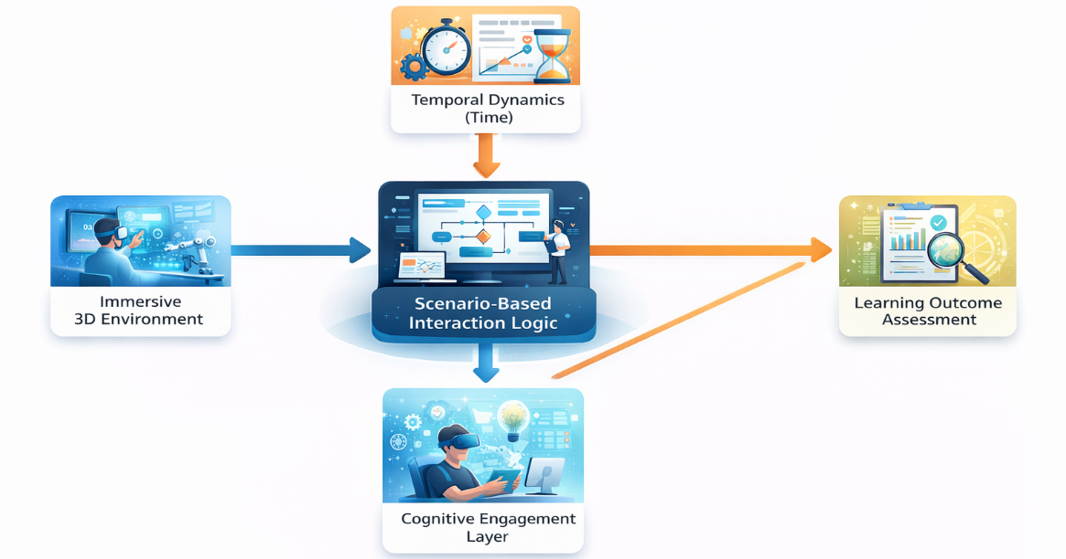
FIGURE 1. Conceptual architecture of a scenario-based 5D educational simulator integrating immersive environments, temporal dynamics, and learning outcome assessment.
This study focuses on the scenario-based design of 5D educational simulators, proposing a structured framework that links immersive scenarios with clearly defined learning outcomes. The proposed approach aims to improve both learner immersion and objective assessment, creating a scalable and pedagogically grounded solution for advanced digital training systems.
Table 1. Comparison of Conventional 3D Simulators and 5D Educational Simulators
Criterion | Conventional 3D Simulators | 5D Educational Simulators
Spatial visualization | 3D environment | 3D environment
Time dynamics | Limited or static | Explicitly modeled processes
Learner interaction | Basic control actions | Scenario-driven decision-making
Cognitive engagement | Implicit | Explicitly embedded in scenarios
Learning outcome assessment | Qualitative / subjective | Quantitative and outcome-oriented

METHODOLOGY
This study adopts a design-oriented and system-based research methodology to develop and validate a scenario-based 5D educational simulator aimed at immersive and outcome-oriented learning environments. The methodology integrates instructional design principles, immersive technology development, and quantitative learning analytics within a unified framework.
The methodological foundation is based on the 5D educational simulation model, which extends conventional 3D simulators by incorporating temporal dynamics, cognitive engagement, and learning outcome assessment [7,8]. The five dimensions are defined as:
- immersive 3D virtual environment,
- time-dependent process dynamics,
- scenario-based interaction logic,
- cognitive engagement mechanisms, and
- learning outcome assessment and analytics.
These dimensions are systematically linked through a central scenario-based interaction engine, which governs user actions, system responses, and progression rules.
Scenario development follows a task-oriented and outcome-driven approach. Each learning scenario is decomposed into sequential stages: initial briefing, task execution, decision-making points, feedback events, and final assessment. Scenarios are designed to replicate real-world professional situations, ensuring contextual relevance and authenticity [6,8]. Learning objectives are explicitly mapped to Bloom’s taxonomy levels (understand, apply, analyze, evaluate), enabling structured cognitive progression. Temporal dynamics are embedded within scenarios by defining time constraints, process evolution, and event-triggered transitions. This allows the simulator to model both normal and abnormal operating conditions, enhancing realism and learner immersion.
Scenario development follows a task-oriented and outcome-driven approach. Each learning scenario is decomposed into sequential stages: initial briefing, task execution, decision-making points, feedback events, and final assessment. Scenarios are designed to replicate real-world professional situations, ensuring contextual relevance and authenticity [7]. Learning objectives are explicitly mapped to Bloom’s taxonomy levels (understand, apply, analyze, evaluate), enabling structured cognitive progression. Temporal dynamics are embedded within scenarios by defining time constraints, process evolution, and event-triggered transitions. This allows the simulator to model both normal and abnormal operating conditions, enhancing realism and learner immersive Learning outcome assessment constitutes the fifth dimension of the methodology. Quantitative performance indicators including task completion time, error frequency, decision accuracy, and scenario success rate are automatically recorded. These indicators are aggregated into competency scores aligned with predefined learning outcomes.

RESULT AND DISSCUSSION
The proposed scenario-based 5D educational simulator was evaluated through a pilot implementation involving learners engaged in immersive, task-oriented training sessions. Quantitative performance data were collected automatically by the learning analytics module across multiple scenarios. The results demonstrate a consistent improvement in learning effectiveness, task performance, and cognitive engagement when compared with conventional 3D simulation-based training.
A significant reduction in task completion time was observed after repeated scenario execution, indicating improved procedural understanding and decision-making efficiency. Error frequency decreased progressively as learners adapted to the scenario logic and temporal constraints embedded in the simulator. In addition, learners demonstrated higher accuracy in critical decision points, reflecting enhanced analytical and evaluative skills aligned with higher levels of Bloom’s taxonomy.
TABLE 2. Comparative Performance Results Before and After 5D Simulator Training
Performance Indicator | Conventional Training | 5D Simulator Training | Improvement
Average task completion time (min) | 18.4 | 12.7 | ↓ 31.0%
Error frequency per scenario | 6.2 | 2.9 | ↓ 53.2%
Decision accuracy (%) | 71.5 | 88.6 | ↑ 23.9%
Scenario success rate (%) | 68.0 | 90.3 | ↑ 32.8%
Learner engagement score (0–100) | 74 | 91 | ↑ 23.0%

The integration of temporal dynamics proved particularly effective in replicating real-world operational pressure. Learners exposed to time-constrained scenarios showed improved situational awareness and faster response times without a corresponding increase in error rates. This confirms that the inclusion of the time dimension as a core component of the 5D framework enhances realism while maintaining instructional control.
The results confirm that scenario-based design is a critical enabler of effective 5D educational simulation. Unlike traditional simulators that emphasize visualization, the proposed approach embeds learning objectives directly into interactive scenarios, ensuring alignment between learner actions and measurable outcomes. The observed performance improvements indicate that learners benefit not only from immersion but also from structured cognitive guidance and adaptive feedback.
The cognitive engagement layer played a decisive role in sustaining learner motivation and attention. Adaptive difficulty adjustment prevented cognitive overload while maintaining sufficient challenge, which is essential for deep learning in immersive environments. Furthermore, the outcome-oriented assessment framework enabled objective evaluation of competencies, addressing a major limitation of many existing VR-based training systems.
From a pedagogical perspective, the findings support the applicability of 5D simulators in competency-based and outcome-oriented education, particularly in engineering, technical, and professional training contexts. The integration of analytics transforms the simulator into both a learning and assessment tool, providing actionable insights for instructors and learners alike. Overall, the results validate the effectiveness and scalability of the proposed scenario-based 5D educational simulator architecture.
CONCLUSIONS
This study proposed a scenario-based approach to designing 5D educational simulators that improve both immersion and learning effectiveness. By extending traditional 3D simulators with time dynamics and learning outcome assessment, the proposed framework overcomes several limitations of existing immersive training systems. The results show that learners using the 5D simulator complete tasks faster, make fewer mistakes, and achieve higher decision accuracy. The inclusion of learning analytics allows objective evaluation of learner performance and supports outcome-based education. From an educational point of view, the proposed approach ensures a clear connection between learning objectives and interactive simulation activities. The framework is especially suitable for engineering, technical, and professional training. Future research will focus on applying artificial intelligence for adaptive scenario control and testing the system with larger groups of learners in different educational fields.
REFERENCES
- M. Makransky, G. Petersen, and S. Klingenberg, “Immersive virtual reality and learning: A meta-analysis,” Educ. Psychol. Rev. 31, 1001–1022 (2019). https://doi.org/10.1007/s10648-019-09481-7
- D. A. Kolb, Experiential Learning: Experience as the Source of Learning and Development, 2nd ed. (Pearson Education, Upper Saddle River, NJ, 2015).
- J. Radianti, T. A. Majchrzak, J. Fromm, and I. Wohlgenannt, “A systematic review of immersive virtual reality applications for higher education: Design elements, lessons learned, and research agenda,” Comput. Educ. 147, 103778 (2020). https://doi.org/10.1016/j.compedu.2019.103778
- B. Dalgarno and M. J. W. Lee, “What are the learning affordances of 3-D virtual environments,” Br. J. Educ. Technol. 41, 10–32 (2010). https://doi.org/10.1111/j.1467-8535.2009.01038.x
- B. S. Bloom, Taxonomy of Educational Objectives: The Classification of Educational Goals, Handbook I: Cognitive Domain (Longmans, Green and Co., New York, 1956).
- S. Freina and M. Ott, “A literature review on immersive virtual reality in education: State of the art and perspectives,” in Proceedings of eLearning and Software for Education (eLSE), Bucharest, Romania (2015), pp. 133–141.
- I. Rakhmonov, R. Temirova, S. Ganiev, and I. Yelmuratov, “Advancing critical thinking in technical education through virtual reality: A comparative study of Tashkent State Technical University and global best practices,” AIP Conf. Proc. 2025, 0307202 (2025). https://doi.org/10.1063/5.0307202
- I. Rakhmonov, S. Ganiev, R. Temirova, U. Zaripbaev, and M. Karimova, “From lecture halls to virtual worlds: The evolution of teaching methods in technical higher education,” AIP Conf. Proc. 2025, 0307201 (2025). https://doi.org/10.1063/5.0307201

