Issues of Energy Efficiency in Thyristor-Controlled Reactive Power Compensators
Olimjon Toirov^{1,a)}, Shokhrukh Azimov¹, Zuvur Toirov²,
Minwu Chen³$,$Yinyu Chen³, Wie Yu⁴
¹Tashkent State Technical University named after Islam Karimov, Tashkent, Uzbekistan
²Bukhara State Technical University, Bukhara, Uzbekistan
³Southwest Jiaotong University, Chengdu, China
⁴Wuhan University, Wuhan, China
^{a)} Corresponding author: olimjon.t@mail.ru
Abstract. This paper is devoted to a scientifically grounded analysis of the impact of reactive power on voltage stability and power factor in railway power supply systems, the evaluation of the operating characteristics of thyristor-controlled reactive power compensation systems, and the identification of ways to improve their energy efficiency and reliability. In order to calculate and control reactive power in real time, a mathematical model based on the instantaneous power theory proposed by Akagi was developed and its suitability for fast control algorithms was substantiated. A comparative analysis of the technical characteristics of various reactive power compensators was carried out. The paper analyzes heat dissipation in thyristor-controlled capacitor devices, thermal resistance networks, natural and forced air cooling as well as liquid cooling methods, and commutation processes. Factors affecting the overall efficiency of the compensation system are studied, and scientifically substantiated solutions are proposed.
INTRODUCTION
Due to the rapid development of the economy, the growth in the number of large and small enterprises, and the improvement of living standards, energy consumption in households has also increased significantly. As demand for electrical networks continues to rise, the requirements for stable operation of power systems are becoming more stringent. Reactive power has a significant influence on electrical networks, as it not only causes voltage drops but also deteriorates voltage stability. In addition, the share of active power transmitted through power lines decreases, energy losses increase, and substantial amounts of electrical energy are wasted [1]. Therefore, reactive power compensation in power systems is of great importance—it reduces reactive current in transmission networks, improves power balance, enhances equipment efficiency, and ensures stable network operation. As the demand for reactive power by electrical equipment continues to grow, the distribution of reactive power in power networks becomes increasingly complex, and the demand for advanced reactive power compensation technologies rises year by year [2]. The capabilities of conventional equipment are no longer sufficient to fully meet modern requirements. In modern power systems, when high-power and high-speed compensation is required, synchronous compensators are gradually being replaced by shunt capacitor banks and electronically controlled compensators [3]. Shunt capacitors are one of the simplest, most reliable, and cost-effective means of reactive power compensation and voltage stabilization. They feature a simple structure, ease of installation, operation, and maintenance, and high economic efficiency. The reactive power supplied by a capacitor $Qc$ can be expressed as follows, assuming constant voltage $U$:

$Q_{c}=\frac{U^{2}}{X_{c}}$ (1)
Where,
$X_{c}=\frac{1}{ωC}$ (2)
After simplifying the formula:
$$\begin{matrix} & Q_{c}=U^{2}ωC & & \text{ (3)}\end{matrix}$$
It can be seen from expression (3) that under reduced voltage conditions a deficit of reactive power arises in the power network 4]. When the voltage drops, the reactive power supplied by the capacitor decreases, which in turn reduces the effectiveness of compensation. Moreover, due to the inherent characteristic of capacitors to supply a fixed amount of reactive power, situations of overcompensation or insufficient compensation may occur when system loads are variable. In addition, if harmonics are present in the network, parallel resonance phenomena may occur, leading to further amplification of harmonic currents. Currently, the most widely used reactive power compensation devices include the static reactive power compensator (SVC), the static reactive power generator (SVG), and the unified power flow controller (UPFC). The SVC operates on the principle of controlled connection and disconnection of reactors and capacitors by means of thyristor control. Its advantages include high response speed, short dynamic response time, almost complete absence of mechanical components, long service life, effective mitigation of voltage fluctuations, and improved system stability [5-7]. For these reasons, the SVC has become one of the most effective methods for reactive power control in electric power systems. An SVC is typically composed of a combination of thyristor-switched capacitor (TSC) elements.
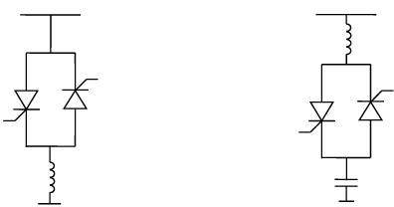
FIGURE 1. SVC-type static reactive power compensator

By monitoring the grid voltage in real time, reactive power compensation is achieved through precise switching on and off of thyristors at specific moments (Fig. 1). Compared to mechanical switches, the thyristor-switched capacitor (TSC) has the following advantages:
- absence of contacts eliminates mechanical wear;
- very fast and accurate switching process;
- the capacitor can be connected to the grid without inrush current;
- the commutation instant is precisely controlled;
- simple design with high reliability;
- low energy consumption;
- does not amplify harmonic components.

EXPERIMENTAL RESEARCH
In an electric power system, the phase difference between voltage and current plays a very important role. The greater the phase difference, the lower the efficiency of the system [8-10]. Therefore, in engineering practice, power is commonly defined as follows:
$S=UI$ (4)
This represents the apparent power.
The ratio of active power to apparent power is called the power factor:
$λ=P/S$ (5)As can be seen from equation (5), when the phase angle between current and voltage is small, the power factor is high, which indicates efficient utilization of the energy source. In other words, when, λ → 1 the system operates very efficiently and almost all the power is usefully utilized. When λ is small, excessive reactive power is present in the system, resulting in increased energy losses. When cosφ → 1 only energy exchange occurs between the source and the load. Therefore, in linear sinusoidal electrical circuits, the physical meaning of the power factor can be expressed as follows.
$λ=cos⁡φ$ (6)
Let us consider the relationship between
$S^{2}=P^{2}+Q^{2}$ (7)
Based on equation (16), the reactive power can be determined as follows.
$Q=\sqrt{S^{2}-P^{2}}$ (8)
In three-phase AC systems, active power and reactive power are equal to the sums of the phase active powers and phase reactive powers, respectively.
The instantaneous power theory was first proposed in the 1980s by the Japanese scientist H. Akagi. Subsequently, he expanded the concepts of instantaneous voltage, instantaneous current, instantaneous active power, and instantaneous reactive power [11-13]. The objective of the instantaneous power theory is to solve the problem of real-time calculation of reactive power in order to achieve fast and accurate reactive power compensation. Akagi developed the instantaneous reactive power theory for three-phase systems by transforming them into the $α-β$ coordinate system.
The scientist transforms the three-phase ABC voltages and currents into a two-phase stationary $α-β$ coordinate system using the following transformation matrix:
$[\begin{aligned}u_{α} \\ u_{β}\end{aligned}]=\frac{2}{3}[\begin{matrix}1 & -\frac{1}{2} & -\frac{1}{2} \\ 0 & \frac{\sqrt{3}}{2} & -\frac{\sqrt{3}}{2}\end{matrix}][\begin{aligned}u_{a} \\ u_{b} \\ u_{c}\end{aligned}]$ (9)
Similarly, three-phase currents are also transformed into the $α-β$ coordinate system.
$[\begin{aligned}i_{α} \\ i_{β}\end{aligned}]=\frac{2}{3}[\begin{matrix}1 & -\frac{1}{2} & -\frac{1}{2} \\ 0 & \frac{\sqrt{3}}{2} & -\frac{\sqrt{3}}{2}\end{matrix}][\begin{aligned}i_{a} \\ i_{b} \\ i_{c}\end{aligned}]$ (10)
$In the α-β$ coordinate system, the instantaneous active power $p$and instantaneous reactive power q are expressed as follows.
$\{\begin{aligned}p=\frac{3}{2}(u_{α}i_{α}+u_{β}i_{β}) \\ q=\frac{3}{2}(u_{α}i_{β}-u_{β}i_{α})\end{aligned}$ (11)
If the three-phase currents and voltages of the system are perfectly symmetrical three-phase sinusoidal waveforms, that is:
3$\{\begin{aligned}p=\frac{3}{2}(u_{α}i_{α}+u_{β}i_{β})=3U_{N}I_{N}cos⁡(φ_{u}-φ_{i}) \\ q=\frac{3}{2}(u_{α}i_{β}-u_{β}i_{α})=3U_{N}I_{N}sin⁡(φ_{u}-φ_{i})\end{aligned}$ (12)
From the results obtained above, it can be seen that the values of instantaneous active power $p$and instantaneous reactive power $q$are fully equal to the conventional active and reactive power values calculated by the traditional method, and they remain constant quantities. However, it should be noted that, within the instantaneous power theory, it is sufficient to know only the instantaneous values of three-phase voltage and current to calculate active and reactive power [14-16]. This significantly accelerates the calculation process and creates favorable conditions for real-time reactive power compensation. In contrast, the conventional theory requires integral values of voltage and current over an entire period, which slows down the computation.
If the three-phase currents and voltages in the system are perfectly symmetrical three-phase sinusoidal waveforms, that is:
$\begin{matrix} & \{\begin{aligned}p=\frac{3}{2}(u_{α}i_{α}+u_{β}i_{β})=3U_{N}I_{N}cos⁡(φ_{u}-φ_{i}) \\ q=\frac{3}{2}(u_{α}i_{β}-u_{β}i_{α})=3U_{N}I_{N}sin⁡(φ_{u}-φ_{i})\end{aligned} & & \end{matrix}$ (13)
RESEARCH RESULTS
The instantaneous active power $p$and instantaneous reactive power $q$fully correspond to the active and reactive powers calculated using the conventional method. They are constant values and are numerically equal to those obtained by the traditional approach. In the instantaneous reactive power theory, only the instantaneous values of three-phase voltage and current are required, which significantly reduces computation time. This method provides a theoretical basis for fast reactive power compensation. In contrast, the conventional theory requires values integrated over an entire period, i.e., voltage and current values over one cycle, which slows down the calculation process.
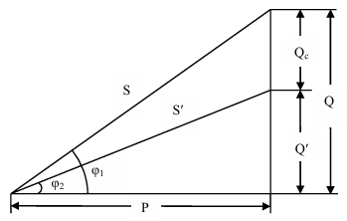
FIGURE 2. Vector diagram of reactive power compensation

$$Q - reactive power before compensation;$$
$$Q^{'} - reactive power after compensation;$$
$$Qᶜ - reactive power of the capacitor \left(compensation amount\right);$$
$$P - active power;$$
$$S - apparent power before compensation;$$
$$S^{'} - apparent power after compensation;$$
$$φ^{1}- power factor angle before compensation;$$
$$φ^{2}- power factor angle after compensation.$$

Assuming the active power $P$remains constant, the compensation amount is determined as follows.
$Q_{c}=Q-Q^{'}$ (14)
The reactive power supplied by the power source is reduced from $Q$to $Q^{'}$. As a result of compensation, the power factor angle decreases from $φ_{1}$to $φ_{2 }$(Fig. 2); therefore:
$$\cos{φ_{1} }→ \cos{φ_{2}}$$
An increase in the power factor significantly enhances the efficiency of the electrical energy source while reducing losses in the power network. In reactive power compensators, thyristors operate under high voltage and large current conditions. As a result, a considerable amount of heat is generated within the thyristor semiconductor structure. If this heat is not adequately dissipated, the crystal temperature may exceed the permissible maximum value, which can lead to device failure, a sharp reduction in service life, or the occurrence of emergency operating modes. Therefore, special attention is paid to the thermal operating conditions of thyristors and to the design of the cooling system in reactive power compensation devices. At present, one of the most critical factors ensuring the reliable operation of reactive power compensation devices used in railway power supply systems is the reliability of the cooling system. The load current flowing through thyristors in the contact network feeders of traction substations in electrified railway power supply systems can reach up to 2200 A, which results in significant heating of the thyristors. To maintain the thyristor temperature within permissible limits, a liquid coolant (ethylene glycol) is used. However, this liquid loses its properties over a certain period (approximately one year), which leads to deterioration of the parameters of the compensation devices. As a consequence, protective relays impose operational restrictions on the equipment [17-20]. To monitor the condition of the coolant, relays measuring up to ten different parameters are installed, including coolant density, electrical conductivity, specific resistance, temperature, concentration, pressure, and others. Degradation of these parameters can ultimately result in malfunction of the compensation system.
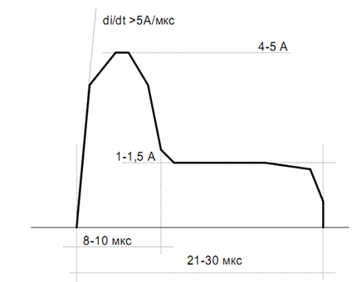
FIGURE 3. Time-domain waveform of the gate current pulse applied to the control electrode for thyristor turn-on

This block diagram (Fig. 3) illustrates the automatic control algorithm for connecting and disconnecting capacitors in a thyristor-controlled TSC-type reactive power compensator. The main objective of the algorithm is to provide the required level of reactive power compensation in the system while protecting the capacitors from excessive switching operations [21-24].
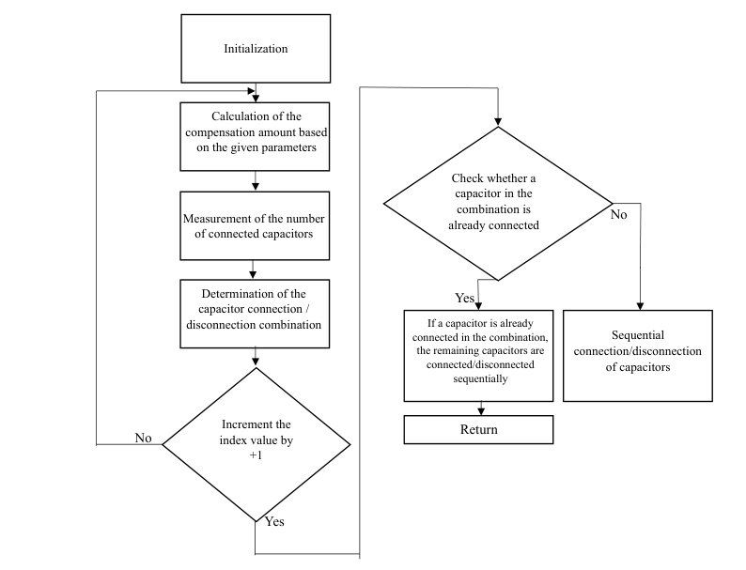
FIGURE 4. Block diagram of capacitor connection/disconnection in a thyristor-controlled compensation device
Within this model, the three-phase currents and voltages of the network are monitored in real time, and the switching processes of the control thyristors are continuously supervised. As a result, effective reactive power compensation is achieved. The presented block diagram represents the automatic control algorithm for capacitor connection and disconnection in a thyristor-controlled TSC-type reactive power compensator. The primary goal of the algorithm is to ensure the required reactive power compensation for the system and to prevent excessive commutation of the capacitors. Through this model, the three-phase currents and voltages of the network are observed in real time, and the switching-on and switching-off processes of the control thyristors are regulated [25-29]. Consequently, reactive power compensation is accomplished. The generated control signals drive twelve pairs of thyristors in the TSC device. Specifically, the opening or closing of the thyristors determines the number of capacitors connected to the grid, thereby defining the degree of reactive power compensation.
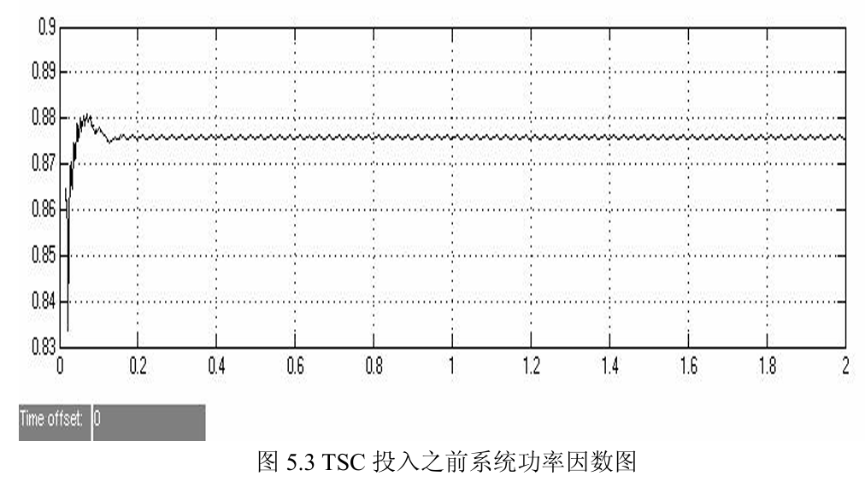
FIGURE 5. Power factor curve of the system after connecting the thyristor-controlled capacitor

After the simulation was carried out, the results were analyzed based on the values of the power factor cosφ As shown in Fig. 5, when the TSC is not connected, the system power factor lies in the range of $0.87-0.88,$ which does not fully satisfy the requirements of the power supply authority. This indicates a low level of energy utilization efficiency. According to Fig. 6, at approximately 0.4 s, the TSC device begins to connect through the firing of the thyristors, and from this moment the power factor gradually increases. After 0.6 s, the system reaches a steady state, and the power factor is maintained within the range of $0.96-0.98$ [30-33]. These values fully meet the requirements set by the power supply authority for reactive power compensation and are in complete agreement with the expected results.
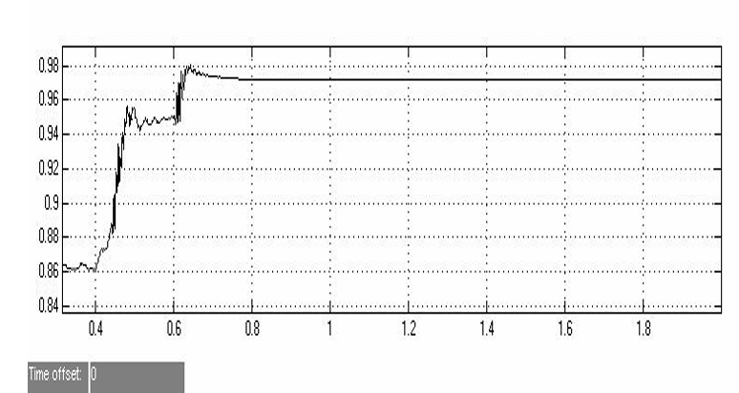
FIGURE 6. Graph of the system power factor after connecting a thyristor-controlled capacitor.

This demonstrates that the proposed system is capable of compensating reactive power with high efficiency, reducing reactive current, minimizing system losses, and simultaneously significantly improving system stability.
To ensure reliable operation of thyristors, the control pulses applied to them must be formed in accordance with specific current and time parameters. The control of a thyristor depends on the typical shape of the gate current pulse, which clearly defines how the control signal varies over time. At the beginning of the pulse, the current rises very rapidly. This stage is critically important for reliable turn-on of the thyristor. When the pulse reaches its peak value, the gate current is approximately 4–5 A. Even though this maximum current is applied for a short duration, it is sufficient to trigger thyristor conduction.In the subsequent part of the pulse, the current decreases to 1–1.5 A and is maintained for 21–30 μs, which is sufficient to keep the thyristor in the conducting state. The total pulse duration is approximately 30–40 μs. As shown in Fig. 3, the rapid rise portion occurs within 8–10 μs, while the holding portion extends over 21–30 μs.If the control pulse applied to the thyristor does not have a sufficient current magnitude or an appropriate waveform, the thyristor may fail to turn on or may turn on with a delay; moreover, instability or unintended turn-off and oscillations may occur during conduction. Therefore, parameters such as the gate current amplitude, the di/dt rate, and the pulse duration are of critical importance in thyristor control. Compliance with these requirements ensures stable thyristor operation and reliable control of power electronic circuits.
CONCLUSIONS
- Existing technical means for reactive power compensation (shunt capacitors, SVC, STATCOM) were compared, and it was proven that a thyristor-controlled capacitor–based compensation system is the most suitable solution for railway power supply conditions. The absence of mechanical contacts, fast switching capability, and inrush-current-free connection of the TSC device were identified as clear technical advantages.
- It was established that applying the TSC device in a star (Y) connection enables independent compensation of each phase. This solution was scientifically substantiated as being particularly effective for railway power supply systems with three-phase unbalanced loads.
- The instantaneous power theory proposed by Akagi was applied for reactive power detection and control. Based on this theory, it was shown through mathematical expressions that reactive power can be determined in real time using only instantaneous values of voltage and current. This approach significantly increases computational speed compared with conventional integral methods.
- An automatic control algorithm for the TSC-based compensation system was developed. The algorithm provides continuous monitoring of grid voltage and current, determines reactive power demand, and ensures optimal connection/disconnection of capacitor groups.
- The results showed that, without TSC connection, the system power factor was in the range cosφ = 0.87–0.88. After the TSC device was connected and the compensation process started, the system stabilized within 0.6 s, and the power factor reached cosφ = 0.96–0.98. These values fully comply with the норматив (standard) requirements for electric power supply systems.
- During the study, special attention was paid to the thermal operating conditions of thyristors and the reliability of the cooling system. It was found that heat dissipation in thyristors operating under high currents (up to 2200 A) can significantly reduce device reliability. Therefore, proper design of forced air and liquid cooling systems was justified as a critical factor for ensuring continuous and safe operation of the compensation system.
REFERENCES
- O. Toirov, K. Allaev, J. Toshov, Modern state of the energy sector of Uzbekistan and issues of their development, E3S Web of Conferences 401, 05090 (2023). https://doi.org/10.1051/e3sconf/202340105090
- M. Chen, Y. Chen & M. Wei. Modeling and Control of a Novel Hybrid Power Quality Compensation System for 25-kV Electrified Railway. // Energies. 12, 3303, (2019). https://doi.org/10.3390/en12173303
- O. Toirov, Sh. Azimov, Z. Toirov. Improving the cooling system of reactive power compensation devices used in railway power supply // AIP Conference Proceedings, 3331, 1, 050030, (2025). https://doi.org/10.1063/5.0305670
- M. Chen, H. Guan, Ch. Yinyu, Y. Chen, F. Peng, L. Mai. Sequence-frame harmonic stability between railway co-phase power supply systems and trains under various operation modes. // Energy. (2025). 335. 137782. https://doi.org/10.1016/j.energy.2025.137782
- D. Jumaeva, U. Raximov, O. Ergashev, A. Abdyrakhimov. Basic thermodynamic description of adsorption of polar and nonpolar molecules on AOGW, // E3S Web of Conferences 425, 04003 (2023) https://doi.org/10.1051/e3sconf/202343401020
- O. Toirov, Sh. Azimov, Z. Najmitdinov, M. Sharipov, Z. Toirov. Improvement of the cooling system of reactive power compensating devices used in railway power supply // E3S Web of Conferences, 497, 01015, (2024). https://doi.org/10.1051/e3sconf/202449701015
- D. Jumaeva, B. Numonov, N. Raxmatullaeva, M. Shamuratova. Obtaining of highly energy-efficient activated carbons based on wood, // E3S Web of Conferences 410, 01018, (2023). https://doi.org/10.1051/e3sconf/202341001018
- O. Toirov, M. Taniev, M. Hamdamov, A. Sotiboldiev, Power Losses Of Asynchronous Generators Based On Renewable Energy Sources E3S Web of Conferences, 434, 01020, (2023) https://doi.org/10.1051/e3sconf/202343401020
- A. Popov, M. Fratu, Reactive power compensation in the railway electrical traction system, using synchronous machines controlled by SCADA. // IOP Conference Series: Materials Science and Engineering. 1138, 012038, (2021). https://doi.org/10.1088/1757-899X/1138/1/012038
- O. Toirov, S. Khalikov, Sodikjon Khalikov, F. Sharopov, Studies of reliability indicators of pumping units of machine irrigation on the example of the “Namangan” pumping station, // E3S Web of Conferences 410, 05015, (2023). https://doi.org/10.1051/e3sconf/202341005015
- D. Bystrov, S. Giyasov, M. Taniev, S. Urokov. Role of Reengineering in Training of Specialists // ACM International Conference Proceeding Series (2020) https://doi.org/10.1145/3386723.3387868
- O. Toirov, V. Ivanova, V. Tsypkina, D. Jumaeva, D. Abdullaeva, Improvement of the multifilament wire lager for cable production, // E3S Web of Conferences 411, 01041 (2023), https://doi.org/10.1051/e3sconf/202341101041
- Y. Chen, M. Chen, Y. Chen, H. Guan, H. Dong. Impedance Modeling and Harmonic Stability Analysis of Electrical Railways Integrated with Energy Storage. 1-6. (2025) https://doi.org/10.1109/ECCE-Europe62795.2025.11238635 .
- O. Toirov, T. Kamalov, U. Mirkhonov, S. Urokov, D. Jumaeva, The mathematical model and a block diagram of a synchronous motor compressor unit with a system of automatic control of the excitation // E3S Web of Conferences, 288, 01083, (2021), https://doi.org/10.1051/e3sconf/202128801083
- Y. Chen, M. Chen, Z. Liang, L. Liu. Dynamic Voltage Unbalance Constrained Economic Dispatch for Electrified Railways Integrated Energy Storage. // IEEE Transactions on Industrial Informatics. 1-11. (2022). https://doi.org/10.1109/TII.2022.3163540
- O. Toirov, S. Urokov, U. Mirkhonov, H. Afrisal, D. Jumaeva, Experimental study of the control of operating modes of a plate feeder based on a frequency-controlled electric drive, // E3S Web of Conferences, SUSE-2021, 288, 01086 (2021). https://doi.org/10.1051/e3sconf/202128801086
- Y. Chen, M. Chen, L. Xu, Z. Liang, Chance-Constrained Optimization of Storage and PFC Capacity for Railway Electrical Smart Grids Considering Uncertain Traction Load. // IEEE Transactions on Smart Grid. 1-13. (2023). https://doi.org/10.1109/TSG.2023.3276198
- O. Toirov, S. Khalikov, Diagnostics of pumping units of pumping station of machine water lifting, // E3S Web of Conferences 365, 04013, (2023). https://doi.org/10.1051/e3sconf/202336504013
- D. Bystrov, M. Gulzoda, Y. Dilfuza, Fuzzy Systems for Computational Linguistics and Natural Language (2020) // ACM International Conference Proceeding Series, https://doi.org/10.1145/3386723.3387873
- O. Toirov, I. Khujaev, J. Jumayev, M. Hamdamov, Modeling of vertical axis wind turbine using Ansys Fluent package program, // E3S Web of Conferences 401, 04040 (2023). https://doi.org/10.1051/e3sconf/202340104040
- D. Jumaeva, A. Abdurakhimov, Kh. Abdurakhimov, N. Rakhmatullaeva, Energy of adsorption of an adsorbent in solving environmental problems, // E3S Web of Conferences, SUSE-2021, 288, 01082 (2021). https://doi.org/10.1051/e3sconf/202128801082
- O. Toirov, M. Khalikova, D. Jumaeva, S. Kakharov, (2023) Development of a mathematical model of a frequency-controlled electromagnetic vibration motor taking into account the nonlinear dependences of the characteristics of the elements, // E3S Web of Conferences 401, 05089, (2023). https://doi.org/10.1051/e3sconf/202340105089
- G. Yu, M. Chen, H. Guan, Y. Chen.. Impedance modeling and stability analysis of AT-fed flexible traction power system for heavy haul railways. // International Journal of Electrical Power & Energy Systems. 172. 111244. (2025) https://doi.org/10.1016/j.ijepes.2025.111244.
- O. Toirov, S. Khalikov. Analysis of the safety of pumping units of pumping stations of machine water lifting in the function of reliability indicators, // E3S Web of Conferences 365, 04010 (2023), https://doi.org/10.1051/e3sconf/202336504010
- О. Toirov, D. Jumaeva, U. Mirkhonov, S. Urokov, S. Ergashev, Frequency-controlled asynchronous electric drives and their energy parameters, // AIP Conference Proceedings 2552, 040021, (2022). https://doi.org/10.1063/5.0218808
- B. Li, M. Chen, G. Yu, Y. Chen K. Li, Robust real-time energy management of flexible traction substation with energy storage and PV for heavy-haul railways. // Control Engineering Practice. 165, 106558, (2025). https://doi.org/10.1016/j.conengprac.2025.106558
- O. Toirov, T. Sadullaev, D. Abdullaev, D. Jumaeva, Sh. Ergashev, I.B. Sapaev, Development of contactless switching devices for asynchronous machines in order to save energy and resources, // E3S Web of Conferences 383, 01029, (2023). https://doi.org/10.1051/e3sconf/202338301029
- Y. Chen, M. Chen, W. Lu, A. Egea-Alvarez, L. Xu. Improving energy efficiency for suburban railways: A two-stage scheduling optimization in a rail-EV smart Hub. // eTransportation. 22. 100366. (2024). https://doi.org/10.1016/j.etran.2024.100366.
- O. Toirov, S. Khalikov, Algorithm and Software Implementation of the Diagnostic System for the Technical Condition of Powerful Units, // E3S Web of Conferences 377, 01004, (2023). https://doi.org/10.1051/e3sconf/202337701004
- M. Chen, H. Deng, Y. Chen & G. Peng, Z. Liang, Stochastic Energy Scheduling for Urban Railway Smart Grids Considering Distributed EVs Charging and PV Output Uncertainty. // IEEE Transactions on Intelligent Transportation Systems. PP. 1-11. (2025). https://doi.org/10.1109/TITS.2025.3558735
- O. Toirov, D. Jumaeva, Z. Okhunjanov, U. Raximov, R. Akhrorova. Investigation of the adsorption of nonpolar adsorbate molecules on the illite surface, // Journal of Chemical Technology and Metallurgy, 58, 2, (2023). https://doi.org/10.59957/jctm.v58i2.61
- Y. Chen, M. Chen, M. Cui, L. Yabo. Voltage Unbalance Probability Pre-Assessment of Electrified Railways With Uncertain Traction Load. IEEE Transactions on Transportation Electrification. (2022). https://doi.org/10.1109/TTE.2022.3158946
- O. Toirov, K. Alimkhodjaev, A. Pardaboev, Analysis and ways of reducing electricity losses in the electric power systems of industrial enterprises, // E3S Web of Conferences, SUSE-2021, 288, 01085 (2021). https://doi.org/10.1051/e3sconf/202128801085

