Harmonic Analysis and Methodology for Determining Power Losses in the Electrical Power Supply System of Mining Excavators
Olimjon Toirov^{1a)}, Okiljon Shodiev², Wei Yu³, Zuvur Toirov⁴, Jasurbek Uralov²
¹Tashkent state technical university named after Islam Karimov, Tashkent, Uzbekistan
²Almalyk State Technical Institute, Tashkent, Uzbekistan
³Wuhan University, Wuhan, China
⁴Bukhara State Technical university, Bukhara, Uzbekistan
^{a)} Corresponding author: olimjontoirov@gmail.com
Abstract. This paper analyzes the higher-order harmonics generated during the operation of electric drives of mining excavators. Based on experimental measurements, the spectra of current and voltage signals for each operating cycle of the excavator were determined, and the dynamic changes in the harmonic composition were studied. The obtained results were used to evaluate the impact of harmonic distortions on the efficiency, energy consumption, and reliability of the electric drive. In addition, the causes of harmonics in industrial power systems, their effects on electrical equipment, and effective methods for their reduction and elimination—using filter-compensation devices, passive and active filter systems—were analyzed. The results of the study have practical significance for improving energy efficiency and ensuring the continuous operation of excavator electric drives.
INTRODUCTION

The operating modes of excavator electric drives exhibit a complex dynamic nature, characterized by frequent load variations, reversing, stopping, starting, and braking processes that occur in repetitive cyclic patterns. Modern excavators predominantly employ digitally controlled systems based on frequency converters, along with intelligent control units equipped with energy regeneration functions. Compared to conventional contactor–resistor and thyristor-based control systems, these technologies enable smooth speed regulation, reduced energy consumption, and effective control of harmonic distortions. In particular, frequency converters utilizing transistor-based extended pulse-controlled devices with pulse-width modulation (PWM) make it possible to ensure optimal torque–speed characteristics of excavator motors, implement load-adaptive control strategies, and introduce automatic diagnostic functions [1-2].

The primary advantages of modern control methods include increased energy efficiency, reduced mechanical shocks, extended service life, and automatic compensation of asymmetric loads and interphase imbalances. However, since inverter-based control systems operate using high-frequency switching pulses, they introduce harmonic currents into the power supply network. Under excavator operating conditions, this may lead to increased reactive power consumption, elevated dielectric stress on insulation systems, and the generation of electromagnetic interference [3-6]. Although their advantages over legacy tap-changing transformer systems are evident, modern inverters require advanced methods for harmonic identification, filtering, and automated harmonic analysis algorithms. Numerous scientific studies indicate that 5th-, 7th-, 11th-, and 13th-order harmonics present in current and voltage spectra have long-term adverse effects on the reliability of excavator drive motors and their control systems [7-10].

These factors demonstrate that, in modern excavators, not only speed and torque control but also harmonic modeling and harmonic monitoring must be implemented as mandatory technological components. Contemporary harmonic analysis techniques are based on real-time monitoring, spectral identification, phase-based active compensation, and neutral-wire-free balancing approaches. Through these methods, not only energy efficiency but also safety and electromechanical stability parameters can be optimized[11-12].

Thyristor- and transistor-based DC drive systems have long been widely used in excavators operating under heavy-load conditions requiring high torque and are still applied in certain heavy-duty machinery today. Thyristor converters typically operate on the principle of phase-angle control, where voltage regulation is achieved by delaying the firing angle. While this approach is structurally simple and reliable at high power levels, it injects significant 5th-, 7th-, and 11th-order harmonic currents into the supply network, degrades power quality, and limits the dynamic response of the control system [13-14]. In excavator duty cycles with sharply varying loads, thyristor-based drives may disrupt phase balance and cause torque pulsations due to synchronization delays in the phase control angle.

In her scientific research on the mathematical modeling of thyristor-controlled DC motors, Salma Nazia Rahman analyzed the harmonic levels generated by various configurations of thyristor rectifiers [15-16]. According to her conclusions, resultant harmonic distortion in thyristor-rectifier-fed DC motor drives ranges from 18% to 40% under no-load operating conditions [17].

METHODOLOGY
The electric drive systems of mining excavators are complex high-power installations characterized by variable loads and bidirectional energy flow. As a result, higher-order harmonics (5th, 7th, 11th, 13th, 17th, and 19th orders) arise in their power supply networks [18], leading to:
- deterioration of electrical power quality,
- additional thermal losses in motors and transformers,
- increased reactive power consumption,
- disturbance of electromagnetic balance within the grid.
The primary objective of this methodology is to develop a structured sequence of practical measurement, calculation, and modeling procedures aimed at identifying and analyzing the harmonic content generated in the electrical drive system of a mining excavator and assessing its impact on power losses.
The theoretical foundation of harmonic analysis is based on Fourier analysis. Any non-ideal sinusoidal current or voltage signal can be represented as the sum of its fundamental component and higher-order harmonics according to the following expression [19]:
$U\left(t\right)=U_{1}∙\sin\left(ωt\right)+\sum_{n=2}^{∞}{U_{n}}sin⁡(nωt+φ)$ (1)
Where:
U₁ – amplitude of the fundamental voltage component,
Uₙ – amplitude of the nth-order harmonic component,
ω – fundamental angular frequency,
φₙ – phase shift angle of the nth harmonic.
Using the proposed methodology:
harmonic energy losses in the power supply network of excavator electric drives are determined;
a comparative THD spectrum is constructed for different control systems (thyristor-based, transistor-based, and frequency-converter-based);
based on measurement results, a harmonic monitoring software system can be developed;
components that reduce system efficiency (e.g., 5th- or 11th-order harmonics) are identified, and criteria for filter selection are substantiated;
the obtained results enable improvement of power quality indices, enhancement of operational reliability, and development of automatic diagnostic algorithms.
Transistor-based converters operate on the principle of pulse-width modulation, in which control is achieved by varying the pulse duty ratio rather than the voltage phase angle. This method provides smoother control, high-precision regulation of torque and speed, effective reversing capability, and reduced starting current surges. However, under PWM operation, high-frequency switching generates higher-order harmonics distributed across the spectrum up to 15–20 kHz. Although a portion of these harmonics is reflected back into the supply network, the majority contributes to additional heating of motor windings and magnetic circuits, accelerating insulation aging due to increased dielectric losses [20].
Electromagnetic effects primarily manifest within the power network and internal electronic modules. Harmonic distortion increases reactive power demand from the grid, deforms voltage waveforms, and causes interference in sensor signals within control units. High-frequency components present in the spectrum may interact with the PWM control algorithm, resulting in false triggering in communication channels, loss of signal synchronization, or even unintended activation of safety protection blocks. Furthermore, electromagnetic radiation caused by harmonics adversely affects nearby monitoring systems and sensors in the form of electromagnetic compatibility degradation [21-23].
When calculating power losses caused by harmonics, several factors must be considered. The most critical parameter is the total harmonic distortion (THD) of current and voltage. Multiple standards exist for evaluating these quantities; in this study, calculations are performed in accordance with the internationally recognized IEC standard [24-26].
Expression for determining the THD value of current:
${THD}_{i}=\frac{\sqrt{I_{2}^{2}+I_{3}^{2}+I_{4}^{2}+I_{5}^{2}+…}}{I_{1}}·100\%$ (2)
Expression for determining the THD value of voltage
${THD}_{u}=\frac{\sqrt{U_{2}^{2}+U_{3}^{2}+U_{4}^{2}+U_{5}^{2}+…}}{U_{1}} ·100\%$ (3)
For equipment and power networks with highly variable loads and current amplitudes that significantly deviate from the nominal current, evaluation based on the TDD value is specified in international standards.
${TDD}_{i}=\frac{\sqrt{I_{2}^{2}+I_{3}^{2}+I_{4}^{2}+I_{5}^{2}+…}}{I_{L}}·100\%$ (4)
I_{L} — the maximum current value attained during a known duty cycle. This value is used to evaluate power factors in power networks with respect to short-circuit current.
The power losses in an electric motor associated with total harmonic distortion consist of two main components.
ƩP= P_{cop.h}+P_{core.h.} | (5)
P_{cop.h} — losses occurring in the copper windings due to harmonic currents. These power losses are primarily evaluated as heat losses. Since each harmonic order produces a separate current component, it is appropriate to calculate the copper winding losses for each harmonic order individually and then determine their total value.

P_{cop.h.}= ∑I_{h}²·R | (6)
P_{core,h} — losses occurring in the magnetic core due to higher-order harmonics, which have a somewhat complex nature. Magnetic core losses are explained not only by heating of the core but also by the degree of magnetic flux dispersion within it.
P_{core.h}= C * (hf₁)^{α} (7)
Where: α — 1.5–2, C — coefficient dependent on the material type.
EXPERIMENTAL RESEARCH
Thus, harmonics affect excavator efficiency not only through energy losses but also act as a comprehensive source of risk that directly impacts operational reliability, mechanical service life, safety, and the stability of automatic control systems [27-30]. Consequently, real-time analysis of the harmonic spectrum and the development of proactive protection mechanisms are considered key priorities in modern intelligent monitoring systems. To evaluate the above-mentioned impact levels and to calculate power losses caused by higher-order harmonics, dedicated software was developed. This software calculates the proportion of harmonics relative to nominal values and the associated power losses, taking into account the bucket capacity of mining excavators and the characteristics of their electric drive control systems (figure 1). In addition, by entering the operating time of the equipment, the software determines total power and energy losses and generates histograms illustrating harmonic contributions. Based on the results of experimental measurements conducted on excavator electric drives, it can be concluded that harmonic generation depends not only on the control strategy but also directly on the operating mode of the excavator. Therefore, excavator operating conditions must be explicitly considered in all calculations.

FIGURE 1. Software interface for harmonic analysis and power loss determination in the electrical power supply system of mining excavators

Figure 2a illustrates the heavy or dynamic operating mode of the excavator electric drive, in which the total harmonic distortion reaches THD ≈ 107%. This indicates a very high contribution of higher-order harmonics. Under such conditions, the effective value of the current increases, leading to additional active power losses, excessive heating of electrical machines, transformers, and cables, as well as accelerated insulation degradation. Figure 2b shows the excavator operating in a relatively stable or light mode, where the total harmonic distortion is approximately THD ≈ 26.9%. This value is significantly lower compared to the dynamic operating mode and indicates the dominance of the fundamental harmonic.

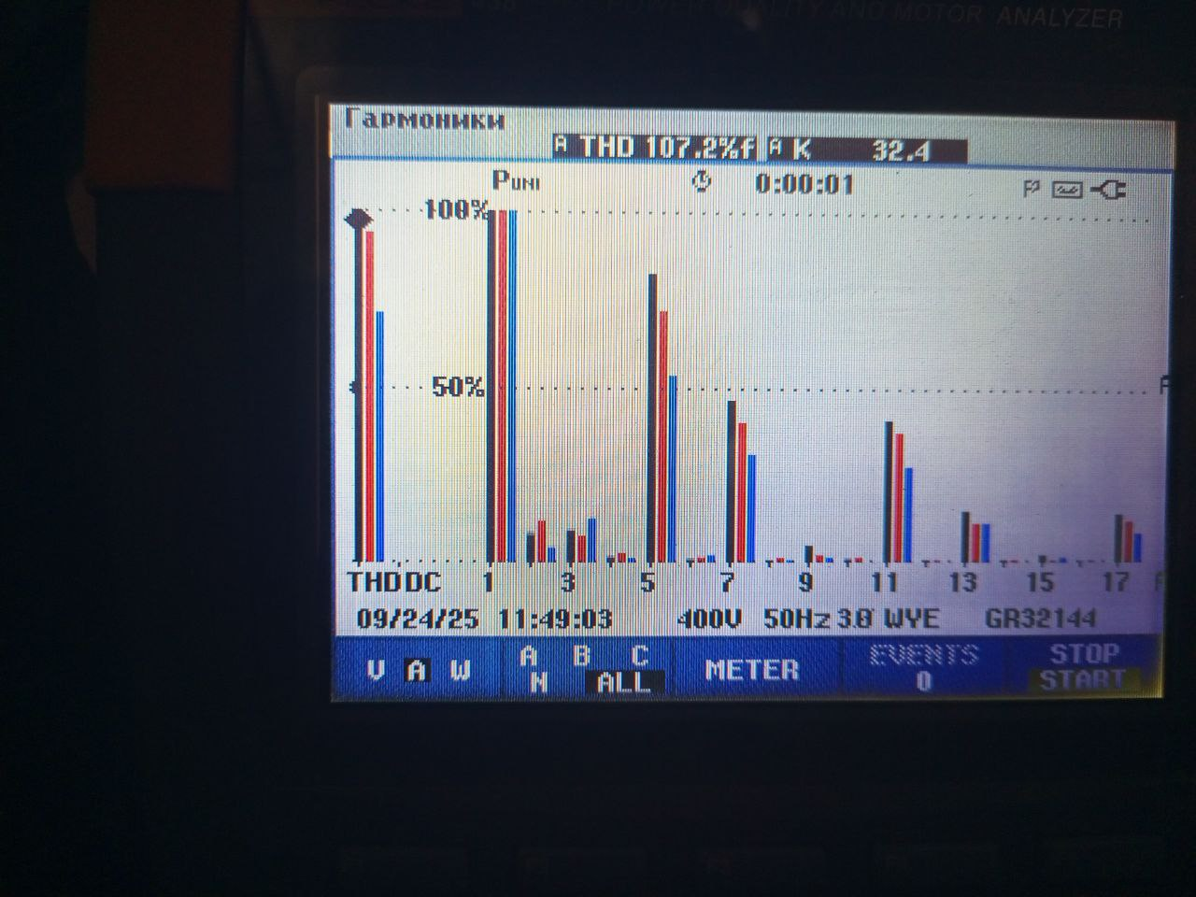 | 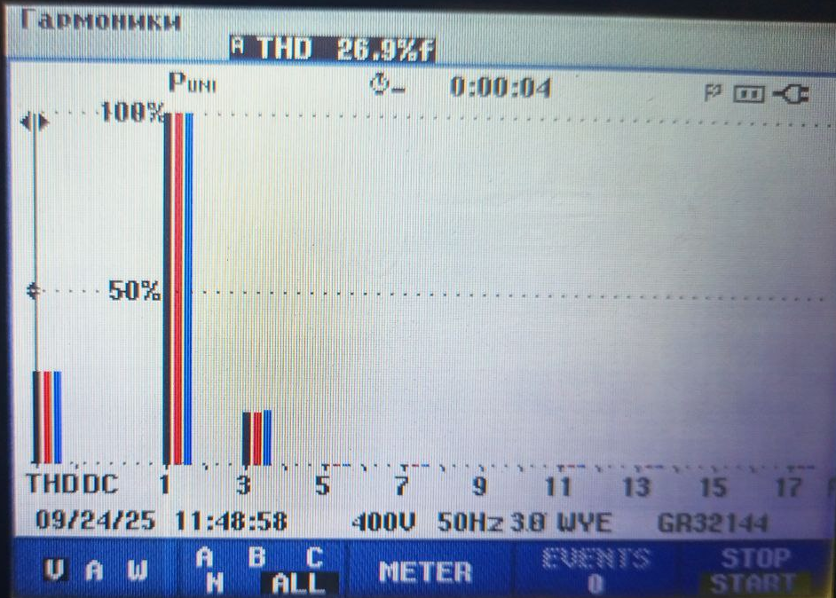
a) | b)
FIGURE 2. Harmonic histograms obtained from measurements of the EKG-15 excavator electric drive using a Fluke 438 II power analyzer under a transistor-based control method: a) heavy or dynamic operating mode, b) stable or light operating mode
Thus, as the operating mode of the excavator changes, the harmonic composition varies substantially. The generation of higher-order harmonics depends not only on the electric drive control method but also directly on the excavator operating mode, load level, and duty cycle. An increase in harmonic content leads to deterioration of power quality, growth of reactive power, and an increase in both power and energy losses. The results presented in this paper provide a scientific basis for assessing the level of harmonic impact under various operating conditions of mining excavators, calculating power losses, and developing effective measures for their reduction, thereby addressing one of the most pressing challenges in modern industrial power supply systems.
RESEARCH RESULTS
The results obtained from the measuring device are entered into the calculation software, and the calculations are performed. The measurement was taken for a single operating cycle, with a cycle duration of 41 seconds (0.012 hours). The values determined from the measurements are as follows: nominal current of 1630 A, nominal power of 1250 kW, and voltage of 430 V. The harmonic proportions obtained from the measurements are entered into the program interface window and algorithm, as shown in the following figure 3-5.
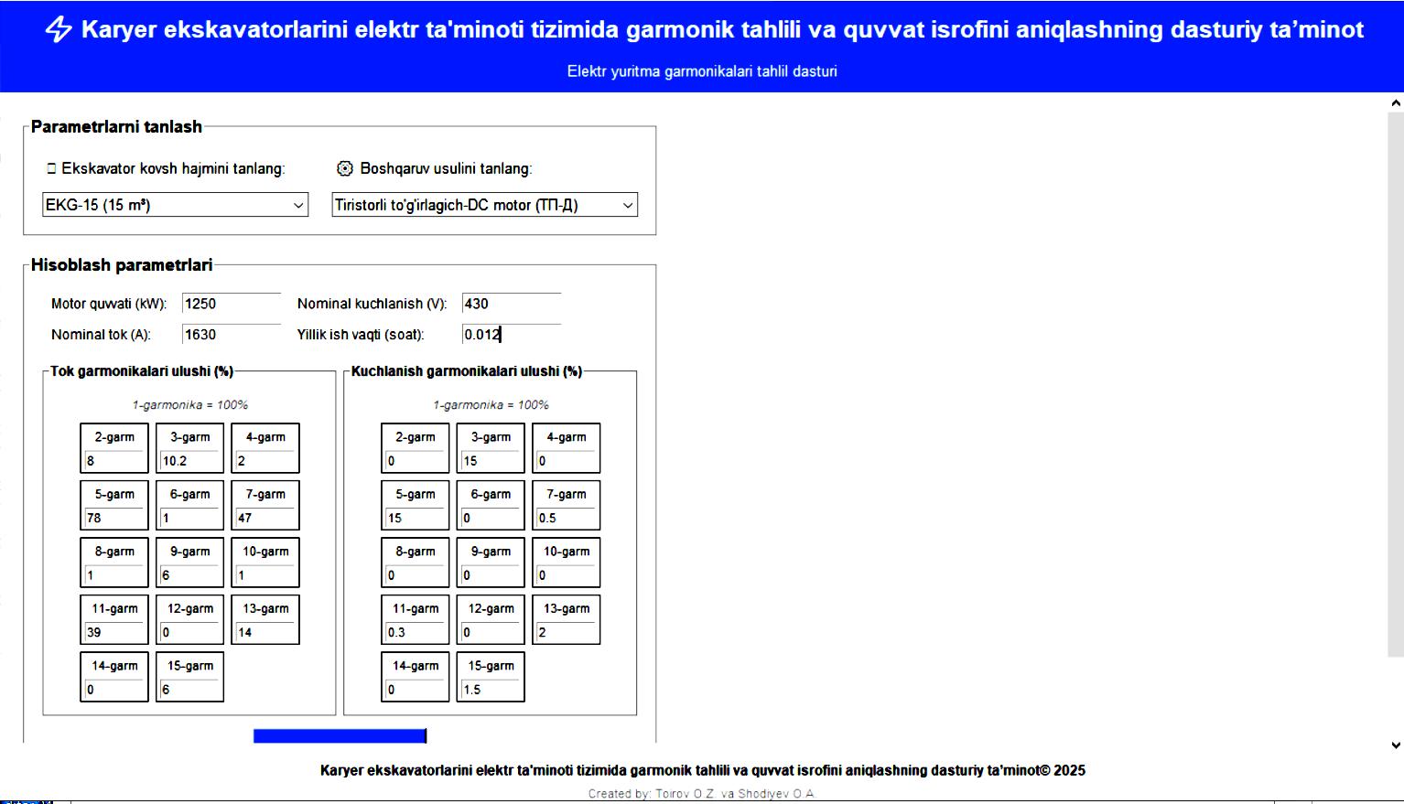

FIGURE 3. Parameter input window of the software for performing calculations

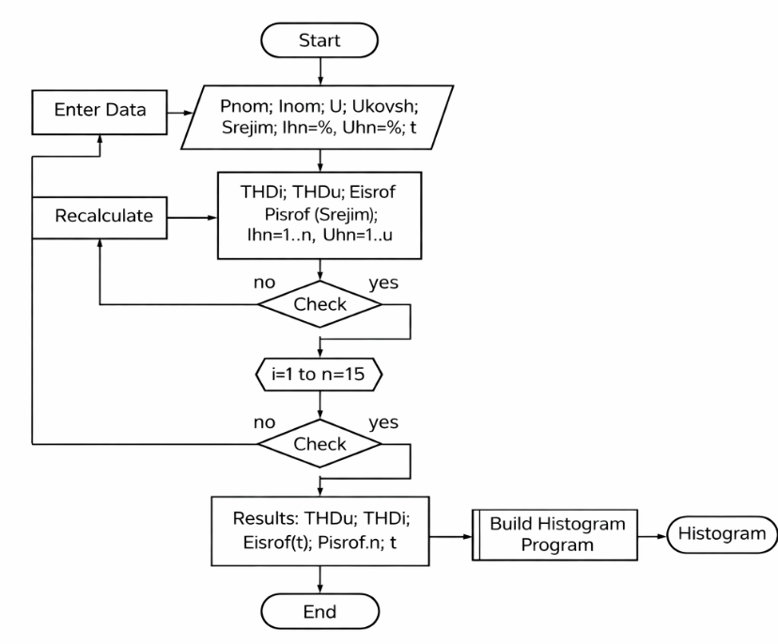
FIGURE 4. Operating algorithm of the software
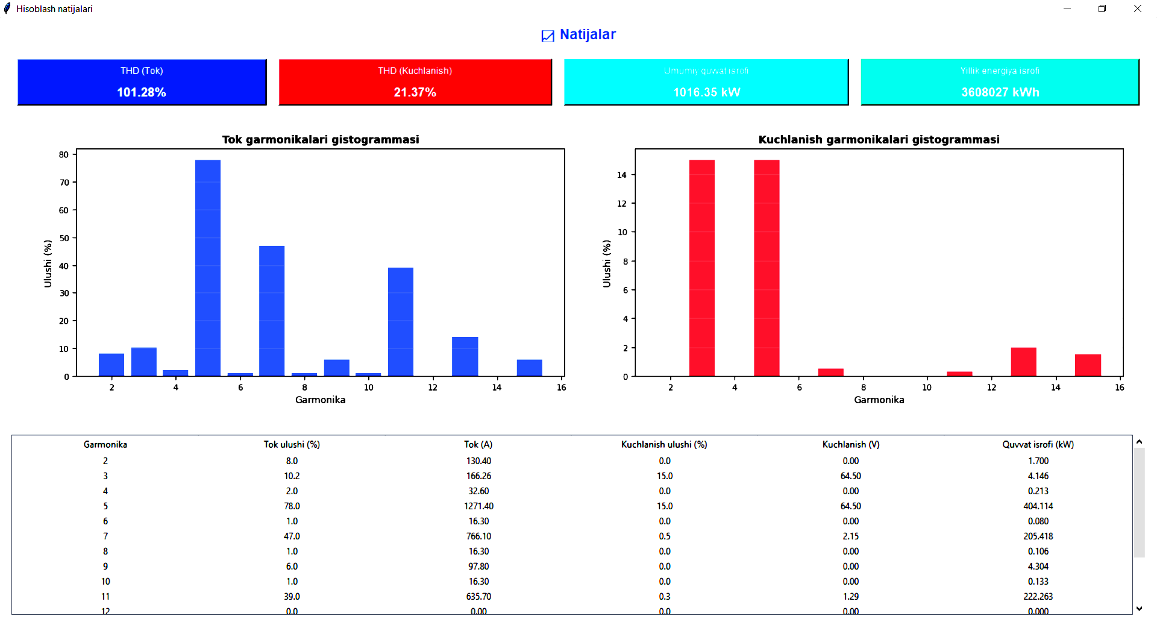
FIGURE 5. Calculation results and harmonic histogram

The following Table 1 presents the harmonic and power loss values occurring in mining excavators with a bucket capacity of 15 m³ under different control methods. These values were obtained from experimental measurements and calculated using the developed software. The harmonics and the associated power losses are directly dependent on the operating mode, and their values are given within the respective variation ranges.

TABLE 1. Harmonics and power losses in mining excavators with a 15 m³ bucket under different control methods
№ | Type of Drive | THD of Current, % | THD of Voltage, % | Power Loss, %
1. | Thyristor rectifier – DC motor | 26–102 | 14–21 | 15–20
2. | Transistor rectifier – DC motor | 45–87 | 12–18 | 12-16
3. | Frequency converter – asynchronous motor | 30–35 | 7–14 | 3-7
CONCLUSIONS
Currently, in mining excavators, the use of control devices (thyristor and transistor converters, as well as frequency converters) combined with dynamically varying loads results in the generation of higher-order harmonics in the power network. These harmonics cause power losses, heating, insulation aging, and deterioration of power quality in motors, transformers, and other electrical equipment. Effectively addressing these issues requires specialized software, which is not merely a data recording tool but serves as a system for analyzing the harmonic spectrum, calculating energy losses, recommending filtering strategies, and providing real-time monitoring capabilities.
The software developed based on the presented methodology serves as a crucial tool for the electric drives of mining excavators, enabling not only the identification of harmonic spectra and calculation of power losses but also real-time monitoring, filter selection, and support in operational decision-making. It significantly contributes to energy savings, enhanced equipment reliability, reduced maintenance costs, and compliance of power quality with standards. For example, using measurements from an experimental cycle lasting 41 seconds (1630 A, 1250 kW, 430 V), the automatically calculated harmonics and power losses clearly demonstrate the economic and technical benefits of implementing DT: within a short period, an optimal filter strategy can be selected, annual energy savings realized, and potential equipment malfunctions prevented.
REFERENCES
1. Li X., Zhang Y., Zhou M., et al. Electro-Hydraulic Control and Energy Recovery System in Excavators // IEEE Transactions on Industrial Electronics, 2023, Vol. 70, №6, pp. 5104–5115.
2. O. Toirov, Sh. Azimov, Z. Toirov. Improving the cooling system of reactive power compensation devices used in railway power supply // AIP Conference Proceedings, 3331, 1, 050030, (2025). https://doi.org/10.1063/5.0305670
3. J.Arrillaga. Power System Harmonic Analysis // Wiley. Chichester, 2003.
4. O. Toirov, Sh. Azimov, Z. Najmitdinov, M. Sharipov, Z. Toirov. Improvement of the cooling system of reactive power compensating devices used in railway power supply // E3S Web of Conferences, 497, 01015, (2024). https://doi.org/10.1051/e3sconf/202449701015 D. Jumaeva, B. Numonov, N. Raxmatullaeva, M. Shamuratova. Obtaining of highly energy-efficient activated carbons based on wood, // E3S Web of Conferences 410, 01018, (2023). https://doi.org/10.1051/e3sconf/202341001018
5. D. Jumaeva, U. Raximov, O. Ergashev, A. Abdyrakhimov, Basic thermodynamic description of adsorption of polar and nonpolar molecules on AOGW, // E3S Web of Conferences 425, 04003 (2023) https://doi.org/10.1051/e3sconf/202343401020
6. O. Toirov, S. Khalikov, Sodikjon Khalikov, F. Sharopov, Studies of reliability indicators of pumping units of machine irrigation on the example of the “Namangan” pumping station, // E3S Web of Conferences 410, 05015, (2023). https://doi.org/10.1051/e3sconf/202341005015
7. Bystrov, S. Giyasov, M. Taniev, S. Urokov, Role of Reengineering in Training of Specialists // ACM International Conference Proceeding Series (2020) https://doi.org/10.1145/3386723.3387868
8. O. Toirov, V. Ivanova, V. Tsypkina, D. Jumaeva, D. Abdullaeva, Improvement of the multifilament wire lager for cable production, // E3S Web of Conferences 411, 01041 (2023), https://doi.org/10.1051/e3sconf/202341101041
9. Z. Chen, E. Spooner. Torque Ripple and Mechanical Stress in Harmonic-Rich Drives // IEEE Transactions on Energy Conversion. New York, 2018.
10. O. Toirov, T. Kamalov, U. Mirkhonov, S. Urokov, D. Jumaeva, The mathematical model and a block diagram of a synchronous motor compressor unit with a system of automatic control of the excitation // E3S Web of Conferences, 288, 01083, (2021), https://doi.org/10.1051/e3sconf/202128801083
11. Nasir B.A. Determination of the Harmonic Losses in an Induction Motor Fed by an Inverter Drive // ETASR. 2022.
12. O. Toirov, S. Urokov, U. Mirkhonov, H. Afrisal, D. Jumaeva, Experimental study of the control of operating modes of a plate feeder based on a frequency-controlled electric drive, // E3S Web of Conferences, SUSE-2021, 288, 01086 (2021). https://doi.org/10.1051/e3sconf/202128801086
13. D. Bystrov, M. Gulzoda, Y. Dilfuza, Fuzzy Systems for Computational Linguistics and Natural Language (2020) // ACM International Conference Proceeding Series, https://doi.org/10.1145/3386723.3387873
14. O. Toirov, S. Khalikov, Diagnostics of pumping units of pumping station of machine water lifting, // E3S Web of Conferences 365, 04013, (2023).
https://doi.org/10.1051/e3sconf/202336504013
15. Grady M. Understanding Power System Harmonics // Baylor University. Waco, 2012.
16. O. Toirov, I. Khujaev, J. Jumayev, M. Hamdamov, Modeling of vertical axis wind turbine using Ansys Fluent package program, // E3S Web of Conferences 401, 04040 (2023). https://doi.org/10.1051/e3sconf/202340104040
17. M Siddique. Investigation of Harmonic Losses to Reduce Rotor Copper Loss // MDPI. 2025.
18. О. Toirov, D. Jumaeva, U. Mirkhonov, S. Urokov, S. Ergashev, Frequency-controlled asynchronous electric drives and their energy parameters, // AIP Conference Proceedings 2552, 040021, (2022). https://doi.org/10.1063/5.0218808
19. P. Grady Understanding Power System Harmonics // Dept. of Electrical & Computer Engineering, Baylor University. Waco, April 2012.
20. O. Toirov, T. Sadullaev, D. Abdullaev, D. Jumaeva, Sh. Ergashev, I.B. Sapaev, Development of contactless switching devices for asynchronous machines in order to save energy and resources, // E3S Web of Conferences 383, 01029, (2023). https://doi.org/10.1051/e3sconf/202338301029
21. S. Rahman, T. Akter, M. Hossain, M. Mahmud. Comparative Study on Thyristor and Rectifier Circuit Based DC Motor Control with Improved Power Factor and Total Harmonic Distortion // 2022.
22. O. Toirov, S. Khalikov, Algorithm and Software Implementation of the Diagnostic System for the Technical Condition of Powerful Units, // E3S Web of Conferences 377, 01004, (2023). https://doi.org/10.1051/e3sconf/202337701004
23. H. Akagi Instantaneous Reactive Power Theory and Applications to Power Conditioning // IEEE Press. New York, 2017.
24. O. Toirov, S. Khalikov, Diagnostics of pumping units of pumping station of machine water lifting, // E3S Web of Conferences 365, 04013, (2023). https://doi.org/10.1051/e3sconf/202336504013
25. Jumaeva, Z. Okhunjanov, U. Raximov, R. Akhrorova. Investigation of the adsorption of nonpolar adsorbate molecules on the illite surface, // Journal of Chemical Technology and Metallurgy, 58, 2, (2023). https://doi.org/10.59957/jctm.v58i2.61
26. O. Toirov, K. Alimkhodjaev, A. Pardaboev, Analysis and ways of reducing electricity losses in the electric power systems of industrial enterprises, // E3S Web of Conferences, SUSE-2021, 288, 01085 (2021). https://doi.org/10.1051/e3sconf/202128801085
27. O.Toirov, K. Allaev, J. Toshov, Modern state of the energy sector of Uzbekistan and issues of their development, E3S Web of Conferences 401, 05090 (2023). https://doi.org/10.1051/e3sconf/202340105090
28. O.Toirov, S. Abdi Yonis, Z. Yusupov, A. Habbal, Control Approach Of A Grid Connected Dfig Based Wind Turbine Using Mppt And Pi Controller, // Advances in Electrical and Electronic Engineering, 21, 3, (2023). https://doi.org/10.15598/aeee.v21i3.5149
29. D. Jumaeva, A. Abdurakhimov, Kh. Abdurakhimov, N. Rakhmatullaeva, O. Toirov, Energy of adsorption of an adsorbent in solving environmental problems, // E3S Web of Conferences, SUSE-2021, 288, 01082 (2021). https://doi.org/10.1051/e3sconf/202128801082
30. O. Toirov, M. Khalikova, D. Jumaeva, S. Kakharov, (2023) Development of a mathematical model of a frequency-controlled electromagnetic vibration motor taking into account the nonlinear dependences of the characteristics of the elements, // E3S Web of Conferences 401, 05089, (2023). https://doi.org/10.1051/e3sconf/202340105089

