Impact of Electric Arc Furnaces as Nonlinear Loads on Power Quality in Industrial Power Supply Systems
Sultonkhoja Mahmutkhonov ^{1,4, a)}, Azizjon Nigmatov ², Sayyora Yunusova ¹, Murod Sherbaev ³
¹ Tashkent state technical university named after Islam Karimov, Tashkent, Uzbekistan
² Tashkent Institute of Irrigation and Agricultural Mechanization Engineers" National Research University, Tashkent, Uzbekistan
³ International University of Chemistry in Tashkent, Tashkent, Uzbekistan
⁴Termez State University of Engineering and Agrotechnology, Termez, Uzbekistan
^{a)} Corresponding author: mahmutkhonov.sultonkhoja.93@gmail.com
Abstract. Electric arc furnaces are major sources of power quality disturbances in metallurgical power supply systems due to their nonlinear and stochastic operating behavior. Conventional assessment methods based on the superposition of voltage distortion components at the point of common coupling fail to adequately represent real operating conditions, where distortion arises from complex interactions between nonlinear current sources, network conductances, and system configuration. This study proposes an alternative evaluation framework that does not rely on the additivity of distortion effects. An equivalent circuit–based approach is applied, in which linear loads are represented by conductances and nonlinear loads by distortion current sources, demonstrating that voltage distortion cannot be decomposed into independent consumer contributions. To address this limitation, the concept of autonomous voltage distortion is introduced, allowing the individual impact of an electric arc furnace to be assessed independently of other connected loads. Phase compatibility indicators, a utility factor, and a voltage impact coefficient are defined to quantify furnace-induced power quality degradation. The proposed methodology provides a physically consistent and practical tool for power quality assessment and supports effective mitigation and responsibility allocation in metallurgical power systems.
INTRODUCTION
The rapid development of metallurgical technologies has led to a significant increase in the use of high-power nonlinear electrical equipment, among which electric arc furnaces occupy a dominant position. These installations are characterized by strongly nonlinear, time-varying, and asymmetric operating modes, resulting in substantial deterioration of power quality indicators in industrial power supply systems. Voltage waveform distortion, harmonic propagation, flicker, and phase unbalance caused by electric arc furnaces have become critical issues affecting not only metallurgical plants but also adjacent consumers connected to the same power network[1-5].
In modern power systems, the assessment of power quality disturbances is commonly performed at the point of common coupling, where multiple consumers interact through a shared electrical infrastructure. Conventional evaluation methods are largely based on the assumption that voltage distortion components produced by individual consumers are additive in nature. Within this framework, the overall distortion level is considered to be equal to the sum of separate contributions attributed to each load. While such an approach may be acceptable for linear or weakly nonlinear consumers, it becomes fundamentally inaccurate when applied to electric arc furnaces due to their pronounced nonlinear behavior and strong interaction with network parameters.
Practical observations and analytical studies indicate that voltage distortion at the point of common coupling is formed as a result of complex electromagnetic interactions between distortion current sources, system impedances, and the operating conditions of other connected consumers. Under these circumstances, the superposition principle does not hold, and the concept of a fixed “share” or “contribution” of an individual nonlinear load loses its physical meaning. As a result, existing assessment techniques often fail to provide a reliable quantitative description of the real impact of electric arc furnaces on power quality[6-7].
This limitation is of particular importance in metallurgical power systems, where high short-circuit power, frequent operating regime changes, and the coexistence of linear and nonlinear loads create conditions for non-additive voltage distortion phenomena. In such systems, the magnitude of voltage distortion caused by an electric arc furnace depends not only on its own parameters but also on the characteristics of the surrounding network and other consumers connected to the point of common coupling. Therefore, an adequate evaluation method must explicitly account for these interdependencies[8-9].
In response to these challenges, there is a growing need for assessment approaches that move beyond additive assumptions and provide a physically justified description of power quality degradation caused by nonlinear industrial loads. In particular, methods that allow the influence of an electric arc furnace to be evaluated independently of other consumers, while still considering the network environment, are of significant practical and scientific interest.
This paper addresses the above-mentioned issues by focusing on the impact of electric arc furnaces as nonlinear loads on power quality in industrial power supply systems. An improved evaluation framework is developed that accounts for the non-additive nature of voltage distortion at the point of common coupling. The proposed approach introduces the concept of autonomous voltage distortion and employs interaction indicators to quantify the influence of electric arc furnaces on voltage quality. The results obtained provide a more accurate basis for power quality assessment, mitigation strategy development, and responsibility allocation between utilities and industrial consumers in metallurgical power networks.

METHODOLOGY
The assessment of power quality degradation in industrial power supply systems is performed at the point of common coupling (PCC), where multiple consumers are interconnected through a shared electrical network. In metallurgical plants, electric arc furnaces operate together with linear and weakly nonlinear loads, forming a complex electromagnetic environment in which voltage distortion arises from the interaction between distortion current sources and the equivalent conductance of the system. To analyze this interaction, an equivalent circuit representation is adopted, in which linear consumers are described by complex conductances, while nonlinear consumers, including electric arc furnaces, are modeled as sources of distortion currents for a given harmonic order or negative-sequence component[10-11].
For a system consisting of N consumers connected to the PCC, the complex voltage distortion corresponding to harmonic order n can be expressed as
$${\underline{U}}_{\text{PCC}}^{\left(n\right)}=\frac{\sum_{k=1}^{N}{{\underline{I}}_{k}^{\left(n\right)}}}{\sum_{k=1}^{N}{{\underline{Y}}_{k}^{\left(n\right)}}} (1)$$
where ${\underline{I}}_{k}^{\left(n\right)}$​ denotes the distortion current generated by the k-th consumer and ${\underline{Y}}_{k}^{\left(n\right)}$​ represents its equivalent conductance at the same frequency component. This expression demonstrates that voltage distortion at the PCC is determined simultaneously by the collective distortion currents and the combined conductance of all connected consumers. As a result, the distortion magnitude cannot be attributed to individual loads through linear superposition[10-11].
In general, the voltage distortion obtained when all consumers operate simultaneously is not equal to the sum of distortions produced by the same consumers operating independently, which can be expressed as
$${\underline{U}}_{\text{PCC}}^{\left(n\right)}≠\sum_{k=1}^{N}{\frac{{\underline{I}}_{k}^{\left(n\right)}}{{\underline{Y}}_{k}^{\left(n\right)}}} (2)$$
This inequality confirms the non-additive nature of voltage distortion in industrial power systems containing strongly nonlinear loads such as electric arc furnaces. Consequently, the use of contribution-based or share-based evaluation approaches becomes physically unjustified.
To enable a meaningful assessment of an individual nonlinear consumer under non-additive conditions, the concept of autonomous voltage distortion is introduced. For the k-th consumer, autonomous voltage distortion is defined as
$${\underline{U}}_{k,\text{aut}}^{\left(n\right)}=\frac{{\underline{I}}_{k}^{\left(n\right)}}{\sum_{m=1}^{N}{{\underline{Y}}_{m}^{\left(n\right)}}} (3)$$
This quantity represents the voltage distortion produced by the consumer interacting with the equivalent conductance of the surrounding power system, independently of distortion currents generated by other consumers. Autonomous voltage distortion serves as a reference measure for evaluating the admissibility of operating conditions at the PCC.
The interaction between multiple consumers is further characterized by considering the vector and scalar summations of distortion currents and conductances. The vector (geometric) sums are defined as
$${\underline{I}}_{Σ}^{\left(n\right)}=\sum_{k=1}^{N}{{\underline{I}}_{k}^{\left(n\right)}}, {\underline{Y}}_{Σ}^{\left(n\right)}=\sum_{k=1}^{N}{{\underline{Y}}_{k}^{\left(n\right)}​} (4)$$
while the corresponding scalar (arithmetic) sums are given by
$$I_{\text{a}}^{\left(n\right)}=\sum_{k=1}^{N}{\left|{\underline{I}}_{k}^{\left(n\right)}\right|}, Y_{\text{a}}^{\left(n\right)}=\sum_{k=1}^{N}{\left|{\underline{Y}}_{k}^{\left(n\right)}\right|​} (5)$$
To quantify the degree of phase alignment among currents and conductances, phase compatibility coefficients are introduced as
$$K_{I}^{\left(n\right)}=\frac{\left|{\underline{I}}_{Σ}^{\left(n\right)}\right|}{I_{\text{a}}^{\left(n\right)}}, K_{Y}^{\left(n\right)}=\frac{\left|{\underline{Y}}_{Σ}^{\left(n\right)}\right|}{Y_{\text{a}}^{\left(n\right)}} (6)$$
These coefficients take values between 0 and 1 and describe the extent to which individual vectors are coherently aligned in the complex plane. Based on these parameters, a utility factor is defined as
$$K_{\text{u}}^{\left(n\right)}=\frac{K_{Y}^{\left(n\right)}}{K_{I}^{\left(n\right)}} (7)$$
The utility factor reflects the effectiveness of joint consumer operation within the same power system. Low values of this factor correspond to unfavorable operating conditions, including resonance phenomena, whereas high values indicate mutual compensation effects that mitigate voltage distortion.
The magnitude of voltage distortion at the PCC can then be expressed as
$$\left|U_{\text{PCC}}^{\left(n\right)}\right|=\frac{I_{\text{a}}^{\left(n\right)} K_{I}^{\left(n\right)}}{Y_{\text{a}}^{\left(n\right)} K_{Y}^{\left(n\right)}}=\frac{I_{\text{a}}^{\left(n\right)}}{Y_{\text{a}}^{\left(n\right)}}⋅\frac{1}{K_{\text{u}}^{\left(n\right)}} (8)$$
To assess the admissibility of an individual consumer’s influence, a voltage impact coefficient is introduced as
$$K_{\text{v},k}^{\left(n\right)}=1-\frac{\left|U_{k,\text{aut}}^{\left(n\right)}\right|}{U_{\text{lim}}^{\left(n\right)}} (9)$$
where $U_{\text{lim}}^{\left(n\right)}$​ denotes the permissible voltage distortion limit defined by applicable power quality standards. Negative values of this coefficient indicate unacceptable operating conditions, while positive values correspond to permissible influence levels.
When applied to electric arc furnaces, the proposed methodology reveals that large distortion currents combined with relatively low equivalent conductance lead to a significant increase in autonomous voltage distortion. This behavior explains the pronounced impact of electric arc furnaces on voltage quality and confirms the suitability of the developed framework for assessing power quality degradation in metallurgical power supply systems.
RESULTS AND DISCUSSION
The proposed methodology was validated using practical data obtained from an operating metallurgical enterprise with a complex power supply structure. The calculation model was developed based on the actual single-line power supply diagram of the plant, which reflects real operating conditions and enables the analysis of nonsinusoidal and asymmetric regimes at different voltage levels. A fragment of the single-line diagram illustrating the main supply paths, voltage levels, and connection points of nonlinear consumers is shown in Fig. 1. The plant is supplied through a 110 kV substation equipped with two three-winding transformers rated at 63 MVA, feeding 35 kV and 10 kV buses that serve as the main points of common coupling (PCCs) for industrial consumers. High-power nonlinear loads are mainly concentrated at the 35 kV level in the form of an electric arc furnace and a secondary metallurgical furnace, while rectifier-fed rolling mill drives dominate the nonlinear load composition at the 10 kV level

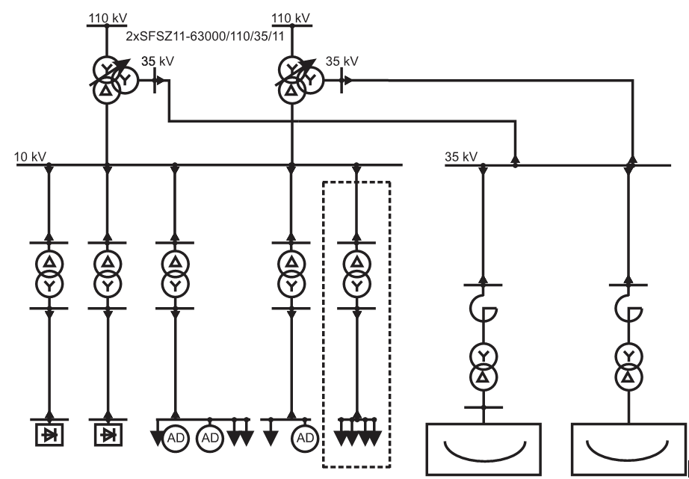
FIGURE 1. Fragment of the single-line power supply diagram of the metallurgical plant showing the main voltage levels (110 kV, 35 kV, and 10 kV) and the connection points of nonlinear loads.

Considering the technological characteristics of the metallurgical process and the dominant harmonic orders observed in practice, the fifth harmonic component was selected for further analysis. Distortion currents and equivalent conductances at the PCCs were determined using a two-measurement approach, which allows the separation of load-generated distortion from network parameters. The obtained results indicate that the highest harmonic distortion levels are associated with PCCs supplying nonlinear loads, while consumers with predominantly linear characteristics operate within permissible limits.
Further insight into the physical origin of the observed distortion is obtained by analyzing autonomous voltage distortion and voltage impact coefficients. The calculated results for consumers connected to the 10 kV PCC are illustrated in Fig. 2. Induction motor groups exhibit very low autonomous fifth harmonic voltage values and impact coefficients close to unity, indicating negligible influence on power quality. In contrast, rectifier-fed rolling mill drives produce autonomous voltage distortion levels significantly exceeding allowable limits, resulting in strongly negative impact coefficients. This confirms that rectifiers act as secondary harmonic current sources and represent the dominant contributors to voltage distortion at the 10 kV PCC
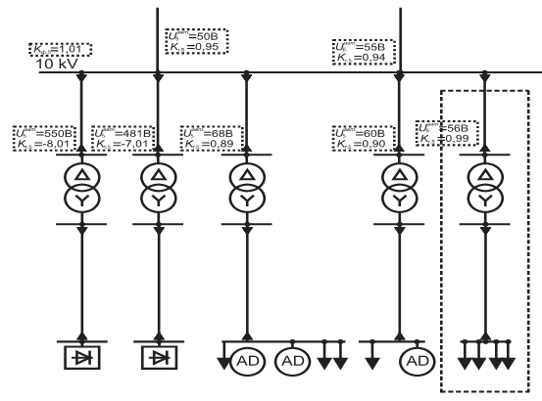
FIGURE 2. Calculated autonomous fifth harmonic voltage values and voltage impact coefficients of consumers connected to the 10 kV point of common coupling.

A similar analysis was performed for the 35 kV PCC, where high-power metallurgical furnaces are connected. The corresponding autonomous voltage distortion values and impact coefficients are presented in Fig. 3. Both the electric arc furnace and the secondary processing furnace demonstrate large autonomous voltage distortion levels and negative impact coefficients, reflecting their strongly nonlinear and time-varying operating characteristics. During furnace operation, voltage fluctuations reaching several hundred volts were observed, which explains the elevated distortion levels at the 35 kV bus. The simultaneous operation of these furnaces significantly deteriorates voltage quality, increases losses in transformers and cable lines, and adversely affects measurement and protection devices connected to the PCC
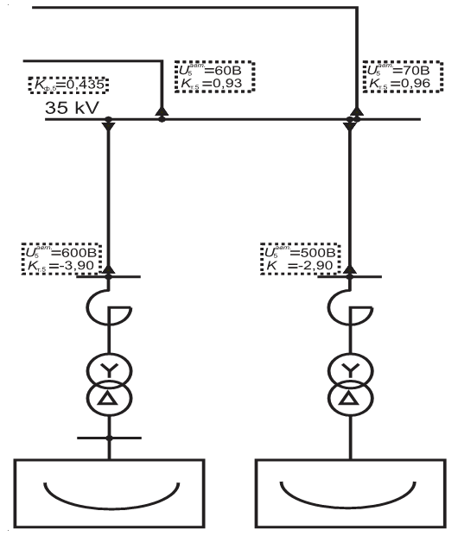
FIGURE 3. Calculated autonomous fifth harmonic voltage values and voltage impact coefficients of consumers connected to the 35 kV point of common coupling.

The calculated utility factors at both voltage levels further confirm unfavorable interaction conditions between connected consumers. Low utility factor values indicate that the combined operation of nonlinear loads amplifies voltage distortion rather than mitigating it. This demonstrates that the coexistence of electric arc furnaces and rectifier-based equipment on the same bus without appropriate mitigation measures is technically inefficient. Overall, the results confirm that the proposed methodology, supported by actual plant schematics and practical calculation data, enables a physically consistent assessment of nonlinear load influence under non-additive conditions. Unlike conventional contribution-based approaches, the use of autonomous voltage distortion and voltage impact coefficients allows problematic consumers to be clearly identified at their respective PCCs, providing a reliable basis for power quality improvement measures in metallurgical power supply systems.
CONCLUSIONS
This study investigated the impact of electric arc furnaces as nonlinear loads on power quality in industrial power supply systems using an improved assessment framework that accounts for the non-additive nature of voltage distortion at the point of common coupling. The results confirm that conventional contribution-based approaches, which assume linear superposition of voltage distortion components, are inadequate for metallurgical power systems dominated by strongly nonlinear and time-varying loads.
An equivalent circuit–based methodology was developed and applied, in which linear consumers were modeled by conductances and nonlinear consumers were represented as distortion current sources. The introduction of the autonomous voltage distortion concept enabled the influence of individual nonlinear loads to be evaluated independently of other connected consumers, while still considering the electrical characteristics of the surrounding network. This approach provides a physically consistent interpretation of voltage distortion formation under non-additive conditions.
Practical validation using data from an operating metallurgical plant demonstrated that electric arc furnaces and rectifier-fed drives are the dominant sources of harmonic voltage distortion at their respective points of common coupling. In contrast, linear consumers such as induction motor groups exhibited negligible influence on voltage quality and impact coefficients close to unity. The calculated voltage impact coefficients and utility factors clearly identified unfavorable operating conditions, in which the joint operation of multiple nonlinear loads significantly amplifies voltage distortion.
The obtained results highlight that the proposed methodology allows a clear differentiation between consumers that deteriorate power quality and those whose influence remains acceptable. This provides a reliable basis for informed decision-making regarding the placement of harmonic filters, compensation devices, and network reconfiguration measures in metallurgical power supply systems. Furthermore, the method can support objective responsibility allocation between utilities and industrial consumers in the context of power quality regulation.
Overall, the developed assessment framework enhances the accuracy and physical justification of power quality analysis in industrial networks with electric arc furnaces and can be extended to other types of high-power nonlinear loads operating under similar conditions.
REFERENCES
- Dugan R.C., McGranaghan M.F., Santoso S., Beaty H.W. Electrical power systems quality. // McGraw-Hill. New York, 2012. pp. 1–528.
- IEC 61000-4-30. Electromagnetic compatibility – power quality measurement methods. // IEC. Geneva, 2015. pp. 1–154.
- Rönnberg S., Bollen M., Gu I.Y.H. On the assessment of harmonic emission from individual loads. // IEEE Transactions on Power Delivery. 30(1), 2015. pp. 272–279. https://doi.org/10.1109/TPWRD.2014.2350006
- Bollen M., Gu I.Y.H. Signal processing of power quality disturbances. // Wiley-IEEE Press. Hoboken, 2006. pp. 1–861.
- Czarnecki L.S. On some misinterpretations of power factor improvement. // IEEE Transactions on Power Delivery. 19(2), 2004. pp. 828–836. https://doi.org/10.1109/TPWRD.2003.820175
- He J., Li Y., Bollen M.H.J. The influence of grid impedance on harmonic emission. // IEEE Transactions on Power Delivery. 30(3), 2015. pp. 1464–1472. https://doi.org/10.1109/TPWRD.2014.2360052
- Langella R., Testa A., Emanuel A.E. Uncertainty in the assessment of harmonic distortion responsibility. // IEEE Transactions on Instrumentation and Measurement. 57(7), 2008. pp. 1452–1460. https://doi.org/10.1109/TIM.2008.917178
- Barros J., Diego R.I. A new method for measurement of harmonic emission from nonlinear loads. // IEEE Transactions on Power Delivery. 21(1), 2006. pp. 278–285. https://doi.org/10.1109/TPWRD.2005.852319
- Mahmutkhonov S., Baizhonova L., Mustayev R., Tashmatova S. Dynamic analysis of voltage-ampere characteristics and harmonic distortions in electric arc furnaces. // AIP Conference Proceedings. 3331(1), 2025. pp. 070023, 1–5. https://doi.org/10.1063/5.0305745.
- Bobojanov M., Mahmutkhonov S. Influence of the consumer to power quality at the point of connection // E3S Web of Conferences 384. 2023. РР, 01041, 1-5. https://doi.org/10.1051/e3sconf/202338401041.
- Bobojanov M.K., Karimov R.Ch., Popkova O.S., Tuychiev F.N., Makhmutkhanov S.K. Analysis of the results of experimental studies of the arc furnace DSP-30. // Power Engineering Research & Technology. 27(2), 2025. pp. 126–137. https://doi.org/10.30724/1998-9903-2025-27-2-126-137

