Synthesis and Analysis of Sorbents Based on Modified Lignin
Maxliyo Abdullayeva ^{a)}, Mustafoqul Urazov
Termez State University of Engineering and Agrotechnologies, Termez, Uzbekistan
^{a)} Corresponding author: maxabdullayeva95@gmail.com
Abstract. In this study, a scientifically grounded approach was developed for obtaining highly functional biosorbents based on the chemical modification of lignin. The work employed a strategy of activating phenolic, carboxyl, and aliphatic hydroxyl groups in the lignin macromolecule through the formation of covalent bonds with amine compounds. The kinetic and thermodynamic characteristics of the modification process were evaluated, and the influence of reaction parameters on the structural and functional properties of the sorbent was determined. The morphology and functional group composition of the obtained modified lignin samples were investigated. Sorption experiments were carried out to assess the ability to chemically bind toxic heavy metal ions such as Zn(II), Cu(II), and Ni(II). The results demonstrate a significant increase in the sorption capacity, kinetic rate, and regeneration efficiency of the modified lignin. The study proposes new scientific foundations for the development of environmentally safe, economically feasible, and renewable raw material based sorbents and offers promising solutions for application in industrial wastewater treatment and gas purification systems.
INTRODUCTION
The environmental challenges of the twenty-first century, including industrial waste generation, contamination of water bodies with heavy metal ions, and the increasing concentration of carbon dioxide in the atmosphere, pose serious global challenges to environmental protection and sustainability. Conventional sorbent materials such as activated carbon, ion-exchange resins, and metal–organic frameworks often fail to fully meet the requirements of large-scale and economically viable environmental technologies due to their high cost, complex synthesis routes, and limitations in regeneration. Therefore, the use of renewable and environmentally benign biomass resources, particularly lignin-based sorbents, has emerged as a promising direction for the development of next-generation sorbent materials.
Lignin is one of the main components of plant biomass and is characterized by a high degree of aromaticity, a complex three-dimensional amorphous network structure, and the presence of phenolic hydroxyl, methoxy, carboxyl, and other functional groups. These functional groups enable chemical complexation, ion exchange, or electrostatic interactions with heavy metal ions and other pollutants. Nevertheless, natural lignin often exhibits limited adsorption performance due to its bulky structure, relatively low specific surface area, and restricted porosity. Consequently, modification and structural optimization are essential for the development of efficient lignin-based sorbents.
In recent years, the sorption properties of lignin have been significantly enhanced through organic modifications involving amine, carboxyl, or sulfonate groups, inorganic modifications such as metal oxides, magnesium hydroxide, and magnetic nanoparticles, as well as composite approaches. For example, a recyclable magnetic sorbent was developed by combining carboxymethylated lignin with Fe3O4 magnetic nanoparticles. This sorbent demonstrated high adsorption capacities for heavy metal ions such as Pb(II), Cu(II), and Ni(II), with values of approximately 189.85, 124.43, and 106.97 mg per gram, respectively, while maintaining substantial sorption performance even after six reuse cycles. In addition, carbon materials derived from lignin have been extensively investigated as promising sorbents for carbon dioxide capture. In one study, carbon synthesized via chemical activation with ZnCl2 exhibited a CO2 adsorption capacity of 4.45 mmol per gram at 273 K and 100 kPa.
Therefore, lignin-based, particularly modified and carbonized, sorbents possess significant potential as environmentally friendly, renewable, and economically viable materials for the adsorption of heavy metal ions, organic pollutants, and gaseous carbon dioxide.
RESEARCH METHODOLOGY AND TOOLS
Lignin is considered one of the most abundant biopolymers on Earth and represents a valuable raw material that is often generated as waste. The structure of lignin is composed of three main propylphenol monomer units, and its chemical modification with amines is regarded as one of the most promising research directions. Although various methods applied in lignin amination pursue the same general goal of introducing amine functionalities into the lignin structure, the resulting polymers differ significantly in their structural characteristics. Consequently, a direct and comprehensive comparison of these materials is practically challenging. The nitrogen content of the modified products also varies over a wide range, typically from 1 to 6 mmol g⁻¹.
In practice, Mannich-type reactions commonly employed for lignin amination often lead to the formation of highly branched or cross-linked macromolecular structures due to the limited solubility of lignin and restrictions associated with polyamine formation. This behavior is closely related to the reactivity of nucleophilic amines, resulting in a mixture of secondary and tertiary amines as well as urea-like nitrogen-containing groups. Such structurally complex lignin–polyamine systems play an important role in polymer synthesis and in determining their functional properties.
In order to elucidate the potential interactions of AcOZD and mOZ with various reactive sites in lignin, the amidation process was first evaluated using model compounds. Benzyl alcohol (AlOH), 2-methoxy-4-methylphenol (PhOH), and benzoic acid (COOH) were selected as model substances representing the corresponding functional groups of lignin. The amidation reaction was carried out in a DMSO medium, as this solvent effectively dissolves lignin and exhibits high thermal stability. Potassium carbonate (K₂CO₃) was employed as a catalyst due to its effectiveness in activating phenolic groups.
The reaction was conducted at 120 °C in the presence of 1.1 equivalents of AcOZD and 0.1 equivalents of K₂CO₃, and its progress was monitored by ¹H NMR spectroscopy using aliquots extracted with ethyl acetate. As expected, experiments with the phenolic model compound resulted in the formation of a product functionalized with an acetamide group. During the reaction, AcOZD was also observed to act as an acetylating reagent: initially, acetylated intermediate products were formed, which gradually disappeared over time, accompanied by an increase in the intensity of signals characteristic of amide groups. The disappearance of acetate groups suggests their possible hydrolytic reversal in the DMSO-d₆ medium, whereas the formation of amide bonds was irreversible and proceeded with the release of CO₂ as a result of AcOZD decarboxylation [7-33].

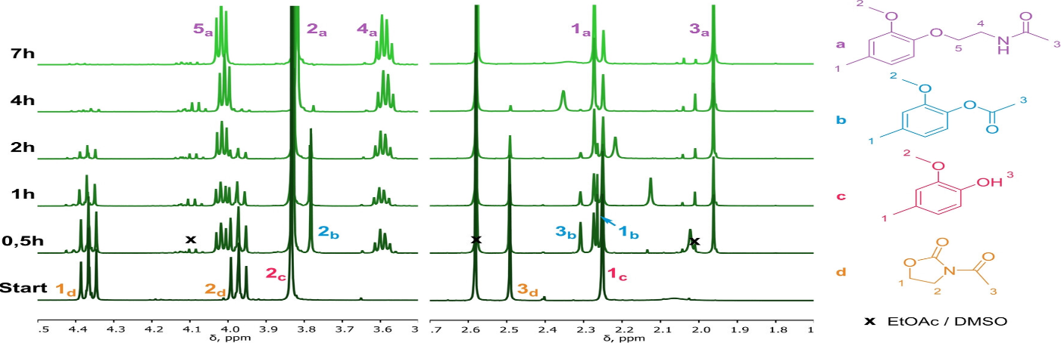
FIGURE 1. ¹H NMR spectra of aliquots withdrawn from the reaction mixture of 2-methoxy-4-methylphenol (PhOH model) with AcOZD.

In another study, optimal amidation and subsequent hydrolysis conditions were applied to three different types of lignin: organosolv lignin derived from hardwood (HW-OL, rich in S units), softwood kraft lignin (SW-KL, rich in G units), and wheat straw soda lignin (WS-SL, containing a high amount of COOH groups). As a result, a total of six amidated lignin samples and, correspondingly, six aminated lignin samples were obtained using two different reagents for each lignin type. The reactions proceeded smoothly under stable conditions and were successfully scaled up to 10 g, confirming the universality of the proposed approach.
The mass yield of the process was evaluated as the ratio of the product mass to the initial lignin mass. During the amidation step, the grafting process led to an increase in mass, and due to high recovery upon precipitation under acidic conditions, the yield reached up to 130 wt%. In the subsequent hydrolysis step, a yield of approximately 80 wt% was recorded, indicating effective isolation of the aminated lignins by dialysis. Overall, the two-step process was completed with an average total yield of about 90 wt%, with the main losses attributed to technological transfer steps.
The degrees of amidation and amination of the lignins were confirmed by ³¹P NMR spectroscopy and elemental analysis. Measurements were carried out in a CDCl₃/pyridine mixture for lignin and amidated lignin samples, and in a DMF-d₇ medium for aminated lignins. All lignin types exhibited similar reactivity after amidation and hydrolysis, with the conversion of phenolic hydroxyl groups being approximately 2–3 mmol g⁻¹. The WS-SL lignin showed the highest conversion, with up to 95% of the initial PhOH groups participating in the reaction. Comparison of the reagents indicated that mOZ provided a higher conversion of phenolic groups, while partial involvement of AlOH and COOH groups was consistent with previous results [8].

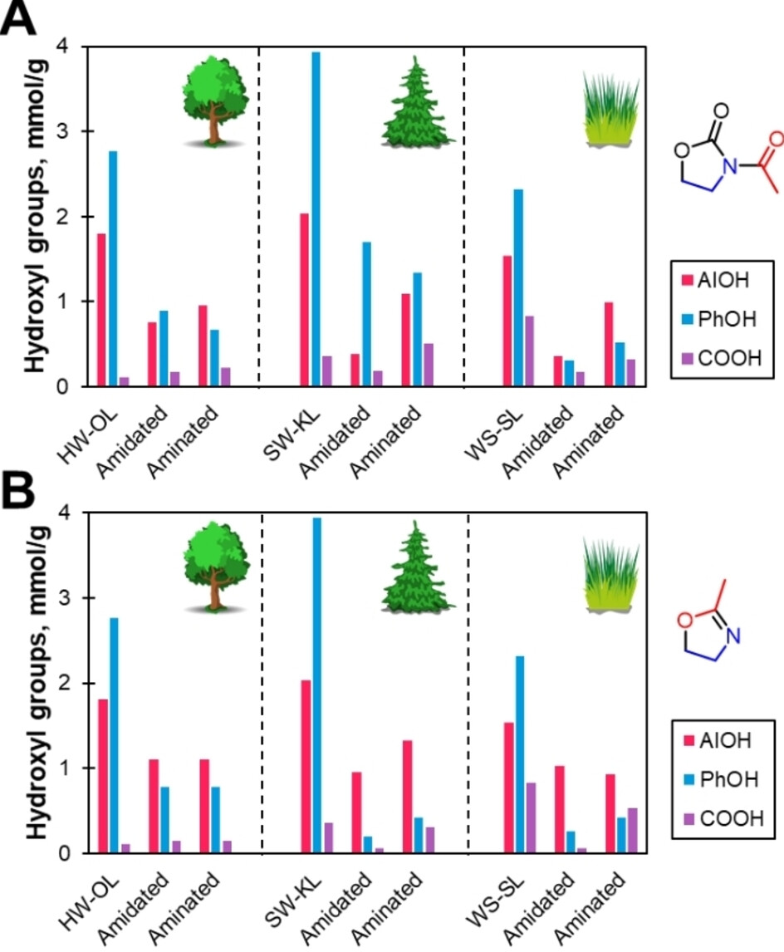
FIGURE 2. 31P NMR As can be seen in the figure, the evolution of AlOH, PhOH, and COOH groups during the amidation–hydrolysis process.

As a logical continuation of the work carried out by previous researchers, in our study we isolated lignin from rice straw and subjected it to an amination reaction in the presence of melamine and formaldehyde. The extraction of lignin from rice straw is environmentally beneficial, as rice straw is a waste raw material generated by the paper industry and agriculture. Lignin was isolated using classical methods, namely the Kraft and Organosolv processes (Figure 3).
Next, to obtain a sorbent from the isolated lignin, we performed its chemical modification. Amination proved to give excellent results, as lignin itself already exhibits sorption properties, which are further enhanced when enriched with amine groups.
The modification procedure was carried out as follows: formaldehyde was placed into a heat-resistant flask, and melamine was gradually added until a uniform mass was obtained. The mixture was stirred at 70 °C using a magnetic stirrer at a rotation speed of 3000 rpm for one minute. Then, lignin was added to the resulting mixture, and the reaction was continued for 4 hours under magnetic stirring at 80–90 °C. The final mass was dried in an oven at 50 °C for 24 hours.

FIGURE 3. Elemental (IQ) analysis of lignin obtained from rice straw.

The resulting sorbent is insoluble in water, exhibits good regeneration properties, and is cheaper and more environmentally friendly compared to conventional sorbents. The morphology and functional group composition of the modified lignin samples were studied. Sorption experiments were conducted to evaluate their ability to chemically bind toxic heavy metal ions such as Zn(II), Cu(II), and Ni(II).
The results demonstrated a significant increase in the sorption capacity, kinetic rate, and regeneration efficiency of the modified lignin. This study provides new scientific foundations for the development of environmentally safe, economically feasible, and renewable raw material–based sorbents and offers promising solutions for industrial wastewater treatment and gas purification systems.
REFERENCE
- A review of lignin-based adsorbent materials: Synthesis and applications in the remediation of heavy metal/antibiotic-containing wastewater. Journal of Environmental Chemical Engineering, 2025. https://doi.org/10.1016/j.jece.2025.119080
- Zhang, Z., Chen, Y., Wang, D., Yu, D. & Wu, C., 2023. Lignin-based adsorbents for heavy metals. Industrial Crops and Products. https://doi.org/10.1016/j.indcrop.2022.116119
- Lignin-derived porous carbons for efficient CO₂ adsorption. Carbon Capture Science & Technology, 2024. https://doi.org/10.1016/j.ccst.2024.100233
- Wang, X., Li, X., Peng, L., Han, S., Hao, C., Jiang, C., Wang, H. & Fan, X., 2021. Effective removal of heavy metals from water using porous lignin-based adsorbents. Chemosphere, 279, 130504. doi: 10.1016/j.chemosphere.2021.130504
- Du, B., Chai, L., Zheng, Q., Liu, Y., Wang, X., Chen, X., Zhai, S., Zhou, J. & Sun, R.C., 2023. Designed synthesis of multifunctional lignin-based adsorbent for efficient heavy metal ions removal and electromagnetic wave absorption. International Journal of Biological Macromolecules, 234, 123668. doi: 10.1016/j.ijbiomac.2023.123668
- Chen, J., An, L., Bae, J.H., Heo, J.W., Han, S.Y. & Kim, Y.S., 2021. Green and facile synthesis of aminated lignin-silver complex and its antibacterial activity. Industrial Crops and Products, 173, 114102. https://doi.org/10.1016/j.indcrop.2021.114102
- Duval, A., Vidal, D., Sarbu, A., René, V. & Avérous, L., 2022. Materials Today Chemistry, 24, 100793. https://doi.org/10.1016/j.mtchem.2022.100793
- Stucker, A., Podschun, J., Saake, B. & Lehnen, R., 2018. Anal. Usullari, 10, 3481–3488. https://doi.org/10.1039/C8AY01272E
- Mahmutkhonov S., Baizhonova L., Mustayev R., Tashmatova S. Dynamic analysis of voltage-ampere characteristics and harmonic distortions in electric arc furnaces. // AIP Conference Proceedings. 3331(1), 2025. pp. 070023, 1–5. https://doi.org/10.1063/5.0305745.
- Bobojanov M., Mahmutkhonov S. Influence of the consumer to power quality at the point of connection // E3S Web of Conferences 384. 2023. РР, 01041, 1-5. https://doi.org/10.1051/e3sconf/202338401041.
- Reymov K.M., Makhmuthonov S.K., Turmanova G., Uzaqbaev Q. Optimization of electric networks modes under conditions of partial uncertainty of initial information // E3S Web of Conferences 289, 07023 (2021). -2021, pp: 1-4, https://doi.org/10.1051/e3sconf/202128907023.
- Alimov, U.K., Reimov, A.M., Namazov, Sh.S., Beglov, B.M. The insoluble part of phosphorus fertilizers, obtained by processing of phosphorites of central kyzylkum with partially ammoniated extraction phosphoric acid. Russian Journal of Applied Chemistry. Russ J Appl Chem (2010) 83(3): 545–552. https://doi.org/10.1134/S107042721030328
- Reymov, A.M., Namazov, S.S., Beglov, B.M. Effect of phosphate additives on physical-chemical properties of ammonium nitrate. Journal of Chemical Technology and Metallurgy 2013 48(4), 391-395. http://dl.uctm.edu/journal/
- Urishev, B., Fakhriddin Nosirov, and N. Ruzikulova. 2023. “Hydraulic Energy Storage of Wind Power Plants.” E3S Web of Conferences, 383. https://doi.org/10.1051/e3sconf/202338304052
- Urishev, B., S. Eshev, Fakhriddin Nosirov, and U. Kuvatov. 2024. “A Device for Reducing the Siltation of the Front Chamber of the Pumping Station in Irrigation Systems.” E3S Web of Conferences, 274. https://doi.org/10.1051/e3sconf/202127403001
- Turabdjanov, S., Sh. Dungboyev, Fakhriddin Nosirov, A. Juraev, and I. Karabaev. 2021. “Application of a Two-Axle Synchronous Generator Excitations in Small Hydropower Engineering and Wind Power Plants.” AIP Conference Proceedings. https://doi.org/10.1063/5.0130649
- L.Jing, J.Guo, T.Feng, L.Han, Z.Zhou and M.Melikuziev, "Research on Energy Optimization Scheduling Methods for Systems with Multiple Microgrids in Urban Areas," 2024 IEEE 4th International Conference on Digital Twins and Parallel Intelligence (DTPI), Wuhan, China, 2024, pp. 706-711, https://ieeexplore.ieee.org/abstract/document/10778839
- Baratov, B.N., Umarov, F.Y., Toshov, Z.H. Tricone drill bit performance evaluation. Gornyi Zhurnal, Moscow, 2021. - № 12. - PP. 60-63. DOI:10.17580/gzh.2021.12.11.
- Toshov, J.B., Toshov, B.R., Baratov, B.N., Haqberdiyev, A.L. Designing new generation drill bits with optimal axial eccentricity | Вопросы проектирования буровых долот нового поколения с оптимальным межосевым эксцентриситетом // Mining Informational and Analytical Bulletin, 2022, (9). - PP. 133–142. DOI: 10.25018/0236_1493_2022_9_0_133
- Toshov J., Makhmudov A., Kurbonov O., Arzikulov G., Makhmudova G. Development and Substantiation of Energy-Saving Methods for Controlling the Modes of Operation of Centrifugal Pumping Units in Complicated Operating Conditions. Proceedings of the 11th International Conference on Applied Innovations in IT, (ICAIIT), November 2023, Koethen, Germany. – РР. 161-165.
- J.B. Toshov, K.T. Sherov, B.N. Absadykov, R.U. Djuraev, M.R. Sikhimbayev, Efficiency of drilling wells with air purge based on the use of a vortex tube. NEWS of the National Academy of Sciences of the Republic of Kazakhstan “Series of geology and technical sciences”. – Almaty, Volume 4, Number 460 (2023), 225–235. https://doi.org/10.32014/2023.2518-170X.331
Toshov J., Toshov B., Bainazov U., Elemonov M. Application of Cycle-Flow Technology in Coal Mines. Proceedings of the 11th International Conference on Applied Innovations in IT, (ICAIIT), March 2023, Koethen, Germany. – РР. 279-284.
- Usmanov, E., Kholikhmatov, B., Rikhsitillaev, B., Nimatov, K. Device for reducing asymmetry // E3s Web of Conferences 461. 2023. PP, 01052, 1-5. https://doi.org/10.1051/e3sconf/202346101052
- Toshov B., Toshov J., Akhmedova L., Baratov B. The new design scheme of drilling rock cutting tools, working in rotation mode pairs. E3S Web of Conferences 383, 04069 (2023) TT21C-2023 https://doi.org/10.1051/e3sconf/202338304069
- J.B. Toshev, M.B. Norkulov, A.A. Urazimbetova and L.G. Toshniyozov. Optimization of scheme of placing cutting structures on the cone drill bit. E3S Web of Conf., Volume 402, 10039 (2023), International Scientific Siberian Transport Forum - TransSiberia 2023, https://doi.org/10.1051/e3sconf/202340210039
- Toshov J., Baratov B., Sherov K., Mussayev M., Baymirzaev B., Esirkepov A., Ismailov G., Abdugaliyeva G., Burieva J. Ways to Optimize the Kinetic Parameters of Tricone Drill Bits. Material and Mechanical Engineering Technology, №1, 2024, 35-45. https://doi.org/10.52209/2706-977X_2024_1_35
- K.T. Sherov, N.Zh. Karsakova, B.N. Absadykov, J.B. Toshov, M.R. Sikhimbayev, Studying the effect of the boring bar amplitude-frequency characteristics on the accuracy of machining a large-sized part. NEWS of the National Academy of Sciences of the Republic of Kazakhstan “SERIES OF GEOLOGY AND TECHNICAL SCIENCES”. – Almaty, Volume 2, Number 464 (2024), 217–227. https://doi.org/10.32014/2024.2518-170X.405
- J. Toshov, L. Atakulov, G. Arzikulov, U. Baynazov, Modeling of optimal operating conditions of cyclic-flow technologies with a belt conveyor at coal mine under the "ANSYS" program. AIP Conf. Proc. 3152, 020006 (2024) / III International Scientific and Technical Conference “Actual issues of Power supply systems” (ICAIPSS2023), 7–8 September 2023, Tashkent, Uzbekistan. https://doi.org/10.1063/5.0218904
- Kholikhmatov B.B., Samiev Sh.S., Erejepov M.T., Nematov L.A. Modelling of laboratory work in the science "Fundamentals of power supply" using an educational simulator based on a programmed logic controller // E3S Web of Conferences 384. 2023. РР, 01032, 1-3. https://doi.org/10.1051/e3sconf/202338401032
- Rakhimov F, Rakhimov F, Samiev Sh, Abdukhalilov D. Justification of Technical and Economic Effectiveness of Application of 20 kV Voltage in Overhead Electric Networks //AIP Conf. Proc. 3152, 030023 (2024). https://doi.org/10.1063/5.0218921
- Taslimov A, Mo'minov V, Samiev Sh, Abdukhalilov D. Issues of Optimization of Electrical Network Parameters Medium Voltage //AIP Conf. Proc. 3331, 020007 (2025). https://doi.org/10.1063/5.0305781
- Toshbekov, O., Urazov, M., Yermatov, S., & Khamraeva, M. 2023). Yeffisient and yesonomisal yenergy use teshnology in the prosessing of domestis soarse wool fiber. In Ye3S Web of Sonferenses (Vol. 461, p. 01068). https://doi.org/10.1051/e3sconf/202346101068
- Jumaniyozov, K., Urozov, M., Toshbekov, O., Salimova, M., Raximova, K., & Khursandova, B. (2025, November). Enhancement of energy-efficient cleaning equipment. In American Institute of Physics Conference Series (Vol. 3331, No. 1, p. 050007). https://doi.org/10.1063/5.0307149
- Sultonova, F., Toshbekov, O., Urozov, M., Boymurova, N., Mustanova, Z., & Boltaeva, I. (2025, November). Enhancing and evaluating the characteristics of specialized workwear for employees in the electric power supply sector. In American Institute of Physics Conference Series (Vol. 3331, No. 1, p. 050006). https://doi.org/10.1063/5.0306350

