Improving Mathematics Teaching in Higher Education through a Competency-Based and STEAM-Integrated Approach
O‘g‘iloy Sultonova ^{a)}, Rasul Turayev, Ergash Turayev, Qahramon Eshqorayev, Aburaxmat Eshqorayev, Hilola Abdusamatova
Termez State University of Engineering and Agrotechnology, Termez, Uzbekistan
^{a)} Corresponding author: qanvar94@mail.ru
Abstract. This quasi-experimental study examines the effectiveness of a competency-based and STEAM-integrated instructional approach in improving undergraduate mathematics learning outcomes in higher education. The study involved a total of 460 undergraduate students, including an experimental group (n=230) and a control group (n=230). The experimental group was instructed using a competency-based teaching model enriched with interdisciplinary STEAM elements, while the control group received traditional lecture-based instruction. Students’ learning outcomes were measured using achievement pre-tests and post-tests. Quantitative data were analyzed using paired-samples and independent-samples t-tests. The results revealed a statistically significant improvement in the experimental group (p < 0.001) with a large effect size (Cohen’s d=1.48). The findings demonstrate that integrating competency-based principles with STEAM methodology significantly enhances students’ mathematical achievement.
INTRODUCTION
In recent years, higher education systems worldwide have increasingly emphasized the development of students’ competencies rather than the mere transmission of subject knowledge. This shift is driven by the growing demand for graduates who are capable of applying mathematical knowledge in real-life and professional contexts, engaging in independent problem-solving, and adapting to rapidly changing technological and social environments. As a result, improving the effectiveness of mathematics teaching in higher education has become a critical pedagogical challenge.
Traditional approaches to teaching mathematics in universities often focus on theoretical explanations and procedural exercises, which may limit students’ ability to transfer knowledge to practical situations. Numerous studies in mathematics education highlight that such approaches frequently lead to passive learning, low motivation, and insufficient development of higher-order thinking skills. In response, the competency-based approach has been proposed as a promising framework for aligning educational outcomes with the needs of contemporary society and the labor market. The competency-based approach emphasizes the integration of knowledge, skills, and attitudes, enabling students to apply what they have learned in diverse and unfamiliar situations. Recently, STEAM education has gained considerable attention as an interdisciplinary approach connecting mathematics with real-life applications. This study addresses this gap by investigating the effectiveness of a competency-based and STEAM-integrated instructional approach in higher education.
This figure-1 illustrates the interaction between competency-based principles, interdisciplinary STEAM integration, and active learning strategies, demonstrating how these components collectively contribute to enhanced mathematical learning outcomes

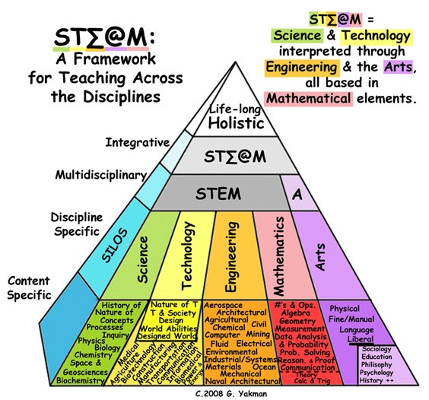
a)
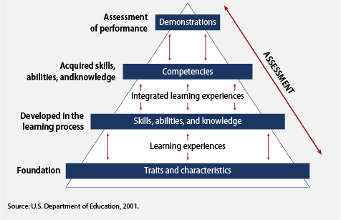
b)
FIGURE 1. Conceptual framework of the competency-based and STEAM-integrated mathematics teaching model. a) The STEAM pyramid model illustrates the progressive levels of integration across disciplines. At the lower levels, subjects are taught separately (content-specific and discipline-specific). As instruction advances, learning becomes multidisciplinary and increasingly integrative, linking concepts across fields. At the highest level, the STEAM framework promotes a holistic, life-oriented approach that fosters creativity, problem solving, and competency development. In this model, science and technology are interpreted through engineering and the arts, while mathematics forms the conceptual foundation that enables learners to apply knowledge to real-world contexts; b) The competency pyramid illustrates the developmental progression from foundational learner characteristics to demonstrated performance. At the base, students enter the learning process with certain traits and characteristics that shape how they engage with instruction. Through structured learning experiences, these traits are gradually transformed into skills, abilities, and knowledge. Integrated learning experiences further synthesize these components, supporting the formation of stable competencies. At the top of the pyramid, learners are able to demonstrate their competencies in authentic contexts. Assessment operates across all levels, ensuring that growth is monitored, learning gaps are identified, and demonstrated performance accurately reflects competency development.
RESEARCH METHODOLOGY
This study employed a quasi-experimental research design involving experimental and control groups of undergraduate students. The experimental group received competency-based and STEAM-integrated instruction, while the control group followed traditional lecture-based methods.
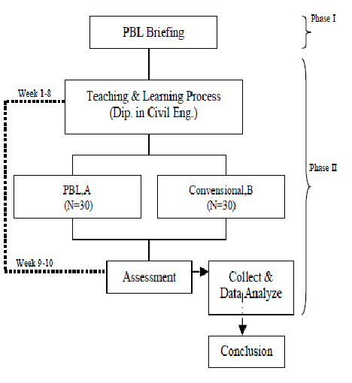
a)
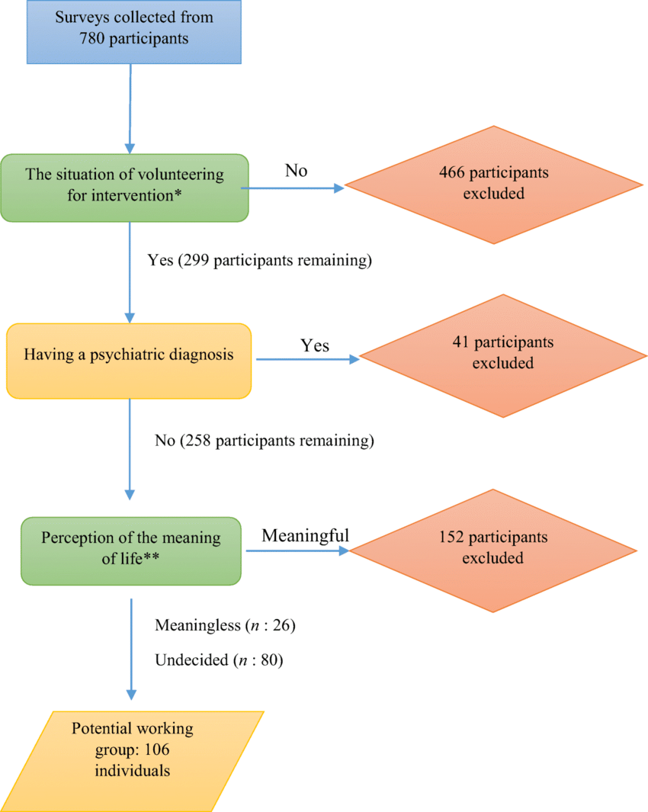
b)
FIGURE 2. Quasi-experimental research design with experimental and control groups.
a) The research procedure for the implementation of the PBL intervention. During Phase I, students receive a PBL briefing followed by the regular teaching and learning process in the Diploma in Civil Engineering program. In Phase II, students are divided into two groups: the PBL group (n = 30) and the conventional instruction group (n = 30). Over Weeks 1–8, each group follows its respective instructional approach. During Weeks 9–10, students are assessed, after which the collected data are analyzed, leading to the formulation of study conclusions.
b) Flow diagram of participant selection. Surveys were initially collected from 780 participants. Individuals who did not volunteer for the intervention were excluded (n = 466), leaving 299 participants. Those reporting a psychiatric diagnosis were then excluded (n = 41), resulting in 258 participants. Next, participants were screened based on their perception of the meaning of life; individuals who reported a meaningful perception were excluded (n = 152). The remaining participants were categorized as meaningless (n = 26) or undecided (n = 80), forming a potential working group consisting of 106 individuals.
This figure presents the structure of the quasi-experimental design, including the pre-test and post-test stages, and clarifies the comparative logic used to evaluate the effectiveness of the instructional intervention
RESULTS
Descriptive statistics. This section presents the quantitative results of the quasi-experimental study examining the effects of a competency-based and STEAM-integrated instructional approach on undergraduate students’ mathematics learning outcomes.
Table 1. Comparison of Pre-test and Post-test Scores
Group | n | Pre-test Mean (SD) | Post-test Mean (SD) | Mean Gain
Experimental | 230 | 54.87 (4.29) | 68.70 (4.63) | +13.84
Control | 230 | 55.07 (4.34) | 58.62 (4.84) | +3.55

Table 1 summarizes the descriptive statistics of pre-test and post-test scores for both the experimental and control groups. At the beginning of the study, the two groups demonstrated comparable levels of mathematical achievement, indicating an equivalent baseline prior to the intervention.
The experimental group (n = 230) achieved a mean pre-test score of 54.87 (SD = 4.29), which increased to a mean post-test score of 68.70 (SD = 4.63). This represents a substantial mean gain of 13.84 points. In contrast, the control group (n = 230) showed a more modest improvement, with mean scores increasing from 55.07 (SD = 4.34) on the pre-test to 58.62 (SD = 4.84) on the post-test, corresponding to a mean gain of 3.55 points.
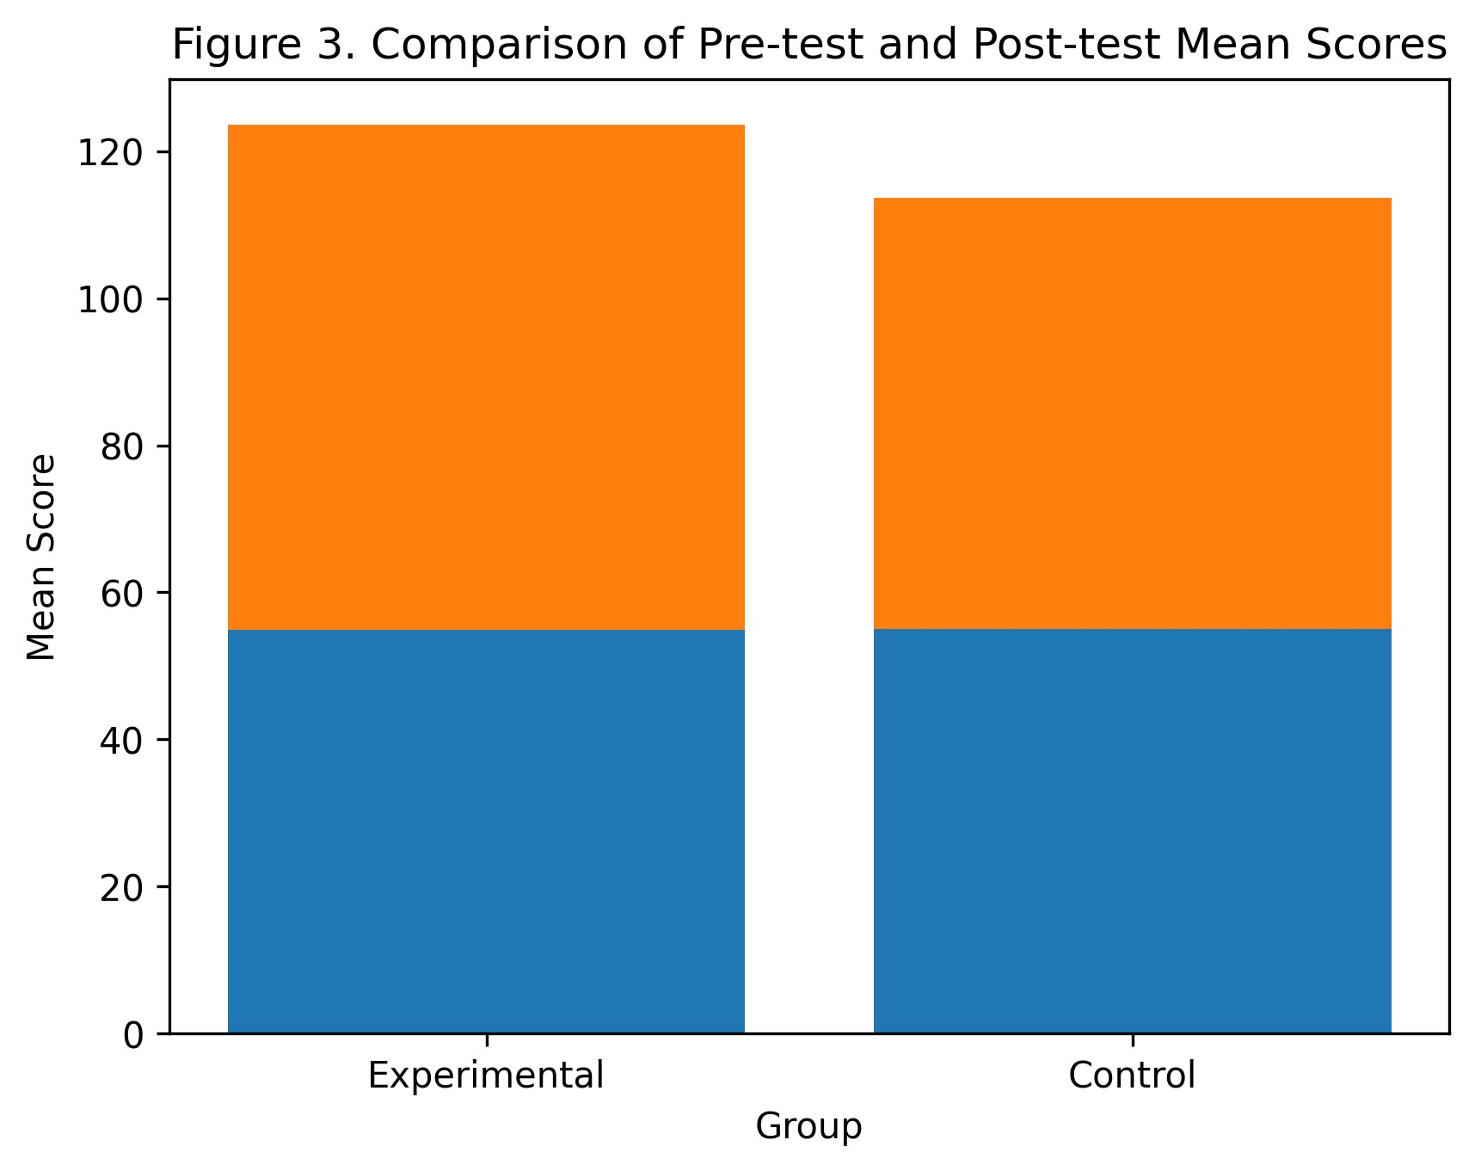
FIGURE 3. Comparison of pre-test and post-test mean scores between experimental and control groups.

This figure highlights the magnitude of learning gains achieved by the experimental group compared to the control group, visually supporting the statistically significant differences identified through inferential analysis.
Inferential statistical analysis. To examine within-group changes, paired-samples t-tests were conducted. The results revealed a statistically significant improvement in the experimental group from pre-test to post-test, t(229)=31.8, p<0.001, indicating a strong positive effect of the competency-based and STEAM-integrated instructional approach. The control group also showed a statistically significant but comparatively smaller improvement, t(229)=9.4, p<0.01, reflecting natural progress associated with traditional instruction. The degrees of freedom reflect paired observations within each group (df=n−1).
To compare learning outcomes between groups, an independent-samples t-test was performed on post-test scores. The analysis demonstrated a statistically significant difference between the experimental and control groups, t(458)=22.6, p<0.001. The effect size was large (Cohen’s d=1.48), indicating a strong practical impact of the instructional intervention on students’ mathematics achievement.

DISCUSSION
The findings of this study provide robust empirical evidence supporting the effectiveness of a competency-based and STEAM-integrated approach to teaching mathematics in higher education. The substantial improvement observed in the experimental group, compared to the relatively modest gains in the control group, suggests that traditional lecture-based instruction alone is insufficient for fostering higher-order mathematical competencies.
The large effect size obtained in the post-test comparison highlights not only statistical significance but also meaningful educational impact [18-47]. This result can be attributed to the instructional model’s emphasis on active learning, interdisciplinary integration, and real-world problem-solving, which collectively promote deeper conceptual understanding and transferable skills.
These findings are consistent with previous research emphasizing the benefits of competency-oriented and interdisciplinary instructional strategies in STEM education. Studies by Freeman et al. (2014) and Yakman and Lee (2012) similarly reported that active, integrated learning environments lead to higher academic performance and increased student engagement. The present study extends this body of literature by demonstrating that such approaches are particularly effective in university-level mathematics education, where abstract concepts often pose challenges for learners.
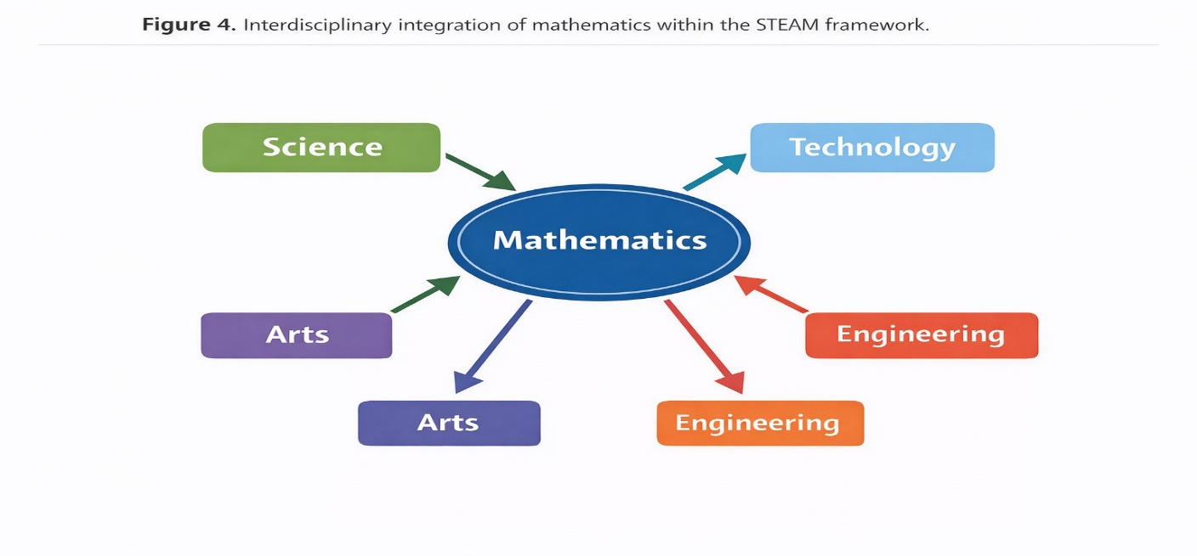
FIGURE 4. Interdisciplinary integration of mathematics within the STEAM framework.

Moreover, the results align with contemporary educational frameworks that emphasize the development of competencies rather than the mere acquisition of knowledge. By integrating STEAM principles, the instructional model encouraged students to connect mathematical concepts with practical applications, thereby enhancing motivation and learning relevance. This integration appears to be a key factor in the significant performance gains observed in the experimental group.
Despite the strengths of the study, certain limitations should be acknowledged. The research was conducted within a single institutional context, which may limit the generalizability of the findings. Future studies could expand the sample across multiple universities and explore longitudinal effects to assess the sustainability of learning gains over time.
This figure demonstrates how mathematics is connected with science, technology, engineering, arts, and real-world problem-solving contexts, reinforcing the role of interdisciplinary learning in developing transferable competencies.
CONCLUSION
This study demonstrates that integrating competency-based principles with STEAM methodology represents an effective strategy for improving the quality of mathematics teaching in higher education. The approach supports the development of key mathematical competencies and enhances student learning outcomes.
REFERENCES
- OECD. (2019). OECD Future of Education and Skills 2030: Education Working Papers. OECD Publishing.
- Voogt, J., Fisser, P., Pareja Roblin, N., Tondeur, J., & van Braak, J. (2015). Technological pedagogical content knowledge – A review of the literature. Journal of Computer Assisted Learning, 31(2), 133–153. https://doi.org/10.1111/jcal.12093
- Bybee, R. W. (2013). The case for STEM education: Challenges and opportunities. NSTA Press.
- English, L. D. (2017). Advancing elementary and middle school STEM education. International Journal of Science and Mathematics Education, 15(1), 5–24. https://doi.org/10.1007/s10763-017-9802-x
- Shavelson, R. J. (2018). Measuring College Learning Responsibly. Stanford University Press.
- Rieckmann, M. (2012). Future-oriented higher education: Which key competencies should be fostered? Futures, 44(2), 127–135. https://doi.org/10.1016/j.futures.2011.09.005
- González, J., & Wagenaar, R. (2005). Tuning educational structures in Europe. Universities’ contribution to the Bologna Process.
- Lai, E. R. (2011). Critical thinking: A literature review. Pearson Research Report.
- Kong, S. C., Chiu, M. M., & Lai, M. (2018). A study of e-learning adoption in higher education. Computers & Education, 125, 23–36. https://doi.org/10.1016/j.compedu.2018.05.004
- Yakman, G., & Lee, H. (2012). Exploring the exemplary STEAM education. Journal of the Korean Association for Science Education, 32(6), 1072–1086.
- Prince, M. (2004). Does active learning work? A review of the research. Journal of Engineering Education, 93(3), 223–231. https://doi.org/10.1002/j.2168-9830.2004.tb00809.x
- Freeman, S., et al. (2014). Active learning increases student performance in STEM. Proceedings of the National Academy of Sciences, 111(23), 8410–8415. https://doi.org/10.1073/pnas.1319030111
- Holmes, W., Bialik, M., & Fadel, C. (2019). Artificial intelligence in education. Center for Curriculum Redesign.
- Darling-Hammond, L., et al. (2020). Implications for educational practice of the science of learning. Educational Psychologist, 55(2), 97–115. https://doi.org/10.1080/00461520.2020.1741114
- OECD. (2021). Innovating Education and Educating for Innovation. OECD Publishing.
- Safarov, N., Yangiboev, R., Bo‘riyev, H., Karshiev, B., Gulboyev, O., Narzullayev, F., & Qurbonov, A. (2025, February). Study of the influence of main factors on the mass and density of saw fiber separator raw material. In AIP Conference Proceedings (Vol. 3268, No. 1, p. 020033). AIP Publishing LLC. https://doi.org/10.1063/5.0257374
- A.K. Nomozov, Kh.S. Beknazarov, Y.A. Geldiev, B.E. Babamurodov, N.Sh. Muzaffarova, S.G. Yuldashova. Synthesis of PFG brand corrosion inhibitor and its quantum chemical calculation results. Chem. Probl., 2025, no. 3(23), 297–309. https://doi.org/10.32737/2221-8688-2025-3-297-309
- Mahmutkhonov S., Baizhonova L., Mustayev R., Tashmatova S. Dynamic analysis of voltage-ampere characteristics and harmonic distortions in electric arc furnaces. // AIP Conference Proceedings. 3331(1), 2025. pp. 070023, 1–5. https://doi.org/10.1063/5.0305745.
- Bobojanov M., Mahmutkhonov S. Influence of the consumer to power quality at the point of connection // E3S Web of Conferences 384. 2023. РР, 01041, 1-5. https://doi.org/10.1051/e3sconf/202338401041.
- Bobojanov M.K., Karimov R.Ch., Popkova O.S., Tuychiev F.N., Makhmutkhanov S.K. Analysis of the results of experimental studies of the arc furnace DSP-30. // Power Engineering Research & Technology. 27(2), 2025. pp. 126–137. https://doi.org/10.30724/1998-9903-2025-27-2-126-137
- Reymov K.M., Makhmuthonov S.K., Turmanova G., Uzaqbaev Q. Optimization of electric networks modes under conditions of partial uncertainty of initial information // E3S Web of Conferences 289, 07023 (2021). -2021, pp: 1-4, https://doi.org/10.1051/e3sconf/202128907023.
- R. K. Kurbaniyazov, A. M. Reimov, A.T. Dadakhodzhaev, Sh. S. Namazov, B. M. Beglov. Nitrogen-phosphoric fertilizers produced by introduction of Central Kyzylkum phosphate raw material into ammonium nitrate melt. Russian Journal of Applied Chemistry. Russ J Appl Chem (2007) 80(11): 1984-88. https://doi.org/10.1134/S1070427207110456
- Namazov, Sh.S., Kurbaniyazov, R.K., Reimov, A.M., Beglov, B.M. Hardness of the granules of ammonium nitrate doped with the Central Kyzylkum Phosphorite. Russian Journal of Applied Chemistry. Russ J Appl Chem (2007) 81(6): 1103–1106. http://dx.doi.org/10.1134/s1070427208060402.
- Kurbaniiazov, R.K., Reimov, A.M., Namazov, Sh.S., Beglov, B.M. Nitrogen-phosphoric fertilizers obtained by interaction of the concentrated solutions of ammonium nitrate with the mineralized mass of the phosphorites of Central Kyzylkum. Russian Journal of Applied Chemistry. Russ J Appl Chem (2009) 82: 1123. https://link.springer.com/journal/11167
- Alimov, U.K., Reimov, A.M., Namazov, Sh.S., Beglov, B.M. The insoluble part of phosphorus fertilizers, obtained by processing of phosphorites of central kyzylkum with partially ammoniated extraction phosphoric acid. Russian Journal of Applied Chemistry. Russ J Appl Chem (2010) 83(3): 545–552. https://doi.org/10.1134/S107042721030328
- Reymov, A.M., Namazov, S.S., Beglov, B.M. Effect of phosphate additives on physical-chemical properties of ammonium nitrate. Journal of Chemical Technology and Metallurgy 2013 48(4), 391-395. http://dl.uctm.edu/journal/
- Reymov Akhmed, Namazov Shafoat. Nitrogen-phosphorous fertilizers on the base of concentrated ammonium nitrate solution and Central Kyzylkum phosphate raw material. Polish Journal of Chemical Technology 16(3), Sep 2014, 30-35. https://doi.org/10.2478/pjct-2014-0046
- Alisher Eshimbetov, Shahobiddin Adizov, Inderpreet Kaur, Akhmed Reymov. Is it possible to differentiate between 2-phenylaminodihydro-1,3-thiazine from 2-phenyliminotetrahydro-1,3-thiazine by spectral methods? New glance to the old problem. European Journal of Chemistry 12 (1) (2021). https://doi.org/10.5155/eurjchem.12.1.77-80.2068
- A.Ahmadjonov, U.Alimov, P.Tuychi, A.Seitnazarov, A.Reimov, Sh.Namazov, S.Sadullayev. Effect of temperature on the kinetics of the process of nitric acid decomposition of Arvaten serpentinite. IOP Conf. Series: Earth and Environmental Science 1142 (2023) 012034. https://www.scopus.com/pages/publications/85151285667
- Xudoyberdiev J., Reymov A., Kurbaniyazov R., Namazov S., Badalova O., Seytnazarov A. Mineral Composition of Nodular Phosphorite of Karakalpakstan and its Processing into Simple Superphosphate. (2023) E3S Web of Conferences, 449, art. no. 06005. https://www.scopus.com/inward/record.uri?eid=2-s2.0-85178595919&doi=10.1051%2fe3sconf%2f202344906005&partnerID=40
- Kosnazarov K., Ametov Y., Khabibullaev A., Reymov A., Turdimambetov I., Shaniyazov S., Berdimuratova A. Characteristics of dust-salt transfer from the dried bottom of the Aral Sea and the Aral region, as well as their lossout. E3S Web of Conferences. https://www.scopus.com/pages/publications/85212840616
- Seyilkhanova A., Reymov Q., Eshmuratov A., Gulimbetov B., Medetov M., Reymov A., Berdimuratova A., Shaniyazov Sh. E3S Web of Conferences ISSN: 25550403Volume: 575. https://www.scopus.com/pages/publications/85212825022
- Turdimambetov I., Murgaš F., Victor F., Oteuliev M., Madreimov A., Shamuratova G., Atabayev S., Reymov A. Geojournal of Tourism and Geosites. ISSN: 20650817, Volume: 57 Pages: 1941 – 1951. https://www.scopus.com/pages/publications/85213872579
- Temirov G., Alimov U., Seytnazarov A., Reymov A., Namazov S., Beglov B. Rheological Properties and Composition of Products of Phosphogypsum Conversion with Sodium Carbonate. Russian Journal of General Chemistry. ISSN: 10703632 Volume: 94 Issue: 7 Pages: 1837 – 1847. https://www.scopus.com/pages/publications/85202786813
- Reymov A., Turdimambetov I., Pirnazarov N., Shaniyazov Sh., Absametova D., Baymurzaev A., Orazbaev A., Usnatdinov A.,Tajetdinov S. Exploring novel techniques for measuring and identifying minuscule dust particles in the atmosphere. E3S Web of Conferences ISSN: 25550403 Volume: 575. https://www.scopus.com/pages/publications/85212822728
- Chavliyeva F., Turakulov B., Kucharov B., Erkayev A., Reymov A., Karshiboev M., Mamajonov M. Study of obtaining potassium hydroxide by electrochemical method on the bases of flotation and hallurgic potassium chloride. New Materials, Compounds and Applications ISSN: 25217194 Volume: 8 Issue: 2 Pages: 244 – 253. https://www.scopus.com/pages/publications/85204364412
- Kuldasheva S., Aziza A., Kulmatov R., Karimova G., Dauletbayeva R., Nortojiyeva G., Reymov A. Study and assessment of mineralogical, chemical and granulometric composition of volatile soil-sand aerosols from the dried-out part of the Aral Sea. E3S Web of Conferences ISSN: 25550403 Volume: 575. https://www.scopus.com/pages/publications/85212848932
- M. Medetov, D. Musaev, U. Shakarbaev, A. Yusupova, J. Tajibaeva, A. Reymov, A. Yusupova, D. Bazarbaeva, B. Gulimbetov. Insect fauna of the Republic of Uzbekistan: Rare true bugs (Hemiptera, Heteroptera). Regulatory Mechanisms in Biosystems ISSN: 25198521 Volume: 15 Issue: 4 Pages: 882 – 888. https://www.scopus.com/pages/publications/85218798691
- Kurbaniyazov R.K., Khudoyberdiev J.H., Reymov A.M., Namazov Sh.S., Radjapov R., Seytnazarov A.R. Characteristics of nodular phosphorites of karakalpakstan and their processing into granular simple superphosphate. ChemChemTech ISSN: 05792991 Volume: 68 Issue: 1 Pages: 109 – 119. https://www.scopus.com/pages/publications/85211354040?origin=resultslist
- M.ZH.Medetov, J.K.Abdullaeva, A.M. Reymov, A.M.Miratdinova, A.K.Seytmuratov, J.D.Tajibaeva, R.S.Kadirov, N.A.Utemuratov, S.K.Kimyonazarov, J. Kudratov, R.S.Urazova, X.X.Keldiyova, U.B.Uralov. Diversity of true bugs (Hemiptera: Heteroptera) of the Southern Aral Sea Region, Uzbekistan. Biodiversitas ISSN: 1412033X Volume: 26 Issue: 7 Pages: 3125 – 3135. https://www.scopus.com/pages/publications/105014219940?origin=resultslist
- Ulugbek Urinov, Nilufar Hamidova and Ilhom Mirzakulov . Chemical technology of oligomers production from homopolymer based on epichlorohydrin and morpholine. E3S Web of Conferences 497, 03030 (2024) ICECAE 2024. https://doi.org/10.1051/e3sconf/202449703030
- Bakhtiyor, K., Gafurov, B., Mamatkulov, A., Shayimov, F., Tukhtaev, B. AIP Conference Proceedings, 3331(1), 080001. https://doi.org/10.1063/5.0306044
- Khusanov, B., Keunimjaeva, A., Jalelova, M., Rustamov, S. AIP Conference ProceedingsOpen source preview, 2024, 3152(1), 030024. https://doi.org/10.1063/5.0218924
- Khusanov, B., Arzuova, S., Radjapov, Z., Babaev, O. AIP Conference ProceedingsOpen source preview, 2024, 3152(1), 030028. https://doi.org/10.1063/5.0219241
- Urishev, B., F. Artikbekova, D. Kuvvatov, F. Nosirov, and U. Kuvatov. 2022. “Trajectory of Sediment Deposition at the Bottom of Water Intake Structures of Pumping Stations.” IOP Conference Series: Materials Science and Engineering, 1030(1). https://doi.org/10.1088/1757-899X/1030/1/012137
- Nosirov, Fakhriddin, Abdurasul Juraev, Ibragim Khamdamov, and Nurmukhammed Kuvatov. 2023. “Economic Calculation of a Photoelectric Station for Degradation Processes.” AIP Conference Proceedings. https://doi.org/10.1063/5.0130642
- Nosirov, Fakhriddin, Oleg Glovatsky, Bekzod Khamdamov, and Armen Gazaryan. 2023. “Increasing the Stability of the Supply Hydraulic Structures.” AIP Conference Proceedings. https://doi.org/10.1063/5.0218867

