Application of GSM Technology for Remote Monitoring of Power Factor Correction Systems
Ikromjon Rakhmonov ^{1, 4}, Shokhrukh Atajiev^{1, a)}, Ziyodullo Eshmurodov ², Kuanishbay Erejepov ³
¹Tashkent state technical university named after Islam Karimov, Tashkent, Uzbekistan
²Navoi State University of Mining and Technologies, Navoiy, Uzbekistan
³Karakalpak State University named after Berdakh, Nukus, Uzbekistan
⁴Termez State University of Engineering and Agrotechnology, Termez, Uzbekistan
^{a)} Corresponding author: mr.shoh.mr@gmail.com
Abstract. Reactive power compensation is an essential aspect of modern electrical power systems, as it directly affects energy efficiency, voltage regulation, and power loss reduction. The increasing complexity of electrical networks and the widespread use of inductive loads have created a need for advanced monitoring and control solutions capable of operating beyond local installations. This study presents the development and analysis of a GSM-based remote monitoring system for power factor correction in three-phase low-voltage electrical networks. The proposed system integrates current and voltage measurement units with a central control module and a GSM communication interface to enable continuous real-time supervision of key electrical parameters, including power factor, reactive power level, capacitor bank status, and voltage characteristics. Measured data are transmitted via the GSM network to remote user interfaces accessible through personal computers and mobile devices, allowing location-independent monitoring and supervision. Experimental and operational results demonstrate that the implemented monitoring platform significantly improves system observability, compensation accuracy, and operational transparency. The system effectively maintains the power factor within the desired range, minimizes unnecessary capacitor switching, and supports early detection of abnormal operating conditions. Furthermore, GSM-based communication enhances maintenance efficiency by reducing the need for on-site inspections and enabling timely corrective actions.
INTRODUCTION
Reactive power compensation plays a vital role in improving the efficiency of electrical power systems and reducing energy losses. The effective management of this process has entered a new stage due to recent technological advancements. In particular, the integration of GSM technology has enabled remote monitoring capabilities, introducing an innovative approach to reactive power management. This thesis discusses the fundamental principles, technological solutions, and practical implementation of reactive power control based on GSM-enabled monitoring systems.
In electrical power systems, reactive power consumption primarily arises from transformers, electric motors, and other inductive loads. Such consumption reduces overall system efficiency and leads to voltage drops as well as increased power losses. By applying reactive power compensation, it is possible to enhance system performance and reduce operational costs. The utilization of GSM modules in this process significantly improves monitoring accuracy and system responsiveness. The Global System for Mobile Communications (GSM) technology is widely used in the telecommunications sector due to its extensive coverage and high reliability, making it a suitable solution for energy management applications. The ability to transmit data in real time through GSM networks enables efficient remote monitoring of reactive power parameters. Moreover, this technology supports not only continuous data acquisition but also timely alerting in emergency or abnormal operating conditions, thereby enhancing the reliability and safety of power factor correction systems.
The proposed GSM-based remote monitoring system is designed to continuously observe key electrical parameters related to power factor correction, such as voltage, current, power factor, and the operational status of capacitor banks. Measurement data are collected through appropriate sensing units and processed by a local control module, which prepares the information for transmission via the GSM network. This architecture allows system operators to access real-time data regardless of geographical location. Remote monitoring significantly enhances the operational transparency of power factor correction systems. By providing timely information on system performance, it enables early detection of abnormal conditions, such as insufficient compensation, capacitor malfunction, or excessive reactive power consumption. As a result, maintenance actions can be planned more efficiently, reducing downtime and preventing potential system failures.
Another important advantage of the GSM-based approach is its scalability and ease of integration into existing power factor correction installations. The monitoring module can be implemented without major modifications to the existing infrastructure, making it a cost-effective solution for both industrial and commercial applications. Furthermore, the use of widely available GSM networks eliminates the need for complex communication infrastructure.

RESEARCH METHODOLOGY
The GSM-based remote monitoring system for reactive power compensation is designed to improve the power factor of electrical networks while enabling continuous remote supervision of system operating conditions, as illustrated in Figure 1. The proposed architecture is connected to a three-phase low-voltage power supply, where phases L1, L2, and L3 deliver electrical energy to the connected loads.
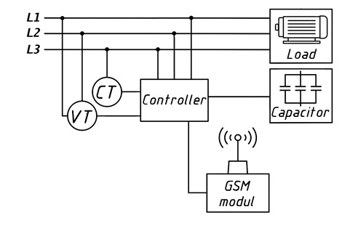
FIGURE 1. GSM-based remote monitoring and control system for reactive power compensation in a three-phase electrical network.

Current and voltage measurements are performed using a current transformer (CT) and a voltage transformer (VT), which continuously monitor phase currents, phase voltages, and phase angle differences. These measured electrical parameters are transmitted to the central controller, which represents the core component of the monitoring and control system. The controller processes the acquired data in real time to evaluate the reactive power level and calculate the instantaneous power factor of the electrical network.
Based on the analyzed operating conditions, the controller automatically determines whether reactive power compensation is required. When a decrease in the power factor is detected, the controller initiates corrective actions by switching the capacitor bank into the network. This process enables the injection of capacitive reactive power, thereby compensating for the inductive reactive power demand and restoring the system to a balanced operating state. Conversely, when the power factor reaches acceptable levels, the controller disconnects the capacitor bank to prevent overcompensation.
The connected load typically consists of electric motors, transformers, and other inductive-type consumers commonly found in industrial and commercial installations. These loads inherently consume reactive power, which leads to increased current flow, voltage drops, and reduced overall system efficiency if not properly compensated. Therefore, continuous monitoring and adaptive control of reactive power become essential for maintaining stable and efficient operation of the power system.
A key feature of the proposed system is the integration of a GSM communication module, which enables the remote transmission of measured data and system status information. Through GSM-based communication, operators can access real-time information on power factor values, capacitor bank status, and overall system performance using mobile devices or computer-based interfaces. This capability allows effective remote supervision, rapid fault detection, and timely maintenance interventions without the need for on-site presence.

RESEARCH RESULTS
The implementation of the GSM-based remote monitoring interface significantly enhances the observability and operational effectiveness of power factor correction (PFC) systems. The developed monitoring platform, accessible through desktop computers, laptops, and mobile devices, provides real-time visualization of key electrical parameters, including power factor, reactive power compensation level, capacitor bank switching status, and voltage–power trends, as illustrated in Figure 2. Continuous access to system data enables a more accurate evaluation of compensation performance and overall system stability. One of the most significant outcomes of the proposed monitoring interface is its capability to track power factor behavior dynamically over time. The graphical representation of power factor variations clearly demonstrates that, once compensation is applied, the system maintains values within the predefined optimal range. Any deviation from nominal operating conditions is immediately reflected on the interface, allowing operators to promptly identify under-compensation or over-compensation scenarios. This real-time feedback mechanism improves decision-making efficiency and significantly reduces response time for corrective actions.
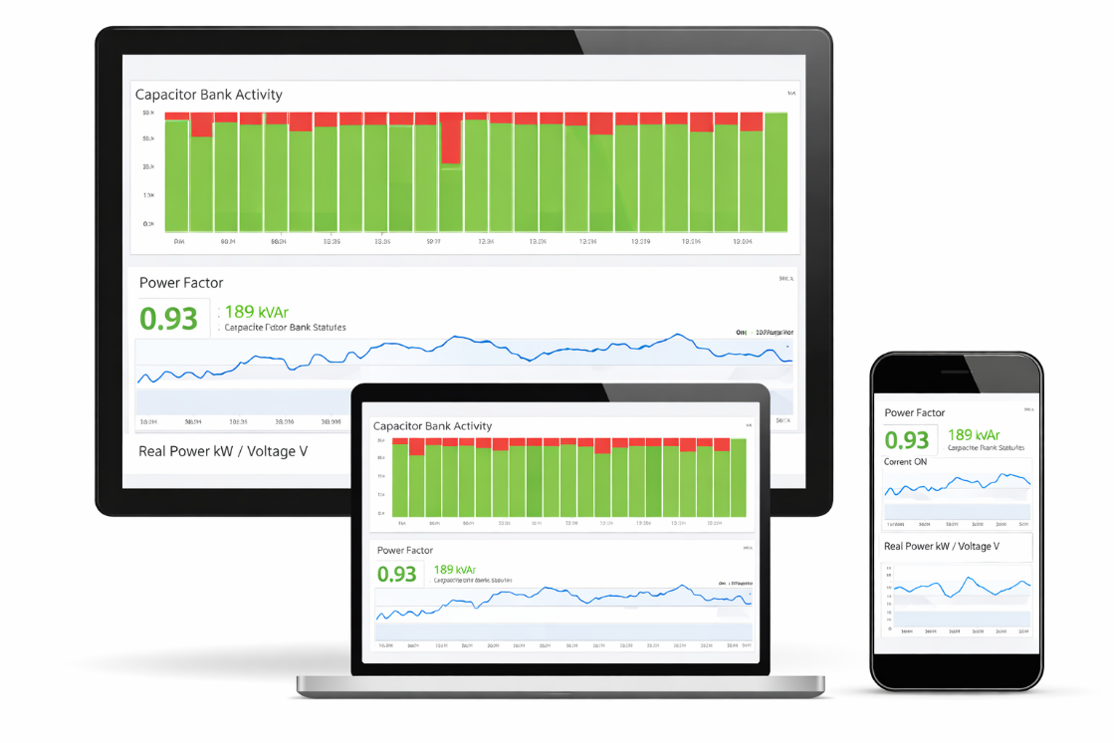
FIGURE 2. GSM-based remote monitoring interface for real-time supervision of power factor correction systems using PC and mobile devices

The visualization of capacitor bank activity plays a crucial role in assessing the effectiveness of reactive power compensation. Bar-chart indicators representing individual capacitor steps illustrate the switching patterns under varying load conditions. The observed results indicate that capacitor banks are activated only when required, thereby minimizing unnecessary switching operations and reducing electrical stress on system components. Such controlled switching behavior contributes to extended capacitor lifespan and enhanced overall system reliability.
In addition to monitoring power factor and capacitor status, the interface provides continuous supervision of real power and voltage parameters. The synchronized display of these variables enables a comprehensive analysis of network operating conditions. Voltage profiles observed during normal operation remain within acceptable limits, confirming that effective reactive power compensation positively influences voltage regulation. Moreover, the correlation between real power demand and compensation activity highlights the adaptive response of the monitoring system to load fluctuations. A major advantage of the proposed monitoring platform lies in its multi-device and location-independent accessibility enabled by GSM communication. Monitoring data transmitted via the GSM network can be securely accessed without physical presence at the installation site. This feature is particularly beneficial for industrial facilities and geographically distributed electrical installations, where on-site supervision may be impractical or costly. The results confirm that remote monitoring facilitates early detection of abnormal operating conditions, such as capacitor bank failures or unexpected increases in reactive power demand, thereby reducing maintenance delays and unplanned outages.
From an operational perspective, the developed monitoring interface improves system transparency and reduces dependence on manual supervision. The intuitive graphical layout ensures that critical information is presented in a clear and structured manner, minimizing the risk of misinterpretation. Furthermore, the availability of historical data trends supports long-term performance assessment and optimization of reactive power compensation strategies.
The GSM communication module serves as a key enabling component of the proposed system by providing reliable remote monitoring and data transmission capabilities. It transfers processed operational data from the central control unit to a remote server or directly to end-user devices, ensuring continuous awareness of system status. Through real-time data delivery, the GSM module supports prompt notification of abnormal operating conditions and enables limited remote supervisory actions when required. This communication framework significantly enhances system responsiveness and operational reliability. The remote monitoring interface, accessible via computers and mobile devices, allows users to observe essential power system indicators in real time. These include power factor values, reactive power compensation levels, and capacitor bank operating status. The ability to remotely verify capacitor activity and system performance reduces dependence on on-site inspections and enables proactive management of power factor correction systems. As a result, the overall system achieves higher energy efficiency, improved power quality, and more convenient operational control for system operators and facility managers.
The application potential of GSM-based reactive power monitoring systems spans multiple sectors. In industrial environments, where large and highly variable inductive loads are common, continuous monitoring enables effective management of reactive power demand and contributes to significant energy savings. In geographically remote or rural areas, where wired communication infrastructure may be limited, GSM-based solutions provide a practical and cost-effective alternative for monitoring electrical networks. Furthermore, in automated electrical substations and power distribution facilities, remote supervision facilitates early fault detection and rapid response to abnormal conditions, thereby improving system safety and operational continuity.
Despite these advantages, the deployment of GSM-based monitoring systems is associated with certain technical and economic limitations. Network coverage gaps and communication interruptions may affect data transmission reliability in some regions. In addition, cybersecurity concerns arise due to the wireless nature of data exchange, and the initial cost of monitoring equipment may present challenges for widespread adoption. However, modern technological advancements offer effective solutions to mitigate these issues. Expanding GSM network coverage and improving signal quality enhance communication reliability, while the application of advanced encryption and authentication mechanisms ensures secure data transmission. Moreover, the development of cost-effective monitoring hardware by local manufacturers can significantly reduce system implementation costs without compromising performance.
CONCLUSIONS
In conclusion, GSM-based remote monitoring systems for reactive power compensation play a critical role in improving the efficiency and operational reliability of electrical power systems. By enabling continuous supervision, remote accessibility, and timely detection of abnormal conditions, these systems contribute to reduced power losses and enhanced power quality. The integration of GSM communication is particularly beneficial in geographically distributed networks and automated power facilities, where conventional monitoring approaches are insufficient.
Future research should focus on the development of advanced control algorithms, the integration of GSM-based monitoring with Internet of Things (IoT) platforms, and the design of more energy-efficient and intelligent monitoring devices. Such advancements will further enhance system adaptability, scalability, and resilience, supporting the transition toward smarter and more sustainable energy management infrastructures.
REFERENCES
- Dinis, C. M., & Popa, G. N. (2024). An experimental analysis of three-phase low-voltage power factor controllers used in a deforming regime. Energies, 17(7), 1647. https://doi.org/10.3390/en17071647
- VAR Compensation On Load Side Using Thyristor Switched Capacitor and Thyristor Controlled Reactor
Var Compensation On Load Side Using Thyristor Switched Capacitor and Thyristor Controlled Reactor. Journal of the Institute of Engineering, April 2021. https://doi.org/10.3126/jie.v16i1.36568
- Raxmonov, I. U., Atajiyev, S. M., & Nematov, L. A. (2025). Reaktiv quvvatni boshqarishda matematik modellashtirish asoslari. Development of Science, 7(11). Retrieved from https://devos.uz/article.php?id=2362
- Khalikov, S., Khalikov, S., Rahmatov, D., Atazhiyev, Sh., & Bakizhanov, A. (2023). Issues of reliability and safety of an electrical substation. AIP Conference Proceedings, 2552, 060016. https://doi.org/10.1063/5.0117214
- Tulyaganov, M., Mirkhaydarov, M., Atajiev, Sh., & Ibragimov, Y. (2023). Application of numerical optimization methods for solving the problems of researching the reliability of electric drives control. AIP Conference Proceedings, 2552, 040013. https://doi.org/10.1063/5.0111953

