Hybrid Data-Driven Model for Forecasting Electricity Losses in Distribution Networks
Xilola Nazirova ^{a)}, Ozoda Nazirova, Shahnoza Ahmadjonova
Tashkent state technical university named after Islam Karimov, Tashkent, Uzbekistan
^{a)} Corresponding author: hilolazahidjanovna1987@gmail.com
Abstract. In this article information on the prospects for the development of wind power in Uzbekistan is given. The possibilities for the application of doubly fed induction generator in wind installations are stated. The use of new combined windings instead of standard windings in doubly fed induction generators used in wind turbines is described, and the possibilities of increasing the power factor and efficiency compared to the parameters of existing standard windings are analyzed.
INTRODUCTION
Electricity losses in distribution networks remain one of the key technical and economic challenges of modern power engineering. This issue is particularly acute in low-voltage 0.4 kV networks, where loss formation is governed by the combined influence of numerous factors, including load non-uniformity, characteristics of electricity consumption regimes, technical condition of equipment, and external operating conditions. The high variability of these factors results in pronounced nonlinearity of electricity loss time series, which significantly complicates reliable forecasting. Traditional forecasting approaches based on classical statistical models and regression analysis provide acceptable accuracy only under strict assumptions regarding data stationarity and the availability of sufficiently large datasets. However, under real operating conditions of distribution networks, the available data are typically represented by noisy time series of limited length containing missing values and anomalous observations. This substantially reduces the effectiveness of classical methods and restricts their practical applicability. In the context of power system digitalization and the widespread deployment of intelligent metering systems, increasing attention has been paid to artificial intelligence techniques capable of identifying hidden patterns in data and adapting to complex process structures. Of particular interest are hybrid neural network models that combine the strengths of different architectures and demonstrate higher forecasting accuracy compared to standalone approaches. For time-series forecasting of electricity losses, a promising direction involves the use of hybrid models that integrate multilayer perceptrons (MLP), which are effective in extracting static relationships, with recurrent neural networks of the LSTM type, capable of capturing temporal correlations and process dynamics. Such integration enables simultaneous consideration of instantaneous and accumulated effects inherent in the operating regimes of distribution networks. Therefore, the development and investigation of a hybrid MLP+LSTM neural network model for forecasting electricity losses in distribution networks represent a relevant scientific and practical task with significant importance for improving the efficiency of power distribution system management [1-2,15-16].

EXPERIMENTAL RESEARCH
The experimental study is based on a time series of daily electricity losses in 0.4 kV distribution networks. The dataset consists of 912 consecutive daily observations obtained from statistical records and operational data of the power supply system. A preliminary visual analysis of the time series is presented in Figure 1. As can be observed from the graph, the daily electricity losses exhibit pronounced nonlinear behavior, the presence of long-term trend components, and short-term fluctuations caused by changes in load regimes and operating conditions. Local irregular variations are also evident, indicating data noise and increasing the complexity of reliable forecasting using conventional methods. At the preprocessing stage, the data were normalized in order to bring the values to a comparable scale and improve the stability of neural network training. Subsequently, the dataset was divided into training, validation, and test subsets in the proportion of 67%, 10%, and 23%, respectively. This data partitioning ensured an objective evaluation of the model’s generalization ability and reduced the risk of overfitting. [7-12].
FIGURE 1. Time series of daily electricity losses in the distribution network

To solve the forecasting problem, a hybrid neural network model MLP+LSTM was employed, combining the advantages of a multilayer perceptron and a long short-term memory network. Such an architecture enables the model to capture both static relationships and temporal dependencies inherent in the data [3-6,9-10].
At the first stage, the input vector 𝑥_{MLP} is processed by the multilayer perceptron to extract informative features:
$h_{1}=σ(W_{1_{MLP}}⋅x_{MLP}+b_{1})$ (1)
$h_{2}=σ(W_{2}h_{1}⋅h_{1}+b_{2})$ (2)
$h_{MLP}=σ(W_{3}h_{2}⋅h_{2}+b_{3})$ (3)
where W_{i} denotes weight matrices, b_{i}​ are bias vectors, and σ (⋅) is the activation function.
In parallel, the temporal sequence x_{LSTM}=(x₁,x₂,…,x_{T}) is processed by the LSTM block designed to capture dynamic dependencies. The LSTM operation is described by the following equations:
$i_{t}=σ(W_{i}\left[ h_{t-1},x_{t}\right]+b_{i})$ (4)
$f_{t}=σ(W_{f}\left[ h_{t-1},x_{t}\right]+b_{f})$ (5)
$o_{t}=σ(W_{o}\left[ h_{t-1},x_{t}\right]+b_{o})$ (6)
$c_{t}=f_{t}‧c_{t-1}+i_{t}‧tang(W_{c}\left[ h_{t-1},x_{t}\right]+b_{c})$ (7)
$h_{t}=o_{t}‧tang(c_{t})$ (8)
The outputs of the MLP and LSTM networks are concatenated into a joint feature vector:
$h_{concat}=[h_{MLP};h_{LSTM}]$ (9)
which is further processed by fully connected layers to obtain the final forecast:
$h_{4}=σ(W_{4}h_{concat}+b_{4})$ (10)
$ŷ=σ(W_{out}h_{4}+b_{out})$ (11)
where $ŷ$ represents the predicted value of daily electricity losses.
The hybrid model was trained using the Adam optimizer with a learning rate of η=0.0005. The Mean Absolute Percentage Error (MAPE) was used as the loss function, allowing the forecasting accuracy to be evaluated in relative terms. To prevent overfitting, an early stopping mechanism was applied: the training process was terminated if no improvement in validation performance was observed for 20 consecutive epochs.
RESEARCH RESULTS
The results of the experimental study confirm the high effectiveness of the developed hybrid MLP+LSTM neural network model for forecasting daily electricity losses. The predictive performance of the model was evaluated using an independent test dataset in order to assess its generalization ability and robustness to noise and irregular fluctuations in the time series. Figure 2 presents a comparison between the actual and predicted values of daily electricity losses. Visual analysis of the curves demonstrates a close agreement between the corresponding trajectories, indicating that the model accurately reproduces both short-term fluctuations and long-term trends of the original time series.
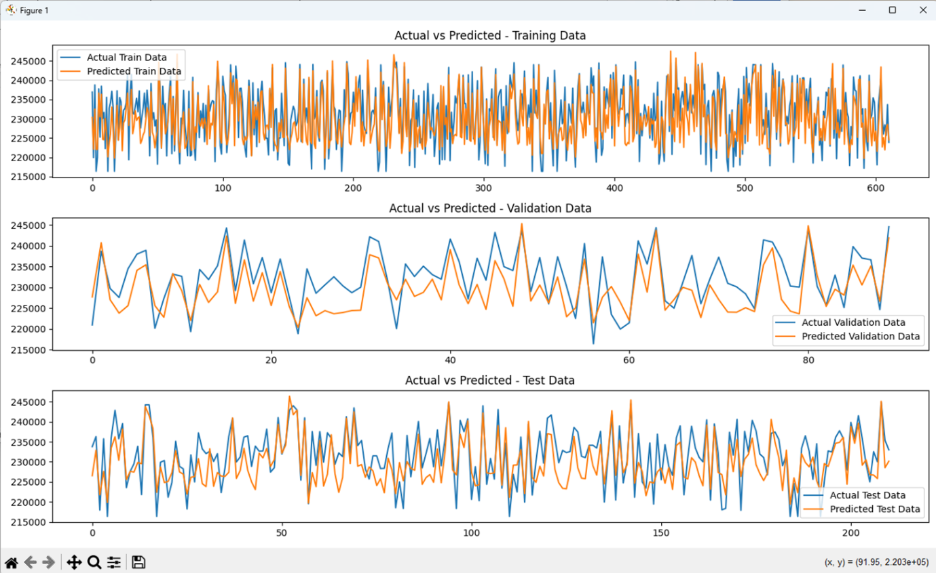
FIGURE 2. Validation of the hybrid model performance at the training, validation, and testing stages; a) Actual vs Predicted – Training Data; b) Actual vs Predicted – Validation Data; c) ctual vs Predicted – Test Data

A quantitative assessment of forecasting accuracy showed that the Mean Absolute Percentage Error (MAPE) of the model on the test dataset equals 1.32%. This low error value confirms the high accuracy of the proposed hybrid model and its practical applicability for electricity loss forecasting in distribution networks. The absence of systematic bias accumulation and the local nature of deviations between actual and predicted values indicate the stability of the model and the lack of overfitting. This confirms the correctness of the selected architecture and the effectiveness of combining a multilayer perceptron with a Long Short-Term Memory neural network. Overall, the obtained results demonstrate that the hybrid MLP+LSTM model successfully captures both static relationships and temporal dependencies in the data, providing reliable and accurate forecasts under conditions of nonlinearity and limited observability. [1-6].
CONCLUSIONS
As demonstrated by the results of the conducted study, the application of a hybrid neural network model based on the integration of MLP and LSTM architectures makes it possible to significantly improve the accuracy of electricity loss forecasting in distribution networks. The proposed approach ensures reliable modeling of complex nonlinear processes and temporal dependencies that are inherent to real operating conditions of low-voltage power networks.
The obtained results indicate that the developed MLP+LSTM hybrid model has the following advantages:
1. High forecasting accuracy, confirmed by a low Mean Absolute Percentage Error (MAPE) value of 1.32%, which indicates the adequacy and practical applicability of the proposed model.
2. Effective extraction of nonlinear patterns in the electricity loss time series due to the use of a multilayer perceptron for feature extraction.
3. Accurate consideration of temporal dependencies, including accumulated and long-term effects of previous operating regimes, provided by the LSTM architecture.
4. Stable generalization capability, confirmed by consistent forecasting performance at the training, validation, and testing stages without signs of overfitting.
5. Robust performance under data uncertainty, including noise, non-stationarity, and limited observation length, which are typical characteristics of measurement data in distribution networks.
Thus, the developed MLP+LSTM hybrid neural network model can be considered an effective tool for electricity loss forecasting. Its application contributes to improving monitoring efficiency and decision-making processes in distribution network management systems and creates prerequisites for the further development of intelligent power systems.
REFERENCES
- Allayev K.R., Nazirova Kh.Z. Comparative assessment of electricity losses using ANN and GMDH methods // Problems of Energy and Resource Saving, 2024. pp. 1–10.
- Allayev K.R., Nazirova Kh.Z. Comparative analysis of the calculation of electricity losses in 10-6-0.4 kV distribution networks AIP Conf. Proc. 3152, 030013 (2024) https://doi.org/10.1063/5.0218854 .
- Allayev K.R., Nazirova Kh.Z., Goyibova S.G. Forecasting electricity losses in 0,4 kv distribution networks using the autoregressive integrated moving average method. AIP Conf. Proc. 3331, 020002 (2025) https://doi.org/10.1063/5.0305940 .
4. Nazirova Kh. Methods for determining static characteristics in industrial electrical networks // E3S Web of Conferences 384, 01046 (2023) https://doi.org/10.1051/e3sconf/202338401046 RSES. 2022
5. Rasulov A.N, Nazirova Kh.Z, Badalov A.A., Saidova M. Study on graphs of electrical load and analysis of power consumption modes // E3S Web of Conferences 497, 01005 (2024) https://doi.org/10.1051/e3sconf/202449701005 ICECAE 2024.
6. Nazirova H.Z., Badalov A.A., Jo’rayev R.R. Comparative Analysis of the Calculation of Electricity Losses in 10-6-0.4 kV Distribution Networks // III International Scientific and Technical Conference "Actual Issues of Power Supply Systems (ICAIPSS1023) AIP Conf Proc. 3152, 030013-1-030013-6, https://doi.org/10.1063/5,0218854.
7. Mahmoud K. Machine learning-based methods for estimating energy losses in large-scale distribution systems with photovoltaics // International Journal of Interactive Multimedia and Artificial Intelligence, 2020.
8. Blinov I. et al. Smart management of energy losses in distribution grids using deep neural networks // Energies, 2025.
9. Chen Y. et al. Statistical and machine learning approaches for electrical power system losses // WIREs Data Mining and Knowledge Discovery, 2025.
10. Tolun G. et al. Practical aspects of machine-learning-based active loss forecasting // IET Research Journal, 2024.
11. Hong T., Dickey D.A. Energy forecasting: methods and models // OTexts, 2020.
12. Tsado J., Usman A., Saka B., Ajagun A.S. Short-term electrical energy consumption forecasting using GMDH-type neural network // Journal of Electrical and Electronics Engineering. 2015. pp. 42–47.
13. Xu H., Dong Y., Wu J., Zhao W. Application of GMDH to short-term load forecasting // Advances in Intelligent and Soft Computing. 2012. pp. 27–32.
14. Hosseini S.A., Taheri B., Abyaneh H., Razavi F. Power swing detection by current signal modeling using the GMDH method // Protection and Control of Modern Power Systems. 2021. 6:15.
15. Dubenko Yu.V., Dyshkant E.E. Forecasting of electricity losses in power networks using artificial intelligence tools // Technical Sciences, 2015.
16. Shagidullin A.V., Gracheva E.I. Determination and forecasting of electricity losses in low-voltage networks using regression analysis // Actual Research Directions, 2014.
17. Koltsov Yu.V. Forecasting electricity losses in distribution networks using neural networks // Butakov Conference, 2023.

