Innovative solutions for enhancing energy efficiciency in the processing of kenaf (Hibiscus cannabinus L.) fibers
Mustafokul Urozov^{1, a)}, Mushtari Fayziyeva¹, Umida Barotova¹, Bakhtiyor Karshiev¹, Khadam Jumaniyozov², Begdavlat Aliyev³
¹ Termez State University of Engineering and Agrotechnologies, Termez, Uzbekistan
² Research Institute of Fiber Crops, Tashkent Region, Uzbekistan
³ Tashkent State University of Economics, Tashkent, Uzbekistan
^{a)} Corresponding author: urazov.mustafo.81@mail.ru
Abstract. In this article, the importance of the natural-fiber kenaf plant for industry is examined in the context of population growth and increasing needs. The main objective of the study is to analyze solutions for improving energy efficiency in the agro-technology and processing stages of kenaf cultivation in Uzbekistan (using Surkhandarya Region as an example). The article highlights the necessity of sowing seeds on time in order to obtain high yields. It is identified that traditional, mechanical, and stagnant-water retting methods used for soaking the stems have low efficiency and certain disadvantages in terms of fiber quality. Results from pilot experiments indicate that alkaline-solution retting and soaking in settled waters produce the best outcomes. Since kenaf processing requires high energy consumption, several innovative solutions have been proposed.
INTRODUCTION
Population growth leads to an increase in needs as well; introducing innovations into industry becomes a necessary task in order to meet demands for clothing, food, and other essential necessities. Fiber crops are becoming an alternative solution in various industrial sectors as a raw material source. Numerous scientific studies have been conducted—and continue to this day—aimed at exploring the potential for producing high-efficiency engineering products from natural fibers in order to reduce production costs and minimize environmental harm [1; pp. 1–92]. Fiber plants contain industrially valuable natural fibers and are appreciated as lightweight, strong, biodegradable, and renewable resources. Kenaf, which is among such natural fibers, is a unique plant with wide application potential in industry.
Kenaf, Hibiscus cannabinus L., is an annual herbaceous plant belonging to the mallow family (Malvaceae) and is classified among valuable bast-fiber crops. The bast fibers in its stem account for 30% of the stem weight, with the fiber itself making up 24% [2; p. 106]. Since its domestication, kenaf has been used by humans for more than six thousand years as a fiber crop for producing items such as thread, rope, and sacks. Sources indicate that the first region where it was domesticated and used agriculturally is North Africa. Its cultivation began in different parts of the world at various times: it has been grown and used in India for 200 years, cultivated in Russia since 1902, in China since 1935, and in the United States its production began during World War II [3; pp. 327–339]. Among the Central Asian countries, Uzbekistan was the first to cultivate kenaf, planting 275 hectares in 1925. Later, it began to be grown in Kyrgyzstan, Kazakhstan, and Turkmenistan as well. During this period, researchers from the Institute of Botany under the Academy of Sciences of Uzbekistan, the Cotton Research Institute, and the Technical Crops Research Institute carried out a number of studies on introducing kenaf into the conditions of Central Asia, developing its cultivation techniques, and examining varietal adaptability. After the country gained independence, the area under kenaf cultivation gradually decreased, but in recent years scientific projects aimed at re-studying and re-introducing this plant have been implemented.

EXPERIMENTAL RESEARCH
There are significant genetic differences among kenaf genotypes in terms of fiber productivity and fiber-yield potential. Today, kenaf fiber is becoming one of the important resources used in various industrial sectors, including lightweight biomaterials, packaging, composites, paper production, and others. In this regard, studying the productivity of different genotypes has practical value for the fiber-plant industry. Currently, more than 370 kenaf accessions collected from various countries are preserved in the genebank of the Research Institute of Plant Genetic Resources of our Republic. One hundred kenaf variety samples belonging to Hibiscus cannabinus L. have been studied, and most of them have been found to be valuable as important initial source material for breeding [4; pp. 449–454].
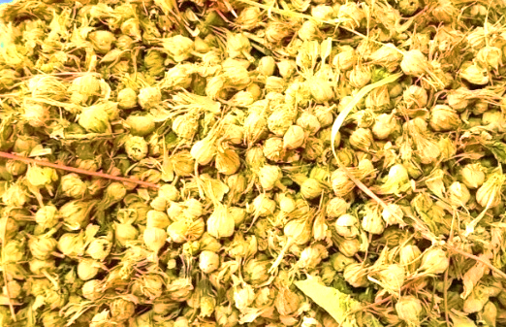
At present, several kenaf varieties—Hibiscus cannabinus L. (kenaf) varieties Uzbekskiy 1972 (1984), Uzbekskiy 2142 (1990), Uzbekistan 2225 (2004), and Uzbekistan 2268 (2010)—are recommended for cultivation in the territory of the Republic of Uzbekistan [5; p. 16]. Currently, research is being conducted in Surxondaryo Region on cultivating kenaf and extracting fiber from it. The standard variety Uzbekskiy 2142 and the promising variety 2147 have been sown, and their agrotechnology is being studied through small field experiments. Fiber extraction and the suitability of this technical fiber for various manufacturing sectors are being investigated, with the aim of expanding the range of industrial products in the future.
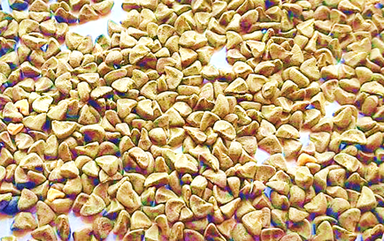
a) b)
FIGURE 1. Seeds of the kenaf standard variety Uzbekskiy 2142. a) seed pod; b) seed

Kenaf is considered a heat-loving plant. A temperature of 10–12°C is sufficient for its seeds to germinate, but the optimal temperature is around 20°C. Compared to other crops cultivated for commercial purposes, kenaf is more adaptable to climatic conditions and soils, and it is considered tolerant to various levels of drought and salinity. Since it is adapted to a temperate climate in production, it is not resistant to cold temperatures. Therefore, to maximize yield, it is important that the temperature during the growing period remains above 10°C. This is because temperature affects biomass and fiber yield, as well as seed productivity [6; p. 3]. In the Surkhandarya region, such climatic conditions are observed during the first weeks of April [13-32]. Taking these climatic factors into account, kenaf seeds were sown in the first week of April, with a row spacing of 60 cm and within-row seed spacing of 10 cm, and the seeds germinated four days later. Because kenaf grows very slowly in the early stages of development, protecting it from weeds is essential. Considering this, inter-row cultivation was carried out twice manually. The weeds were removed and the inter-row spaces were loosened. Afterwards, in the second week of May, a repeated sowing was carried out. However, due to high temperatures, kenaf growth was not effective. At the initial stages of development, kenaf requires a large amount of water. To ensure constant soil moisture, irrigation was performed once every two weeks, ten times in total, until the stems reached maturity, applying water until the soil surface was completely covered. To nourish the kenaf and increase fiber productivity, fertilization was carried out three times using urea (CO(NH₂)₂) and nitrogen (N₂) fertilizers. The period from sowing the seeds to harvesting the green stems amounted to 147 days.
These photographs show the growth stages of the kenaf planted for the experiment. The growth stages of kenaf were analyzed based on phenological observations. Phenology is a field of science that studies the relationship between climate and periodic biological events, and it examines the response of a plant (kenaf) to seasonal and climatic changes in the environment in which it grows. Seasonality causes regular and periodic changes in the quality and quantity of resources available to plants [7; p. 51].

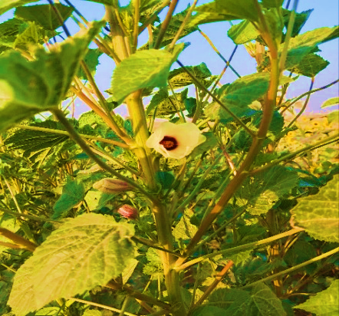
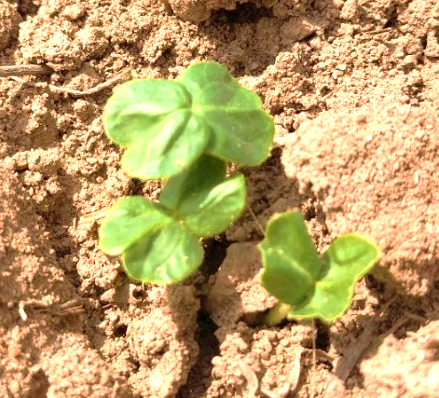
a) b)
FIGURE 2. The growth process of the kenaf (Hibiscus cannabinus L.) plant. a) Seedling; b) The Appearance of the Plant

For example, sowing seeds too early may lead to several negative consequences. In such cases, the seeds may not germinate uniformly, which adversely affects seedling growth. Likewise, sowing the seeds late may lead to a shortened growing period, negatively influencing the photosynthesis process, growth efficiency, and biomass production due to the unfavorable timing of planting [8; pp. 381–4]. Thus, in order to increase the productivity of fiber crops such as kenaf, it is important that the phenological phases of the plant correspond to the climatic and seasonal conditions of the environment. These processes are presented in the following table.

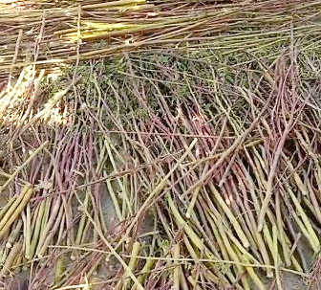
TABLE 1. Biometric parameters of the kenaf plant based on phenological observation results.
№ | Plant height, cm | Number of leaves, pcs | Number of branches, pcs | Capitula, pcs | Flowers, pcs
№ | 1st replication (04.04.2025)
1 | 206 | 450 | 59 | 95 | 8
2 | 192 | 412 | 50 | 40 | 2
3 | 199 | 418 | 58 | 30 | 1
4 | 203 | 460 | 55 | 45 | 2
5 | 208 | 511 | 51 | 60 | 4
6 | 213 | 548 | 64 | 70 | 5
7 | 186 | 390 | 40 | 32 | 1
8 | 208 | 420 | 48 | 75 | 7
9 | 215 | 460 | 60 | 98 | 12
10 | 192 | 364 | 48 | 68 | 6
Total | 2022 | 4433 | 533 | 613 | 48
Average | 202.2 | 443.3 | 53,3 | 61,3 | 4,8

FIGURE 3. Natural drying of kenaf stems.
It is emphasized that, in order to increase energy efficiency by reducing transportation and other costs, the fibrous bark should be separated from the fresh stems immediately after harvesting. This is because at this stage the stems are still moist, making the bark easier to remove. Taking this into account, after harvesting, part of the kenaf stems was mechanically decorticated (removal of the fibrous bark). This method required considerable labor and time. Due to the presence of many lateral branches on some stems and the high degree of lignification, the fibrous bark did not separate as long, continuous fibers. It was found that manually removing the fibrous bark was inefficient.
To facilitate separation of the fibrous bark layer from the stems, the fresh stems were retted in stagnant water. After being retted for ten days, the stems were dried naturally under sunlight. The dried stems were then mechanically decorticated. However, when retted in stagnant water, the stem and fibrous bark layers did not separate well. Because the lignin and pectin substances in the kenaf did not sufficiently decompose during retting, several difficulties occurred during decortication, and the fibrous bark did not separate from the stem in uniform long lengths.
To improve the retting process, the stems were soaked in four different types of water: sodium chloride (NaCl) solution, alkaline K₂CO₃ (ash) solution, muddy water, and stagnant water. Each bundle of stems was 30 cm long and weighed 400 grams.
- In stems retted in sodium chloride (NaCl) solution, the fibrous bark layer remained very rigid, and the fibers adhered tightly to each other.
- In stems retted in alkaline K₂CO₃ (ash) solution, the epidermis layer dissolved due to the alkaline environment, allowing the fibers to separate easily. Fiber separation was uniform, with a whitish and glossy appearance.
- The properties and separability of fibers retted in muddy water were found to be almost identical to those retted in ash water.
- All fibers in stems retted in stagnant water separated quickly, easily, and in continuous uniform lengths. However, the fibers did not exhibit a uniform color.
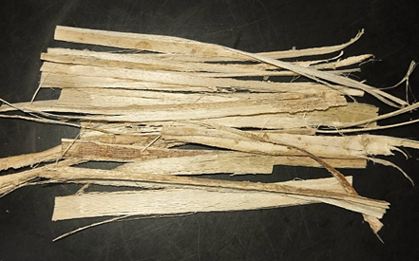 | 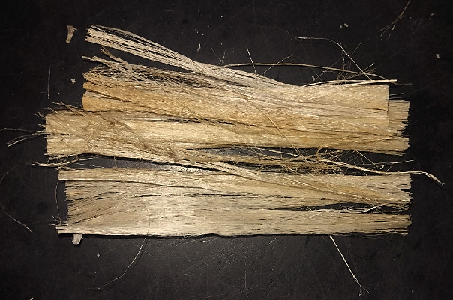
FIGURE 4. Fiber retted in sodium chloride (NaCl) solution. | FIGURE 5. Alkaline solution of K₂CO₃ (potash) fiber steeped in water.
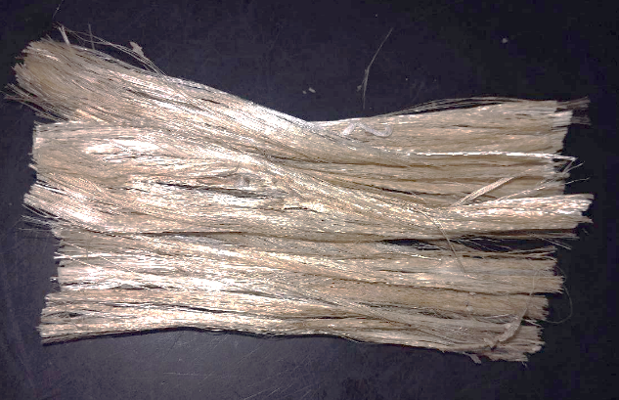 | 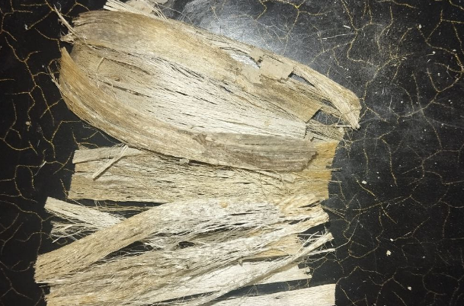
FIGURE 6. Fiber retted in muddy water. | FIGURE 7. Fiber retted in stagnant water.

Based on these pilot experiments, the fibers retted in alkaline solution and muddy water yielded the best and most efficient results. However, these methods have several drawbacks in terms of energy efficiency. For example, they require a long processing time, it is difficult to maintain the optimal pH range (6.0 to 7.5) during retting, and the fiber quality does not fully meet the required standards.
Reducing energy consumption in the processing of kenaf—a plant of significant importance in agriculture and the textile industry—is crucial. Obtaining high-quality fiber from kenaf stems is a highly energy-intensive process. In traditional processing methods, a large portion of electrical and thermal energy is consumed for mechanical crushing and fiber extraction (decortication), biological or chemical retting, and drying of the wet fibers. The increase in global energy resource prices and the tightening of environmental requirements necessitate the optimization of these processes. A comprehensive approach is needed to enhance energy efficiency in kenaf processing. [9, pp. 27–41]
Modernizing mechanical processing is also one of the solutions to this problem. Older-generation decorticators have a low efficiency coefficient. Due to high friction and outdated motors, electrical energy is wasted. As a solution, it is advisable to use frequency-converter devices. By automatically adjusting the motor speed according to the load, electricity consumption can be reduced by 20–30%. These devices control the electric motor of the fiber-separation machine, reducing speed according to load rather than running the motor at full power constantly, thus saving energy. Examples of such devices include: [10, p. 278]
- ABB (Switzerland) ACS-series drives, which are among the most reliable industrial-standard devices, featuring precise energy control and energy-recovery functions.
- Siemens (Germany) SINAMICS G120 series, specifically optimized for conveyors and crushers, offering up to 30% energy savings.
- Schneider Electric (France) Altivar Process series not only controls motor speed but also provides energy-consumption monitoring.
- Danfoss (Denmark) VLT® AutomationDrive series operates reliably in harsh industrial environments with high dust and humidity (such as kenaf-retting facilities). [11, pp. 603–612]
Energy efficiency can be improved by using modern decorticators. Examples of advanced energy-efficient models include:
- Cretes (Belgium) technology — one of the world leaders in processing bast fibers such as flax and kenaf. Their modern lines use multi-roller systems. The advantage of this technology is that the stem is not beaten but bent and crushed, which requires less force and preserves fiber quality.
- HempTrain™ Advanced Processing Plant (Canada) — although designed for hemp, it is suitable for kenaf as well. This system separates fiber and core aerodynamically without crushing the stem and is significantly more energy-efficient than traditional decorticators.
- Mobile field decorticators (e.g., China’s 4GL series or European equivalents) — process kenaf directly in the field, allowing only the fiber to be transported, thus saving transport energy and costs.
Energy-efficient electric motors of the IE3 (Premium Efficiency) and IE4 (Super Premium Efficiency) classes can save 4–6% more electricity compared to standard motors due to reduced heat losses.
Drying wet fibers is the most heat-intensive stage. In traditional convective dryers, a large portion of the hot air is released into the atmosphere. As a solution, new innovative drying systems should be applied. Heat-recovery equipment captures outgoing hot air and uses its energy to warm the incoming cold air.
- Rotary heat recuperators are rotating drum-type units installed in the ventilation system of drying chambers. They are highly efficient for processing large volumes of air and can recover up to 80% of heat.
- Plate heat exchangers are another solution, enabling heat transfer between contaminated hot air and clean cold air through thin metal plates without mixing the air streams. Their advantage is that dust and fine particles from kenaf fibers do not enter the clean air. [12, p. 182]
In addition to simple greenhouse-type systems, special industrial solar collectors are used for solar-energy-based drying. One example is solar air-heating collectors. Installed on the drying facility’s roof or walls, they heat incoming air to 40–60°C before it enters the drying chamber, significantly reducing gas or electricity consumption. SolarWall® collectors exemplify this technology; these perforated metal panels absorb sunlight, draw in air, and deliver heated air into the building or drying chamber. [13, pp. 317–328]
Unlike traditional hot-air drying, infrared (IR) drying directly heats the water inside the fiber. Examples of such equipment include:
- Gas-fired infrared emitters, which operate on natural gas without open flames. They are more cost-effective than electrical systems and suitable for large-scale fiber processing. Examples include Heraeus Noblelight (now Excelitas) gas-catalytic systems and GoGaS units.
- Electric IR modules, consisting of quartz or halogen lamps installed above a conveyor belt. Their advantage is rapid drying of thin layers of washed fiber. Compared to convective drying, they shorten processing time and direct energy precisely to fiber moisture. [14, pp. 1475–1486]
Optimization of the retting process. Retting the stems to separate fibers typically requires long durations and controlled temperatures. Enzymatic treatment and closed-loop water systems can provide effective solutions.
- In enzymatic treatment, temperatures must be kept steady and the enzyme solution uniformly distributed among the fibers for enzymes (such as pectinase) to remain active. Circulating-pump modular reactors—such as Thies (Germany) or Loris Bellini (Italy) iMaster horizontal systems—can be used. Although originally intended for dyeing, they are ideal for enzymatic processing. Their operation involves pumping the water–enzyme mixture through kenaf bundles under pressure. An integrated heat exchanger maintains stable temperatures. Compared to open retting ponds, this method reduces heat loss by up to 90% and lowers enzyme consumption. [15, pp. 10–20]
- For closed-loop water systems, flotation units and ceramic-membrane filters can be used. Flotation works by injecting air bubbles that lift organic waste to the surface, where scraper mechanisms collect it. Scrapers, typically chain-driven blades or rotating paddles, move slowly along the water surface and remove only the top layer without disturbing the water. Flotation units rapidly clean large volumes of water before biological treatment and maintain temperature stability. Ceramic-membrane filters, unlike polymer membranes, withstand hot water and return cleaned water to the system without cooling. Traditional methods cool, clean, and reheat the water—doubling energy use. Ceramic membranes avoid this energy loss. As a result, energy required to reheat water in the next cycle is significantly reduced, and water resources can be recycled by 80–90%. [16, p. 250]
Using kenaf waste as an energy source. Another energy-saving solution is generating energy from kenaf processing waste. One of the biggest advantages in processing is the ability to use the woody core as fuel. After fiber extraction, about 60–70% of the plant mass consists of lignified core, which has high calorific value. It can be compressed into briquettes or pellets and burned in the factory’s own boilers. This greatly reduces dependence on external energy sources (gas, coal). Heat generated from burning the core can be used for drying fibers and heating retting baths. [17, p. 293]
Implementing energy-saving technologies in kenaf-fiber processing enterprises is both economically and environmentally beneficial. Such technologies can reduce production costs by approximately 10–15%. Analyses show that traditional technologies require an average of 350 kWh of electricity and 5.5 Gcal of heat to produce 1 ton of kenaf fiber. With the proposed innovations, electricity consumption can be reduced to 210–240 kWh per ton (a 30% saving), mainly due to reducing idle operation of pneumatic transport and crushing machines. Heat consumption decreases to 3.0 Gcal per ton (about 45% savings), achieved by reusing drying-unit heat and filtering retting water with ceramic membranes without cooling. The share of energy costs in production decreases, improving product competitiveness. Considering these criteria, future research plans include testing a combined bio-enzymatic and ultrasonic retting technology. In this process, specialized biotechnological enzymes soften the lignin, pectin, and hemicellulose layers in kenaf stems, facilitating fiber separation. This approach is environmentally friendly, saves water and energy, and significantly improves fiber quality. Ultrasonic assistance enhances the effectiveness of enzymatic treatment by accelerating the penetration of the enzyme solution into the stems, reducing retting time by 2–3 times. Applying this combined bio-enzymatic and ultrasonic technology in Uzbekistan would improve fiber quality, reduce water and energy consumption, and increase the profitability and export potential of the kenaf industry. Increasing energy efficiency in the processing of kenaf (Hibiscus cannabinus L.) fibers is therefore not only economically beneficial, but an ecological necessity. The main focus should be on equipment modernization, implementation of combined bio-enzymatic and ultrasonic retting technologies, heat-recovery solutions, and using production waste as an energy source. These measures can transform the kenaf sector into a profitable and competitive industry.
CONCLUSIONS
A thorough scientific study of kenaf (Hibiscus cannabinus L.) and its fibers’ technological properties enables the efficient use of renewable resources in industry. Improving energy efficiency in kenaf fiber processing is not only economically beneficial but also an ecological necessity. Traditional methods—especially retting in stagnant water and using outdated decorticators—are characterized by low efficiency and high energy consumption. Although experiments showed that retting in alkaline solutions and stagnant water produced better results, these methods still have significant limitations.
The main focus should be on modernizing equipment, implementing heat-recovery systems, and utilizing production waste as an energy source. These measures can reduce electricity consumption by up to 30% and thermal energy use by up to 45%, thereby lowering production costs and transforming kenaf into a competitive and sustainable industrial resource.

REFERENCES
1. Manickam Ramesh, Kenaf (Hibiscus cannabinus L.) fibre based bio-materials: A review on processing and properties, Progress in Materials Science, 2016, Vol.78–79, pp.1–92, DOI:10.1016/j.pmatsci.2015.11.001, 1–92 pages. https://www.researchgate.net.
2. Lukov, M., & Abduraximov, N. (2025, May 24). Kenaf cultivation technology. In Global environmental problems, desertification, and food security: Proceedings of the International Scientific and Practical Conference (p. 106). Termez. DOI: 10.5281/zenodo.15636538. https://ilmiyanjumanlar.uz
3. Webber, C.L. III, Bledsoe, V.K., Bledsoe, R.E., 2002. Kenaf harvesting and processing. In: Janick, J., Whipkey, A. (Eds.), Trends in New Crops and New Uses. ASHS Press, Alexandria, VA, pp. 327–339. Kenaf_Harvesting_and_Processing%20(1).
4. Nuridinov, A. A., Talebaeva, M., & Tulyaganova, V. (2021). Agrobiological and economic characteristics of the kenaf (Hibiscus cannabinus L.) collection. Academic Research in Educational Sciences, 2(10), 449-455. DOI: 10.24412/2181-1385-2021-10-449-455https://cyberleninka.ru
5. Ministry of Agriculture of the Republic of Uzbekistan. (2025). State Register of Agricultural Crops Recommended for Sowing in the Territory of the Republic of Uzbekistan. Voris-nashriyot, p. 16. https://ru.scribd.com
6. T. C. Kujoana, W. J. Weeks, M. M. Van der Westhuizen, M. Mabelebele & N. A. Sebola (2023) Potential significance of kenaf (Hibiscus cannabinus L.) to global food and feed industries,
Cogent Food & Agriculture, 9:1, 2184014, DOI: 10.1080/23311932.2023.2184014. https://www.tandfonline.com/doi/full/10.1080/23311932.2023.2184014.
7. Fatanmi, E. O., Ajibade, G. A., & Folorunsho, A. E. (2013). Phenological studies of two varieties of Hibiscus cannabinus Linn in Ile-Ife, South West, Nigeria. Journal of Biology, Agriculture and Healthcare,
3(8), 49. ISSN 2224-3208 (Paper), ISSN 2225-093X (Online). Retrieved from Pages 51. file:///C:/Users/user/Downloads/HibiscusPublished.pdf.
8. Cosentino, S. L., D’Agosta, G. M., Copani, V., & Testa, G. (2004). Yield and development of kenaf (Hibiscus cannabinus L.) crop in relation to genotype, sowing time and plant population in Mediterranean environment. In 2nd World Conference on Biomass for Energy, Industry and Climate (p. 127). Rome, Italy. pp 381-4. https://www.academia.edu
9. Kenaf (Hibiscus Cannabinus L.) as a sustainable source of cellulose fibers for industrial
applications: a review, Carbohydrate Polymers, vol. 207, pp. 27–41, 2019. https://www.researchgate.net
10. Toshbekov, O., Urazov, M., Yermatov, S., & Khamraeva, M. 2023). Yeffisient and yesonomisal yenergy use teshnology in the prosessing of domestis soarse wool fiber. In Ye3S Web of Sonferenses (Vol. 461, p. 01068).
https://doi.org/10.1051/e3sconf/202346101068
11. Jumaniyozov, K., Urozov, M., Toshbekov, O., Salimova, M., Raximova, K., & Khursandova, B. (2025, November). Enhancement of energy-efficient cleaning equipment. In American Institute of Physics Conference Series (Vol. 3331, No. 1, p. 050007). https://doi.org/10.1063/5.0307149
12. Sultonova, F., Toshbekov, O., Urozov, M., Boymurova, N., Mustanova, Z., & Boltaeva, I. (2025, November). Enhancing and evaluating the characteristics of specialized workwear for employees in the electric power supply sector. In American Institute of Physics Conference Series (Vol. 3331, No. 1, p. 050006). https://doi.org/10.1063/5.0306350
- Mahmutkhonov S., Baizhonova L., Mustayev R., Tashmatova S. Dynamic analysis of voltage-ampere characteristics and harmonic distortions in electric arc furnaces. // AIP Conference Proceedings. 3331(1), 2025. pp. 070023, 1–5. https://doi.org/10.1063/5.0305745.
- Bobojanov M., Mahmutkhonov S. Influence of the consumer to power quality at the point of connection // E3S Web of Conferences 384. 2023. РР, 01041, 1-5. https://doi.org/10.1051/e3sconf/202338401041.
- Bobojanov M.K., Karimov R.Ch., Popkova O.S., Tuychiev F.N., Makhmutkhanov S.K. Analysis of the results of experimental studies of the arc furnace DSP-30. // Power Engineering Research & Technology. 27(2), 2025. pp. 126–137. https://doi.org/10.30724/1998-9903-2025-27-2-126-137
- Reymov K.M., Makhmuthonov S.K., Turmanova G., Uzaqbaev Q. Optimization of electric networks modes under conditions of partial uncertainty of initial information // E3S Web of Conferences 289, 07023 (2021). -2021, pp: 1-4, https://doi.org/10.1051/e3sconf/202128907023.
- R. K. Kurbaniyazov, A. M. Reimov, A.T. Dadakhodzhaev, Sh. S. Namazov, B. M. Beglov. Nitrogen-phosphoric fertilizers produced by introduction of Central Kyzylkum phosphate raw material into ammonium nitrate melt. Russian Journal of Applied Chemistry. Russ J Appl Chem (2007) 80(11): 1984-88. https://doi.org/10.1134/S1070427207110456
- Namazov, Sh.S., Kurbaniyazov, R.K., Reimov, A.M., Beglov, B.M. Hardness of the granules of ammonium nitrate doped with the Central Kyzylkum Phosphorite. Russian Journal of Applied Chemistry. Russ J Appl Chem (2007) 81(6): 1103–1106. http://dx.doi.org/10.1134/s1070427208060402.
- Kurbaniiazov, R.K., Reimov, A.M., Namazov, Sh.S., Beglov, B.M. Nitrogen-phosphoric fertilizers obtained by interaction of the concentrated solutions of ammonium nitrate with the mineralized mass of the phosphorites of Central Kyzylkum. Russian Journal of Applied Chemistry. Russ J Appl Chem (2009) 82: 1123. https://link.springer.com/journal/11167
- Alimov, U.K., Reimov, A.M., Namazov, Sh.S., Beglov, B.M. The insoluble part of phosphorus fertilizers, obtained by processing of phosphorites of central kyzylkum with partially ammoniated extraction phosphoric acid. Russian Journal of Applied Chemistry. Russ J Appl Chem (2010) 83(3): 545–552. https://doi.org/10.1134/S107042721030328
- Reymov, A.M., Namazov, S.S., Beglov, B.M. Effect of phosphate additives on physical-chemical properties of ammonium nitrate. Journal of Chemical Technology and Metallurgy 2013 48(4), 391-395. http://dl.uctm.edu/journal/
- Urishev, B., Fakhriddin Nosirov, and N. Ruzikulova. 2023. “Hydraulic Energy Storage of Wind Power Plants.” E3S Web of Conferences, 383. https://doi.org/10.1051/e3sconf/202338304052
- Urishev, B., S. Eshev, Fakhriddin Nosirov, and U. Kuvatov. 2024. “A Device for Reducing the Siltation of the Front Chamber of the Pumping Station in Irrigation Systems.” E3S Web of Conferences, 274. https://doi.org/10.1051/e3sconf/202127403001
- Turabdjanov, S., Sh. Dungboyev, Fakhriddin Nosirov, A. Juraev, and I. Karabaev. 2021. “Application of a Two-Axle Synchronous Generator Excitations in Small Hydropower Engineering and Wind Power Plants.” AIP Conference Proceedings. https://doi.org/10.1063/5.0130649
- Melikuziev M.V. Determination of the service area and location of transformer substations in the city power supply system. E3S Web of Conferences 384, 01033 (2023) RSES 2022. https://doi.org/10.1051/e3sconf/202338401033
- Melikuziev M.V., Usmonaliev S., Khudoyberdiev N., Sodikov J., Imomaliev Z. Issues of the design procedure for the power supply system. AIP Conference Proceedings 3152, 040031 (2024). https://doi.org/10.1063/5.0218873
- Melikuziev M.V., Fayzrakhmanova Z., Akhmedov A., Kasimova G. Development of an Educational Simulator's Working Logic for the Course 'Fundamentals of Power Supply'. AIP Conference Proceedings 3152, 050025 (2024). https://doi.org/10.1063/5.0218875
- Melikuziev M.V., Nematov L.A., Novikov A.N., Baymuratov K.K. Technical and economic analysis of parameters of city distribution electric network up to 1000 V. E3S Web of Conferences 289, 07016 (2021) Energy Systems Research. https://doi.org/10.1051/e3sconf/202128907016
- L.Jing, J.Guo, T.Feng, L.Han, Z.Zhou and M.Melikuziev, "Research on Energy Optimization Scheduling Methods for Systems with Multiple Microgrids in Urban Areas," 2024 IEEE 4th International Conference on Digital Twins and Parallel Intelligence (DTPI), Wuhan, China, 2024, pp. 706-711, https://ieeexplore.ieee.org/abstract/document/10778839
- Shukhrat Umarov, Murot Tulyaganov. Peculiarities of simulation of steady modes of valve converters with periodic power circuit structure. III International Scientific and Technical Conference “Actual Issues of Power Supply Systems” (ICAIPSS2023). AIP Conf. Proc. 3152, 050004-1–050004-7; https://doi.org/10.1063/5.0218869
- Murot Tulyaganov, Shukhrat Umarov. Improving the energy and operational efficiency of an asynchronous electric drive. III International Scientific and Technical Conference “Actual Issues of Power Supply Systems” (ICAIPSS2023); https://doi.org/10.1063/5.0218876
- Shukhrat Umarov, Khushnud Sapaev, Islambek Abdullabekov. The Implicit Formulas of Numerical Integration Digital Models of Nonlinear Transformers. AIP Conf. Proc. 3331, 030105 (2025); https://doi.org/10.1063/5.0305793

