Research of electromagnetic current converters for control and management of reactive power consumption of asynchronous motor supplied with energy produced by a solar photoelectric system
Saidikrom Azamov ^{a)}, Mohir Makhsudov, Zailobiddin Boikhanov
Andijon state technical institute, Andijon, Uzbekistan
^{a)} Corresponding author: azamovsaidikrom1992@gmail.com
Abstract. Worldwide, great importance is being given to the use of solar energy sources, which are classified as renewable energy sources, in order to ensure continuous and high-quality supply of electrical energy to consumers. It is well known that in industry and production sectors, 60–70% of the consumers of generated electrical energy are asynchronous motors; in asynchronous motors, active power is consumed for useful work, while reactive power is consumed during the starting process to generate the magnetic field flux. Monitoring and controlling the consumption of reactive power, as well as improving existing current converters and developing new types using digital technologies and implementing them in practice, are considered relevant issues. In this research work, the results of studies are presented on supplying electrical energy generated by solar panels to asynchronous motors widely used in production and the national economy, generating reactive power for asynchronous motors, measuring, monitoring, and evaluating the asymmetry indicators of consumed reactive power, as well as the structural principles of a new type of electromagnetic current converter, its further improvement in terms of compactness, reliability, response speed, compliance with economic affordability requirements, and the application of digital technologies in dynamic operating modes
INTRODUCTION
At present, the gradual depletion of oil, gas, coal, and other primary energy sources worldwide requires the step-by-step implementation of solar, wind, and bioenergy resources in practice. In this regard, scientists in the energy sector of our country are also conducting a number of scientific, pedagogical, and practical studies on the use of solar energy sources, which have already become widely popular; however, the issues of further development of the sector, improving the quality indicators of electrical energy generated by solar panels and implementing them in practice, as well as re-servicing existing solar energy installations, have not been sufficiently studied [1].
Asynchronous motors, which are considered among the main consumers of electrical energy, when supplied with electrical energy generated by solar panels, require the generation, measurement, monitoring, and control of reactive power in them 4AA63A4Y3 An asynchronous motor of the type was selected [2]. The technical data are as follows: $P_{n}=0,25 kVt$, $U_{n}=380 V$, $f=50 Gts$, $n=1500 ayl/min$, ${r'}_{1}=0,15 Ω$, ${x'}_{1}=0,082 Ω$, ${r''}_{2}=0,14 Ω$, ${x''}_{2}=0,17 Ω$, ${cosφ}_{n}=0,65 \%$, $η_{n}=0,68 \%$, ${x'}_{1}=0,082 Ω$, being equal, and the stator windings of the asynchronous motor are connected in a star configuration to the single-phase solar electrical energy network. The number of stator windings is W₁ = 110[3]
Therefore, in order to supply a three-phase asynchronous motor from a single-phase solar electrical energy transmission network, capacitor banks are selected [4].
In this case, the capacitance of the capacitor banks, which are connected to supply reactive power to the single-phase electrical transmission network of the solar energy source and serve to reduce losses in the electrical network, is determined based on the following analytical expression [5].
$C_{worker}=\frac{I_{N}}{U_{N}}*2800$ [mkF] (1)
Here: Uₙ is the nominal voltage, Iₙ is the nominal current. As is known from analyses and research, when connecting three-phase asynchronous motors to a single-phase source, the starting capacitor bank is selected to be larger than the operating capacitor, with C_{start} = (2.5–3)·C. The reason for this is that during the starting period the operating capacitor cannot supply sufficient electric current [6]. After the asynchronous motor starts and develops rotational torque, it is necessary to disconnect the starting capacitor by means of a controlled contact. Otherwise, the starting capacitor also becomes a capacitive load and turns into a consumer of the solar energy source network [7]. An asynchronous motor supplied from a single-phase electrical energy source based on solar panels ensures power characteristics corresponding to three-phase motors in order to provide normal operation and stability under various operating modes [8]. In this case, the operating capacitor bank, phase-shifting inductance, and starting capacitors make it possible for a three-phase squirrel-cage rotor asynchronous motor to operate in the corresponding operating modes [9]. Currently, in our country, current transformers and electromagnetic current converters with Rogowski coil sensors are used for monitoring and controlling consumed electrical energy [10].
Current transformers are measuring transformers, manufactured with rated currents of 1 A to 5 A; they have large dimensions, high energy consumption, and become saturated after the nineteenth harmonic [11]. When measuring consumed electrical energy, they transmit data in a generalized form to the secondary winding. Another electromagnetic current converter is the Rogowski coil current converter [12]. In this type of converter, the magnetic field generated around the measured current cuts through the Rogowski coil. This produces a voltage proportional to the rate of change of the current and to the mutual inductance between the conductors. The value of the measured electric current is proportional to the voltage generated in the Rogowski coil, and this type of current converter is suitable for single-phase consumers [13]. However, a Rogowski coil-based flexible converter does not provide the capability to measure the reactive power of an asynchronous motor with high accuracy [14].

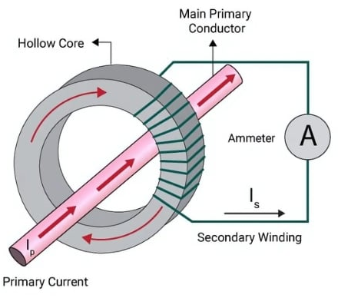  a) | 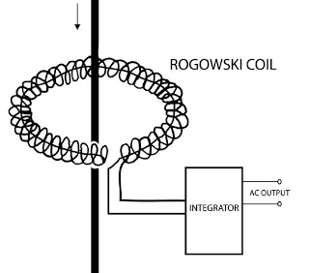  b)
FIGURE 1: a) schematic diagram of the general view of a current transformer. In this case, the primary winding w₁ of the transformer has terminals I_{p} and I_{s}, which are connected in series to the monitored alternating current circuit.
b) in the figure, 1 is the magnetic core, is the measured electric conductor, and the output voltage terminal is obtained through an integrator by measuring via the generated magnetic flux.

EXPERIMENTAL RESEARCH
The electromagnetic current converter investigated in this study, intended for an asynchronous motor supplied from a single-phase electrical energy source generated by solar panels, has advantages over existing electromagnetic current converters in that, since it is located between the stator slots and the insulation wedge of the asynchronous motor, it converts the current supplied to the stator of the asynchronous motor into a signal in the form of secondary voltage with high accuracy without external influences. The magnetic core does not become saturated, it has compact dimensions, and it is suitable for both three-phase and single-phase asynchronous motors.
The electromagnetic current converter used in the study has the capability of star and delta connection of its outputs, and they are placed in the gap between the stator slots and the insulation wedge in accordance with the stator windings.
In order to ensure stable and high-efficiency operating modes of an asynchronous motor supplied from a single-phase electrical transmission network of a solar energy source, research work was carried out on an asynchronous motor equipped with operating and starting capacitor banks as well as phase-shifting inductive elements. The research work was conducted to provide continuous and high-quality electrical energy to a three-phase asynchronous motor with stator windings connected in a star configuration from a single-phase solar electrical energy transmission network. For this purpose, solar panels manufactured by the Growatt company, which are widely used in our country due to their economic affordability, long service life, availability of service support, resistance to external temperature variations, ability to generate alternating current frequency, and other advantages, were selected.
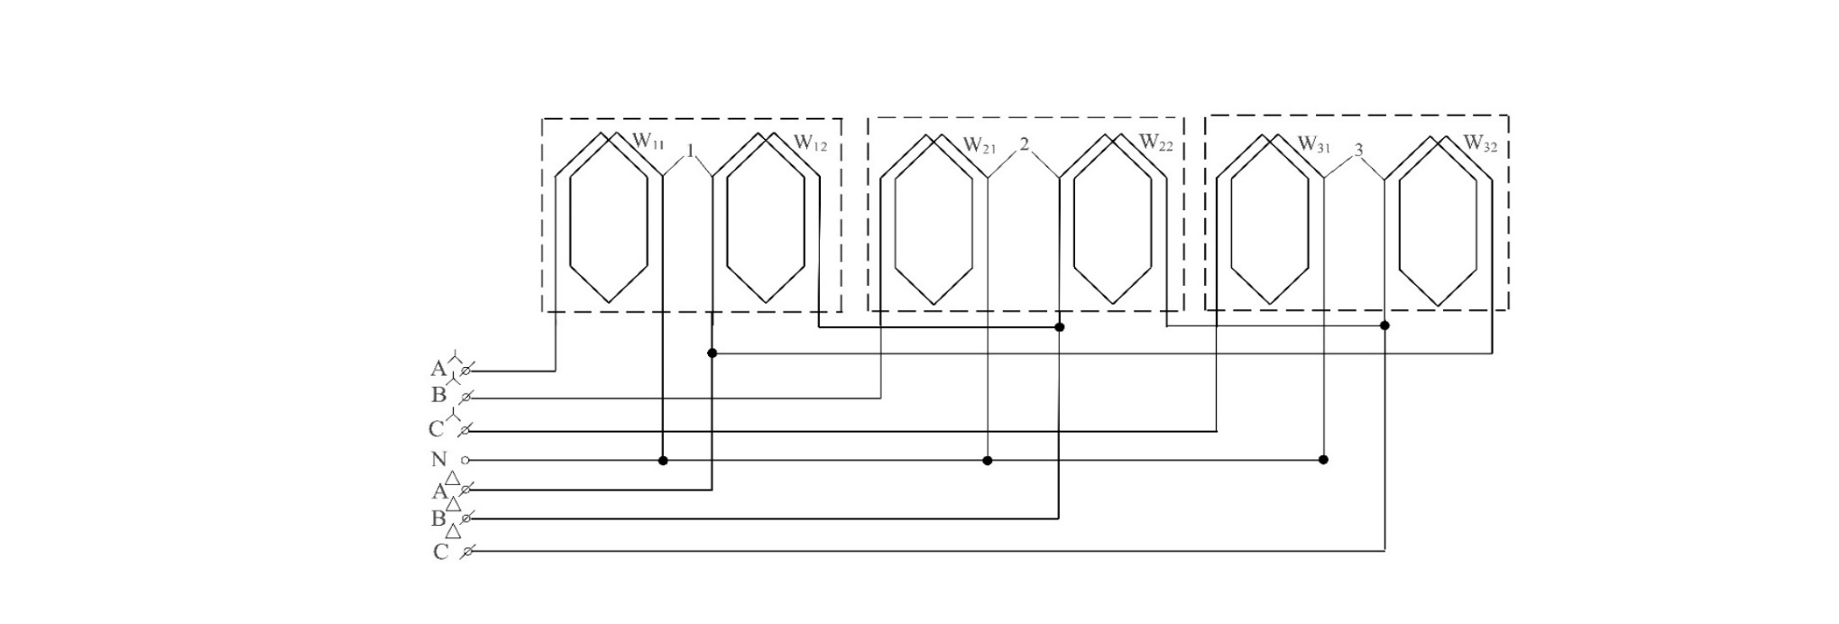
FIGURE 2. Schematic diagram of an electromagnetic current converter for monitoring and controlling the reactive power of an asynchronous motor supplied from a single-phase electrical network of a solar energy source. Elements 1, 2, and 3 are paired-order measuring sensitive elements; W1.1, W1.2, W2.1, W2.2, W3.1, and W3.2 are the primary windings of the asynchronous motor stator windings, and the current converter secondary output terminals.

The technical data of the inverter devices that convert the electrical energy generated by the Growatt company’s solar panels into alternating current are presented. The given solar panel inverters are capable of operating for a long time at high efficiency values when installed in a special room temperature environment with the panels mounted perpendicular to solar radiation at 90°.
Table 1. Technical data of an inverter device that converts direct current into alternating current
№ | Technical data
1. | Model type | Growat 15T L3-X
2. | Temperature range | -30⁰C….….+55⁰C
3. | DC-input | 12 DC 13A
4. | AC- output | 230 VAC 50/60 Hz, 13A 1phase

The principal schematic diagram for the 4AA63A4Y3 asynchronous motor supplied from a single-phase alternating current electrical transmission network generated by the inverter presented in Table 1.1 is as follows.
RESEARCH RESULTS
When an asynchronous motor is supplied from a single-phase electrical network of a solar energy source, in the monitoring and control of reactive power, the dynamic characteristic of the electromagnetic current converter of an asynchronous motor equipped only with a starting capacitor bank is first considered. In the research work, when supplied from a single-phase electrical power supply system of a solar energy source, the dynamic characteristic of the electromagnetic current converter during the starting of an asynchronous motor using a starting capacitor bank is considered.
From the analysis of the dynamic characteristic, it is known that for an asynchronous motor supplied from a single-phase solar electrical network and equipped with a starting capacitor bank, the measured output voltage of the electromagnetic current converter was 3.5 V
$U_{aΣ}=3,5U_{a}$ (V) (2)
We consider the dynamic characteristic of the electromagnetic current converter of an asynchronous motor supplied from a single-phase electrical power supply system of a solar energy source and connected to the network using starting and operating capacitor banks as well as a phase-shifting inductive winding.

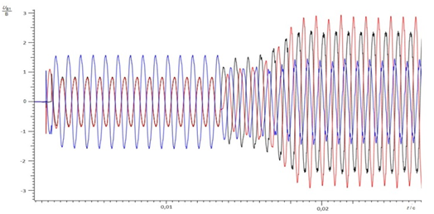
FIGURE 3. Dynamic characteristic of the electromagnetic current converter of an asynchronous motor equipped with starting and operating capacitor banks

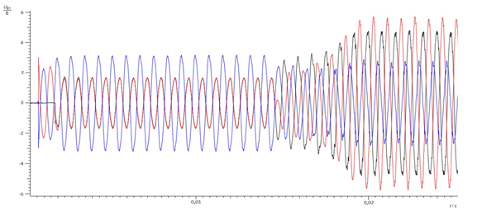
FIGURE 4. Dynamic characteristic of the electromagnetic current converter of an asynchronous motor equipped with starting and operating capacitor banks.

From the analysis of the dynamic characteristic, it is known that when measuring the output voltage of the electromagnetic current converter of an asynchronous motor supplied from a single-phase solar electrical energy transmission network and equipped with starting and operating capacitor banks as well as a phase-shifting inductive winding, the output voltage was 5 V. Based on the signal data obtained from this output voltage, the value of reactive power is calculated.
$Q=U*I*sinφ$ [VAR] (3)

Thus, U is the nominal voltage, I is the nominal current consumed by the asynchronous motor, and $sinφ$ is the reactive power coefficient, $sinφ=\sqrt{1-{cosφ}^{2}}$.

$Q=U*I*sinφ$= 220$*$0,80$*$0,58=102,8 [VAR].

CONCLUSIONS
By means of the electromagnetic current converter rings of the asynchronous motor placed between the stator slots and the insulated wedge, the assessment of the consumed reactive power using the output voltages of the current converter rings makes it possible to investigate the distribution of magnetic quantities and parameters formed in the electromagnetic current converter elements that convert current into a signal. The dynamic characteristics of the measuring sensitive rings, including the times to reach steady-state and stability, when the asynchronous motor is connected to the network using a phase-shifting inductive winding together with starting and operating capacitors, amount to t = 0.02 s. Compared to the cases where the asynchronous motor is connected only with a starting capacitor or with a starting and operating capacitor scheme, when connected to the network according to a scheme with a phase-shifting inductive winding and starting and operating capacitors, the reactive power consumption is lower, and the asynchronous motor operates in steady and stable operating modes.

REFERENCES
- O. Ishnazarov, X. Xaydarov, “Mathematical Analysis of the Impact of External Factors on the Operating Modes
of Pump Installations in the Technological Process,”, Journal of Academia Open, vol. 10, no. 1, 2025, https://doi.org/10.21070/acopen.10.2025.10507 .
2. I. Siddikov, A.Malikov, M. Makhsudov, Z. Boikhanov, &R . Uzaqov, Study of the static characteristics of the secondary stator voltage converter of the currents of an induction motor. (2022, June). In American Institute of Physics Conference Series (Vol. 2432, No. 1, p. 020003) .https://ui.adsabs.harvard.edu/abs/2022AIPC.2432b0003S/abstract
3. Z. Chen, T. Lei, J. Hua, Z. Urazali Ugli and A. R. Yigitali, "Short-term photovoltaic power generation prediction based on VMD-IGWO-LSTM," 2024 IEEE 4th International Conference on Digital Twins and Parallel Intelligence (DTPI), Wuhan, China, 2024, pp. 682-686, https://doi:10.1109/DTPI61353.2024.10778814
4. A. Mustafoqulov, R. Baratov, Z. Radjapov, S. Kadirov, B.Urinov, “Angular displacement measurement and control sensors of agricultural robot-manipulators,” in 2024 BIO Web of Conferences 2024. https://10.1051/bioconf/202410503003
3. I. Siddikov, D. Karimjonov, S. Aʼzamov, R. Uzakov, “Study on determination of an asynchronous motorʼs reactive power by the current-to-voltage converter,” in 2022 IOP Conference Series: Earth and Environmental Science, 2022, https://doi:10.1088/1755-1315/1142/1/
4. M. Yakubov, I. Karimov, D. Abdullayev, “Structure and distribution of function between the stages of the information and measurement system for diagnostics of traction substations and contact network installations” in 2023 E3S Web of Conferences, vol. 383, no. 01027, pp.36-49, https://doi.org/10.1051/e3sconf/ 202338301027.
7. Mustafoqulov, M. Farhod, S. Azamov, E. Dilmurod, Y. Gulora “Analysis of a 10 kW mini pumped hydro storage plant with solar integration in Uzbekistan” https://www.researchgate.net/figure/Final-calculated-parameters-of-the-10-kWh-mini-PSH-with-solar-panel-integration_tbl1_398957985
8. J. Nizamov, Sh. Ergashov, D. Kurbanbaeva, “Phase angle measurement device between the resultable electric drive force and the electric drive force of the main harmonic magnetic field in the air gap of the industrial,” in 2024 AIP Conference Proceedings, 2024, vol. 3152, no. 040021 https://doi.org/10.1063/5.0218808
9. Z. Boixanov, I. Siddikov, J. Nizamov, S. Abdurahmonov, “Three-phase asynchronous motor three-phase current converter for the research of electromagnetic processes,” in 2025 AIP Conf. Proc. 4 November 2025; 3331 (1): 030038. https://doi.org/10.1063/5.0306165
10. N. Pirmatov, X. Xaydarov, “Investigating the issues of energy saving by means of a mathematical model of transient processes of asynchronous engines in pump units,” (in Uzbek), Journal of Science and innovative development, vol. 6, no. 5, pp. 63-71, https://dx.doi.org/10.36522/2181-9637-2023-5-7
11. M. Makhsudov, D. Karimjonov, “Research algorithm and dynamic characteristics of three-phase electromagnetic current transducers in filter-compensation devices,” in 2023 E3S Web of Conferences vol. 461, no. 01056, https://10.1051/e3sconf/202346101056
12. S. Amirov, I. Karimov, I. Abduazimova, “Application of the method of direct mathematical modeling to diamond-shaped contact lines,” 2023 E3S Web of Conferences, vol.401, no. 02060, Cited 1 times. https://doi.org/10.1051/e3sconf/202340102060
13. N. Pirmatov, X. Xaydarov, “Investigating the issues of energy saving by means of a mathematical model of transient processes of asynchronous engines in pump units,” (in Uzbek), Journal of Science and innovative development, vol. 6, no. 5, pp. 63-71, https://dx.doi.org/10.36522/2181-9637-2023-5-7
14. Dilyorbek Karimjonov, Mokhirbek Makhsudov, Abduqunduz Xalimjanov, Dilshodbek Abdukhalilov, Durbek Axmedov, Xolmirza Mamajonov; Modeling the structures of three-phase asynchronous motor reactive power variations using electromagnetic transducers. AIP Conf. Proc. 27 November 2024; 3244 (1): 060018. https://doi.org/10.1063/5.0241567.
15. R. Schürhuber, B. R. Oswald, L. Fickert, J. Fortmann. Verhalten von Windkraftanlagen mit doppelt speisenden Asynchrongeneratoren (DFIG) bei Kurzschlüssen und anderen Netzfehlern. Elektrotechnik & Informationstechnik (2020) 137/8: 415–424. https://doi.org/10.1007/s00502-020-00829-2
16. Design and analysis of an asynchronized synchronous generator for high-power wind power plants, Anton Andreevich Kotov. Dissertation for the degree of candidate of technical sciences. Chelyabinsk - 2021, pp. 22-24.
17. N.Rashidov, Kh.Rozmetov, S.Rismukhamedov, M.Peysenov. E3S Web of Conferences, 384, 01043, (2023), https://doi.org/10.1051/e3sconf/202338401043
18. Fabian Büssis. Steuerung und Regelung einer Windenergie-Netzeinspeisung mit doppeltgespeistem Asynchrongenerator. Department Informations- und Elektrotechnikder Fakultät Technik und Informatikder Hochschule für Angewandte Wissenschaften Hamburg.
19. Bobojanov M., Mahmutkhonov S. Influence of the consumer to power quality at the point of connection // E3S Web of Conferences 384. 2023. РР, 01041, 1-5. https://doi.org/10.1051/e3sconf/202338401041.
20. Ansys Maxwell 3D V.15 - Electromagnetic and Electromechanical Analysis: user’s guide/ Ansys Inc. – Pittsburgh, 2012. –1006 p.

