Methodology for Calculating Higher Harmonics in AC Electric Arc Furnaces Using Dynamic V–I Characteristics
Makhsud Bobojanov ^{1, 4, a)}, Ulugbek Mukhamedkhanov ¹, Aziz Abduganiev ², Jasurbek Gayratov ³
¹ Tashkent state technical university named after Islam Karimov, Tashkent, Uzbekistan
² Tashkent Institute of Irrigation and Agricultural Mechanization Engineers" National Research University, Tashkent, Uzbekistan
³ Fergana state technical university, Fergana, Uzbekistan
⁴ Termez State University of Engineering and Agrotechnology, Termez, Uzbekistan
^{a)} Corresponding author: mbobojanov@yahoo.com
Abstract. Electric arc furnaces (EAFs) are among the most nonlinear and dynamically unstable loads in industrial power systems, generating significant levels of current and voltage distortion. The alternating-current arc undergoes ignition and extinction twice per cycle, producing waveforms that deviate from sinusoidal behavior and give rise to higher harmonics, interharmonics, and a DC component. Traditional analytical arc models such as the Mayr and Cassie formulations rely on simplified energy-balance assumptions and therefore fail to capture the complex transient phenomena influencing harmonic generation in real furnaces. Consequently, accurate harmonic assessment requires the use of experimentally obtained dynamic volt–ampere (V–I) characteristics that describe the instantaneous arc behavior under operating conditions. This study develops a methodology for calculating higher harmonics in AC electric arc furnaces using experimental dynamic V–I data, addressing the limitations of classical models and enabling more precise evaluation of power-quality disturbances associated with modern high-power EAF installations. The proposed approach provides a practical foundation for analyzing harmonic emissions and supports improved design of power-supply systems for arc-furnace operations. [1-6]
INTRODUCTION
Electric arc furnaces (EAFs) are classified as highly irregular and dynamically varying electrical loads, and because of this nature, they impose serious challenges on industrial power networks. During operation, the arc behaves as a nonlinear and unstable element, which results in significant deterioration of power quality indicators. Higher harmonic components, voltage imbalance, flicker effects, and even a noticeable DC offset can appear in the supply current. These distortions originate from the fact that an AC arc repeatedly ignites and extinguishes within each half cycle, making the shape of current and voltage waveforms far from sinusoidal [1,2,5,6].
A precise representation of the AC arc is difficult to achieve because the arc column simultaneously involves thermal, electromagnetic, and gas-dynamic processes whose parameters continuously change over time. Attempting to solve the complete system of nonlinear equations describing these interactions is impractical for real industrial furnaces. Therefore, simplified arc models have historically been used. One widely referenced example is the Mayr model, which formulates the energy balance of the arc column as: [3]
$\frac{dQ}{dt} = {E }_{i}- P_{0},$ (1)
where $(Q)$denotes the thermal energy per unit length of the arc, $(E)$ and (i) represent the instantaneous voltage and current, and $(P_{0})$​ is the heat dissipation rate. Under this approach, the dynamic volt-ampere relation is approximated by:
$E=k\exp\left(\frac{Q}{Q_{0}}\right),$ (2)
and its differentiation yields the expression:
$\frac{1}{E}\frac{dE}{dt} - \frac{1}{i}\frac{di}{dt}= \frac{{E }_{i}- P_{0}}{Q_{0}},$ (3)
In the case where the arc current is sinusoidal $(i=I_{m}\sin\left(ωt\right)$, the corresponding arc voltage becomes:
$E\left(t\right)=\text{const}⋅\sin\left(ωt\right)- ( 1 + \frac{\cos\left(2ωt-φ\right)}{2ωθ\sqrt{1+4ω^{2}θ^{2}}})$, (4)
where the thermal time constant of the arc is expressed as $θ=\frac{Q_{0}}{P_{0}}$ . This formulation shows that for small θ, sharp peaks appear at the moments of arc re-ignition and extinction. These peaks are responsible for generating high-frequency harmonic components and for amplifying voltage fluctuations in the supplying grid.
Despite their historical significance, classical analytical arc models do not fully capture the transient behavior of modern industrial furnaces. Their assumptions—such as constant heat loss, uniform temperature distribution, or quasi-stationary behavior—do not reflect real operating conditions, especially during melting stages where the arc length, conductivity, and thermal state vary rapidly[1-5].
Therefore, for accurate evaluation of harmonics produced by electric arc furnaces, it is necessary to use experimentally measured dynamic volt–ampere characteristics. Such measurements represent the true instantaneous relationship between current and voltage and account for all rapid transitions, stochastic variations, and interactions with the external circuit. Consequently, they form a reliable basis for determining higher harmonic levels generated by AC electric arc furnaces and for improving the design of power-supply systems intended for heavy-duty metallurgical processes.

EXPERIMENTAL RESEARCH
The experimental research was carried out to obtain reliable dynamic volt–ampere (V–I) characteristics of an alternating-current electric arc under real industrial operating conditions. These characteristics form the fundamental basis for the accurate calculation of higher harmonics of current and voltage in electric arc furnaces (EAFs). Classical analytical arc models, including the Mayr and Cassie equations, describe only averaged or stationary arc states and fail to capture the strongly nonlinear, transient, and stochastic behavior of the electric arc during actual furnace operation. In industrial EAFs, rapid arc ignition and extinction, electrode movement, arc length fluctuations, and thermal inertia lead to significant waveform distortions that cannot be adequately represented by theoretical models alone. Therefore, direct experimental measurements of instantaneous arc voltage and current are essential to correctly assess harmonic generation mechanisms and power-quality deterioration at the point of common coupling [6].

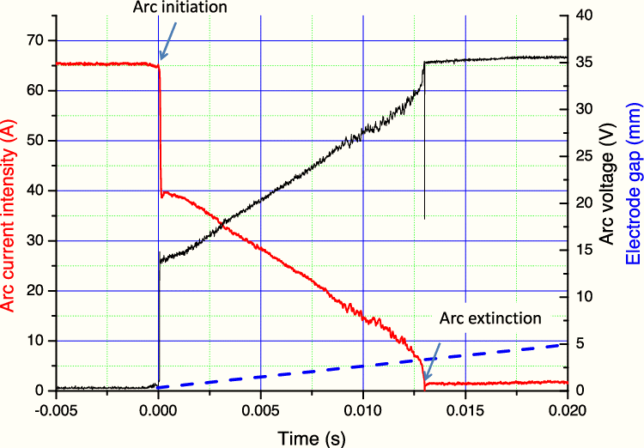
FIGURE 1. Time-domain variation of arc current, arc voltage, and electrode gap during arc initiation and extinction.

The experimental investigation was conducted on a three-phase AC electric arc furnace operating under normal technological load conditions during different melting stages. Instantaneous arc voltage and current signals were measured directly on the furnace short network using high-accuracy voltage and current sensors. A high-speed digital oscilloscope with sufficient bandwidth was employed to capture both low-order harmonics and high-frequency transient components associated with unstable arc behavior [7-9]. Figure 1 illustrates typical experimentally recorded voltage and current waveforms of the electric arc, where pronounced non-sinusoidal shapes, steep voltage peaks, and current discontinuities are clearly observed. These features confirm the highly nonlinear and time-varying nature of the arc process.
During different melting stages, continuous waveform recordings were performed over multiple supply cycles. From these measurements, instantaneous voltage–current pairs were extracted at each sampling instant. The recorded data revealed strong asymmetry between positive and negative half-cycles, as well as significant variations within a single period. Using these instantaneous data points, dynamic V–I characteristics were constructed. Figure 2 presents a typical dynamic V–I curve of the electric arc, demonstrating loop-shaped trajectories that change continuously within each half-cycle. These curves reflect the combined influence of arc plasma dynamics, electrode movement, and thermal inertia, which cannot be represented by static or averaged V–I characteristics.
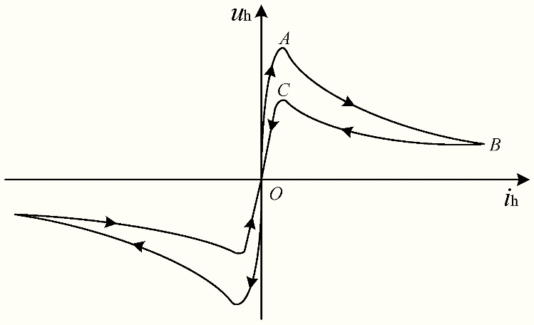
FIGURE 2. Schematic dynamic V–I characteristic of an AC electric arc showing nonlinear hysteresis loops.

To evaluate harmonic distortion, the measured voltage and current signals were processed using discrete Fourier transform (DFT) techniques. Harmonic spectra were obtained for each phase. The analysis shows that voltage harmonic amplitudes increase significantly during periods of arc instability, particularly at arc ignition and extinction. Figure 3 illustrates a representative harmonic spectrum of the arc voltage, where dominant low-order harmonics and noticeable higher-order components are present. This confirms that harmonic distortion in electric arc furnaces is strongly dependent on instantaneous arc behavior rather than steady-state operating conditions.
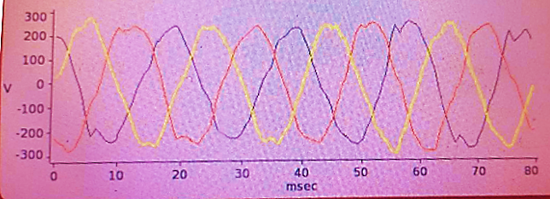
FIGURE 3. Harmonic spectrum of arc voltage showing the distribution of voltage harmonics as a percentage of the fundamental component.

The experimentally obtained dynamic V–I characteristics were subsequently used for harmonic level caculation and for validating existing arc models. The results clearly demonstrate that real arc voltage contains sharp transient peaks, while current waveforms are highly distorted and non-periodic. Consequently, harmonic distortion levels in industrial electric arc furnaces are governed primarily by momentary arc behavior. The inclusion of experimentally measured dynamic V–I characteristics significantly improves the accuracy of harmonic assessment and provides a realistic basis for analyzing the impact of EAFs on power quality in industrial power systems.
RESEARCH RESULTS
This section presents the consolidated results of the experimental investigation performed on the short network of the electric arc furnace (EAF). The obtained results integrate waveform observations, dynamic volt–ampere behavior, harmonic distortion characteristics, and power-quality indices derived from real industrial measurements [1,2,5,6].
Experimental measurements of three-phase voltages at the furnace short network reveal pronounced non-sinusoidal waveforms throughout all melting stages. The recorded voltages exhibit irregular peak amplitudes, phase asymmetry, and significant waveform deformation, which directly reflect the unstable nature of arc burning. Sharp transient voltage peaks occur repeatedly during each supply cycle, corresponding to arc ignition and extinction events. These transients introduce high-frequency components into the voltage waveform and serve as the primary source of harmonic and interharmonic generation. Phase asymmetry is mainly caused by uneven electrode positioning, arc-length fluctuations, and nonuniform molten metal conditions, leading to unbalanced electrical stress on the supply network.
Analysis of instantaneous voltage–current data extracted from the measured oscillograms allowed the construction of dynamic volt–ampere (V–I) characteristics of the electric arc. The resulting V–I curves form loop-shaped trajectories that vary significantly from one half-cycle to another. Arc ignition is characterized by a sudden voltage rise at relatively low current levels, whereas arc extinction is accompanied by a rapid voltage drop, even when current continues flowing for a short time due to plasma inertia. These results clearly demonstrate the strongly nonlinear and time-varying behavior of the arc and confirm that static or averaged arc characteristics cannot adequately represent real furnace operation.
Spectral analysis using discrete Fourier transform (DFT) techniques revealed a complex harmonic structure in both current and voltage signals. Elevated total harmonic distortion values were observed, with current THD exceeding 20% during unstable arc conditions. The harmonic spectrum is dominated by low-order harmonics, while higher-order harmonics and interharmonics appear during rapid arc transients. In addition, a small DC component was detected in the arc current, leading to waveform asymmetry and contributing to increased transformer stress. The magnitude and distribution of harmonics were found to vary significantly with the melting stage, confirming the strong dependence of harmonic generation on instantaneous arc behavior.
Measured flicker indices further indicate a considerable deterioration of power quality. Short-term flicker severity values significantly exceed typical compatibility limits, while long-term flicker remains elevated due to sustained arc instability. These voltage fluctuations are closely correlated with ignition and extinction peaks observed in the voltage waveform. Increased reactive power demand and noticeable voltage unbalance were also recorded, demonstrating that the impact of EAF operation extends beyond harmonic distortion and affects overall network performance.

TABLE 1. Experimental power-quality indices measured at the electric arc furnace short network
Index | Unit | Range | Average | Main Effect
Voltage THD (THDU) | % | 6.5–14.2 | 10.8 | Voltage waveform distortion
Current THD (THDI) | % | 12.0–28.5 | 21.4 | Increased losses, heating
Low-order harmonics (3rd–7th) | % of fundamental | 8–18 | 12 | Network imbalance
High-order harmonics (≥11th) | % of fundamental | 3–9 | 6 | EMI, resonance risk
Interharmonics | % of fundamental | 1.5–6.0 | 3.8 | Flicker generation
Flicker Pst | – | 1.2–2.6 | 1.9 | Visible light flicker
Flicker Plt | – | 0.9–1.8 | 1.3 | Long-term voltage fluctuation

The summarized power-quality indices presented in Table 1 confirm that electric arc furnace operation introduces severe disturbances into the supply network, including high THD, pronounced flicker, harmonic and interharmonic components, voltage imbalance, and increased reactive power consumption. These results emphasize that realistic evaluation of the power-quality impact of EAFs requires experimental analysis based on dynamic arc behavior rather than steady-state assumptions.
Overall, the experimental findings demonstrate that arc-generated voltage and current are highly distorted, asymmetric, and strongly time-dependent. The observed dynamic V–I loops, harmonic variability, and flicker levels confirm the necessity of using experimentally obtained arc characteristics for accurate harmonic prediction, power-quality assessment, and the development of effective mitigation strategies in industrial electric arc furnace installations.
CONCLUSIONS
The experimental investigation of the electric arc furnace short network demonstrates that the AC arc is a highly nonlinear, nonstationary, and dynamically unstable element that significantly affects power quality in industrial electrical systems. The measured voltage waveforms confirm that the arc introduces sharp ignition and extinction peaks, pronounced waveform distortion, and considerable phase asymmetry. These effects occur as a direct consequence of rapid variations in arc length, electrode movement, and thermal instabilities within the arc column.
Dynamic V–I characteristics extracted from the measurements reveal loop-shaped, cycle-dependent trajectories, which cannot be represented by classical static models. The shape and amplitude of these loops change continuously during the melting process, proving that real arc behavior is governed by fast transient thermal and electrodynamic processes rather than steady-state assumptions.
Harmonic spectrum analysis shows that the arc generates high-order harmonics, interharmonics, and a detectable DC offset. These spectral components vary throughout the furnace operation and are especially prominent during unstable arc phases. Such disturbances lead to increased total harmonic distortion, voltage imbalance, reactive power fluctuations, and flicker in the supply network.
The findings clearly indicate that accurate modeling of electric arc furnace behavior must rely on experimentally measured dynamic characteristics rather than simplified analytical arc models. The use of real-time waveform data provides a more reliable basis for harmonic evaluation, network-impact assessment, and the development of mitigation strategies for improving power quality in industrial systems.
Overall, the research confirms that the electric arc furnace is a dominant source of electrical disturbances, and its behavior should be analyzed using high-resolution experimental data to ensure precise characterization and effective control of power-quality problems in modern metallurgical facilities.
REFERENCES
- Zarudi, V., Krizhanskiy, I., & Temkin, M. Dynamic behavior of AC electric arcs and their influence on power systems. Metallurgical Power Engineering Press, 2015.
- Mayr, O. “Beitrag zur Theorie des statischen und dynamischen Lichtbogens.” Archiv für Elektrotechnik, vol. 37, pp. 588–608, 1943.
- Cassie, A. M. “Arc rupture and circuit severity: A contribution to the theory of switchgear.” CIGRE Report, 1939.
- Reymov K.M., Makhmuthonov S.K., Turmanova G., Uzaqbaev Q. Optimization of electric networks modes under conditions of partial uncertainty of initial information // E3S Web of Conferences 289, 07023 (2021). -2021, pp: 1-4, https://doi.org/10.1051/e3sconf/202128907023.
- Bobojanov M.K., Mahmutkhonov S.K. Harmonic analysis of an electric Arc Furnace through time-based dynamic modeling of the Electric Arc // International Journal of Advanced Research in Science, Engineering and Technology. India, 2024. – Vol. 11, Issue 9, September 2024. ISSN: 2350-0328. PP. 22311-22314.
- Mahmutkhonov S., Baizhonova L., Mustayev R., Tashmatova S. Dynamic analysis of voltage-ampere characteristics and harmonic distortions in electric arc furnaces. // AIP Conference Proceedings. 3331(1), 2025. pp. 070023, 1–5. https://doi.org/10.1063/5.0305745.
- Bobojanov M., Mahmutkhonov S. Influence of the consumer to power quality at the point of connection // E3S Web of Conferences 384. 2023. РР, 01041, 1-5. https://doi.org/10.1051/e3sconf/202338401041.
- Bobojanov M.K., Karimov R.Ch., Popkova O.S., Tuychiev F.N., Makhmutkhanov S.K. Analysis of the results of experimental studies of the arc furnace DSP-30. // Power Engineering Research & Technology. 27(2), 2025. pp. 126–137. https://doi.org/10.30724/1998-9903-2025-27-2-126-137
- Alimov A.A., Ruzinazarov M.R., Mahmutkhonov S.K., Uzakov В. Methods of phase, chain analysis and calculation of electric consumption of complex objects with interproduction relations // International Journal of Advanced Science and Technology. Vol. 29, No. 11s, (2020), pp. 1386-1393.

