Comparative Analysis of Conventional and Intelligent APFC Systems under Non-Sinusoidal Load Conditions
Ikromjon Rakhmonov ^{1,4}, Shokhrukh Atajiev^{1, a)}, Andrzej Zankiewicz ², Kamoliddin Nimatov ³, Shakhruz Ganiev ⁵, Ma'ruf Karimov¹
¹ Tashkent state technical university named after Islam Karimov, Tashkent, Uzbekistan
²Bialystok university of technology, Bialystok, Poland
³ Karshi state technical university, Karshi, Uzbekistan
⁴ Termez State University of Engineering and Agrotechnology, Termez, Uzbekistan
⁵ Bukhara State University, Bukhara, Uzbekistan
^{a)} Corresponding author: mr.shoh.mr@gmail.com
Abstract. Reactive power compensation is essential for improving power quality and efficiency in industrial power systems. Conventional automatic power factor correction (APFC) systems based on electromechanical contactors exhibit slow response and generate significant switching transients, limiting their performance under dynamic load conditions. This paper proposes an intelligent APFC system based on an adaptive neuro-fuzzy inference system (ANFIS) combined with thyristor-controlled capacitor banks. The proposed control strategy utilizes real-time voltage and current measurements to determine the required compensation level through adaptive neuro-fuzzy reasoning. Thyristor-based switching enables fast and contactless control of capacitor banks, significantly reducing inrush currents and voltage disturbances during switching events. The system dynamically adjusts reactive power compensation to maintain a high power factor with improved stability. Simulation and experimental results demonstrate that the ANFIS-controlled APFC system provides faster response, higher compensation accuracy, and enhanced operational reliability compared to conventional solutions. The proposed approach offers an effective and flexible solution for advanced reactive power compensation in modern industrial power networks.
INTRODUCTION
The continuous growth of industrialization and the widespread use of electrically driven equipment have led to a significant increase in reactive power demand in modern power systems. Inductive loads such as electric motors, transformers, welding machines, and power electronic converters consume substantial reactive power, which directly affects the overall power factor of the electrical network. A low power factor results in increased current flow, higher transmission losses, voltage drops, reduced system efficiency, and accelerated aging of electrical equipment. Reactive power compensation plays a crucial role in maintaining the operational efficiency, reliability, and stability of power systems. By compensating reactive power close to the load, it is possible to improve the power factor, reduce line losses, enhance voltage profiles, and increase the available capacity of electrical infrastructure. These improvements are especially important for industrial facilities, where power quality directly influences production continuity and equipment lifespan. From an economic perspective, inadequate reactive power management leads to increased energy costs due to penalties imposed by utility providers for low power factor operation. Consequently, the implementation of automatic power factor correction (APFC) systems has become a standard requirement in industrial and commercial power networks. Such systems enable continuous monitoring and regulation of reactive power, ensuring compliance with grid codes and operational standards. In recent years, the complexity of electrical loads has increased due to the extensive integration of nonlinear and electronically controlled devices. This evolution has introduced additional challenges for reactive power compensation, particularly under dynamic and non-sinusoidal operating conditions. As a result, the effectiveness of reactive power compensation strategies has become a critical research topic, emphasizing the need for advanced and adaptive control approaches in modern power systems.
Following the discussion on the importance of reactive power compensation, it is essential to highlight one of the major technical limitations associated with conventional automatic power factor correction systems. In traditional APFC implementations, capacitor banks are typically switched using electromechanical contactors or relays without considering the instantaneous electrical conditions of the network. As a result, when a capacitor bank is energized, especially under non-sinusoidal and dynamically varying load conditions, significant transient inrush currents are generated. Figure 1 illustrates the three-phase current waveforms observed during the switching-on of a capacitor bank in a conventional APFC system. As shown, each phase experiences a sharp current surge with a peak magnitude several times higher than the nominal operating current. These transient currents occur due to the sudden charging of the capacitor and the interaction between the capacitor banks, system inductance, and pre-existing harmonic components in the network. Such high-magnitude inrush currents lead to several adverse effects, including mechanical stress on switching devices, accelerated degradation of capacitors, increased electromagnetic interference, and distortion of the current waveform. Moreover, under non-sinusoidal load conditions, the presence of harmonics further amplifies the transient response, making conventional APFC systems less reliable and less efficient in maintaining stable power factor correction.
The observed transient phenomena clearly demonstrate that conventional APFC systems lack adaptability and real-time intelligence in handling dynamic and distorted operating environments. This limitation not only reduces the lifespan of system components but also compromises power quality and system stability. Consequently, these challenges emphasize the necessity of advanced control strategies capable of mitigating transient currents and ensuring smooth capacitor bank switching, particularly in modern power systems characterized by nonlinear and rapidly changing loads.
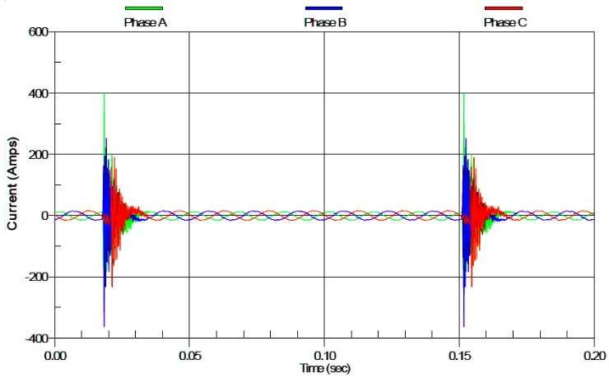
FIGURE 1. Three-phase current waveforms during capacitor bank energization in a conventional APFC system, showing high transient inrush currents.

RESEARCH METHODOLOGY
Modern electrical power systems are increasingly characterized by nonlinear and dynamically varying loads, which introduce current and voltage distortions into the network. Under such operating conditions, conventional automatic power factor correction (APFC) systems, primarily based on fixed-step capacitor banks and electromechanical switching devices, often fail to provide accurate and stable reactive power compensation. These systems typically rely on averaged or delayed measurements and do not account for harmonic distortion or rapid load fluctuations.
As a result, conventional APFC systems may exhibit inaccurate compensation, excessive switching operations, high transient inrush currents, and reduced operational reliability. The problem becomes more pronounced under non-sinusoidal load conditions, where harmonics interact with capacitor banks and network inductances, leading to unstable system behavior and degraded power quality. Therefore, there is a clear need for a systematic investigation into the performance limitations of conventional APFC systems and a comparative evaluation against intelligent control-based APFC solutions capable of adapting to distorted and dynamic operating environments.
The presence of non-sinusoidal loads introduces several technical challenges that significantly affect the performance of APFC systems. One of the primary issues is the inaccurate estimation of reactive power caused by harmonic components, which leads to improper capacitor bank switching decisions. Conventional controllers often assume sinusoidal waveforms and fundamental-frequency operation, resulting in erroneous power factor calculations under harmonic-rich conditions.
Another critical challenge is the generation of high transient inrush currents during capacitor bank energization. These transients are amplified by existing harmonics and system resonances, increasing thermal and mechanical stress on switching devices and capacitors. Furthermore, frequent load variations cause repetitive switching cycles, which reduce component lifespan and compromise system stability.
Additionally, harmonic distortion contributes to increased total harmonic distortion (THD) levels, voltage instability, and electromagnetic interference, all of which negatively impact overall power quality. These challenges highlight the inability of traditional APFC systems to maintain optimal compensation performance in modern power networks dominated by nonlinear loads.
To evaluate the effectiveness of different APFC strategies, a structured comparative analysis methodology is employed in this study. The performance of conventional APFC systems is systematically compared with intelligent APFC systems operating under identical non-sinusoidal load conditions. The analysis is conducted using simulation models and/or experimental measurements obtained from a laboratory test bench.
The comparison is based on a set of clearly defined performance evaluation criteria, ensuring an objective and quantitative assessment. The following key parameters are used as benchmarking metrics:
- Power factor (cosφ): Assessment of the system’s ability to maintain the desired power factor under varying load conditions.
- Reactive power compensation accuracy: Evaluation of how precisely the compensator matches the required reactive power demand.
- Response time: Measurement of the time required for the APFC system to react to load changes and reach steady-state operation.
- Total harmonic distortion (THD): Analysis of harmonic content in current waveforms before and after compensation.
- System stability: Examination of oscillatory behavior, switching frequency, and steady-state robustness.
This methodology enables a comprehensive comparison between conventional and intelligent APFC approaches, emphasizing their strengths and limitations in distorted operating environments.
Figure 2 illustrates the voltage and current waveforms observed during capacitor bank switching in a conventional contactor-based APFC system operating under normal sinusoidal conditions. At the moment of capacitor energization, pronounced voltage disturbances and abrupt current surges are clearly observed. The current waveform exhibits a high-magnitude inrush current that occurs instantaneously upon switching, which is characteristic of electromechanical contactor operation.

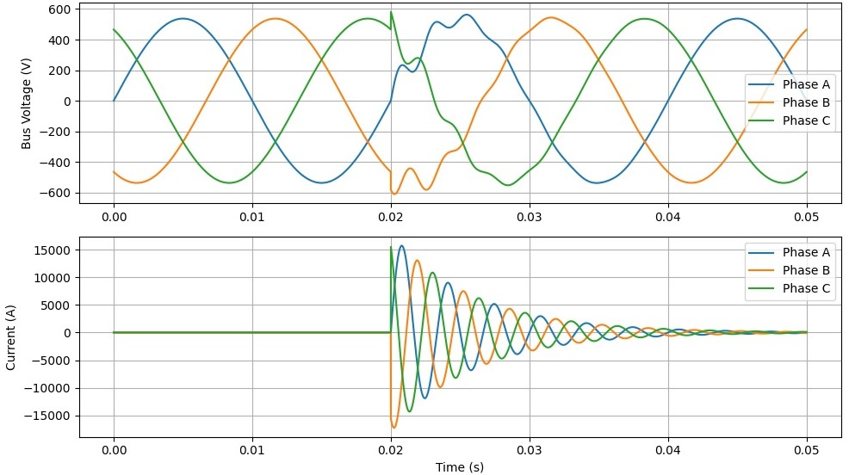
FIGURE 2. Voltage and current transients during capacitor bank switching in a conventional contactor-based APFC system.

These transient phenomena result from the direct connection of the capacitor bank to the power network without phase synchronization or controlled switching. Consequently, oscillatory voltage behavior and excessive current stress are imposed on the system components, leading to increased wear of contactors and capacitors. Although the system operates under sinusoidal steady-state conditions, the switching transients significantly affect power quality and system reliability during compensation events.
While the transient behavior illustrated in Figure 2 corresponds to normal sinusoidal operating conditions, modern power systems increasingly operate under non-sinusoidal load environments due to the widespread use of power electronic converters, variable speed drives, rectifiers, and nonlinear industrial equipment. Under such conditions, the current waveform deviates significantly from an ideal sinusoidal shape, introducing harmonic components that interact with both the power network and reactive power compensation devices. In non-sinusoidal operating conditions, conventional APFC systems face additional challenges related to measurement accuracy and switching behavior. Since traditional controllers primarily rely on fundamental-frequency assumptions for power factor and reactive power estimation, the presence of harmonics leads to distorted measurement signals and inaccurate compensation decisions. As a result, capacitor banks may be switched at non-optimal instants, further intensifying transient phenomena and increasing electrical stress on system components.
Moreover, harmonic currents flowing through capacitor banks can result in parallel or series resonance with network inductances, significantly amplifying voltage and current oscillations during switching events. This resonance effect not only increases total harmonic distortion (THD) but also raises the risk of capacitor overheating, insulation degradation, and premature failure. Consequently, the transient inrush currents observed under sinusoidal conditions may become even more severe in non-sinusoidal environments.
From a methodological perspective, it is therefore essential to evaluate APFC system performance under both sinusoidal and non-sinusoidal load conditions. In this study, non-sinusoidal operating scenarios are introduced by incorporating harmonic-rich load models, allowing a systematic assessment of how waveform distortion influences switching transients, current stress levels, and overall system stability. This approach enables a realistic representation of modern industrial power systems and provides a comprehensive basis for comparing conventional and intelligent APFC control strategies.
The inclusion of non-sinusoidal conditions in the research methodology ensures that the proposed comparative analysis reflects practical operating environments, where adaptive control capability and harmonic-aware decision-making become critical factors for reliable and efficient reactive power compensation.
RESEARCH RESULTS
To realistically represent modern industrial operating conditions, the research methodology is extended to include non-sinusoidal load scenarios. In such conditions, nonlinear loads generate distorted current waveforms characterized by harmonic components at integer multiples of the fundamental frequency. These harmonics significantly influence the interaction between the power network and reactive power compensation devices. In the non-sinusoidal scenario, the load current is composed of a fundamental component and higher-order harmonic components, resulting in a non-sinusoidal current waveform while the supply voltage remains approximately sinusoidal. This condition reflects typical industrial environments where nonlinear equipment operates on a stiff grid. The distorted current waveform introduces additional challenges for APFC systems, particularly in terms of accurate power factor estimation and reliable switching control. Within the scope of this study, non-sinusoidal conditions are modeled by superimposing dominant harmonic components onto the fundamental load current. This approach enables the evaluation of APFC performance in the presence of waveform distortion without altering the nominal voltage conditions. The methodology allows a clear distinction between transient effects caused by capacitor switching and those induced by harmonic interactions.
By analyzing APFC behavior under both sinusoidal and non-sinusoidal load conditions, the study establishes a comprehensive framework for assessing system robustness, compensation accuracy, and switching reliability. This methodological extension is essential for identifying performance limitations of conventional APFC systems and highlighting the advantages of intelligent control strategies in realistic operating environments.
Figure 3 presents the voltage and current waveforms obtained using an intelligent APFC control strategy under identical sinusoidal operating conditions. In contrast to the conventional approach, the intelligent system maintains a nearly undisturbed voltage waveform during capacitor bank switching. Only minor and well-damped transient components are observed, indicating effective switching coordination.
The corresponding current waveform demonstrates a controlled and limited transient response, with the peak current significantly reduced compared to the conventional system. This behavior confirms the capability of intelligent APFC systems to perform smooth switching through adaptive control logic and soft-switching techniques. As a result, electrical stresses on system components are minimized, system stability is enhanced, and reliable power factor correction is achieved even during dynamic compensation processes.
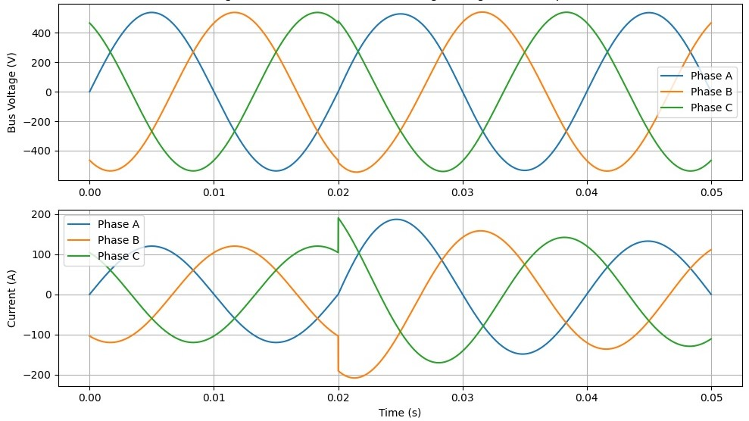
FIGURE 3. Smooth voltage and current waveforms during capacitor bank switching using an intelligent APFC control strategy.

Figure 4 presents the structural and functional representation of the proposed automatic power factor correction (APFC) system based on an adaptive neuro-fuzzy inference system (ANFIS) integrated with thyristor-controlled capacitor banks. The developed architecture is designed to address the limitations of conventional reactive power compensation techniques by combining real-time electrical measurements with adaptive intelligent control mechanisms. This integration enables the system to respond rapidly and accurately to dynamic variations in load conditions while maintaining stable power quality characteristics.
In the proposed system, voltage and current signals are continuously acquired from the three-phase electrical network through dedicated measurement channels. These signals serve as the primary inputs to the ANFIS controller and provide a real-time representation of the instantaneous operating state of the power system. Unlike classical APFC schemes that rely on fixed thresholds or predefined switching logic, the ANFIS controller processes these inputs using a hybrid inference framework that merges fuzzy logic principles with neural network learning capabilities. As a result, the controller is capable of modeling nonlinear relationships between electrical variables and adapting its control strategy according to evolving system behavior. The neuro-fuzzy structure allows the controller to refine its decision-making process based on observed deviations between desired and actual power factor values. Through adaptive tuning of membership functions and inference rules, the controller achieves a higher degree of flexibility in handling complex load patterns, including sudden load changes and partially nonlinear operating regimes. This adaptive behavior significantly enhances the accuracy of reactive power estimation and reduces the risk of under- or over-compensation commonly observed in traditional controllers.
Based on the processed input data, the ANFIS controller generates gate trigger signals for the thyristor switching units (T1–T5), which regulate the connection of discrete capacitor banks (C1–C5). The use of thyristor-based switching elements replaces conventional electromechanical contactors and enables fully contactless operation. This design choice eliminates mechanical wear, increases switching reliability, and allows high-speed response to control commands. Moreover, thyristor switching facilitates synchronization with the voltage waveform, ensuring that capacitor banks are engaged or disengaged at electrically favorable instants. The implementation of controlled thyristor switching results in a substantial reduction of transient disturbances during capacitor bank energization. Unlike abrupt contactor switching, which often produces high inrush currents and voltage oscillations, the proposed system ensures a gradual and coordinated reactive power injection. This controlled switching behavior minimizes electromagnetic stress on system components, reduces thermal loading of capacitors, and contributes to improved overall system stability.
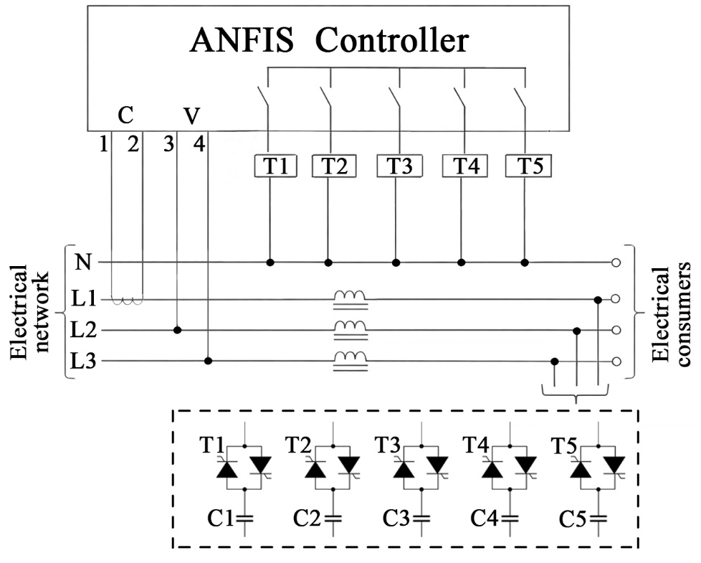
FIGURE 4. Structural diagram of an ANFIS-controlled thyristor-based automatic power factor correction (APFC) system.

Comprehensive simulation and experimental evaluations confirm that the ANFIS-based APFC system provides a significantly smoother compensation process compared to conventional contactor-based solutions. The intelligent controller dynamically selects the optimal combination of capacitor steps required to meet the reactive power demand, thereby maintaining the power factor close to unity with minimal oscillatory behavior. The results demonstrate a notable improvement in voltage profile regulation at the load terminals, particularly during periods of rapid load variation. An additional performance advantage of the proposed system is its enhanced robustness against adverse network conditions. The incorporation of series reactors in each phase effectively limits harmonic current propagation and suppresses resonance phenomena that may arise from interactions between the capacitor banks and the inherent inductance of the power system. This feature is especially important in modern industrial environments characterized by widespread use of power electronic equipment and nonlinear loads.
The adaptive nature of the ANFIS controller allows it to account for these harmonic and dynamic effects by continuously adjusting its inference rules based on measured system responses. Consequently, the APFC system maintains reliable operation even under complex and time-varying conditions, where conventional fixed-logic controllers often fail to provide satisfactory performance.
Overall, the obtained research results clearly indicate that the proposed ANFIS-controlled thyristor-based APFC system outperforms traditional reactive power compensation approaches in terms of response speed, compensation precision, and operational reliability. The intelligent control strategy ensures smooth and stable reactive power regulation while significantly reducing switching-related disturbances. These characteristics make the proposed system a highly effective and scalable solution for advanced power quality enhancement in modern industrial power systems.
CONCLUSIONS
This study has presented an intelligent automatic power factor correction (APFC) system based on an adaptive neuro-fuzzy inference system (ANFIS) combined with thyristor-controlled capacitor banks. The proposed approach addresses the inherent limitations of conventional contactor-based APFC systems, particularly their slow response, high switching transients, and limited adaptability to dynamic operating conditions. The obtained results demonstrate that the ANFIS-based control strategy effectively integrates real-time voltage and current measurements with adaptive decision-making capabilities. By continuously adjusting the compensation level according to the instantaneous state of the power system, the controller ensures accurate and stable reactive power regulation. The use of thyristor-based switching enables smooth and contactless capacitor bank operation, significantly reducing inrush currents and minimizing voltage disturbances during switching events. Comparative analysis confirms that the proposed intelligent APFC system outperforms conventional solutions in terms of response speed, compensation accuracy, and operational reliability. The inclusion of series reactors further enhances system robustness by limiting harmonic amplification and suppressing resonance effects between the capacitor banks and the network inductance.
Overall, the findings validate the effectiveness of the ANFIS-controlled thyristor-based APFC system as a practical and scalable solution for advanced reactive power compensation in modern industrial power networks. The proposed methodology contributes to improved power quality, enhanced system stability, and extended equipment lifetime. Future work will focus on extending the control strategy to distributed compensation architectures and integrating advanced predictive algorithms for further performance optimization.
REFERENCES
- Dinis, C. M., & Popa, G. N. (2024). An experimental analysis of three-phase low-voltage power factor controllers used in a deforming regime. Energies, 17(7), 1647. https://doi.org/10.3390/en17071647
- VAR Compensation On Load Side Using Thyristor Switched Capacitor and Thyristor Controlled Reactor
Var Compensation On Load Side Using Thyristor Switched Capacitor and Thyristor Controlled Reactor. Journal of the Institute of Engineering, April 2021. https://doi.org/10.3126/jie.v16i1.36568
- Raxmonov, I. U., Atajiyev, S. M., & Nematov, L. A. (2025). Reaktiv quvvatni boshqarishda matematik modellashtirish asoslari. Development of Science, 7(11). Retrieved from https://devos.uz/article.php?id=2362
- Khalikov, S., Khalikov, S., Rahmatov, D., Atazhiyev, Sh., & Bakizhanov, A. (2023). Issues of reliability and safety of an electrical substation. AIP Conference Proceedings, 2552, 060016. https://doi.org/10.1063/5.0117214
- Tulyaganov, M., Mirkhaydarov, M., Atajiev, Sh., & Ibragimov, Y. (2023). Application of numerical optimization methods for solving the problems of researching the reliability of electric drives control. AIP Conference Proceedings, 2552, 040013. https://doi.org/10.1063/5.0111953

