LSTM-Based Real-Time Forecasting of Dynamic Stability Parameters in Power Systems Integrated with Renewable Energy Sources
Numon Niyozov ^{1,4, a)}, Liu Chuang ², Zamira Shayumova ³, Madina Ganikhanova ¹
¹ Tashkent state technical university named after Islam Karimov, Tashkent, Uzbekistan
² Northeast Electric Power University, Jilin, China
³ Navoi State University of Mining and Technologies, Navoiy, Uzbekistan
⁴ Termiz State University of Engineering and Agrotechnologies, Termiz, Uzbekistan
^{a)} Corresponding author: nomonniyozov1992@gmail.com
Abstract. High penetration of renewable energy sources introduces nonlinear and time-varying dynamics that complicate real-time stability assessment in electrical power systems. This study proposes a data-driven forecasting framework based on Long Short-Term Memory (LSTM) neural networks for predicting key dynamic stability parameters in renewable-rich power grids. Multivariate time-series data generated from power system simulations are used as inputs, including load demand, renewable generation, frequency, voltage, inertia, energy storage state, and meteorological variables. The LSTM model is trained using sliding time windows and optimized through systematic hyperparameter tuning. Forecasting accuracy is evaluated using the Mean Absolute Percentage Error metric, with test results demonstrating errors below 1.2%. An adaptive preprocessing mechanism based on Z-score normalization is implemented to mitigate the impact of outliers and improve robustness. The proposed approach enables continuous real-time prediction of frequency and voltage behavior, inertia variation, and recovery time, supporting early detection of critical system conditions. The results confirm that LSTM-based forecasting is an effective tool for intelligent monitoring and predictive stability assessment in power systems with large-scale renewable energy integration.
INTRODUCTION
National energy systems are undergoing rapid structural transformation as renewable energy sources increasingly replace conventional generation. In Uzbekistan, this transformation is particularly pronounced due to the high potential of solar and wind resources. According to projected energy scenarios, the share of renewable energy in the national energy balance is expected to grow significantly by 2030, with solar and wind power reaching a dominant position in the installed generation capacity. Such a transition fundamentally changes the operational characteristics of the power system [1,2].
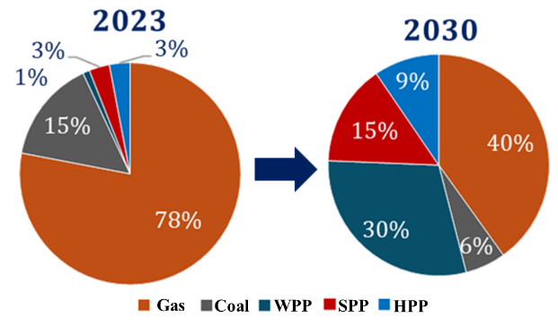
FIGURE 1. Comparative Analysis of Uzbekistan’s Energy Balance for the Period 2023–2030
The increasing penetration of RES leads to heightened variability in power generation, which complicates the real-time assessment of system stability. Reduced mechanical inertia, rapid fluctuations in generation, and changing load patterns require forecasting tools capable of processing large volumes of time-dependent data. Traditional deterministic methods are often insufficient for capturing these nonlinear dynamics. Therefore, intelligent forecasting approaches based on data-driven models become essential. Long Short-Term Memory (LSTM) neural networks are well suited for this task, as they can learn temporal dependencies in sequential data and predict future system states. The application of LSTM-based forecasting enables continuous evaluation of dynamic stability indicators, supports early detection of potentially critical conditions, and enhances decision-making in power systems with a high share of renewable energy.

METHODOLOGY
A data-driven forecasting methodology based on Long Short-Term Memory (LSTM) neural networks is employed to predict dynamic stability parameters in power systems with high renewable energy integration. Time-series datasets are generated from simulated system operation, capturing the dynamic interaction between load variations and renewable generation. The input variables include system load, solar and wind power output, network frequency, voltage magnitude, inertia coefficient, energy storage state, and meteorological parameters such as wind speed [3,4].
The LSTM architecture is selected due to its ability to model nonlinear temporal dependencies in sequential data. Input data are structured using a sliding window approach with a sequence length of 60 time steps, enabling the model to learn dynamic patterns preceding stability changes. The neural network consists of stacked LSTM layers followed by an output layer that produces forecasts of key system indicators, including future frequency, voltage fluctuations, inertia behavior, and recovery time.
Model training is conducted using supervised learning, while predictive performance is evaluated using the Mean Absolute Percentage Error (MAPE) metric. To improve robustness, adaptive data preprocessing is applied through normalization and Z-score-based outlier detection [5,6]. When prediction errors exceed predefined thresholds, anomalous values are replaced with median estimates, and the model is retrained. This methodology ensures high forecasting accuracy and enables real-time monitoring and predictive assessment of system stability.
RESULT AND DISSCUSSION
The effectiveness of the LSTM-based forecasting framework was evaluated using time-series data generated from simulations of an electrical power system with large-scale renewable energy integration [6,7]. The forecasting process follows the algorithmic structure, which includes data preprocessing, sequence formation, model training, validation, testing, and continuous real-time updating. The LSTM model processes multivariate input sequences and produces forecasts of key dynamic stability indicators, including frequency, voltage, inertia, and recovery time.
The input data were structured into sliding windows with a sequence length $SL=60$, meaning that each forecast is based on the previous 60 time steps. Mathematically, the forecasting task can be expressed as:

${\hat{y}}_{t+1}=f(x_{t-SL+1},x_{t-SL+2},…,x_{t})$ (1)

where $x_{t}$represents the multivariate input vector at time $t$, and $f(⋅)$denotes the nonlinear function approximated by the LSTM network.
The systematic tuning of LSTM hyperparameters played a decisive role in achieving high predictive accuracy. The ranges and optimal values are tested which corresponds to the experimental results presented in the study.

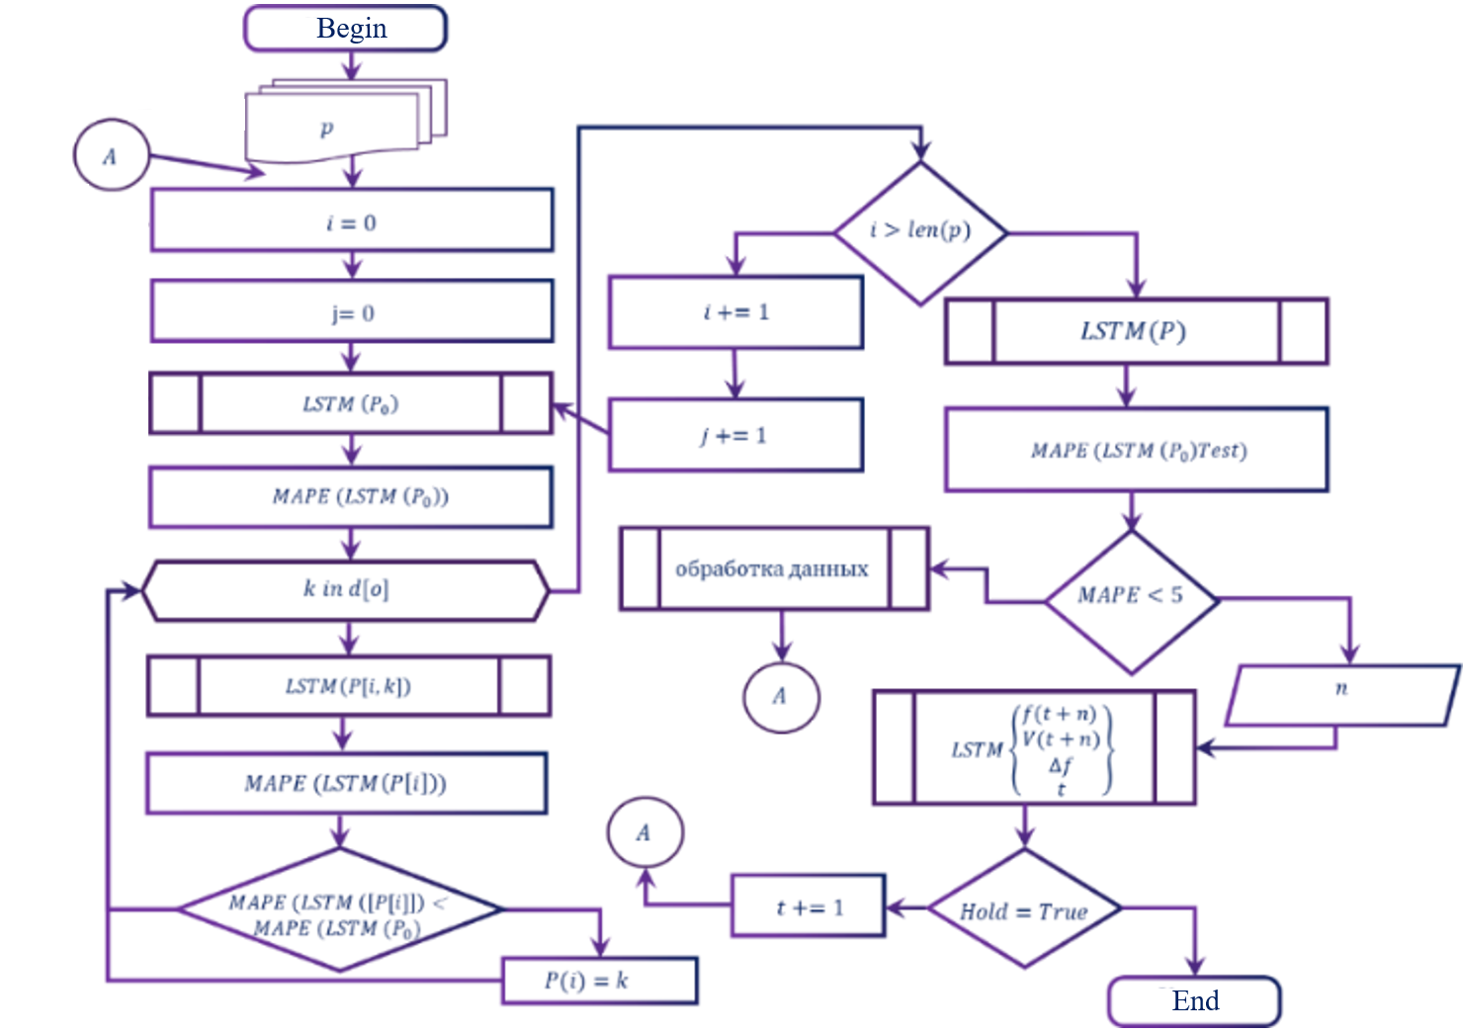
FIGURE 2. LSTM-based algorithm for modeling and updating dynamic characteristics of RES-integrated grid

TABLE 1. Optimal LSTM Hyperparameter Configuration
Hyperparameter | Optimal value | Tested range
Sequence length (SL) | 60 | 0–150
LSTM units (Layer 1) | 64 | 8–128
LSTM units (Layer 2) | 32 | 8–128
Dropout rate | 0.1 | 0.1–0.5
Batch size | 8 | 16–128
Learning rate | 0.01 | 0.0001–0.01
Optimizer | Adam | Adam, RMSProp, Nadam

The influence of the sequence length on forecasting accuracy where the minimum error is observed at $SL=61$, confirming the suitability of the selected window size. Furthermore, the neuron configuration of 64 units in the first LSTM layer and 32 units in the second layer yields the lowest error, indicating an optimal balance between model complexity and generalization capability.
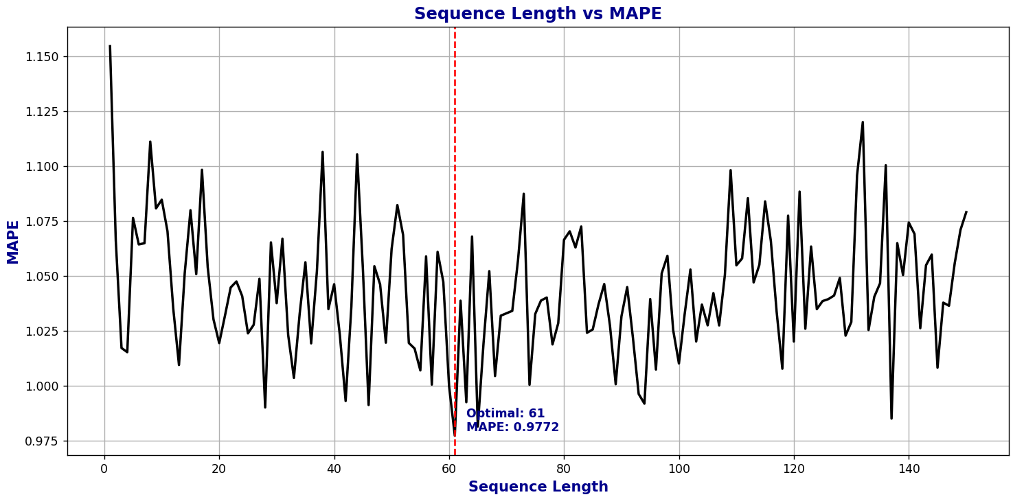
FIGURE 3. Determination of the Optimal Sequence Length

Model performance was assessed using the Mean Absolute Percentage Error (MAPE), defined as:
$$MAPE=\frac{1}{N}\sum_{i=1}^{N}{∣\frac{y_{i}-{\hat{y}}_{i}}{y_{i}}∣}×100\%$$
where $y_{i}$and ${\hat{y}}_{i}$denote the actual and predicted values, respectively. The resulting MAPE values for different datasets are presented.

Table 2. Forecasting Accuracy of the LSTM Model
Dataset | Training set | Validation set | Test set
MAPE (%) | 2.70 | 1.36 | 1.17

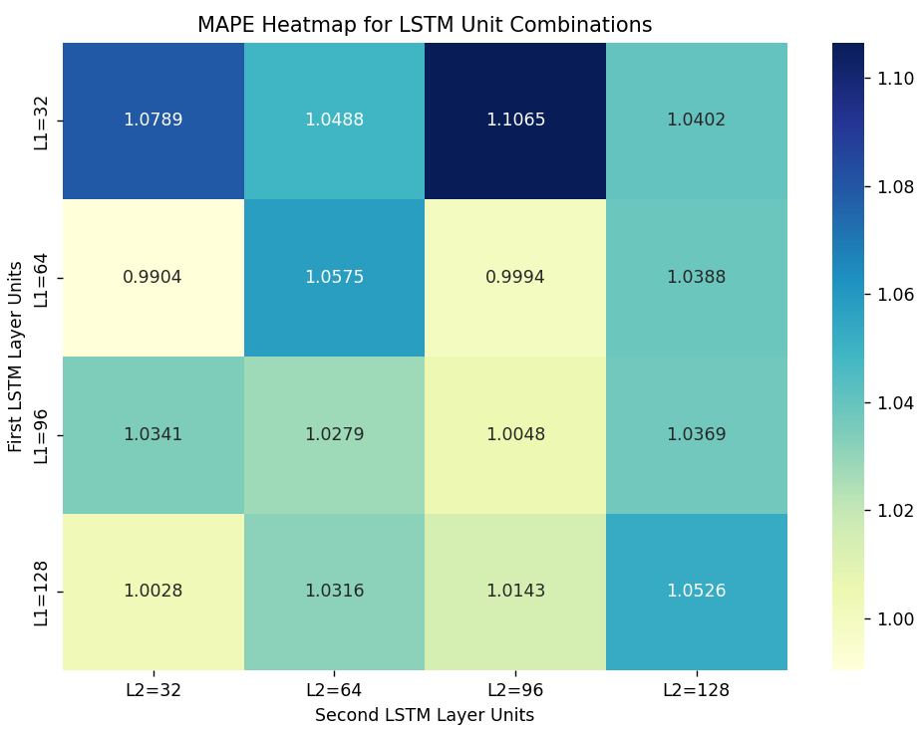
FIGURE 4. MAPE Heatmap for Different LSTM Unit Configurations (Layer1 × Layer2)
These results indicate strong generalization performance and confirm that the model avoids overfitting despite the nonlinear and dynamic nature of the data.
A comparative evaluation of optimization algorithms where Adam, RMSProp, and Nadam are assessed based on forecasting error. The Adam optimizer consistently achieves the lowest MAPE, demonstrating faster convergence and greater stability during training. This behavior aligns with Adam’s adaptive moment estimation mechanism, which combines first- and second-order gradient information.

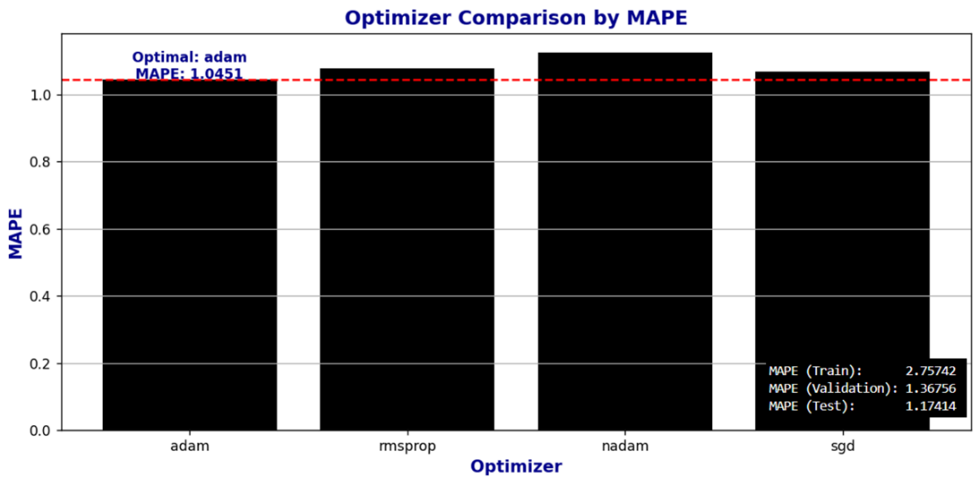
FIGURE 5. Comparison of Optimizer Algorithms Based on MAPE for LSTM Model Performance Evaluation

The final forecasting results demonstrate minimal prediction errors for frequency and voltage, with reported errors of 0.0009 and 0.0173, respectively. The model predicts system behavior over a 500-minute horizon and does not indicate any unstable operating conditions within this interval. When the MAPE exceeds the predefined threshold of 5%, automatic data correction is triggered using Z-score normalization:
$Z=\frac{x-μ}{σ}$ (2)
Values exceeding the threshold are replaced with the median, ensuring robustness and sustained prediction accuracy.

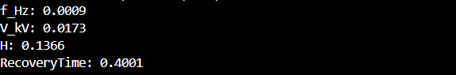
FIGURE 6. Results of the dynamic characteristics model of a power grid integrated with large-scale renewable energy sources.

The results confirm that the LSTM-based framework provides reliable real-time forecasting of dynamic stability parameters and is well suited for intelligent monitoring and preventive control in power systems with high renewable energy penetration.
CONCLUSIONS
The results confirm that data-driven forecasting using Long Short-Term Memory neural networks is an effective tool for real-time assessment of dynamic stability in power systems with a high share of renewable energy sources. The developed LSTM model successfully captures nonlinear temporal dependencies in multivariate time-series data and provides accurate predictions of key stability indicators, including frequency, voltage, inertia, and recovery time. The achieved forecasting accuracy, with Mean Absolute Percentage Error values below 1.2% on test data, demonstrates strong generalization capability and robustness.
Systematic optimization of model hyperparameters and the use of adaptive data preprocessing, including Z-score-based outlier correction, significantly enhance prediction reliability under dynamically changing operating conditions. The forecasting framework enables continuous monitoring and early detection of potentially critical system states, supporting proactive operational decisions. The absence of predicted instability over the analyzed forecasting horizon further confirms the adequacy of the proposed approach. Overall, the LSTM-based methodology represents a practical and efficient solution for intelligent monitoring and predictive stability assessment, contributing to the reliable integration of large-scale renewable energy sources into modern power systems.
REFERENCES
- Rakhmonov, I. U., Ushakov, V. Ya., Niyozov, N. N., & Kurbonov, N. N. (2023). Forecasting electricity consumption using LSTM neural networks. Bulletin of the Tomsk Polytechnic University. Geo Assets Engineering, 334(12), 125–133. https://doi.org/10.18799/24131830/2023/12/4407
- Greff, K., Srivastava, R. K., Koutník, J., Steunebrink, B. R., & Schmidhuber, J. (2017). LSTM: A search space odyssey. IEEE Transactions on Neural Networks and Learning Systems, 28(10), 2222–2232. https://doi.org/10.1109/TNNLS.2016.2582924
- Saleem, M. I., Saha, S., Roy, T. K., & Ghosh, S. K. (2024). Assessment and management of frequency stability in low inertia renewable energy rich power grids. IET Generation, Transmission & Distribution. Early Access. https://doi.org/10.1049/gtd2.13129
- Visser, L. R., Schuurmans, E. M. B., AlSkaif, T. A., Fidder, H. A., & Van Voorden, A. M. (2022). Regulation strategies for mitigating voltage fluctuations induced by photovoltaic solar systems in an urban low-voltage grid. International Journal of Electrical Power & Energy Systems, 137, 107695. https://doi.org/10.1016/j.ijepes.2021.107695
- Niyozov, N. N., Liu, C., & Usmonov, E. G. (2025). An overview of current approaches to evaluating the stability and reliability of power systems with large-scale renewable energy integration. In Proceedings of the Republican Scientific-Technical Conference “Development of Modern Electric Machines and Drives for Green Economy” (pp. 126–128). Tashkent, Uzbekistan.
- Niyozov, N. N., Liu, C., & Usmonov, E. G. (2025). Algorithmic approach to frequency and voltage control for static and dynamic stability analysis in electrical power networks. In Proceedings of the Republican Scientific-Technical Conference “Development of Modern Electric Machines and Drives for Green Economy” (pp. 418–421). Tashkent, Uzbekistan.
- Rakhmonov, I. U., Nematov, L. A., Niyozov, N. N., Reymov, K. M., & Yuldoshev, T. M. (2020). Power consumption management from the positions of the general system theory. Journal of Physics: Conference Series, 1515, 022054. https://doi.org/10.1088/1742-6596/1515/2/022054

