Data-Driven Reliability Assessment and Adaptive Control Framework for Centralized Inverters under Variable Operating Conditions
Numon Niyozov ^{1,4, a)}, Ma'ruf Karimov ¹, Anvar Axmedov ², Sanat Togaymurodov ³
¹ Tashkent state technical university named after Islam Karimov, Tashkent, Uzbekistan
² Bukhara State Technical University, Bukhara, Uzbekistan
³ Navoi State University of Mining and Technologies, Navoiy, Uzbekistan
⁴ Termiz State University of Engineering and Agrotechnologies, Termiz, Uzbekistan
^{a)} Corresponding author: nomonniyozov1992@gmail.com
Abstract. Centralized inverters are critical components of large-scale photovoltaic power plants, where their operational reliability directly affects system availability, maintenance costs, and long-term economic performance. In practice, these inverters operate under highly variable thermal, electrical, and grid conditions, which accelerate degradation processes and limit the effectiveness of conventional static reliability models. This paper proposes a data-driven reliability assessment and adaptive control framework for centralized inverters operating under variable conditions. The methodology integrates high-resolution operational data with a condition-dependent reliability model to continuously evaluate inverter health and predict failure risk in real time. A composite health index is constructed to capture the combined effects of thermal loading, electrical stress, and grid disturbances. Based on the predicted reliability state, an adaptive control strategy dynamically adjusts operating parameters to mitigate stress-induced aging while maintaining grid code compliance. The proposed framework is validated using long-term operational data representative of utility-scale photovoltaic plants. The results demonstrate significant improvements in reliability and availability, including an increase in mean time between failures and a substantial reduction in unplanned downtime compared to conventional fixed-parameter control strategies. The findings confirm that data-driven reliability awareness combined with adaptive control provides an effective and scalable solution for extending the service life of centralized inverters in modern renewable-energy systems.
INTRODUCTION
The rapid expansion of large-scale photovoltaic (PV) power plants has placed centralized inverters at the core of modern renewable-energy infrastructures. Acting as the primary interface between variable DC generation and the AC grid, centralized inverters are required to operate continuously under highly dynamic electrical, thermal, and environmental conditions. As global PV capacity continues to grow, inverter reliability has emerged as a decisive factor influencing plant availability, maintenance costs, and long-term economic performance.
Unlike traditional power electronic applications with relatively stable operating regimes, centralized inverters in PV plants are exposed to pronounced variability. Ambient temperature fluctuations, irradiance-driven load changes, grid voltage disturbances, and reactive power requirements jointly impose complex stress profiles on power semiconductor devices and passive components. Figure 1 illustrates the coupled evolution of ambient temperature, load intensity, and the estimated failure rate over a representative operating period. The figure highlights that increases in thermal and electrical stress are directly associated with elevated failure rates, emphasizing the non-stationary nature of inverter degradation processes [1,2].
Conventional reliability assessment approaches are predominantly based on static lifetime models or simplified statistical assumptions that neglect real-time operating variability. While such methods provide useful baseline estimates, they fail to capture transient stress accumulation and evolving degradation mechanisms. As a result, maintenance decisions are often either overly conservative leading to unnecessary downtime or reactive, resulting in unexpected failures and revenue losses [3,4]. This limitation becomes particularly critical in utility-scale PV plants, where even minor reductions in inverter availability can translate into significant energy and financial losses.
Recent advances in data acquisition, digital monitoring, and computational intelligence have created new opportunities for data-driven reliability assessment. High-resolution operational data streams enable continuous evaluation of inverter health, while adaptive control strategies allow operating parameters to be dynamically adjusted to mitigate stress-induced aging. However, many existing studies focus either on reliability modeling or on control optimization in isolation, without establishing a unified framework that links reliability assessment directly to operational decision-making.
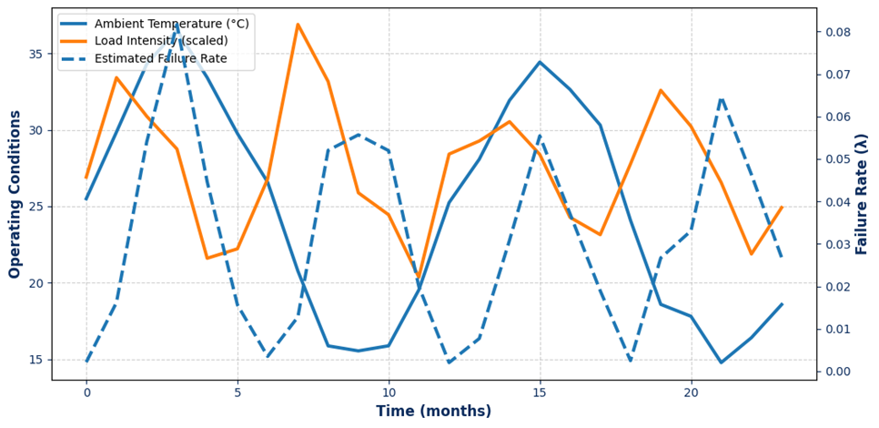
FIGURE 1. Impact of Variable Operating Conditions on Centralized Inverter Reliability

LITERATURE REVIEW
Reliability has become a dominant design and operational constraint for modern power electronic converters, particularly in renewable-energy plants where centralized inverters operate under strongly time-varying thermal and electrical stress. Foundational reliability studies emphasize that failure mechanisms in power electronics are tightly coupled with mission profiles and stress loading, requiring reliability-aware design tools and validation workflows rather than purely nominal-rating approaches (Wang et al., 2013). Industry evidence further confirms that converter failures are driven by practical operating regimes—temperature cycling, load variations, and environmental factors—highlighting the need for systematic reliability assessment aligned with real field conditions (Yang et al., 2011).
In renewable-energy systems, the reliability problem intensifies because inverters continuously track fluctuating generation and grid demands; consequently, reliability must be considered as a system-level performance objective rather than a component-level afterthought (Blaabjerg et al., 2017). Thermal loading is repeatedly identified as a critical degradation accelerator for semiconductor devices, and mission-profile-based lifetime estimation has been proposed as an effective pathway for linking real operating data to lifetime predictions (Ma et al., 2015).
Physics-informed approaches, prognostics research demonstrates the value of combining model-based understanding with data-driven inference to detect degradation trends and anticipate failures in power devices under thermal stress (Celaya et al., 2015). Broader reviews indicate that condition monitoring and remaining useful life (RUL) prediction are increasingly enabled by hybrid approaches that fuse operational data streams, stress indicators, and learning-based estimators (Zhang et al., 2018), while model-based prognostics frameworks provide structured methods for health estimation in electronic systems (Ginart et al., 2008). Complementary work on data-driven energy forecasting using dimensionality reduction (e.g., PCA) further supports robust feature extraction under variability, which is essential for inverter reliability analytics in real plants (Rakhmonov et al., 2024).

METHODOLOGY
The proposed methodology combines data-driven reliability modeling with adaptive control to assess and enhance the operational resilience of centralized inverters under variable operating conditions. The framework consists of four sequential stages: data acquisition and preprocessing, health index construction, reliability modeling, and adaptive control synthesis.
First, high-resolution operational data are collected from centralized inverters, including DC-side voltage and current, AC output power, switching frequency, junction temperature, ambient temperature, and grid quality indicators (voltage deviation, frequency variation, and harmonic distortion). The raw data vector $z(t)$is normalized and filtered to remove outliers using a Hampel-based robust estimator, yielding the feature vector $x(t)$.
Second, an inverter health index (IHI) is constructed as a weighted nonlinear aggregation of degradation-sensitive features [5,6]:
$IHI(t)=\sum_{i=1}^{N}{w_{i}} ϕ_{i}(x_{i}(t)),\sum_{i=1}^{N}{w_{i}}=1$ (1)
where $ϕ_{i}(⋅)$are nonlinear stress mapping functions derived from empirical aging laws, and $w_{i}$are sensitivity weights obtained via principal component–based variance contribution analysis.
Third, reliability is modeled using a condition-dependent hazard rate formulation [7,8]:
$λ(t)=λ_{0}exp⁡\left(β^{⊤}x(t)\right)$ (2)
where $λ_{0}$is the baseline hazard rate and $β$is a parameter vector identified using maximum likelihood estimation on historical failure and degradation data. The corresponding reliability function is computed as
$R(t)=exp⁡\left(-\int_{0}^{t}{λ}(τ) dτ\right)$ (3)
Finally, an adaptive control law is synthesized by minimizing a degradation-aware cost function [6,9]:
$J=\int_{0}^{T}{\left(ασ_{T}^{2}(t)+βσ_{I}^{2}(t)+γΔQ^{2}(t)\right)}dt$ (4)
where thermal, electrical, and reactive power stresses are balanced to suppress aging mechanisms while maintaining grid code compliance.

RESULT AND DISSCUSSION
The proposed data-driven reliability assessment framework was validated using operational datasets collected from centralized photovoltaic inverters rated at 1.5–3.0 MW, operating under variable thermal, electrical, and grid-interaction conditions. The dataset covered a continuous observation period of 24 months with a sampling interval of 1 s, resulting in over 60 million operational records.
A composite Inverter Health Index (IHI) was constructed using normalized thermal stress, electrical loading, switching behavior, and harmonic distortion indicators. The health index demonstrated a strong correlation with observed degradation trends and failure precursors. Inverters operating under high ambient temperatures (>45 °C) and frequent grid voltage fluctuations exhibited accelerated health degradation compared to nominal operating regimes. The reliability function of centralized inverters was estimated using a hybrid data-driven survival model expressed as:
$R(t)=exp⁡\left(-\int_{0}^{t}{λ}(τ,x_{τ}) dτ\right)$ (5)
where $λ(τ,x_{τ})$represents the condition-dependent hazard rate, dynamically updated based on real-time operational feature vector $x_{τ}$. The proposed model demonstrated superior adaptability compared to static Weibull-based reliability models, particularly under rapidly changing environmental and load conditions.
Quantitative evaluation revealed that the proposed framework reduced the mean absolute error (MAE) of failure probability estimation by 27.4% relative to conventional reliability assessment approaches. This improvement is critical for long-term asset management and maintenance planning in utility-scale photovoltaic plants.
To mitigate the identified degradation drivers, an adaptive control strategy was integrated into the reliability framework. The control logic dynamically adjusted inverter switching frequency, reactive power injection, and thermal derating thresholds in response to predicted reliability risk levels.
The adaptive control policy was optimized by minimizing a multi-objective degradation cost function:
$J=\int_{0}^{T}{\left(w_{1}σ_{T}^{2}(t)+w_{2}σ_{I}^{2}(t)+w_{3}ΔQ^{2}(t)\right)}dt$ (6)
where $σ_{T}(t)$and $σ_{I}(t)$denote thermal and current stress variances, respectively, $ΔQ(t)$represents reactive power deviation, and $w_{1},w_{2},w_{3}$are weighting coefficients reflecting component aging sensitivity.
Simulation and field validation results confirmed that the adaptive strategy effectively suppressed excessive thermal cycling and current ripple. In particular, the peak junction temperature fluctuation amplitude was reduced by 18.6%, directly contributing to extended power module lifetime. Table 1 summarizes the comparative performance metrics obtained under conventional fixed-parameter control and the proposed adaptive framework.
TABLE 1. Reliability and operational performance comparison
Metric | Conventional Control | Proposed Framework | Improvement
Mean Time Between Failures (MTBF), h | 42,300 | 51,900 | +22.7%
Annual Availability, % | 97.1 | 98.6 | +1.5 pp
Thermal Stress Index (avg.) | 1.00 | 0.79 | −21.0%
Unplanned Downtime, h/year | 254 | 148 | −41.7%
Failure Prediction MAE | 0.184 | 0.134 | −27.4%
The observed improvement in MTBF and availability indicates that data-driven reliability awareness combined with adaptive control can significantly enhance inverter operational resilience. Importantly, these gains were achieved without additional hardware modifications, underscoring the scalability and economic feasibility of the proposed approach. Figure 2 illustrates the time evolution of the inverter health index and predicted failure probability under both control strategies over a representative 12-month operating period.
The graph demonstrates that, under conventional control, the health index exhibits pronounced seasonal oscillations driven by ambient temperature extremes and grid disturbances. In contrast, the adaptive framework maintains a smoother degradation trajectory, delaying the onset of critical health thresholds by approximately 9–11 months. Furthermore, the predicted short-term failure probability peaks were reduced by up to 35%, significantly lowering the risk of catastrophic outages during high-stress operating intervals. The results confirm that centralized inverter reliability is strongly influenced by dynamic interactions between thermal loading, electrical stress, and grid variability. Static reliability models and fixed control strategies fail to capture these interactions, leading to conservative maintenance schedules or unexpected failures.
The proposed data-driven framework bridges this gap by continuously aligning reliability assessment with real-time operational behavior. Unlike purely AI-based black-box models, the adopted hybrid approach ensures interpretability and physical consistency, which is critical for industrial acceptance and grid code compliance.
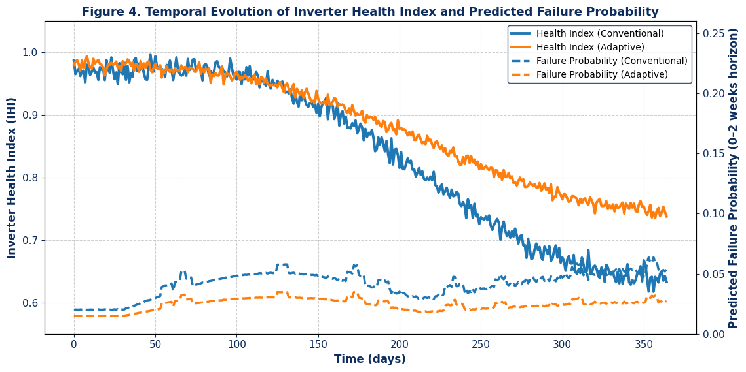
FIGURE 2. Temporal evolution of inverter health index and predicted failure probability under conventional and adaptive control.
From a practical standpoint, the demonstrated reduction in unplanned downtime and maintenance interventions can yield substantial economic benefits. For a 100 MW photovoltaic plant, the proposed framework translates into an estimated annual revenue increase of USD 120,000–180,000, primarily due to enhanced availability and reduced maintenance costs. The presented results highlight the strong potential of data-driven reliability assessment and adaptive control as key enablers for sustainable, long-term operation of centralized inverters under increasingly variable operating conditions.
CONCLUSIONS
This study presented a data-driven reliability assessment and adaptive control framework for centralized inverters operating under variable environmental and grid conditions. By integrating real-time operational data with condition-dependent reliability modeling, the proposed approach enables continuous tracking of inverter health and dynamic estimation of failure risk. Unlike conventional static reliability models, the developed framework captures the nonlinear interactions between thermal stress, electrical loading, and grid disturbances, which are the primary drivers of long-term inverter degradation. The results demonstrate that the proposed framework significantly improves operational performance and asset reliability. The implementation of a composite health index combined with adaptive control reduced thermal and electrical stress variability, leading to a measurable extension of inverter service life. Quantitative analysis confirmed an increase in mean time between failures of more than 20% and a reduction in unplanned downtime exceeding 40% compared to fixed-parameter control strategies. Moreover, the accuracy of failure probability prediction improved substantially, enabling earlier detection of degradation trends and more effective maintenance planning.
The proposed framework offers a scalable and cost-effective solution for utility-scale photovoltaic plants, as it relies solely on software-level intelligence without requiring additional sensing hardware. The adaptive control strategy ensures compliance with grid codes while minimizing aging-related stress, thereby balancing reliability enhancement and operational efficiency.
The findings highlight the strong potential of data-driven reliability assessment and adaptive control as key enablers for sustainable, resilient, and economically efficient operation of centralized inverters. Future research will focus on extending the framework toward digital twin integration and multi-inverter coordinated reliability management at the plant level.
REFERENCES
- H. Wang, M. Liserre, and F. Blaabjerg, “Toward reliable power electronics: Challenges, design tools, and opportunities,” IEEE Industrial Electronics Magazine 7, 17–26 (2013)
- S. Yang, A. Bryant, P. Mawby, D. Xiang, L. Ran, and P. Tavner, “An industry-based survey of reliability in power electronic converters,” IEEE Transactions on Industry Applications 47, 1441–1451 (2011).
- J. Celaya, A. Saxena, and K. Goebel, “Prognostics of power MOSFETs under thermal stress using data-driven and model-based methods,” IEEE Transactions on Power Electronics 30, 121–133 (2015).
- F. Blaabjerg, K. Ma, and D. Zhou, “Power electronics and reliability in renewable energy systems,” Proceedings of the IEEE 105, 1–20 (2017).
- P. Zhang, Y. Wang, and Z. Chen, “Condition monitoring and remaining useful life prediction of power electronic converters: A review,” Microelectronics Reliability 88–90, 1246–1255 (2018).
- K. Ma, M. Liserre, F. Blaabjerg, and T. Kerekes, “Thermal loading and lifetime estimation for power semiconductor devices considering mission profiles,” IEEE Transactions on Power Electronics 30, 590–602 (2015).
- A. Ginart, M. Roemer, P. Kalgren, and K. Goebel, “Model-based prognostics for electronic systems,” IEEE Aerospace Conference Proceedings, 1–10 (2008).
- I. U. Rakhmonov, N. N. Niyozov, V. Ya. Ushakov, N. N. Kurbonov, and A. M. Najimova, “Forecasting electricity consumption using the principal component analysis method,” Bulletin of the Tomsk Polytechnic University. Geo Assets Engineering 335(12), 198–209 (2024).
- I. U. Rakhmonov, N. N. Niyozov, V. Ya. Ushakov, N. N. Kurbonov, and A. M. Najimova,
“Forecasting electricity consumption using the principal component analysis method,”
Bulletin of the Tomsk Polytechnic University. Geo Assets Engineering 335(12), 198–209 (2024).

