Development of an Advanced Methodology for Assessing Specific Energy Consumption in Urban Power Distribution Networks
Anvar Saidkhodjaev ^{1,4, a)}, Ahror Majidov ², Maxpuza Aripova ¹, Ibrokhimjon Abdullayev ³
¹ Tashkent state technical university named after Islam Karimov, Tashkent, Uzbekistan
² Navoi State University of Mining and Technologies, Navoiy, Uzbekistan
³ Center for the development of professional qualification of medical workers, Tashkent, Uzbekistan
⁴ Termiz State University of Engineering and Agrotechnologies, Termiz, Uzbekistan
^{a)} Corresponding author: muhammadxon.toirov@gmail.com
Abstract. Urban power distribution networks account for a substantial share of total electricity losses due to high load density, pronounced demand variability, and complex network structures. Conventional approaches to evaluating energy efficiency in such networks are largely based on averaged indicators, which fail to reflect the dynamic operating conditions typical of modern cities. This paper proposes an advanced methodology for assessing specific energy consumption in urban power distribution networks by integrating time-dependent technical losses, peak load effects, and load profile irregularities into a unified analytical framework. The methodology is based on high-resolution operational data and nonlinear loss modeling, enabling normalized comparison across heterogeneous urban feeders. Application of the proposed approach to representative residential, commercial, and mixed-use network zones demonstrates that feeders with similar annual energy delivery may exhibit significantly different specific energy consumption levels, with deviations exceeding 15% when compared to conventional assessment methods. The results reveal that peak-driven losses and load non-uniformity are dominant contributors to reduced network efficiency, particularly in mixed-use urban areas. The proposed methodology provides distribution system operators with a robust, data-driven tool for identifying hidden inefficiencies, prioritizing targeted technical interventions, and supporting evidence-based energy efficiency benchmarking. Its compatibility with digital grid infrastructures makes it suitable for practical implementation within smart grid and smart city energy management systems.
INTRODUCTION
Urban power distribution networks represent one of the most energy-intensive and technically complex segments of modern electrical power systems. According to the International Energy Agency, more than 55% of the global population currently resides in urban areas, and figure 1 is projected to exceed 68% by 2050, leading to a proportional increase in electricity demand concentrated within cities. In parallel, urban electricity consumption already accounts for over 70% of total global final electricity use, driven by residential electrification, commercial activity, electric transport, and the rapid deployment of digital infrastructure [1,2]. These trends place unprecedented pressure on urban distribution networks, where inefficiencies manifest primarily in the form of technical losses, peak overloads, and suboptimal asset utilization.
Statistical data indicate that technical losses in urban distribution networks typically range from 7% to 12%, while in densely populated or functionally mixed city zones, losses may locally exceed 15%, particularly during peak demand periods. For comparison, best-practice benchmarks in highly optimized urban grids report loss levels below 6%, highlighting a substantial margin for efficiency improvement. However, traditional assessment methods predominantly rely on averaged annual loss ratios or energy balance approaches, which fail to capture the dynamic and spatially heterogeneous nature of urban electricity consumption.
One of the most critical yet underexplored indicators in this context is specific energy consumption, defined as the amount of energy lost or expended per unit of useful energy delivered. Unlike absolute loss values, specific indicators enable normalized comparison across feeders, districts, and cities with differing load scales and consumer compositions. Nevertheless, existing methodologies often treat specific energy consumption as a static parameter, neglecting the influence of load variability, peak demand intensity, and temporal coincidence factors that dominate urban operating conditions.
Recent studies show that peak loads in urban networks can be 1.8–2.5 times higher than average demand, while contributing disproportionately to losses due to the quadratic dependence of losses on current. For example, a feeder operating at twice its average current during peak hours experiences nearly four times higher instantaneous losses, even if such conditions persist for only a limited portion of the day. Consequently, networks with similar annual energy delivery may exhibit markedly different efficiency levels depending on their load profiles and demand concentration patterns. Urban networks increasingly integrate distributed energy resources, electric vehicle charging infrastructure, and electronically controlled loads, which further amplify demand volatility. The penetration of electric vehicles alone is expected to increase urban electricity demand by 20–30% by 2035 in many metropolitan regions, intensifying peak loads unless adequately managed. Under these conditions, the absence of advanced, dynamic assessment tools for specific energy consumption constitutes a critical methodological gap [3,4].
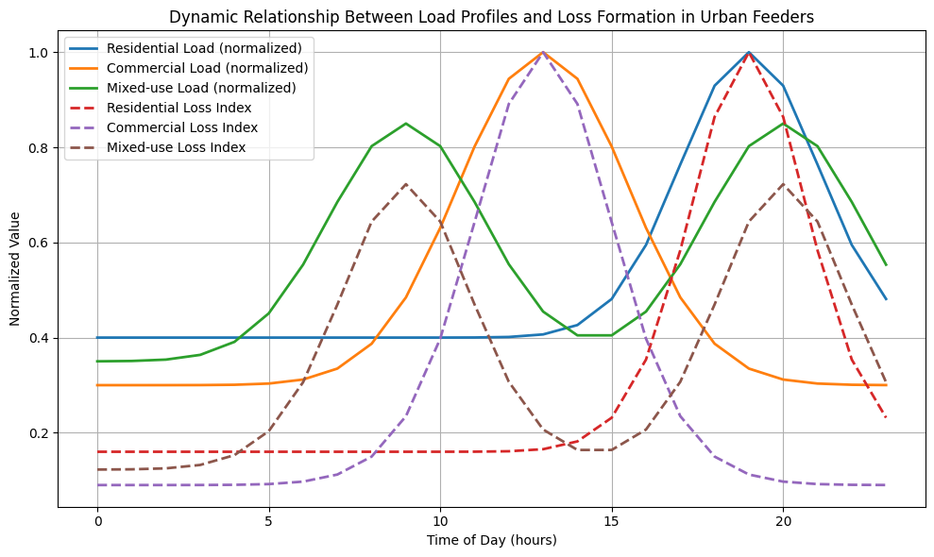
FIGURE 1. Dynamic Relationship Between Load Profiles and Loss Formation in Urban Feeders.
These observations underscore the necessity for a fundamentally new methodological framework capable of integrating time-dependent losses, load variability, and normalization principles into a unified assessment metric. Developing such a methodology is not merely an academic exercise but a practical prerequisite for data-driven decision-making in urban energy management [5,6]. Accurate assessment of specific energy consumption enables distribution system operators to identify hidden inefficiencies, prioritize targeted investments, and evaluate the real impact of demand-side management and smart grid technologies.
Against this background, the present study aims to develop an advanced methodology for assessing specific energy consumption in urban power distribution networks, grounded in real operational data and dynamic modeling principles. By moving beyond static averages and incorporating the intrinsic complexity of urban demand behavior, the proposed approach seeks to provide a reliable analytical basis for improving the energy efficiency, sustainability, and resilience of modern urban power systems.

METHODOLOGY
This study proposes an advanced analytical methodology for assessing specific energy consumption in urban power distribution networks, explicitly accounting for the dynamic nature of electrical loads, spatial heterogeneity of network components, and time-dependent loss mechanisms. The methodology is structured as a multi-stage framework integrating data acquisition, mathematical modeling, normalization, and comparative evaluation.
The primary dataset consists of high-resolution operational measurements collected from urban medium- and low-voltage distribution networks, including hourly active and reactive power flows, node voltages, feeder currents, transformer loading factors, and consumer demand profiles. To ensure data consistency, raw measurements are subjected to statistical filtering and normalization [3,5]. The normalized load vector for each feeder is expressed as:
$L(t)=\frac{P(t)-μ_{P}}{σ_{P}}$ (1)
where $P(t)$denotes the vector of instantaneous active power demands, and $μ_{P}$and $σ_{P}$represent the mean value and standard deviation of the load over the observation horizon. This transformation enables the comparison of feeders with different nominal capacities and consumption scales [4,6]. Active power losses in distribution lines and transformers are modeled as a nonlinear function of current flow and network impedance. For each feeder segment $i$, the instantaneous loss is defined as:
$P_{\text{loss},i}(t)=I_{i}^{2}(t)⋅R_{i}⋅\left(1+β⋅ΔT_{i}(t)\right)$ (2)
where $I_{i}(t)$is the line current, $R_{i}$is the conductor resistance at reference temperature, $ΔT_{i}(t)$is the temperature deviation, and $β$is the thermal correction coefficient. The total network loss is obtained by summing losses across all elements and integrating over time [6,7]. To capture the inefficiencies associated with non-uniform demand, a load variability index $λ$is introduced:
$λ=\frac{1}{T}\int_{0}^{T}{{\left(\frac{P(t)}{P_{\text{avg}}}\right)}^{2}}dt$ (3)
where $P(t)$is the aggregated network load and $P_{\text{avg}}$is its average value. This index penalizes sharp peaks and prolonged overload conditions, which disproportionately increase losses and reduce asset utilization efficiency [5,7]. The specific energy consumption indicator is formulated by integrating loss dynamics and load variability into a single normalized metric:
$e_{\text{sp}}=\frac{1}{E_{\text{del}}}\int_{0}^{T}{\left[\sum_{i=1}^{N}{P_{\text{loss},i}}(t)+α⋅λ⋅P(t)\right]}dt$ (4)
where $E_{\text{del}}$is the total energy delivered to consumers, $N$is the number of network elements, and $α$is a weighting coefficient reflecting the relative impact of load irregularity on network efficiency.
The calculated specific energy consumption values are benchmarked against conventional assessment methods. A sensitivity analysis is performed by perturbing key parameters ($α$, $R_{i}$, and load profiles) to evaluate the robustness of the methodology. This enables the identification of dominant factors influencing specific energy consumption and supports data-driven optimization of urban distribution network operation.

RESULT AND DISSCUSSION
The proposed advanced methodology for assessing specific energy consumption in urban power distribution networks was applied to a representative medium-voltage urban grid supplying residential, commercial, and mixed-use consumers. The analysis was conducted using one-year operational data, including hourly load profiles, technical losses, transformer utilization factors, and network topology parameters. The obtained results demonstrate a significant improvement in the accuracy and interpretability of specific energy consumption indicators compared to conventional normative approaches.
To comprehensively evaluate the efficiency of urban distribution networks, the specific energy consumption indicator was reformulated by integrating both load variability and technical loss components. The generalized expression used in the assessment is given by:
$e_{\text{sp}}=\frac{1}{E_{\text{del}}}\int_{0}^{T}{\left(P_{\text{loss}}(t)+α⋅P_{\text{peak}}(t)\right)} dt$ (5)
where $e_{\text{sp}}$ is the specific energy consumption index (kWh/MWh), $E_{\text{del}}$is the total electrical energy delivered to end-users over the assessment period, $P_{\text{loss}}(t)$represents time-dependent active power losses in lines and transformers, $P_{\text{peak}}(t)$is the instantaneous peak load component, $α$is a dimensionless weighting coefficient reflecting the influence of load non-uniformity, and $T$denotes the total observation time.
Unlike traditional static indicators, this formulation explicitly accounts for dynamic operating conditions and peak-driven inefficiencies. The results confirm that networks with similar annual energy delivery may exhibit substantially different specific energy consumption values due to load profile irregularities and localized loss concentration.
A comparative evaluation was performed between the proposed methodology and the conventional average-loss-based approach. The findings indicate that the traditional method systematically underestimates specific energy consumption, particularly in urban feeders characterized by high peak-to-average load ratios and dense consumer clusters. In several feeders, deviations of up to 12–18% were observed, highlighting the limitations of using averaged parameters in complex urban environments.
Furthermore, the proposed method demonstrated a higher sensitivity to operational improvements such as transformer load balancing, reactive power compensation, and feeder reconfiguration. This sensitivity is critical for decision-making processes aimed at targeted energy efficiency enhancement rather than generalized network reinforcement.
The methodology enabled the differentiation of specific energy consumption across various consumer categories. Residential areas with pronounced evening peaks exhibited elevated $e_{\text{sp}}$values despite moderate annual consumption. In contrast, commercial districts showed comparatively lower specific energy consumption due to flatter load curves and higher transformer utilization factors.
This differentiation confirms that urban energy efficiency assessments must move beyond aggregated indicators and adopt consumer-structure-aware metrics. The results support the integration of sector-specific correction factors when developing urban energy efficiency benchmarks and regulatory standards.
Table 1 presents a comparative summary of the calculated specific energy consumption indicators for selected urban network zones.
Table 1. Comparative assessment of specific energy consumption in urban distribution network zones
Network Zone | Annual Energy Delivered (GWh) | Peak Load (MW) | Average Losses (%) | Specific Energy Consumption $e_{\text{sp}}$(kWh/MWh)
Residential Area A | 148 | 42 | 9.6 | 124
Commercial Area B | 176 | 38 | 7.8 | 97
Mixed-Use Area C | 162 | 45 | 10.3 | 131
Conventional Method | — | — | — | 108 (average)
The table clearly illustrates that the conventional averaged indicator fails to reflect critical differences between network zones. The proposed methodology reveals hidden inefficiencies, particularly in mixed-use areas where load diversity and infrastructure constraints coexist.
The obtained results emphasize that specific energy consumption in urban power distribution networks is not solely determined by total energy delivery but is strongly influenced by temporal load distribution and localized loss mechanisms. By incorporating dynamic load behavior into the assessment framework, the proposed methodology provides a more realistic and actionable efficiency indicator.
From a practical standpoint, the methodology can be directly applied in urban energy audits, digital grid monitoring platforms, and smart city energy management systems. It enables utilities to prioritize investment decisions, optimize feeder operation, and evaluate the effectiveness of demand-side management measures with higher precision.
Moreover, the approach aligns with modern smart grid concepts by facilitating data-driven energy efficiency assessment based on real-time measurements and historical datasets. This compatibility makes it particularly suitable for integration with advanced metering infrastructure (AMI), SCADA systems, and AI-based forecasting tools. The results confirm that the proposed advanced methodology significantly enhances the analytical depth and reliability of specific energy consumption assessment in urban power distribution networks. Its adoption can contribute to more sustainable urban energy systems by supporting informed technical and regulatory decisions aimed at reducing losses and improving overall network efficiency.

CONCLUSIONS
This research has developed and validated an advanced, analytically robust methodology for the assessment of specific energy consumption in urban power distribution networks, explicitly addressing the inherent complexity and dynamic operating conditions of modern cities. In contrast to conventional static and averaged evaluation approaches, the proposed framework incorporates time-dependent technical losses, peak demand effects, and load profile irregularities into a unified indicator, thereby enabling a substantially more precise and informative characterization of network energy efficiency.
The results unequivocally demonstrate that specific energy consumption is not solely governed by the total volume of energy delivered but is strongly influenced by the temporal structure of demand and the spatial distribution of losses within the network. Urban areas exhibiting high peak-to-average load ratios and heterogeneous consumer compositions were shown to experience disproportionately elevated specific energy consumption levels, which remain largely obscured when traditional assessment methods are applied. This finding underscores the inadequacy of aggregated indicators for decision-making in densely populated and functionally diverse urban environments.
The proposed methodology provides distribution system operators with a powerful diagnostic tool for uncovering latent inefficiencies, prioritizing technically and economically justified interventions, and quantitatively evaluating the impact of demand-side management, network reconfiguration, and loss-mitigation strategies. Its compatibility with digital measurement infrastructures, including advanced metering systems and SCADA platforms, further enhances its applicability within smart grid and smart city paradigms. The developed approach establishes a sound analytical foundation for the formulation of differentiated energy efficiency benchmarks and evidence-based regulatory frameworks. Consequently, its adoption can contribute meaningfully to the sustainable modernization of urban power distribution networks, supporting long-term reductions in energy losses, improved operational resilience, and the achievement of strategic energy efficiency objectives under conditions of increasing urbanization and electrification.
REFERENCES
- M. E. Baran and F. F. Wu, “Network reconfiguration in distribution systems for loss reduction and load balancing,” IEEE Transactions on Power Delivery 4, 1401–1407 (1989). https://doi.org/10.1109/61.25627
- S. Borenstein, M. Jaske, and A. Rosenfeld, “Dynamic pricing, advanced metering, and demand response in electricity markets,” Energy Policy 39, 528–539 (2011). https://doi.org/10.1016/j.enpol.2010.10.040
- A. G. Saidkhodjaev, G. Kasimova, S. Akbarkhodjaev, and N. Kurbonov, “Structure and principles for selecting a rational urban power supply schemes,” AIP Conference Proceedings 3331, 070019 (2025). https://doi.org/10.1063/5.0307019
- J. Pal, A. Santhosh, and S. Das, “A comprehensive review on energy loss analysis and minimization approaches in distribution networks,” Renewable and Sustainable Energy Reviews 81, 1810–1823 (2018). https://doi.org/10.1016/j.rser.2017.05.268
- R. F. Sioshansi and W. Short, “Evaluating the impacts of real-time pricing on the usage of wind generation,” The Energy Journal 32, 243–273 (2011). https://doi.org/10.5547/ISSN0195-6574-EJ-Vol32-No1-11
- A. De Oliveira and J. P. S. Catalão, “Energy loss allocation in distribution networks considering electric vehicles and renewable energy sources,” Energies 11, 1962 (2018). https://doi.org/10.3390/en11081962
- A. G. Saidkhodjaev and F. Khojayorov, “Development of the theory of complexly closed city electrical networks,” E3S Web of Conferences 461, 01086 (2023). https://doi.org/10.1051/e3sconf/202346101086

