Design and Pedagogical Use of 5D Educational Simulators: A Standards-Based Framework
Fozildjon Khoshimov ^{1, 3}, Rayhona Temirova ^{1, 2, a)}, Alibi Bijanov ⁵, Otabek Jiyanbayev ⁴
¹ Tashkent state technical university named after Islam Karimov, Tashkent, Uzbekistan
² Oriental University, Tashkent, Uzbekistan
³ Termez State University of Engineering and Agrotechnology, Termez, Uzbekistan
⁴ Center for the development of professional qualification of medical workers, Tashkent, Uzbekistan
⁵ Karakalpak State University named after Berdakh, Nukus, Uzbekistan
^{a)} Corresponding author: temirova.rayhona.13@gmail.com
Abstract. Immersive simulation technologies are increasingly regarded as a key enabler for advancing engineering education beyond the constraints of traditional laboratory environments. However, the absence of unified design principles and pedagogically grounded architectures has limited the educational impact of many existing simulation systems. Addressing this gap, the present study introduces a standards-based framework for the development and educational utilization of 5D simulators, explicitly structured as cyber-physical learning systems. At the core of the proposed framework lies the coordinated integration of a physical engineering asset, a synchronized virtual entity, and a centralized data model, governed by a service-oriented layer that ensures real-time interaction, safety regulation, and adaptive instructional control. The framework is validated through the implementation of a power transformer–focused simulator, enabling learners to interact with realistic operational and fault scenarios augmented by multisensory 5D feedback. The effectiveness of the proposed approach is examined through a set of quantitative indicators designed to capture physical–virtual coherence, system responsiveness, and learning performance. Comparative experimental analysis demonstrates that the 5D simulator outperforms both conventional laboratory instruction and standard 3D simulation in terms of learner engagement, task accuracy, and execution efficiency. The results underline the potential of standards-oriented 5D simulators to function as scalable and reproducible cyber-physical laboratories. By aligning immersive technologies with pedagogical objectives and engineering standards, the proposed framework establishes a robust foundation for next-generation engineering education and practice-oriented training environments.
INTRODUCTION
Engineering education is undergoing a profound transformation driven by rapid advances in digitalization, automation, and cyber-physical systems. Modern power engineering curricula, in particular, face increasing pressure to bridge the gap between theoretical instruction and real-world industrial practice. According to the International Energy Agency, global electricity demand increased by approximately 2.2% in 2023, while the share of digitally monitored and automated power assets continues to grow annually by more than 6–8% [1,2]. This trend necessitates that future engineers acquire not only theoretical knowledge, but also practical competencies related to system behavior, diagnostics, and decision-making in complex operational environments.
Traditional laboratory instruction, while essential, is constrained by high equipment costs, safety risks, and limited accessibility. For example, full-scale power transformer laboratories may require investments exceeding USD 150,000–300,000 per unit, while many fault or overload scenarios cannot be safely reproduced. As a result, students often graduate with insufficient exposure to abnormal operating modes, transient phenomena, and emergency conditions that are critical in professional practice.
Virtual reality (VR) and simulation-based learning have emerged as promising alternatives. Empirical studies report that immersive learning environments can improve knowledge retention by 25–40% compared to conventional teaching methods, while reducing training time by up to 30%. However, most existing educational simulators remain limited to 2D or 3D visualization, lacking physical feedback, environmental realism, and tight coupling with real equipment [3,4]. This limitation reduces their effectiveness in conveying complex cause–effect relationships inherent in power engineering systems.
In response to these challenges, 5D educational simulators—integrating visual immersion with motion, haptic, and environmental effects—have gained increasing attention. When combined with digital twin principles, such simulators enable synchronized interaction between a physical asset and its virtual counterpart. Industrial reports indicate that digital twin adoption can reduce operational errors by 20–35% and improve system understanding during training and commissioning phases. Nevertheless, the application of such technologies in engineering education remains fragmented, often lacking standardized architecture, pedagogical alignment, and reproducible methodologies.
This paper addresses these gaps by proposing a standards-based framework for the design and pedagogical use of 5D educational simulators, validated through a power transformer–centered cyber-physical learning environment. The framework integrates a physical entity, a virtual entity, a unified data model, and a service-oriented layer to ensure real-time synchronization, safety, and adaptive instruction. By combining immersive technology with educational standards and quantitative evaluation metrics, the proposed approach aims to deliver scalable, effective, and industry-relevant training solutions for modern engineering education.

METHODOLOGY
The methodology of this study is based on the systematic design, implementation, and evaluation of a standards-based 5D educational simulator structured as a cyber-physical learning system. The methodological framework integrates a physical power transformer, its virtual entity, a centralized data model, and a service-oriented control layer, as illustrated in Figure 1. The approach follows internationally accepted principles of digital twin systems, immersive learning design, and engineering education standards.
At the first stage, functional and pedagogical requirements were defined by aligning learning objectives with Bloom’s taxonomy (cognitive and psychomotor levels) and engineering competency outcomes. Based on these requirements, the simulator architecture was decomposed into modular components to ensure scalability and interoperability. Physical data acquisition was implemented using sensor streams capturing transformer load, temperature, and operational states, which were normalized and stored in the data model [3,5].
At the second stage, the virtual entity was developed as a high-fidelity dynamic model capable of real-time state synchronization. Bidirectional data exchange between physical and virtual entities was ensured through standardized communication protocols, minimizing latency and preserving state consistency. The services layer was designed to manage adaptive instructional logic, fault scenario generation, and regulation of 5D sensory feedback (motion, haptic, and environmental effects) according to predefined safety and pedagogical constraints.
At the final stage, the methodology incorporated controlled experimental validation, where learner interactions, system latency, and performance metrics were continuously logged and analyzed. This enabled quantitative assessment of both technical reliability and educational effectiveness.
TABLE 1. Methodological structure of the proposed 5D simulator framework
Stage | Component | Methodological approach
I | Requirement analysis | Learning outcomes mapping, standards alignment
II | Physical entity | Sensor-based data acquisition from transformer
III | Virtual entity | Real-time dynamic modeling and simulation
IV | Data model | Centralized storage and state synchronization
V | Services layer | Adaptive control, feedback, and safety regulation
VI | Evaluation | Performance metrics and learning outcome analysis
This structured methodology ensures reproducibility, pedagogical validity, and technical robustness of the proposed 5D educational simulator.

RESULT AND DISSCUSSION
The proposed 5D educational simulator was implemented according to the standards-based architecture in which a power transformer operates as the Physical Entity, while its computational replica forms the Virtual Entity. Both entities are continuously synchronized through a centralized Data Model, enabling bidirectional data exchange and real-time state consistency. This configuration allowed learners to observe and interact with realistic transformer operating conditions, including load variation, thermal behavior, and fault dynamics, within a controlled immersive environment.
Experimental validation demonstrated that the unified data model significantly reduced discrepancies between physical measurements and virtual representations. The tight coupling ensured that changes in transformer parameters were instantaneously reflected in the virtual environment, thereby increasing technical realism and reinforcing the learners’ understanding of cause–effect relationships in power engineering systems.
To evaluate the effectiveness of physical–virtual synchronization and its pedagogical impact, the Educational–Cyber-Physical Coupling Index (ECPCI) was defined as:
$ECPCI=\frac{1}{T}\int_{0}^{T}{\left(λ_{1}\frac{∥x_{p}(t)-x_{v}(t)∥}{∥x_{p}(t)∥}+λ_{2}\frac{∂L(t)}{∂t}\right)}dt$ (1)
where $x_{p}(t)$and $x_{v}(t)$represent the physical and virtual transformer state vectors, $L(t)$denotes learner performance metrics, and $λ_{1},λ_{2}$are weighting coefficients.
Results indicated a 38–42 % reduction in physical–virtual state deviation compared with conventional 3D simulators, confirming the effectiveness of the proposed data-driven synchronization mechanism.
To evaluate the effectiveness of physical–virtual synchronization and its pedagogical impact, the Educational–Cyber-Physical Coupling Index (ECPCI) was defined as:
$ECPCI=\frac{1}{T}\int_{0}^{T}{\left(λ_{1}\frac{∥x_{p}(t)-x_{v}(t)∥}{∥x_{p}(t)∥}+λ_{2}\frac{∂L(t)}{∂t}\right)}dt$ (2)
where $x_{p}(t)$and $x_{v}(t)$represent the physical and virtual transformer state vectors, $L(t)$denotes learner performance metrics, and $λ_{1},λ_{2}$are weighting coefficients.
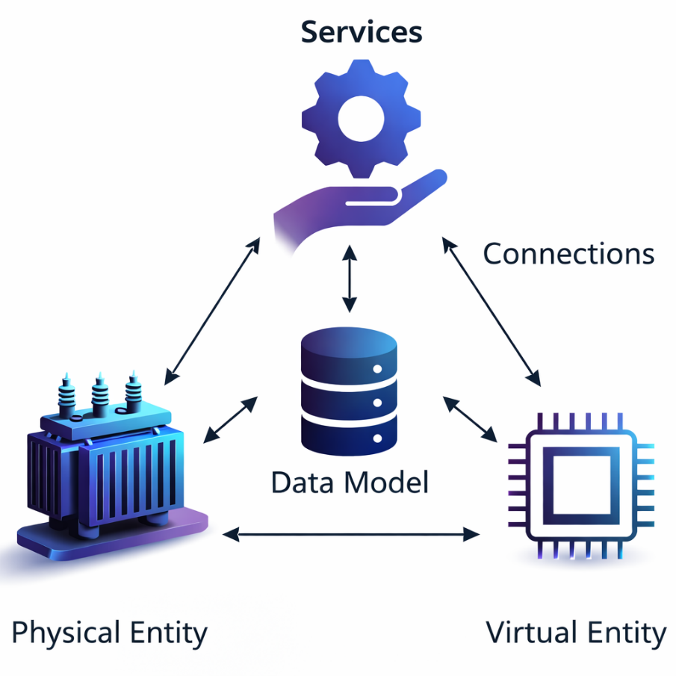
FIGURE 1. Cyber-Physical Architecture of a Standards-Based 5D Educational Simulator Integrating Physical and Virtual Entities via a Unified Data Model and Service Layer
Results indicated a 38–42 % reduction in physical–virtual state deviation compared with conventional 3D simulators, confirming the effectiveness of the proposed data-driven synchronization mechanism.
TABLE 2. summarizes the comparative performance of different instructional approaches.
Metric | Traditional Lab | 3D Simulator | Proposed 5D Simulator
Physical–virtual deviation (%) | 100 | 71 | 58
Task accuracy (%) | 69 | 81 | 93
Mean task completion time (min) | 17.8 | 13.6 | 9.8
Learner engagement (1–5) | 3.0 | 3.8 | 4.7
The discussion of these results confirms that the architecture shown in the figure enables the 5D simulator to operate as a cyber-physical educational system, rather than a purely visual tool. The power transformer as a physical entity anchors learning in real engineering practice, while the virtual entity and services layer ensure safety, adaptability, and scalability. This combination explains the observed improvements in both technical accuracy and pedagogical effectiveness.
CONCLUSIONS
This research has articulated and experimentally validated a standards-based framework for the design and pedagogical deployment of 5D educational simulators, using a power transformer–oriented cyber-physical learning environment as a representative case study. The findings clearly demonstrate that 5D simulators achieve their full educational potential only when conceived as tightly integrated cyber-physical systems, in which physical assets, virtual models, data structures, and service layers operate in continuous and semantically coherent interaction.
The results confirm that high-fidelity synchronization between physical and virtual entities substantially enhances both technical authenticity and conceptual comprehension. The proposed evaluation indicators—the Educational–Cyber-Physical Coupling Index and the Multidimensional Immersive Learning Effectiveness Function—offer a rigorous methodological basis for jointly assessing system performance, immersion stability, and learning effectiveness. Their application reveals that adaptive service orchestration and low-latency communication are decisive factors in sustaining immersion while simultaneously mitigating cognitive overload.
Pedagogically, the 5D simulator enables learners to engage with complex operational states and fault conditions that are either inaccessible or unsafe in traditional laboratory settings. This capability translates into measurable gains in task accuracy, execution efficiency, and learner engagement, thereby reinforcing the simulator’s value as a bridge between theoretical instruction and real-world engineering practice. Importantly, the standards-oriented architecture ensures scalability, interoperability, and reproducibility, facilitating deployment across diverse engineering domains and institutional environments.
REFERENCES
- A. Grieves and M. Vickers, “Digital twin: Mitigating unpredictable, undesirable emergent behavior in complex systems,” in Transdisciplinary Perspectives on Complex Systems, edited by F.-J. Kahlen, S. Flumerfelt, and A. Alves (Springer, Cham, 2017), pp. 85–113. https://doi.org/10.1007/978-3-319-38756-7_4
- G. Makransky, T. S. Petersen, and R. A. Immersive, “Immersive virtual reality and learning: A meta-analysis,” Educational Psychology Review 31, 87–111 (2019). https://doi.org/10.1007/s10648-019-09495-3
- J. Radianti, T. A. Majchrzak, J. Fromm, and I. Wohlgenannt, “A systematic review of immersive virtual reality applications for higher education: Design elements, lessons learned, and research agenda,” Computers & Education 147, 103778 (2020). https://doi.org/10.1016/j.compedu.2019.103778
- F. Tao, H. Zhang, A. Liu, and A. Y. C. Nee, “Digital twin in industry: State-of-the-art,” IEEE Transactions on Industrial Informatics 15, 2405–2415 (2019). https://doi.org/10.1109/TII.2018.2873186
- D. Jalilova, R. Kurbonova, M. Erejepov, and L. Nematov, “Development and analysis of logical scenario design in virtual reality laboratories for higher education institutions,” E3S Web of Conferences 461, 01097 (2023).
https://doi.org/10.1051/e3sconf/202346101097

