Automatic cooling systems ensuring the reliable operation of transformers
Olimjon Toirov, Shavkatjon Xudoberdiyev ^{a)}
Tashkent State Technical University named after Islam Karimov, Tashkent, Uzbekistan
^{a)} Corresponding author: shavkatjonxudoberdiev@gmail.com
Abstract. The article investigates a protective device designed to prevent short-circuit, fire, and explosion incidents that may arise in high-power transformer substations used in electric power transmission networks under severe operating conditions. The implementation of an automatic cooling system aimed at protecting transformers from fire and explosion makes it possible to reduce energy losses in the power supply system and to decrease the excess heat generated in electrical circuits due to overloading. As a result, the reliable service life of transformers and transformer substations is significantly extended.
INTRODUCTION
In recent years, fundamental changes aimed at developing the economy and improving the lifestyle of the population have been implemented in our country. Currently, all sectors of the economy and our life cannot be imagined without electricity. Such a rapid pace of development observed in all spheres of society and economy leads to an increase in the need for electricity. In Uzbekistan, special importance is attached to the careful development of the energy industry, and the stable supply of electricity to consumers [1]. It is known that high-voltage power (550 kV; 110 kV; 10 kV; 6 kV) is converted to a voltage of 0.4 kV by step-down transformer substations in electricity distribution networks. In these processes, cases of failure of step-down transformer substations due to overloads are often observed. Transformer failures can be caused mainly by overheating of transformer oil and short circuit due to overloading.

METHODOLOGY
As a result of the inability of the existing automated protection devices and systems to provide full and reliable protection of expensive high-voltage transformers, there are interruptions in the uninterrupted supply of energy to consumers [2]. From this point of view, it is necessary to use methods and devices based on new technologies that protect high-voltage transformers from emergency short circuits [3]. It is known that ensuring continuous operation of the transformer by continuous control and prevention of overheating of the dielectric cooling oil of high-voltage transformers, as well as its long-term operation at high power, is one of the most urgent problems of current continuous energy transmission [4].
If we analyzed the scientific research and engineering works carried out in this direction, for example, a method and device for early detection of the explosion of the transformer, created by Indian scientists, was proposed for preventive protection against the subsequent fire. This device consists of a case filled with coolant and pressure sensors placed inside it, which actuate valves and expel inert gases inside the case. Here, the pressure rise and pressure generator are not shown [5].
Also known is the device that protects the automatic connection network against the explosion and burning of the transformer at high pressure, and this device includes a gas relay, a sensitive electric relay, a special relay, a dielectric cooling tank, a control unit and a slot for releasing the nitrogen gas produced. Dielectric oil emits nitrogen gas during the cooling of the boiler, when the nitrogen gas is released, the gas relay and the sensitive electric relay are activated and send a signal to the control unit [6-7].
The method and tool used in this device cannot fully satisfy the current need. Also, this device does not have a system of automatic disconnection and reconnection of the transformer in the event of a short circuit in the high and low voltage lines. The protection means of the proposed devices do not meet the current requirements. Protection devices of transformer devices have not changed significantly as the demand for energy supply has increased.

EXPERIMENTAL RESEARCH
Taking into account the shortcomings of the above devices, in order to increase the efficiency of the protective devices of the transformer devices and ensure continuous operation, it is necessary to introduce tools that ensure continuous, high-power and long-time operation of the transformer by continuously controlling the temperature of the dielectric cooling oil and preventing overheating [8-10].
To achieve the given task, we present the block diagram of the device that protects and ensures continuous operation of the following transformer devices, as well as the device for protecting the transformer from fire and explosion (Fig. 1).The proposed transformer fire and explosion protection device includes a radiator, thermal relay and sensors made of pipes filled with cooling liquid placed inside its housing, as well as a pump that circulates the cooling liquid in the radiator and for additional cooling of the radiator from the outside of the transformer housing. the fan is placed.

YK
PK
HD
D
Р
TP
FIGURE 1. Block diagram of the transformer fire and explosion protection device.

So, the transformer fire and explosion protection device mainly consists of four parts, namely T-transformer, D-sensor, N-cooling oil circulation (circulation) pump; R-radiator and fan. In the structural structure of the proposed transformer fire and explosion protection device, the relay is connected to the sensor and is fastened to the casing with a pull-on hinge. Also, the cooling radiator is attached to the housing with a tube connecting the transformer housing [11-13]. The electric motor of the freon driving pump is attached to the freon storage barrel with a tube. The high voltage and low voltage insulators of the transformer and the neutral wire of the transformer are connected to the ground from the case.
The device that starts the electric motor in the event of a transformer emergency consists of an electrical contact device connected to a thermorelay ork, and is fixed to the transformer body. Let's consider the operation process of the transformer fire and explosion protection device [14-16]. It is known that when the transformer substation works for a long time at full capacity, the primary and secondary windings begin to heat up in turn. At the same time, the dielectric oils inside the transformer housing also begin to heat up . The heating of the dielectric oil often reaches the ignition temperature, and this process can lead to an explosive situation [17-19]. In the proposed device, the temperature control device is placed inside the transformer housing. Control device - sensor 3 sends a message to the thermorelay when the oil temperature reaches 80 0C.
Thermorelay 1, in turn, activates 2 electric motors 12 and 15. The first electric motor 15 rotates the main fan 8, and the radiator 15 starts cooling the freon passing through it. The second electric motor 12 drives the gear pump 11. The gear pump creates high pressure and forces the freon 6 in the barrel 13 to circulate inside the transformer housing, and the freon circulates through the pipes, and the cooling device 19 located inside the transformer starts to cool the transformer housing 20 and the dielectric oil [20-22]. A sensor immersed in transformer oil disconnects the circuit of the cooling system 24 through a thermorelay when the temperature of the dielectric oil, primary and secondary circuits is 60 C [23-25]. When working in this way, the operation process of the transformer will be extended and it will serve for many years. The circuit diagram of the transformer fire and explosion protection device is shown in Fig. 2 and its structural drawing is shown in Fig. 3.
This protection device was used in the 63/10 model transformer providing electricity to the small production company "Nur" which operates in Yozyovon town of Fergana region, Yozyovon district. 0.5 kW MDW-07 (or 1.1 kW MDW-15 MDW-15S) model nosos with 0.5 kW power and 2760 rpm in transformer fire and explosion protection device, and RJ-6511 model device as cooling system applied. This device has a radiator and a motor that rotates the fan blade attached to it [26-30]]. By extending the service life of transformers in the power transmission system, it is possible to reduce economic costs by up to 60%, and it is possible to prevent interruptions in the system and provide consumers with uninterrupted electricity [31-35].

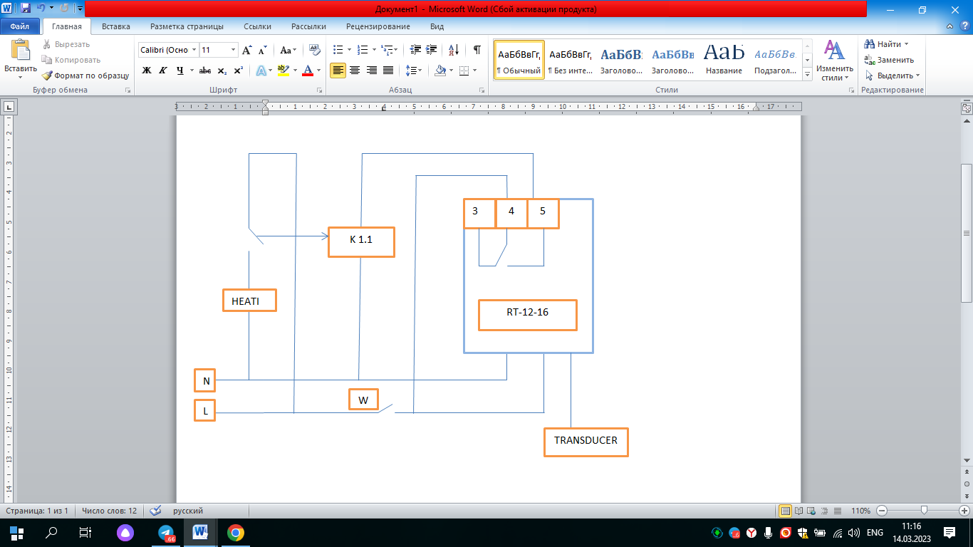
FIGURE 2. Electrical diagram of the transformer fire and explosion protection device

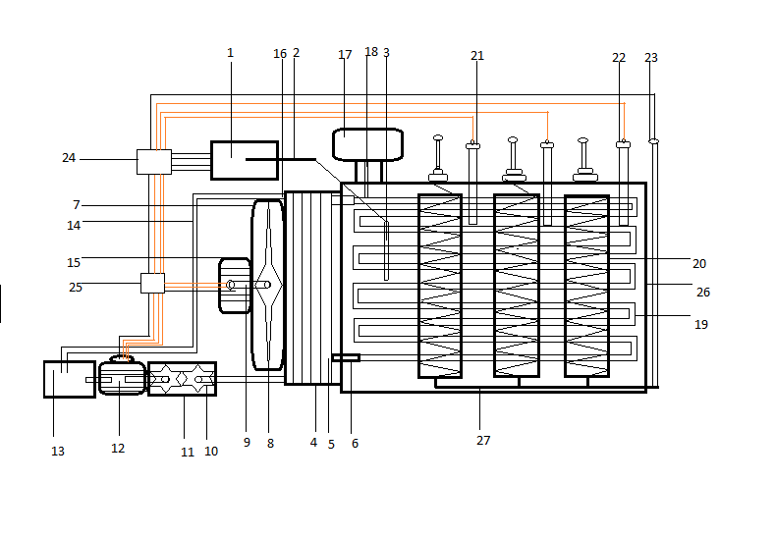
FIGURE 3. Construction drawing of transformer fire and explosion protection device

1-thermorelay; Cable for connecting the sensor with the 2nd thermorelay; 3-thermometer; 4-cooling radiator; 5-pipes carrying freon to the radiator; 6-connecting (input) pipe between the radiator and the transformer body; 7-fan housing; 8-fan blade; 9th motor axis; 10th pump (with rotor); 11-pump housing; 12-gear pump electric motor; 13-freon storage volume (barrel); 14 pipe connecting the freon barrel with the radiator; 15 - the main motor that rotates the blade of the main fan; 16-freon pouring pipe into the barrel; 17-dielectric oil storage barrel; 18-pipe connecting the oil casing with the transformer casing; 19 freon rotating tube inside the transformer housing; Primary and secondary windings of the 20th transformer; 21-high voltage insulator; 22-low-voltage insulator; 23-transformer grounding and neutral wire; 24, the device for starting the electric motor in case of emergency of the transformer; 25. a device that activates the system in the event of an emergency; 26. The steel case of the transformer; 27-zero cable connecting high and low voltage circuits.
CONCLUSION
It can be said that by continuously controlling and preventing the overheating of the dielectric cooling oil of the transformers, it is possible to ensure the continuous operation of the transformer and its operation at high power for a long time. The automatic transformer cooling system is a new system for detection and prevention of explosions and fires in electric transformers. Transformer failure is mainly caused by overheating of transformer oil and short circuit due to overloading. As a result of the inability of the existing automated protection devices and systems to provide full and reliable protection of expensive high-voltage transformers, interruptions in the uninterrupted supply of energy to consumers occur. In this regard, it is necessary to use methods and devices based on new technologies that protect high-voltage transformers from emergency short circuits. One such device is a transformer protection device against fire and explosion
The transformer protection device can be summarized as follows
-Reducing energy waste.
-Reducing the heat in the boilers resulting from overloading
-Extending the period of operation of plants
-Extending the working time by introducing a cooling system to the transformers
-To increase the capacity of the transformer by introducing a cooling system to the transformers.
We achieve reduction of oil waste in transformers. By extending the service life of transformers in the power transmission system, it is possible to reduce economic costs by up to 60%.
REFERENCES
- K. Allaev, J. Toshov, Modern state of the energy sector of Uzbekistan and issues of their development, E3S Web of Conferences 401, 05090 (2023). https://doi.org/10.1051/e3sconf/202340105090
- A. Karimov., M. Mirhaydarov. Fundamentals of electrical engineering and electronics: “University. Textbook for students”, 1995. 468.
- O. Toirov, Sh. Azimov, Z. Toirov. Improving the cooling system of reactive power compensation devices used in railway power supply // AIP Conference Proceedings, 3331, 1, 050030, (2025). https://doi.org/10.1063/5.0305670
- M. Taniev, M. Hamdamov, A. Sotiboldiev, Power Losses Of Asynchronous Generators Based On Renewable Energy Sources E3S Web of Conferences, 434, 01020, (2023) https://doi.org/10.1051/e3sconf/202343401020
- O. Toirov, S. Khalikov, Sodikjon Khalikov, F. Sharopov, Studies of reliability indicators of pumping units of machine irrigation on the example of the “Namangan” pumping station, // E3S Web of Conferences 410, 05015, (2023). https://doi.org/10.1051/e3sconf/202341005015
- Sh. Azimov, Z. Najmitdinov, M. Sharipov, Z. Toirov. Improvement of the cooling system of reactive power compensating devices used in railway power supply // E3S Web of Conferences, 497, 01015, (2024). https://doi.org/10.1051/e3sconf/202449701015
- D. Bystrov, S. Giyasov, M. Taniev, S. Urokov. Role of Reengineering in Training of Specialists // ACM International Conference Proceeding Series (2020) https://doi.org/10.1145/3386723.3387868
- O. Toirov, V. Ivanova, V. Tsypkina, D. Jumaeva, D. Abdullaeva, Improvement of the multifilament wire lager for cable production, // E3S Web of Conferences 411, 01041 (2023), https://doi.org/10.1051/e3sconf/202341101041
- T. Kamalov, U. Mirkhonov, S. Urokov, D. Jumaeva, The mathematical model and a block diagram of a synchronous motor compressor unit with a system of automatic control of the excitation // E3S Web of Conferences, 288, 01083, (2021), https://doi.org/10.1051/e3sconf/202128801083
- D. Jumaeva, B. Numonov, N. Raxmatullaeva, M. Shamuratova. Obtaining of highly energy-efficient activated carbons based on wood, // E3S Web of Conferences 410, 01018, (2023). https://doi.org/10.1051/e3sconf/202341001018
- Y.X. Guan., J.Lin., Ch.Zhou., D.Ke, Ch.Chen., W.H., Z. Dynamic pressure analysis and protection of transformer in internal arcing fault by FEM. Proceedings of the 5th IEEE International Conference on Electric Utility Deregulation, Restructuring and Power Technologies, DRPT 2015
- D. Jumaeva, U. Raximov, O. Ergashev, A. Abdyrakhimov. Basic thermodynamic description of adsorption of polar and nonpolar molecules on AOGW, // E3S Web of Conferences 425, 04003 (2023) https://doi.org/10.1051/e3sconf/202343401020
- O. Toirov, S. Urokov, U. Mirkhonov, H. Afrisal, D. Jumaeva, Experimental study of the control of operating modes of a plate feeder based on a frequency-controlled electric drive, // E3S Web of Conferences, SUSE-2021, 288, 01086 (2021). https://doi.org/10.1051/e3sconf/202128801086
- M.S.Brady., R.D. Bressy., G.Magnier, P.Perigaud, G. Prevention of transformer tank explosion part 1: Experimental tests on large transformers. American Society of Mechanical Engineers, Pressure Vessels and Piping Division (Publication) PVP. 2008.
- Ch, L. Kazienko., Damian. The Development of an Explosion Protection System in the Starting Air Manifold of a High Power Engine. System Safety: Human - Technical Facility - Environment. 2019.
- M.A. Taghikhani, Prediction of hottest spot temperature in power transformer windings with non-directed and directed oil-forced cooling, Electr. Power Energy Syst. (2009).
- L. Borowic, R.Włodarz, K.Chwastek, Eco-efficient control of the cooling systems for power transformers, Journal of Cleaner Productionb Vol. 139, 15, 2016,
- O. Toirov, S. Khalikov, Diagnostics of pumping units of pumping station of machine water lifting, // E3S Web of Conferences 365, 04013, (2023). https://doi.org/10.1051/e3sconf/202336504013
- D. Bystrov, M. Gulzoda, Y. Dilfuza, Fuzzy Systems for Computational Linguistics and Natural Language (2020) // ACM International Conference Proceeding Series, https://doi.org/10.1145/3386723.3387873
- O. Toirov, I. Khujaev, J. Jumayev, M. Hamdamov, Modeling of vertical axis wind turbine using Ansys Fluent package program, // E3S Web of Conferences 401, 04040 (2023). https://doi.org/10.1051/e3sconf/202340104040
- D. Jumaeva, A. Abdurakhimov, Kh. Abdurakhimov, N. Rakhmatullaeva, Energy of adsorption of an adsorbent in solving environmental problems, // E3S Web of Conferences, SUSE-2021, 288, 01082 (2021). https://doi.org/10.1051/e3sconf/202128801082
- R.S. Dondapati, V. Saini, N. Kishore, Enhancement of performance parameters of transformer using nanofluids, Int J SciEng Technol, 2015
- O. Toirov, M. Khalikova, D. Jumaeva, S. Kakharov, (2023) Development of a mathematical model of a frequency-controlled electromagnetic vibration motor taking into account the nonlinear dependences of the characteristics of the elements, // E3S Web of Conferences 401, 05089, (2023). https://doi.org/10.1051/e3sconf/202340105089
- T.S. Ramu, B.K. Keshavan, K.N. Balasubramanya Murthy, Application of a class of nanofluids to improve the loadability of power transformers In: Proceedings of the IEEE 10th international conference on the properties and applications of dielectric materials (ICPADM) 2012
- O. Toirov, S. Khalikov. Analysis of the safety of pumping units of pumping stations of machine water lifting in the function of reliability indicators, // E3S Web of Conferences 365, 04010 (2023), https://doi.org/10.1051/e3sconf/202336504010
- О. Toirov, D. Jumaeva, U. Mirkhonov, S. Urokov, S. Ergashev, Frequency-controlled asynchronous electric drives and their energy parameters, // AIP Conference Proceedings 2552, 040021, (2022). https://doi.org/10.1063/5.0218808
- T. Sadullaev, D. Abdullaev, D. Jumaeva, Sh. Ergashev, I.B. Sapaev, Development of contactless switching devices for asynchronous machines in order to save energy and resources, // E3S Web of Conferences 383, 01029, (2023). https://doi.org/10.1051/e3sconf/202338301029
- O. Toirov, S. Khalikov, Algorithm and Software Implementation of the Diagnostic System for the Technical Condition of Powerful Units, // E3S Web of Conferences 377, 01004, (2023). https://doi.org/10.1051/e3sconf/202337701004
- D. Jumaeva, Z. Okhunjanov, U. Raximov, R. Akhrorova. Investigation of the adsorption of nonpolar adsorbate molecules on the illite surface, // Journal of Chemical Technology and Metallurgy, 58, 2, (2023). https://doi.org/10.59957/jctm.v58i2.61
- K. Alimkhodjaev, A. Pardaboev, Analysis and ways of reducing electricity losses in the electric power systems of industrial enterprises, // E3S Web of Conferences, SUSE-2021, 288, 01085 (2021). https://doi.org/10.1051/e3sconf/202128801085
- O. Toirov, V. Tsypkina, V. Ivanova, D. Isamukhamedov, M. Kozlitin, Z. Toirov. Overview of Modern Materials Used for the Production of Optical Fiber for Fiber Optic Cables AIP Conference Proceedings, 3331 (1), 050029 (2025). https://doi.org/10.1063/5.0305669
- T. Sadullaev, U. Hoshimov, S. Urokov, A. Naimov, J. Khudoyorov, Z. Toirov. Development of an integrated method for rating electrical energy consumption during the drilling process, // AIP Conference Proceedings, 3331 (1), 050028, (2025). https://doi.org/10.1063/5.0305668
- N. Avezova, O. Toirov, A. Usmanov. Review of Modern Approaches in the Development of Hybrid Biogas Systems // Applied Solar Energy, 60 (6), (2024) https://doi.org/10.3103/S0003701X25600845
- O. Filina, A. Khusnutdinov, O. Toirov, Kh. Vakhitov, A. Abdyllina, Investigation the conditions of existence and disturbances of brush-collector contact // E3S Web Conf. 563, 01009, (2024). https://doi.org/10.1051/e3sconf/202456301009
- O. Toirov, Sh. Atoev, T. Sadullayev, D. Jumaeva, Energy-saving operating modes and functional diagrams of a cotton-cleaning device based on frequency-controlled electric drives. // AIP Conference Proceedings, 3152 (1), 030016, https://doi.org/10.1063/5.0218797

