Binders as a factor in increasing the energy efficiency of granular active adsorbents
Dilnoza Jumaeva^{1,a)}, Zukhriddin Okhunjonov², Olimjon Toirov³, Zilola Nomonova², Dilnoza Salikhanova¹
¹Institute of General and Inorganic Chemistry, Academy of Sciences of the Republic of Uzbekistan
²Fergana State Technical University
³Tashkent State Technical University named after Islam Karimov, Tashkent, Uzbekistan
^{a)} Corresponding author: d.jumayeva@list.ru
Abstract. This article investigates the role of binders in the granulation of chemically active adsorbents and their influence on mechanical strength, porous structure, and adsorption performance. The granulation process is a critical stage in the production of activated adsorbents, as it determines the structural stability and functional efficiency of the final material. Various types of binders, including natural organic binders (dextrin, carboxymethyl cellulose), mineral binders (bentonite, silicates), polymer binders (polyacrylamide), and recycled industrial binders (oil sludge), were analyzed in terms of their functional roles and effects on granule strength and adsorption capacity.
The study demonstrates that binder concentration significantly affects granule integrity, pore volume, and adsorption efficiency. Optimal binder content ensures a balance between mechanical strength and porosity, while excessive binder content leads to pore blockage and reduced adsorption capacity. Experimental results revealed that dextrin at a concentration of 13–15% provides optimal granule strength while preserving high porosity and adsorption capacity. Furthermore, the effect of granule size on adsorption efficiency was evaluated, showing that granules with a diameter of 2.5 mm exhibit the highest adsorption capacity (up to 100 mg/g). The findings confirm that the appropriate selection of binder type, concentration, and granule size is essential for producing mechanically stable and highly efficient chemically active adsorbents.
INTRODUCTION
In recent years, the increase in solid waste has been growing rapidly in line with the growth of industry. In order to prevent these problems, by studying the chemical composition of waste as a secondary product, by studying the possibilities of using it in industrial wastewater treatment by purposeful processing, obtaining adsorbents with high sorption properties, and by using it in wastewater treatment of certain natural types, returning the purified water to the technological cycle as technical water will satisfy the need for water, save resources, and serve as a solution to economic and environmental problems.
Naturally, one of the urgent issues of today is the creation and introduction of modern technologies for wastewater treatment, which is one of the important issues of our time. In this, first of all, taking into account the importance of introducing low-cost technologies, their chemical composition, along with the choice of raw materials, is of great importance. If the high demand of sorption materials for carbon-based adsorbents serves to solve the problem of adsorbents in production enterprises, their development using waste raw materials serves to solve environmental and ecological problems. Therefore, it is assumed that the study of the literature review of the dissertation work will be carried out by evaluating the resources in the analysis of the scientific basis of the raw materials for the production of adsorbents. In the production of activated adsorbents, the implementation of the granulation process and the selection of suitable binders are of critical importance [1-5] The primary role of binders is to ensure the cohesion of raw materials into granules, [6-9] enhance mechanical strength, and preserve the porous structure [10-12]. One of the main functions of binders is to mechanically strengthen the granules, thereby preventing the disintegration of adsorbent granules [13-15]. By controlling the porous structure of the adsorbent, binders contribute to ensuring the optimal pore volume within the granules and the uniform distribution of chemically active components [16-18]. In addition, binders provide stability against the effects of water and organic solvents, thereby improving the mechanical durability of the adsorbent in various environments [19]. While preserving the granule structure, binders also help maintain a maximum specific surface area [20-23].

METHODOLOGY
When incorporating a binder into the selected raw material for adsorbent production, low binder concentrations (≤2%) result in granules that are prone to rapid disintegration, exhibit low mechanical stability, and possess high porosity. At medium concentrations (3–5%), the granules become mechanically strong, while adsorption capacity and pore structure remain well balanced. At high concentrations (>5%), the granules become excessively rigid, pore volume decreases, and this leads to a reduction in adsorption capacity. Below, the mass ratio relationships selected as optimal for granules of various sizes are presented.
Among the presented samples, natural binders such as dextrin and carboxymethyl cellulose possess significant advantages as environmentally friendly and renewable materials. Polymer binders are advantageous in protecting granules from leaching under the action of water and acids. Oil sludge, which is a recycled petroleum waste, serves as a binder that provides high adsorption capacity due to its high porosity; however, it exhibits low environmental safety. In the granulation process of chemically activated raw materials, binders play a crucial role in maintaining mechanical stability and preserving the porous structure.

TABLE 1. Effect of Binders on the Mechanical Strength and Adsorption Capacity of Adsorbents
Type of Binder | Functional role | Effect on Mechanical Strength | Porosity and Adsorption Capacity
Dextrin | Natural organic binder | Moderate | Soft structure, moderate porosity
Bentonite | Mineral-based binder | High | Stable pores, moderate adsorption capacity
Polyacrylamide (PAA) | Polymer binder | Very high | Small pores, high mechanical strength
Silicates (Na₂SiO₃, K₂SiO₃) | Inorganic binder | High | Mesoporous structure, good hydrophobicity
Carboxymethyl cellulose (CMC) | Natural polysaccharide | Moderate | Open pore structure, good moisture control
Oil sludge | Binder based on recycled petroleum waste | Moderate | Large pores, high adsorption capacity, low environmental safety

Based on the characteristics of the selected binders, dextrin and oil sludge were chosen as binders for the granulation of chemically activated sorption materials. The use of dextrin as a binder is particularly important for forming adsorbent granules, enhancing mechanical strength, and preserving the porous structure, as it is a natural binder. The determination of its optimal concentration was found to depend on several factors, as established through the conducted analyses (Table 1). Table 1 presents an analysis of the relationships between the selected binder, its functional role, and its effects on granule strength and adsorption properties.
According to the scientific conclusions of the conducted studies, the optimal dextrin concentration was determined to be 13–15%. At this concentration, dextrin provides sufficient mechanical strength to the granules and prevents their disintegration (Table 2).

TABLE 2. Effect of Dextrin Binder Concentration on Granule Properties
Dextrin Content (%) | Granule Strength | Porosity and Adsorption Capacity | Suitability
≤12% | Low | High porosity, low mechanical stability of the adsorbent | Not suitable
13–15% | High | High porosity and high mechanical strength | Suitable
>15% | Excessively rigid – adsorption decreases | Low porosity, reduced adsorption capacity | Not suitable

High porosity is maintained, allowing the adsorption capacity to remain at its maximum level. When dextrin is used as a binder at concentrations exceeding 15%, the granules become excessively rigid and pore blockage may occur, resulting in a decrease in adsorption capacity. The dextrin concentration of 13–15% ensures the best balance between granule strength and adsorption capacity and is therefore considered optimal.

EXPERIMENTAL RESEARCH
The effect of granule size on the adsorption capacity of chemically activated adsorbents was also investigated. It was found that when the granule diameter was φ = 1.0 mm, the adsorption capacity was 55 mg/g, whereas at φ = 2.5 mm, it increased to 100 mg/g. Adsorption efficiency began to reach a maximum at φ = 2.0 mm (approximately 90%), and at φ = 2.5 mm, the adsorption capacity reached its maximum value, which was selected as the optimal granule size. However, as the granule size increased further (φ = 3–5 mm), a decrease in adsorption capacity was observed.

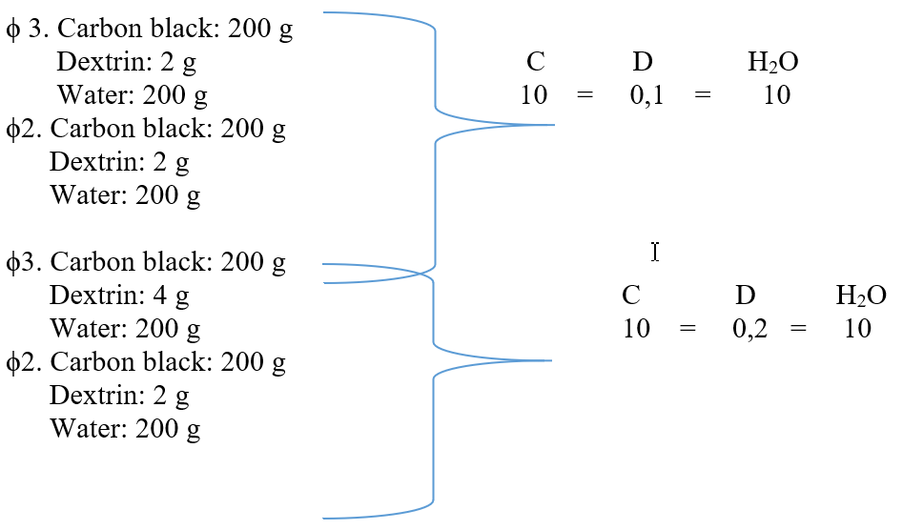 (1)

Experimental studies showed that the adsorption capacity reached its highest value at a granule diameter of φ = 2.5 mm, which was therefore selected as the optimal size. Smaller granules (φ = 1.0–1.5 mm) exhibited lower adsorption capacity due to insufficient pore formation. In contrast, larger granules (φ = 3–5 mm) showed reduced adsorption capacity as a result of the limited formation of active surface areas within the pores. For optimal adsorption performance, a CAA granule size of φ = 2.5 mm is recommended. Although granules in the size range of 2–4 mm are commonly specified during the development of CAA production technology, experimental results and industrial requirements confirm that granules around 2.5 mm provide superior adsorption performance. Experimental studies revealed that the adsorption capacity reaches its maximum at a GCA granule size of φ = 2.5 mm, which was therefore identified as the optimal size.
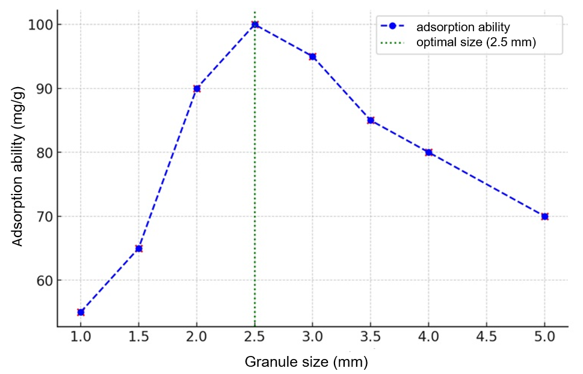
FIGURE 1. Effect of GCA Granule Size on Adsorption Capacity
In contrast, smaller granules (φ = 1.0–1.5 mm) exhibited lower adsorption capacity due to insufficient formation of pores. For larger granules (φ = 3–5 mm), a decrease in adsorption capacity was observed, which is attributed to the lack of formation of sufficiently active surface areas within the pores. For optimal adsorption performance, a GCA granule size of 2.5 mm is recommended. In larger granules, the pores may not effectively contribute to the formation of an active surface. As shown in the graph presented in Figure 1, when the GCA granule size was φ = 1.0 mm, the adsorption capacity was 55 mg/g, whereas at φ = 2.5 mm, it increased to 100 mg/g. At a granule size of φ = 2.5 mm, the adsorption process reached its maximum level, and this size was therefore selected as optimal. As the granule size increased further (φ = 3–5 mm), the adsorption capacity decreased.
Thus, it was substantiated that the highest adsorption capacity is achieved at a GCA granule size of φ = 2.5 mm. However, during the development of GCA production technology, a granule size range of 2–4 mm is often specified based on technological process conditions. Moreover, experimental studies have demonstrated that granules within this size range also exhibit high adsorption performance, and this range has been selected in accordance with the requirements of industrial production facilities. Figure 1 shows the graph of the power factor of asynchronous generator with phase rotor over time. The power factor variation in asynchronous generator with phase rotor is directly related to the capacitor banks connected to the stator winding. When the generator stator winding is supplied with the required reactive power, the power factor reaches its maximum value.
CONCLUSIONS
This study comprehensively examined the role of binders in the granulation of chemically activated adsorbents and their influence on mechanical strength, porous structure, and adsorption performance. The results demonstrated that the granulation process is a critical stage in adsorbent production, as it directly determines the structural stability, durability, and functional efficiency of the final sorption material.
It was established that the type and concentration of binders significantly affect granule integrity and adsorption properties. At low binder concentrations (≤2%), granules exhibit poor mechanical stability and are prone to disintegration, while excessive binder content (>5%) leads to overly rigid granules, reduced porosity, and diminished adsorption capacity. An optimal binder concentration range of 3–5% ensures a balanced relationship between mechanical strength and porosity. In particular, dextrin was identified as the most effective natural binder, providing an optimal balance between granule strength and adsorption efficiency at a concentration of 13–15%.
Furthermore, the influence of granule size on adsorption capacity was systematically investigated. The experimental results revealed that a granule diameter of 2.5 mm ensures the highest adsorption capacity (up to 100 mg/g) due to the optimal development of pore structure and active surface area. Smaller granules exhibited insufficient pore formation, while larger granules showed reduced adsorption efficiency due to limitations in active surface accessibility.
Overall, the findings confirm that the careful selection of binder type, concentration, and granule size is essential for producing mechanically stable and highly efficient chemically activated adsorbents. The obtained results provide a scientific basis for optimizing granulation technology and can be effectively applied in the industrial production of adsorbents intended for environmental protection and wastewater treatment processes.
REFERENCES
- Skoczko, I., & Guminski, R. (2020). Research on the development of technologies for the production of granulated activated carbons using various binders. Materials, 13(22), 5180.
- Dürig, T., & Karan, K. (2019). Binders in wet granulation. In Handbook of pharmaceutical wet granulation (pp. 317-349). Academic Press.
- Wu, C., Luo, Y., Cuniberti, G., Xiao, Y., & Gelinsky, M. (2011). Three-dimensional printing of hierarchical and tough mesoporous bioactive glass scaffolds with a controllable pore architecture, excellent mechanical strength and mineralization ability. Acta biomaterialia, 7(6), 2644-2650.
- Alsaqoor, S., Borowski, G., Alahmer, A., & Beithou, N. (2022). Using of adhesives and binders for agglomeration of particle waste resources. Advances in Science and Technology. Research Journal, 16(3), 124-135.
- Akhtar, F., Andersson, L., Ogunwumi, S., Hedin, N., & Bergström, L. (2014). Structuring adsorbents and catalysts by processing of porous powders. Journal of the European Ceramic Society, 34(7), 1643-1666.
- Dlamini, D. S., Tesha, J. M., Vilakati, G. D., Mamba, B. B., Mishra, A. K., Thwala, J. M., & Li, J. (2020). A critical review of selected membrane-and powder-based adsorbents for water treatment: Sustainability and effectiveness. Journal of cleaner production, 277, 123497.
- Tang, S. H., & Zaini, M. A. A. (2020). Development of activated carbon pellets using a facile low-cost binder for effective malachite green dye removal. Journal of Cleaner Production, 253, 119970.
- Ramachandran, R., Poon, J. M. H., Sanders, C. F., Glaser, T., Immanuel, C. D., Doyle III, F. J., & Cameron, I. T. (2008). Experimental studies on distributions of granule size, binder content and porosity in batch drum granulation: Inferences on process modelling requirements and process sensitivities. Powder Technology, 188(2), 89-101.
- Jin, S. K., Kim, S. H., Choi, J. S., & Yim, D. G. (2019). Effect of diverse binder materials and their addition levels on physico-chemical characteristics of sausages. Journal of Food Measurement and Characterization, 13(2), 1558-1565.
- Alsaqoor, S., Borowski, G., Alahmer, A., & Beithou, N. (2022). Using of adhesives and binders for agglomeration of particle waste resources. Advances in Science and Technology. Research Journal, 16(3), 124-135.
- Meng, Z., Liu, S., & Li, G. (2016). Adsorption capacity, adsorption potential and surface free energy of different structure high rank coals. Journal of Petroleum Science and Engineering, 146, 856-865.
- Yu, Y., Perumal, P., Corfe, I. J., Paul, T., Illikainen, M., & Luukkonen, T. (2023). Combined granulation–alkali activation–direct foaming process: A novel route to porous geopolymer granules with enhanced adsorption properties. Materials & Design, 227, 111781.
- Kumar, P. S., Prot, T., Korving, L., Keesman, K. J., Dugulan, I., van Loosdrecht, M. C., & Witkamp, G. J. (2017). Effect of pore size distribution on iron oxide coated granular activated carbons for phosphate adsorption–Importance of mesopores. Chemical Engineering Journal, 326, 231-239.
- Raposo, F., De La Rubia, M. A., & Borja, R. (2009). Methylene blue number as useful indicator to evaluate the adsorptive capacity of granular activated carbon in batch mode: Influence of adsorbate/adsorbent mass ratio and particle size. Journal of hazardous materials, 165(1-3), 291-299.
- Rostocki, A., Unyay, H., Ławińska, K., & Obraniak, A. (2022). Granulates based on bio and industrial waste and biochar in a sustainable economy. Energies, 16(1), 56.
- Kouznetsova, T.F., Kopysh, E.A., Kulbitskaya, L.V., Jumaeva, D.J., Ivanets, A.I. Textural properties of ordered nanoporous silica synthesized on mesogenic template//Proceedings of the National Academy of Sciences of Belarus, Chemical Series, 2023, 59(2), P.125–138.
- Sagdullaeva, D. Turaev, A.S. Ruzmetova, D. Research of Ecological Safety and Chemical Compositions of Phospholipids Obtained from Local Vegetable Oils and Their Miscelles International Symposium "Sustainable Energy and Power Engineering 2021" (SUSE-2021) E3S Web of Conferences 288, pp.01084 (7 pp.)
- Dilnoza Jumaeva, Akmal Abdurakhimov, Khodjiakbar Abdurakhimov, Nigora Rakhmatullaeva and Olimjon Toirov, (2021) Energy of adsorption of an adsorbent in solving environmental problems, E3S Web of Conferences 288, 01082.
- Juraevna D. J., Yunusjonovich U. R., Karimovich O. E. Studying on the activated absorbents derived from waste of a grape seed, Journal of Chemical Technology and Metallurgy, 2022.
- Eshmetov R., Salikhanova D., Jumaeva D., Eshmetov I., Sagdullaeva D. Journal of Chemical Technology and Metallurgy, 2022.
- Bakhronov Kh., Ergashev O., Karimov Kh., Akhmedova N., Absalyamova I., Abdullayeva Sh. (2023). E3S Web of Conferences, 458, 02008.
- Dilnoza Jumaeva, Olimjon Toirov, Zuhriddin Okhunjanov, Umidjon Raximov, Rano Akhrorova. Investigation of the adsorption of nonpolar adsorbate molecules on the illite surface, Journal of Chemical Technology and Metallurgy, 2023.
- Dilnoza Jumaeva, Akmal Abdurakhimov, Khodjiakbar Abdurakhimov, Nigora Rakhmatullaeva and Olimjon Toirov. (2021), Energy of adsorption of an adsorbent in solving environmental problems, E3S Web of Conferences 288, 01082.

