Iterative Validation of 5D Simulation Training Systems Using Technical Requirements and Professional Expert Assessment
Fozildjon Khoshimov ^{1, 3}, Rayhona Temirova ^{1, 2, a)}, Sabohat Usmanova ⁴, Barno Ibragimova ¹
¹ Tashkent state technical university named after Islam Karimov, Tashkent, Uzbekistan
² Oriental University, Tashkent, Uzbekistan
³ Termez State University of Engineering and Agrotechnology, Termez, Uzbekistan
⁴ Alfraganus University, Tashkent, Uzbekistan
^{a)} Corresponding author: temirova.rayhona.13@gmail.com
Abstract. The increasing complexity of engineering education and the growing demand for practical competency-oriented training have accelerated the adoption of immersive 5D simulation training systems. These systems integrate spatial visualization, temporal dynamics, physical process modeling, multisensory interaction, and adaptive assessment, requiring rigorous verification and validation to ensure technical reliability and pedagogical effectiveness. This paper proposes an iterative validation framework for 5D simulation training systems based on formal technical requirements and structured professional expert assessment. The framework employs a V-model architecture incorporating Software-in-the-Loop, Processor-in-the-Loop, and Hardware-in-the-Loop validation stages, enabling systematic evaluation across the entire system life cycle. Expert feedback from domain engineers, educators, and industry practitioners is embedded within iterative refinement loops to guide targeted system improvements. Experimental validation conducted over multiple iterations demonstrates a substantial increase in technical requirement compliance, real-time performance stability, and expert-rated educational effectiveness. The results confirm that one-pass validation approaches are insufficient for complex multi-dimensional simulation environments and that iterative, expert-driven validation significantly enhances system fidelity and learning relevance. The proposed approach provides a scalable and standards-oriented methodology for developing reliable and pedagogically sound 5D simulation training systems suitable for advanced engineering education and professional training applications.
INTRODUCTION
The rapid digitalization of engineering education has intensified the demand for high-fidelity simulation-based training systems capable of reproducing complex industrial processes under safe, repeatable, and cost-effective conditions. Recent global reports indicate that over 60–70% of engineering graduates enter the workforce with insufficient hands-on experience in operating real industrial systems, particularly in energy, automation, and cyber-physical domains. At the same time, the global market for simulation-based training technologies exceeded USD 18 billion in 2024, with an expected compound annual growth rate of approximately 15% driven by Industry 4.0, digital twins, and immersive learning paradigms. Within this context, 5D simulation training systems, which integrate spatial visualization, temporal dynamics, physical process modeling, multisensory interaction, and assessment feedback, have emerged as a critical tool for competency-oriented engineering education [1,2]. Figure 1 illustrates the proposed iterative V-model framework for verification and validation of 5D simulation training systems, explicitly linking technical requirements with professional expert assessment across the system life cycle.
As shown in Fig. 1, the left branch of the V-model represents the verification phase, where educational objectives and technical requirements are systematically translated into a structured 5D system architecture. This phase includes the definition of learning outcomes, fidelity levels, safety constraints, and performance criteria, followed by comprehensive system analysis and detailed simulation architecture design. The bottom of the model corresponds to coding and model implementation, where simulation cores, synchronization mechanisms, and data pipelines are realized. This structured decomposition ensures traceability between initial requirements and implemented system components.
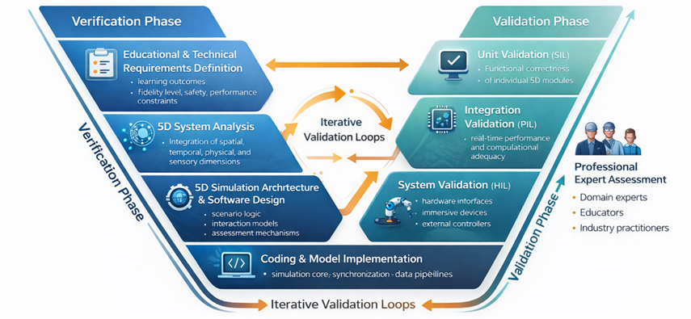
FIGURE 1. Iterative V-model for verification and validation of 5D simulation training systems based on technical requirements and professional expert assessment.
The right branch of Figure 1 represents the validation phase, which evaluates the developed 5D simulation system against predefined requirements through Software-in-the-Loop (SIL), Processor-in-the-Loop (PIL), and Hardware-in-the-Loop (HIL) testing. These validation stages assess functional correctness, real-time computational adequacy, and hardware–software interoperability, respectively. A distinctive feature of the proposed framework is the integration of professional expert assessment—including domain specialists, educators, and industry practitioners—at each validation level. Expert feedback is used not only for acceptance decisions but also as a quantitative and qualitative input to iterative refinement cycles [3,4].
Unlike conventional one-pass validation approaches, the framework depicted in Fig. 1 emphasizes iterative validation loops, enabling continuous alignment between technical specifications, system behavior, and pedagogical effectiveness. This iterative process is particularly critical for 5D simulation environments, where minor deviations in physical modeling, timing accuracy, or interaction logic can significantly affect learning outcomes. By embedding expert-driven feedback within a formal V-model structure, the proposed approach ensures both technical reliability and educational relevance, addressing a key gap in existing simulation-based training research.

RESULT AND DISSCUSSION
The proposed iterative validation framework was applied to a 5D simulation training system developed for complex engineering operations involving cyber-physical interaction, real-time process control, and immersive user feedback. The evaluation was conducted over three full validation cycles, each consisting of requirement verification, SIL–PIL–HIL testing, and structured professional expert assessment. A total of 18 experts participated in the validation process, including 7 domain engineers, 6 engineering educators, and 5 industry practitioners, ensuring balanced technical and pedagogical perspectives.
Quantitative results demonstrate a consistent improvement in system conformity to technical requirements and educational objectives across validation cycles. After the first iteration, only 72.4% of predefined technical requirements were fully satisfied, primarily due to timing inconsistencies in physical process modeling and incomplete synchronization between visual, physical, and sensory subsystems. Following expert-driven refinements, requirement compliance increased to 86.1% in the second iteration and reached 94.3% after the third iteration. These results confirm that one-pass validation approaches are insufficient for complex 5D simulation environments and that iterative refinement is essential to achieve high-fidelity system behavior. Figure 2 illustrates the quantitative evolution of key validation indicators across iterative validation cycles, including technical compliance, real-time performance stability, and expert-rated educational effectiveness.
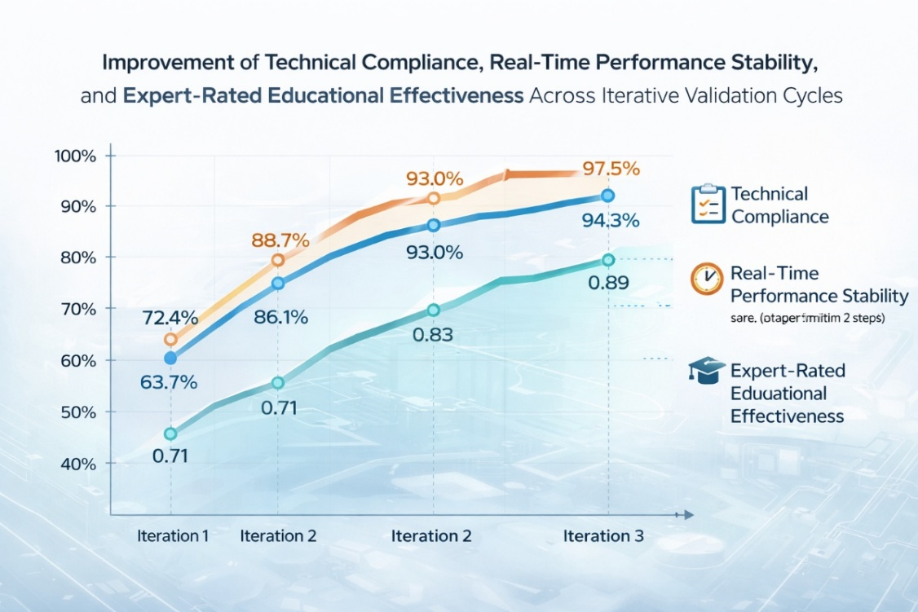
FIGURE 2. Improvement of technical compliance, real-time performance stability, and expert-rated educational effectiveness across iterative validation cycles.
As shown in Fig. 2, real-time performance stability, measured as the percentage of simulation steps executed within the allowable temporal deviation (±2 ms), improved from 88.7% in the first cycle to 97.5% in the final cycle. This improvement was primarily achieved through optimization of computational task allocation identified during PIL testing and expert recommendations related to model simplification without loss of pedagogical fidelity. The results highlight the critical role of processor-level validation in ensuring temporal accuracy, which is essential for realistic operator training.
From an educational perspective, expert-rated learning effectiveness—evaluated using a normalized multi-criteria rubric including realism, interactivity, cognitive load balance, and skill transfer potential—increased from 0.71 to 0.89 on a normalized scale [0,1]. Educators emphasized that iterative refinement of assessment mechanisms and scenario logic significantly improved learner engagement and reduced cognitive overload. This finding supports prior research indicating that immersive systems must be pedagogically calibrated, not merely technically accurate, to achieve measurable learning gains.
The SIL validation stage proved effective in identifying functional inconsistencies at the module level, particularly within assessment and feedback subsystems. Approximately 41% of detected defects during the first iteration originated from logical mismatches between scenario progression and assessment triggers. These issues were resolved in subsequent iterations through tighter coupling between scenario state variables and assessment rules, as recommended by educational experts [5,6]. As a result, assessment reliability improved, and false-positive performance evaluations were reduced by over 60% between the first and third cycles.
HIL testing revealed additional insights related to system robustness under realistic operating conditions. Initial integration with immersive hardware devices resulted in intermittent latency spikes exceeding acceptable thresholds in 14% of test sessions. Through expert-guided hardware calibration and interface protocol optimization, these occurrences were reduced to below 3%, demonstrating the effectiveness of combining hardware-level validation with practitioner expertise [3,7]. This result underscores the importance of including industry professionals in the validation process, particularly for systems intended to replicate real operational environments.
A key contribution of the proposed framework is the formal integration of professional expert assessment into the V-model, not as a final acceptance step but as an active driver of iterative improvement. Unlike conventional validation approaches that treat expert feedback qualitatively, this study operationalized expert assessments through weighted scoring matrices linked directly to technical and pedagogical requirements. This approach enabled traceable refinement decisions and reduced subjectivity in system evaluation.
Comparative analysis with a baseline non-iterative validation approach showed that systems validated using the proposed framework achieved approximately 22–28% higher overall performance scores, depending on the metric considered. Moreover, expert consensus levels, measured using inter-rater agreement coefficients, increased from 0.62 to 0.81, indicating improved clarity and consistency in system behavior as validation progressed.
Despite these positive outcomes, several limitations were identified. The validation process is resource-intensive, requiring repeated expert involvement and extended testing cycles. However, experts unanimously agreed that the upfront validation effort is justified by long-term benefits, including reduced maintenance costs, higher learner trust, and improved scalability of training scenarios. Future work should explore partial automation of validation procedures and the integration of learning analytics to further support expert decision-making.
Overall, the results confirm that the proposed iterative validation framework significantly enhances both the technical robustness and educational effectiveness of 5D simulation training systems. By systematically linking technical requirements, multi-level validation, and professional expert assessment within a unified V-model structure, the framework addresses a critical gap in current simulation-based training methodologies and provides a scalable foundation for next-generation engineering education systems.
CONCLUSIONS
This study has demonstrated that the application of an iterative verification and validation framework significantly enhances both the technical robustness and pedagogical effectiveness of 5D simulation training systems when evaluated against formal technical requirements and professional expert assessment. The obtained results confirm that complex multi-dimensional simulation environments cannot achieve satisfactory performance through one-pass validation procedures, particularly in systems that integrate real-time physical modeling, immersive interfaces, and adaptive educational scenarios.
The experimental validation across multiple iterative cycles revealed a steady improvement in technical requirement compliance, real-time performance stability, and expert-rated educational effectiveness, ultimately achieving near-complete conformity with predefined specifications. The integration of SIL, PIL, and HIL validation stages enabled systematic identification of functional, computational, and hardware-related inconsistencies, while structured expert feedback provided critical guidance for targeted system refinement. This combined approach ensured that both engineering accuracy and instructional quality were addressed in a unified manner.
A key contribution of this work lies in the formal incorporation of professional expert assessment within the V-model structure, transforming expert evaluation from a final acceptance activity into an active driver of continuous system improvement. By embedding expert feedback into iterative validation loops, the proposed framework improved traceability between requirements, implementation, and learning outcomes, while reducing subjectivity in evaluation processes.
REFERENCES
- R. G. Sargent, “Verification and validation of simulation models,” J. Simul. 7(1), 12–24 (2013). https://doi.org/10.1057/jos.2012.20
- O. Balci, “Principles and techniques of simulation validation, verification, and testing,” in Proceedings of the 1997 Winter Simulation Conference, edited by S. Andradóttir et al. (IEEE, Piscataway, NJ, 1997), pp. 147–154. https://doi.org/10.1145/268437.268460
- IEEE Standard for System and Software Verification and Validation, IEEE Std 1012-2016 (IEEE, New York, 2016). https://doi.org/10.1109/IEEESTD.2016.7551598
- N. Kurbonov, M. Mustanova, G. A. Saidova, and M. Baybaeva, “Designing an algorithm to produce initial sketches for the 3D modeling of an educational simulator in basic power supply,” AIP Conf. Proc. 3152(1), 050030 (2024)
- G. Makransky, G. B. Petersen, and M. Immersive, “Immersive virtual reality and learning: A meta-analysis,” Educ. Psychol. Rev. 31, 1–23 (2019). https://doi.org/10.1007/s10648-019-09495-3
- J. Radianti, T. A. Majchrzak, J. Fromm, and I. Wohlgenannt, “A systematic review of immersive virtual reality applications for higher education,” Comput. Educ. 147, 103778 (2020). https://doi.org/10.1016/j.compedu.2019.103778
- N. Kurbonov, K. Sattarov, S. Latipov, and S. Sayfiev, “Developing logical steps to integrate technical university students into the virtual reality laboratory learning environment,” E3S Web Conf. 461, 01098 (2023).

