Chemical Analysis of High Energy-Efficient Active Sorbents
Dilnoza Jumaeva^{1,a)}, Nigora Rakhmatullaeva², Olimjon Toirov³, Akmal Abdurakhimov², Kamola Hamroqulova¹
¹Institute of General and Inorganic Chemistry, Academy of Sciences of the Republic of Uzbekistan, Tashkent, Uzbekistan
²Tashkent Chemical Technology Institute, Tashkent, Uzbekistan
³Tashkent State Technical University named after Islam Karimov, Tashkent, Uzbekistan
^{a)} Corresponding author: d.jumayeva@list.ru
Abstract. In this article, the chemical composition of sorption materials activated from paulownia tree wood and bark waste was comprehensively analyzed, including the quantitative content of elements and oxides. Changes occurring in the raw material composition before and after activation were investigated through the observation of variations in mass composition. The identified structural and compositional changes were subjected to detailed analysis. Considering the requirements imposed on adsorbents, where the carbon content is expected to exceed 86%, the activation results demonstrate significant enrichment in carbon. Specifically, while the initial carbon content of the raw material was C = 54.2%, this value increased to C = 85.0% after thermal activation and reached C = 98.7% following steam activation. The research results were obtained based on energy-dispersive X-ray fluorescence (EDXRF) analysis, which enabled a comparative characterization of the elemental and oxide compositions of the raw materials before and after the activation process.
INTRODUCTION
At present, issues related to environmental protection have gained significant importance. This is primarily due to the fact that the environmental pollution indicator has reached critically high levels, which is characterized by a decrease in the oxygen content of the air and an increase in the concentration of heavy molecular gases. One of the most fundamental and pressing challenges in ecology and environmental protection today is air pollution, alongside emissions released into the atmosphere. One of the key factors determining human health and longevity is not only the consumption of clean water but also the inhalation of clean air. Currently, the rapid increase in the number of industrial enterprises has led to a sharp rise in atmospheric pollution. This is because industrial facilities release various toxic gases into the environment as waste emissions, resulting in air contamination by complex mixtures of heavy gases with diverse compositions. Such pollution poses a serious threat to human health and contributes to the increasing prevalence of respiratory and asthmatic diseases.
Taking into account the relevance of the problem, the main objective of this scientific research was defined as follows. In oil and gas production enterprises, zeolites are currently used as catalysts for drying natural gas supplied for public consumption and for removing toxic sulfur dioxide. However, the gases consumed by the population are not completely purified before being delivered for domestic use. As a result, during daily cooking activities, household users—particularly women—are exposed to partially combusted and harmful gases, which may lead primarily to gastric cancer as well as diseases of the upper respiratory tract. In this context, the use of kitchen ventilation hoods is considered a practical means of preventing health disorders that pose a threat to human well-being [1–2].
The present study focuses on investigating the adsorption mechanism of a carbon-based adsorbent with high adsorption capacity, derived from plant-based raw materials, as a substitute for imported adsorbents, and on evaluating its application in gas adsorption processes. Based on the selected raw materials used as sorption media, activated adsorbents were prepared, and comprehensive investigations were conducted on the physicochemical and colloidal properties of carbonaceous materials before and after activation. Furthermore, the application of these materials according to their properties and nature is considered an important factor in addressing large-scale challenges related to environmental protection and ensuring the chemical and biological safety of ecosystem infrastructure.
In industrial manufacturing enterprises, there is a high potential for producing activated adsorbents from large quantities of waste materials generated as a result of chemical and mechanical processing during production processes. In this context, sorption materials can be obtained by selecting appropriate activation methods for these waste masses. Initially, it is advisable to determine the carbon content of the selected raw materials in accordance with adsorbent requirements and, based on an investigation of their chemical composition, to organize the pyrolysis process in a manner compatible with the existing infrastructure of industrial enterprises.
Depending on the physicochemical properties of sorption materials during activation processes, carbon adsorbents are hereinafter referred to as activated carbon materials, abbreviated as ACMs (Activated Carbon Materials). For the production of adsorbents, surface solids with a highly porous internal structure and a high degree of dispersity, which are widely available in nature, are mainly selected. According to the analysis of the literature [116; pp. 3–13], various types of sorbents are produced from different raw material sources using a wide range of organic wastes, such as coconut shells, fruit stone shells, rice husk residues, and wood waste from the furniture industry, among many others. The principal role of sorbent materials in the adsorption process is associated with their high specific surface area (S). The parameters that characterize the ability of a material to function as an effective adsorbent include a high specific surface area, low ash content, and developed porosity. When developing adsorbents and recommending their application in specific industrial sectors, the composition of the selected raw materials and their carbon content are of critical importance [14–20]. It is well known that coal (both lignite and hard coal), which is naturally considered a semi-finished adsorbent, contains a high proportion of carbon. However, there are other types of raw materials that are widely distributed in nature, and the utilization of their waste as adsorbents can contribute to solving numerous economic and environmental problems. It is known that in countries with well-developed forestry sectors and extensive forested areas, such as Russia and Belarus, the raw material base for activated adsorbents is largely based on birch wood. Adsorbents produced from this raw material are purchased as imported products for use in certain industrial sectors of Uzbekistan [21–25]. Based on the analysis of the results obtained in this study, recommendations are proposed for the development of import-substituting materials [26–31].

METHODOLOGY
Based on energy-dispersive X-ray fluorescence (EDXRF) analysis, the elemental and oxide compositions of raw materials before and after activation were analyzed using a rapid qualitative and quantitative determination method for major and minor elements present in various samples. Owing to the multifunctionality of this method, the study enabled multi-element analysis over a wide concentration range—from parts per million (ppm) to high mass fractions (% by mass)—for elements ranging from sodium (¹¹Na) to uranium (⁹²U). This spectrometric technique is particularly suitable for the semi-quantitative determination of elemental composition in samples with completely unknown matrices. The spectrometer is characterized by high analytical performance, as well as versatility and ease of operation. In addition, it offers a broad range of applications, being effectively used in processes ranging from scientific research and development to industrial and factory-based quality control. The instrument developed by Rigaku represents a reliable method for determining fundamental research parameters and is based on algorithmic software designed for backscattered radiation. This software enables the automatic estimation of concentrations of unidentified low atomic number elements and the application of appropriate corrections. The use of this method for determining the compositional characteristics of raw materials provides essential information for identifying the composition of the primary raw material, which is a critical basis for implementing subsequent stages of the research [32].
EXPERIMENTAL AND RESEARCH RESULTS
The experimental studies, aimed at the targeted utilization of paulownia tree waste, began with an investigation of its adsorptive properties by examining the elemental and oxide composition of the raw material. The elemental composition of the initial paulownia wood waste was determined using X-ray fluorescence (XRF) analysis (Figure 1). The results indicated that the sample composition is predominantly represented by light elements and alkali-earth metals, which is characteristic of natural lignocellulosic raw materials. The primary elements identified include silicon (Si) at 0.226 wt%, which constitutes a major component of the mineral phase. Calcium (Ca) at 0.363 wt% and potassium (K) at 0.503 wt% are biogenic elements that constitute a significant portion of the wood ash composition. Aluminum (Al) at 0.104 wt% and magnesium (Mg) at 0.125 wt% indicate the presence of aluminosilicate and magnesium-containing mineral phases. In addition, iron (Fe) at 0.242 wt% occurs as a natural microcomponent. Elements such as chromium (Cr), manganese (Mn), nickel (Ni), copper (Cu), zinc (Zn), strontium (Sr), and zirconium (Zr) were detected in very low amounts (≤0.01 wt%), reflecting the natural geochemical origin of the raw material. Importantly, the absence of high concentrations of heavy metals indicates that this raw material is suitable for the environmentally safe synthesis of adsorbents. The XRF results expressed in oxide form clearly illustrate the composition of mineral phases in the raw material. The main oxides include SiO₂ at 0.483 wt%, confirming the dominance of silicon dioxide in the sample, which provides a basis for the future formation of silicon-carbon composite structures. CaO at 0.505 wt% and K₂O at 0.603 wt% represent the main components of the ash and exhibit strong alkaline properties. Al₂O₃ at 0.185 wt% and MgO at 0.207 wt% indicate the presence of aluminosilicate phases, while Fe₂O₃ at 0.349 wt% plays an important role in the formation of redox-active centers.
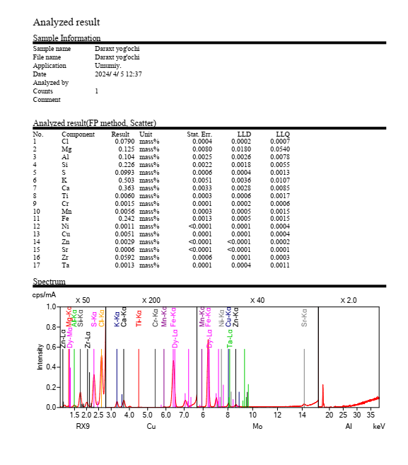 | 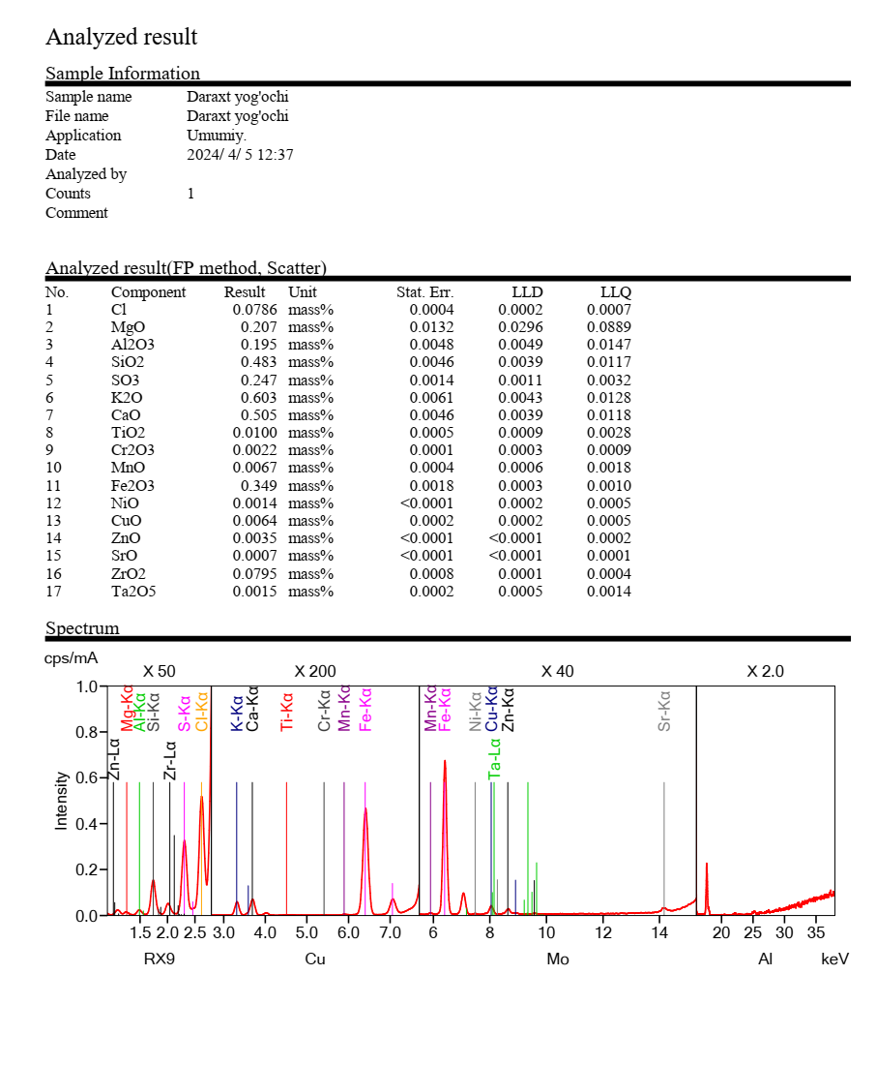
a) | b)
FIGURE 1. Elemental (a) and oxide (b) composition of the initial Paulownia wood waste

Additionally, small amounts of oxides such as TiO₂, MnO, Cr₂O₃, NiO, CuO, and ZnO were detected. Oxides like Fe₂O₃ and TiO₂ can exhibit catalytic effects during the activation process, potentially accelerating the formation of a porous structure in the raw material. The presence of K₂O and CaO acts as natural agents that promote gas release and carbonization processes at high temperatures. Paulownia wood waste can be considered a mineral–carbon hybrid system. The SiO₂–Al₂O₃–CaO–K₂O system provides a favorable environment for the subsequent formation of micro- and mesoporous structures. The presence of natural alkali and transition metal oxides indicates that this raw material is highly suitable for chemical or thermal activation. Low concentrations of heavy metals increase the potential for environmentally safe application of the resulting adsorbents. In the course of the study, the chemical composition of the selected raw material after activation—specifically, the content of elements and oxides—was investigated (Figure 2). After activation, the paulownia wood waste is abbreviated as PPAU-A, i.e., Paulownia pyrolysis activated carbon adsorbent. Its elemental (1) and oxide (2) compositions are presented in mass%. Among the mineral components in the sample, the following elements were predominant: K = 0.503% and Ca = 0.363%, which constitute the main part of the ash–mineral residual phase in the wood matrix. These elements can subsequently form surface alkaline/basic centers. Silicon (Si) at 0.226% corresponds to the siliceous phase—primarily SiO₂/silicates—contributing to structural rigidity and mechanical stability in the carbon matrix. Iron (Fe) at 0.242% was also observed, providing the potential for the formation of redox-active centers during activation and subsequent applications. Other elements, such as Mg (0.125%), Al (0.104%), and S (0.0993%), were present at moderate levels, while Ti, Cr, Mn, Ni, Cu, and Zn were detected in very low concentrations. In the wood waste, the total content of mineral additives is low and is mainly concentrated within the K–Ca–Si–Fe system. The oxide composition of the raw material, expressed in terms of phase distribution, is as follows: K₂O = 0.603% and CaO = 0.505%. The predominance of these alkali-earth oxides enhances the fundamental nature of the material’s surface.
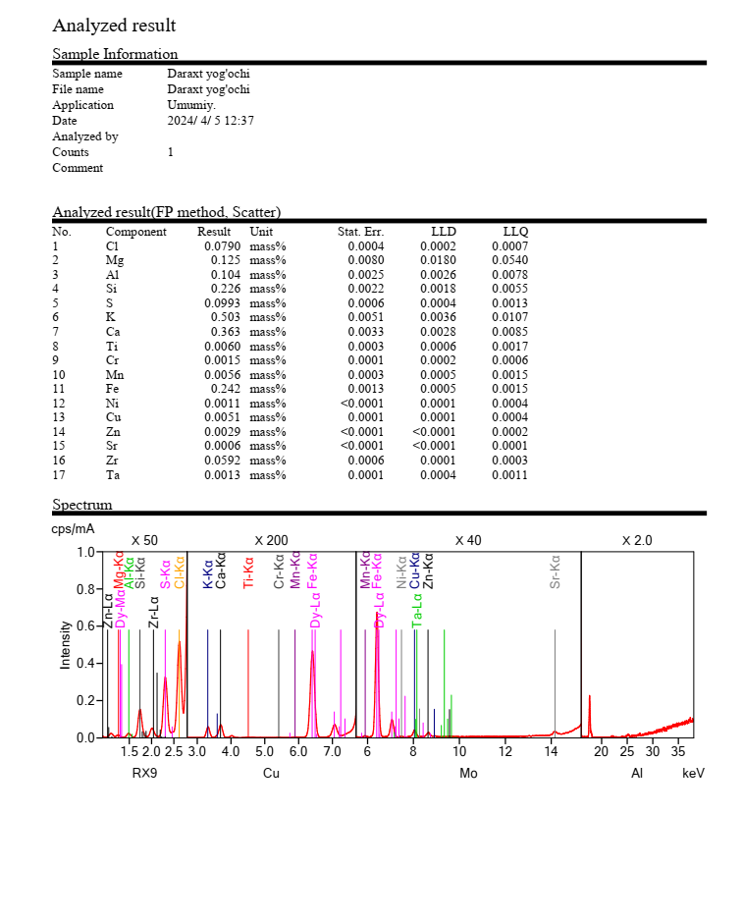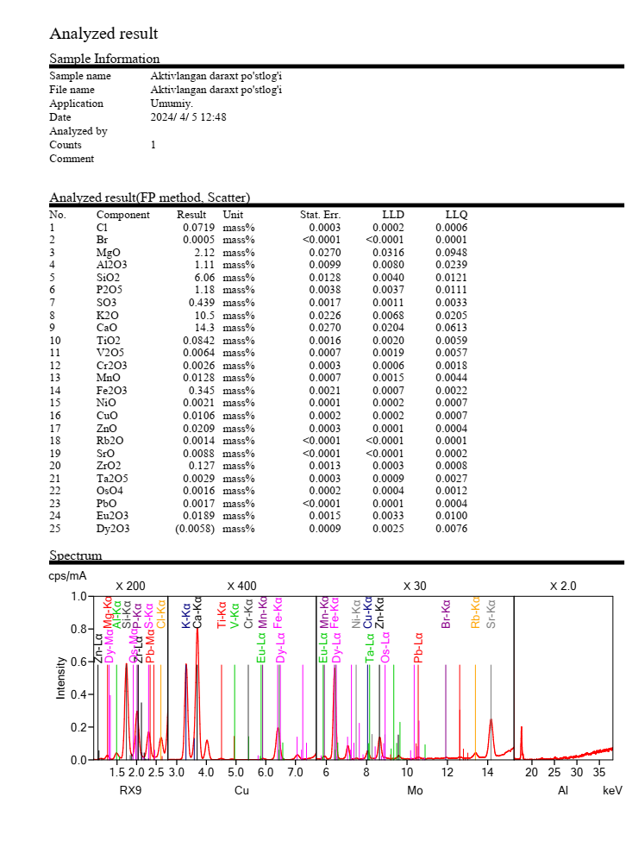
a) | b)
FIGURE. 2. Elemental (a) and oxide (b) composition of Paulownia wood waste after activation (PPAU-A)

This is particularly beneficial for capturing acidic gases or ions, such as H₂S and other acidic components. The SiO₂ content is 0.483%, forming a siliceous phase that acts as a mineral skeleton, enhancing structural stability. Although Fe₂O₃ is present at 0.349%, it is important for catalytic and redox properties, especially in adsorption–oxidation mechanisms. SO₃ is retained at 0.247%, which may correspond to natural organic-sulfate fragments or residues from the processing procedure. Other oxides, such as MgO (0.207%), Al₂O₃ (0.185%), and Cr₂O₃, MnO, NiO, CuO, ZnO, are observed in very low concentrations. Overall, the oxide composition confirms the presence of alkali (K₂O), alkaline-earth (CaO), siliceous (SiO₂), and iron oxide (Fe₂O₃) phases. Although the mineral content is low, it is functionally significant, with the main mineral components being K, Ca, Si, and Fe. The predominance of K₂O and CaO increases the likelihood of forming active surface centers, which enhances interactions with acidic adsorbates. The presence of Fe₂O₃ enables the formation of redox-active sites, which can contribute not only to adsorption but also to catalytic pathways. Very low concentrations of heavy metal oxides such as NiO, CuO, ZnO, and Cr₂O₃ increase the environmental safety of the material and its practical application potential. The numerous peaks in the spectrum indicate a multi-component system with a predominantly low-mineral ash phase.
CONCLUSION
The carbon content is a critical factor in both conventional and non-traditional activated sorbents, and their chemical analyses indicate a high carbon concentration. As a result, the observed changes, mass losses, and the quantity of particles that volatilize or melt into a resinous form within the activation temperature range have been analyzed, allowing important conclusions to be drawn regarding the yield of the resulting adsorbent. Prior to activation, the mineral content in paulownia wood waste is low, with K, Ca, Si, and Fe elements predominating. This reflects a low-mineralized, organic-rich structure characteristic of the wood tissue. In oxide form, K₂O, CaO, SiO₂, and Fe₂O₃ were detected, indicating that the mineral phase initially had a limited share. After activation, the relative concentration of mineral phases sharply increased due to the decomposition and volatilization of organic components. As a result, a K₂O–CaO–SiO₂ dominant system was formed in the material, and the significant increase in CaO and K₂O content indicates enhanced basic (alkaline) properties of the material surface. Furthermore, the retention of Fe₂O₃ (≈0.35 wt%) confirms the presence of redox-active centers in the activated sample. Trace elements (Ti, Mn, Cr, Ni, Cu, Zn, etc.) and their oxides were observed at very low concentrations, enhancing the environmental safety and practical applicability of the material. As a result of activation, paulownia wood waste transforms from a low-mineralized organic raw material into a mineral–carbon active material with alkaline properties. The resulting K₂O–CaO–SiO₂–Fe₂O₃-based system makes the material promising for both adsorption and catalytic applications.
REFERENCES
1. Jumaeva D., Raximov U., Toirov O., Ergashev O., Abdyrakhimov A. Basic thermodynamic description of adsorption of polar and nonpolar molecules on AOGW//E3S Web of Conferences, 2023, 425, 0400. https://doi.org/10.1051/e3sconf/202342504003
2. Jumaeva D., Toirov O., Numonov B., Raxmatullaeva N., & Shamuratova M. (2023). Obtaining of highly energy-efficient activated carbons based on wood. In E3S Web of Conferences (Vol. 410, p. 01018). EDP Sciences. https://doi.org/10.1051/e3sconf/202341001018
3. Kinle, K., & Bader, E. Activated carbons and their industrial applications. Leningrad, 1984. 215 pp.
4. Fundamentals of sorption processes. Educational and methodological complex of the discipline. Far eastern federal university (FEFU), 2021, pp. 10–15. “Sorption processes and membrane technologies”. Educational and methodological complex of the discipline. Far eastern federal university (FEFU), 2021, pp. 20–24.
5. Bogdanovich, N.I., & Chernousov, Yu.I. Sorbents Based on wood waste for the treatment of wastewater from the pulp and paper industry. Pulpa, 1989, No. 5, p. 41. GOST 4453-93. Activated clarifying wood charcoal in powder form. Moscow, 1993, p. 21.
6. Kalinicheva, O.A., Bogdanovich, N.I., & Dobele, G.V. Pre-pyrolysis of wood raw material in the synthesis of activated carbons with sodium hydroxide. lesnoy Zhurnal, 2008, No. 2, pp. 117–122.
7. Kel’tsev, N.V. Fundamentals of adsorption technology. Moscow, 1976. 135 pp.
8. Komarov, V.S., & Rat’ko, A.I. Adsorbents: Production, structure, and properties. Minsk, 2009. 238 pp.
9. Sultan Alam, Muhammad Sufid Khan, Whid Bibi, Ivar Zekker, Juris Burlakovs, Makrand M. Ghngrekr, Gourv Dhr Bhowmick, nan Kllistov, Nikoli Pimenov and Muhammad Zhaoor Preparation of activted Carbon from the Wood of Paulownia tomentos as an Efficient adsorbent for the Removal of acid Red 4 and Methylene Blue Present in Wastewater //Water 2021, 13(11), 1453; https://doi.org/10.3390/w13111453
10. Ahmad, M.M. Loh, J. Aziz. Phosphorylated wood designed as biosorbent for effectively removing Ni2+ from wastewater // https://doi.org/10.1016/j.dyepig.2006.05.034
11. https://www.sciencedirect.com/science/rticle/bs/pii/S0926669 02 0306567
12. https://www.sciencedirect.com/science/rticle/bs/pii/S0926669 02 2012109
13. https://www.mdpi.com/2073-4441/13/11/1453
14. Toles C., Mrshll W.E., Johans M.M. J. Chem. Technol nd Biotechnol. 1998. 72, 3. p. 255-263.
15. Agafonov, G.V., & Kharin, V.M. Method for purifying aqueous-alcohol solutions and device for its implementation. Patent No. 2261898, 9 pp.
16. esolution of the Cabinet of Ministers on Measures for the Restoration of Fast-Growing and Industrially Developed Paulownia Plantations in the Republic. 27 August 2020, No. 520. №520.
17. https://www.fcebook.com/groups/bogdorchilik/posts/2404609226497438
18. Gordon, L.V., Skvortsov, S.O., & Lisov, V.I. Technology and equipment of forest chemical industries. Textbook for technical colleges, 5th edition, revised. Moscow: Lesnaya promyshlennost, 1998. 360 pp.
19. Patent No. 2352349 (RF) A61K 36/185. Method for processing birch bark. Levdansky, V.A.; Levdansky, A.V.; Kuznetsov, B.N. Application No. 2008102252/15; filed 21 February 2008; published 20 April 2009.
20. Patent No. 2051096 C01B 31/08. Method for producing activated carbon. Shchipko, M.L.; Yangolov, O.V.; Kuznetsov, B.N. Application No. 93034069/26; published 27 December 1995, Bulletin No. 36.
21. Kononov, G.N., Mazitov, L.A., & Klimov, V.O. Thermolysis of lignocellulosic raw materials. scientific works of the Moscow state university of forestry, 1994, No. 273, pp. 61–65.
22. Petrov, V.S., Simkin, Yu.Ya., & Krylova, O.K. Technology of sorbents and other carbon materials from plant-derived waste. Chemistry for sustainable development, 1996, Vol. 4, No. 4–5, pp. 389–394.
23. Pokrovskaya, E.N., Nikiforova, T.P., & Makovsky, Yu.A. 1st All-Russian conference on low-flammability polymer materials: Abstracts of reports. Volgograd, 1995, pp. 105–107.
24. Bogdanovich, N.I., Dobele, G.V., & Savrasova, Yu.A. Synthesis of carbon adsorbents from lignocellulosic materials via thermochemical activation with naoh. In: Current problems of adsorption theory, porosity, and adsorption selectivity: Proceedings of the XIV All-Russian symposium with participation of foreign scientists, 26–30 April 2010, Moscow–Klyazma, 2010, pp. [page numbers not specified].
25. Hu S. Study on course of pyrolysis with phosphoric acid method by thermal analysis / S.Hu, B.Huang, Q.Lin // Chemistry and industry of forest products. 1998. V. 18, №2. P. 53-58.
26. Jumaeva D., Toirov O., Okhunjanov Z., Raximov U., Akhrorova R. Investigation of the adsorption of nonpolar adsorbate molecules on the illite surface //Journal of Chemical Technology and Metallurgy, 2023, 58(2), P.353–359.
27. Jumaeva D., Abdurakhimov A., Abdurakhimov K., Rakhmatullaeva N., Toirov O. Energy of adsorption of an adsorbent in solving environmental problems. E3S Web https://www.scopus.com/ record/display.uri?eid=2-s2 085145559385&origin=resultslist&sort=plf-f 6. of Conferences.
28. Jumaeva D.J., Raximov U.Y., Ergashev O.K. Studying on the activated absorbents derived from waste of a grape seed studying on the activated absorbents derived from waste of a grape seed. Journal of Chemical Technology and Metallurgy, 57, 5, 2022,. (Scopus. Impact factor: 0,806)
29. Jumayeva D.J., Abdurakhimov A.Kh., Abdurakhimov Kh.A., Raxmatullayeva N.T., Toirov O.Z. Energy of adsorption of an adsorbent in solving environmental problems. E3S Web of Conferences 288, 01082 (2021). Issue E3S Web Conf. Volume 288, 2021 International Symposium “Sustainable Energy and Power Engineering 2021” (SUSE-2021).
30. Kouznetsova T.F., Kopysh E.A., Kulbitskaya L.V., Jumaeva D.J., Ivanets A.I. Textural properties of ordered nanoporous silica synthesized on mesogenic template//Proceedings of the National Academy of Sciences of Belarus, Chemical Series, 2023, 59(2), P.125–138.
31. Juraevna D. J., Yunusjonovich U. R., Karimovich O. E. Studying on the activated absorbents derived from waste of a grape seed, Journal of Chemical Technology and Metallurgy, 57, 5, 998-1005, (2022).
32. Elemental analysis by X-Ray Fluorescence. Applied Rigaku Technologies, Inc.

